Mouse Actions
For Mouse hover
https://demo.opencart.com/
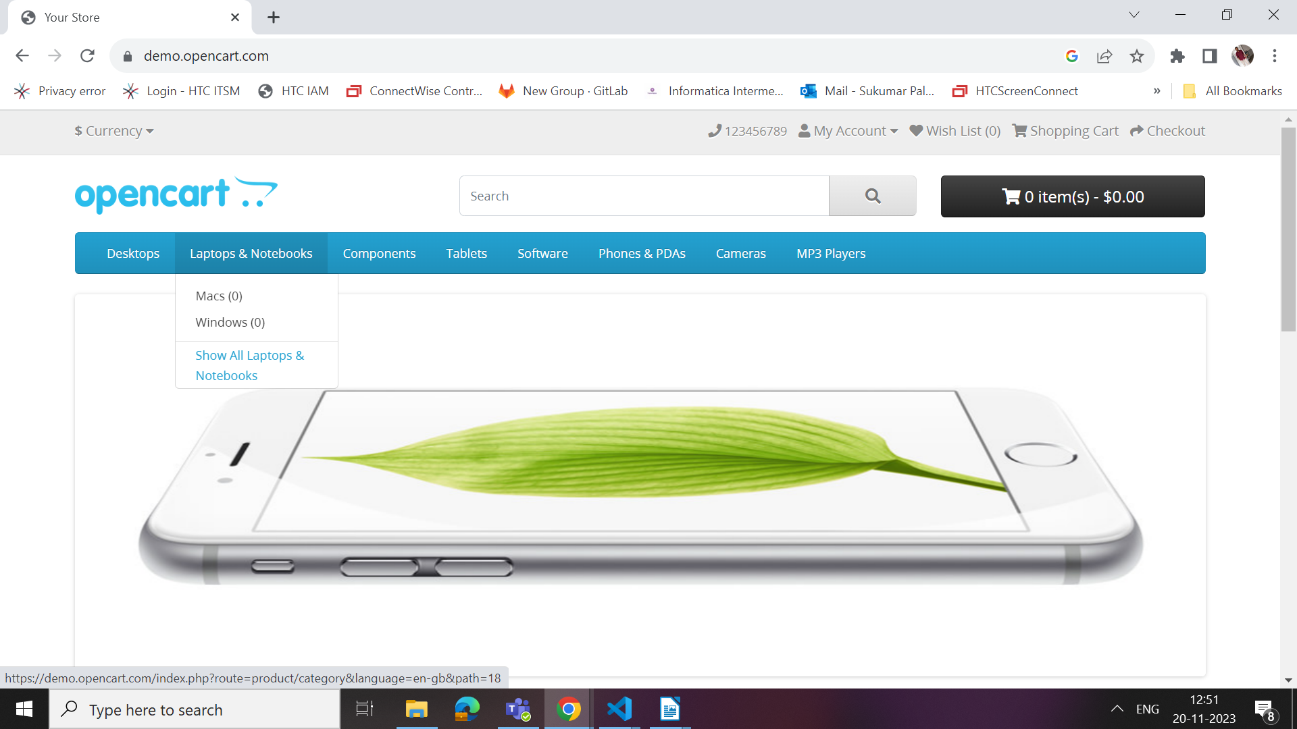

For Right Click
https://swisnl.github.io/jQuery-contextMenu/demo.html
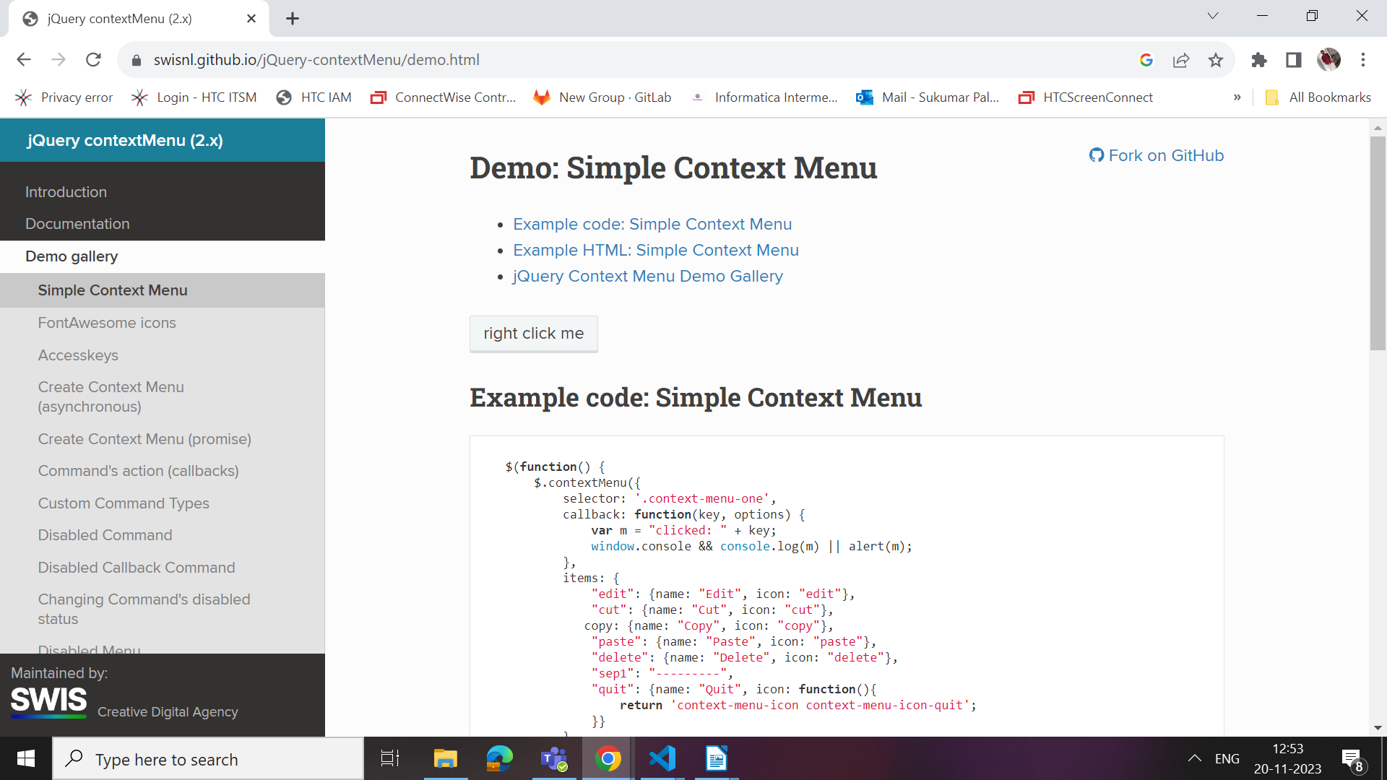
For Double Click
https://www.w3schools.com/tags/tryit.asp?filename=tryhtml5_ev_ondblclick3
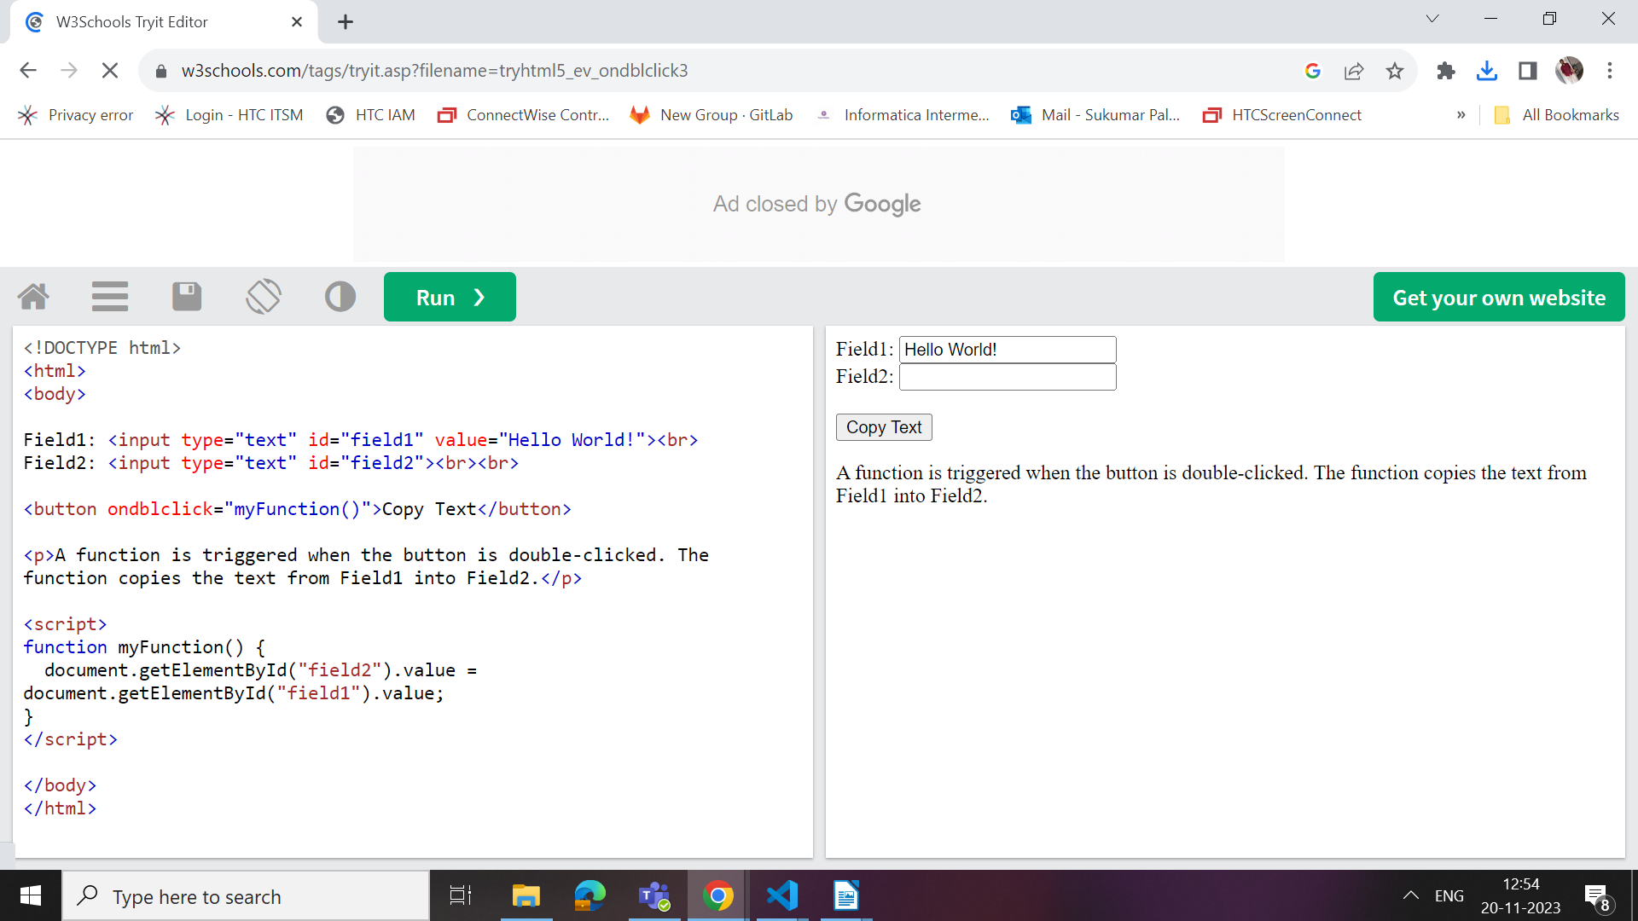

For Drag and drop
http://dhtmlgoodies.com/scripts/drag-drop-custom/demo-drag-drop-3.html#google_vignette
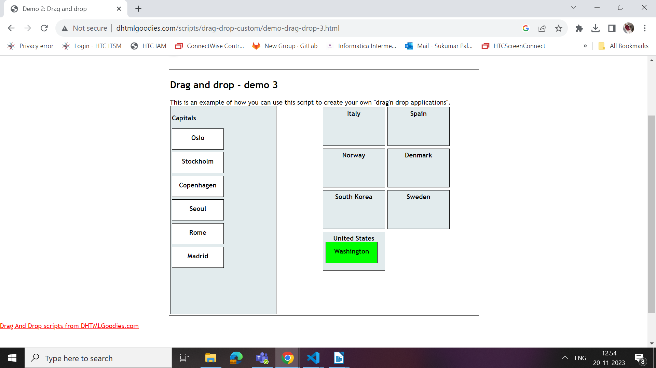

For scroll and view
https://en.wikipedia.org/wiki/List_of_national_birds
