Write a playwright test script to handle file upload, Taking screen shots and record the videos for tests.
i. For single file upload
http://the-internet.herokuapp.com/upload
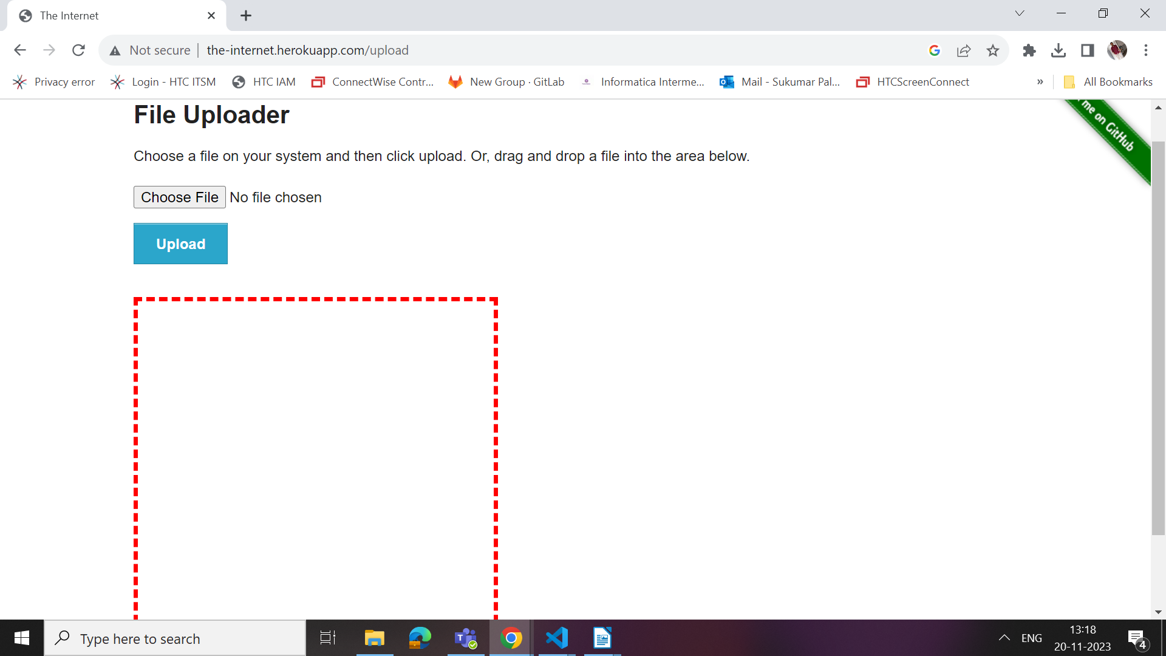
ii. For multiple files upload
https://davidwalsh.name/demo/multiple-file-upload.php
