Write a playwright script to automate Frames/iFrames and Web Tables/Pagination
i. For iFrames
https://the-internet.herokuapp.com/iframe

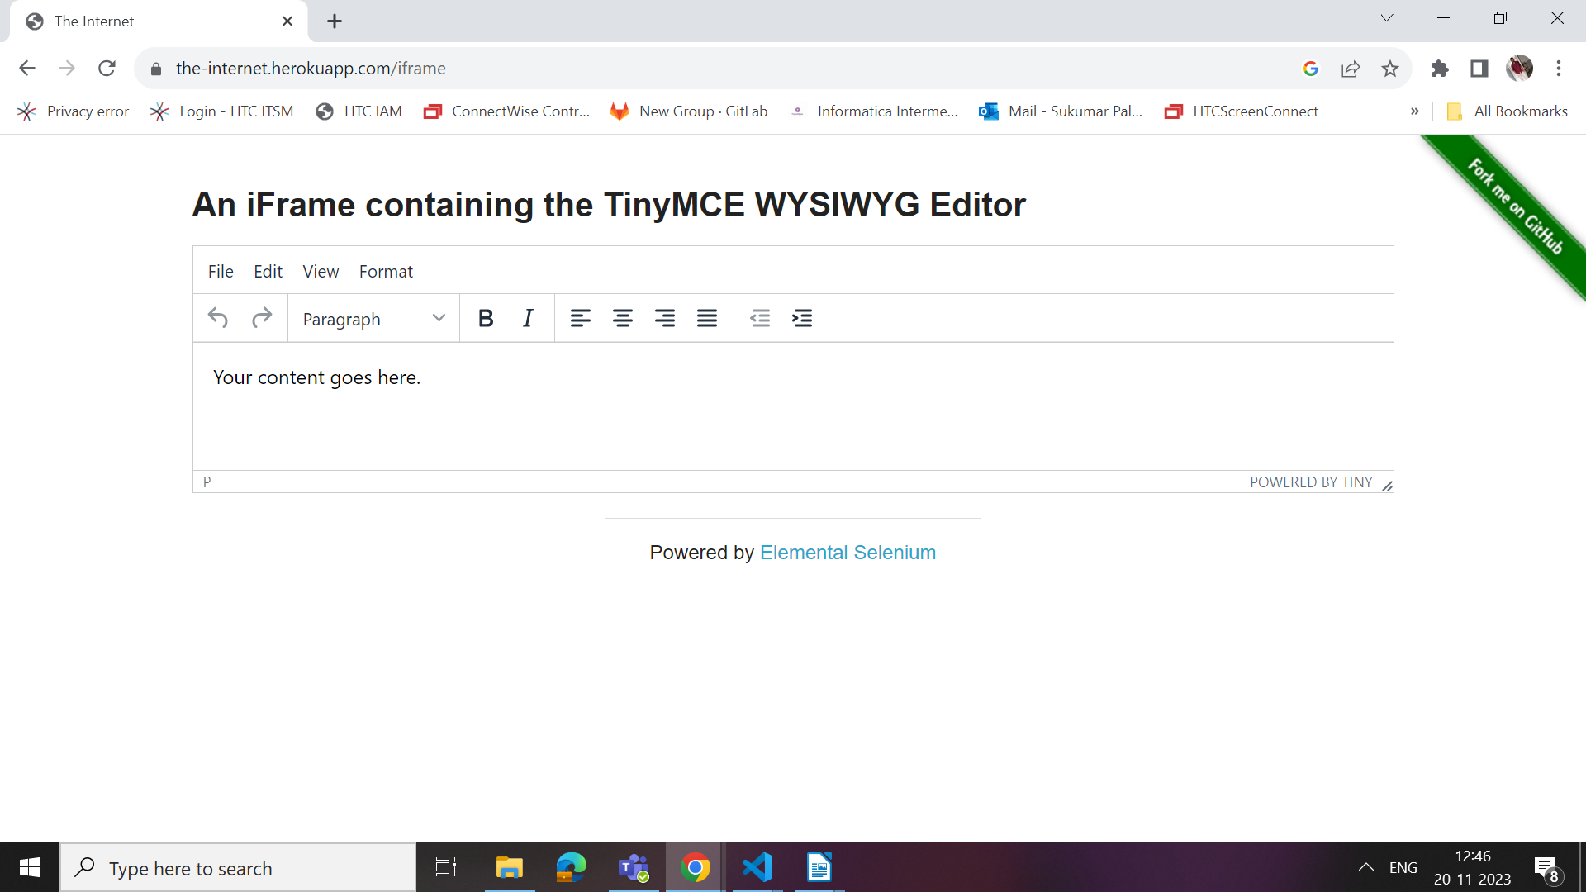
Note:
Navigate to the url given, Identify the iframe and enter some text into the text area given.

ii. For Web tables/Pagination
https://demo.opencart.com/admin/index.php?route=common/login

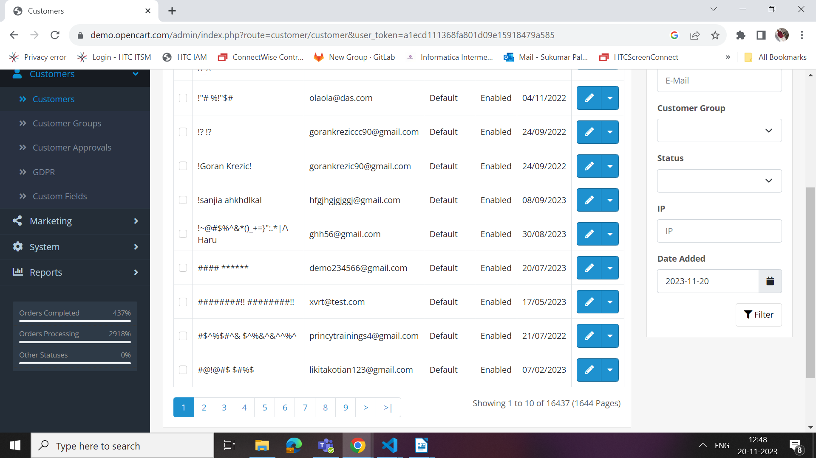

Note: Navigate to the above url by giving username and password as ‘demo’.
Click on Customers--> Customer
Print all customer details like customerName, Email, CustomerGroup, Status and Date added of first 10 pages.

