[1]

**Online Organic Health Food Store website using Django**

Prof. Abha Marathe, Ganesh Karode.

Department Of Computer Science and Engineering

Vishwakarma Institute of Technology Pune, India

***Abstract* : The ‘E-commerce Web application’ Services Department strives to provide solutions to improve and transfer in a simple and effective way in the digital age and to help reduce personal stress and time. To help support store-collection, digital implementation, and digital projects of the External Partnership Center, Provides services that include digital analogue processing, metadata management, digital storage, and acquisition and access to digital collections. "Shop Management System" is a web application written for all applications, designed to help users manage and organize virtual purchases. This software is easy to use for both beginners and advanced users. Includes common sense and good, attractive user interface, combined with powerful search Installation and reporting capability. The store system report center helps you get a good idea of what different members are offering, making it easier for users to find a product.**

***Keywords-* E-commerce , Metadata mangement , Digital preservation.**

# ***INTRODUCTION***

Organic food products and other organic ingredients are grown without the use of pesticides, synthetic fertilizers, sewage sludge, or ionizing radiation. Common fruits and vegetables are often sprayed with pesticides. When you buy such fruits and vegetables, these stubborn chemicals stay in the food. The second major difference between a normal diet and a natural diet is that most common foods are genetically modified or contain genetically modified organisms. Organic food is not readily available in the market. There are only certain stores where natural food is available. E-commerce is the process of doing business through a computer network. Online shopping is a type of online shopping store where the consumer is connected directly to the seller's computer online. Overcoming the difficulties of buying organic food. We have made a proposal for the best online organic store that provides organic food just by staying at home and following E-commerce mode of purchase. The program has two modules namely, Admin and clients. The administrator has the authority to add live foods to the website, view downloaded products, view customers and view customer orders. Customers can register and sign in using the information. Customers who have the authority to view products, crave products and can add to cart and pay, can view their previous order history and can track their order.

1. ***LITERATURE REVIEW***

|  |  |  |  |
| --- | --- | --- | --- |
| **SR. NO** | **Author(s) and Year** | **Explanation of Study** | **Important Feature**  **Examined in the**  **Study** |
| 1 | Bhalekar , P., Ingle, S. and Pathak, K. (2014) | Study of ecommerce | Benefits and limitations of ecommerce |
| 2 | Khurana, A. and Mehra, J. (2015) | E-commerce  opportunities and challenges | The concept of ecommerce, ecommerce scenario in India, and opportunities and  various challenges in e-commerce |
| 3 | Belkhamza, Z. and Wafa, S. (2014) | E-commerce impact on global market | Global influence of e-commerce and its benefits |
| 4 | Dan, C. (2014) | Electronic commerce | Discussed the historical and current activities in e-  commerce process |

# ***METHODOLOGY***

**Modules:**

The system comprises of 2 major modules with their sub-modules.In online Food Ordering System Features for Admin Side.

1. **Dashboard** – For the admin dashboard, you will be able to all the basic access in the whole system. Such as cart items orders, items, users and categories.
2. **Manage Items**– The admin has access to the item management information system. He can add, update and delete the items.
3. **Manage Orders** – As the main functions of the admin, the admin can reject or accept from the customers on a case to case basis.
4. **Manage Categories** – For the categories, the admin has the features of managing the category. The example category used in this system is best selling foods, spicy, and new foods.
5. **Manage Users** – The admin can manage the user’s account. Admin can add, update and delete users in the system.
6. **Login and Logout** – By default one of the security features of this system is the secure login and logout system.

The frontend of this Online Food Ordering System using Django has these basic features of the website.

1. **Home Page** – On the home page, you can see directly the list of foods for sale, login, logout, .
2. **Viewing Products** – by default on the frontend, the customer can automatically view all the foods, the price and description of foods.
3. **Checkout Order**– The customer can checkout order in the frontend that can confirmed by the admin in the backend.
4. **Login and Logout –**The customer need to login in the system before they can add to cart their orders and they can also logout after they finish their order.
5. **Sign up –** the customer need to register or sign up first before they can login into the system.
6. **Add to Cart**– One of the features of this system is that, wherein the customer can temporarily add their order in the add to cart.

### **RESULTS AND DISCUSSIONS**

This website has two modules namely, Admin and Users. Admin has authority to add organic food list on the website, view products uploaded, view customers and view the customer’s order. Customers can register and login using credentials. Users has authority to view products, desire products and can add to cart and do payment for it, they can view their previous order history and also can track their order.

**User module:**

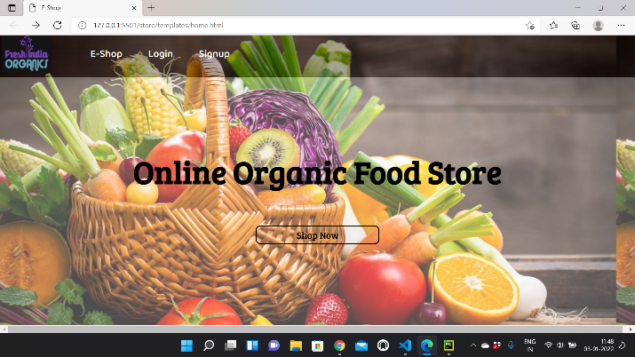

Screenshot 1: Homepage

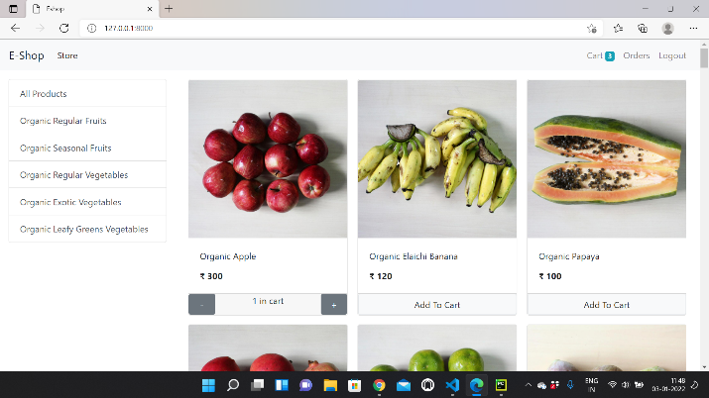

Screenshot 2: Products page

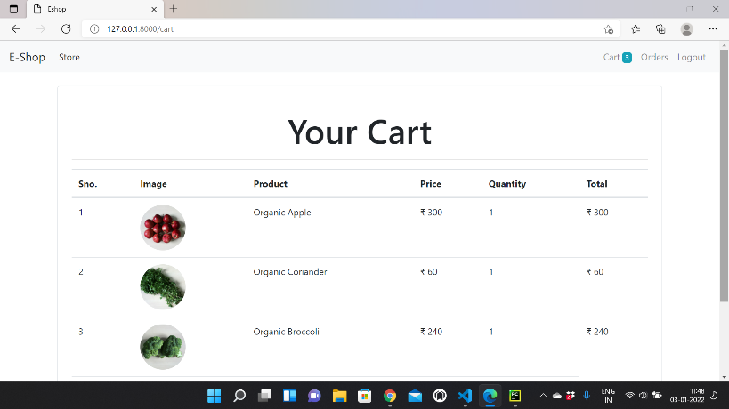

Screenshot 3: Cart page

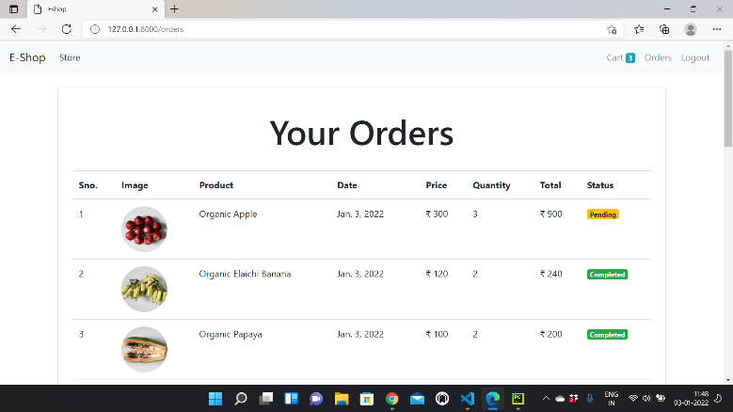

Screenshot 4: Order page

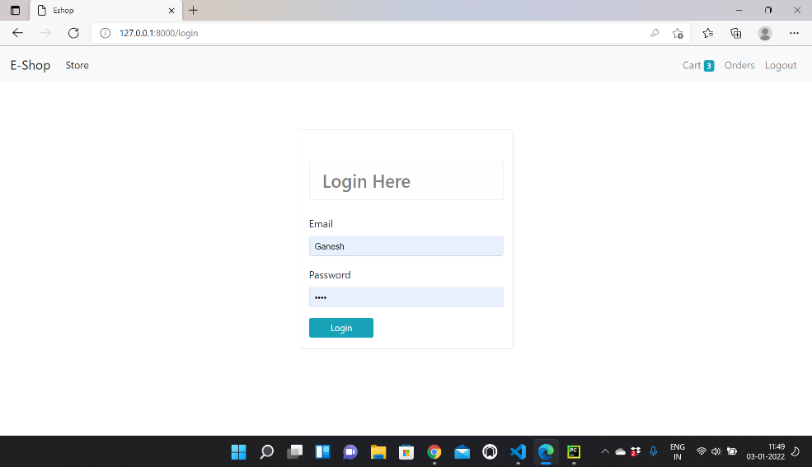

Screenshot 5: Login page

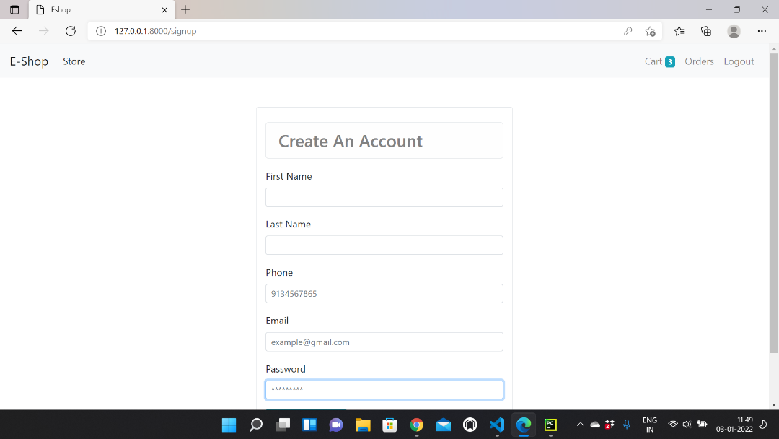

Screenshot 6:Signup page

# **Admin module:**

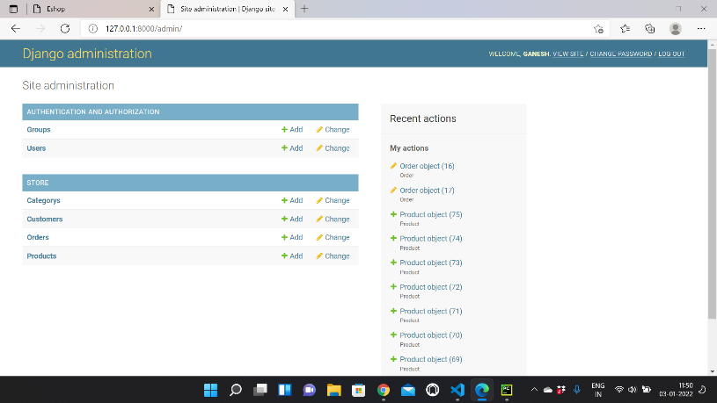

Screenshot 7: Admin page

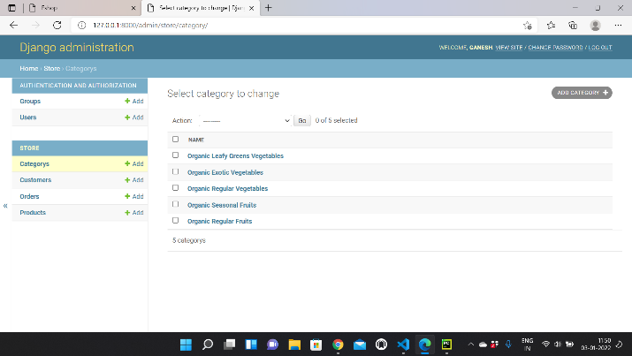

Screenshot 8: Categorys of products

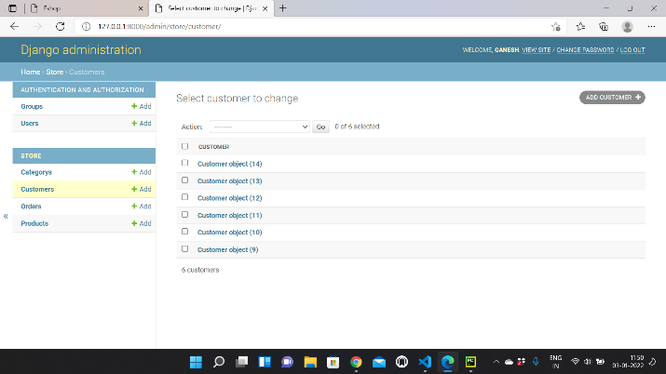

Screenshot 9: Custmers Information

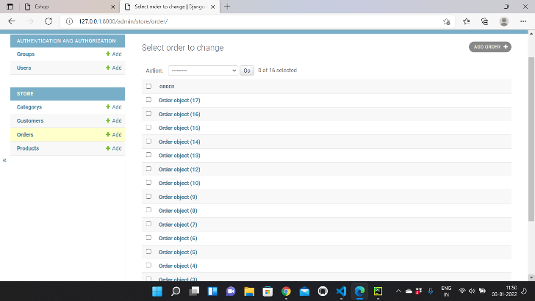

Screenshot 10: Orders Information

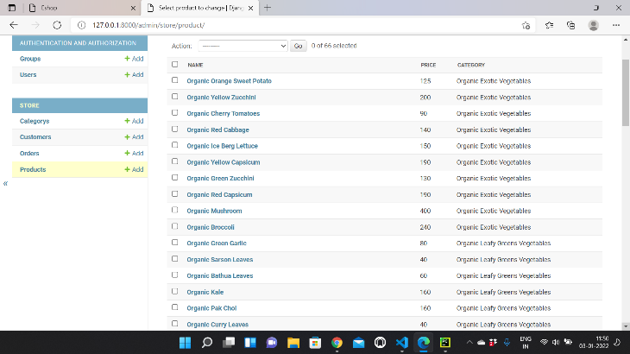

Screenshot 11: Products Information

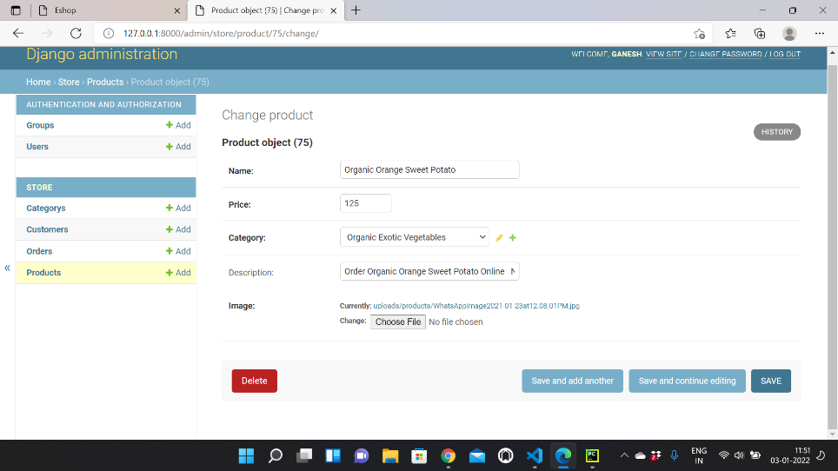

Screenshot 12: Products Added

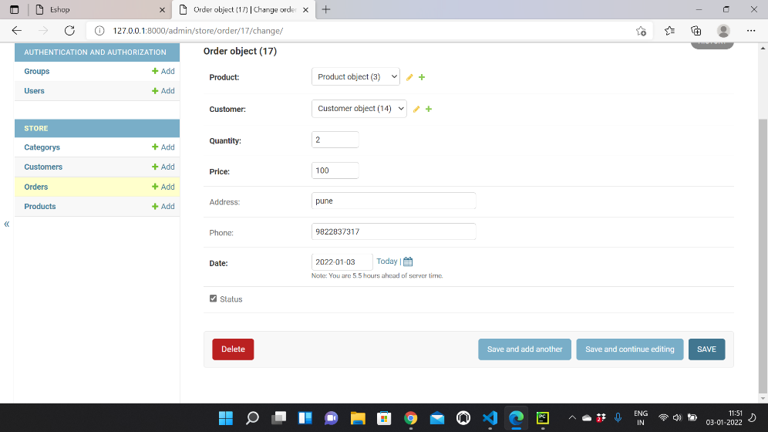

Screenshot 13: Orders Status

# ***CONCLUSION***

This project is a low-cost job to meet the needs of the store. Several easy-to-use codes have also been adopted. This package will appear to be a powerful package that meets all the needs of the organization. The purpose of software editing is to provide a framework that allows the client to make appropriate estimates made within the timeframe at the beginning of the software project and should be updated regularly as the project progresses.

This website provides an electronic version of the store cheating system that will benefit users and the store visitor. It makes the whole process online where users can search for a product, and purchase a variety of products. It also has a general user location by logging into the system where the user can log in and view the status of the ordered item and request items. It provides an administrator access point where administrators can add a variety of items, review user activity nd add information about various customer events.

1. ***REFERENCES***
2. Bhalekar, P., Ingle, S. and Pathak, K. (2014) ‘The study of ecommerce.’ *Asian Journal of Computer Science And Information Technology,* 4(3) Retrieved from [http://www.innovativejournal.in/index.php/ajcsit/articl e/viewFile/729/628](http://www.innovativejournal.in/index.php/ajcsit/article/viewFile/729/628)
3. Khurana, A. and Mehra, J. (2015) ‘E-commerce: Opportunities and challenges.’ *The International Journal Of Business & Management*, 3(1) Retrieved from [http://www.theijbm.com/wpcontent/uploads/2015/01/27.-BM1501-049.pdf](http://www.theijbm.com/wp-content/uploads/2015/01/27.-BM1501-049.pdf)
4. Belkhamza, Z. and Wafa, S. (2014) ‘The role of uncertainty avoidance on E-commerce acceptance across cultures.’ *International Business Research*, 7(5) Retrieved from [http://ccsenet.org/journal/index.php/ibr/article/viewFil e/32181/20469](http://ccsenet.org/journal/index.php/ibr/article/viewFile/32181/20469)
5. Dan, C. (2014) ‘Electronic commerce: State-of-the-art.’

*American Journal of Intelligent Systems*, 4(4) Retrieved from [http://article.sapub.org/10.5923.j.ajis.20140404.02.ht ml#Sec5](http://article.sapub.org/10.5923.j.ajis.20140404.02.html#Sec5)

1.