**VOC to COCO conversion**

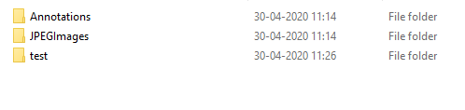

* Above is input in data folder of voc format
* Use following cammand to create json file of coco format
* python voc2coco.py ./data/Annotations ./data/output.json
* coco_output.json will be created in same data folder.

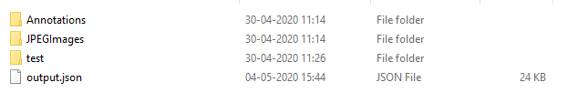

**JSON TO YOLO Conversion**

* JSON file and image folder are the inputs for JSON to YOLO conversion
* Output.json and JPEGImages are input files
* Run the python run file from JSON2YOLO folder
* python run.py --json_file_dir C:\Users\Desktop\voc2coco-master\voc2coco-master\data\coco_output.json --folder_name data --image_folder_dir C:\Users\Desktop\voc2coco-master\voc2coco-master\data\JPEGImages
* new out folder is created in same directory of python file.
* Using given folder_name, files created and edited in out folder

