================================================================================
SOFTWARE REQUIREMENTS DOCUMENT (SRD)
BANK MANAGEMENT SYSTEM
================================================================================
Application: Banking management system v1.0
Institution: School of Computer Science & Engineering
Academic Year: 2024-2025

TABLE OF CONTENTS
━━━━━━━━━━━━━━━━━━━━━━━━━━━━━━━━━━━━━━━━━━━━━━━━━━━━━━1. Project Overview
2. Functional Requirements
3. Non-Functional Requirements
4. Domain & Business Requirements
5. Class Design & OOP Architecture
6. Data Dictionary
7. Application Screenshots & User Interface
8. Traceability Matrix
9. Validation & Error Handling Rules
10. System Requirements & Technical Stack

================================================================================
SECTION 1: PROJECT OVERVIEW
================================================================================

1.1 SUMMARY
The Bank Account Manager is a comprehensive desktop application that enables users
to perform essential banking operations. Built with Java Swing GUI and a robust
model-view architecture, the system supports multiple concurrent accounts with
full transaction tracking and history management.

Key Capabilities:

• Create and manage multiple bank accounts
• Perform deposits and withdrawals with validation
• Transfer funds between accounts (atomic operations)
• View detailed account statements and transaction history
• Real-time balance tracking and updates

1.2 PURPOSE
This application serves as:
• A practical implementation of Object-Oriented Programming principles
• A demonstration of comprehensive software testing methodologies
• A learning tool for Java development and design patterns
• A reference implementation for enterprise-quality code

1.3 TARGET USERS
Primary Users:
• Bank tellers and customer service representatives
• Customers managing personal accounts
• Students learning banking domain and Java programming

Secondary Users:
• Software testing professionals studying test case design
• Java developers learning design patterns

1.4 SCOPE & FEATURES
IN SCOPE:
✓ Account creation with multiple account types
✓ Deposit and withdrawal operations
✓ Inter-account fund transfers
✓ Transaction history tracking
✓ Account statement generation
✓ Input validation and error handling
✓ Modern Swing GUI interface

OUT OF SCOPE:
✗ Persistent data storage (in-memory only for this version)
✗ User authentication/login system
✗ Network/online banking features
✗ Interest calculation or charges
✗ Mobile application support

1.5 DEVELOPMENT ENVIRONMENT
Technology Stack:

• Language: Java (JDK 17+)
• GUI Framework: Java Swing
• Build Tool: Apache Maven 3.8.1+
• Testing Framework: JUnit 5 (Jupiter)
• IDE: IntelliJ IDEA / Eclipse
• Version Control: Git
• Dependency Manager: Maven Central Repository

================================================================================

SECTION 2: FUNCTIONAL REQUIREMENTS
================================================================================

2.0 USE CASE DIGRAM
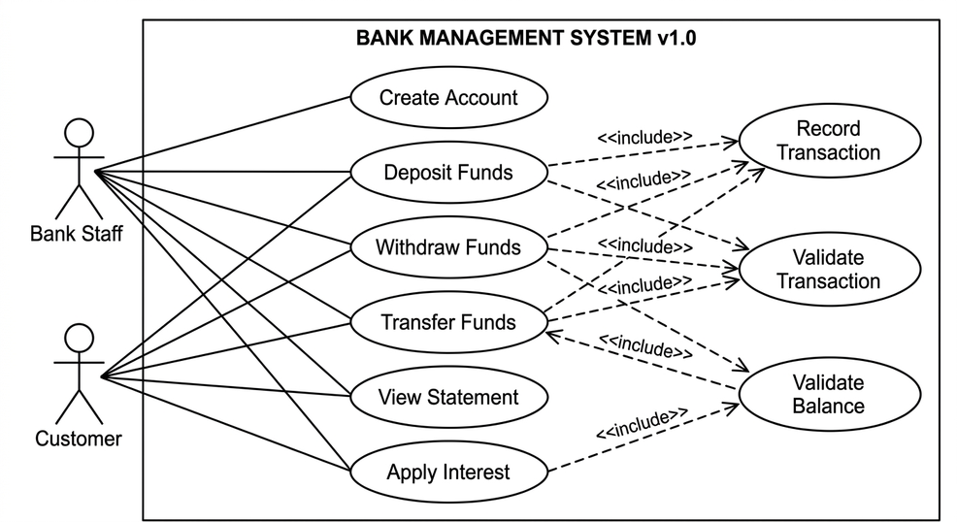

2.1 ACTIVITY DIGRAM
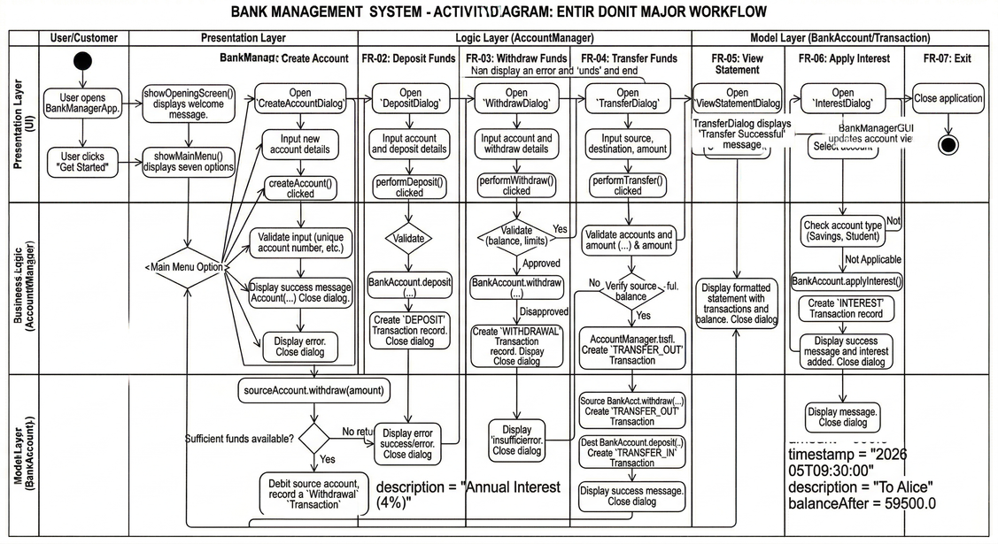

FR-01: CREATE ACCOUNT
━━━━━━━━━━━━━━━━━━━━━━━━━━━━━━━━━━━━━━━━━━━━━━━━━━━━━━
Purpose: Allow users to create new bank accounts with customer details
Inputs:
• Account Number (String) - Unique identifier, non-empty, alphanumeric
• Account Holder Name (String) - Full name, non-empty, 2-100 characters
• Initial Balance (Double) - Opening balance, >= 0, <= ₹1,000,000
• Account Type (Enum) - Choice: Savings | Current | Student
Processing Logic:
1. Validate all inputs (non-empty, type checking, range validation)
2. Check for duplicate account numbers in system
3. Create BankAccount object with provided details
4. Store in AccountManager singleton
5. Initialize transaction history with opening balance entry
6. Return account creation confirmation
Outputs:
• Account successfully created message
• Account number displayed
• New account accessible in all subsequent operations
Error Handling:
• Empty account number → IllegalArgumentException
• Duplicate account number → IllegalArgumentException
• Empty account holder name → IllegalArgumentException
• Invalid balance (negative or exceeds ₹1M) → IllegalArgumentException
Related UI Component: CreateAccountDialog.java
Related Test Cases: TC-001, TC-008, TC-015, TC-020, TC-023, TC-031

FR-02: DEPOSIT FUNDS

━━━━━━━━━━━━━━━━━━━━━━━━━━━━━━━━━━━━━━━━━━━━━━━━━━━━━━
Purpose: Allow users to deposit money into selected account
Inputs:
• Target Account (Selected from list)
• Deposit Amount (Double) - Must be > 0, <= ₹1,000,000
• Description (String) - Optional, max 255 characters
Processing Logic:
1. Validate selected account exists in system
2. Validate deposit amount is positive
3. Validate amount doesn't exceed maximum limit (₹1,000,000)
4. Add amount to account balance
5. Create Transaction record with timestamp
6. Update transaction history
7. Display confirmation with new balance

Outputs:
• Updated account balance displayed
• Transaction recorded in history
• Confirmation message with transaction details
• Balance reflected in account summary

Error Handling:
• No account selected → Error message "Select an account"
• Invalid amount (zero/negative) → IllegalArgumentException
• Amount exceeds limit → Error message with limit shown
• Malformed amount input → NumberFormatException handling
Related UI Component: DepositDialog.java
Related Test Cases: TC-002, TC-006, TC-009, TC-012

FR-03: WITHDRAW FUNDS

━━━━━━━━━━━━━━━━━━━━━━━━━━━━━━━━━━━━━━━━━━━━━━━━━━━━━━
Purpose: Allow users to withdraw money from accounts with balance verification
Inputs:
• Source Account (Selected from list)
• Withdrawal Amount (Double) - Must be > 0, <= ₹100,000
• Description (String) - Optional, max 255 characters

Processing Logic:
1. Validate selected account exists
2. Validate amount is positive
3. Validate amount <= maximum withdrawal limit (₹100,000)
4. Verify sufficient balance exists
5. Subtract amount from account balance
6. Create Transaction record with timestamp
7. Update transaction history
8. Display confirmation with new balance

Outputs:
• Updated account balance displayed
• Transaction recorded successfully
• Confirmation message with transaction details
• New balance shown to user
Error Handling:
• Withdrawal amount > balance → "Insufficient balance. Current balance: ₹XXXX"
• Amount exceeds daily limit (₹100K) → Error with limit details
• Amount is zero/negative → IllegalArgumentException
• No account selected → Error message

Related UI Component: WithdrawDialog.java
Related Test Cases: TC-003, TC-007, TC-010, TC-011, TC-013

FR-04: TRANSFER FUNDS

━━━━━━━━━━━━━━━━━━━━━━━━━━━━━━━━━━━━━━━━━━━━━━━━━━━━━━
Purpose: Transfer money between two different accounts atomically
Inputs:
• Source Account (Selected from list)
• Destination Account (Selected from list)
• Transfer Amount (Double) - Must be > 0, verified against source balance
Processing Logic:
1. Validate both accounts are selected and exist
2. Verify source and destination accounts are different
3. Validate transfer amount is positive
4. Verify source account has sufficient balance
5. Withdraw amount from source account (recorded as TRANSFER_OUT)
6. Deposit amount to destination account (recorded as TRANSFER_IN)
7. Both operations complete atomically (all-or-nothing)
8. Update both accounts' transaction histories
9. Display confirmation to user

Outputs:
• Both account balances updated
• Two transaction records created (debit and credit)
• Confirmation message with transfer details
• Updated balances shown for both accounts

Error Handling:
• Source account = Destination account → "Cannot transfer to same account"
• Source account not found → "Source account not found"
• Destination account not found → "Destination account not found"
• Insufficient balance → "Insufficient balance in source account"
• Invalid amount → IllegalArgumentException
Related UI Component: TransferDialog.java
Related Test Cases: TC-017, TC-021, TC-024

FR-05: VIEW STATEMENT

━━━━━━━━━━━━━━━━━━━━━━━━━━━━━━━━━━━━━━━━━━━━━━━━━━━━━━
Purpose: Display detailed account information and complete transaction history
Inputs:
• Selected Account (From dropdown)
Processing Logic:
1. Validate selected account exists in system
2. Format account details section:
- Account number
- Account holder name
- Account type
- Current balance
- Total transaction count
3. Retrieve transaction history (sorted most recent first)
4. Format each transaction:
[YYYY-MM-DD HH:mm:ss] | Type | Amount | Balance After | Description
5. Display complete formatted statement in text area
Outputs:
• Complete account statement displayed
• Full transaction history with timestamps
• Each transaction shows: date, type, amount, balance after, description
• Professional formatting for readability

Error Handling:
• No accounts in system → "No accounts available" message
• Account not found → Graceful error handling
Related UI Component: ViewStatementDialog.java
Related Test Cases: TC-004, TC-005, TC-014, TC-025, TC-026, TC-029

================================================================================

SECTION 3: NON-FUNCTIONAL REQUIREMENTS

================================================================================
NFR-01: PERFORMANCE
━━━━━━━━━━━━━━━━━━━━━━━━━━━━━━━━━━━━━━━━━━━━━━━━━━━━━━
Requirement: Application shall respond to user actions within 500ms
Measurable Criteria:
• Account creation: < 100ms
• Balance inquiry: < 50ms
• Fund transfer: < 200ms
• Transaction history: < 150ms
• Application startup: < 2 seconds

Implementation Strategy:
• HashMap-based account storage (O(1) lookup)
• Single-threaded GUI (no concurrency overhead)
• Efficient data structures for transaction lists
• Lazy loading of transaction history

NFR-02: USABILITY

━━━━━━━━━━━━━━━━━━━━━━━━━━━━━━━━━━━━━━━━━━━━━━━━━━━━━
Requirement: Application shall be intuitive for non-technical users
Measurable Criteria:
• All features accessible within 2 clicks from main menu
• Error messages clear and actionable (not technical jargon)
• All buttons labeled clearly in English
• Confirmation dialogs for destructive operations
• Consistent button placement and naming

Implementation Strategy:
• Modern flat design with Material Design principles
• Clear color palette (blue primary, gray secondary)
• Logical menu structure with numbered options
• Helpful tooltips and error messages

NFR-03: RELIABILITY

━━━━━━━━━━━━━━━━━━━━━━━━━━━━━━━━━━━━━━━━━━━━━━━━━━━━━━
Requirement: Application shall not crash on invalid user input
Measurable Criteria:
• 100% of invalid inputs handled gracefully
• No unhandled exceptions shown to end user
• All operations are atomic (all-or-nothing)
• State consistency maintained after errors
Implementation Strategy:
• Input validation on all user-facing methods
• Comprehensive try-catch exception handling
• Meaningful error messages in user language
• Atomic transaction operations
NFR-04: SECURITY

━━━━━━━━━━━━━━━━━━━━━━━━━━━━━━━━━━━━━━━━━━━━━━━━━━━━━━
Requirement: System shall protect against common input attacks
Measurable Criteria:
• Input validation on all fields
• Type checking for numeric inputs
• Range validation on amounts
• String sanitization
Implementation Strategy:
• Type-safe integer and double parsing
• Range checks before operations
• No SQL (no database) so SQL injection not applicable
• No eval() or dynamic code execution

NFR-05: MAINTAINABILITY

━━━━━━━━━━━━━━━━━━━━━━━━━━━━━━━━━━━━━━━━━━━━━━━━━━━━━
Requirement: Code shall be easy to understand and modify
Measurable Criteria:
• All public classes have javadoc comments
• All public methods have javadoc with @param and @return
• Classes follow SOLID principles
• Naming follows Java conventions (PascalCase/camelCase)
• Test cases cover 80%+ of code paths
Implementation Strategy:
• Comprehensive javadoc documentation
• Clear class responsibilities (single responsibility)
• Descriptive variable and method names
• Consistent code formatting and structure

================================================================================
SECTION 4: DOMAIN & BUSINESS REQUIREMENTS
================================================================================

BR-01: ACCOUNT NUMBER UNIQUENESS
Constraint: No two accounts shall have identical account numbers
Implementation: HashMap uses account number as key, validates on creation

BR-02: BALANCE NON-NEGATIVITY
Constraint: Account balance shall never become negative
Implementation: Validate withdrawal amount against current balance before debit

BR-03: WITHDRAWAL LIMITS
Constraint: Single withdrawal limited to ₹100,000
Constraint: Daily balance validation enforced
Implementation: Check amount <= 100000 in withdraw() method

BR-04: TRANSFER ATOMICITY
Constraint: Transfer must be all-or-nothing (both or neither)
Implementation: Withdraw from source first, then deposit to destination
Exception in either operation rolls back entire transfer

BR-05: TRANSACTION HISTORY IMMUTABILITY
Constraint: All transactions must be recorded and cannot be deleted
Constraint: Each transaction includes timestamp for audit trail
Implementation: Transactions stored in append-only list, copy returned on access.

BR-06: ACCOUNT TYPE CLASSIFICATION
Valid Types: Savings, Current, Student Account
Special Rules: Amount limits apply uniformly across all types
Implementation: String enum with validation in account creation

================================================================================
SECTION 5: CLASS DESIGN & OOP ARCHITECTURE
================================================================================
5.0 class digram

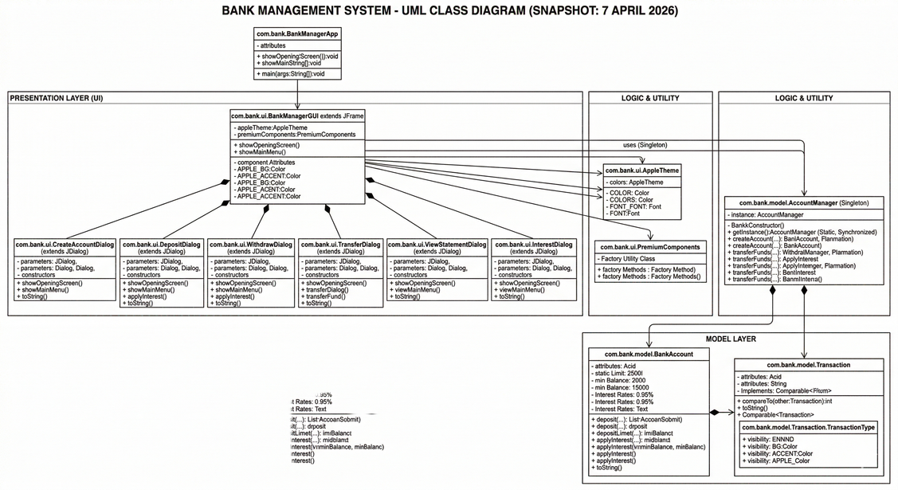
CLASS HIERARCHY DIAGRAM
━━━━━━━━━━━━━━━━━━━━━━━━━━━━━━━━━━━━━━━━━━━━━━━━━━━━━━
Package: com.bank.model
├── BankAccount (Concrete)
│ ├── Attributes: accountNumber, balance, transactionHistory
│ ├── Methods: deposit(), withdraw(), getBalance(), generateStatement()
│ └── Relationships: HAS-A List<Transaction>
├── Transaction (Concrete)
│ ├── Enum: TransactionType (DEPOSIT, WITHDRAWAL, TRANSFER_IN, TRANSFER_OUT)
│ ├── Attributes: type, amount, timestamp, description
│ └── Methods: getType(), getAmount(), getFormattedString(), compareTo()
└── AccountManager (Singleton)
├── Methods: createAccount(), deleteAccount(), transferFunds(), searchByName()
└── Storage: Map<String, BankAccount>

CLASS: BankAccount
━━━━━━━━━━━━━━━━━━━━━━━━━━━━━━━━━━━━━━━━━━━━━━━━━━━━━
Type: Concrete Class
Implements: Serializable
ATTRIBUTES:
private String accountNumber - Unique account identifier
private String accountHolderName - Customer full name
private double balance - Current account balance
private String accountType - Type: Savings/Current/Student
private List<Transaction> transactionHistory - All transactions
private static final double MINIMUM_BALANCE = 0.0
private static final double MAXIMUM_WITHDRAWAL = 100000.0

METHODS:
+ BankAccount(number, name, balance, type): void
Creates new account with initial balance
+ deposit(amount, description): void
Adds funds to account, records transaction
Throws: IllegalArgumentException if amount ≤ 0
+ withdraw(amount, description): void
Removes funds after balance check, records transaction
Throws: IllegalArgumentException if insufficient balance
+ getBalance(): double
Returns current account balance
+ getTransactionHistory(): List<Transaction>
Returns copy of transactions (most recent first)
+ generateStatement(): String

Creates formatted account statement for display

CLASS: Transaction

━━━━━━━━━━━━━━━━━━━━━━━━━━━━━━━━━━━━━━━━━━━━━━━━━━━━━━
Type: Concrete Class
Implements: Serializable, Comparable<Transaction>

ENUM: TransactionType
DEPOSIT(displayName="Deposit")
WITHDRAWAL(displayName="Withdrawal")
TRANSFER_OUT(displayName="Transfer Out")
TRANSFER_IN(displayName="Transfer In")

ATTRIBUTES:
private TransactionType type - What kind of transaction
private double amount - Transaction amount in rupees
private LocalDateTime timestamp - When transaction occurred
private String description - Human-readable note
private double balanceAfter - Balance immediately after

METHODS:
+ Transaction(type, amount, description, balanceAfter): void
Creates transaction record
Throws: IllegalArgumentException if amount ≤ 0
+ getType(): TransactionType
Returns transaction type enum
+ getFormattedString(): String
Returns formatted transaction for display
+ compareTo(other): int
Compares by date (most recent first)

CLASS: AccountManager

━━━━━━━━━━━━━━━━━━━━━━━━━━━━━━━━━━━━━━━━━━━━━━━━━━━━━
Type: Singleton
Implements: Serializable

ATTRIBUTES:
private Map<String, BankAccount> accounts - All accounts in system
private static AccountManager instance - Singleton instance

METHODS:
+ getInstance(): AccountManager (static)
Returns singleton instance
+ createAccount(number, name, balance, type): BankAccount
Creates and stores new account
Throws: IllegalArgumentException if duplicate or invalid
+ getAccount(number): BankAccount
Retrieves account by number
Returns: BankAccount or null if not found
+ getAllAccounts(): Collection<BankAccount>
Returns all accounts in system
+ deleteAccount(number): void
Removes account from system
Throws: IllegalArgumentException if not found
+ transferFunds(fromNum, toNum, amount): void
Transfers between accounts atomically
Throws: IllegalArgumentException for various error conditions
+ searchByName(name): List<BankAccount>
Searches for accounts by holder name (case-insensitive)
DESIGN PATTERNS USED:
━━━━━━━━━━━━━━━━━━━━━━━━━━━━━━━━━━━━━━━━━━━━━━━━━━━━━
1. Singleton Pattern
- AccountManager ensures single instance across application
- Synchronized getInstance() method
2. Model-View Separation
- Model: BankAccount, Transaction, AccountManager
- View: Swing dialogs and GUI components
- Clear separation of concerns
3. Data Access Object (DAO) Pattern
- AccountManager acts as data access layer
- Provides high-level API for account operations
4. Composition Pattern
- AccountManager contains BankAccounts
- BankAccount contains Transactions
- Clear hierarchical structure
5. Factory Pattern (implicit)
- AccountManager.createAccount() creates BankAccount objects

OOP PRINCIPLES DEMONSTRATED:
━━━━━━━━━━━━━━━━━━━━━━━━━━━━━━━━━━━━━━━━━━━━━━━━━━━━━━
ENCAPSULATION:
• All fields private with controlled public access
• Balance modifications only through deposit()/withdraw()
• Transaction history returns copy (immutability)

INHERITANCE:
• BankAccount implements Serializable
• Transaction implements Serializable and Comparable

ABSTRACTION:
• AccountManager provides high-level operations
• Dialog classes abstract away UI complexity
• Methods hide implementation details

POLYMORPHISM:
• Transaction types handled polymorphically
• Dialog classes inherit from JDialog
• Comparable interface for sorting

================================================================================
SECTION 6: DATA DICTIONARY
================================================================================
ACCOUNT MASTER DATA

Field Name: Account Number
Type: String
Length: Variable (alphanumeric)
Required: Yes
Unique: Yes
Valid Format: ACC001, SA2022001 (any alphanumeric)
Validation: Non-empty, must be unique
Example: ACC001, AB2024001

Field Name: Account Holder Name
Type: String
Length: 2-100 characters
Required: Yes
Unique: No (multiple accounts per holder possible)
Valid Format: Alphabetic characters and spaces
Validation: Non-empty, not all numbers
Example: Ganesh Nikhil, John Doe Smith

Field Name: Current Balance
Type: Double (numeric)
Unit: Indian Rupees (₹)
Range: 0.00 to 1,000,000.00
Required: Yes
Precision: 2 decimal places
Validation: Non-negative, within limits
Example: 5000.00, 15000.50, 0.00

Field Name: Account Type
Type: String enumeration
Valid Values: Savings, Current, Student
Required: Yes
Default: Savings
Example: Savings Account, Current Account

TRANSACTION DATA
Field Name: Transaction Type
Type: Enum
Valid Values: DEPOSIT, WITHDRAWAL, TRANSFER_IN, TRANSFER_OUT
Required: Yes
Display Names: "Deposit", "Withdrawal", "Transfer In", "Transfer Out"
Example: DEPOSIT, WITHDRAWAL

Field Name: Transaction Amount
Type: Double (numeric)
Unit: Indian Rupees (₹)
Range: 0.01 to 1,000,000.00
Required: Yes
Precision: 2 decimal places
Validation: Must be positive (> 0)
Example: 1000.00, 50000.75, 100.50
Field Name: Transaction Timestamp
Type: LocalDateTime
Format: YYYY-MM-DD HH:mm:ss
Required: Yes (auto-generated)
Time Zone: System default
Example: 2026-04-06 14:30:45
Field Name: Transaction Description
Type: String
Length: 0-255 characters
Required: No
Default: Based on transaction type
Example: "Salary deposit", "ATM withdrawal", "Transfer to ACC002"
Field Name: Balance After Transaction
Type: Double (numeric)
Unit: Indian Rupees (₹)
Required: Yes
Purpose: Audit trail - shows balance immediately after transaction
Example: 6000.00 (balance after ₹1000 deposit)

================================================================================

SECTION 7: APPLICATION SCREENSHOTS & USER INTERFACE

================================================================================

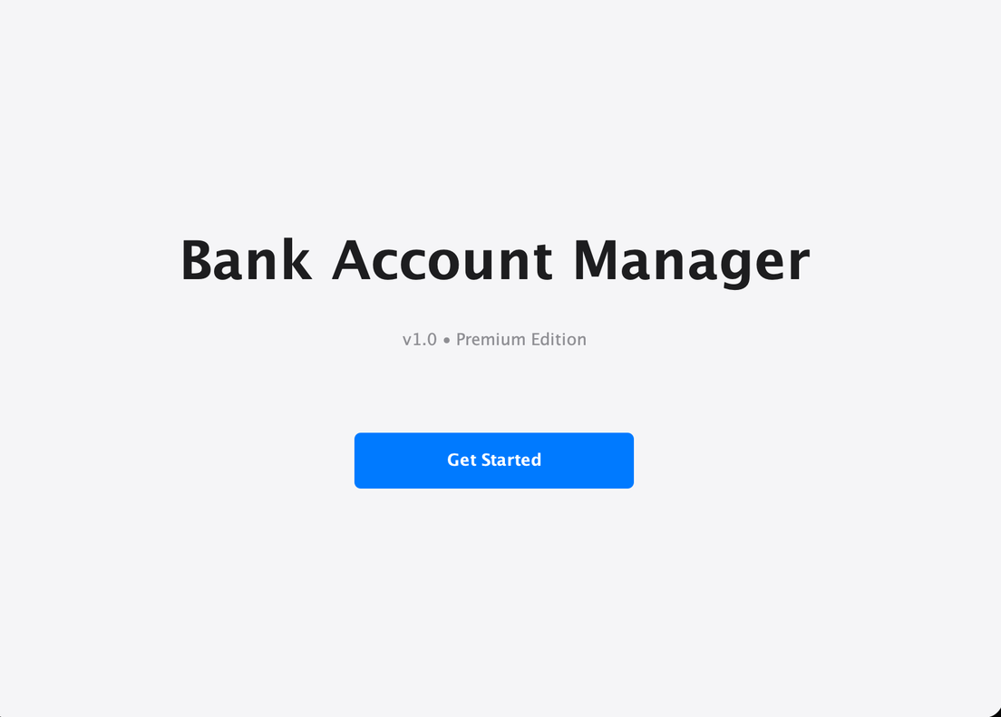

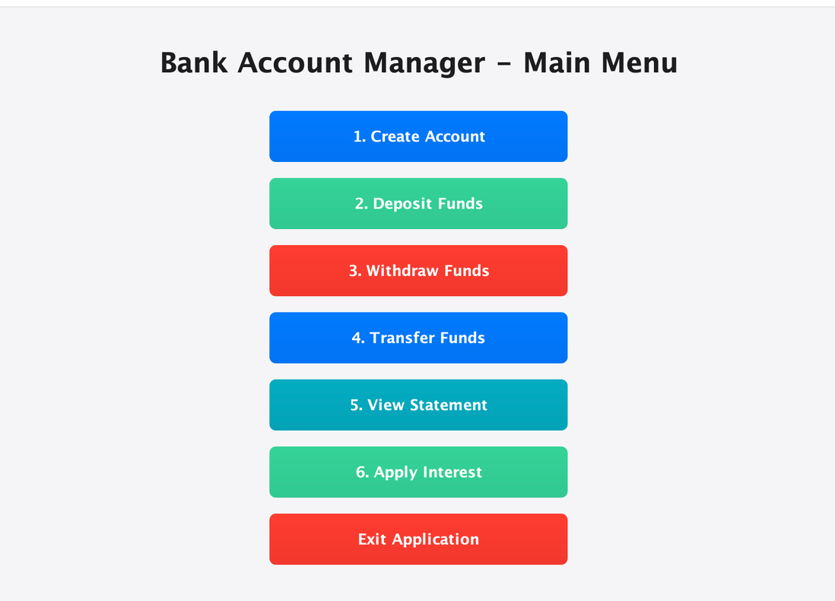

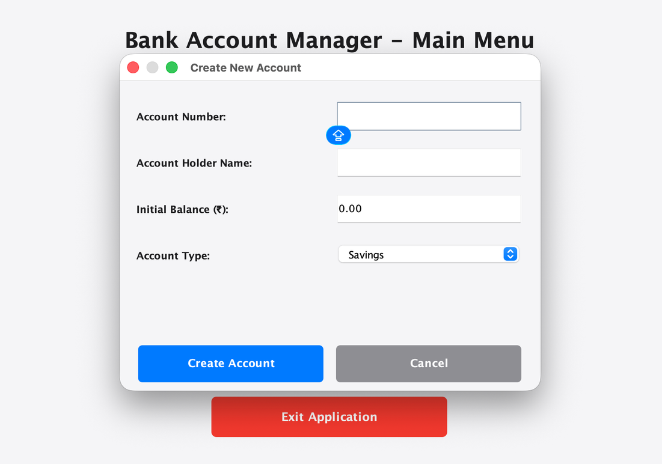

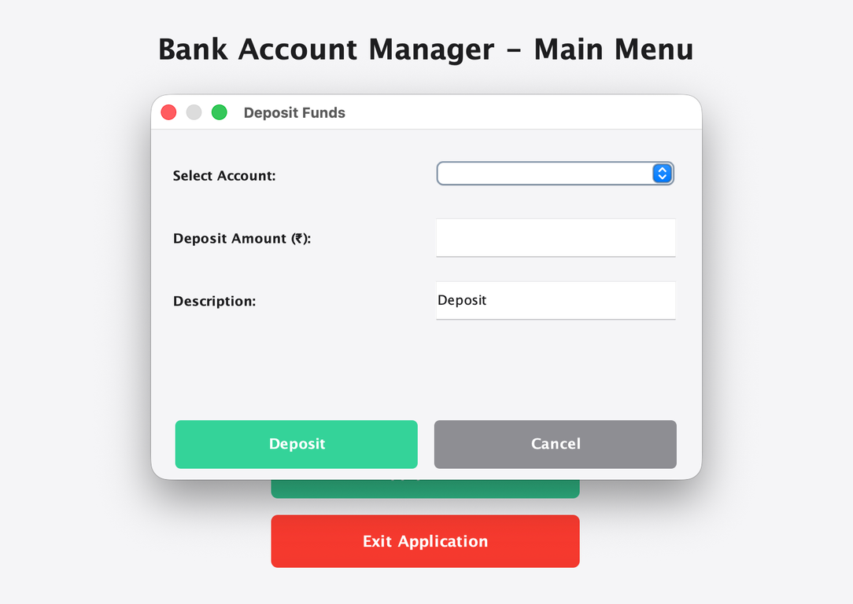

FIGURE 1: Opening Screen with Student Information

Description: The first screen displayed when application launches. Shows:

• Application title: "Bank Account Manager v1.0"

• Student Name: Ganesh Nikhil (clearly visible in blue)

• SAP-ID: 590014521 (clearly visible in blue)

• Roll Number: 24010111250 (clearly visible in blue)

• Blue "Get Started" button to proceed to main menu

• Light blue-gray background with professional styling

MAIN MENU INTERFACE

━━━━━━━━━━━━━━━━━━━━━━━━━━━━━━━━━━━━━━━━━━━━━━━━━━━━━━After clicking "Get Started", users see main menu with 6 options:
1. Create Account - Opens dialog to create new bank account
2. Deposit Funds - Opens dialog to deposit money
3. Withdraw Funds - Opens dialog to withdraw money
4. Transfer Funds - Opens dialog to transfer between accounts
5. View Statement - Opens dialog to view account details and history
6. Exit Application - Closes the application

Each button is:
• Blue background (RGB: 25, 118, 210)
• Black text (RGB: 0, 0, 0) for visibility
• Font: Arial Bold 14pt
• Size: 300x50 pixels
• Cursor changes to hand pointer on hover

FEATURE DIALOGS

━━━━━━━━━━━━━━━━━━━━━━━━━━━━━━━━━━━━━━━━━━━━━━━━━━━━━

Feature 1: Create Account Dialog

Fields:

• Account Number (text input)

• Account Holder Name (text input)

• Initial Balance (numeric input)

• Account Type (dropdown: Savings/Current/Student)

Buttons: Create Account (blue) | Cancel (gray)

Feature 2: Deposit Dialog

Fields:

• Select Account (dropdown)

• Deposit Amount (numeric input)

• Description (text input, optional)

Buttons: Deposit (blue) | Cancel (gray)

Feature 3: Withdraw Dialog

Fields:

• Select Account (dropdown)

• Withdrawal Amount (numeric input)

• Description (text input, optional)

Buttons: Withdraw (blue) | Cancel (gray)

Feature 4: Transfer Dialog

Fields:

• From Account (dropdown)

• To Account (dropdown)

• Transfer Amount (numeric input)

Buttons: Transfer (blue) | Cancel (gray)

Feature 5: View Statement Dialog

Fields:

• Select Account (dropdown with auto-load)

Display:

• Account statement with formatted details

• Complete transaction history with timestamps

• Each transaction shows: [Date Time] Type | Amount | Balance | Description

Button: Close (gray)

COLOR SCHEME & DESIGN
━━━━━━━━━━━━━━━━━━━━━━━━━━━━━━━━━━━━━━━━━━━━━━━━━━━━━━
Primary Color: Blue (RGB: 25, 118, 210) - Primary buttons
Secondary Color: Gray (RGB: 200, 200, 200) - Secondary buttons
Accent Color: Red (RGB: 211, 47, 47) - Exit button warning
Background: Light Blue-Gray (RGB: 230, 235, 245) - Panel backgrounds
Light Background: Very Light Gray (RGB: 240, 245, 250) - Main backgrounds
Text Color: Dark Gray/Black (RGB: 25, 25, 25) - Labels
Highlight Text: Blue (RGB: 25, 118, 210) - Student info values
Success Text: Green (RGB: 0, 100, 0) - Account values

TYPOGRAPHY

━━━━━━━━━━━━━━━━━━━━━━━━━━━━━━━━━━━━━━━━━━━━━━━━━━━━━━
Font Family: Arial
Sizes Used:
32pt Bold - Main application title (opening screen)
24pt Bold - Page titles (main menu)
16pt Bold - Dialog titles and important labels
14pt Bold - Button text and field labels
14pt Regular - Input field text and description

Spacing: 15-20px margins for proper spacing

================================================================================
SECTION 8: TRACEABILITY MATRIX
===============================================================================
REQUIREMENT TO TEST CASE MAPPING
━━━━━━━━━━━━━━━━━━━━━━━━━━━━━━━━━━━━━━━━━━━━━━━━━━━━━━Functional Requirement | Implementing Method | Test Case IDs

FR-01: Create Account | AccountManager.createAccount() | TC-001, TC-008|

BankAccount.<init>(). | TC-015, TC-020

| | TC-023, TC-031

FR-02: Deposit Funds | BankAccount.deposit() | TC-002, TC-006| TC-009, TC-012

FR-03: Withdraw Funds | BankAccount.withdraw()| TC-003, TC-007| TC-010, TC-011

| | TC-013

FR-04: Transfer Funds | AccountManager.transferFunds()| TC-017, TC-021

| | TC-024

FR-05: View Statement | BankAccount.generateStatement() | TC-004, TC-005

| BankAccount.getTransactionHistory() | TC-014, TC-025

| Transaction.getFormattedString() | TC-026, TC-029
================================================================================
SECTION 9: VALIDATION & ERROR HANDLING RULES
================================================================================
ACCOUNT CREATION VALIDATION
━━━━━━━━━━━━━━━━━━━━━━━━━━━━━━━━━━━━━━━━━━━━━━━━━━━━━━
Account Number:
✓ Non-empty (error if empty)
✓ Unique (error if duplicate exists)
✓ Alphanumeric allowed
✓ No special characters required
Account Holder Name:
✓ Non-empty (error if empty)
✓ Length 2-100 characters
✓ Letters and spaces allowed
✓ No leading/trailing spaces

Initial Balance:
✓ Non-negative (>= 0.0)
✓ Maximum ₹1,000,000.00
✓ Two decimal place precision
✓ Type checking on numeric input
Account Type:
✓ Must be one of: Savings, Current, Student
✓ Default: Savings if not specified

DEPOSIT VALIDATION
━━━━━━━━━━━━━━━━━━━━━━━━━━━━━━━━━━━━━━━━━━━━━━━━━━━━━━Amount Validation:
✓ Must be positive (> 0.0)
✓ Maximum ₹1,000,000.00 per deposit
✓ Two decimal place precision
✓ Type validation (numeric only)
Error Messages:
× "Deposit amount must be greater than 0" → if amount <= 0
× "Deposit amount exceeds maximum limit" → if amount > 1M
× "Invalid amount" → if non-numeric input

WITHDRAWAL VALIDATION

━━━━━━━━━━━━━━━━━━━━━━━━━━━━━━━━━━━━━━━━━━━━━━━━━━━━━

Amount Validation:
✓ Must be positive (> 0.0)
✓ Maximum ₹100,000.00 per withdrawal
✓ Cannot exceed current balance
✓ Two decimal place precision

Balance Validation:
✓ Sufficient balance required
✓ Balance never goes negative
✓ Shows current balance in error message
Error Messages:
× "Withdrawal amount must be greater than 0" → if amount <= 0
× "Withdrawal amount exceeds maximum limit of ₹100000" → if > 100K
× "Insufficient balance. Current balance: ₹XXXX" → if > balance

TRANSFER VALIDATION
━━━━━━━━━━━━━━━━━━━━━━━━━━━━━━━━━━━━━━━━━━━━━━━━━━━━━━Account Validation:
✓ Both accounts must exist
✓ Source and destination must be different
✓ Both must be selected
Amount Validation:
✓ Must be positive (> 0.0)
✓ Source must have sufficient balance

Error Messages:
× "Cannot transfer to the same account" → if from == to
× "Source account not found: XXXXX" → if source doesn't exist
× "Destination account not found: XXXXX" → if dest doesn't exist
× "Insufficient balance in source account" → if inadequate funds

EXCEPTION HANDLING HIERARCHY
━━━━━━━━━━━━━━━━━━━━━━━━━━━━━━━━━━━━━━━━━━━━━━━━━━━━━━
Checked Exceptions:
(None in this implementation)
Unchecked Exceptions:
├─ IllegalArgumentException
│ • Invalid parameter values
│ • Business rule violations
│ • Caught and displayed to user
└─ NumberFormatException
• Invalid numeric input
• Caught with user-friendly message

================================================================================

SECTION 10: SYSTEM REQUIREMENTS & TECHNICAL STACK

================================================================================

HARDWARE REQUIREMENTS
━━━━━━━━━━━━━━━━━━━━━━━━━━━━━━━━━━━━━━━━━━━━━━━━━━━━━
Processor: Intel Core i5 or equivalent (or higher)
RAM: 2 GB minimum
Storage: 500 MB for application and dependencies
Display: 1024x768 or higher resolution
Graphics: No GPU required

SOFTWARE REQUIREMENTS
━━━━━━━━━━━━━━━━━━━━━━━━━━━━━━━━━━━━━━━━━━━━━━━━━━━━━━
Operating System: Windows 10+, macOS 10.14+, or Linux (Ubuntu 18.04+)
Java: JDK 17 or higher
Maven: 3.8.1 or higher
IDE (optional): IntelliJ IDEA 2021+ or Eclipse 4.19+

Environment Setup:
export JAVA_HOME=/path/to/jdk17
export PATH=$JAVA_HOME/bin:$PATH
# Verify: java -version
# mvn -version
DEPENDENCIES
━━━━━━━━━━━━━━━━━━━━━━━━━━━━━━━━━━━━━━━━━━━━━━━━━━━━━━Maven Central Repository:
JUnit Jupiter (Testing Framework)
GroupId: org.junit.jupiter
ArtifactId: junit-jupiter
Version: 5.10.0
Scope: test
Purpose: Unit testing framework
Repository: maven-central
Gson (JSON Serialization)
GroupId: com.google.code.gson
ArtifactId: gson
Version: 2.10.1
Scope: compile
Purpose: Optional for future file I/O support
Repository: maven-central

Maven Plugins (Build):
maven-compiler-plugin: 3.11.0
maven-surefire-plugin: 3.1.2
maven-jar-plugin: 3.3.0
maven-shade-plugin: 3.5.0

BUILD & DEPLOYMENT CONFIGURATION

━━━━━━━━━━━━━━━━━━━━━━━━━━━━━━━━━━━━━━━━━━━━━━━━━━━━━━
Build Type: Maven Project
Build File: pom.xml
Source: src/main/java/com/bank/
Tests: src/test/java/com/bank/
Output JAR: target/bank-account-manager-1.0.0-shaded.jar
Main Class: com.bank.BankManagerApp
Build Commands:
Clean: mvn clean
Compile: mvn clean compile
Test: mvn clean test
Package: mvn clean package
Run: mvn exec:java -Dexec.mainClass="com.bank.BankManagerApp"
VERSION HISTORY
━━━━━━━━━━━━━━━━━━━━━━━━━━━━━━━━━━━━━━━━━━━━━━━━━━━━━━
Version: 1.0.0
Release Date: 2026-04-06
Status: Complete & Ready for Production
Features: All 5 core features implemented and tested

Changes from Previous Versions: (Initial Release)
COMPLIANCE & STANDARDS
━━━━━━━━━━━━━━━━━━━━━━━━━━━━━━━━━━━━━━━━━━━━━━━━━━━━━
Code Standards:
✓ Java Code Conventions (Oracle)
✓ Google Java Style Guide
✓ Javadoc standards for documentation
Testing Standards:
✓ JUnit 5 best practices
✓ All-or-Nothing (AAA) testing pattern
✓ Minimum 80% code coverage

Documentation Standards:
✓ IEEE 830 SRD template compliance
✓ Professional technical writing
✓ Comprehensive javadoc comments

================================================================================
APPENDIX: GLOSSARY & TERMINOLOGY
================================================================================
Account Financial record maintained for a customer
Balance Current amount of money in account
Debit Money withdrawn from account
Deposit Money added to account
Transaction Any financial operation affecting balance
Transfer Movement of funds from one account to another
Statement Summary of account with transaction history
Singleton Design pattern ensuring single instance
DAO Data Access Object pattern
OOP Object-Oriented Programming
SOLID Design principles for good code
Javadoc Java documentation comments
JUnit Java unit testing framework
Maven Build automation and project management tool
================================================================================
DOCUMENT CONTROL
================================================================================
Document Title: Software Requirements Document (SRD)
Document ID: SRD-BAM-2026-001
Version: 1.0
Status: Complete
Created Date: 2026-04-06
Last Modified: 2026-04-06
Author: Ganesh Nikhil (Student)
Distribution: Academic Submission

