|  |
| --- |
| **A**  **PROJECT REPORT ON** |
|  |
|  |
| Hotel Booking System |
|  |
|  |
| SUBMITTED IN  PARTIAL FULFILLMENT OF  **DIPLOMA IN MOBLIE COMPUTING (PG-DMC)** |
|  |
|  |
|  |
|  |
|  |
|  |
|  |
| **BY**  **Ganesh Phad** |
|  |
|  |
| **UNDER THE GUIDENCE OF**  Manjusha Nikam |
|  |
|  |
|  |
| **AT**  **SUNBEAM INSTITUTE OF INFORMATION TECHNOLOGY,**  **PUNE** |

|  |  |  |  |
| --- | --- | --- | --- |
| **SUNBEAM INSTITUTE OF INFORMATION TECHNOLOGY,**  **PUNE.** | | | |
|  | | | |
|  | | | |
|  | | | |
|  | | | |
| **CERTIFICATE** | | | |
|  | | | |
| This is to certify that the project | | | |
|  | | | |
| Hotel Booking System | | | |
|  | | | |
| Has been submitted by | | | |
|  | | | |
| **Ganesh Phad** | | | |
|  | | | |
|  | | | |
| In partial fulfillment of the requirement for the Course of **PG Diploma in Mobile Computing (PG-DMC SEPT 2021)** as prescribed by The **CDAC** ACTS, PUNE. | | | |
|  | | | |
|  | | | |
| Place: Pune | | | Date: 14-April-2022 |
|  | | | |
|  | | | |
|  | | | |
|  | | | |
|  | | | |
|  | | | **Manjusha Nikam** |
|  | | | **Project Guide** |
|  |

**ACKNOWLEDGEMENT**

I would like to express my special thanks of gratitude to my teacher Manjusha Nikam as well as our Director Nitin Khudale who gave me the golden opportunity to do this wonderful project on the topic Hotel Booking System, which also helped me in doing a lot of Research and I came to know about so many new things I am really thankful to them.

**ABSTRACT**

The project “Online Hotel Booking System” is a system based on accessing the internet to book for rooms in a hotel. The purpose of this study is to develop and implement an online hotel reservation system for hotels, that will replace the manual method of booking for hotel rooms. The use of online view of room rates and uploading of available rooms and facilities was used for the new system so that the customer can view and make his choice before arrival, and also in the case of emergency travelling.

|  |  |  |
| --- | --- | --- |
|  | **INTRODUCTION** | 1 |
|  | 1.1 Introduction | 2 |
|  | **Product Overview and Summary** |  |
|  | 2.1 Purpose |  |
|  | 2.2 Scope |  |
|  | 2.3 User Classes and Characteristics |  |
|  | 2.4 Design and Implementation Constraints |  |
|  | **REQUIREMENTS** |  |
|  | 3.1 Functional Requirements |  |
|  | 3.1.1 Use case for User and Admin. |  |
|  |  |  |
|  | 3.2 Non - Functional Requirements |  |
|  | 3.2.1 Usability Requirement |  |
|  | 3.2.2 Performance Requirement |  |
|  | 3.2.3 Reliability Requirement |  |
|  | 3.2.4 Portability Requirement |  |
|  | 3.2.5 Security Techniques |  |
|  | **PROJECT DESIGN** |  |
|  | 4.1 Data Model |  |
|  | 4.1.1 Database Design |  |
|  | 4.2 Process Model |  |
|  | 4.2.1 Functional Decomposition Diagram |  |
|  | 4.2.2 Data Flow Diagram (DFD) |  |
|  | **PROJECT RELATED STATISTICS** |  |
|  | **CONCLUSION** |  |

**INDEX**

**LIST OF TABLES**

|  |  |  |
| --- | --- | --- |
| **Section** | **Table Title** | **Page** |
| **Fig 2** | **Complete Database(E-R Diagram)** |  |
|  |  |  |
|  |  |  |
|  |  |  |
|  |  |  |
|  |  |  |

**LIST OF FIGURES**

|  |  |  |
| --- | --- | --- |
| **Section** | **Figure Title** | **Page** |
| **Fig 1** | **User & Admin Use Case Diagram** |  |
| **Fig 3-5** | **Admin ,Client ,Mobile Block Diagram** |  |
| **Fig 6-17** | **Admin and Client Web App Screen Shots** |  |
| **Fig 18-23** | **Mobile Application Screen Shots** |  |
|  |  |  |
|  |  |  |
|  |  |  |
|  |  |  |
|  |  |  |
|  |  |  |
|  |  |  |
|  |  |  |

**INTRODUCTION**

The manual method of booking for hotel rooms in India is characterized with numerous problems. Some of these are :customers having little or no information about the hotels within their vicinity; A guest checking into a hotel room that is either too expensive or too unbefitting for his/her personality; Prolonged delay by the receptionist in retrieving certain information about any particular guest that checked into the hotel whenever such information being demanded by the manager; The foul play that sometimes occurs when information about the guest that checked into a hotel are not officially documented by the receptionist etc. All these problems and more would definitely make a hotel experience a down turn in business

The main purpose of this work is therefore to develop a web application and mobile application program that would circumvent all those problems encountered in the manual hotel booking system, so that customers can easily go online with their mobile phones, tablets or laptops in order to browse the relevant information they need about the hotels within their locality so that they can book for the appropriate suite that is within their budget.

**The goal of this project:**

The purpose of this project was to provide customers facility and services to book hotel online without manually go there and book .the Online Hotel Booking System is a very easy-to-use Web-based application. Everyone who knows how to use a Web browser and mobile applications can book rooms on specific date and finish the basic payment process online. Users will receive a confirmed message included basic booking details after finishing all steps in reservation.

**Product Overview and Summary**

**Purpose:**

Through research of similar apps we found a number of features that seemed useful in our design. Simplistic Design: Overall, we found that the Moves app presented an extremely clean and simplistic layout that presented important information as soon as it was opened. We decided to model our app with this same mentality of keeping screens simplistic and present important data upfront

**Scope**:

User can signup or if user already have registered can sign in through sign in page first . After that user can select city in which they want to book hotel . hotel list will get display as per selected city . then user can check hotel and select for further details . after selecting hotel user reach to the full hotel details page to see the all details of the selected hotel . once user is fulfillments with their requirements they can book hotel by clicking on book now button it takes to the booking confirmation page which needs all the user information and check in check out dates , no of rooms ,no of peoples so on . when user done with filling information ready to book hotel finally its reach to the booking confirmed page . other side admin keep tracks on hotels as admin can add hotel , update hotel and delete hotel as per requirements .

**User Admin Classes and Characteristics**:

As based on multiple platforms there are multiple API we have created for user and admin to fetch and insert the data in server side here we have used nodeJs server with exrpress framework which is providing facilities to create API

And React-Native platforms have their own implementation of Data persistence For Example Android Uses shared preference which contains a helper class to provide such functionality

**Design and Implementation Constraints**

**User Interface**

In order to effectively incorporate each of the focus areas of our application (Sign in ,Sign up , booking confirmation and booking confirmed ) into the user interface without creating too much clutter, we opted to use a tabbed design. When the app is initially opened, the user is taken to the “home” tab.

**WebApp and MobileApp Design**:

Relatively early in the development process, we came to the decision to separate each functionality on different pages. After researching several different methods for implementing this type of multi-page app design, we came to the decision to use the folder structure on server and client side, where each functionality of admin and user with its JS pages in appropriate folder so its more understandable. On sever side we have used noeJS server with the expressJS framework and library which is providing the suitable library and methods to create API there is different folders and js pages in that we have created API’s for users and admin as well which directly connects to the database so using the database queries and function and routers get , post , put , delete methods user and admin can insert and fetch data. To other client side we have used react java script library for building user and admin interfaces . React allows us to use reusable UIComponants . By Creating components it makes easy as components avoiding reuse the code . we have used function components for user as well as admin . React is rendering HTML so for designing the UI Pages we have used HTML library for front end . also we have used may functionalities of react as props , lists , events , conditions , forms , router and css styling . React Hooks like useState , useEffects , Callback plays an vita role on client side.

**Functional Requirements**

**Use Case for User and Admin**:

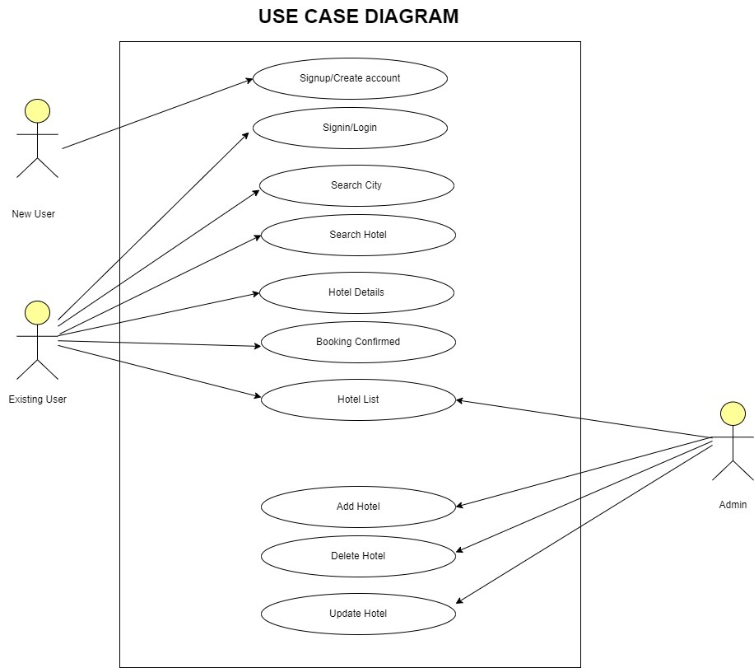

Fig. 1

**Non - Functional Requirements**

**Usability Requirement :**

Web and MobileApplication should be easy to use and provide basic user interface that can be used without any tutorial.

Multiple views must be used for modularity in this concept, I will be referring to the ease of use of a mobile application. The aim of the use of the mobile application is to get some features and functionality and the application would be difficult to use without the usability being considered. Every application is expected to be effective, sophisticated, and satisfactory and the color and contrast should be intact and follow some other principles that are considered the standard to be followed by developers. The design of the application should be done in such a way that users of all abilities would be able to use the UI efficiently.

Also, those with different disabilities such as hearing impairment, low vision, or blindness should be able to engage themselves in using the apps. Users of all apps should be able to appreciate the color and contrast of the mobile applications. Developers should also take into consideration the sound implementation of the app, which is an alternative to the visual implementation. Unnecessary sounds should always be avoided and the sounds that interpret screen elements or content should be designed for a correct or almost correct efficiency.

**Data Model**

Database In order to effectively store the user’s and admin Details which is provided while sign up . we have created five tables (user , hotel , city , booking confirmation , rating) in our database for that mysql database used . each tabled play different role . in user table user stores its details as name , phone , email, password and role with its unique id for that we had made id auto increment after sign in user signin API gets call and its store info in database same as other table in hotel table admin can add , update and delete hotels from database . hotel table having attributes as hotel name , hotel id (auto increment) , hotel picture , address , details , hotel price.so hotel table has its API’s on server side . in city table there is city id and city name attributes involved so user can select city and hotel as per selected city . in booking confirmation table there are fields such as user name , email , phone , check in , check out , no of days , no of rooms ,total amount , days etc. so user has to fill all the information in confirmation form so its get saved in database by fetching the booking confirmation API . days gets calculated as per check in check out dates . after getting proper days by fetching the total amount formula which have created client side gets called and user can see the final amount and other information on booking confirmed page.

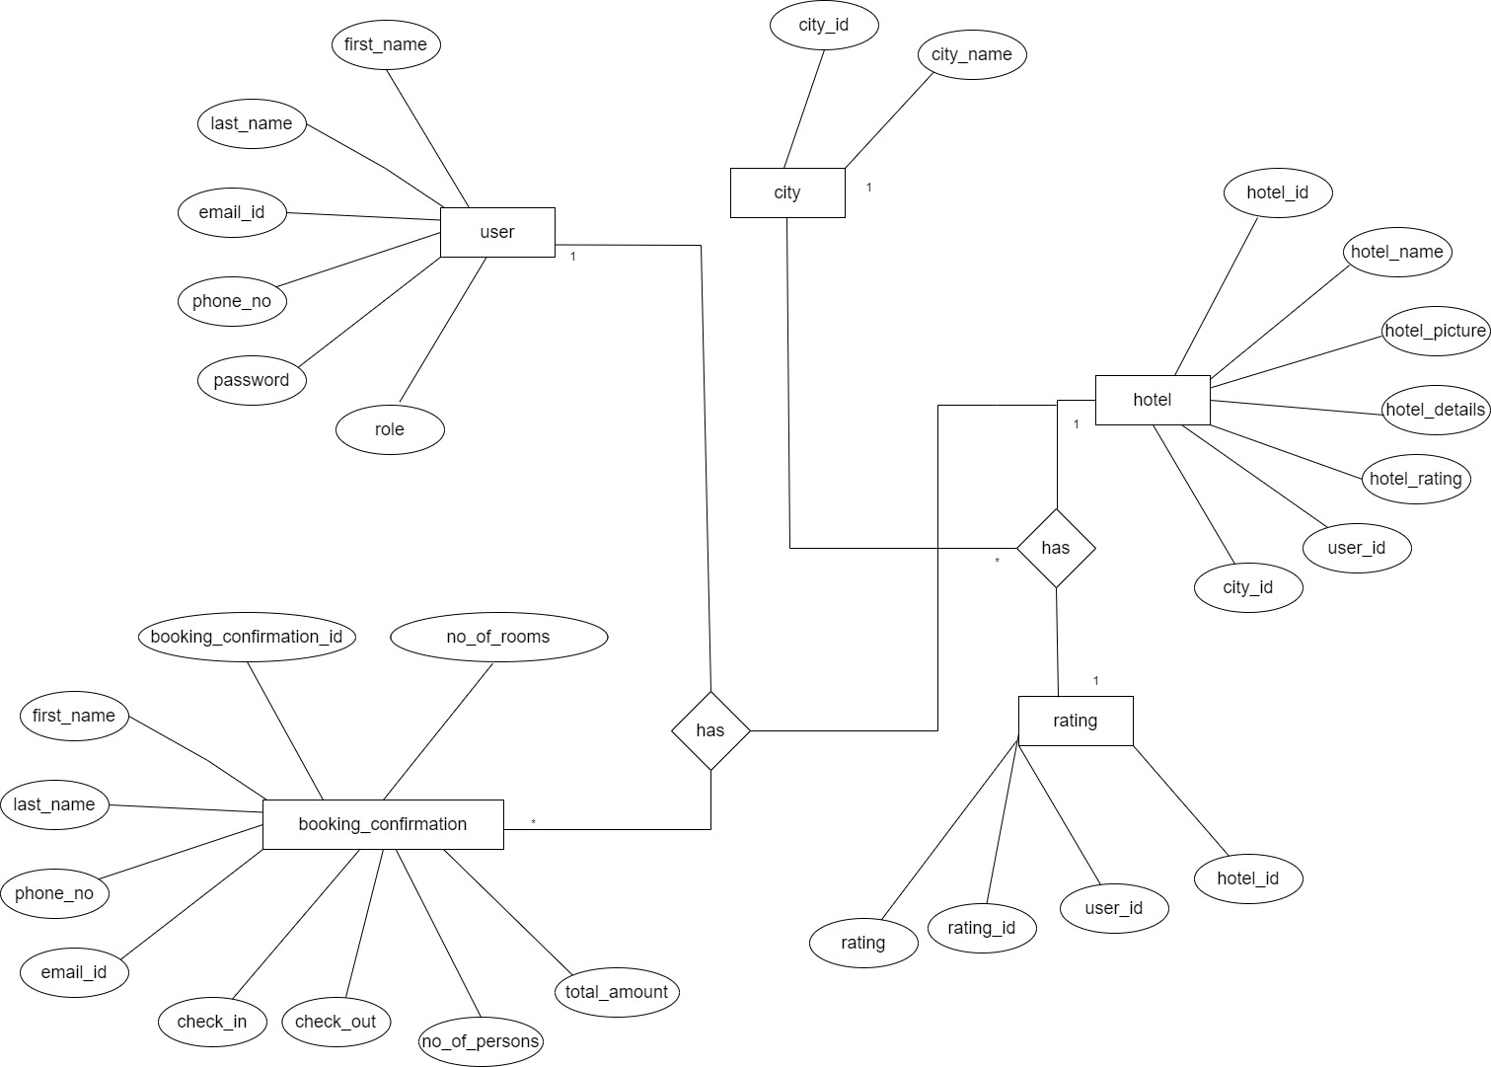

Fig 2.E-R Diagram Complete Database

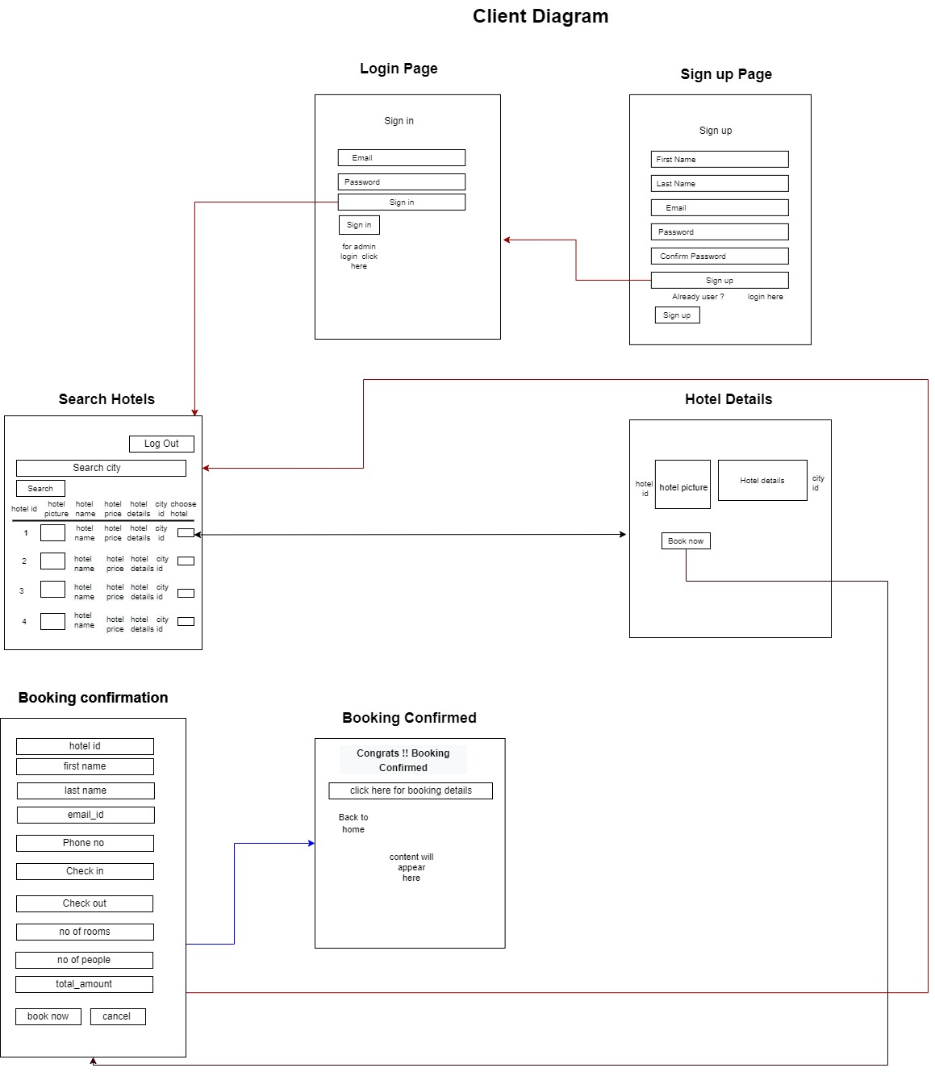

Fig 3. Client Block Diagram

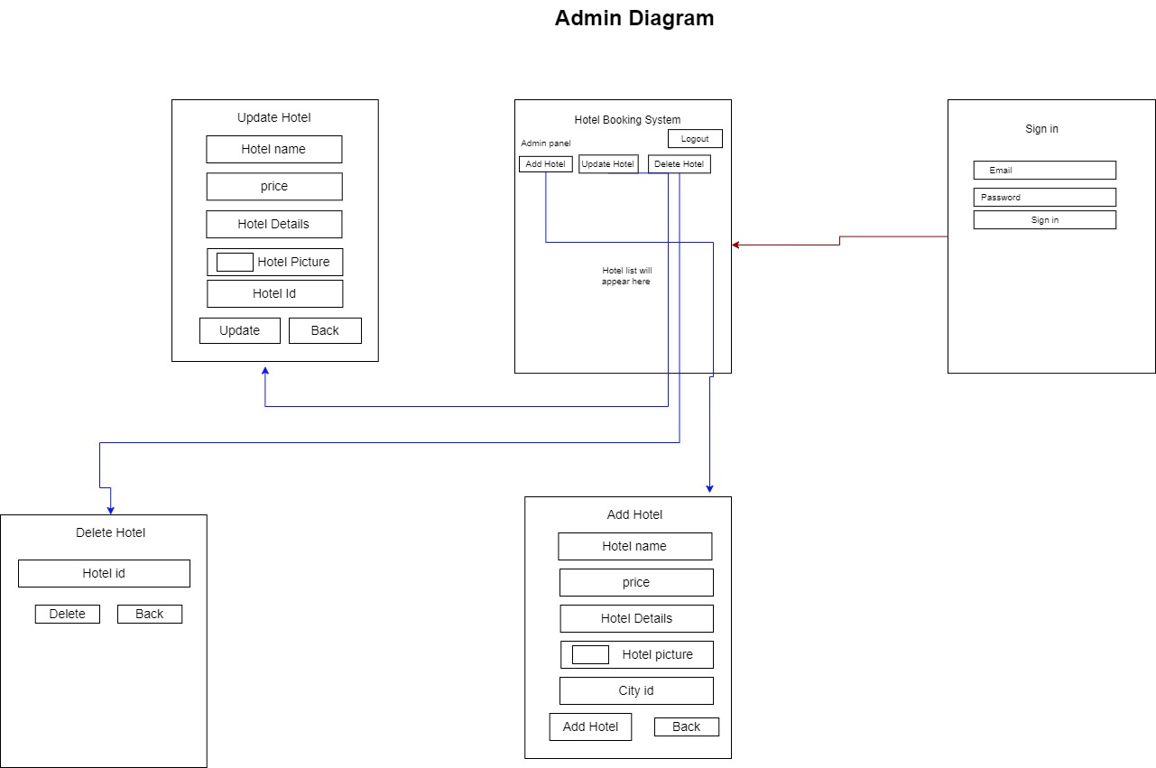

Fig 4. Admin Block Diagram

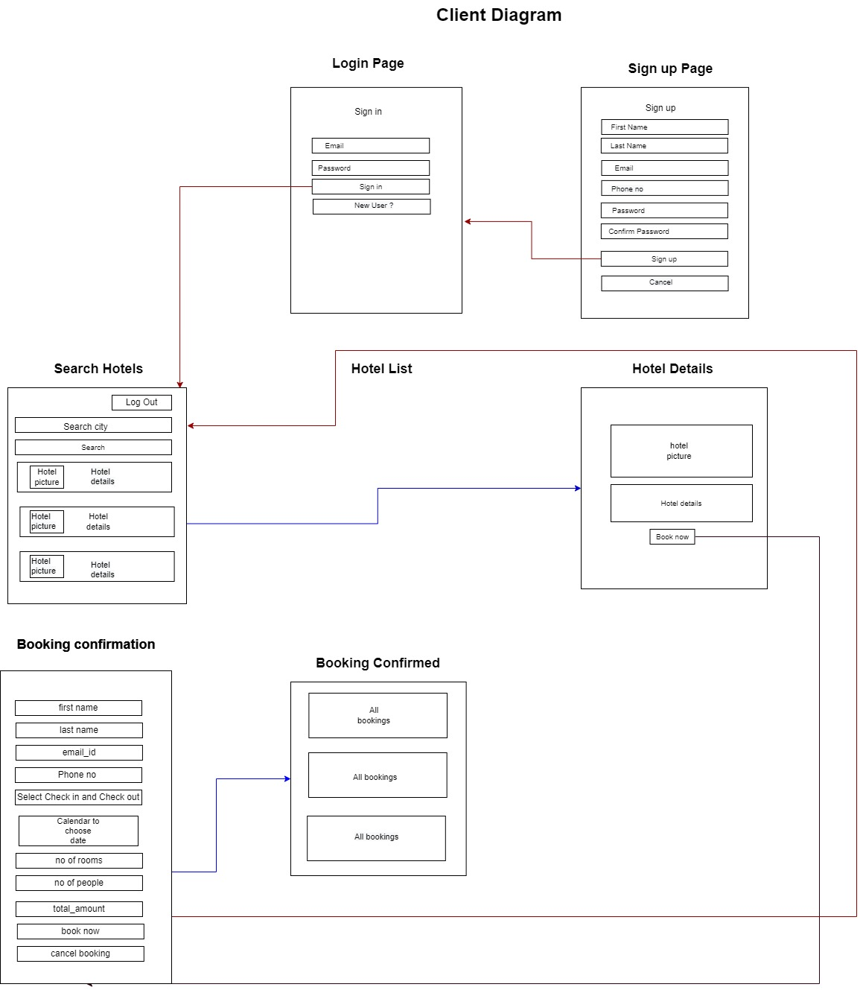

Fig 5. Mobile Block Diagram

**ScreenShots**

* + - 1. **Admin**

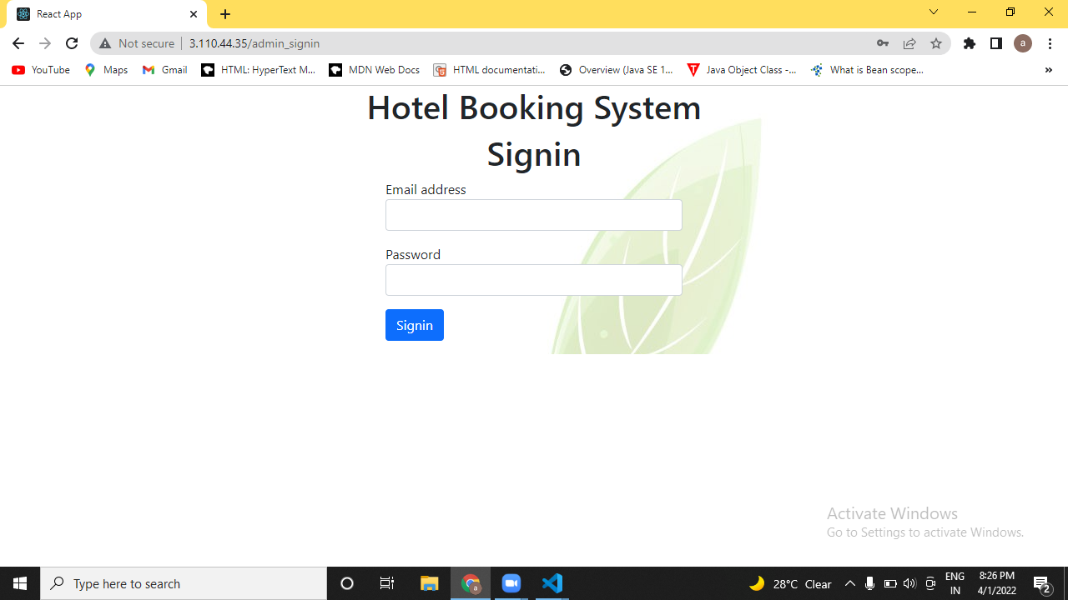

Fig. 6.Admin Signin

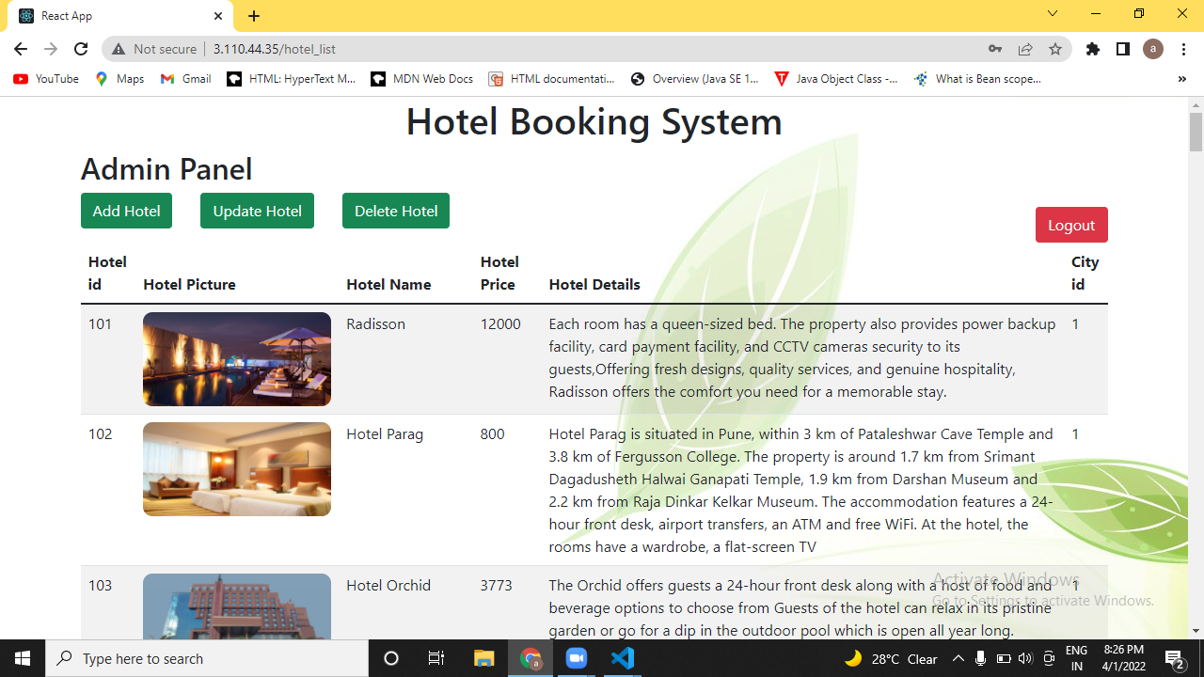

Fig. 7. Admin Home

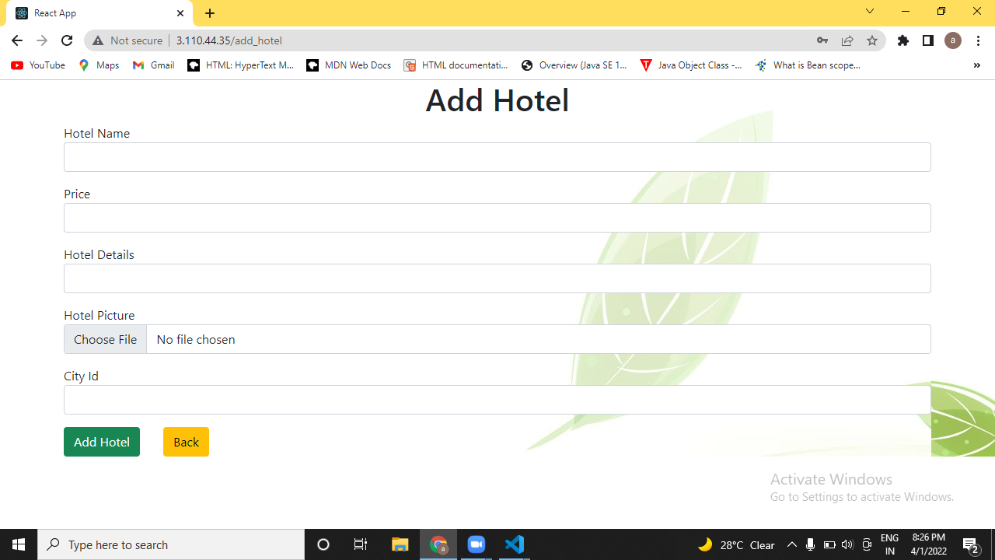

Fig. 8. Add Hotel

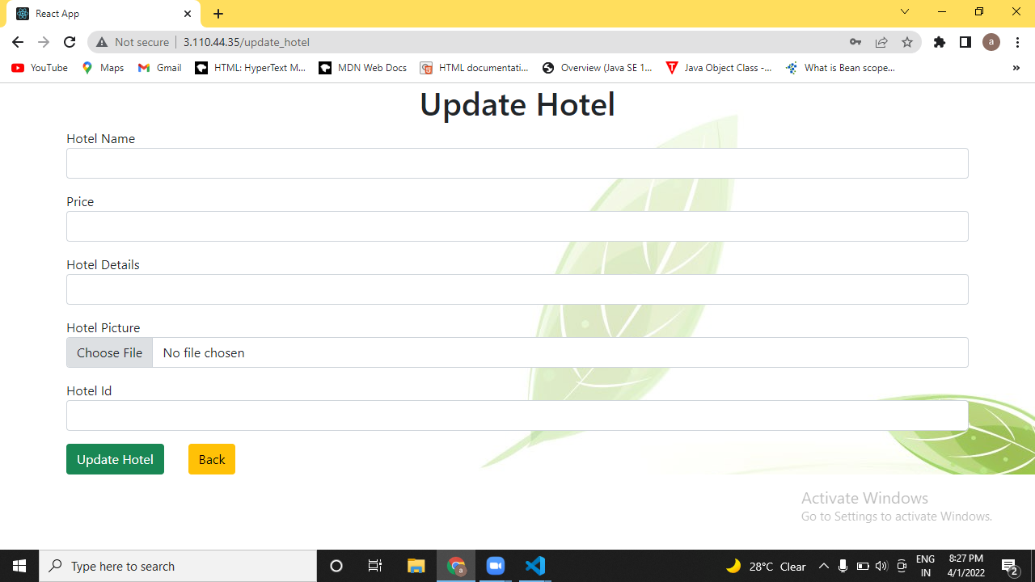

Fig. 9 Update Hotel

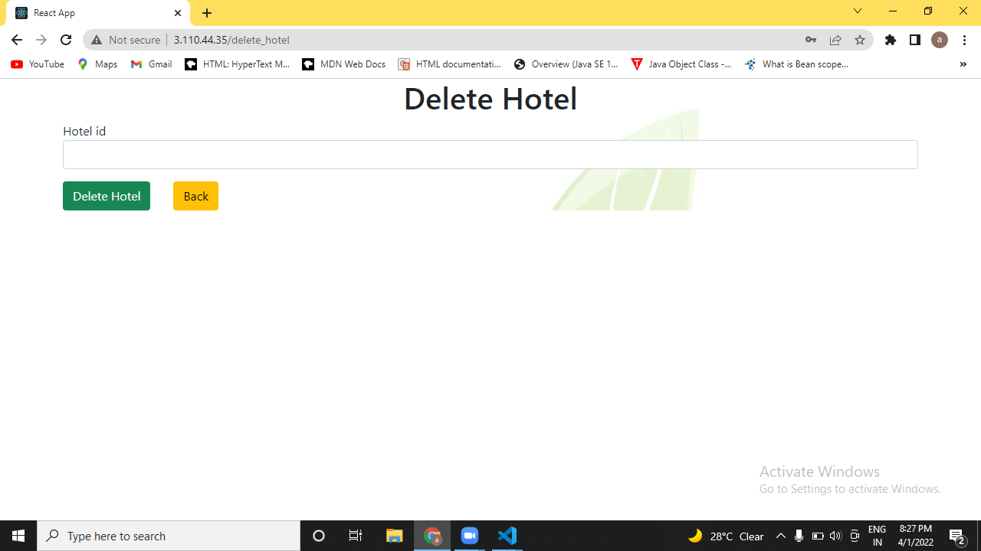

Fig. 10 Delete Hotel

* + - 1. **Client**

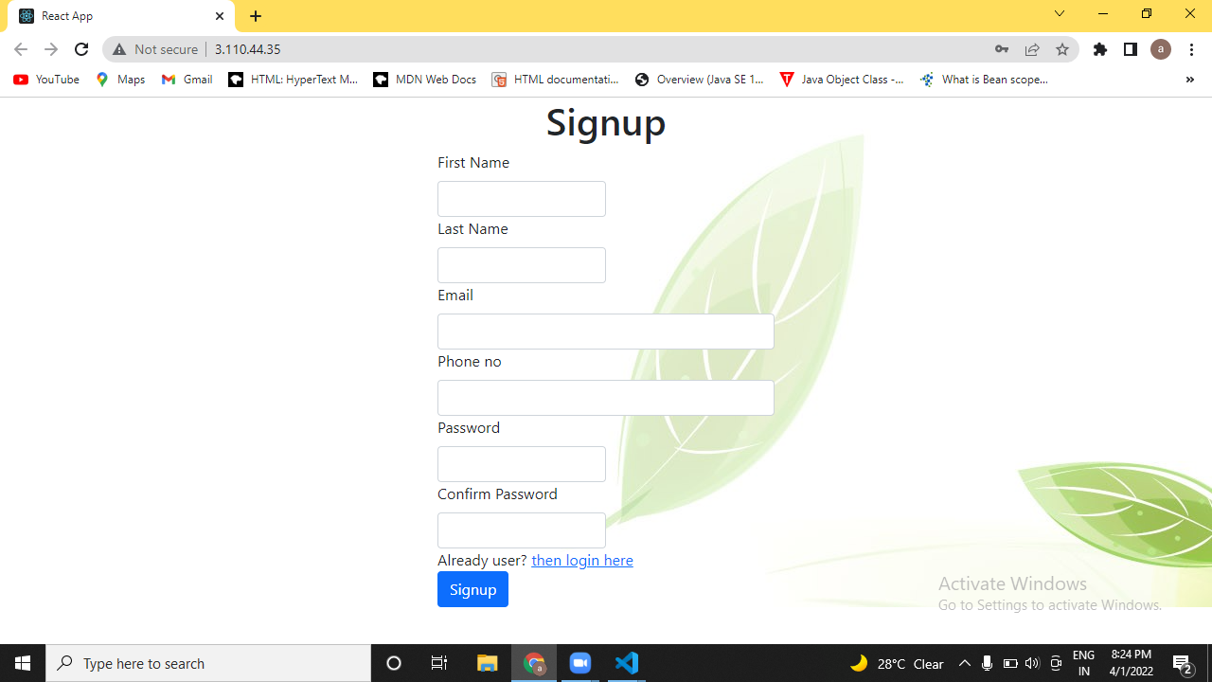

Fig. 6 Client Signup

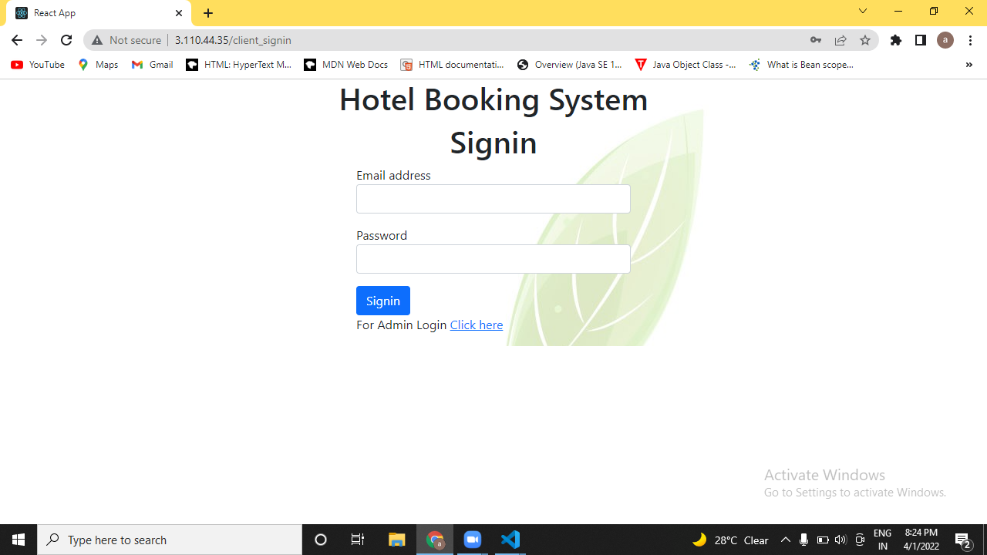

Fig. 11 Client Signin

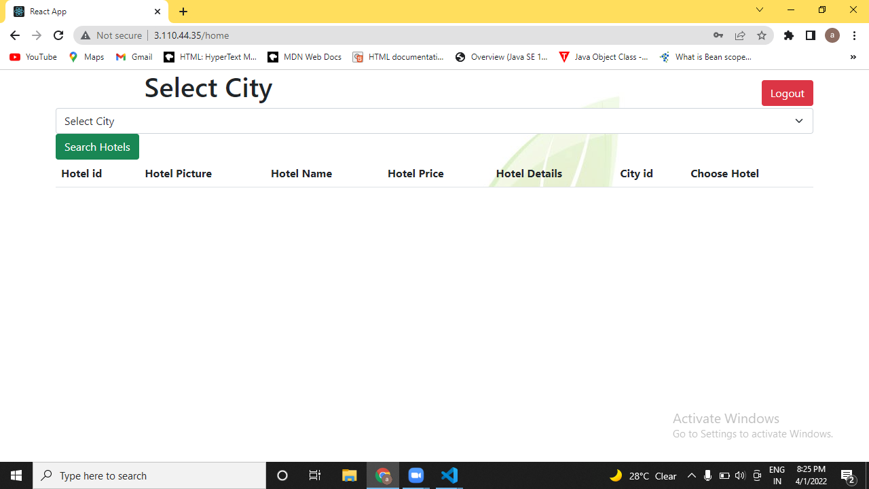

Fig. 12 Client Home

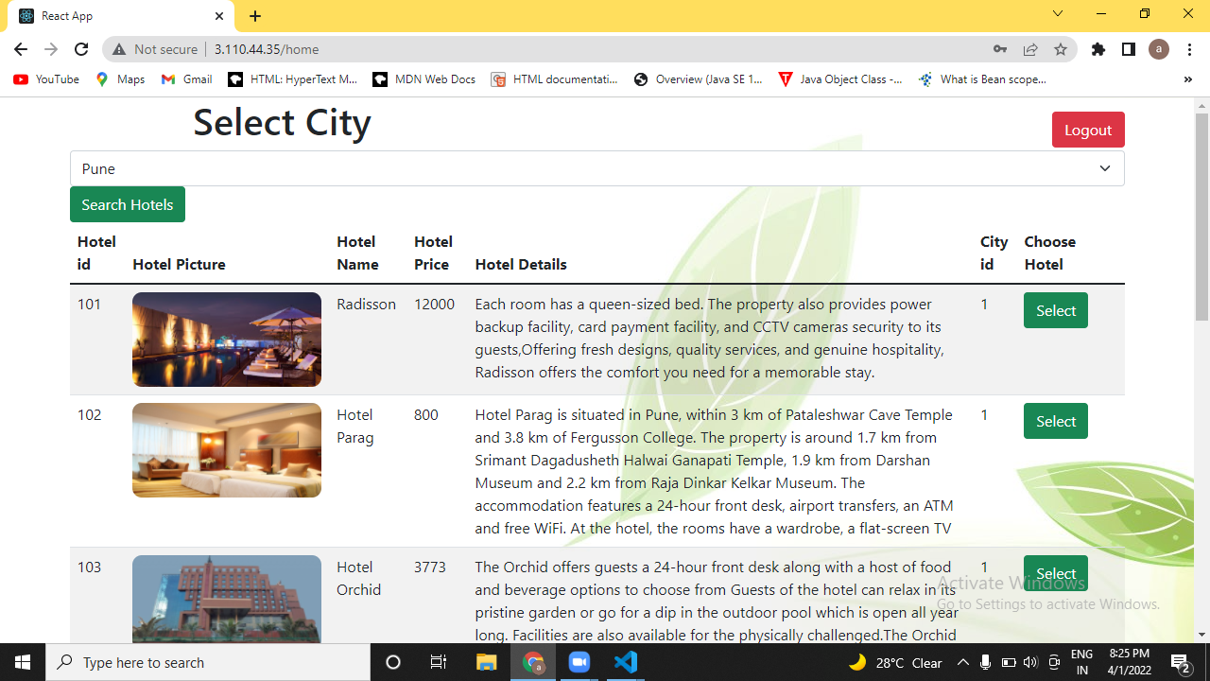

Fig. 13 Search City

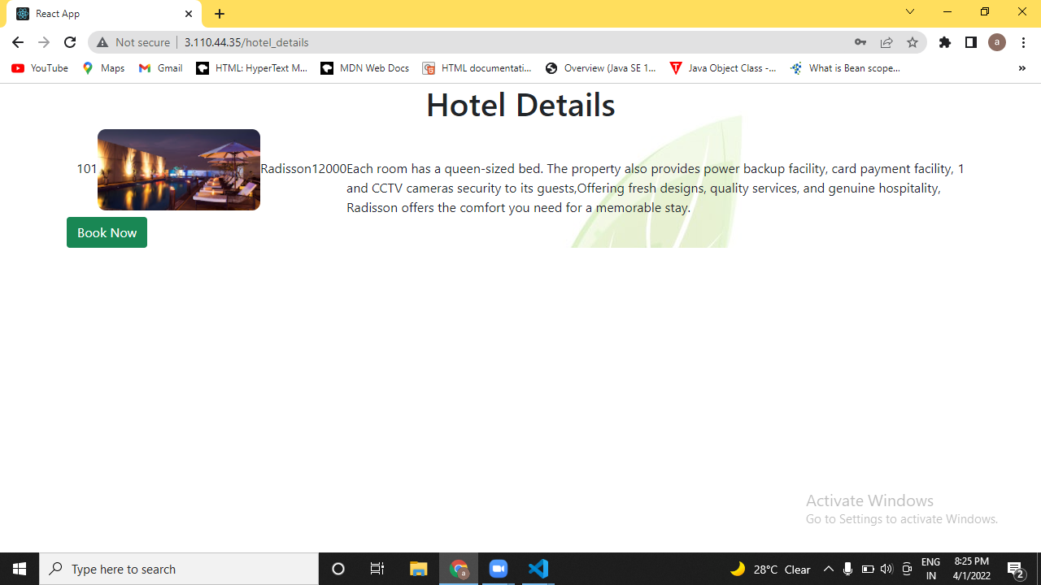

Fig. 14 Hotel Details

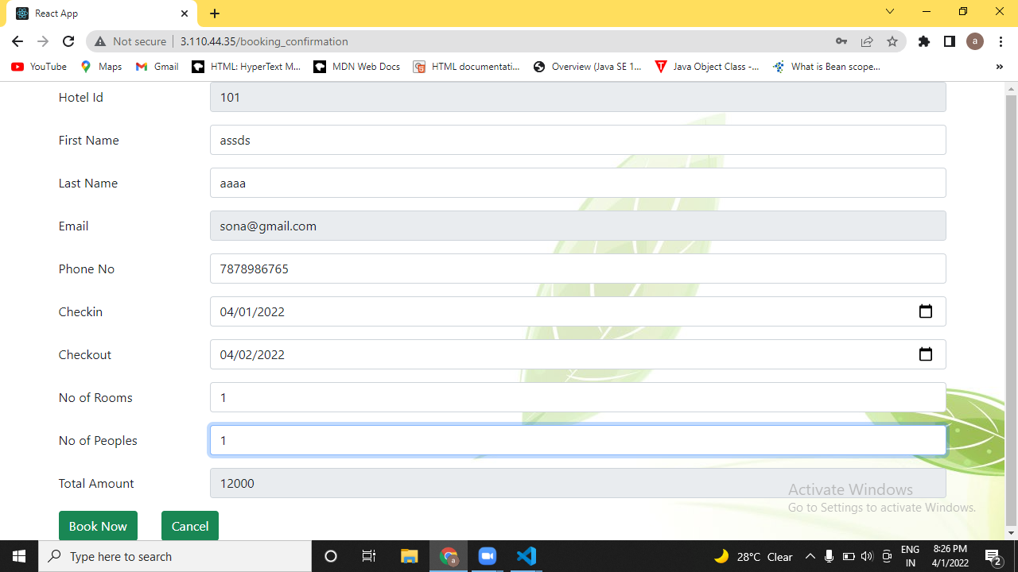

Fig. 15 Booking Confirmation

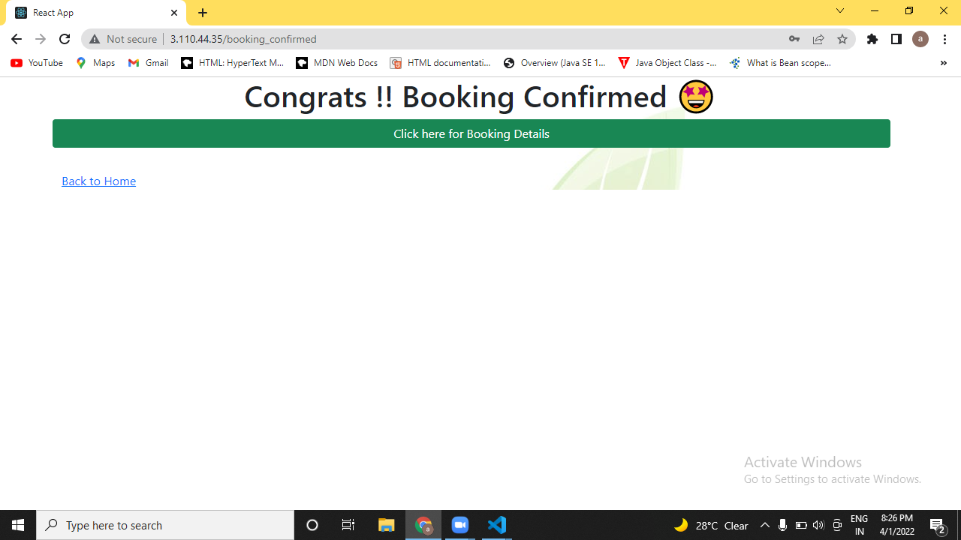

Fig. 16 Booking Confirmed

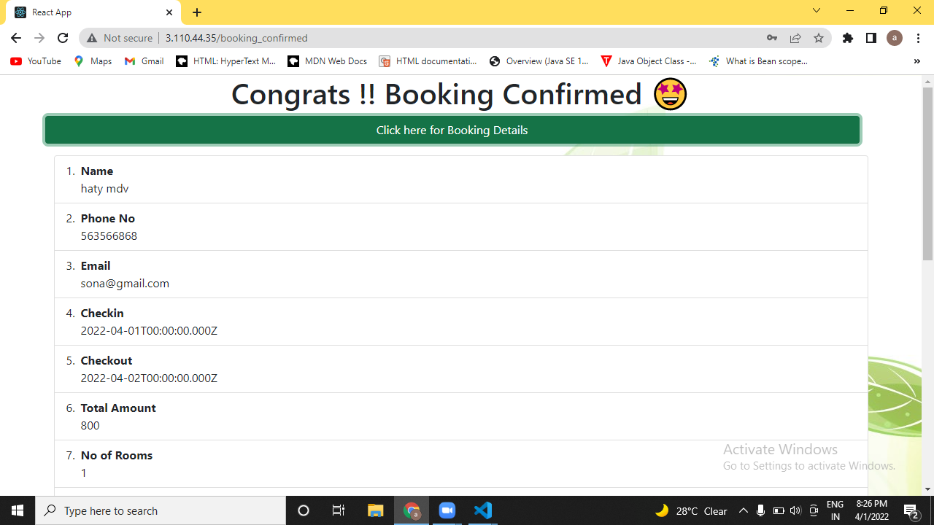

Fig. 17 Booking Details

* + - 1. **Mobile**

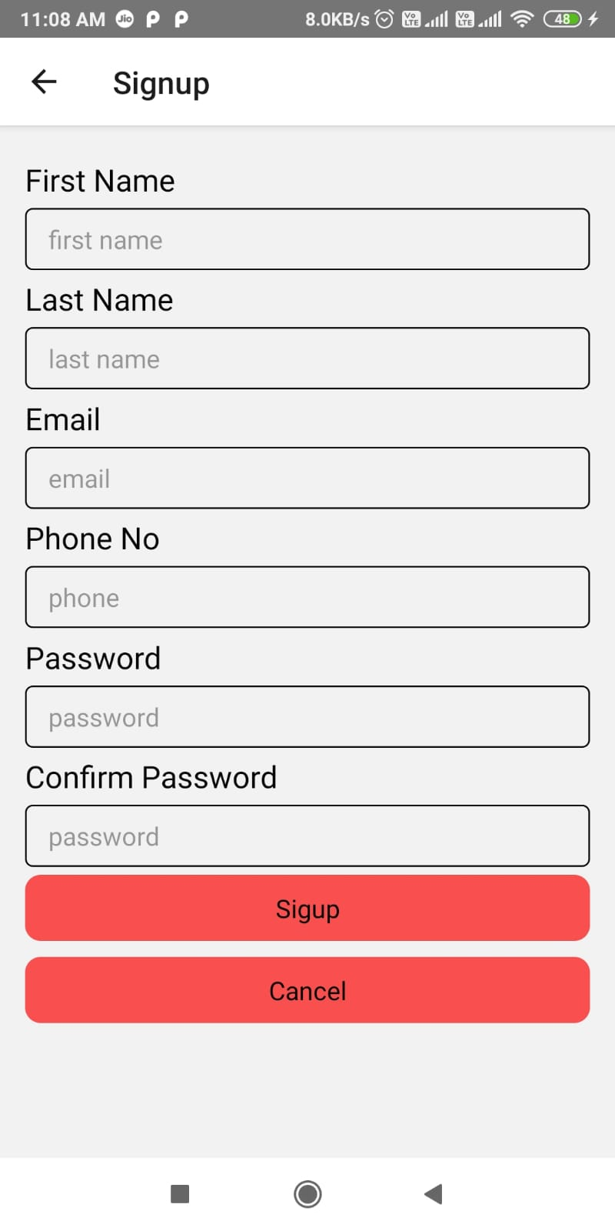

Fig. 18 Mobile Signup

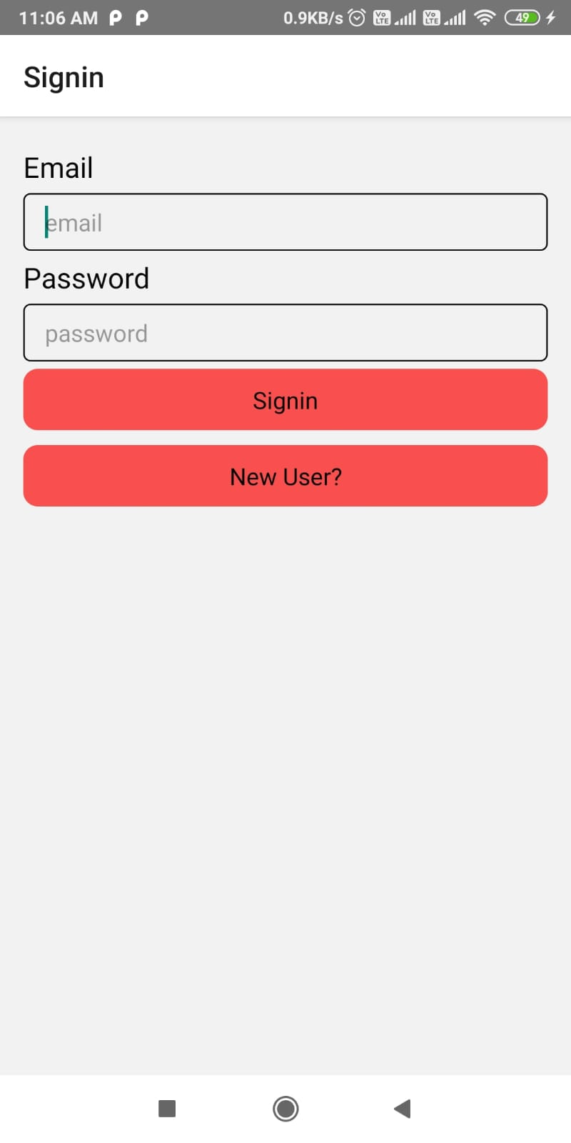

Fig. 19 Mobile Signin

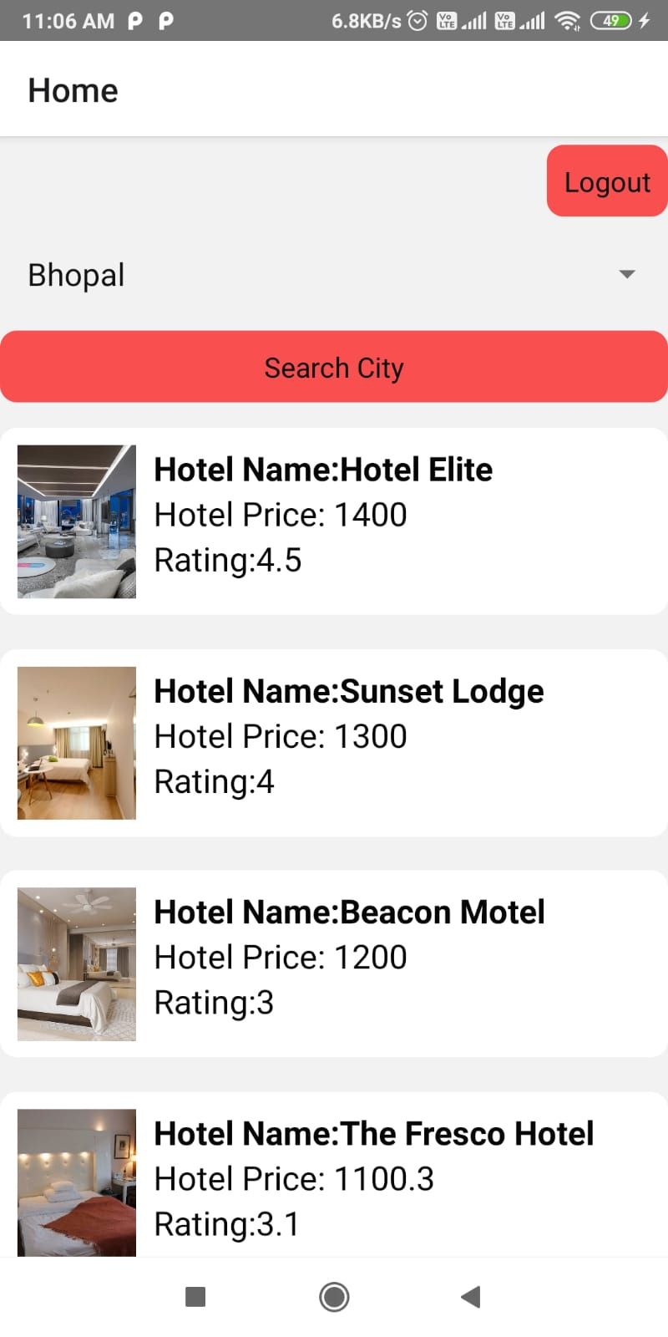

Fig. 20 Mobile Home

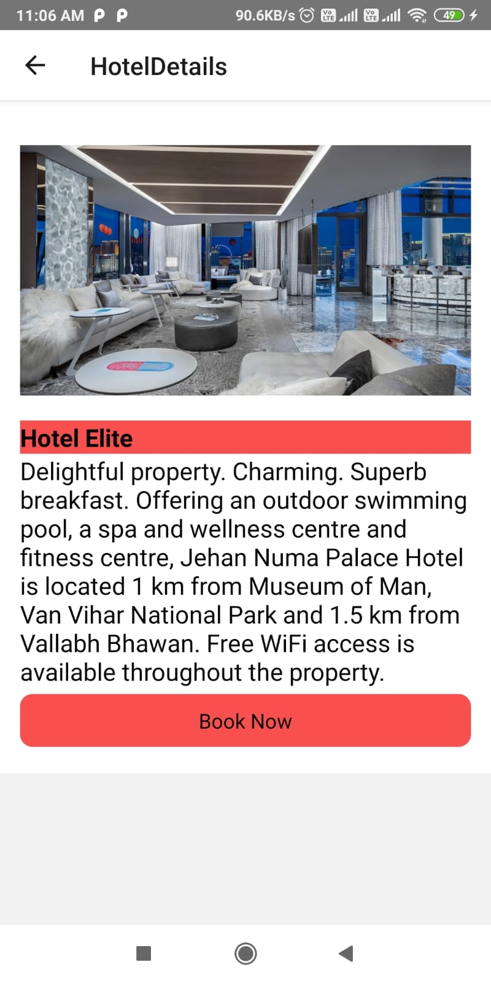

Fig. 21 Mobile Hotel Details

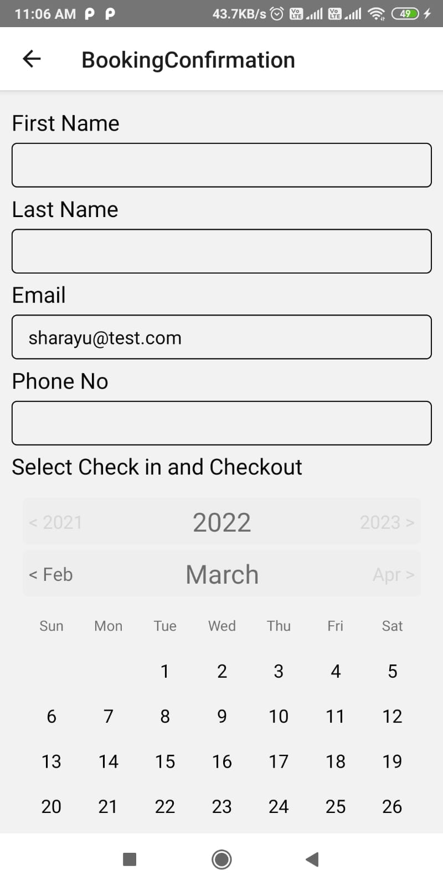

Fig. 22 Mobile BookingConfirmation

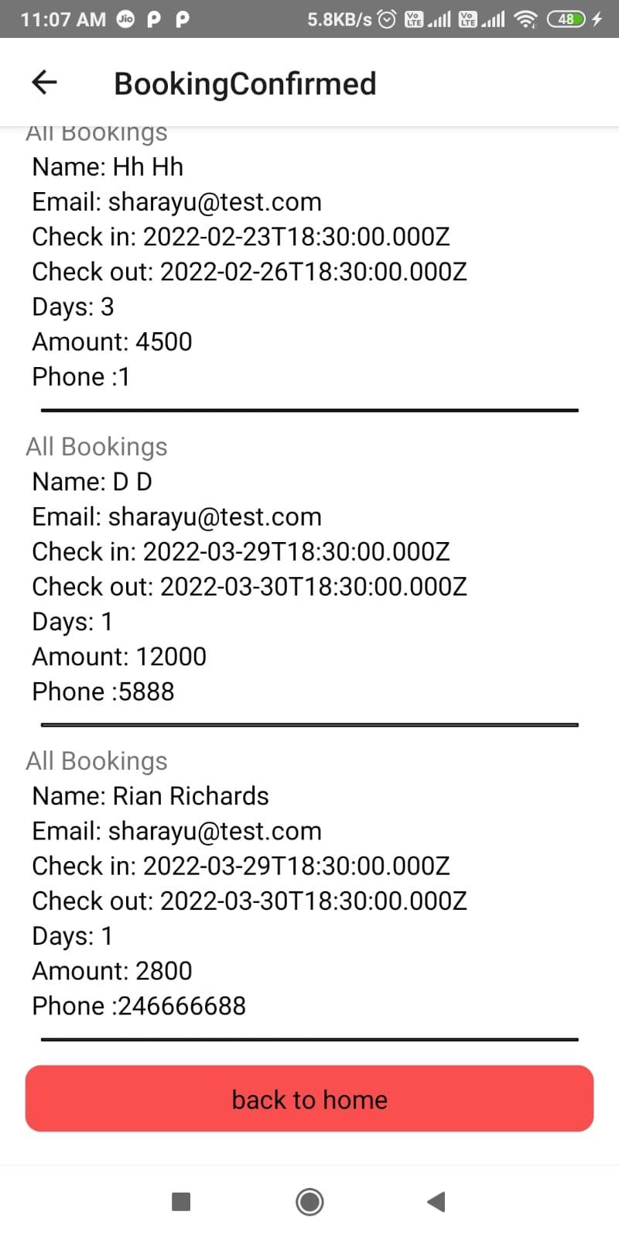

Fig. 23 Mobile Booking Details

**Conclusion**

This is to conclude that the project that I undertook was worked upon with a sincere effort. Most of the requirements have been fulfilled up to the mark and the requirements which have been remaining, can be completed with a short extension. The project made here is just to ensure that this product could be valid in today real challenging world. Here all the facilities are made and tested.Currently the system works for limited number of administrators to work.

**Future Work**

There are many future possibilities, as per client requirements we can add many functionalities, like for admin we can make available lot of data about customers in admin portal and for users also we can do lots of improvements in user interface and also in backend.

**References**

<https://reactnative.dev/docs/getting-started>

<https://reactjs.org/docs/hooks-state.html>

https://reactjs.org/docs/hooks-effect.html

<https://github.com/dilipchandima/rn-select-date-range>

https://getbootstrap.com/docs/5.1/layout/containers/