PYTHON FULLSTACK INTERVIEW VIEW NOTES
- Pagadala Leela Sri Ganesh Guptha

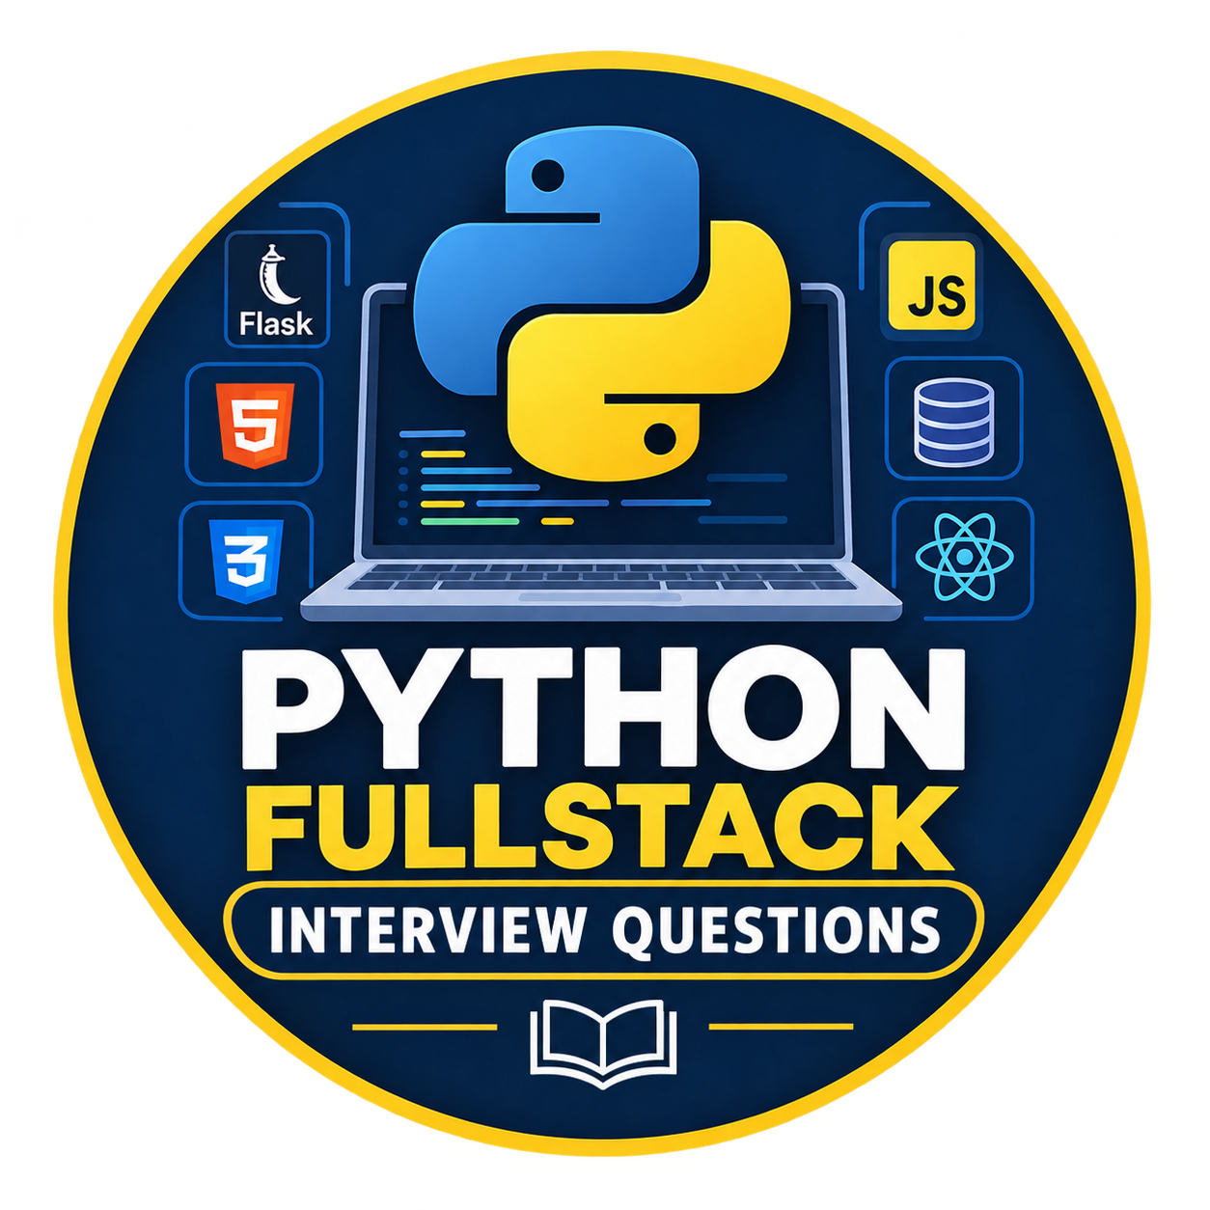

INTRODUCTION :
Theory :
Python is a high-level programming language known for its simple and readable syntax. It has the following features:
- Requires fewer lines of code compared to other programming languages like Java.
- Supports multiple programming paradigms including object-oriented, functional and procedural programming.
- Dynamically typed and has automatic garbage collection
- Widely used in web development, automation, data analysis, artificial intelligence and many other fields.
- Cross-platform, works on Windows, Mac and Linux without major changes.
- Used by top tech companies like Google, Netflix and NASA.
Probable Questions :
1.What is Python?
Short “Elevator Pitch” Answer
“Python is a high-level, interpreted, dynamically typed language known for its simple syntax. It supports object-oriented, functional, and procedural programming, runs on any platform, and is widely used in web development, automation, data science, and AI. I prefer it because I can build solutions quickly with fewer lines of code.”
Example:
print("Hello, World!")
This code prints Hello, World! on the screen.
2.Why use Python?

We use Python because it is easy to learn, has simple syntax, requires less code, and provides many libraries for different tasks. It helps developers build applications quickly.

Example: We can use Python with Flask to develop web applications.

- Simple syntax, so it’s quick to learn and write
- Fewer lines of code than languages like Java
- Huge library support (NumPy, Pandas, Django, TensorFlow)
- Works for web, automation, data science, and AI
- Large community and plenty of help online
3.What are the key features of Python?
- Easy and readable syntax
- Interpreted (runs line by line)
- Dynamically typed (no need to declare variable types)
- Automatic garbage collection (memory is managed for you)
- Cross-platform (Windows, Mac, Linux)
- Supports multiple programming styles
4.What is an interpreted language and Is Python interpreted or compiled?
Interview answer:
An interpreted language is a language whose code is executed through a runtime or interpreter rather than being directly run as native machine code compiled ahead of time.
Python typically compiles source code into bytecode and executes it using the Python Virtual Machine.
the usual answer is “Python is an interpreted language.”
5.What does “dynamically typed” mean?
You don’t declare a variable’s type. Python decides it at runtime.
python
x = 10 # int
x = "hello" # now a string, no error
6. What does “high-level language” mean?
Interview answer:
A high-level programming language is a language that is easier for humans to read and write because it hides many low-level hardware details.
Example: Python, Java, and JavaScript are high-level programming languages.
It’s far from machine code and close to human language. You don’t manage memory or hardware directly.
7. What are the programming paradigms Python supports?
- Procedural: step-by-step functions
- Object-oriented: classes and objects
- Functional: lambda, map, filter
8. What is garbage collection?
Python automatically frees memory that’s no longer used, so you don’t have to delete objects manually.
Explanation :

In different programming languages, memory management works differently. Some languages automatically clean up unused memory, while others require the programmer to manage memory more directly.

How do different languages handle memory cleaning?
1. Python — Automatic memory management
Python automatically identifies and reclaims memory occupied by objects that are no longer needed, using reference counting and garbage collection.
x = [10, 20, 30]x = None # The list may now be eligible for cleanup
You usually don't need to free memory manually.
2. Java — Automatic garbage collection
Java also automatically cleans up objects that are no longer reachable.
Student s = new Student();
s = null; // Object may become eligible for garbage collection
The programmer does not normally free an object's memory directly.
3. C — Manual memory management
In C, if you allocate memory dynamically, you generally need to release it yourself when you're finished using it.
int *p = malloc(sizeof(int));

*p = 10;

free(p); // Release allocated memory
p = NULL;
If you forget to release memory that is no longer needed, you can cause a memory leak.
4. C++ — Manual or automatic techniques
C++ allows manual memory management using new and delete, but modern C++ commonly uses smart pointers and other resource-management techniques to clean up safely.
int* p = new int(10);

delete p; // Release dynamically allocated memory
p = nullptr;

Why is garbage collection important?
Imagine your program creates 1,000 objects while running. Later, it stops using 800 of them.
- Without proper cleanup, unused memory can accumulate.
- With garbage collection, the runtime can reclaim memory occupied by objects that are no longer needed.
- This memory can then be reused by the program.
One important point: Python's garbage collection does not mean every unused object is cleaned up immediately. Cleanup timing depends on the implementation and circumstances.

Interview-ready answer
Q. What is garbage collection in Python?
Garbage collection is a memory-management mechanism that automatically reclaims memory occupied by objects that are no longer needed. Python primarily uses reference counting and supplements it with a cyclic garbage collector to handle reference cycles. This reduces the need for manual memory management and helps prevent memory leaks.
Remember this simple comparison:
Language | Typical memory cleanup
Python | Automatic
Java | Automatic
C | Often manual for dynamically allocated memory
C++ | Manual options and automatic resource-management techniques
Interview tip: If asked why Python is easier to manage than C in this area, explain that Python handles most object-memory cleanup automatically, whereas C programmers often need to allocate and release dynamic memory explicitly.

9. Is Python platform independent?
Yes. The same code runs on Windows, Mac, and Linux without major changes, as long as Python is installed.
10. Where is Python used?
Web development, automation and scripting, data analysis, machine learning and AI, and testing. Companies like Google, Netflix, and NASA use it.
Python is used in many fields, such as:
- Web development — Flask, Django
- Automation and scripting
- Artificial intelligence and machine learning
- Data analysis — Pandas, NumPy
- Testing and software development tools
- APIs and backend development

Python vs Other Languages
11. Python vs Java: what’s the difference?

Python generally has simpler, more concise syntax, while Java uses more explicit type declarations and is commonly compiled to JVM bytecode. Both support object-oriented programming and are widely used in software development

Python | Java
Dynamically typed | Statically typed
Fewer lines of code | More verbose
Interpreted | Compiled to bytecode, run on JVM
Slower in speed | Faster in speed
12. What are the disadvantages of Python?
- Slower than C, C++, or Java
- Uses more memory
- Not ideal for mobile app development
- The GIL (Global Interpreter Lock) limits true multithreading
13. Why is Python popular?
Python is popular because it is easy to read, supports multiple programming paradigms, has a large community, and provides many libraries and frameworks. It is also cross-platform.

14. What are the main features of Python?
Interview answer:
The main features of Python are:
- Easy to learn: Simple, readable syntax.
- High-level: Hides many low-level hardware details.
- Interpreted: Commonly executed through an interpreter.
- Dynamically typed: We don't need to declare variable types explicitly.
- Object-oriented: Supports classes and objects.
- Cross-platform: Runs on Windows, Linux, and macOS.
- Automatic memory management: Python manages memory and reclaims many unused objects through garbage collection.
- Rich libraries: Provides libraries for web development, data analysis, AI, and more.
15. What is a dynamically typed language?
Interview answer:
A dynamically typed language does not require us to declare a variable's data type explicitly. The type is determined at runtime.
Example:
x = 10x = "Hello"
Here, x initially refers to an integer and later refers to a string. Python allows this.
16. What is cross-platform compatibility?
Interview answer:
Cross-platform compatibility means a program can run on different operating systems with little or no modification, provided the required Python version and dependencies are available.
Example: A Python script can run on Windows, Linux, and macOS.
17. Is Python an object-oriented programming language?
Interview answer:
Yes, Python supports object-oriented programming using classes and objects. It also supports procedural and functional programming styles.
18. What are the advantages of Python?
Interview answer:
Python's main advantages are its simple syntax, faster development, large library ecosystem, cross-platform support, and strong community support.
19. What are the limitations of Python?
Interview answer:
Python can be slower than compiled languages such as C or C++ for some CPU-intensive tasks. It can also consume considerable memory in certain applications, and it is not the first choice for every mobile or low-level system application.
20. Is Python free to use?
Interview answer:
Yes, Python is free and open-source. Anyone can download, use, and modify it according to its license.
21. Who developed Python?
Interview answer:
Python was created by Guido van Rossum and was first released in 1991.

First Program : Hello World Program

The Hello World program demonstrates the basic structure of a Python program.
# This is a comment. It will not be executed.
print("Hello, World!")
Output
Hello, World!
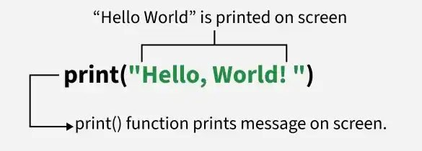
print() is a built-in Python function that istructs computer to print / display text on scree ,whatever enclosed within ‘’ or “” is printed as it is
Python uses Indentation (spaces / tabs ) to define block where as other languages uses {} (c,c++,Java)

Comments:

Just a readale comments for understanding ,they will not be executed and not considered / neglected for compliation

# - for single line comments and “”” “”” is for multiple line comments

.

Python Applications, Advantages and Disadvantages :

As Mentioned Above Python is Used in Many Industries while it powers applications in web development, data science, machine learning, automation, scientific computing, and many other domains.

Real World Use Case
- YouTube: World’s largest video-sharing platform uses Python for features like video streaming and backend services.
- Instagram: This popular social media app relies on Python’s simplicity for scaling and handling millions of users.
- Spotify: Python is used for backend services and machine learning to personalize music recommendations.
- Dropbox: The file hosting service uses Python for both its desktop client and server-side operations.
- Netflix: Python powers key components of Netflix’s recommendation engine and content delivery systems (CDN).
- Google: Python is one of the key languages used in Google for web crawling, testing and data analysis.
- Uber: Python helps Uber handle dynamic pricing and route optimization using machine learning.
- Pinterest: Python is used to process and store huge amounts of image data efficiently.

Applications
Python is used for:
- Web Development: Frameworks like Django, Flask.
- Data Science and Analysis: Libraries like Pandas, NumPy, Matplotlib.
- Machine Learning and AI: TensorFlow, PyTorch, Scikit-learn.
- Automation and Scripting: Automate repetitive tasks.
- Game Development: Libraries like Pygame.
- Web Scraping: Tools like BeautifulSoup, Scrapy.
- Desktop Applications: GUI frameworks like Tkinter, PyQt.
- Scientific Computing: SciPy, SymPy.
- Internet of Things (IoT): MicroPython, Raspberry Pi.
- DevOps and Cloud: Automation scripts and APIs.
- Cybersecurity: Penetration testing and ethical hacking tools.

Advantages
- Presence of third-party modules: Python has a rich ecosystem of third-party modules and libraries that extend its functionality for various tasks.
- Extensive support libraries: Python boasts extensive support libraries like NumPy for numerical calculations and Pandas for data analytics, making it suitable for scientific and data-related applications.
- Open source and large active community base: Python is open source, and it has a large and active community that contributes to its development and provides support.
- Dynamically typed language: Python is dynamically typed, meaning you don't need to declare data types explicitly, making it flexible but still reliable.
- Object-Oriented and Procedural programming language: Python supports both object-oriented and procedural programming, providing versatility in coding styles.

Disadvantages
- Performance: Python is an interpreted language, which means that it can be slower than compiled languages like C or Java. This can be an issue for performance-intensive tasks.
- Global Interpreter Lock: The Global Interpreter Lock (GIL) is a mechanism in Python that prevents multiple threads from executing Python code at once. This can limit the parallelism and concurrency of some applications.
- Memory consumption: Consume a lot of memory, especially when working with large datasets or running complex algorithms.
- Dynamically typed: Dynamically typed language, which means that the types of variables can change at runtime. This can make it more difficult to catch errors and can lead to bugs.
- Packaging and versioning: It has a large number of packages and libraries, which can sometimes lead to versioning issues and package conflicts.
- Lack of strictness: It's flexibility can sometimes be a double-edged sword. While it can be great for rapid development and prototyping, it can also lead to code that is difficult to read and maintain.
- Not Ideal for Some Domains: Less suitable for low-level system programming, embedded systems, mobile apps, and frontend development.

