Step 1 : Enable Entity Framework Nuget Packages.

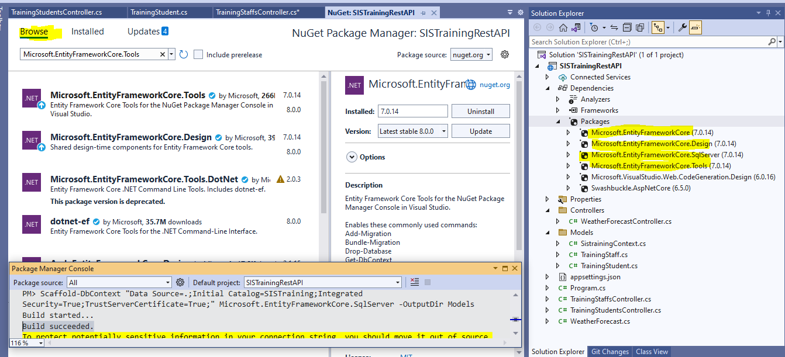

Prepare your DB Connection strings and run scaffold in Nuget Package manager Console.

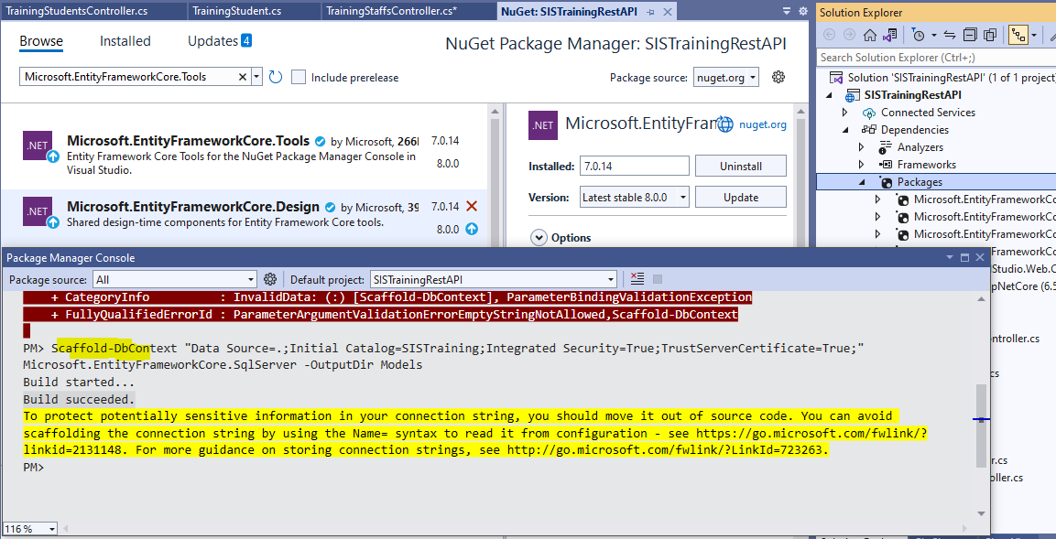

Data Source=.; (Server Name)

Initial Catalog=SISTraining; (DB Name)

Integrated Security=True;

TrustServerCertificate=True;

After Scafolding :

