SYNOPSIS

PERSONAL VIRTUAL ASSISTANT:

JARVIS

USING PYTHON

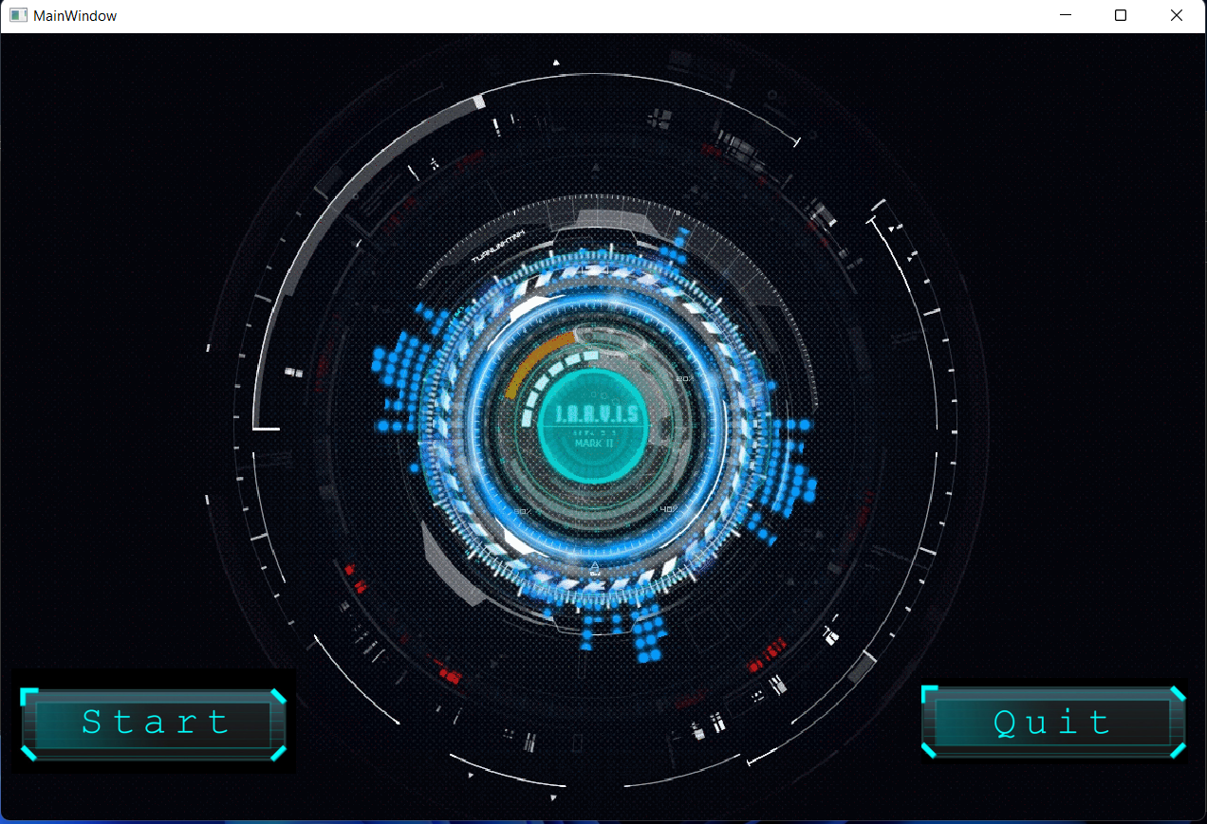

**ABSTRACT**

The project aims to develop a personal virtual assistant. This project draws its inspiration from virtual assistant like Cortana, Siri and Google assistant. In this project we use Python language. As we know Python is an emerging language so it becomes easy to write a script for Virtual Assistant in Python. The instructions for the assistant can be handled as per the requirement of user. Speech recognition is the Alexa Siri, etc. In Python there is an API called Speech Recognition which allows us to convert speech into text. It was an interesting task to make my own assistant. Searching on Google without opening the browser, and performing many other daily tasks like playing music, opening your favourite website with the help of a single voice command. In the current scenario, advancement in technologies are such that they can perform any task with same effectiveness or can say more effectively than us. By making this project. I realized that the concept of Al in every field in decreasing human effort and saving time.

**Software and Hardware requirements specification:**

**Hardware requirements**

* RAM: 512 MB or more
* Hard disk: 16 GB or more

**Software requirements**

* Visual Studio Code
* Qt Designer

**REFERENCES**

**WEBSITES:**

1. [www.stackoverflow.com](http://www.stackoverflow.com)
2. [www.python.org](http://www.python.org)

**YOUTUBE CHANNELS:**

1. Codewithharry
2. Avi Upadhyay