Work Flow for Travel-Agency task

1. Create AWS infra using terraform script for following services.

- Setting up VPC with public, private, Data base private subnets, igw, NAT gateway, SG, route tables.
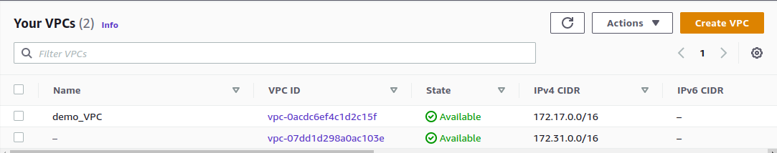
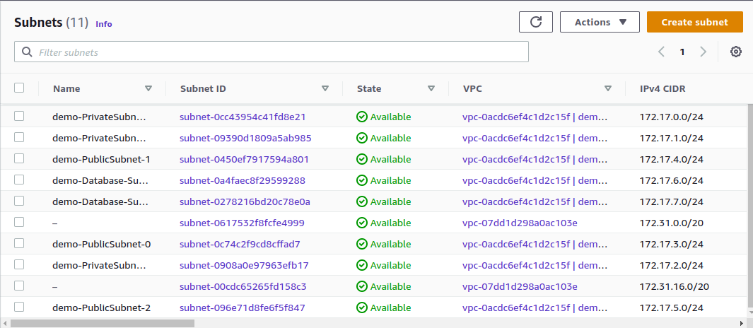
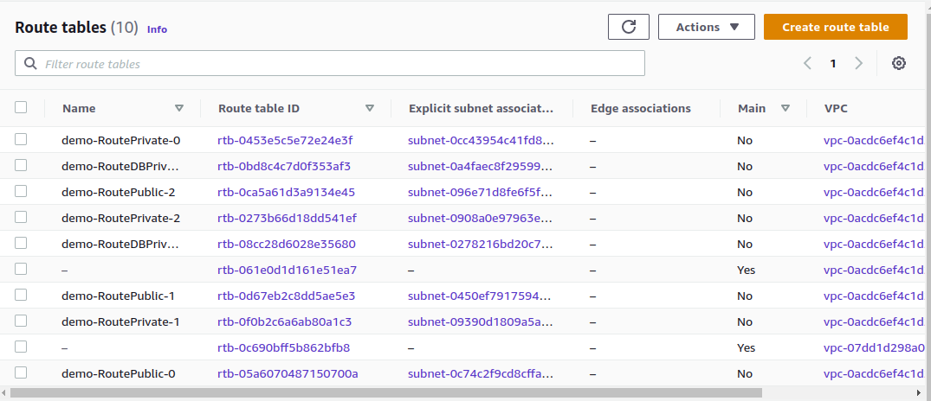

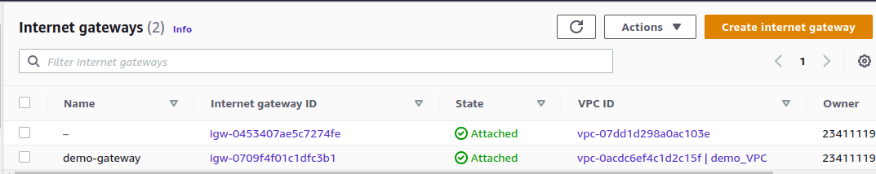

- EC-2 public server for Jenkins
- ECS Demo-Cluster in private subnet

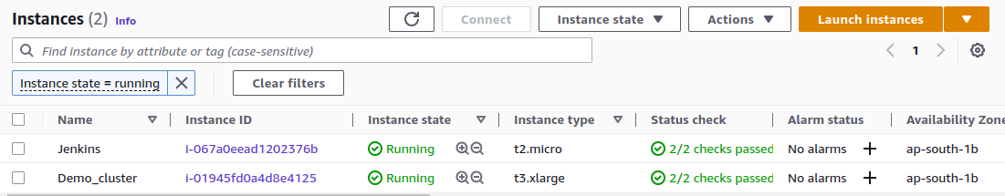

- S3 Bucket for backend-terraform-task & travel-agency-loadbalancers-logs

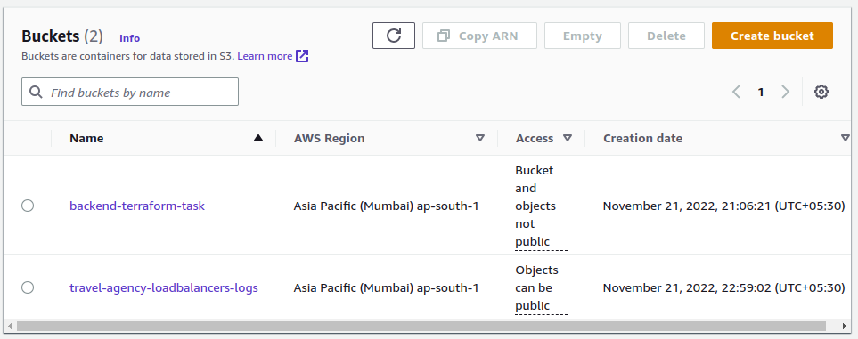

- Setting up ECR (travel-agency), ECS service and Autoscalling
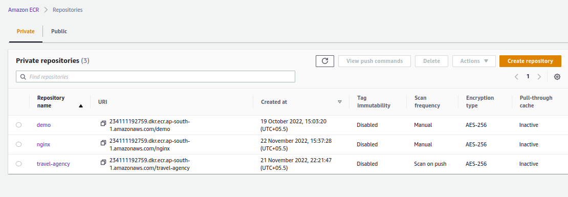
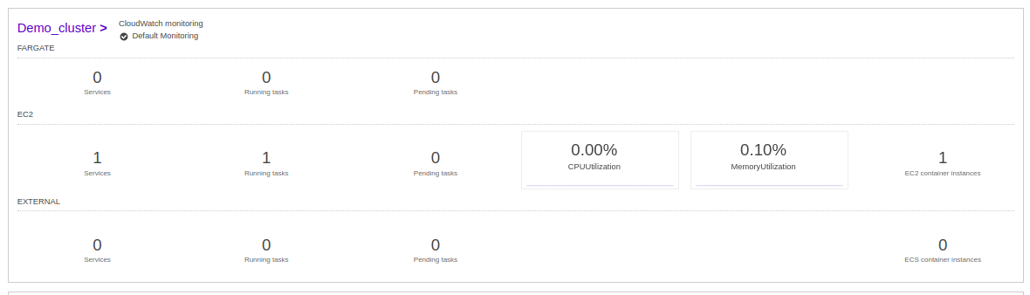

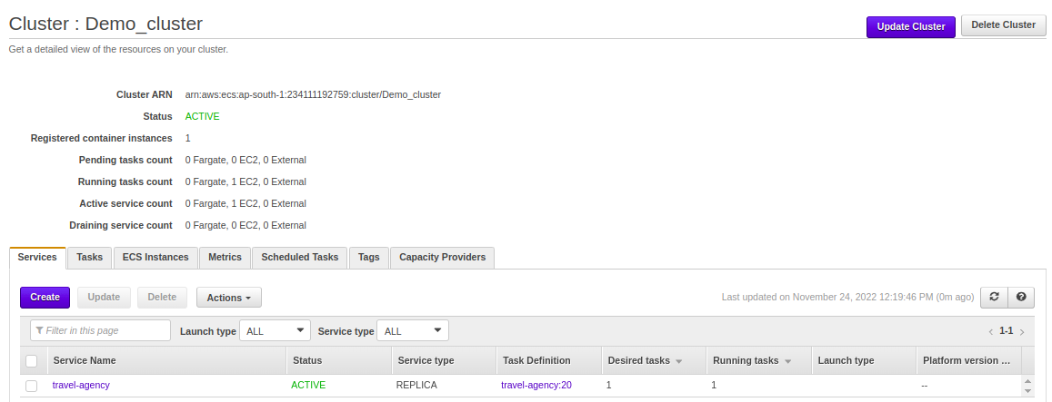
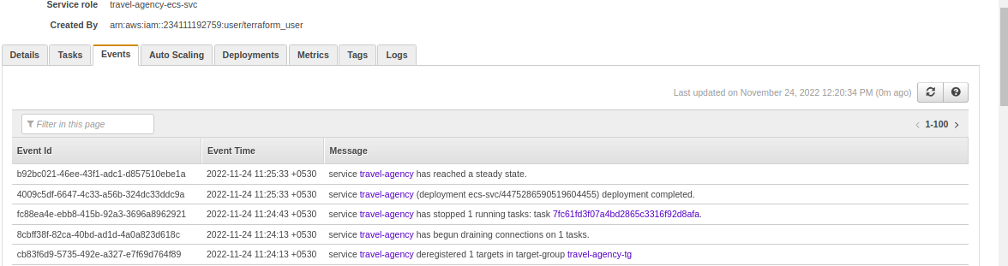
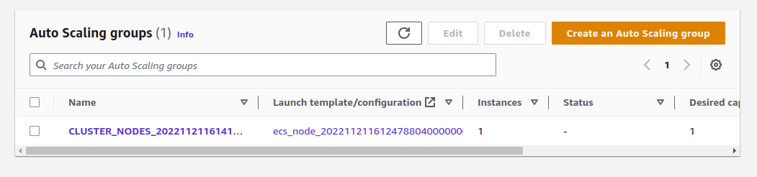

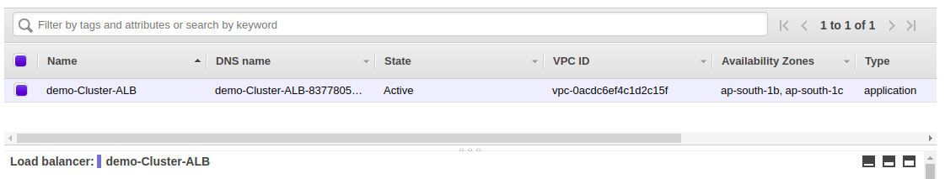
- Setting up Load balancer

- Setting up RDS

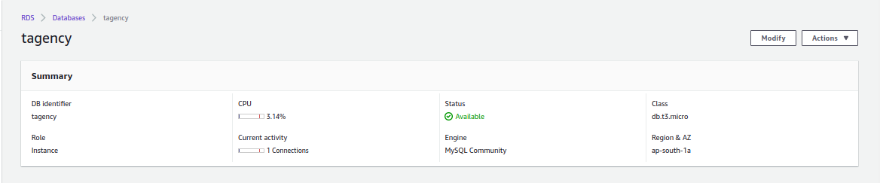

For execution of above terraform script use following commands
- terraform init
- terraform plan
- terraform apply

2. After setting up infra install following packages in server and take the access.
- Java
- Jenkins
- Docker
- Git

3. Clone git repository https://github.com/Atiksujon360/travel-agency.git

4. Create Dockerfile for php image and push it to git repository

https://github.com/prafulnc14/Travel-Agency_Task.git

5. Import sql file in the tagency database using following commands

- mysql -u admin -p -h tagency.c7vb75mjfxjx.ap-south-1.rds.amazonaws.com (ask for password : admin123)

- show databases;

- mysql -u admin -p -h tagency.c7vb75mjfxjx.ap-south-1.rds.amazonaws.com tagency < tagency.sql

- use tagency;

- select * from customers; (for checking new entries)
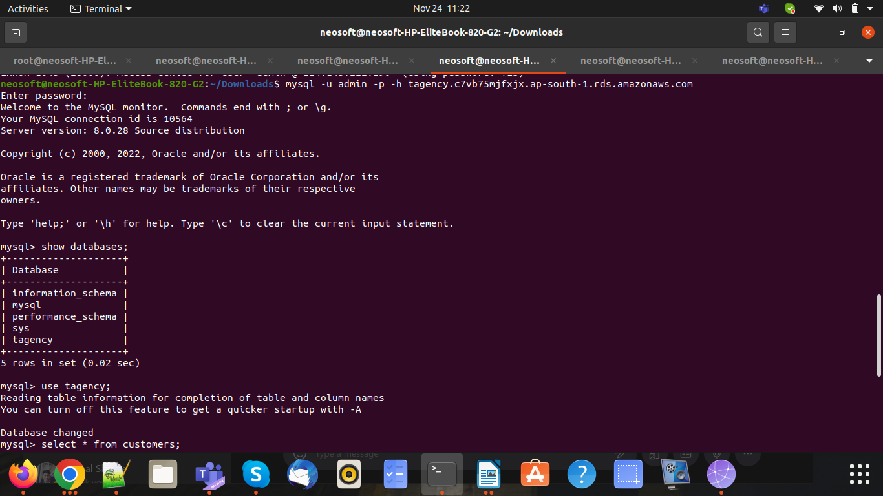
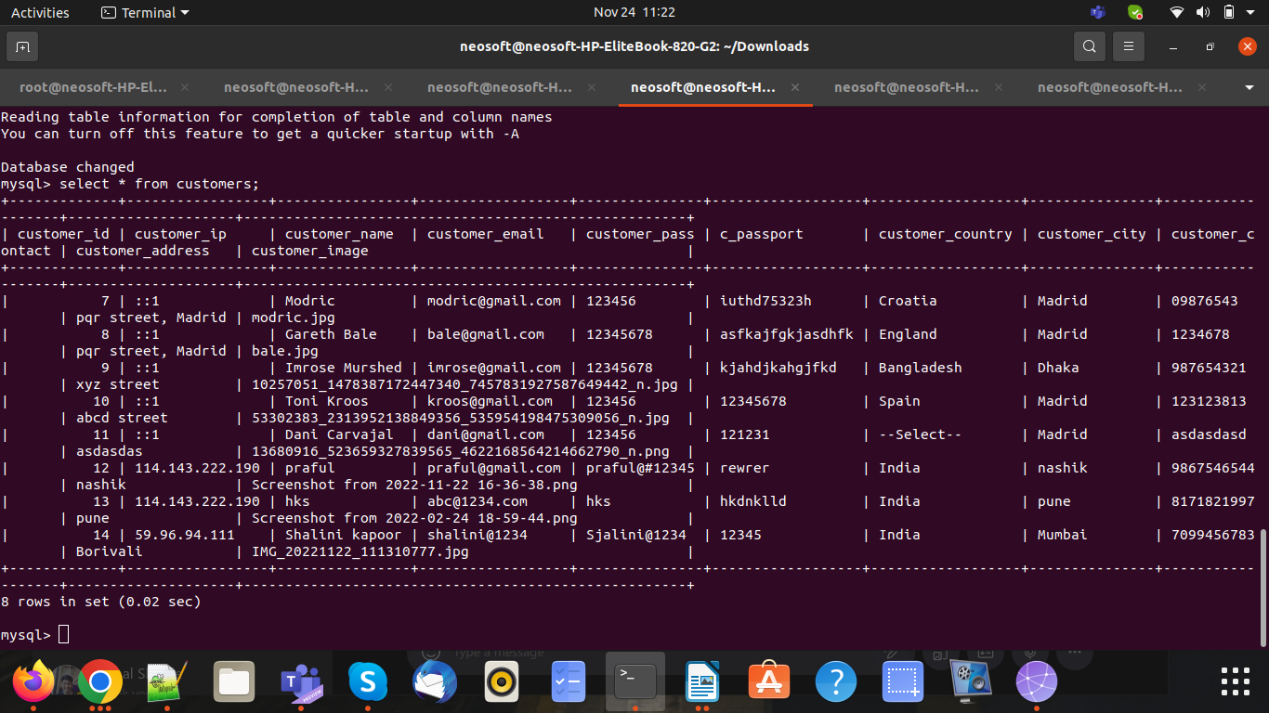

6. For deployment on ECS throgh Jenkins CI-CD using freestyle job & write a script name as ecs.sh

- Clone the repository https://github.com/prafulnc14/Travel-Agency_Task used master banch
- Loging to ECR and build docker
- Push the image to ECR repository
- Deploy on the ECS

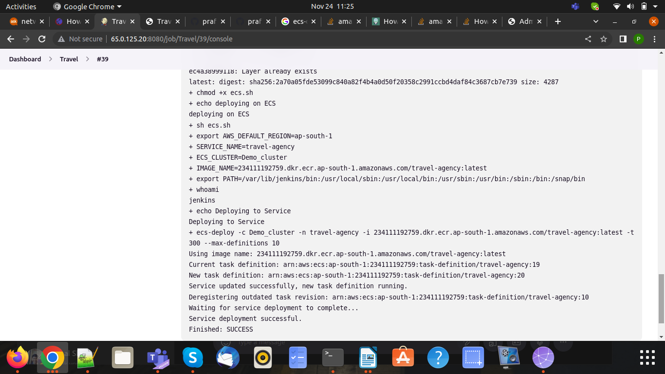

7. For setting up website used free domain which already available for DNS used Route 53 service

- https://traveldemo.tk/

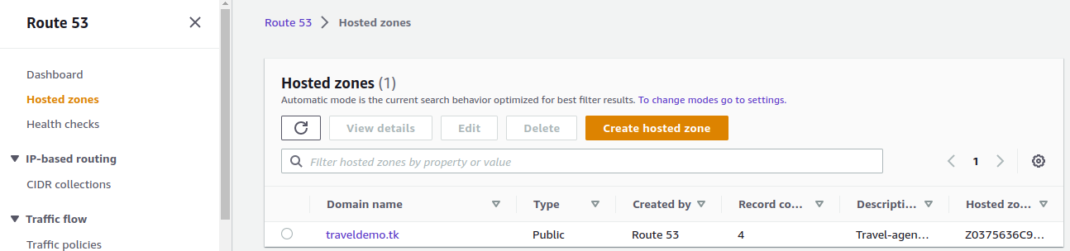

8. For Admin login

- User name: admin@gmail.com
- Password: admin
9. Supporting Screenshots for Home-page, Login-page, Admin-page.

