
MANNAGUDDE SHIVARAM & SUSHEELA GATTY FOUNDATION ಮಣ್ಣಗುಡ್ಡೆ ಶಿವರಾಮ ಮತ್ತು ಸುಶೀಲಾ ಗಟ್ಟಿ ಫೌಂಡೇಶನ್
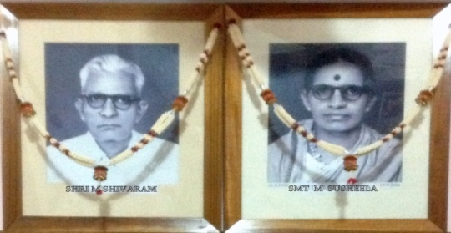

#1, Rajnivas, Mannagudde, Mangalore 575 003.
www.gattyfoundation.org. Phone:9448836436

Fulfilling Philanthropic & Charitable Mission
Focused on upliftment of Meritorious & Deserving Students from Gatty Community
Committed towards Advancement of Education.

First English Essay Writing Competition 2016

The MANNAGUDDE SHIVARAM & SUSHEELA GATTY FOUNDATION is pleased to announce the new Merit Prize Scheme : First English Essay Writing Competition for students from Gatty Community. The effort is to ignite the hidden talents and bring out the best in our children through a platform of competition.
We have selected the following subject for the Essay Competition:

”Importance of English Language in our Life”

FIRST PRIZE : Rs.5,000/-
SECOND PRIZE : Rs.2,000/-
THIRD PRIZE : Rs.1,000/-

>> Page 2

Page 2/2

RULES OF THE COMPETITION:

- The competition is open to all students from the Gatty Community studying in SSLC or higher classes. (i. e. SSLC/10th Std./PUC/Diploma/Any Degree Course/PG course etc.)

- Marks will be awarded for presentation, style of writing, thought-process, flow of contents, accuracy of facts and figures, correctness of spelling and grammar.
- The length of the essay should be limited to 1000 words. The essay should be typewritten and printed on one side of the page with maximum of 30 lines per page. Handwritten manuscripts will not be accepted.
- The contents of the Essay should be original and should not be copied from other sources.
- Important: The participating students should write their (1) Name, (2) Father’s Name, (3) Complete Postal Address, (4) PIN code, (5) Date of Birth, and (6) Mobile Number of Self/Parents in a separate paper along with (7) Copy of the School/College student ID card or Proof of studentship/Class of study and (8) Passport size photograph. Name should not be written on the Essay pages.
- The Essay should be submitted to the Foundation at the following address Mannagudde Shivaram & Susheela Gatty Foundation, #1 “Rajnivas”, Mannagudde, Mangalore 575003.
- The last date for submission of the Essay is 31.10.2016.
- Names of the Prize Winners will be informed through personal communications followed by announcement in our website www.GattyFoundation.org and www.Facebook.com/ MannaguddeGattyFoundation.
- The decision of the Trustees in respect of award of prizes is final. The Trustees reserve the right to cancel the Competition/Prizes in case the Essays are found not up to the mark.

FOUNDER TRUSTEES
M K Girishprasanna Gatty S/o Mr M S Krishnamohan Gatty
M K Ganeshprasanna Gatty S/o Mr M S Krishnamohan Gatty
Shwetha Ganeshprasanna Gatty W/o Mr M K Ganeshprasanna Gatty
Vani Krishnamohan Gatty W/o Mr M S Krishnamohan Gatty
M S Krishnamohan Gatty S/o Late Shri M Shivaram & Smt Susheela Gatty

