URL: <https://github.com/ganeshrajashekar/Poker-ICM>

**Instructions to execute Poker Solution program.**

1. download the zip file from the github

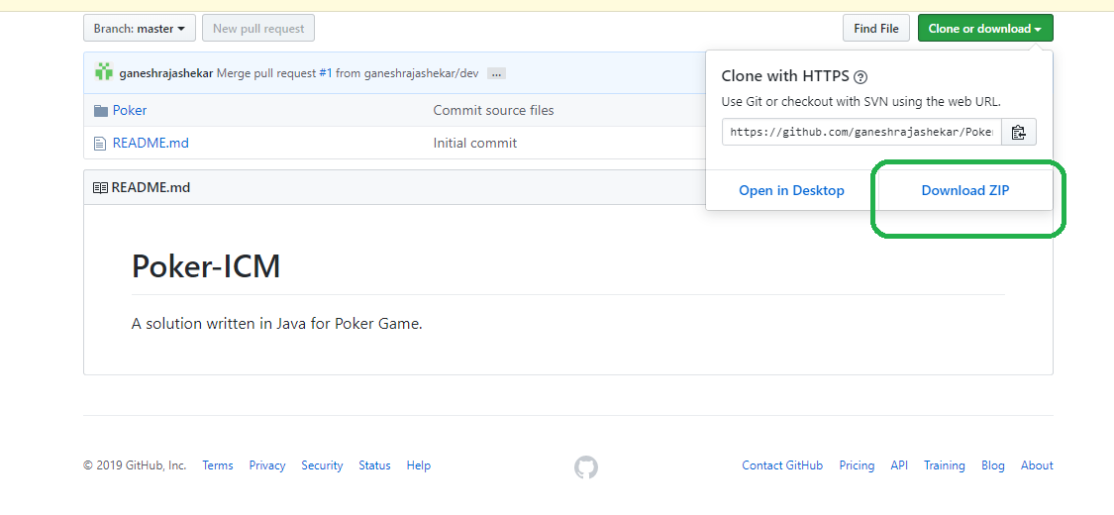

1. Extract the zip file

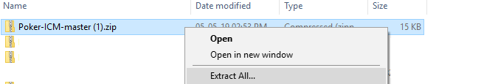

1. Open the folder *Extracted folder/Poker/bin

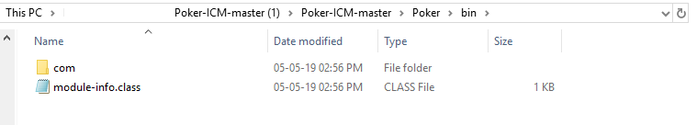

1. Open command window prompt in that folder.



*NOTE: Below steps are executed assuming that JAVA is installed on the executor’s machine and SYSTEM PATH variable is set.*

1. Execute below command to create Jar file.
2. **jar cfe poker-solution.jar com.icm.poker.PokerSolution com/icm/poker/*.class**
3. run

**java -jar poker-solution.jar** to Launch and provide inputs from STDIN

or

run

**type poker-hands.txt | java -jar poker-solution.jar** to provide file output to the JAR as input.

Sample Jar file created in my workspace for your reference.

