CHAPTER 4
Implementation
4.1 Technology Stack
The NTTH implementation uses a carefully selected set of open-source technologies chosen for their maturity, performance at the target traffic scale, and compatibility with the Docker-based deployment model.
Layer | Technology | Version | Purpose
Backend | Python 3.11 | 3.11.x | All backend agents, REST API, analysis pipeline
Packet Capture | Scapy | 2.5.x | Raw packet sniffing and feature extraction
Anomaly Detection | scikit-learn | 1.3.x | Isolation Forest training and inference
Web Framework | FastAPI | 0.104.x | REST API + WebSocket server
Message Broker | Redis | 7.2.x | Pub/Sub inter-agent communication
Database | SQLite + SQLAlchemy | 3.43 + 2.0 | Event storage and query layer
SSH Honeypot | Cowrie | 2.5.x | SSH/Telnet deception and session logging
Firewall | nftables (Linux kernel) | 1.0.x | Packet filtering and DNAT rules
WiFi Capture | Scapy + ath9k_htc | Kernel 5.15 | Monitor mode 802.11 frame capture
Frontend | Flutter | 3.16.x | Web and Android real-time dashboard
Containerization | Docker + Compose | 24.x + V2 | Service isolation and deployment
Async HTTP | aiohttp / uvicorn | 3.9 / 0.24 | ASGI server for FastAPI
Table 4.1: Complete technology stack summary with versions and purpose.
4.2 Hardware Requirements
Component | Minimum Spec | Test Deployment Spec
Processor | 2 cores, 1.6 GHz x86_64 | Intel Core i5-8250U, 4 cores, 1.6–3.4 GHz
RAM | 4 GB DDR4 | 8 GB DDR4 2400 MHz
Storage | 20 GB SSD/HDD | 256 GB NVMe SSD
Primary NIC | Gigabit Ethernet | Intel I219-V (1 Gbps, built-in)
WiFi Adapter | Any monitor-mode adapter | TP-Link TL-WN722N v1 (Atheros AR9271)
OS | Ubuntu 20.04+ LTS | Ubuntu 22.04.3 LTS (kernel 5.15.0-91)
Docker | Docker Engine 20.x | Docker Engine 24.0.7, Compose V2.21
Network Position | SPAN port or inline | Inline bridge (br0) between switch and gateway
Table 4.2: Hardware requirements and test deployment configuration.
4.3 Backend Service Architecture
The backend consists of five Python services running as independent Docker containers, each corresponding to one of the agent stages defined in the architecture chapter. A sixth service hosts the FastAPI REST API and WebSocket server. All services communicate through the Redis container using the shared Docker network bridge.
Each agent service is implemented as a Python asyncio application, using the aioredis library for non-blocking Redis Pub/Sub operations. This allows the Threat Assessment Agent, for example, to subscribe to the feature_vectors channel, process arriving feature sets through the Isolation Forest scorer, and publish results — all within a single event loop iteration without blocking on IO operations.
4.4 Packet Capture and Processing Engine
The Capture Agent uses Scapy's AsyncSniffer in combination with a BPF (Berkeley Packet Filter) expression to selectively capture traffic. The BPF filter excludes loopback traffic, ARP broadcasts, and the NTTH's own Redis and API communication, reducing the volume of packets entering the processing pipeline.
Packets are buffered in a 5-second sliding window keyed by source IP address. At the end of each window, the 10-dimensional feature vector is computed from the buffered packets for each active source IP with more than 5 packets in the window. The feature vector is then published to the Redis ntth:features channel as a JSON-serialized dictionary alongside the source IP and window timestamp.
# Simplified Capture Agent — feature extraction loop
async def process_window(src_ip: str, packets: list) -> FeatureVector:
pkt_count = len(packets)
byte_count = sum(len(p) for p in packets)
dst_ports = [p[TCP].dport for p in packets if p.haslayer(TCP)]
syn_count = sum(1 for p in packets if p.haslayer(TCP) and p[TCP].flags == 'S')
icmp_count = sum(1 for p in packets if p.haslayer(ICMP))
return FeatureVector(
src_ip=src_ip,
pkt_rate=pkt_count / WINDOW_SECONDS,
byte_rate=byte_count / WINDOW_SECONDS,
dst_port_entropy=entropy(Counter(dst_ports).values()),
syn_ratio=syn_count / max(pkt_count, 1),
icmp_rate=icmp_count / WINDOW_SECONDS,
unique_dst_ips=len(set(p[IP].dst for p in packets if p.haslayer(IP))),
unique_dst_ports=len(set(dst_ports)),
)
4.5 IDS Rule Engine Implementation
The IDS Rule Engine is a Python module that evaluates each feature vector against a set of 15 handwritten detection rules. The rules are defined as Python dataclasses with a condition function and an associated severity enumeration. When a feature vector is received by the Threat Assessment Agent, each rule's condition function is evaluated against the vector's attributes. If multiple rules match, the highest severity match sets the IDS_Score component.
@dataclass
class IDSRule:
name: str
severity: Severity
condition: Callable[[FeatureVector], bool]
SYN_FLOOD_RULE = IDSRule(
name="SYN_FLOOD",
severity=Severity.CRITICAL,
condition=lambda fv: (
fv.syn_ratio > 0.7 and fv.pkt_rate > 80 and fv.unique_dst_ips <= 3
)
)
PORT_SCAN_RULE = IDSRule(
name="PORT_SCAN",
severity=Severity.HIGH,
condition=lambda fv: (
fv.unique_dst_ports > 20 and fv.pkt_rate > 5 and fv.byte_rate < 50000
)
)
4.6 Isolation Forest Anomaly Detector
The Isolation Forest is trained offline on a 72-hour baseline capture of normal network traffic from the test environment, collected before any attack experiments were conducted. The training dataset consists of approximately 280,000 feature vectors extracted from normal traffic windows. The sklearn IsolationForest implementation is configured with 100 estimators, a contamination parameter of 0.05, and 'auto' max_samples.
After training, the model is serialized to a joblib file and loaded by the Threat Assessment Agent at startup. Inference on a single feature vector takes approximately 0.4 milliseconds on the test hardware. The model retraining schedule is managed by a weekly cron job that uses a rolling window of confirmed-normal traffic samples for retraining. The newly trained model is validated against a held-out normal traffic set before being atomically swapped into the active model path.
# Anomaly score normalization
def normalize_anomaly_score(raw_score: float) -> float:
# raw_score: sklearn IsolationForest score_samples() output
# Normal traffic: -0.05 to -0.2; Anomalous: -0.3 to -0.5
scaled = (-raw_score - 0.05) / 0.45 # shift and scale to [0, 1]
scaled = max(0.0, min(1.0, scaled)) # clamp
return float(scaled)
4.7 Firewall and Honeypot Integration
The Enforcement Agent interacts with the Linux kernel's nftables subsystem through subprocess calls to the nft command-line utility. The agent maintains a Python module called ntth_nft_manager that implements three operations: rule insertion, rule deletion, and rule listing. Each operation is validated before execution through a pre-validation function that checks the rule syntax against a whitelist of permitted rule templates.
# nftables BLOCK rule template
BLOCK_RULE_TEMPLATE = (
"nft add rule inet ntth_filter forward "
"ip saddr {src_ip} drop comment \"{rule_id}\""
)
# nftables DNAT honeypot redirect template (SSH example)
HONEYPOT_DNAT_TEMPLATE = (
"nft add rule ip ntth_nat prerouting "
"ip saddr {src_ip} tcp dport {orig_port} "
"dnat to {honeypot_ip}:{honeypot_port} "
"comment \"{rule_id}\""
)
The nftables table structure used by NTTH consists of two custom tables: ntth_filter (DROP rules) and ntth_nat (DNAT rules). These tables are initialized at system startup and cleared on shutdown, leaving the host's existing iptables/nftables configuration untouched. Cowrie runs in its Docker container with a custom configuration that mimics the hostname, SSH server version string, and filesystem structure of a typical Ubuntu server.
4.8 Flutter Dashboard Implementation
The Flutter dashboard provides real-time visibility into the system's operation through a WebSocket connection to the FastAPI backend. It is implemented as a Flutter web application that can be served as a static site and accessed from any modern browser, with the same codebase compiled to a native Android APK for mobile access without modification. The dashboard consists of seven screens: Dashboard Overview, Threat Events, Firewall Rules, Honeypot Sessions, Network Topology, WiFi Events, and Device Management.
State management uses the Provider package. A single NTTHDataProvider class manages the application's global state, receiving WebSocket messages and updating the relevant state objects — ThreatList, FirewallRuleList, HoneypotSessionList, DeviceList, and TopologyGraph. The network topology screen renders a force-directed graph of discovered LAN devices using the Flutter graph_view package. Nodes are colored by device status: green (normal), yellow (alerted), orange (throttled), red (blocked or redirected).
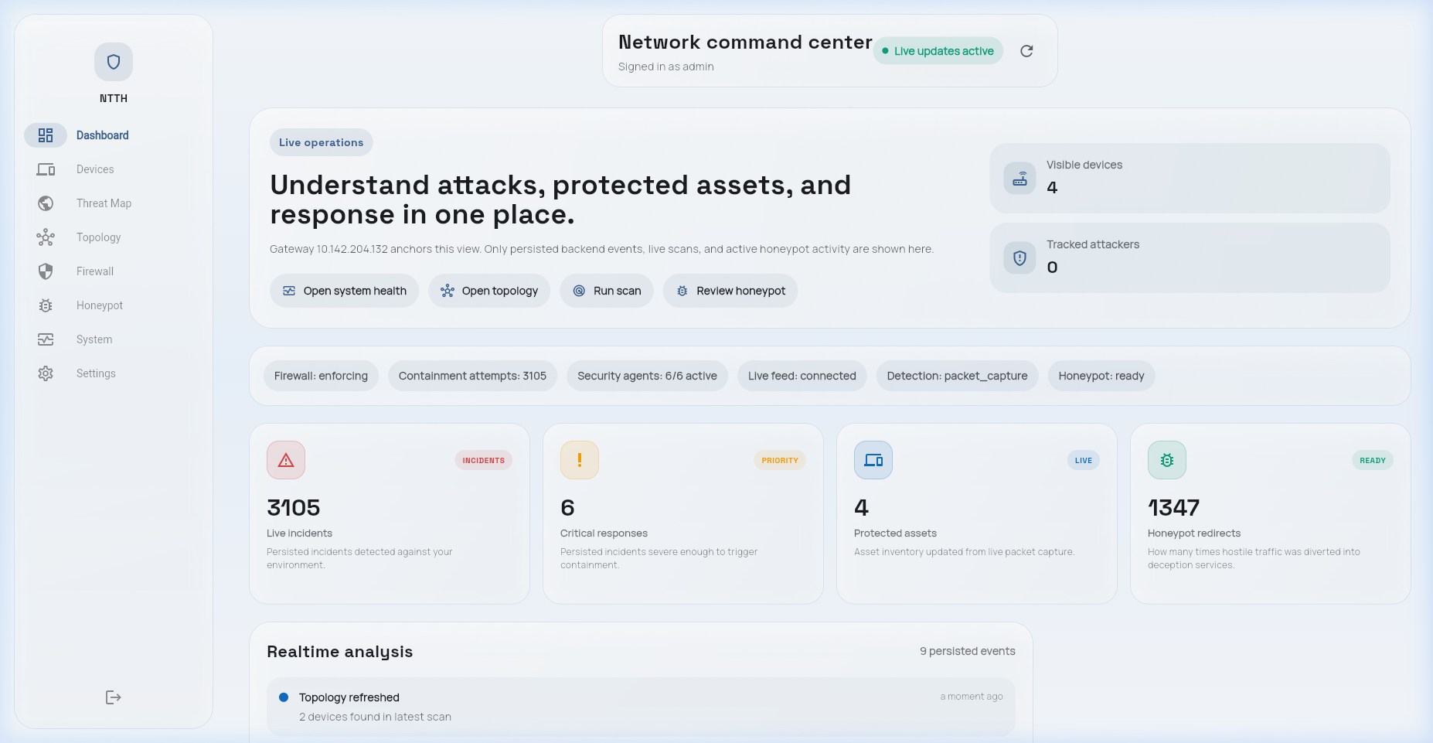
Figure 4.4: Flutter dashboard architecture showing WebSocket real-time data flow and REST API calls.
4.9 WiFi Monitor Module
The WiFi Monitor Module runs as a separate Python process attached to the Atheros AR9271 USB adapter in monitor mode. The adapter is placed in monitor mode at startup using the iwconfig command. The module uses Scapy's sniff() function with a BPF filter for 802.11 management frames to capture probe requests, deauthentication frames, and disassociation frames.
Probe requests are analyzed for unusual probe rates from a single MAC address (threshold: >30 per 60-second window). Deauthentication frames are counted in a 10-second rolling window; when the count exceeds 20 frames in 10 seconds, a DEAUTH_ATTACK alert is raised. Since MAC addresses on management frames can be spoofed, the alert notes this caveat in the dashboard display alongside the captured frame data.
4.10 REST API Endpoints
The FastAPI REST API provides 14 endpoints covering all read and control operations. All endpoints require a Bearer token for authentication. The API is served on port 8000 with TLS enabled in production configurations.
Method | Endpoint | Description
GET | /api/v1/threats | List recent threat events with pagination
GET | /api/v1/threats/{id} | Get single threat event details
GET | /api/v1/rules | List all active firewall rules
DELETE | /api/v1/rules/{id} | Manually delete a firewall rule
POST | /api/v1/rules | Manually create a custom firewall rule
GET | /api/v1/honeypot/sessions | List honeypot sessions
GET | /api/v1/honeypot/sessions/{id} | Get full session detail with command log
GET | /api/v1/devices | List all discovered network devices
GET | /api/v1/topology | Get network graph data (nodes + edges)
GET | /api/v1/wifi/events | List WiFi probe and deauth alerts
GET | /api/v1/stats/summary | System-wide statistics for dashboard KPIs
POST | /api/v1/config/threshold | Update risk score enforcement thresholds
GET | /api/v1/health | System health check for all agent services
WS | /ws | WebSocket endpoint for real-time dashboard updates
Table 4.3: REST API endpoints with HTTP methods and descriptions.
4.11 Docker Deployment
The entire NTTH backend is containerized using Docker Compose. One notable challenge in the Docker configuration is that the Capture Agent requires NET_RAW and NET_ADMIN capabilities for raw packet capture mode. Similarly, the Enforcement Agent requires NET_ADMIN capability and a bind-mount of /etc/nftables.conf. These elevated capabilities are intentionally scoped to only the specific services that require them.
Container | Image | Exposed Port | Special Privileges
ntth-capture | ntth/capture:latest | — | NET_RAW, NET_ADMIN, host network
ntth-assessor | ntth/assessor:latest | — | None
ntth-decision | ntth/decision:latest | — | None
ntth-enforcer | ntth/enforcer:latest | — | NET_ADMIN, nft bind-mount
ntth-reporter | ntth/reporter:latest | — | None
ntth-api | ntth/api:latest | 8000 (HTTPS) | None
ntth-redis | redis:7.2-alpine | 6379 (internal) | None
ntth-cowrie | cowrie/cowrie:latest | 2222 (internal) | None
ntth-wifi | ntth/wifi:latest | — | NET_RAW, host network
Table 4.4: Docker container configuration with image names, ports, and privilege requirements.
The full system reaches steady state — all containers running, all agents subscribed to their channels, and the API serving requests — approximately 12 seconds after issuing the docker compose up command.

