WeatherScope

Weather data analysis system

A project report submitted as part of academic requirements for the python programming course.
2nd year | B. Tech | Computer Science and Engineering

PROJECT TEAM DETAILS
S. No. | Team Member | Roll Number | Role
1. | Yellamreddy Sai Ganesh Reddy | 25102A040199 | Visualization
2. | Saga Veera Venkata Surendra | 25102A040144 | Frontend
3. | Pelluri Abhilash | 25102A040180 | Data processing
4. | Singamala Balaadithya | 25102A040169 | Database
5. | Sushma Sree Anepakula | 25102A040143 | Backend

UNDER THE GUIDANCE OF
Mr. Mohammad Valli
DEPARTMENT OF COMPUTER SCIENCE AND ENGINEERING
MOHAN BABU UNIVERSITY
ACADEMIC YEAR: 2026–2027
ABSTRACT
The Weather Data Analysis System is a web-based application designed to process, validate, store, and analyze historical weather data. It allows users to upload CSV datasets and obtain meaningful insights through statistical analysis, monthly summaries, and graphical visualizations.
The system uses Python and Flask for backend processing, Pandas and NumPy for data analysis, Matplotlib for chart generation, MySQL for data storage, and HTML, CSS, and JavaScript for the user interface.
Its data validation mechanism identifies invalid records based on observation date, location, temperature, humidity, and rainfall. Only valid records are considered for analysis and database storage, while invalid records are reported with their corresponding errors.
The application generates monthly weather statistics, including temperature, humidity, and rainfall measurements, along with temperature trend and rainfall comparison charts. It also provides features to retrieve and explore stored weather records.
Overall, the system transforms raw historical weather data into organized statistical information, making weather patterns easier to understand through an interactive web-based platform.

1. INTRODUCTION
Weather information plays an important role in agriculture, transportation, environmental management, and water resource planning. Analysing historical weather observations helps identify patterns and understand variations in temperature, humidity, and rainfall across different periods and locations.
However, raw weather datasets may contain missing values, incorrect entries, or inconsistent formats. Processing such data manually can be time-consuming and may produce inaccurate results. Therefore, an efficient system is required to validate, organize, analyse, and visualize weather information.
The Weather Data Analysis System is a web-based application developed to simplify this process. It allows users to upload historical weather datasets in CSV format or use a predefined sample dataset. The system validates important fields, identifies invalid records, and processes only valid observations for further analysis.
The application is developed using Python and Flask for backend processing, Pandas and NumPy for data analysis, Matplotlib for visualization, MySQL for database management, and HTML, CSS, and JavaScript for the frontend.
The system generates monthly weather statistics based on location, including minimum, maximum, and average temperature, humidity measurements, and rainfall summaries. Temperature trends and rainfall variations are presented through graphical charts, while validated records can be stored and retrieved from the database.
The main objective of the project is to integrate web development, data validation, database management, and data analytics into a single platform. The system focuses exclusively on historical weather data analysis and does not provide real-time weather updates or forecasting.

2. PROBLEM STATEMENT
Historical weather datasets often contain missing values, incorrect entries, and inconsistent formats, making manual processing and analysis difficult and time-consuming. Analysing such data without proper validation may lead to inaccurate statistical results and misleading conclusions.
There is also a need for an integrated platform to organize weather records, calculate monthly statistics, and present temperature and rainfall patterns in an understandable format. Managing and retrieving historical records manually further increases the effort required for analysis.
The Weather Data Analysis System addresses these challenges by providing a web-based solution that accepts CSV datasets, validates weather records, identifies invalid entries, and performs statistical analysis using valid data. It also stores validated records in a MySQL database and presents analytical results through monthly summaries and graphical visualizations.
Therefore, the project aims to reduce manual effort, improve data reliability, simplify record management, and make historical weather analysis more accessible and efficient.

3. OBJECTIVES AND SCOPE
3.1 Objectives
The main objective of the Weather Data Analysis System is to develop a web-based platform for validating, processing, storing, and analysing historical weather data.
The specific objectives are:
- Data Upload: Allow users to upload weather datasets in CSV format.
- Data Validation: Identify invalid records by checking dates, locations, temperature, humidity, and rainfall values.
- Data Processing: Clean and organize valid records using Python libraries.
- Statistical Analysis: Calculate monthly temperature, humidity, and rainfall statistics.
- Data Visualization: Generate temperature trend and rainfall comparison charts.
- Database Management: Store and retrieve validated weather records using MySQL.
- Interactive Dashboard: Display summaries, charts, validation results, and stored records.
- Sample Data Support: Provide a predefined dataset for exploring application features.

3.2 Scope of the Project
The project focuses on analysing historical weather data provided through CSV files. It integrates data validation, statistical analysis, database storage, and graphical visualization into a single web-based application.
The system supports:
- Uploading CSV weather datasets and loading sample data.
- Validating weather attributes and identifying invalid records.
- Generating monthly statistical summaries.
- Visualizing temperature and rainfall patterns.
- Storing and retrieving validated records through MySQL.
- Viewing and filtering available weather records and summaries through the dashboard.

3.3 Scope Exclusions
The current version is limited to historical weather data analysis and does not include:
- Real-time weather updates through external APIs.
- Weather forecasting or future climate predictions.
- Machine learning-based prediction models.
- Direct data collection from weather stations or sensors.
- Advanced geographical mapping or satellite-based analysis.
These features may be considered for future development to extend the system's capabilities.

4. EXISTING AND PROPOSED SYSTEM
4.1 Existing System
Traditionally, weather data is maintained in spreadsheets or CSV files and analysed manually. Users identify incorrect entries, calculate statistical values, and create charts to understand weather patterns.
This approach becomes difficult when handling large datasets containing observations from multiple dates and locations. Manual processing is time-consuming and may lead to validation and calculation errors.
Disadvantages:
- Requires considerable manual effort.
- Time-consuming for large datasets.
- Difficult to identify invalid records.
- Possibility of errors in statistical calculations.
- Limited centralized storage and record retrieval.
- Less effective graphical representation of weather patterns.

4.2 Proposed System
The proposed Weather Data Analysis System is a web-based application that automates historical weather data processing and analysis.
Users can upload CSV files or load a predefined sample dataset through an interactive dashboard. The Flask backend processes the data using Python libraries, validates weather records, and separates valid and invalid observations.
Valid records are stored in MySQL, while monthly statistical summaries are generated using Pandas and NumPy. Matplotlib is used to display temperature trends and rainfall comparisons through graphical charts.

Advantages:
- Automated CSV processing and data validation.
- Identification and reporting of invalid records.
- Accurate statistical analysis of valid observations.
- Centralized storage using MySQL.
- Graphical visualization of weather patterns.
- Easy retrieval and exploration of stored records.
- Interactive web-based dashboard.

4.3 Comparison Between Existing and Proposed Systems
Existing System | Proposed System
Manual data processing | Automated data processing
Manual error identification | Automatic data validation
Manual statistical calculations | Analysis using Pandas and NumPy
Spreadsheet-based storage | MySQL database storage
Limited visualization | Charts using Matplotlib
Difficult record retrieval | Database-based retrieval
More manual effort | Reduced processing effort
Less interactive | Interactive web dashboard

4.4 Summary
The proposed system improves traditional weather data analysis by integrating validation, statistical processing, database management, and graphical visualization into a single web-based application. It reduces manual effort and provides an organized approach to analysing historical weather observations.

5. REQUIREMENTS SPECIFICATION
The Weather Data Analysis System requires suitable hardware and software resources for data processing, database management, visualization, and web application development.

5.1 Hardware Requirements
Component | Minimum Requirement
Processor | Dual-core processor or above
RAM | 4 GB or above
Storage | Sufficient available disk space
Display | Laptop or desktop monitor
Input Devices | Keyboard and mouse
Network | Internet connection for accessing the deployed application

5.2 Software Requirements
Software Technology | Purpose
Python | Backend programming and data processing
Flask | Web application and API development
Pandas | CSV handling, data cleaning, and analysis
NumPy | Numerical calculations
Matplotlib | Graph generation and visualization
MySQL | Relational database management
MySQL Connector | Python–MySQL communication
HTML | Webpage structure
CSS | Interface styling and layout
JavaScript | Frontend interactions and API communication
Python-dotenv | Environment variable management
Visual Studio Code | Code editing and development
Web Browser | Accessing and testing the application
Render | Cloud hosting and deployment

5.3 Technology Overview
The application uses Python and Flask for backend development and API handling. Pandas and NumPy perform data cleaning, numerical calculations, and statistical analysis, while Matplotlib generates weather visualization charts.
MySQL, connected through MySQL Connector, stores and retrieves validated weather records. The frontend uses HTML, CSS, and JavaScript to provide an interactive dashboard and communicate with the backend. Python-dotenv manages configuration variables, while Visual Studio Code supports development and Render is used for deployment.

5.4 Development Environment
The application was developed using Visual Studio Code with Python and Flask. MySQL was used for database management, and a web browser was used for testing the interface. The application supports local execution and cloud deployment through Render.

6. SYSTEM ARCHITECTURE
The WeatherScope Analytics Platform follows a layered client-server architecture consisting of four layers: Presentation, Application, Analysis, and Database. Each layer performs a specific function and communicates with the others to process weather datasets and display results.

6.1 Presentation Layer
Developed using HTML, CSS, and JavaScript, this layer provides the dashboard interface for CSV uploads, sample data loading, validation reports, charts, and stored records. It communicates with the backend through API requests.

6.2 Application Layer
Developed using Python and Flask, this layer manages HTTP requests and coordinates the analysis and database modules. It processes user requests and returns results to the frontend in JSON format.
6.3 Analysis Layer
Implemented in analysis.py using Pandas, NumPy, and Matplotlib, this layer validates datasets, separates valid and invalid records, calculates monthly statistics by location, and generates temperature and rainfall charts.
6.4 Database Layer
The MySQL database stores validated weather observations. The database.py module manages database connections, table initialization, record insertion, retrieval, and deletion.

6.5 Data Flow Between Layers
Layer | Main responsibility | Output
Presentation | User interactions and API requests | Backend requests
Application | Coordinates application operations | Processing results
Analysis | Validation, cleaning, statistics, and charts | Valid records and analytical results
Database | Stores and retrieves weather observations | Stored records

6.6 Architecture Summary
The layered structure separates user interactions, application processing, data analysis, and storage. This improves code organization, maintainability, and the ability to extend individual components without major changes to the entire application.

7. PROJECT STRUCTURE
The Weather Data Analysis System follows a modular project structure in which backend processing, frontend development, database management, and datasets are organized separately. This improves code readability, maintenance, and debugging.
7.1 Project Directory Structure
The project contains the following directories and files:
WeatherSystem-main/
│
├── backend/
│ ├── app.py
│ ├── analysis.py
│ ├── database.py
│ └── requirements.txt
│
├── data/
│ ├── sample_weather_data.csv
│ └── weather_project_import.csv
│
├── database/
│ └── schema.sql
│
├── frontend/
│ ├── index.html
│ ├── css/
│ │ └── style.css
│ └── js/
│ └── script.js
│
├── .env.example
├── .gitignore
├── README.md
└── run.py

7.2 Description of Project Files
File / Directory | Description
backend/app.py | Manages Flask routes, API requests, and communication between application modules.
backend/analysis.py | Handles CSV processing, data validation, statistical analysis, and chart generation.
backend/database.py | Manages MySQL connections, table creation, insertion, retrieval, and deletion of records.
backend/requirements.txt | Lists the Python packages required by the application.
data/ | Contains sample and importable weather CSV datasets.
database/schema.sql | Defines the database structure and weather_records table.
frontend/index.html | Defines the structure of the application dashboard.
frontend/css/style.css | Controls the dashboard's appearance, layout, and styling.
frontend/js/script.js | Handles user interactions, API communication, charts, and dynamic dashboard updates.
.env.example | Provides a template for database configuration variables.
.gitignore | Specifies files and directories excluded from Git tracking.
README.md | Contains project information, requirements, and execution instructions.
run.py | Configures the application entry point and starts the Flask server.

7.3 Application Execution
The run.py file is used to start the application locally. After executing it, the dashboard can be accessed through:
http://127.0.0.1:5000

7.4 Importance of Modular Structure
The modular organization provides the following advantages:
- Maintainability: Individual components can be modified independently.
- Code Reusability: Common operations can be reused across modules.
- Debugging: Errors can be located more easily.
- Scalability: Additional features can be introduced when required.
- Collaboration: Team members can work on separate components.

7.5 Summary
The organized project structure separates frontend, backend, analysis, database, and dataset components. This makes the application easier to understand, maintain, test, and extend.

8. MODULE DESCRIPTION
The WeatherScope Analytics Platform uses a modular architecture to manage data uploads, validation, analysis, database operations, and dashboard display.
8.1 Backend Module – app.py
The app.py module initializes the Flask application and defines API routes. It handles dashboard requests and CSV uploads, coordinates data processing and database operations, and returns results in JSON format.
8.2 Data Analysis Module – analysis.py
The analysis.py module uses Pandas, NumPy, and Matplotlib to read CSV files, validate required columns and values, separate valid and invalid records, calculate monthly statistics, and generate temperature and rainfall charts.
8.3 Database Module – database.py
The database.py module manages MySQL connectivity using MySQL Connector. It loads configuration from environment variables, initializes database tables, inserts validated records, retrieves observations, executes SQL queries, and supports record deletion.
8.4 Frontend Structure – index.html
The index.html file defines the dashboard layout, including navigation, CSV upload, sample data loading, summary cards, charts, monthly statistics, and the database explorer.
8.5 Styling Module – style.css
The style.css file controls the dashboard's appearance through colours, typography, spacing, component styling, and responsive layouts.
8.6 Frontend Functionality – script.js
The script.js file manages user interactions, file uploads, API communication, JSON responses, dashboard updates, charts, database records, filtering, and refresh operations.
8.7 Application Launcher – run.py
The run.py file configures the module search path, imports the Flask application, and starts the local development server at http://127.0.0.1:5000.
8.8 Dependency Management – requirements.txt
This file lists the required Python packages: Flask, Pandas, NumPy, Matplotlib, mysql-connector-python, and python-dotenv.
8.9 Module Integration
The frontend sends requests to the Flask backend, which coordinates validation and analysis. Valid records are stored in MySQL, while the processed results and visualizations are displayed on the dashboard.
8.10 Summary
The modular architecture improves code organization, simplifies maintenance and debugging, and supports future enhancements.

9. DATABASE DESIGN
The WeatherScope Analytics Platform uses MySQL as its Relational Database Management System (RDBMS) to store, manage, and retrieve validated weather observations. The database is named weather_analysis, and its main table is weather_records.
9.1 Database Name
The application uses a MySQL database named weather_analysis. It stores validated weather observations and allows previously stored records to be retrieved whenever required.
9.2 Table Structure
The weather_records table stores individual weather observations using the following attributes:
Column Name | Data Type | Description
record_id | INT | Unique identifier for each record
observation_date | DATE | Date of the weather observation
location | VARCHAR(100) | Location associated with the observation
temperature | FLOAT | Temperature in Celsius
humidity | FLOAT | Humidity percentage
rainfall | FLOAT | Rainfall in millimetres

9.3 Explanation of Attributes
- record_id: Auto-incremented primary key that uniquely identifies each record.
- observation_date: Stores the observation date using the DATE data type.
- location: Stores the location name using VARCHAR(100).
- temperature: Stores temperature measurements in Celsius, including decimal values.
- humidity: Stores relative humidity as a percentage.
- rainfall: Stores rainfall measurements in millimetres, including fractional values.

9.4 Primary Key
The record_id attribute is the primary key of the weather_records table. It uniquely identifies each row and uses AUTO_INCREMENT to generate a new identifier whenever a record is inserted.

9.5 Database Operations
The application uses the following SQL operations to manage weather records.
1. CREATE DATABASE
Creates the database if it does not already exist.
CREATE DATABASE IF NOT EXISTS weather_analysis;

2. CREATE TABLE
Defines the structure of the weather records table.
CREATE TABLE IF NOT EXISTS weather_records (
record_id INT AUTO_INCREMENT PRIMARY KEY,
observation_date DATE,
location VARCHAR(100),
temperature FLOAT,
humidity FLOAT,
rainfall FLOAT
);
3. INSERT
Stores validated weather observations.
INSERT INTO weather_records
(observation_date, location, temperature, humidity, rainfall)
VALUES
('2026-08-15', 'Chennai', 32.5, 65, 12.4);
4. SELECT
Retrieves stored weather records.
SELECT * FROM weather_records;
5. TRUNCATE
Removes all records while retaining the table structure.
TRUNCATE TABLE weather_records;

9.6 Database Connectivity
Python communicates with MySQL using MySQL Connector. The connection functionality is implemented in database.py, while configuration details are loaded from environment variables using Python-dotenv.
The connection parameters include:
- Database host and port.
- Username and password.
- Database name.
This approach keeps database configuration separate from the application source code.

9.7 Data Storage and Retrieval Process
The database process follows these steps:
- The user uploads a weather dataset.
- The analysis module validates the observations.
- Invalid records are excluded from insertion.
- Valid records are passed to the database module.
- A MySQL connection is established.
- Validated observations are inserted into weather_records.
- Stored records are retrieved when requested.
- Retrieved information is displayed in the dashboard.

9.8 Summary
The MySQL database provides structured and persistent storage for validated weather observations. The weather_records table maintains essential details such as date, location, temperature, humidity, and rainfall. Integration through MySQL Connector enables the application to store, retrieve, and manage weather data efficiently.

10. APPLICATION WORKFLOW
The WeatherScope Analytics Platform follows a systematic process to convert raw weather datasets into meaningful statistical information through data uploading, validation, storage, analysis, and visualization.

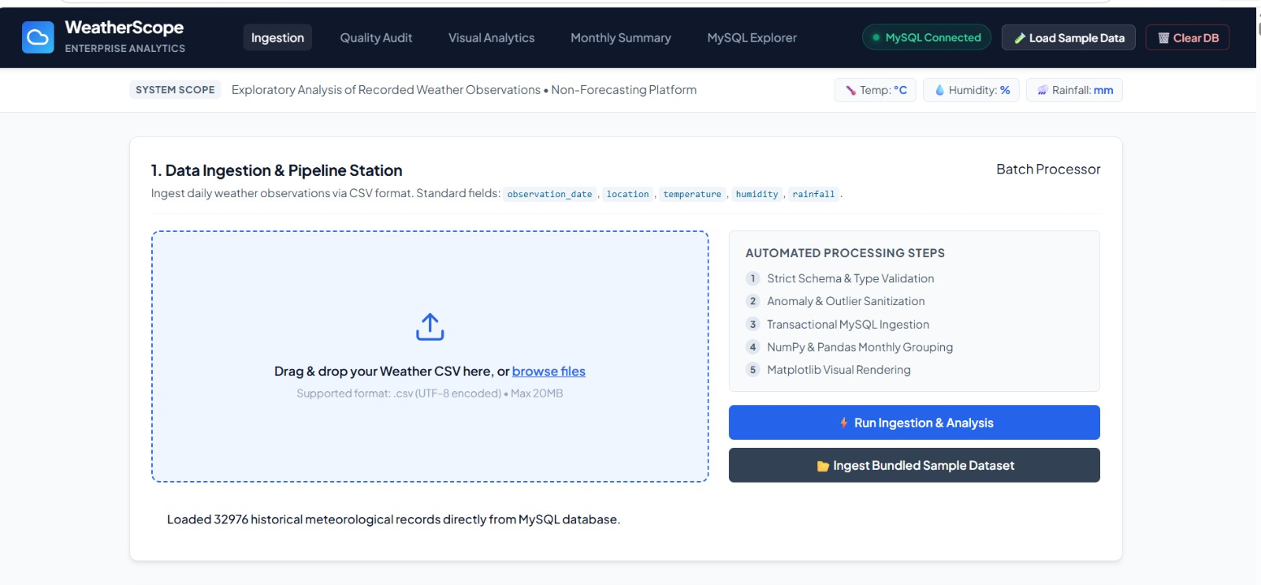
Fig 10: Dashboard Overview

10.1 CSV Data Upload
Users can upload CSV files through the dashboard using file selection or drag-and-drop functionality. A predefined sample dataset can also be loaded. JavaScript sends the selected file to the Flask backend through an HTTP POST request.

10.2 Data Reading and Structure Verification
The uploaded file is read into a Pandas DataFrame. The application checks for the required columns: observation_date, location, temperature, humidity, and rainfall. Files with missing required columns are reported as structurally invalid.

10.3 Data Validation
Each observation is checked against predefined conditions.
Field | Validation condition
Observation Date | Must be a valid date
Location | Must not be empty
Temperature | Numeric value between -60°C and +60°C
Humidity | Numeric value between 0% and 100%
Rainfall | Numeric value greater than or equal to 0 mm
Records containing missing values, incorrect formats, or measurements outside the accepted ranges are marked invalid.

10.4 Data Cleaning and Quality Report
The application separates observations into valid and invalid records. Only valid records are used for statistical analysis and database storage. Invalid records are excluded, and their row numbers and validation reasons are included in the data-quality report.
The report displays the total, valid, and invalid record counts along with the overall quality percentage.

For the sample dataset:
Parameter | Result
Total records | 40
Valid records | 36
Invalid records | 4
Data quality | 90%

10.5 Database Storage
Validated observations are inserted into the weather_records table in the weather_analysis MySQL database using MySQL Connector. Invalid records are excluded. Previously stored records can also be retrieved for dashboard display.

10.6 Statistical Analysis
Pandas and NumPy are used to calculate monthly statistics grouped by location. These include:
- Temperature: Minimum, maximum, and average.
- Humidity: Minimum, maximum, and average.
- Rainfall: Total, average, and maximum.
The results help compare historical weather conditions across months and locations.
10.7 Data Visualization

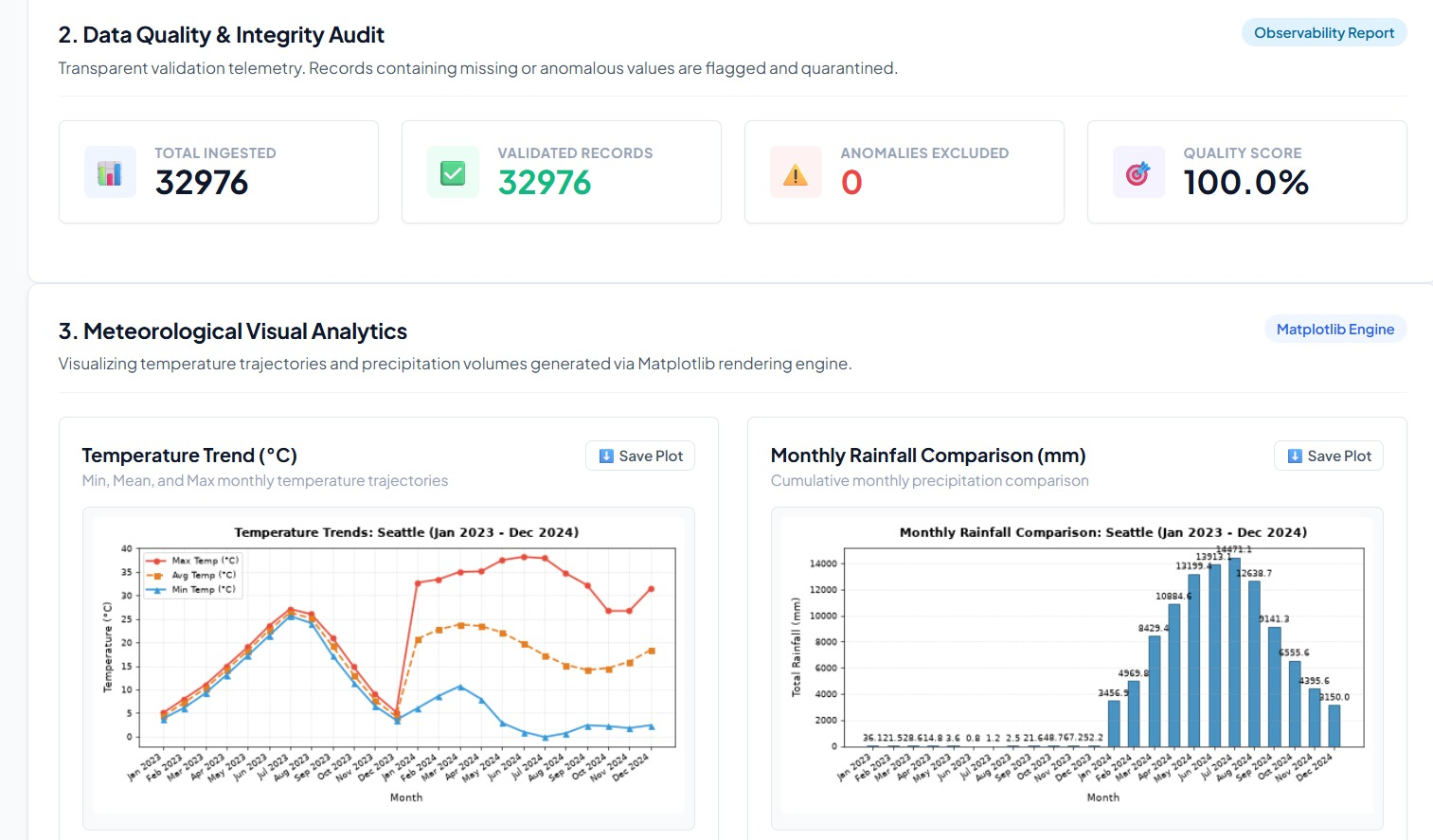
Fig 10.7: Temperature and rainfall charts

Matplotlib generates graphical representations of the calculated statistics:
- Temperature Trend Chart: A line chart showing monthly minimum, average, and maximum temperatures.
- Monthly Rainfall Comparison: A bar chart comparing total rainfall across different months.
These visualizations make weather patterns easier to understand.

10.8 Dashboard Display
The Flask backend returns the processed information to the frontend, where JavaScript updates the dashboard. It displays data-quality summaries, statistical results, charts, and stored records, along with filtering and refresh controls.

10.9 Complete Application Workflow
The overall process follows these steps:
- Upload a CSV file or load the sample dataset.
- Read the dataset and verify its structure.
- Validate and separate valid and invalid records.
- Generate the data-quality report.
- Store valid observations in MySQL.
- Calculate monthly weather statistics.
- Generate charts using Matplotlib.
- Display the results on the dashboard.
10.10 Summary
The application integrates data uploading, validation, database storage, statistical analysis, and visualization into a single workflow. This process reduces manual effort and provides an organized method for exploring historical weather conditions.

11. API DESCRIPTION
Application Programming Interfaces (APIs) enable communication between different components of a software application. WeatherScope uses Flask to provide backend API endpoints through which the frontend communicates with the server.
The frontend sends HTTP requests for operations such as CSV uploading, sample data processing, retrieving stored records, and clearing database contents. The backend processes these requests and returns responses in JSON format, which JavaScript uses to update the dashboard.
11.1 Overview of API Endpoints
The application uses the following Flask routes:
API Endpoint | HTTP Method | Purpose
/ | GET | Loads the main dashboard
/api/upload | POST | Uploads and analyses a CSV file
/api/sample | GET | Processes the predefined sample dataset
/api/records | GET | Retrieves stored database records
/api/dashboard | GET | Retrieves dashboard information
/api/records/purge | POST | Clears stored database records

11.2 Description of API Endpoints
1. Dashboard Route – /
- Method: GET
- Purpose: Loads the main WeatherScope dashboard, including its upload section, summaries, charts, and database explorer.
2. CSV Upload API – /api/upload
- Method: POST
- Purpose: Receives uploaded CSV files and passes them to the analysis module for validation and processing. Valid records are stored in MySQL, while invalid records are reported separately.
3. Sample Dataset API – /api/sample
- Method: GET
- Purpose: Loads and processes the predefined sample dataset from the project's data directory without requiring a manual upload.
4. Database Records API – /api/records
- Method: GET
- Purpose: Retrieves stored observations from the weather_records table and displays them in the database explorer.
5. Dashboard Data API – /api/dashboard
- Method: GET
- Purpose: Retrieves the information required to restore or refresh the dashboard using available stored data.
6. Database Purge API – /api/records/purge
- Method: POST
- Purpose: Clears all stored weather records when the user selects the database-clearing option.
11.3 HTTP Methods Used
The application uses two HTTP methods:
- GET: Requests information from the server. It is used for loading the dashboard, processing sample data, retrieving records, and refreshing dashboard information.
- POST: Sends information or requests server-side operations. It is used for CSV uploads and clearing stored records.
11.4 JSON Response Handling
The backend returns processing results in JSON (JavaScript Object Notation), a lightweight format for exchanging structured data.
Responses may contain:
- Operation status.
- Total, valid, and invalid record counts.
- Data-quality percentage and validation errors.
- Monthly statistical summaries.
- Chart-related information.
- Retrieved database records.
JavaScript processes these responses and updates the corresponding dashboard components.
11.5 Frontend and Backend Communication
The communication process follows these steps:
- The user performs an action on the dashboard.
- JavaScript sends an HTTP request to the appropriate Flask endpoint.
- Flask receives and processes the request.
- The backend communicates with the analysis or database module when required.
- A JSON response is returned to the frontend.
- JavaScript processes the response and updates the dashboard.
11.6 Importance of API Integration
API integration provides several advantages:
- Connects frontend and backend components.
- Separates interface operations from server-side processing.
- Supports file uploads and database retrieval.
- Enables dynamic dashboard updates.
- Improves modularity and maintainability.
11.7 Summary
Flask API endpoints provide communication between the frontend and backend components of WeatherScope. Using HTTP methods and JSON responses, the application supports CSV uploads, sample dataset processing, database retrieval, dashboard updates, and record management. This integration enables the application modules to work together efficiently.

12. TESTING AND RESULTS
12.1 Introduction
The WeatherScope Analytics Platform was tested using a sample dataset containing 40 weather observations. Testing covered CSV processing, data validation, statistical calculations, database operations, chart generation, and dashboard functionality.
12.2 Testing Methodology
Testing focused on verifying the following operations:
- CSV uploading and sample dataset processing.
- Identification and exclusion of invalid records.
- Accuracy of monthly statistical calculations.
- Temperature and rainfall chart generation.
- Flask and MySQL connectivity.
- Database retrieval, filtering, and deletion.
- Dashboard functionality and result display.
Data validation testing also checked incorrect date formats, non-numeric values, missing locations, and measurements outside the accepted ranges.
12.3 Test Dataset
The file sample_weather_data.csv contained 40 observations with the following attributes:
Attribute | Description
Observation Date | Date of weather observation
Location | Observation location
Temperature | Temperature in Celsius
Humidity | Humidity percentage
Rainfall | Rainfall in millimetres
The dataset included valid and invalid records to evaluate the validation process.
12.4 Data Validation Results
After processing, the application identified 36 valid records and 4 invalid records.
Metric | Result
Total records | 40
Valid records | 36
Invalid records | 4
Data-quality score | 90%
The data-quality score was calculated as:
[
\text{Quality Score} =
\frac{\text{Valid Records}}{\text{Total Records}}\times100
]
[
=\frac{36}{40}\times100=90%
]
Invalid records identified
Row | Validation error
37 | Invalid date format
38 | Non-numeric temperature
39 | Negative humidity
40 | Negative rainfall
All four records were identified as invalid and excluded from analysis and database insertion.
12.5 Functional Testing Results
The following test cases were performed to verify the application's major features.
Test case | Expected result | Outcome
Open application | Dashboard loads | Passed
Upload CSV | File is processed | Passed
Load sample data | Sample dataset is processed | Passed
Validate records | Invalid records are identified | Passed
Calculate data quality | Correct percentage is displayed | Passed
Generate statistics | Monthly statistics are calculated | Passed
Generate charts | Temperature and rainfall charts appear | Passed
Retrieve records | Stored records are displayed | Passed
Filter records | Records are filtered correctly | Passed
Clear records | Stored records are removed | Passed
12.6 Analysis and Visualization Results
The 36 valid observations were used to calculate monthly statistics grouped by location. These included minimum, maximum, and average temperature and humidity, along with total, average, and maximum rainfall.
The application generated two visualizations:
- Temperature Trend Chart: Displays monthly minimum, average, and maximum temperatures using a line chart.
- Monthly Rainfall Comparison Chart: Displays total rainfall across different months using a bar chart.
These charts help users compare historical weather variations.

12.7 Database Testing Results
Database operations were tested using the MySQL database weather_analysis. The tests covered database connectivity, table creation, insertion of validated observations, record retrieval, and deletion. The operations worked as expected, and invalid records were excluded from insertion.
12.8 Overall Results and Conclusion
Testing demonstrated that the WeatherScope Analytics Platform successfully performs its primary functions. From the 40 sample observations, it identified 36 valid and 4 invalid records, achieving a data-quality score of 90%.
The application successfully performed data validation, statistical analysis, visualization, and database management, meeting its intended functional requirements.

13. CONCLUSION AND FUTURE ENHANCEMENTS
13.1 Conclusion
The WeatherScope Analytics Platform was developed to provide an organized solution for analysing historical weather observations. It allows users to upload CSV datasets or use predefined sample data, validate records, identify invalid entries, and generate statistical summaries and graphical visualizations.
The application calculates monthly temperature, humidity, and rainfall statistics using valid observations. Python, Flask, Pandas, NumPy, Matplotlib, and MySQL work together to support data processing, analysis, visualization, and storage through a single web-based dashboard.
During testing, the application processed 40 sample records, identified 36 valid records and 4 invalid records, and achieved a data-quality score of 90%.
Overall, the project demonstrates how web technologies and data analysis techniques can transform raw historical weather observations into meaningful statistical information.
13.2 Future Enhancements
The application can be improved further through the following enhancements:
- Support for Additional Data Formats: Extend file uploading to support Excel (XLSX) and JSON datasets.
- Advanced Data Visualization: Introduce heatmaps, interactive charts, and additional comparison visualizations.
- Extended Statistical Analysis: Include median, standard deviation, seasonal analysis, and year-to-year comparisons.
- Improved Data Management: Add options to edit or delete selected records, export processed data, and maintain upload history.
- User Authentication and Access Control: Introduce login functionality and user roles for controlled access.
- Location-Based Analysis: Enable comparisons of historical weather conditions across multiple locations.
- Report Generation and Export: Provide downloadable analytical reports in PDF and Excel formats.
13.3 Final Remarks
The WeatherScope Analytics Platform establishes a foundation for historical weather analysis through data validation, statistical processing, visualization, and database integration. The proposed enhancements can further expand its capabilities and usability.
The project also provided practical experience in developing a full-stack data analysis application by integrating frontend technologies, Python-based backend processing, and relational database management.

14. REFERENCES
The following official documentation and resources were consulted during the development of the WeatherScope Analytics Platform.
14.1 Programming Languages and Frameworks
- Python Software Foundation – Python Documentation
- Pallets Projects – Flask Documentation
- MDN – HTML Documentation
- MDN – CSS Documentation
- MDN – JavaScript Documentation
14.2 Data Analysis and Visualization Libraries
- pandas Development Team – pandas Documentation
- NumPy Developers – NumPy Documentation
- Matplotlib Development Team – Matplotlib Documentation
14.3 Database Technologies
- Oracle – MySQL Documentation
- MySQL – Connector/Python Developer Guide
14.4 Development and Deployment Tools
- Microsoft – Visual Studio Code Documentation
- Render – Render Documentation
- Python Packaging Authority – pip Documentation
14.5 Project Resources
Project source code, database schema, sample weather datasets, and implementation notes developed during the project.

