Week-2
Aim :
Perform data preprocessing tasks and Demonstrate performing association rule mining on data sets
Data Preprocessing in Weka
- Applying Discretization Filter
  - Discretization converts numeric attributes into nominal ranges.
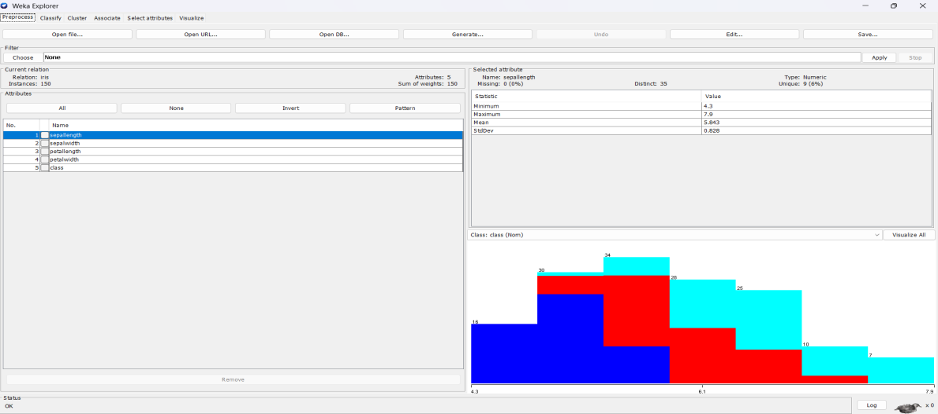
  - This helps algorithms like Apriori which require categorical inputs
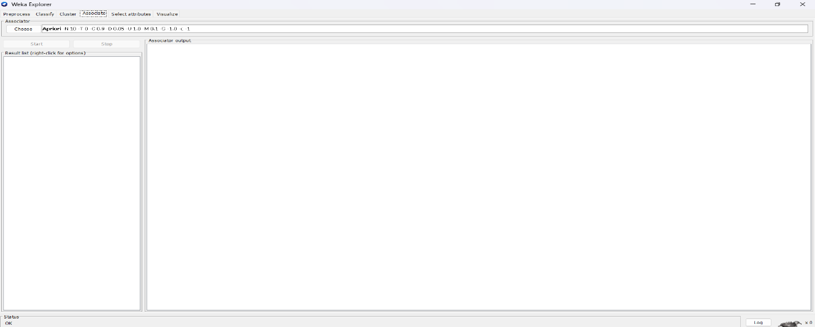

  - Weka provides supervised and unsupervised discretization filters.

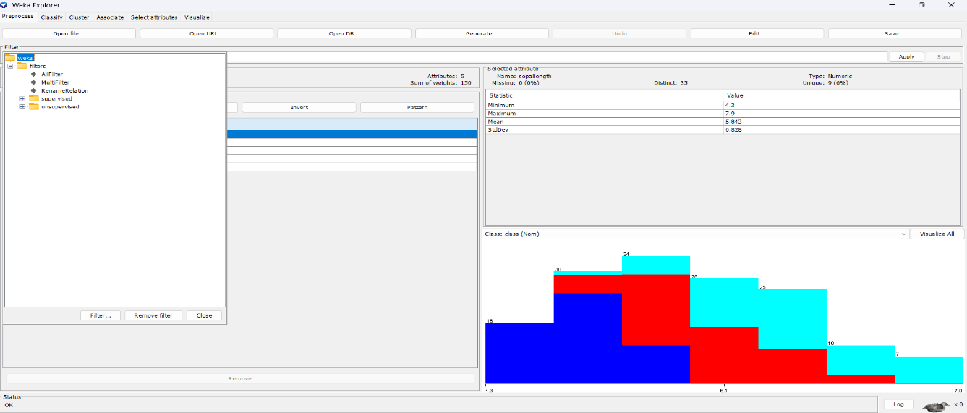

  - The filter can be applied from the Preprocess panel.
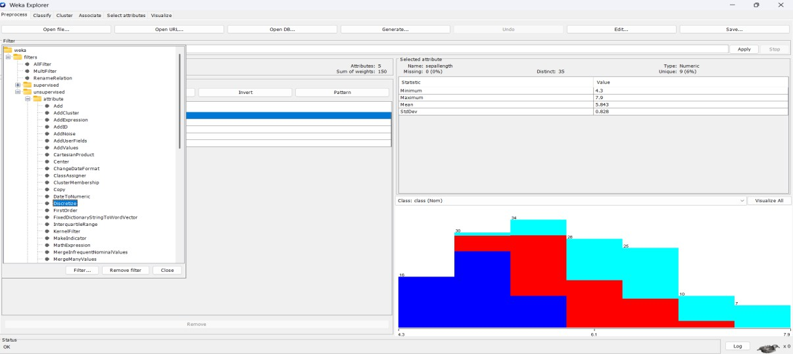
- Discretization improves interpretability in association rules.
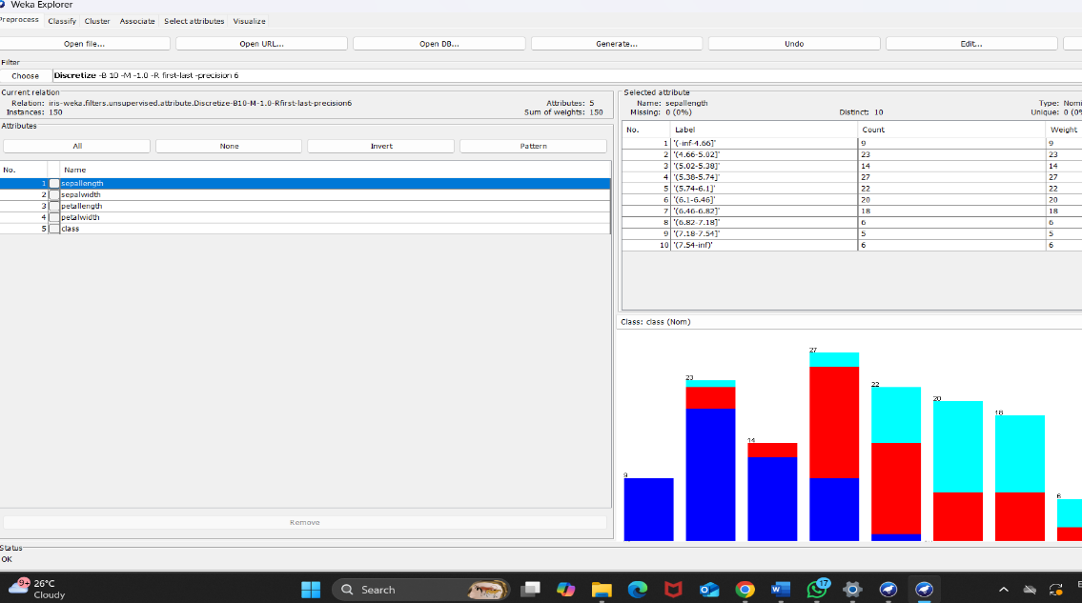
- Applying Resample Filter
  - Resample filter is used for random sampling of instances.

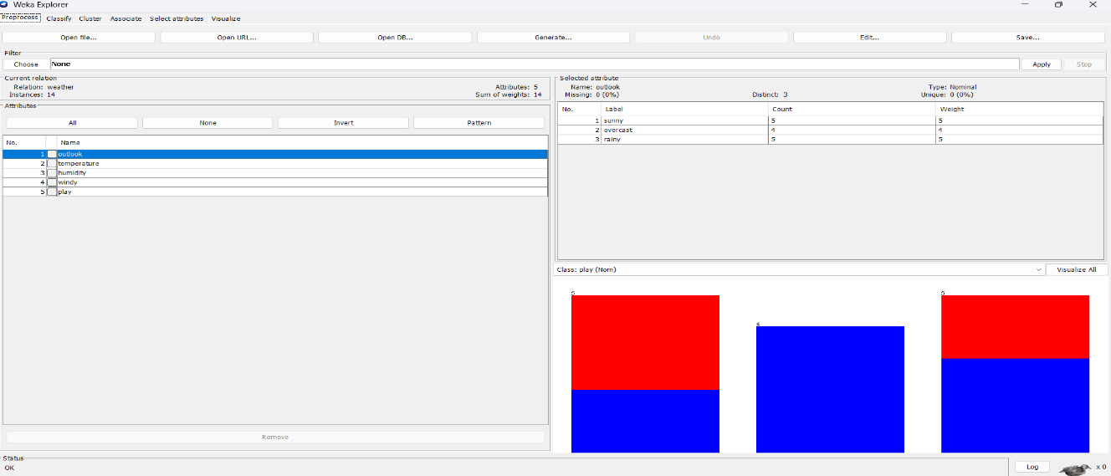
- It can be applied with or without replacement.
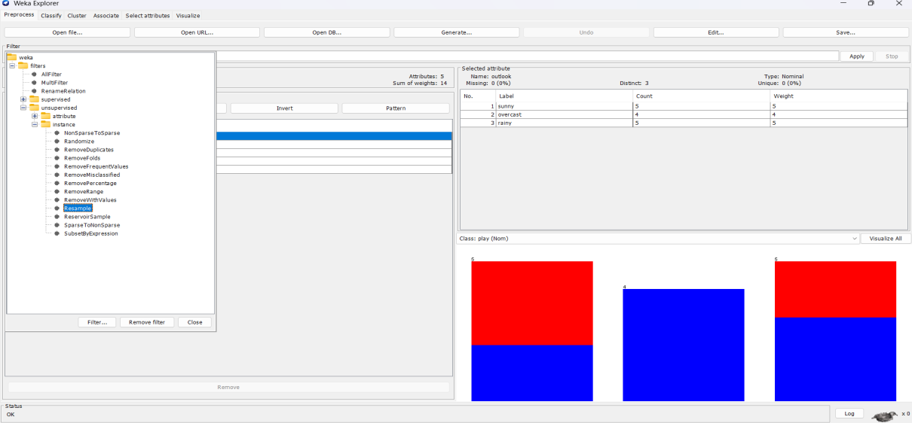
- It helps in balancing datasets with class imbalance.
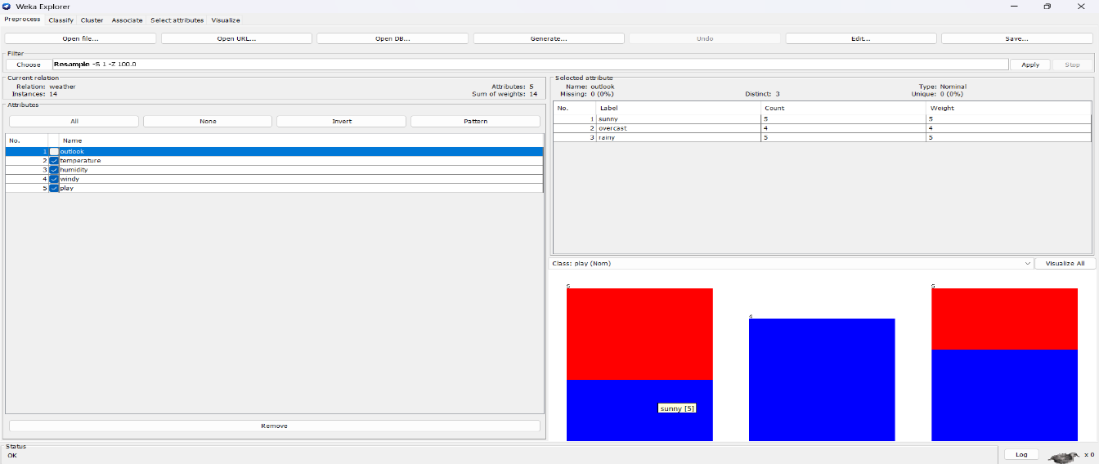
- Users can specify the percentage of data to retain.
- Resampling improves fairness in classification and rule mining.

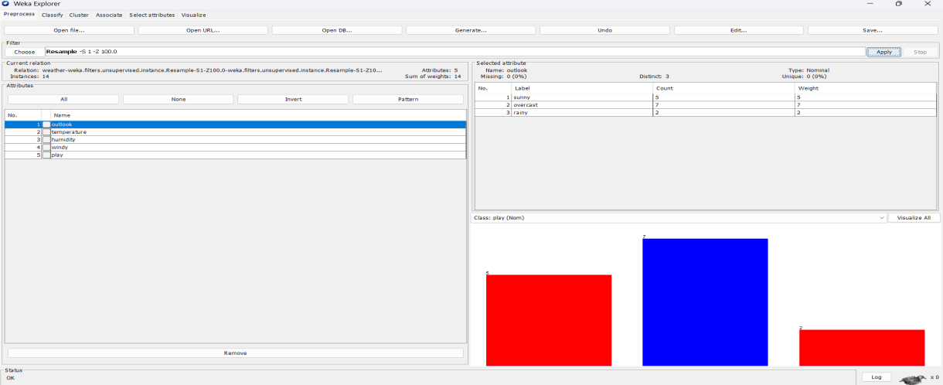
- Other Filters in Weka
  - Weka provides Normalize and Standardize filters for scaling data.
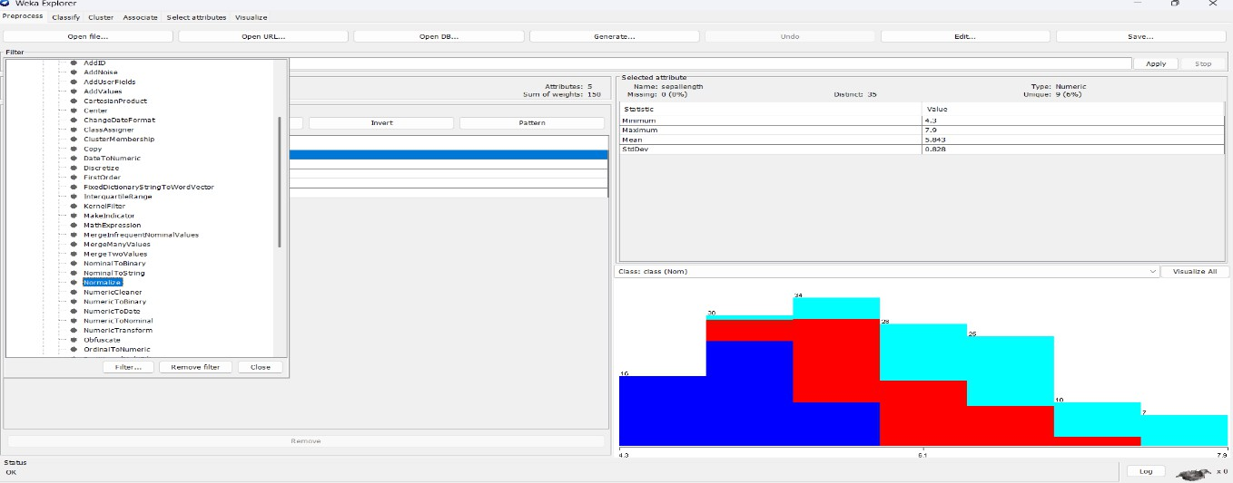
- Attribute removal filter allows removing unwanted fields.
- Replace missing values filter is used for data cleaning
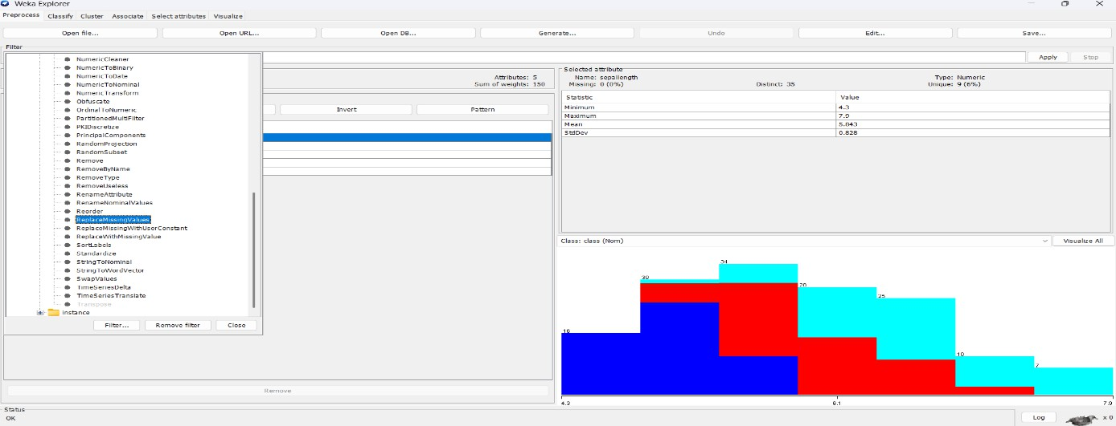

  - Nominal to Binary filter converts nominal attributes into binary form.

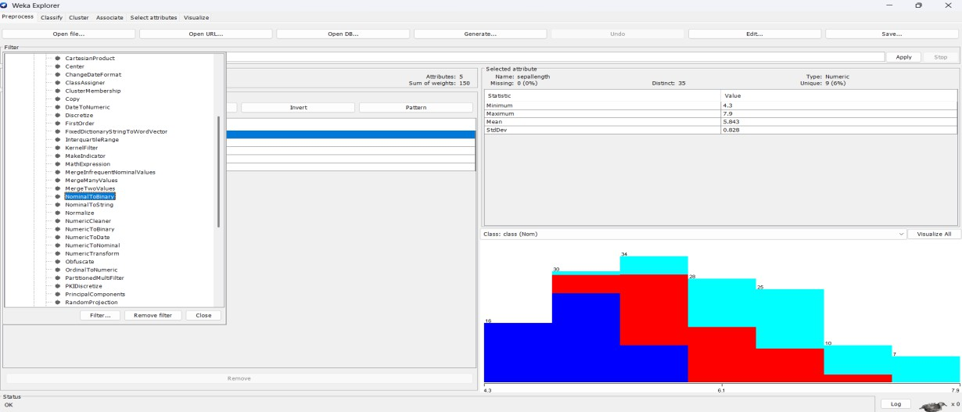
  - These filters enhance the quality and usability of data.
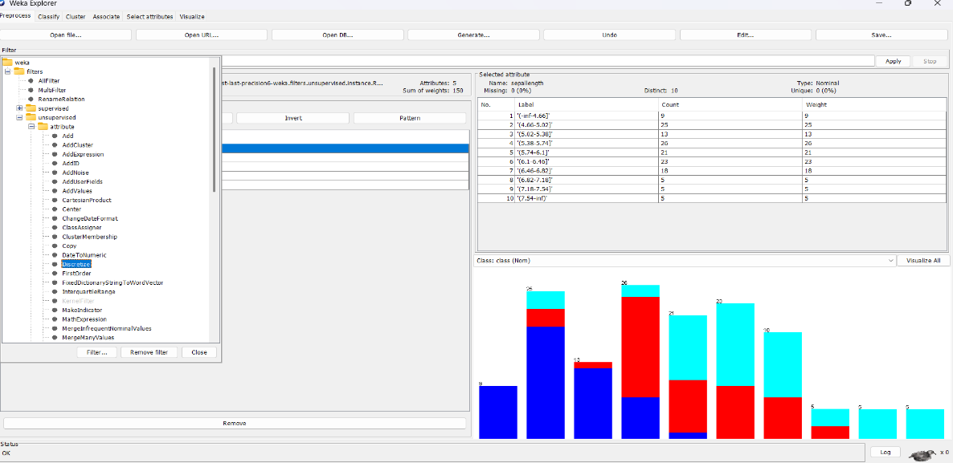
Association Rule Mining in Weka
- Running Apriori on Weather Dataset
  - Open weather.nominal dataset in Weka.
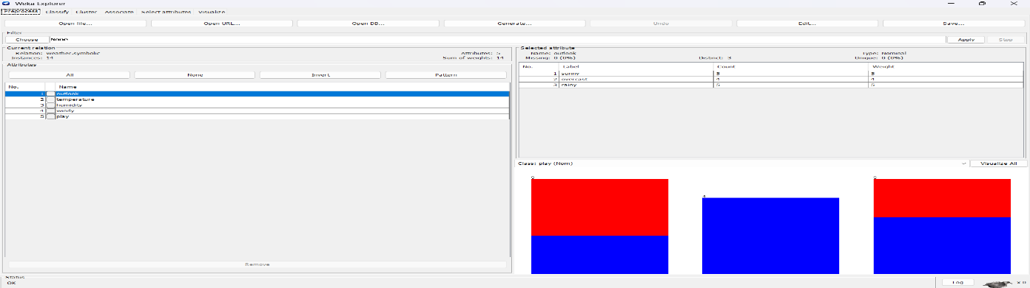
- Select Associate → Apriori algorithm.

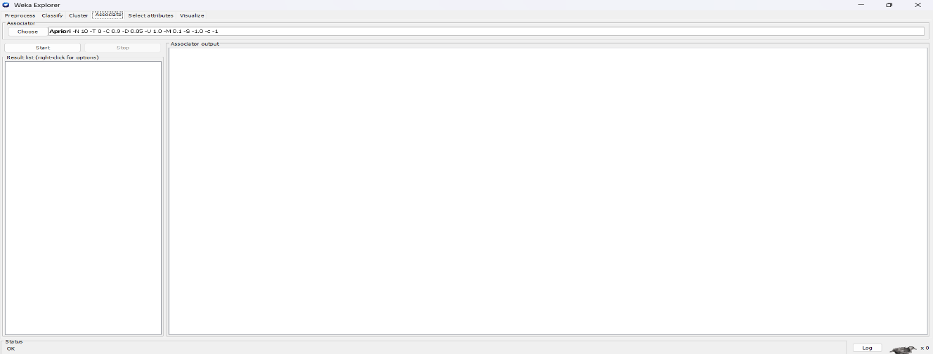
- Run with default support (0.1) and confidence (0.9).
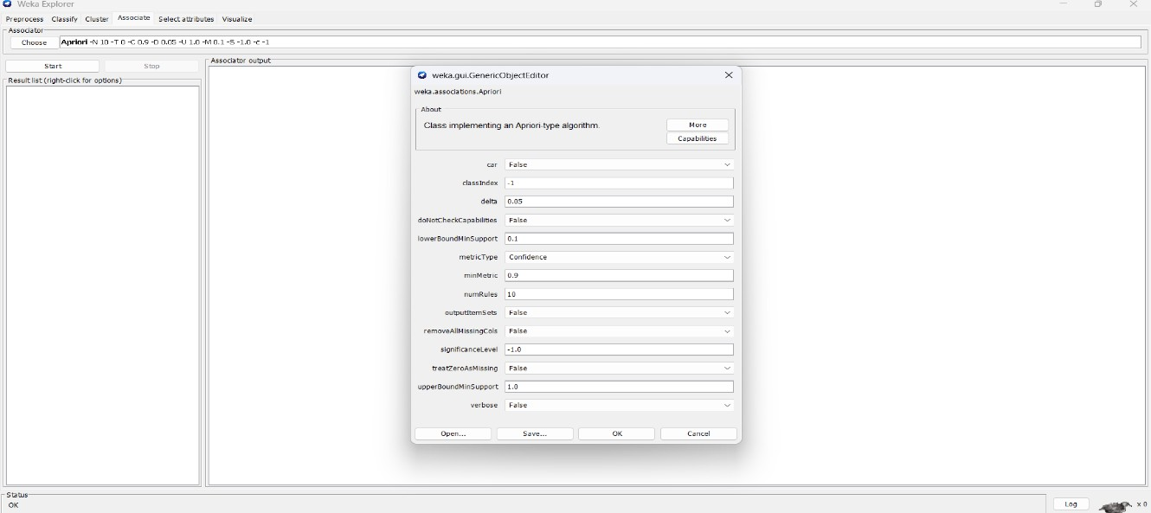
- Apriori generates rules like “If Outlook=Sunny then Play=No.”
- Rules represent hidden relationships among attributes.
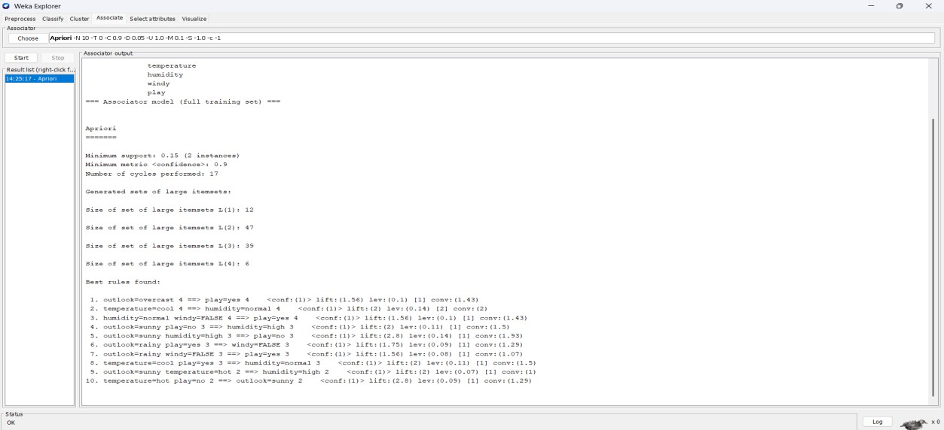

- Running Apriori on Iris Dataset

- Open iris.arff dataset in Preprocess panel.
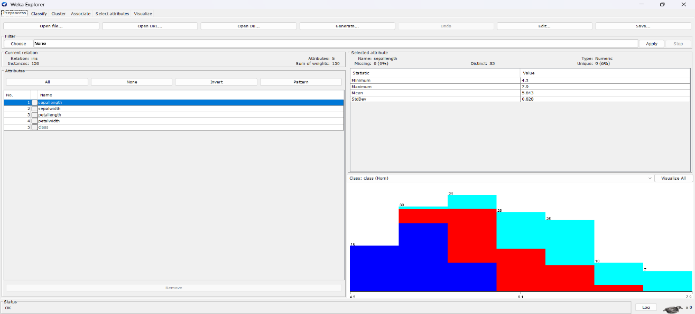
- Apply discretization filter to convert numeric attributes.
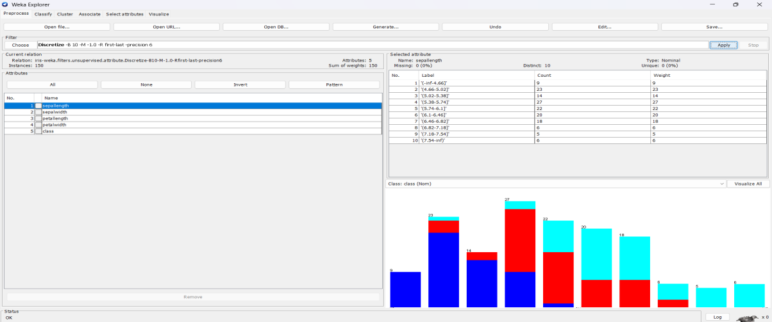
- Run Apriori algorithm with minimum support 0.2 and confidence 0.8.
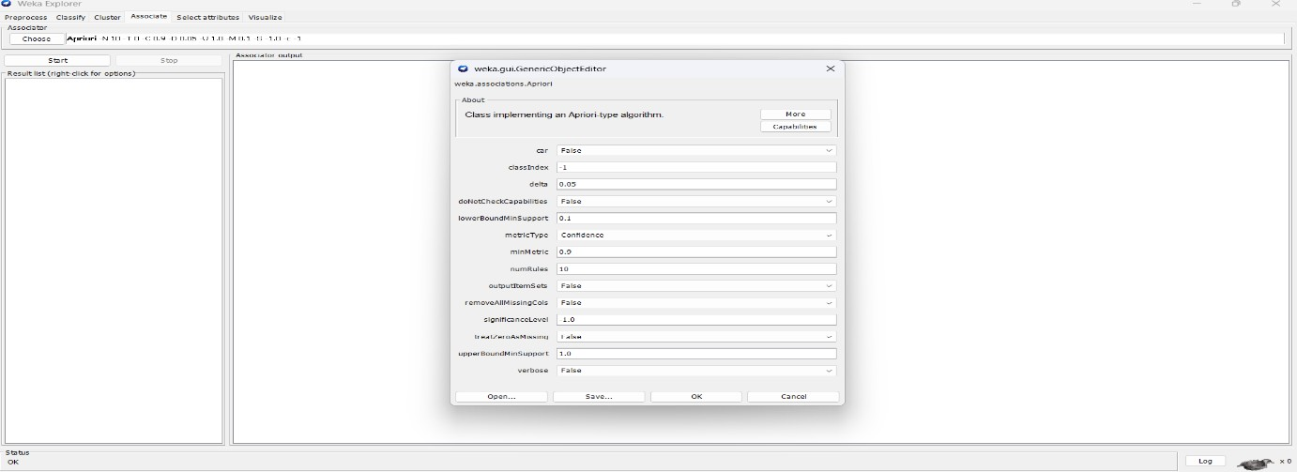
- Generated rules include attribute-value relations for flower types.

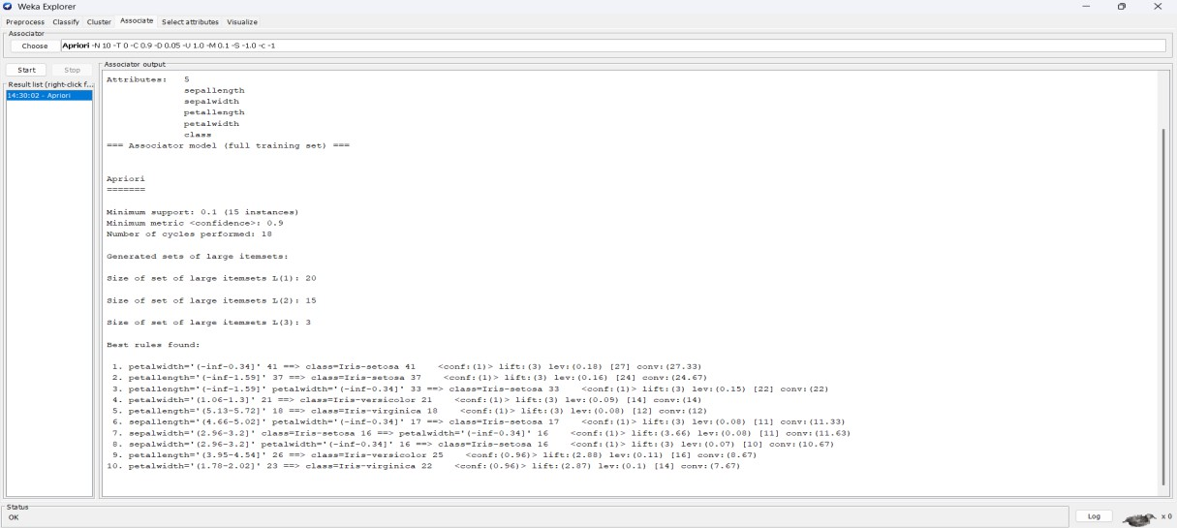
- Discretization helps Apriori produce meaningful categorical rules
- Running Apriori on Glass Dataset
  - Load glass.arff dataset into Weka.
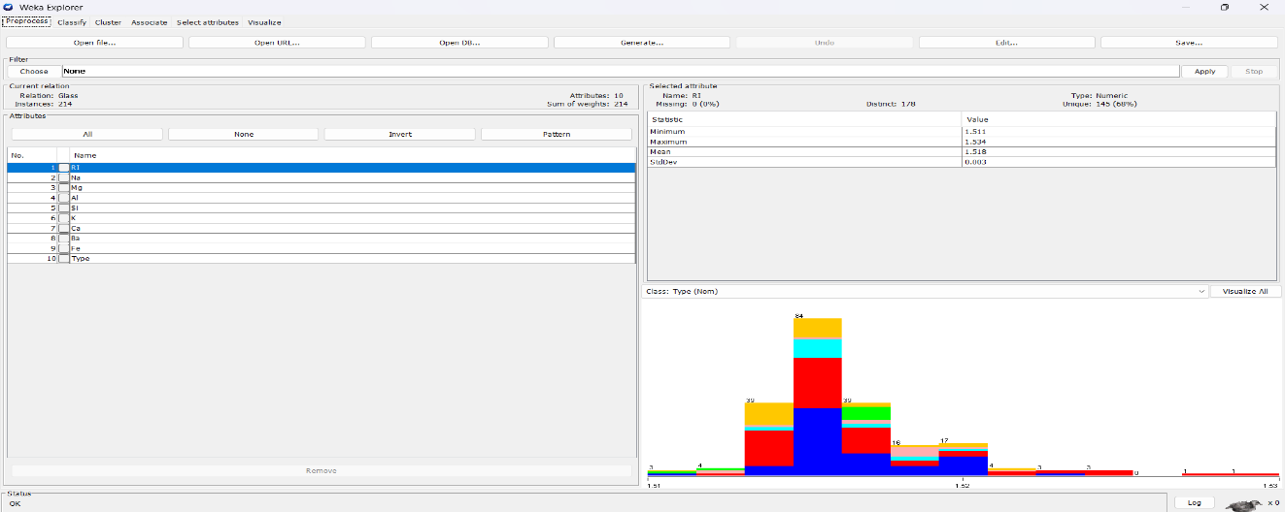
- Since Glass has many numeric attributes, apply discretization.
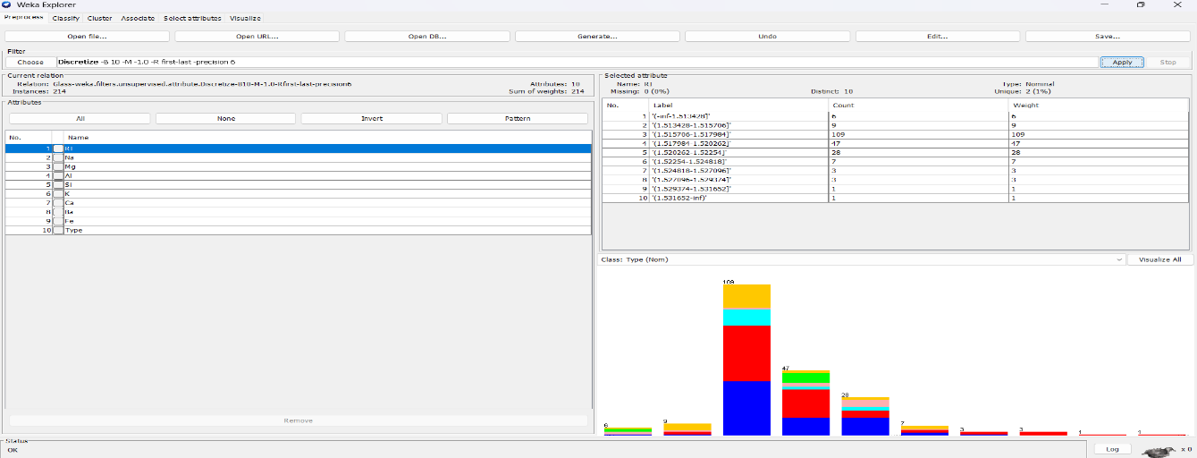
- Run Apriori with lower support (0.05) due to large attribute set.

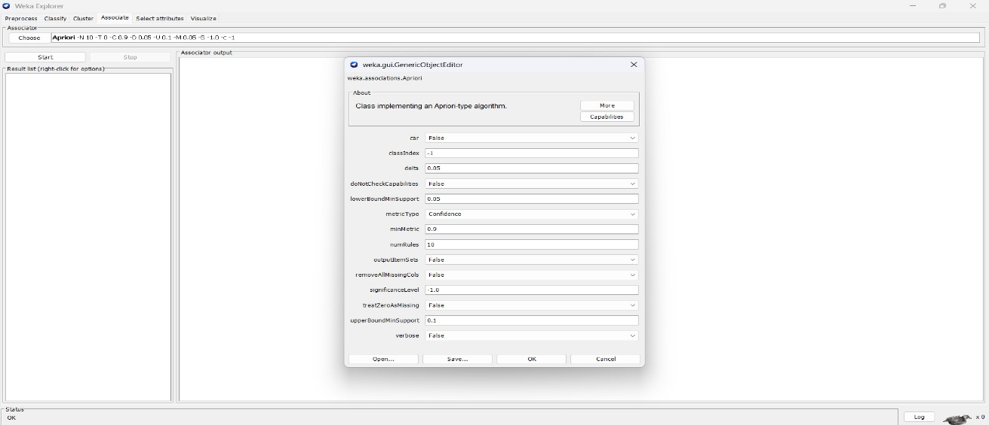
- Generated rules may highlight chemical compositions linked to glass type.
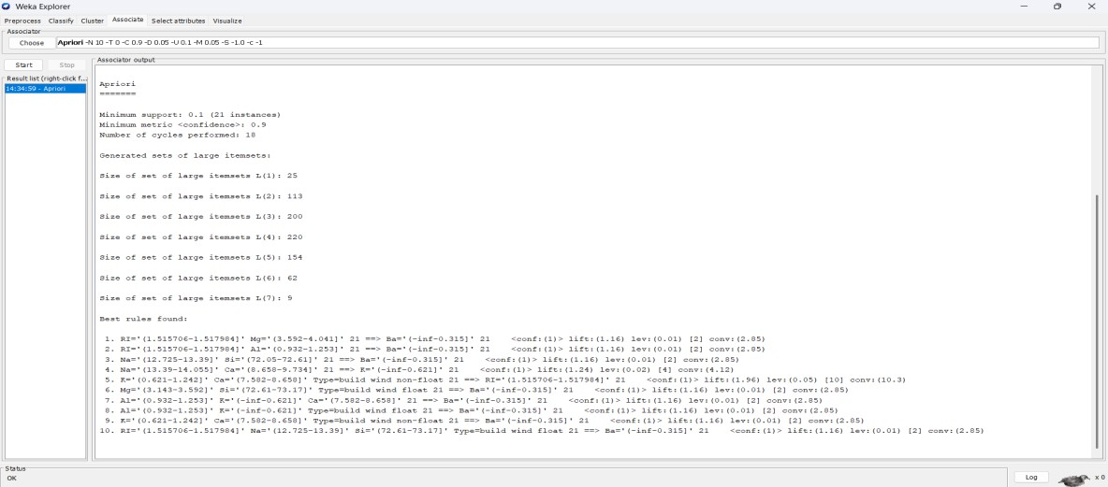
- Insights help identify key features that differentiate glass categories.
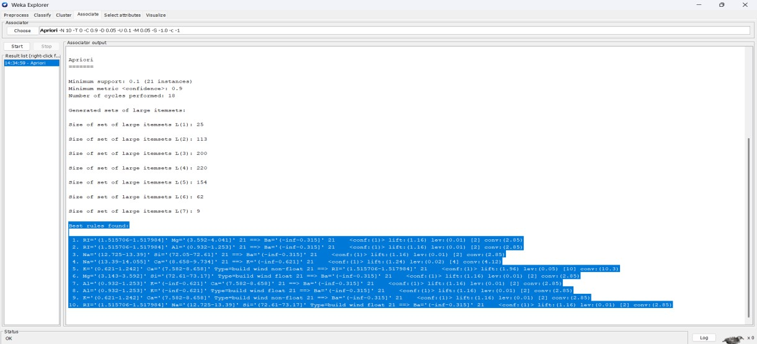
Effect of Discretization in Rule Generation
- Without Discretization

- Numeric attributes make rule generation difficult.
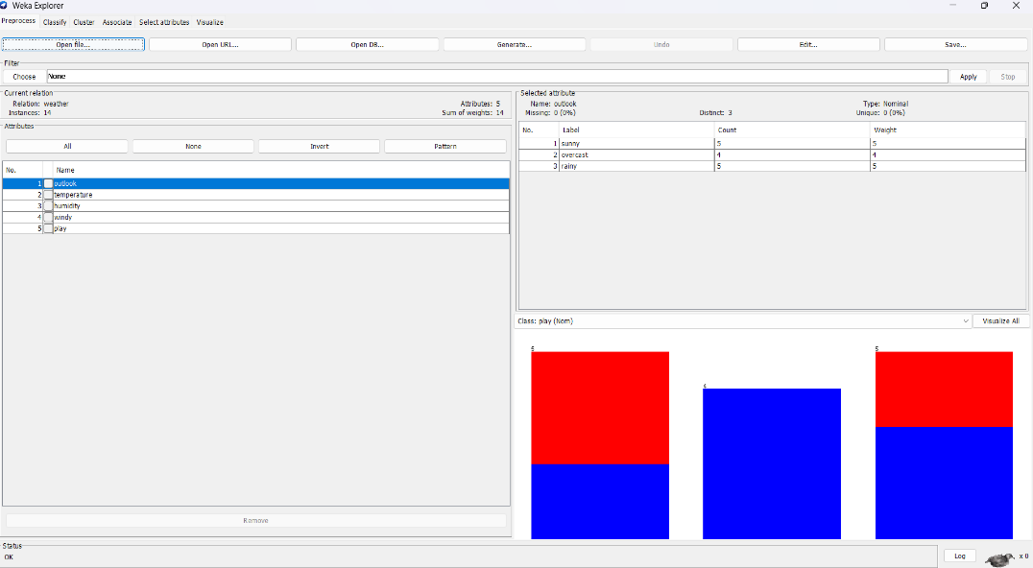
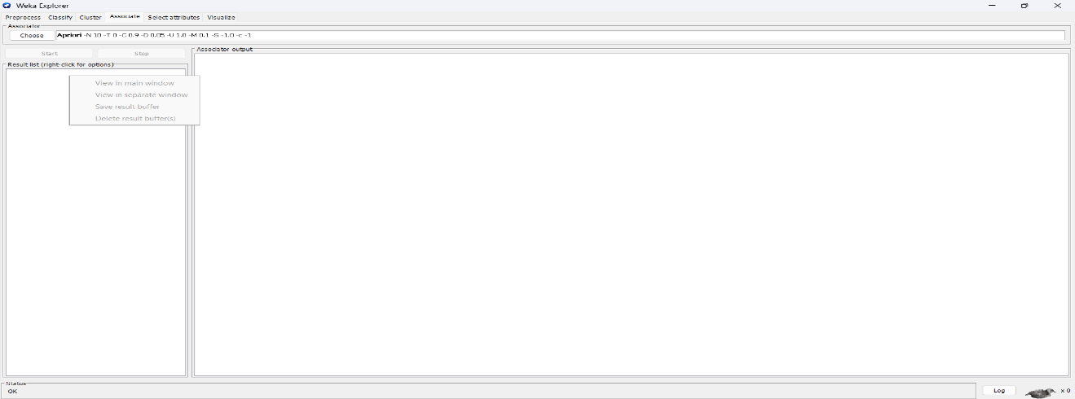

- Apriori may fail to produce useful rules.
- Continuous values reduce chances of frequent patterns.
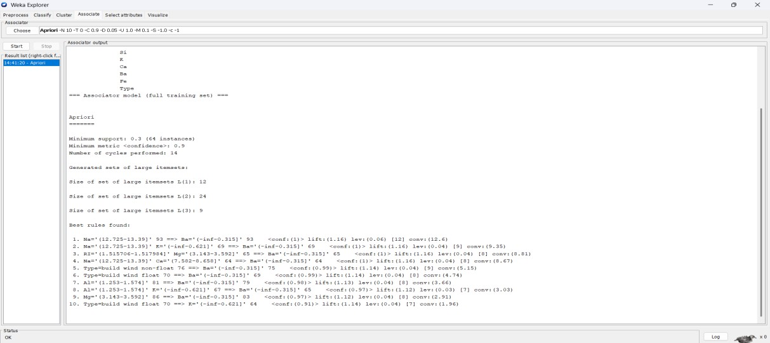
- Rules may be very specific with little generalization.
- Insights are limited and harder to interpret.

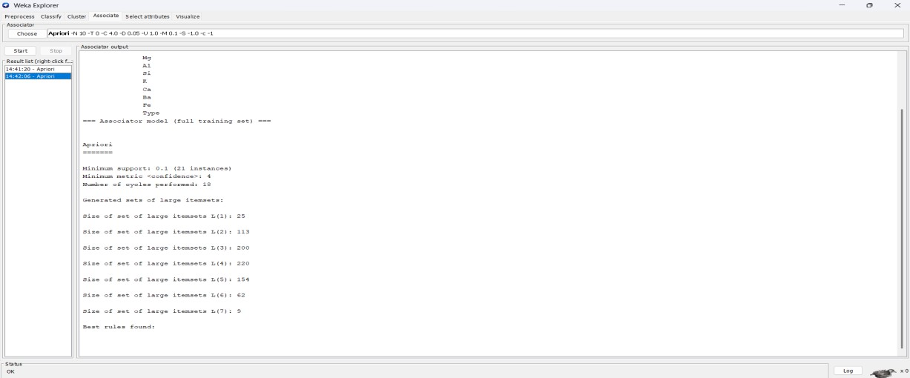
- With Discretization
  - Numeric attributes are converted into ranges (bins).
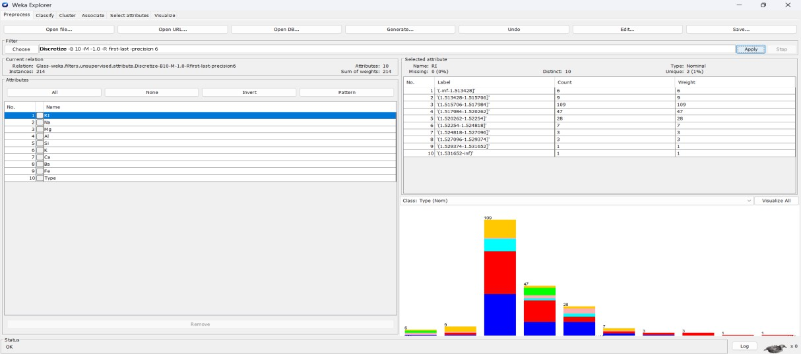
- Frequent patterns become easier to detect.
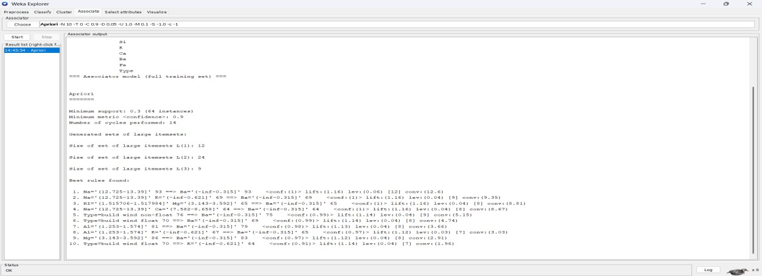
- Rules become simpler and more interpretable.
- Support and confidence of rules improve.

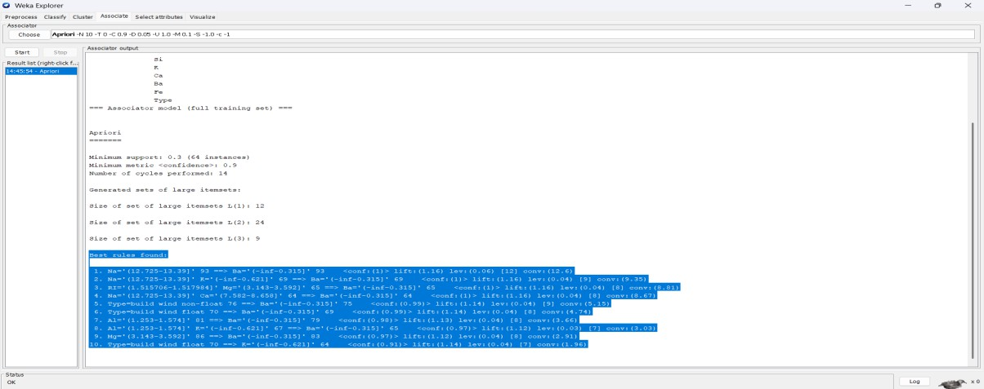
- Discretization clearly enhances Apriori performance.
Insights and Observations
- Preprocessing improves the quality of data for mining tasks.
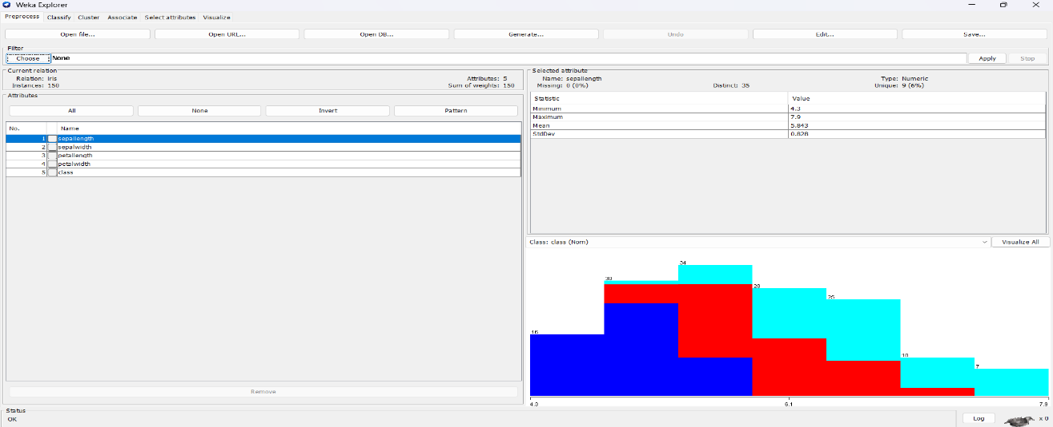
- Discretization significantly helps in Apriori rule generation.
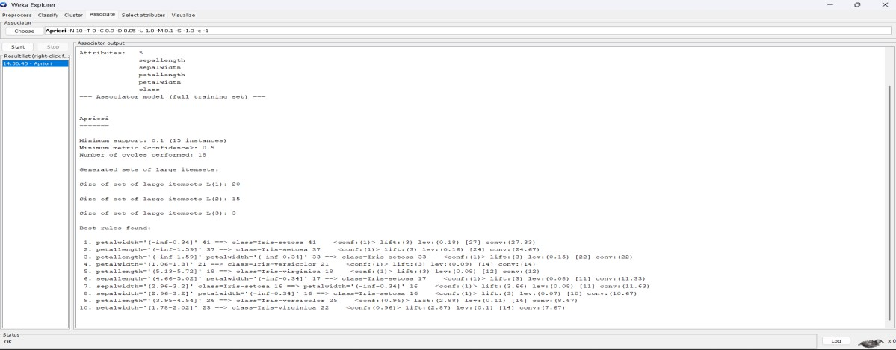
- Weather dataset gives simple and interpretable rules.

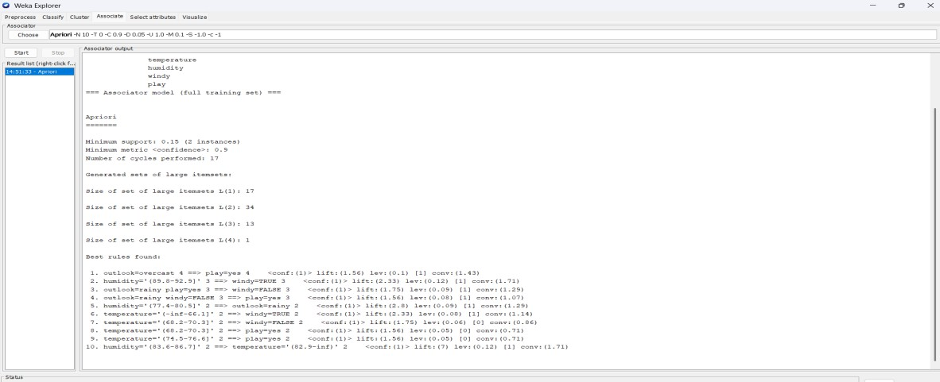
- Iris and Glass datasets generate complex rules after discretization.
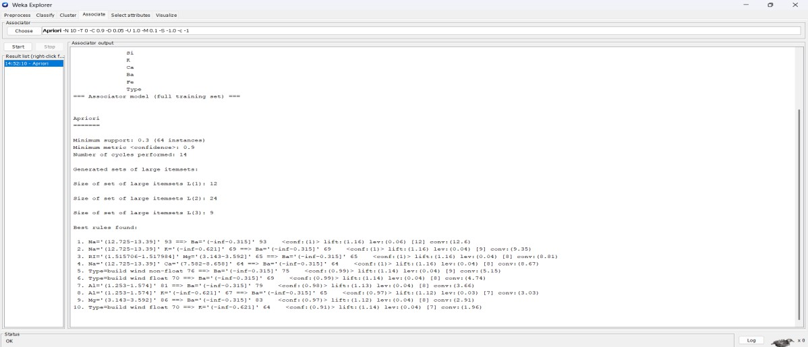
- Overall, Apriori with discretized attributes produces more meaningful insights.
Before Decritization:
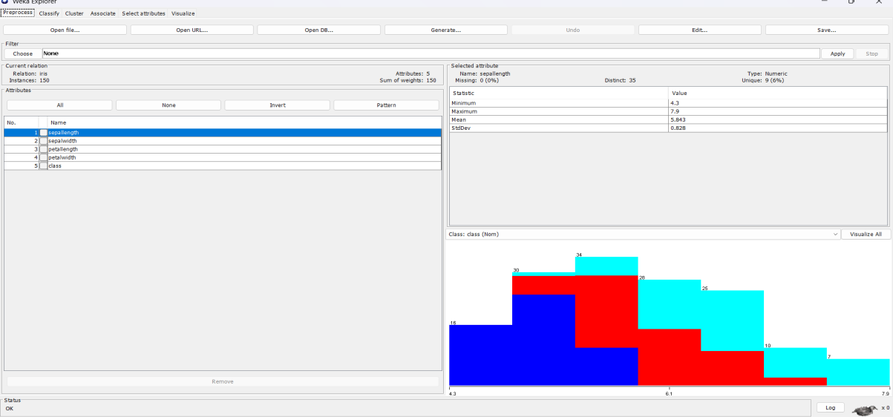
After Decritization:

