Week-3

- Demonstrate performing classification on data sets Weka/R
  - Load each dataset and run 1d3, J48 classification algorithm. Study the classifier output. Compute entropy values, Kappa statistic.
  - Extract if-then rules from the decision tree generated by the classifier, Observe the confusion matrix.
  - Load each dataset into Weka/R and perform Naïve-bayes classification and k- Nearest Neighbour classification. Interpret the results obtained.
  - Plot RoC Curves
  - Compare classification results of ID3, J48, Naïve-Bayes and k-NN classifiers for each dataset, and deduce which classifier is performing best and poor for each dataset and justify.

AIM: To perform different classification algorithms on datasets in Weka (ID3, J48, Naïve Bayes, and k-NN), analyze entropy and Kappa statistic, extract rules, plot ROC curves, and compare classifier performance.
Exploring and Loading Datasets in WEKA
WEKA comes bundled with several sample datasets such as Iris, Weather, Diabetes, etc. To explore datasets:
- Open WEKA Explorer.
- Click Open file in the Preprocess panel.
- Navigate to the data folder within the WEKA installation directory.
- Select a dataset like iris.arff or weather.arff.
Loading a dataset allows you to view the attributes and instances and apply preprocessing, classification, clustering, and more.

Example: Loading the Iris Dataset
Open WEKA Explorer.
In the Preprocess panel, click Open file. Select the iris.arff file.
The dataset loads and displays attributes such as sepal length, sepal width, petal length, petal width, and class.
You can now proceed to classify, cluster, or visualize this dataset.

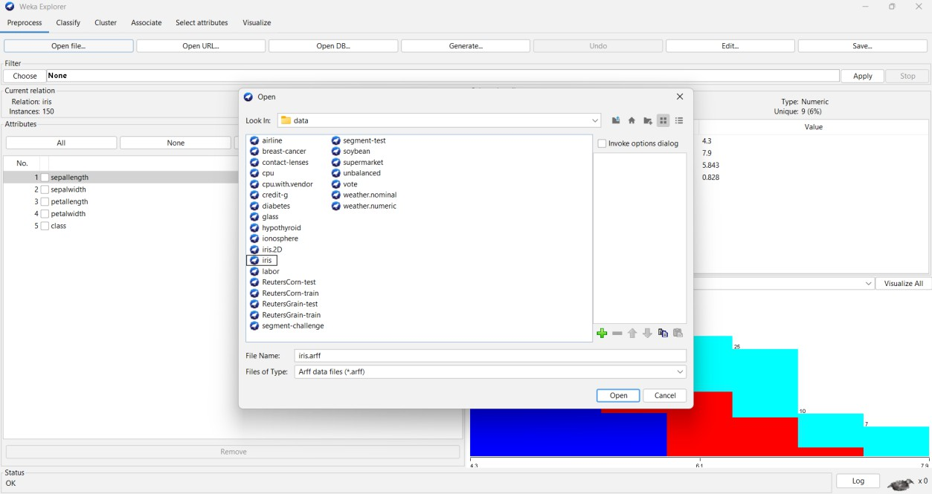
After loading the iris data set the visualization of the preprocess is as shown in the figure. The attributes are sepallength , sepalwidth,petallength,petalwidth.
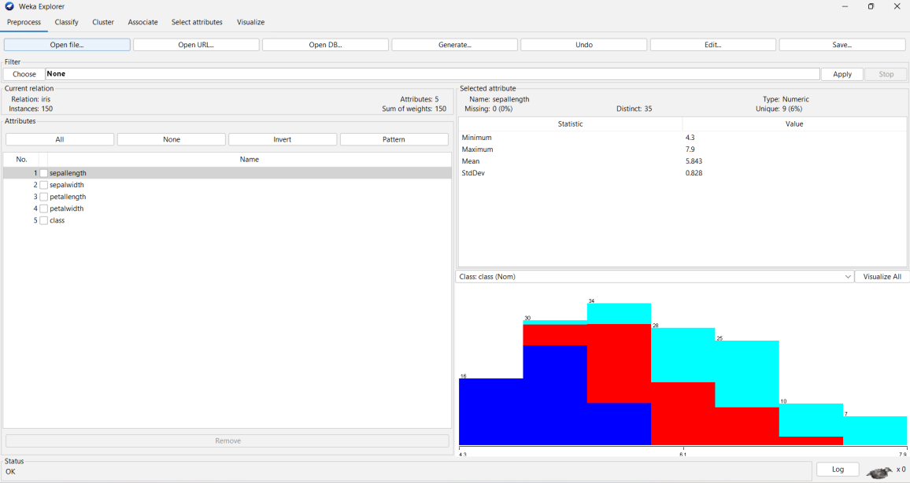
The value and statistic of the each attribute is as shown. Histograms of each attribute of the data is shown below.

Discretizing the data:
  - It is important to discritize the data because it involves transforming continuous numeric attributes into discrete, categorical (nominal) attributes.
  - Open the filter.
  - Select the Unsupervised data.

  - Click on the discretize.
  - Apply this filter on the data.
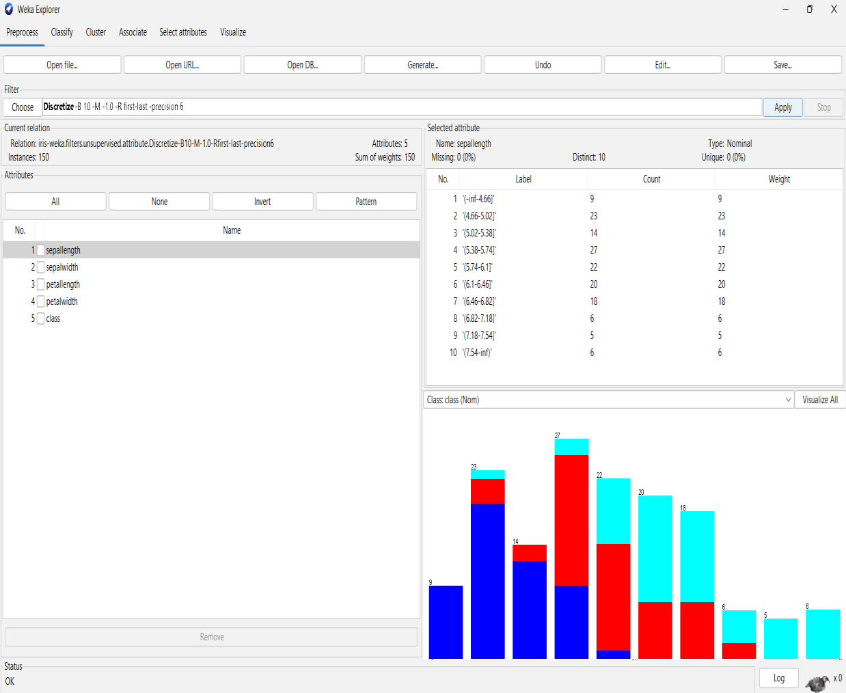
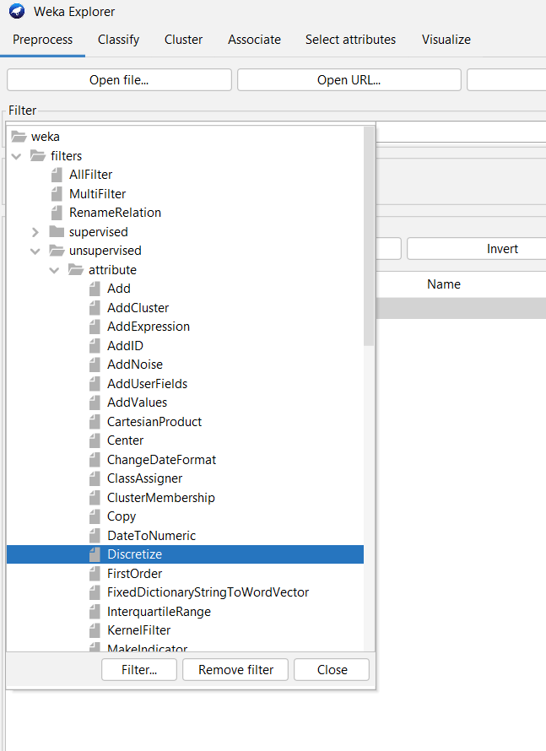
Filter Application: A "Discretize" filter has been applied to the "iris" dataset. This
filter, Discretize -B 10 -M -1.0 -R first-last -precision 6, transforms numerical attributes into nominal (categorical) ones by dividing them into 10 bins.

Classification on the data:
  - To apply the classification on the data set, click on the classify panel.
  - Select the different algorithms to perform on the data (J48,Id3 ,etc.., classification algorithms). Select the J48 algorithm as shown in fig.
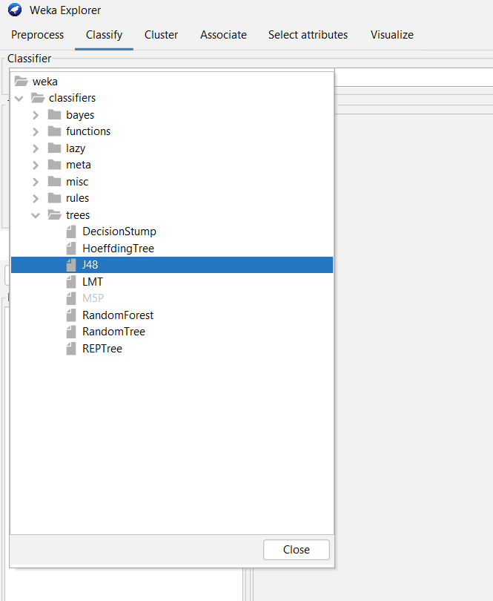
After applying the J48 algorithm, the default Cross-validation folds 10 in test options. Click on the start button to see the classifier output.
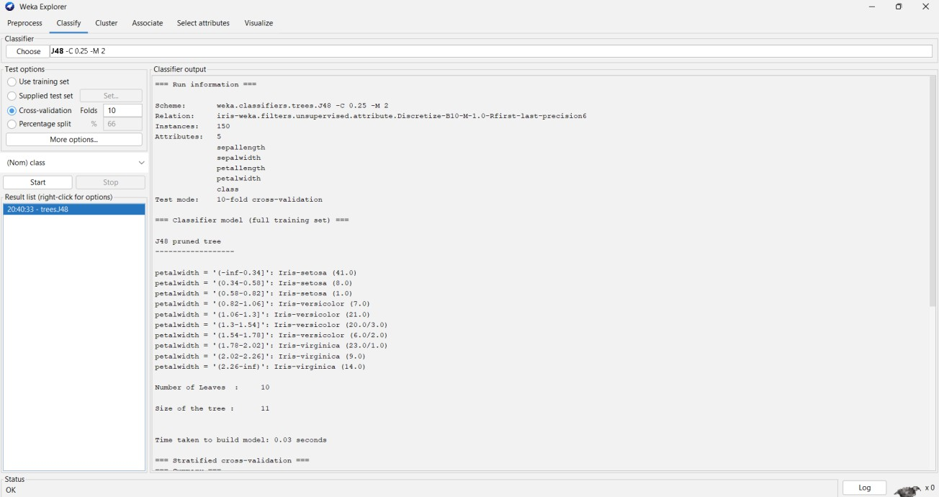

Visualization of a J48 algorithm in tree mode:
  - In the result list , it shows the present running algorithm.
  - Click on the right side to see more options.
  - Click on the Visualize tree option to see the output in the tree mode.
  - Do the process as shown in the figure.

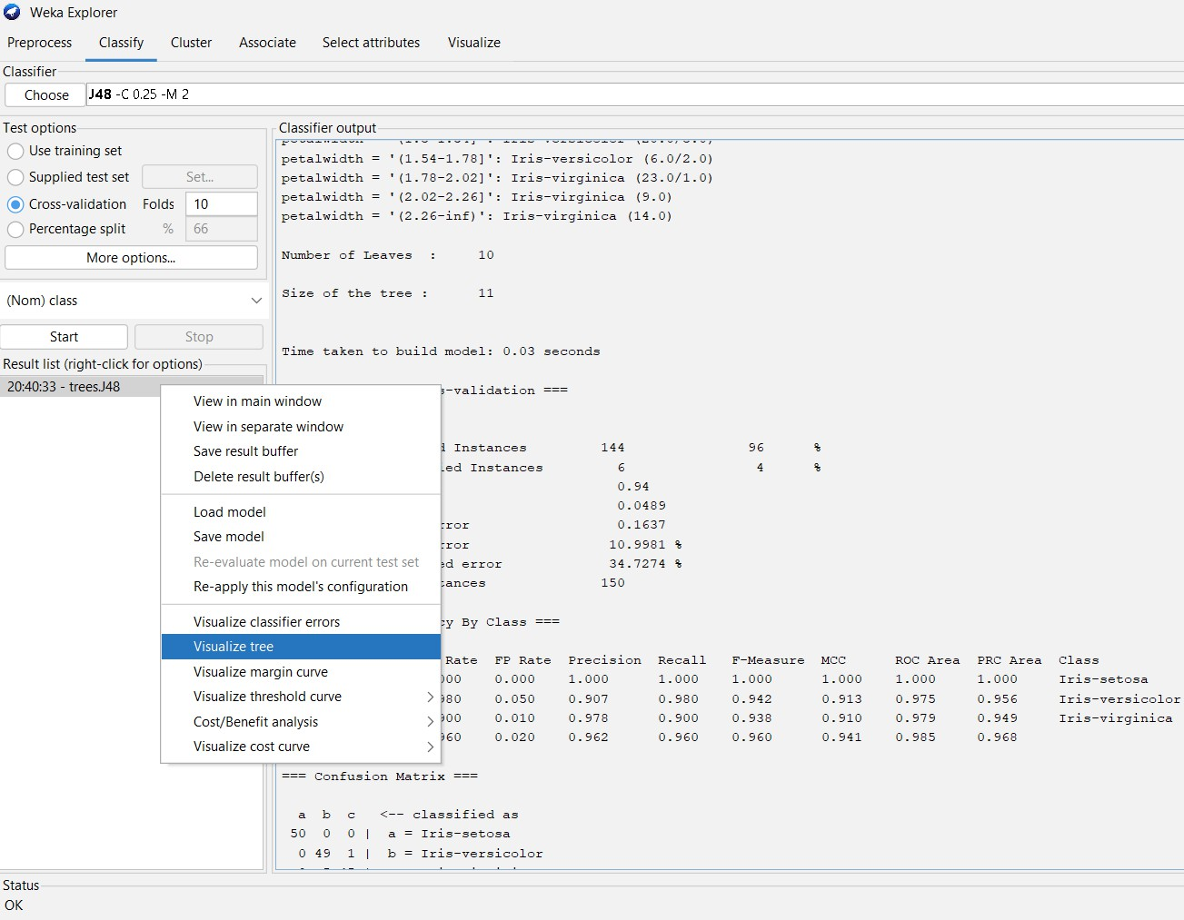
Classifier tree visualizer as shown in fig.
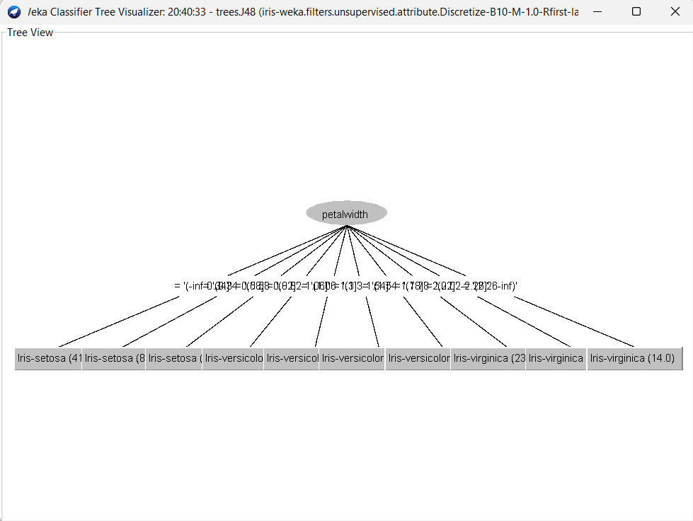

- Load each dataset into Weka/R and perform Naïve-bayes classification and k- Nearest Neighbour classification. Interpret the results obtained.
DATA SET:

  - Performing the Naïve-bayes classification on the same data set (i.e.. is Iris data set).
  - Here the data set Iris is already in discretization mode as we done in the above algorithm.
  - Click on the classify panel.
  - Select the Classifiers and open the bayes.
  - In that bayes select the NaiveBayes algorithm.
  - Do the process as shown in the figure.
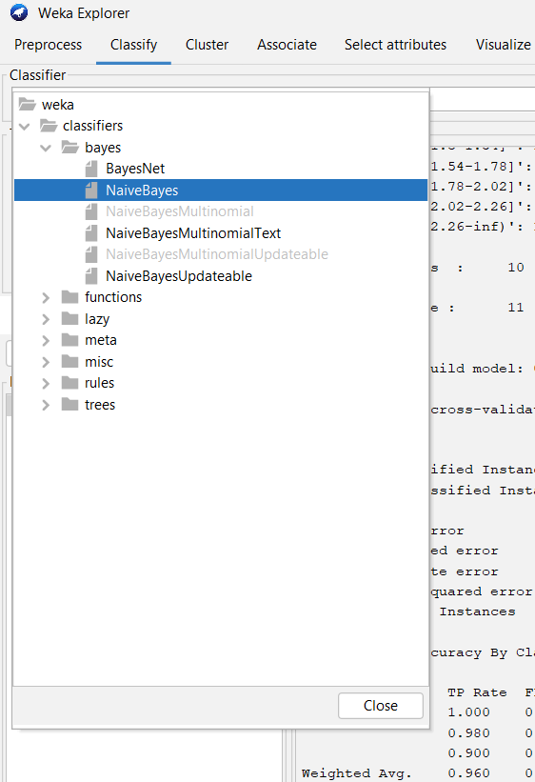

After choosing the Navie-Bayes Algorithm:
  - In the test options the default cross validation folds is 10.
  - Click on the start button to observe the classifier output for the Navie-bayes Algorithm.

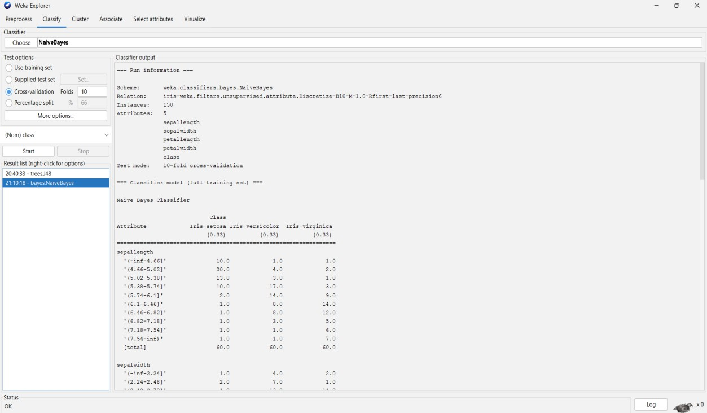
-Nearest Neighbour Classification algorithm:
- K It is also one of the classification algorithm like J48,Id3 etc..
- Choose the IBk algorithm from the lazy classifiers.
- As shown in figure.
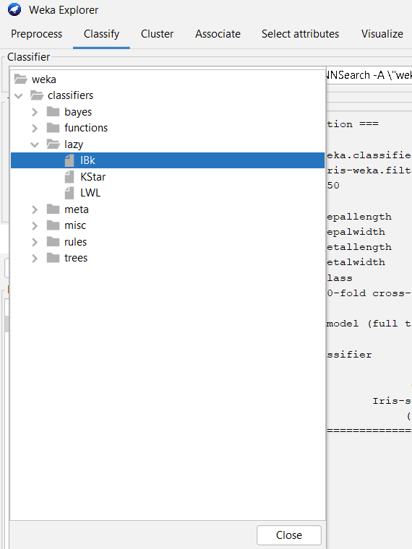
After choosing the IBk Algorithm
- In the test options the default cross validation folds is 10.

- Click on the start button to observe the classifier output for the IBk Algorithm.
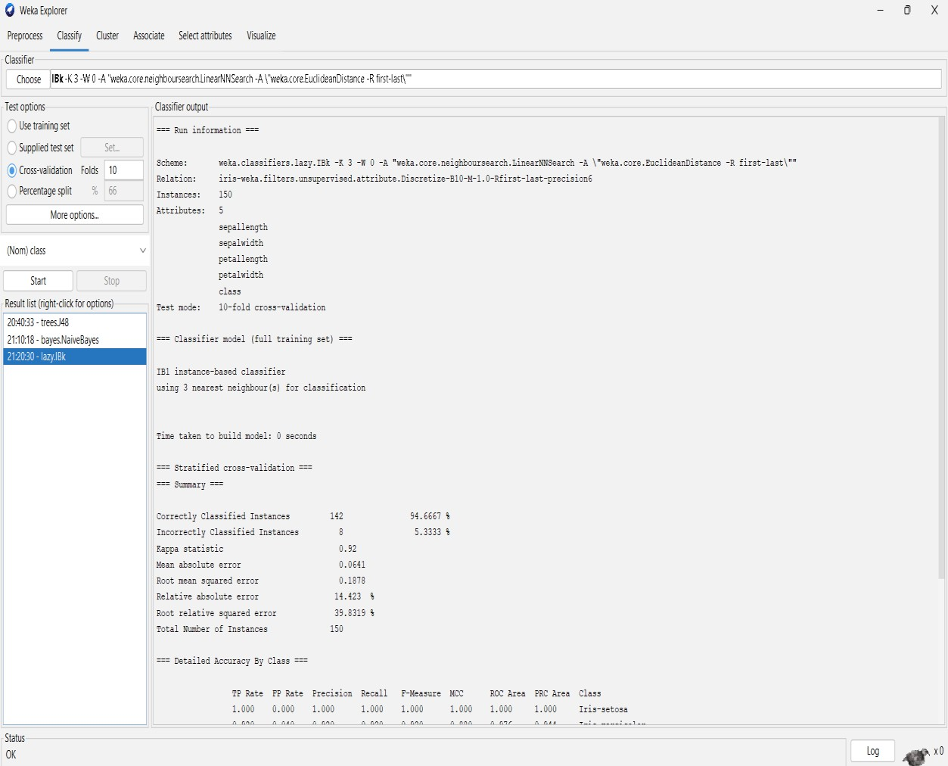

Here it is the Generic Object Editor for the classification on the iris data set with Ibk classification algorithm.
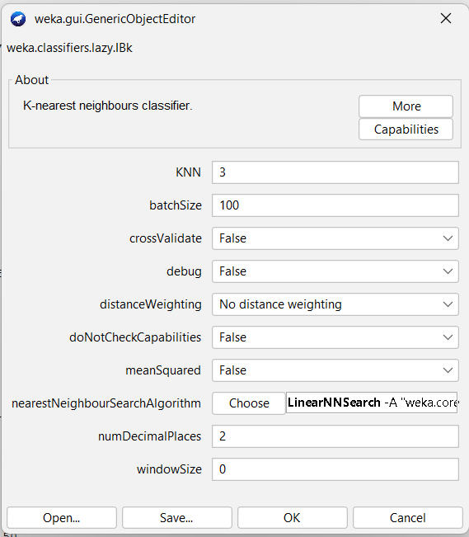
Plot RoC Curves
ROC Curve Visualization in Weka (IBk Classifier)

- After executing the IBk (k=3) classifier on the Iris dataset using 10-fold cross- validation, the results are listed under the Result list.
- By right-clicking on the classifier result, Weka provides multiple options for analyzing the model.
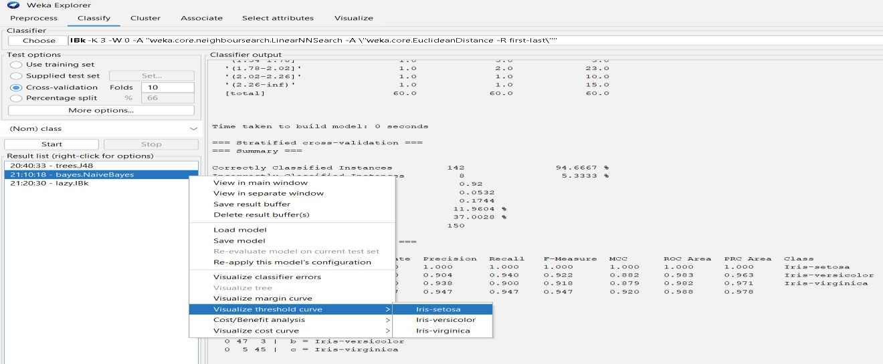

- Click on the Visualize threshold curve, in that select the Iris-setosa.
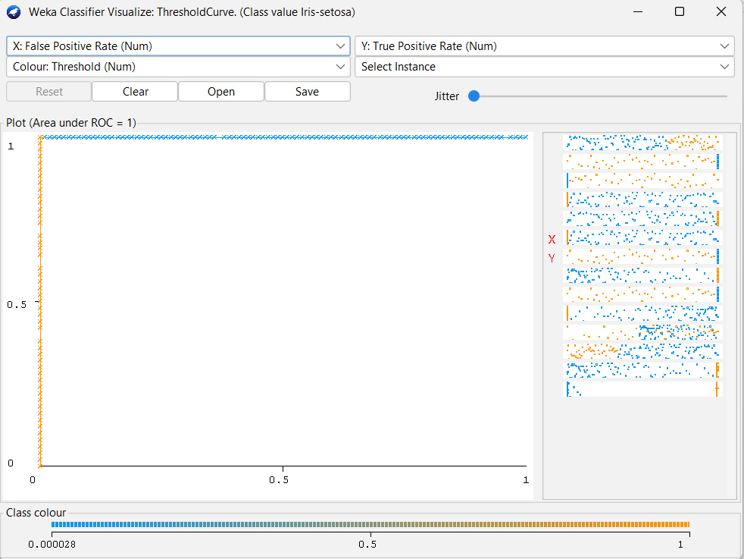
- ROC Curve plots the True Positive Rate (TPR) against the False Positive Rate (FPR).
- It is used to evaluate the discriminative ability of a classifier.
- The Area Under Curve (AUC) values shown in the summary are very close to 1.0, indicating that the classifier has high accuracy and strong class separation capability.

- Click on the Visualize threshold curve, in that select the Iris-versicolor.
- ROC Curve plots the True Positive Rate (TPR) against the False Positive Rate (FPR).
- It is used to evaluate the discriminative ability of a classifier.
- The Area Under Curve (AUC) values shown in the summary are very close to 1.0, indicating that the classifier has high accuracy and strong class separation capability.
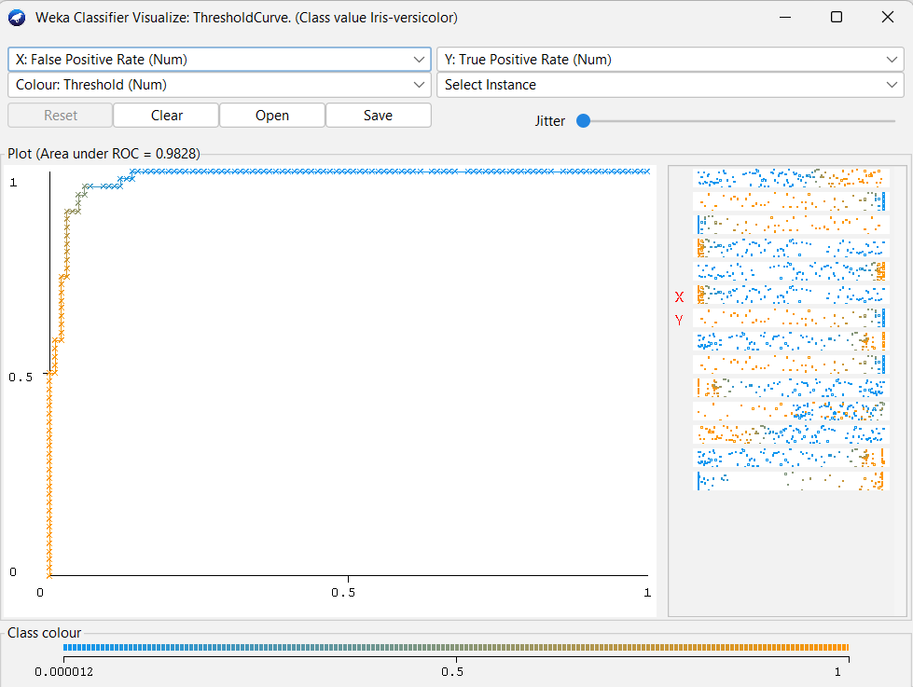

- Click on the Visualize threshold curve, in that select the Iris-versicolor.
- ROC Curve plots the True Positive Rate (TPR) against the False Positive Rate (FPR).
- It is used to evaluate the discriminative ability of a classifier.
- The Area Under Curve (AUC) values shown in the summary are very close to 1.0, indicating that the classifier has high accuracy and strong class separation capability.

