Total Revenue

select sum(total_price) as Total_Revenue from pizza_sales;

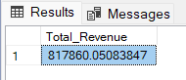

Average Order Value

select sum(total_price) / COUNT (distinct order_id) as Avg_Order_Value from pizza_sales;

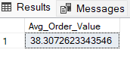

Total Pizza Sold

select sum(quantity) as Total_Pizza_sold from pizza_sales;

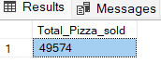

Total Orders

select count(distinct order_id) as Total_Orders from pizza_sales;

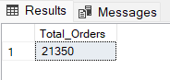

Average pizzas per order

select cast(cast (sum(quantity) as decimal(10,2) )/ cast(COUNT(distinct order_id) as decimal(10,2))as decimal(10,2))

as avg_pizzas_per_order from pizza_sales;

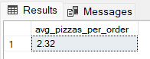

Orders in a day

select DATENAME(DW, order_date)as order_day, COUNT(distinct order_id)as Total_orders from pizza_sales

group by DATENAME(DW,order_date);

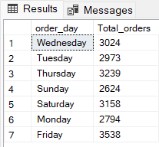

Orders in a month

select DATENAME(MONTH, order_date)as month_name, COUNT(distinct order_id)as Total_orders from pizza_sales

group by DATENAME(MONTH,order_date) order by Total_orders desc;

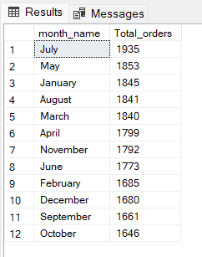

**Sales by Pizza Category**

select pizza_category, sum(total_price)as Total_sales,sum(total_price) * 100/

(select sum (total_price) from pizza_sales where MONTH(order_date) = 1) as PCT

from pizza_sales

where MONTH(order_date) = 1

group by pizza_category;

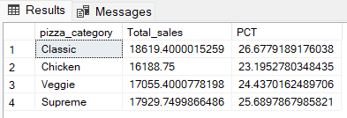

Sales by pizza size

select pizza_size, cast(sum(total_price)as decimal (10,2))as Total_sales,cast(sum(total_price) * 100/

(select sum (total_price) from pizza_sales where datepart(QUARTER,order_date)=1)as decimal(10,2))as PCT

from pizza_sales

where datepart(QUARTER,order_date)=1

group by pizza_size

order by PCT desc;

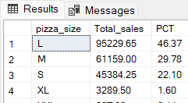

Top 5 pizza names

select top 5 pizza_name, SUM(total_price) as Total_revenue from pizza_sales

group by pizza_name

order by Total_revenue desc;

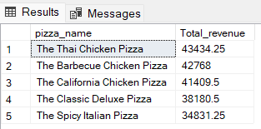

Bottom 5 pizzas

select top 5 pizza_name, SUM(total_price) as Total_revenue from pizza_sales

group by pizza_name

order by Total_revenue asc;

