MIGRATION VALIDATOR
Technical Documentation & Handover Guide

Data Migration Validation Framework
PostgreSQL • MSSQL • Athena → Snowflake

Version 1.0
Comprehensive Reference for New Team Members

Table of Contents

Right-click and choose 'Update Field' to build the Table of Contents.

1. What This Tool Does
The Migration Validator compares data between a source database and Snowflake after a migration to confirm that the data landed correctly. It provides a repeatable, automated mechanism for verifying data integrity across heterogeneous database platforms, eliminating manual spot-checks and reducing the risk of silent data corruption during migration.
Given a source table (PostgreSQL, MSSQL, or Athena) and a Snowflake target table, the tool performs the following operations end-to-end:
- Extracts column schemas from both the source and target databases.
- Matches source columns to target columns using a three-tier cascade: exact, then fuzzy, then AI.
- Assigns a transformation rule to each column pair (for example, casting a boolean to '1'/'0', or normalizing timestamps to a UTC string).
- Generates validation SQL queries that produce comparable, normalized output from both sides.
- Writes those queries into YAML files that are ready for an automated validation runner.
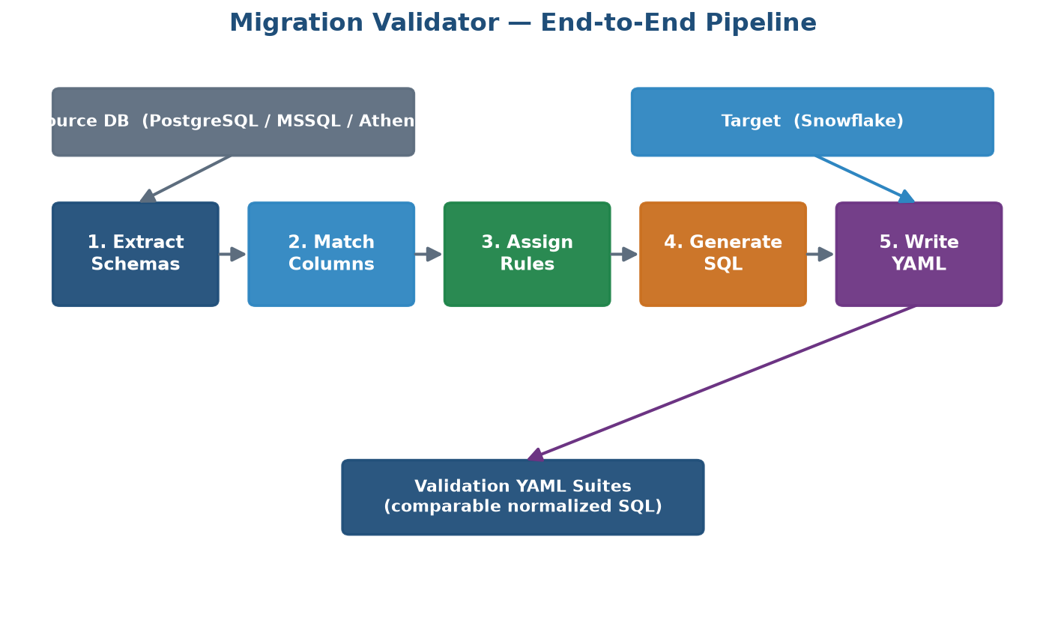
Figure 1 — End-to-end pipeline from schema extraction to YAML suite generation.
The Core Idea
The central design principle is to wrap every column in COALESCE(CAST(expr AS TEXT), '<<NULL>>') on both sides, then compare the results. In SQL, the expression NULL != NULL evaluates to unknown, which breaks straightforward equality comparisons. The '<<NULL>>' sentinel converts nulls into a concrete, comparable token so that null values on the source side correctly match null values on the target side.
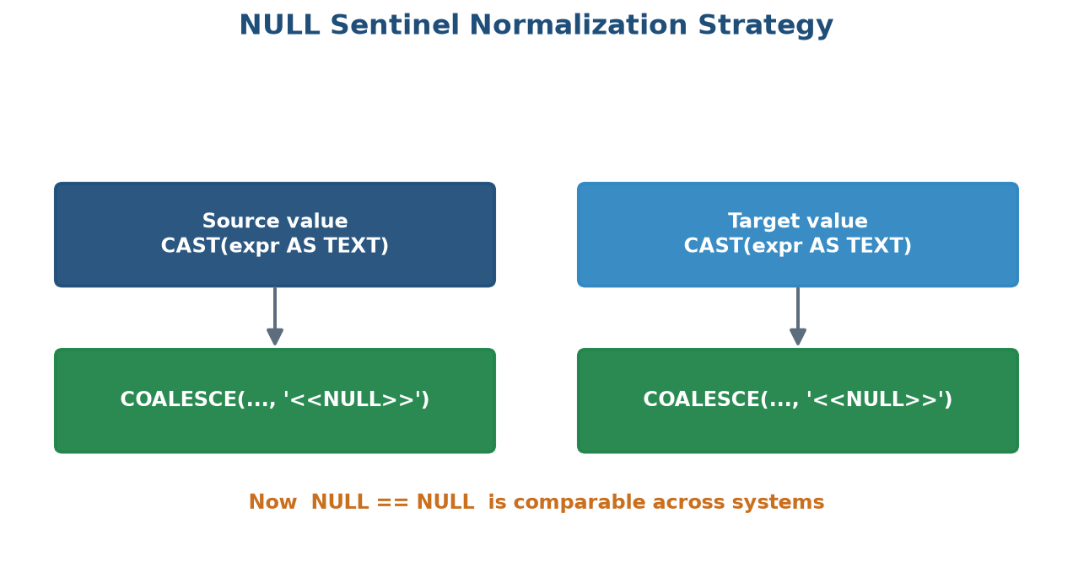
Figure 2 — The NULL sentinel normalization strategy makes nulls comparable across systems.
2. Project Structure
The repository is organized into a configuration layer, a source-code layer, and a documentation layer. The key top-level directories and files are summarized below.
Path | Purpose
.env | Your private credentials — never committed to version control.
.env.example | Template file; copy this to .env and fill in values.
config/bronze/ | YAML configuration for count and data validation suites.
src/ai/ | Prompt building, response parsing, and AI rule planning.
src/matching/ | Exact, fuzzy, and candidate column matchers with confidence scoring.
src/rules/ | Database-specific transformation rules (Athena, MSSQL, Postgres, Snowflake).
src/dynamic_suite/ | Suite generation and query optimization logic.
src/batch/ | Batch runner, config parser, and manifest writer for multi-table runs.
src/generated_queries/ | SQL query generation and YAML config writing.
src/validate_cli.py | Command-line entry point for running validations.

3. Setup — First Time
Before running the tool for the first time, install the Python dependencies and configure your database credentials. The steps below assume a working Python 3 installation.
3.1 Install Dependencies
pip install -r requirements.txt

3.2 Configure Credentials
Copy the provided template to a private .env file and populate it with your source and target connection details:
cp .env.example .env
# then edit .env with your credentials

Security Note: The .env file contains sensitive credentials and must never be committed to version control. It is already listed in .gitignore.

4. Running the Tool
The primary entry point is the command-line interface. A single-table validation run extracts schemas, matches columns, assigns rules, and writes the resulting YAML suite.
python src/validate_cli.py \
--source-table public.customers \
--target-table BRONZE.CUSTOMERS \
--source-type postgres

The tool prints progress for each stage and writes the generated validation suite to the configured output directory. Review the console output for any low-confidence matches that may require manual verification.
5. How Column Matching Works
Column matching is performed as a prioritized cascade. Each source column is first tested for an exact match; if none is found, a fuzzy similarity match is attempted; and finally, for ambiguous or unmatched columns, an AI-based semantic match may be used.
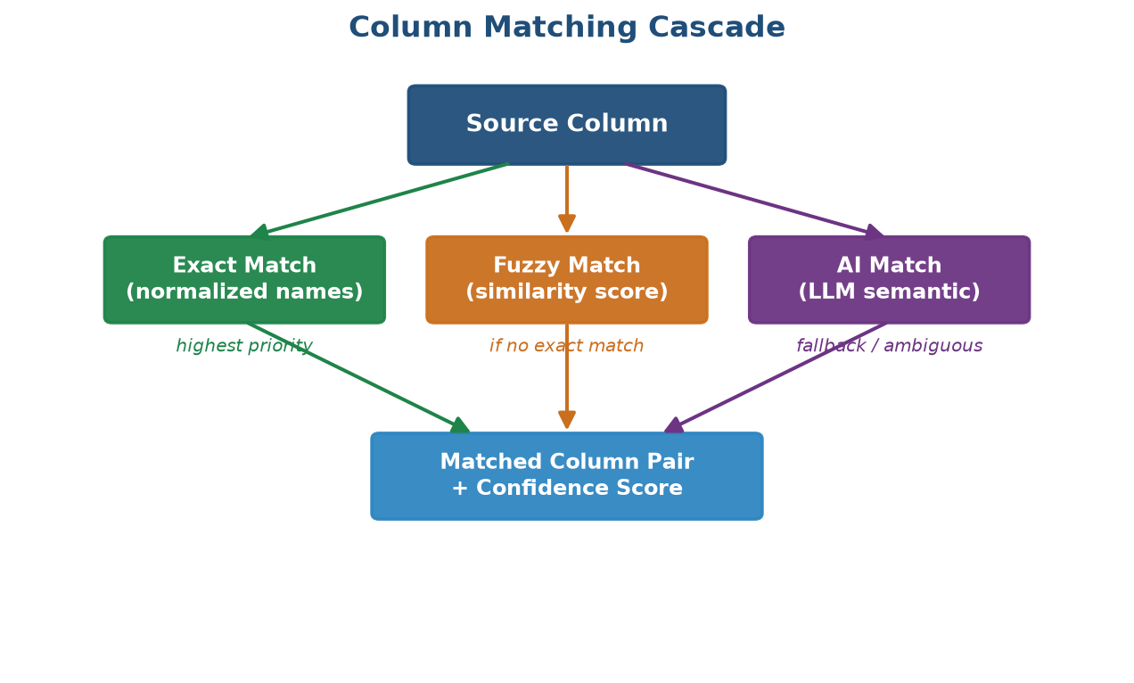
Figure 3 — The three-tier column matching cascade with confidence scoring.
- Exact match — column names are normalized (case, underscores, whitespace) and compared directly. Highest confidence.
- Fuzzy match — a string-similarity score is computed; matches above a configurable threshold are accepted.
- AI match — a language model resolves semantic equivalence when names differ substantially. Used as a fallback.
Every matched pair carries a confidence score. Pairs below the configured threshold are flagged for human review rather than being silently accepted.

6. How Rules Work
A rule defines how a column's value is transformed into a normalized, comparable text form. Rules are database-specific because each engine has different casting semantics, date formats, and boolean representations. The rule engine selects the appropriate rule based on the source data type and the target data type.
Rule Type | Example Transformation
Boolean | TRUE/FALSE → '1'/'0' text.
Timestamp | Local timestamp → normalized UTC string.
Numeric | Cast to text with consistent precision/scale.
Default | COALESCE(CAST(expr AS TEXT), '<<NULL>>').
Rules live under src/rules/, with one module per database engine. A shared base module captures common logic so that engine-specific modules only override what differs.
7. How to Add a New Rule
Extending the tool with a new transformation rule follows a consistent pattern. This keeps the rule catalog maintainable and ensures new rules are discoverable by the rule engine.
- Identify the correct engine module under src/rules/ (for example, postgres_base_rules.py).
- Add a rule function that accepts the column expression and returns normalized SQL text.
- Register the rule so the rule engine can select it based on data type.
- Add or update the entry in rules_catalog.json if the rule is catalog-driven.
- Validate the output on a representative table before rolling it out broadly.
Tip: Always return values wrapped with the NULL sentinel so new rules remain consistent with the framework's comparison strategy.

8. AI Integration
AI is used in two complementary ways: to resolve ambiguous column matches and to recommend transformation rules for unusual data types. The AI layer under src/ai/ is composed of a prompt builder, a response parser, and a rule planner.
- Prompt Builder — assembles structured prompts describing source and target schemas.
- Response Parser — converts the model's response into structured match and rule decisions.
- Rule Planner — plans which rules apply, using AI suggestions where static logic is insufficient.
AI decisions are always accompanied by confidence signals so that human reviewers can prioritize verification where it matters most.

9. Output — What Gets Generated
The primary output of the tool is a set of validation YAML suites. Each suite contains the normalized SQL for both source and target sides, along with metadata describing the matched columns and the rules applied to each. These suites are consumed by an automated validation runner that executes the queries and compares results.
- Data validation suites — per-column normalized comparison queries.
- Count validation suites — row-count checks between source and target.
- Manifest — an index of all generated suites for a batch run.
10. Batch Mode (Multiple Tables)
For migrations spanning many tables, batch mode processes a list of tables in a single run. A configuration file enumerates the source and target tables; the config parser reads it, and the batch runner iterates over each entry, generating suites and recording a manifest.
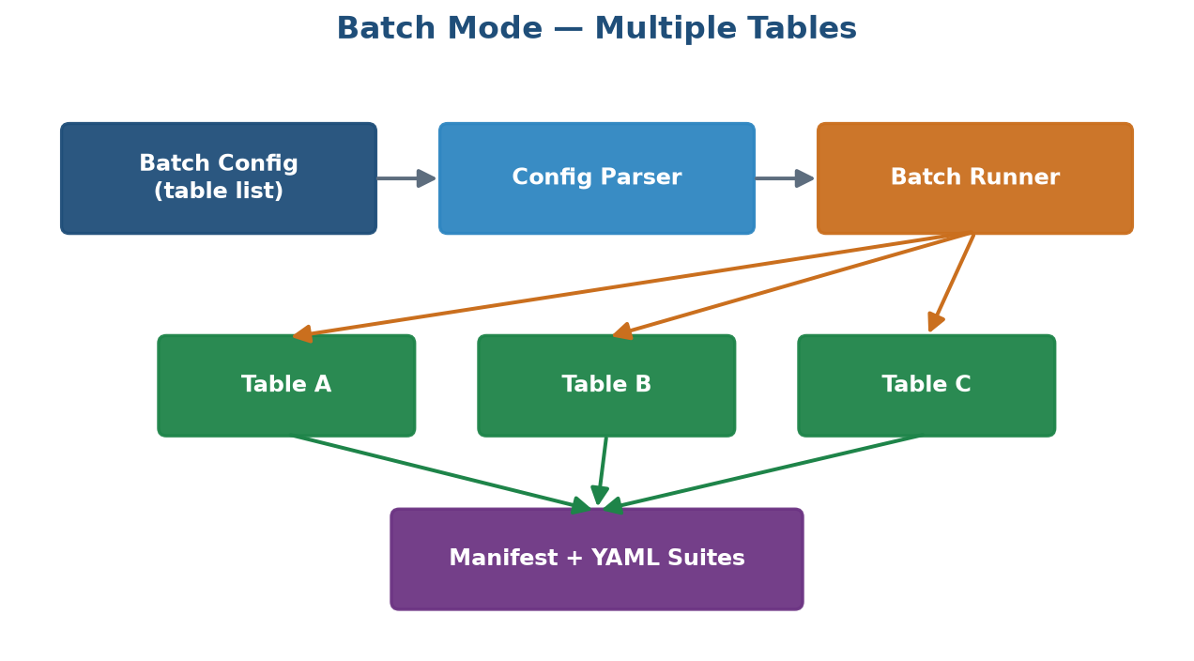
Figure 4 — Batch mode processes multiple tables and produces a consolidated manifest.
Batch mode is the recommended approach for production migrations because it guarantees consistent configuration across tables and produces a single manifest for traceability.
11. The YAML Config Files Explained
Configuration files under config/bronze/ define both count and data validation suites. They are human-readable and version-controlled, making validation logic auditable and reproducible.
Config Type | Location | Purpose
Count validation | config/bronze/count_validation/ | Row-count parity checks.
Data validation | config/bronze/data_validation/ | Column-level value comparisons.
Dynamic suites | *_dynamic_suite.yaml | Auto-generated, optimized query suites.
A typical data-validation entry declares the source and target expressions, the applied rule, and any thresholds that govern acceptable mismatch rates.

12. Fuzzy Match & Failure Thresholds
Two categories of thresholds control the tool's behavior. Match thresholds decide whether a fuzzy column match is accepted automatically, while failure thresholds decide whether a validation result is considered a pass or a failure.
- Match threshold — the minimum similarity score for an automatic fuzzy match. Below this, the pair is flagged for review.
- Failure threshold — the maximum tolerated mismatch rate before a validation is marked as failed.
Guidance: Start with conservative thresholds and relax them only after reviewing real mismatch patterns. Overly permissive thresholds can mask genuine data issues.

13. Static Column Exclusion List
Some columns should never participate in validation — for example, audit timestamps, surrogate keys regenerated on load, or system-managed metadata. The static exclusion list lets you declare these columns so they are skipped consistently across runs.
- Add the column name to the exclusion configuration.
- Re-run generation; excluded columns are omitted from the produced suites.
- Document why each column is excluded to preserve institutional knowledge.
14. Common Workflows
14.1 Validate a Single Table
Run the CLI with the source and target table names to generate and inspect one suite.
14.2 Validate a Full Schema
Populate a batch config with all tables, then run batch mode to produce a complete manifest.
14.3 Re-run After a Fix
After correcting a rule or exclusion, regenerate only the affected suites and re-validate.

15. Environment Variables Reference
All connection and behavioral settings are supplied through environment variables loaded from the .env file. The table below lists the most important variables.
Variable | Description
SOURCE_DB_HOST | Hostname of the source database.
SOURCE_DB_USER | Source database username.
SOURCE_DB_PASSWORD | Source database password.
SNOWFLAKE_ACCOUNT | Snowflake account identifier.
SNOWFLAKE_USER | Snowflake username.
SNOWFLAKE_PASSWORD | Snowflake password.
AI_API_KEY | API key for the AI matching/rule service.
16. Key Design Decisions
The following decisions shape the architecture and are important context for anyone extending the tool.
- Text normalization for comparison — all values are cast to text and null-guarded so that comparisons are engine-agnostic.
- Cascade matching — deterministic exact and fuzzy matching are preferred over AI, which is reserved for genuinely ambiguous cases.
- Config as code — validation logic lives in version-controlled YAML for auditability and reproducibility.
- Engine-specific rules — casting and formatting differences are isolated per database engine to keep logic clear.
- Confidence everywhere — every automated decision carries a confidence signal to guide human review.
Handover Summary: You now have the full picture: how the tool extracts, matches, transforms, generates, and validates. Start with a single-table run to build intuition, then scale to batch mode for production migrations.

