Migration Validator
Technical Documentation
Cross-Database Migration Validation Framework
Prepared by: Ganesh Rustum Mane
ganesh_rustummane@epam.com
Date: 2026-08-18

Table of Contents

1. Business Problem
As part of the Storable Data Migration/Modernization Project, data is being migrated from multiple source systems such as PostgreSQL, Microsoft SQL Server, and AWS Athena into Snowflake. To ensure successful migration, data validation needs to be performed between source and target tables. However:
- There are hundreds of tables across different source systems.
- Each table contains numerous columns with different data types.
- Validation requires applying data type-specific normalization rules before comparing data.
- Writing validation SQLs manually for every table is time-consuming, error-prone, and difficult to maintain.
This creates a significant bottleneck in the testing and reconciliation process.

2. Solution Overview
Migration Validator is a Python-based framework built to remove this bottleneck. Instead of engineers hand-writing validation SQL per table, the tool automatically extracts schema metadata from each source system and Snowflake, matches columns deterministically (exact and fuzzy matching with confidence scoring) and falls back to an AI model only for genuinely ambiguous columns, and assembles the result into a single canonical validation plan. A dialect-aware rule registry then normalizes each column by data type (booleans, numerics, timestamps, text, JSON, UUIDs, etc.) so that source and target values can be compared like-for-like even across different SQL dialects. From this plan, the tool uses AI to generate the actual normalized SQL and validation configuration, executes it against the live source and Snowflake databases, and produces coverage-aware pass/fail reports. A batch mode drives this same process in parallel across hundreds of tables from a single configuration file, making it practical to validate an entire migration scope without writing a single manual SQL statement.

3. Architecture
Migration Validator is organized into clearly separated layers, each with a single responsibility. The table below summarizes the major layers and the source modules that implement them.
Item | Description
CLI | src/validate_cli.py — interactive menu and all subcommands (generate, batch, rules, list-tables, etc.); the main entry point.
Pipeline Orchestrator | src/validation_pipeline.py — wires schema extraction, matching, AI resolution, plan building, and SQL/YAML generation together (class ValidationPipeline).
DB Connection Factories | src/db/factory.py and src/db/{postgres,mssqlserver,snowflake,athena,base}.py — .env-driven raw connectors used to execute live queries.
Schema Extraction | src/sql_extractor/extractors.py — dialect-specific information_schema/catalog introspection returning column and table metadata, and primary-key detection.
Column Matching | src/matching/{exact_matcher,fuzzy_matcher,confidence,normalizer,candidate_matcher}.py — deterministic exact-match, then fuzzy match (RapidFuzz), then multi-factor confidence scoring.
AI Layer | src/ai/rule_planner.py (plus prompt_builder, response_parser) — invoked only for columns the deterministic matcher marks as ambiguous.
Canonical Validation Plan | src/core/validation_plan.py and plan_store.py — the CanonicalValidationPlan object, persisted as output/plans/**/*.plan.json; this is the single contract all downstream artifacts are generated from.
Type Normalization Rules | src/rules/*.py (postgres_base_rules, mssql_rules, athena_rules, snowflake_rules) plus src/rules_catalog.json — a rule registry keyed by (source type, target type) producing dialect-specific COALESCE/CAST normalization expressions.
SQL / YAML Generation | src/generated_queries/{ai_sql_generator,sql_query_generator,yaml_config_writer,query_output_manager}.py — AI-generated normalized SQL for both sides, written into idempotently-upserted YAML validation configs.
Exclusions | src/exclusions/* and config/exclusions.yaml — static, user-supplied, and pattern-based column exclusions, always reported alongside coverage percentage.
Batch Orchestration | src/batch/{batch_runner,config_parser,manifest_writer}.py — fans the per-table pipeline out across a tables.yaml file using a ThreadPoolExecutor, producing a consolidated manifest.json.
Validation Execution Engine | src/validation/{validation_executor,count_validator,data_validator,config_schema,plan_validator}.py — loads and executes the generated YAML against live databases and compares results.
Learning / Feedback | src/learning/{feedback,retrieval}.py — learned column-mapping examples that feed back into future matching and AI prompts.
The diagram below shows how these layers connect end to end: configuration and credentials flow into the CLI and pipeline orchestrator, which drives schema extraction, column matching, AI-assisted resolution for ambiguous cases, and assembly of the canonical validation plan. That plan is the single point from which SQL, YAML configuration, live execution, comparison, and reporting are all generated.
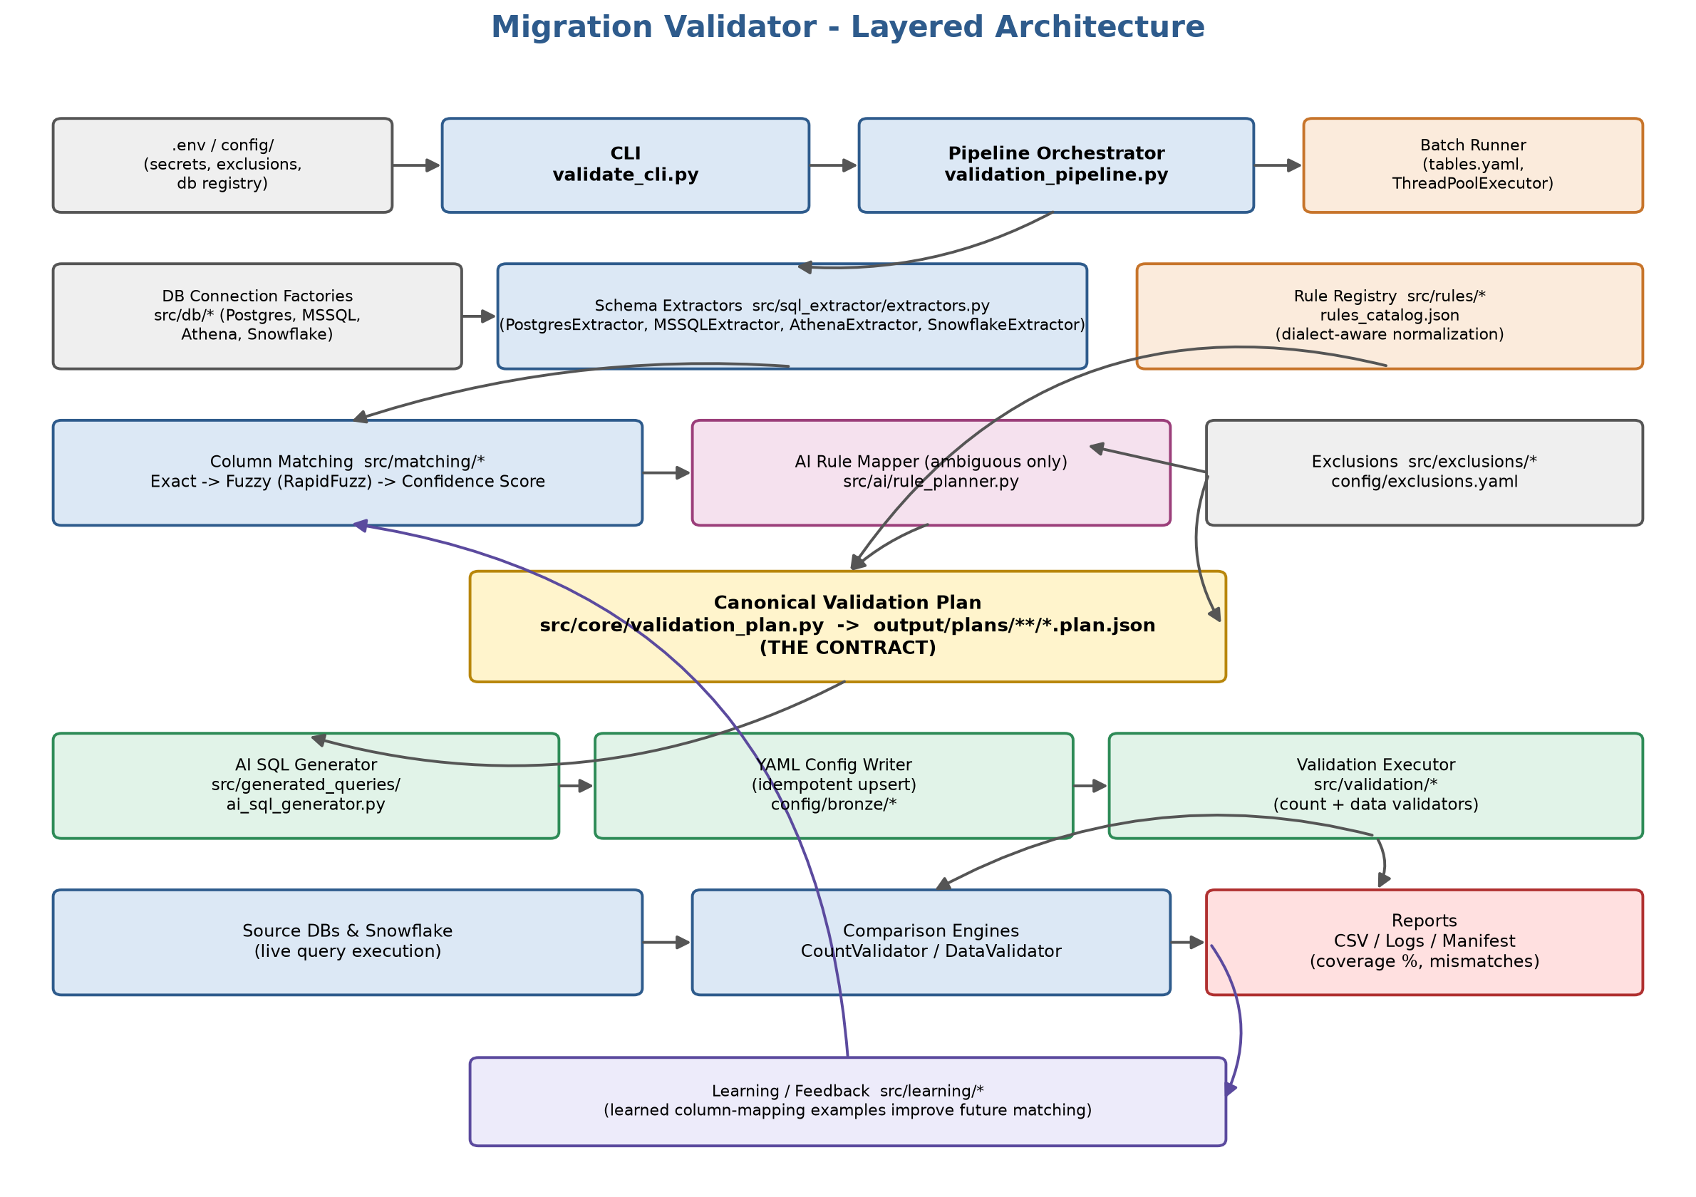
Figure 1: Migration Validator layered architecture

4. Workflow / End-to-End Process
A single table (or a batch of tables) is validated through a seven-step generation pipeline (the modern run_with_plan() flow in ValidationPipeline), followed by a separate execution phase:
- Step 1 — Extract Schemas: column metadata is pulled from the source system and Snowflake via the dialect-specific extractors, including primary-key detection on both sides.
- Step 2 — Apply Column Exclusions: user-supplied and static/pattern exclusions are removed from the source column list before matching begins.
- Steps 3–4 — Deterministic Matching: an exact matcher (case-insensitive, normalized names) runs first; anything unresolved goes through RapidFuzz-based fuzzy matching and a multi-factor confidence score. A score of 0.95 or above is auto-accepted, 0.75–0.95 is routed to the AI layer, and below 0.75 is left unmatched.
- Step 5 — AI Resolution (ambiguous columns only): the AI rule planner resolves only the columns flagged ai_needed, keeping AI usage token-efficient.
- Step 6 — Build & Validate the Canonical Validation Plan: all match decisions are assembled into a CanonicalValidationPlan, validated (a failing plan blocks SQL generation), and persisted as plan.json — the authoritative contract for the table.
- Step 7 — Generate SQL & YAML: the AI SQL generator produces dialect-aware, normalized SELECT statements for both source and target using the type-normalization rules, and the results are upserted (never hand-appended) into YAML validation configuration files.
Execution Phase (run separately, e.g. via the CLI's "Execute YAML" option or ValidationExecutor.execute_batch()):
- The generated YAML is loaded and schema-validated (Pydantic).
- Live connections are opened to the source system and Snowflake.
- CountValidator compares scalar row counts between source and target.
- DataValidator executes the normalized queries, resolves primary keys, detects missing rows, compares common rows, and writes mismatch details.
- Results are written out as CSV summaries and logs, always paired with a coverage percentage and an exclusion summary.
For migrations spanning hundreds of tables, the same seven-step generation logic is run per table pair by the batch subsystem, driven by a single tables.yaml file and executed in parallel via a ThreadPoolExecutor, producing a consolidated manifest.json summarizing success or failure per table — removing the need to configure or invoke the tool manually for each table.
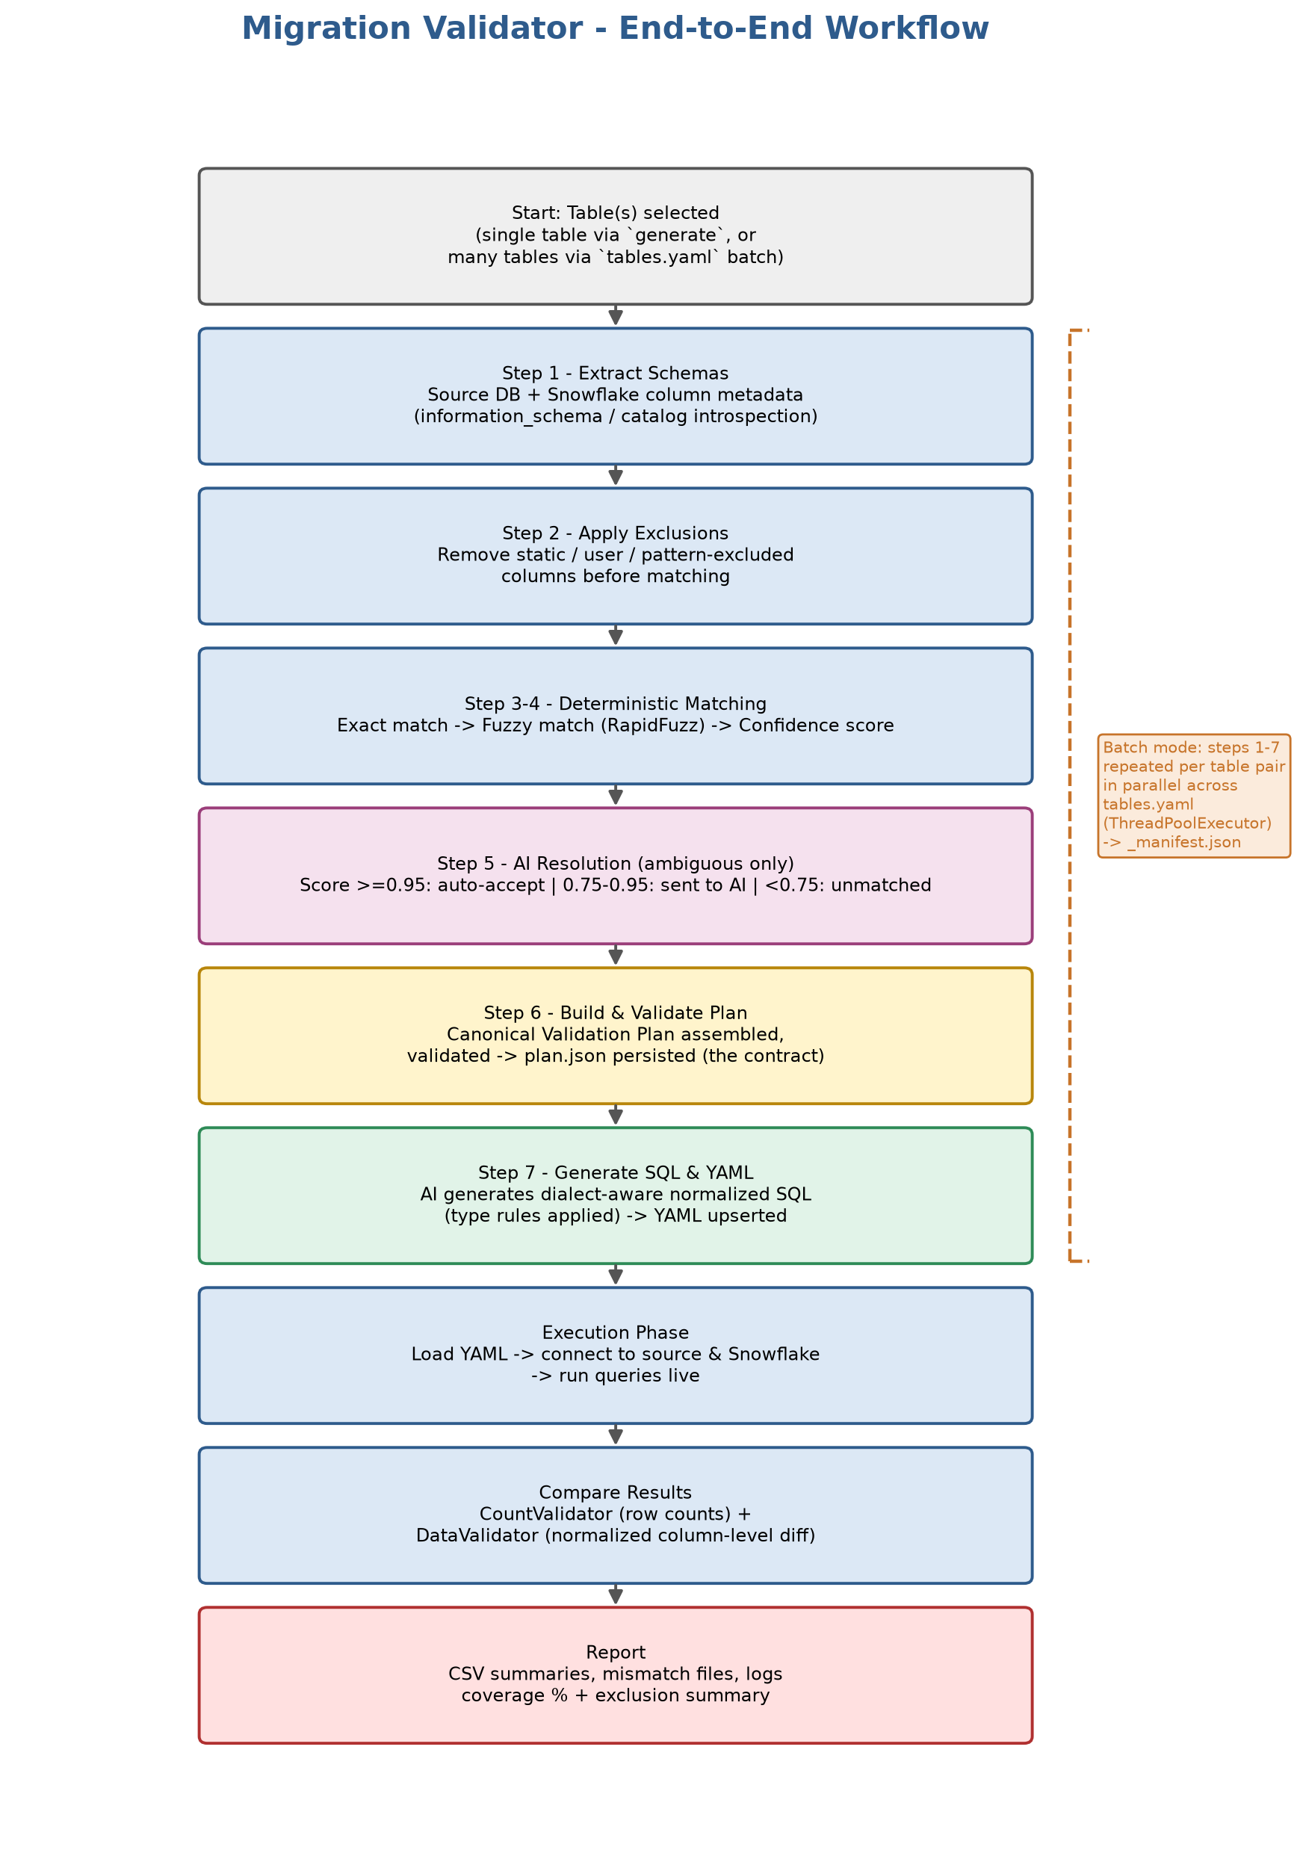
Figure 2: End-to-end workflow, including the batch/multi-table branch

5. Key Features
- AI-only column mapping for ambiguous cases — no silent rule-based fallback; missing AI credentials cause a loud, explicit failure rather than a degraded result.
- Dialect-aware type normalization rule registry (PostgreSQL, MSSQL, Athena, Snowflake) using a consistent COALESCE + CAST + NULL-sentinel pattern so values are genuinely comparable across dialects.
- A canonical JSON plan (plan.json) as the single source of truth — every downstream artifact (SQL, YAML, reports) is a regenerable render target, never hand-edited.
- Scalable batch processing that validates hundreds of tables in parallel from one tables.yaml configuration file.
- Column coverage and exclusions are always reported alongside pass/fail results, with a LOW COVERAGE flag when coverage drops below 80%.
- Idempotent YAML upsert — generated validation configuration is parsed, merged, and rewritten, never appended to, keeping configs stable across repeated runs.

6. Technology Stack
Category | Details
Language | Python 3.13 / 3.14
Database Drivers | psycopg2-binary (PostgreSQL), pyodbc (MSSQL/ODBC), snowflake-connector-python, boto3 (Athena/S3 query results)
Data & Config Handling | pandas, pyyaml, pydantic (>=2.0, structural validation of generated YAML), python-dotenv
Column Matching | rapidfuzz (with a difflib fallback if unavailable)
AI Backends | EPAM DIAL (OpenAI-compatible Azure endpoint via the AzureOpenAI client) as primary; Anthropic Claude as a direct fallback backend
Testing | pytest / pytest-cov for unit and contract tests
Config Formats | .env (secrets), YAML (exclusions, database registry, generated validation configs, batch table lists), JSON (canonical plan.json, rule catalogs)

7. Conclusion
Migration Validator directly addresses the business problem behind the Storable Data Migration/Modernization Project: it eliminates the need to hand-write validation SQL for hundreds of tables, ensures every comparison applies consistent, type-aware normalization regardless of source dialect, and scales cleanly to large migration scopes through its batch subsystem. Because every generated artifact traces back to a single canonical validation plan and every run reports column coverage and exclusions explicitly, the validation process remains fully auditable — giving the migration and testing teams confidence that source and target data have been reconciled correctly, without the time cost and error risk of manual SQL authoring.

