SQL Generator - Claude SQL/YAML Generation
  - architecture brief for Claude API key approval
Purpose: generate migration-validation SQL and YAML from database schema metadata, reviewed mappings, exclusions, and data rules. The flow is controlled by a Python script and this document covers generation only.

How It Works
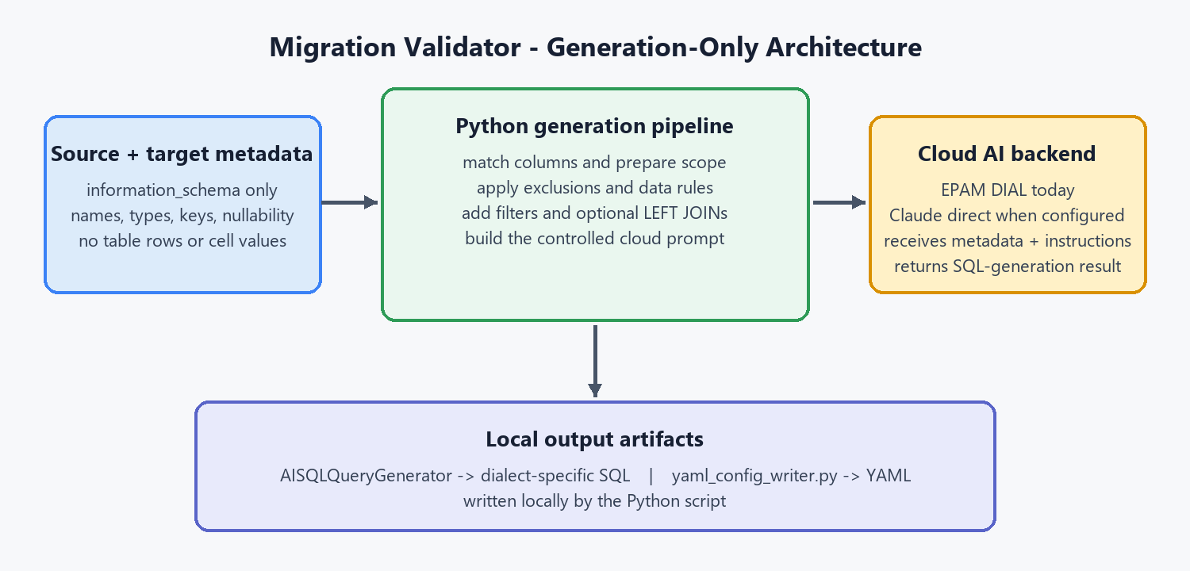
In one sentence: Python prepares a small, structured generation request, sends metadata and rules to the configured cloud AI backend, and writes the resulting SQL/YAML artifacts locally.

What the Claude Receives
- Schema metadata: table and column names, types, ordinal position, nullability, and key indicators where available.
- Mapping context: source-to-target mappings, ambiguous candidates, aliases, and rule identifiers.
- Scope controls: excluded columns, Fivetran/system exclusions, normalization or transformation rules, filters, and optional JOIN/ON instructions.
- Generation request: the SQL dialect, selected tables, and the natural-language validation requirement.

What Does Not Cross the Boundary
Table rows, cell values, credentials, passwords, connection strings, PII, and arbitrary full-table extracts are not part of the generation request.

Implementation
Component | Role | Location
Python pipeline | Prepares metadata, exclusions, rules, filters, and prompts | webapp/app.py / src/validate_cli.py
AISQLQueryGenerator | Cloud-assisted dialect-specific SQL generation and checks | src/generated_queries/ai_sql_generator.py
Rule Book + exclusions | Controls normalization, transformation, and excluded columns | src/rule_book.py / src/rules/ / config/
YAML writer | Persists the canonical plan as YAML | src/generated_queries/yaml_config_writer.py

Cloud Backend and Controls
DIAL_API_KEY uses EPAM DIAL today. CLAUDE_API_KEY selects Anthropic Claude direct when DIAL is not configured. Local exact/fuzzy matching reduces AI calls; prompts are bounded, SQL output is checked for dialect issues, and token usage is logged. No hard spend ceiling is claimed.
This is custom in-house software for Storable's migration-validation process. The cloud AI service is a controlled generation dependency; Python remains the orchestrator and writes the generated SQL/YAML artifacts locally.

