Shortest-Job-First Scheduling
Shortest-Job-First (SJF) is a CPU scheduling algorithm that selects the process with the smallest burst time for execution. It minimizes waiting time and is widely regarded as an optimal scheduling technique for reducing average waiting and turnaround times.
SJF can be implemented in two forms:
- Non-Preemptive SJF: Once a process starts, it runs to completion.
- Preemptive SJF (also known as Shortest Remaining Time First, SRTF): If a new process arrives with a shorter burst time than the remaining time of the current process, the CPU is preempted.

Characteristics of SJF
- Priority: Shorter burst time processes are given priority.
- Optimality: It minimizes the average waiting time and turnaround time.
- Complexity: Requires knowledge of burst times in advance, which is difficult in real- world scenarios.

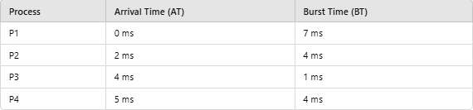
Example of Non-Preemptive SJF Scheduling Given Processes:

Step 1: Arrange Processes by Arrival Time
Initially, only P1 is available. When P2, P3, and P4 arrive, the process with the shortest burst time is selected.

Step 2: Execute Processes
- P1 executes first (no other process available at 0 ms).
- At 7 ms, P2, P3, and P4 are ready. P3 (1 ms) executes next.
- After P3, the next shortest burst time is P2 (4 ms).
- Finally, P4 executes.
Gantt Chart

P1 | P3 | P2 | P4

0 7 8 12 16
Step 3: Calculate Metrics
- Completion Time (CT):
o P1: 0 + 7 = 7 ms
o P3: 7 + 1 = 8 ms
o P2: 8 + 4 = 12 ms
o P4: 12 + 4 = 16 ms
  - Turnaround Time (TAT): TAT=CT−
  - P1: 7 - 0 = 7 ms
  - P2: 12 - 2 = 10 ms
  - P3: 8 - 4 = 4 ms
  - P4: 16 - 5 = 11 ms

Waiting Time (WT):
WT=TAT−BT
  - P1: 7 - 7 = 0 ms
  - P2: 10 - 4 = 6 ms
  - P3: 4 - 1 = 3 ms
  - P4: 11 - 4 = 7 ms

Table:
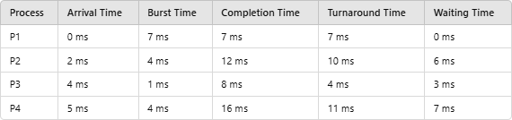
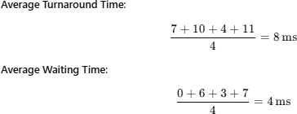

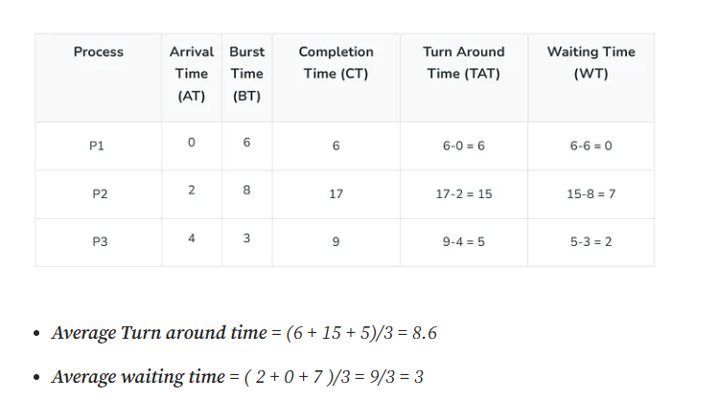

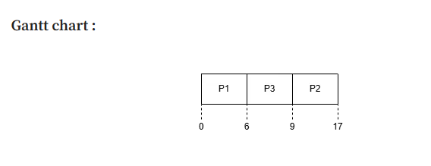
If arrival time (AT) is not provided in the question, then there is an automatic rule:

✅ Assume all Arrival Times = 0

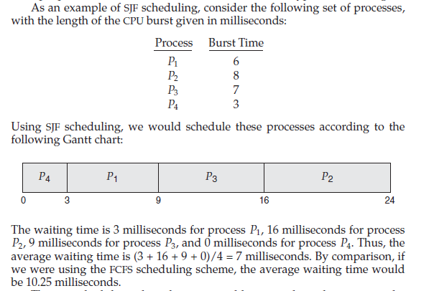

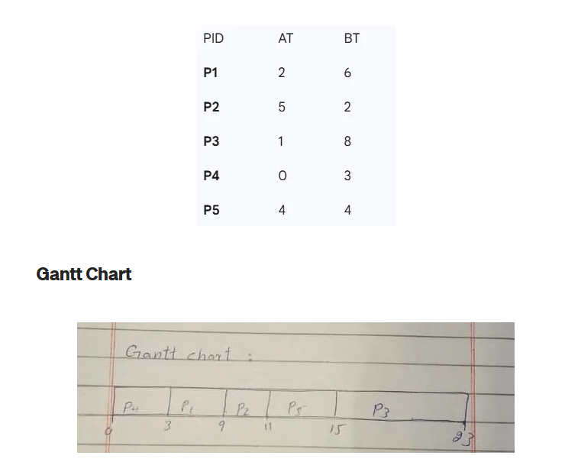

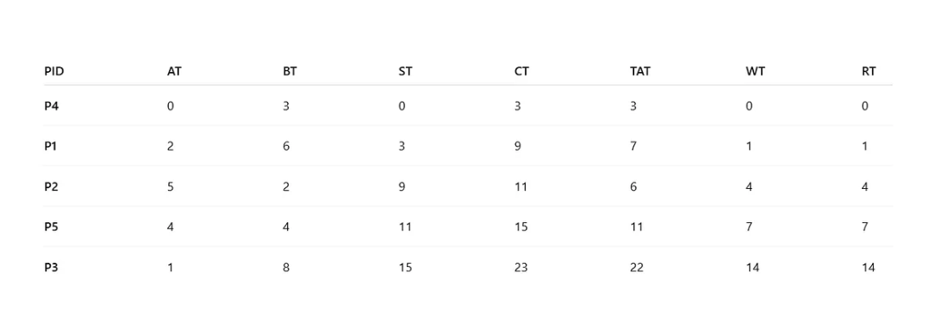

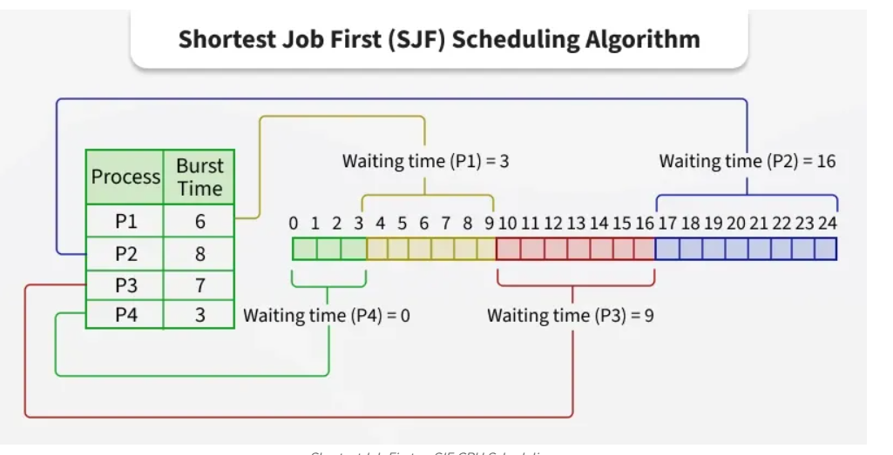

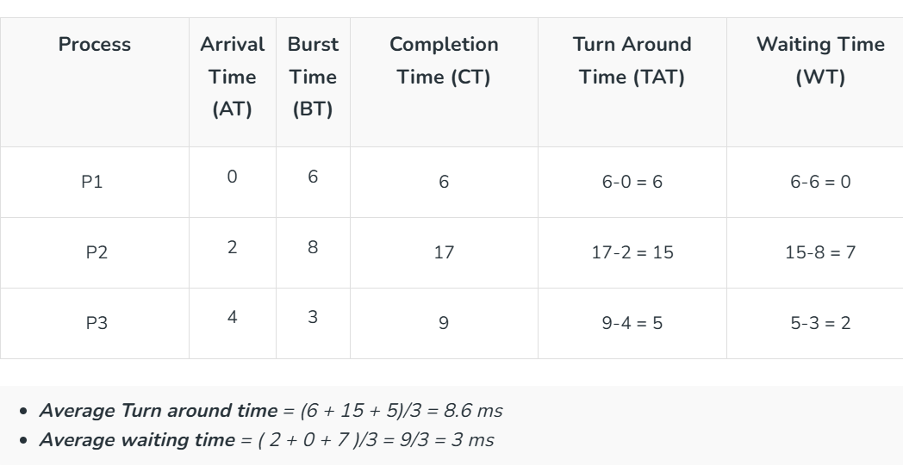

Algorithm: Shortest Job First (SJF – Non-Preemptive)
- Start
- Read number of processes n
- For each process:
  - Read Arrival Time (AT)
  - Read Burst Time (BT)
  - Assign Process ID
- Sort all processes in ascending order of Burst Time (BT)
(If two burst times are equal, maintain arrival order)
- Set:
  - WT[0] = 0
- For each process from 1 to n-1:
  - Calculate Waiting Time:
WT[i] = WT[i-1] + BT[i-1] - AT[i]
  - If WT[i] < 0
WT[i] = 0
- For each process from 0 to n-1:
  - Calculate Turnaround Time:
TAT[i] = BT[i] + WT[i]
- Calculate:
  - Average Waiting Time
Average WT = (Sum of WT) / n
  - Average Turnaround Time
Average TAT = (Sum of TAT) / n

Algorithm: Improved Shortest Job First (SJF – Non-Preemptive)
- Start
- Read number of processes n
- For each process:
  - Read Arrival Time (AT)
  - Read Burst Time (BT)
  - Assign Process ID
  - Mark process as not completed
- Set:
  - current_time = 0
  - completed = 0
- While (completed < n):
  - Among all processes where:
AT[i] ≤ current_time
AND process is not completed
select the process with minimum Burst Time (BT).
  - If no such process is found:
current_time = current_time + 1
(CPU is idle)
  - Else:
    - Calculate Completion Time:
CT[i] = current_time + BT[i]
    - Calculate Turnaround Time:
TAT[i] = CT[i] - AT[i]
    - Calculate Waiting Time:
WT[i] = TAT[i] - BT[i]
    - Mark process as completed
    - Update current time:
current_time = CT[i]
    - Increment completed count
- Calculate:
  - Average Waiting Time
Average WT = (Sum of WT) / n
  - Average Turnaround Time
Average TAT = (Sum of TAT) / n
- Display results:
  - Process ID
  - Arrival Time
  - Burst Time
  - Completion Time
  - Waiting Time
  - Turnaround Time
  - Averages
- Stop

Advantages of SJF
- Optimal for Waiting Time: SJF minimizes the average waiting time.
- Efficient: Reduces turnaround time for shorter processes.

Disadvantages of SJF
- Starvation: Longer processes may experience indefinite delays.
- Uncertainty: Exact burst times are often difficult to predict.
- Not Suitable for Time-Sharing: Non-preemptive SJF cannot handle interactive systems effectively.
SJF scheduling is a highly efficient algorithm for batch systems where burst times are predictable. However, its practical implementation is limited due to the challenges of estimating burst times and potential starvation of longer processes. To overcome these drawbacks, Shortest Remaining Time First (SRTF) or other dynamic scheduling methods are often preferred in modern systems.

Shortest Remaining Time First Scheduling Algorithm

The pre-emptive version of Shortest Job First (SJF) scheduling is called Shortest Remaining Time First (SRTF). In SRTF, the process with the least time left to finish is selected to run. The running process continues until it finishes or a new process with a shorter remaining time arrives, ensuring the fastest finishing process always gets priority.

The pre-emptive version of Shortest Job First (SJF) scheduling is called Shortest Remaining Time First (SRTF). In SRTF, the process with the least time left to finish is selected to run. The running process continues until it finishes or a new process with a shorter remaining time arrives, ensuring the fastest finishing process always gets priority.

Example of SJF Algorithm:
Scenario 1: Processes with Same Arrival Time
Example: Consider the following table of arrival time and burst time for three processes P1, P2 and P3.

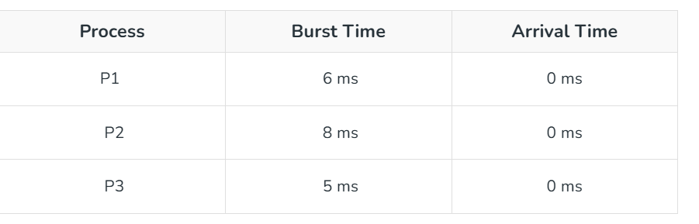

- Time 0-5 (P3): P3 runs for 5 ms (total time left: 0 ms) as it has shortest remaining time left.
- Time 5-11 (P1): P1 runs for 6 ms (total time left: 0 ms) as it has shortest remaining time left.
- Time 11-19 (P2): P2 runs for 8 ms (total time left: 0 ms) as it has shortest remaining time left.

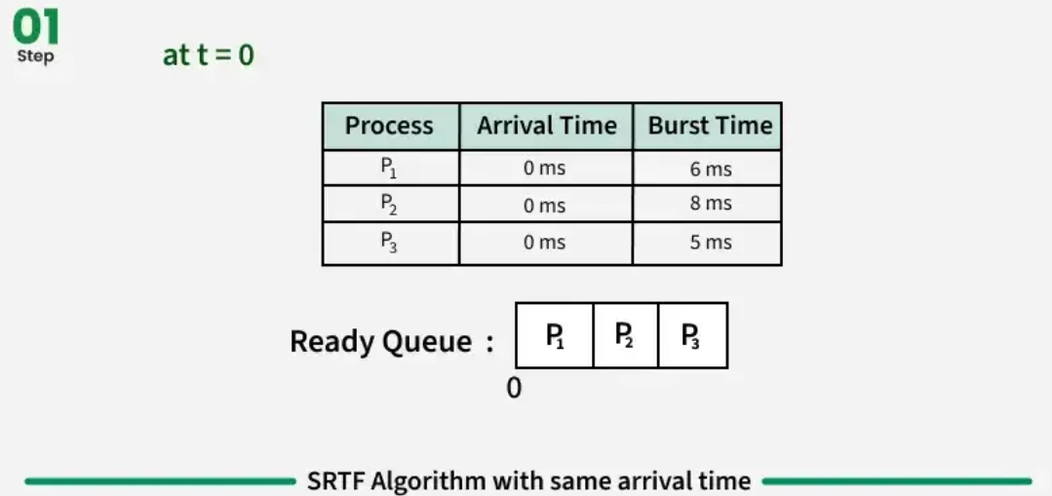

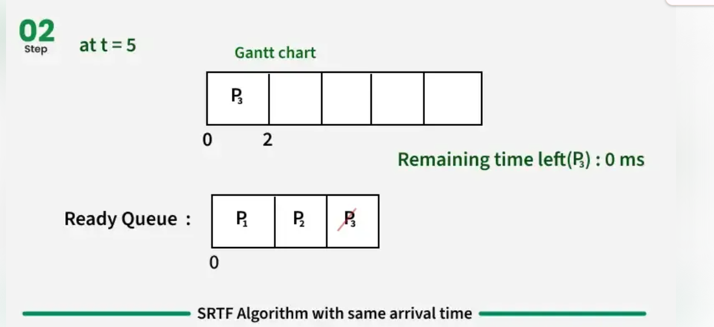

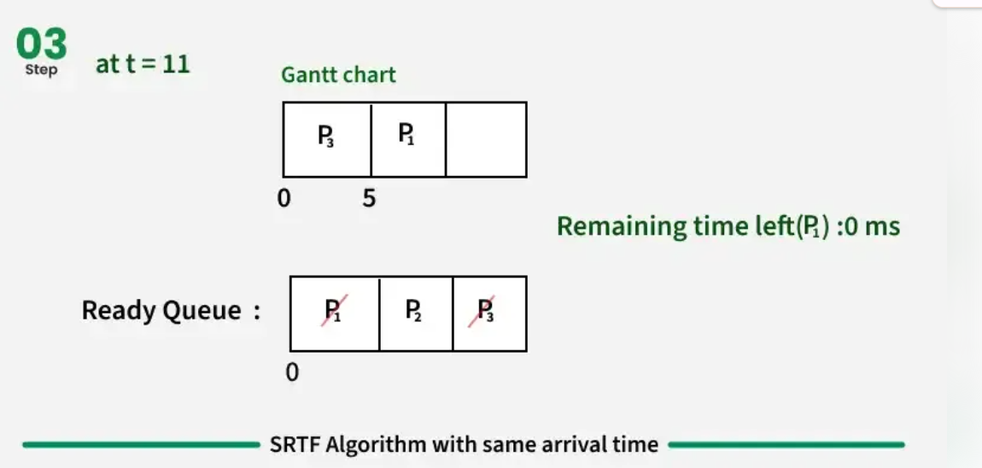

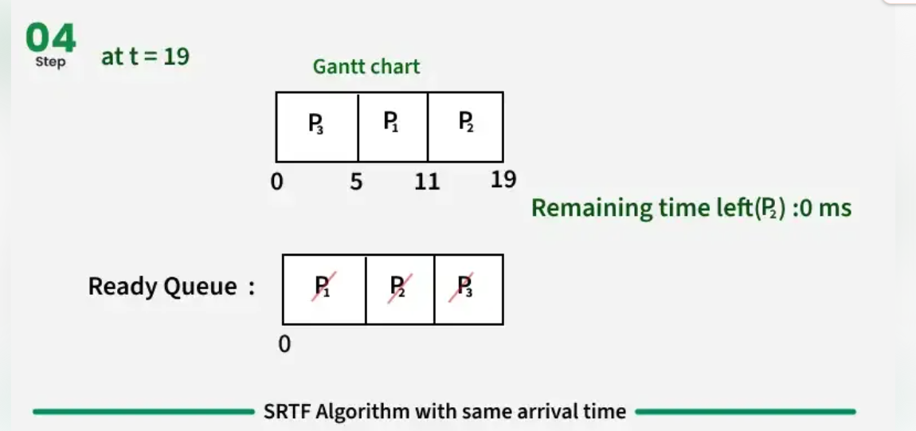

Scenario 2: Processes with Different Arrival Times
Consider the following table of arrival time and burst time for three processes P1, P2 and P3.

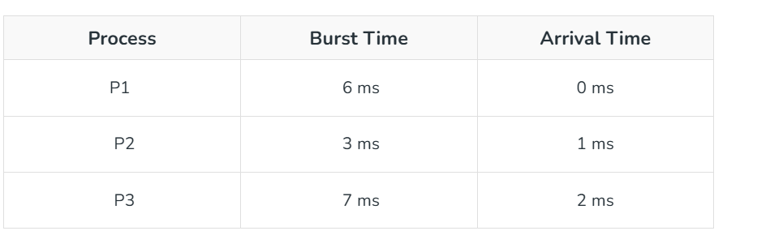

Step-by-Step Execution:
- Time 0-1 (P1): P1 runs for 1 ms (total time left: 5 ms) as it has shortest remaining time left.
- Time 1-4 (P2): P2 runs for 3 ms (total time left: 0 ms) as it has shortest remaining time left among P1 and P2.
- Time 4-9 (P1): P1 runs for 5 ms (total time left: 0 ms) as it has shortest remaining time left among P1 and P3.
- Time 9-16 (P3): P3 runs for 7 ms (total time left: 0 ms) as it has shortest remaining time left.

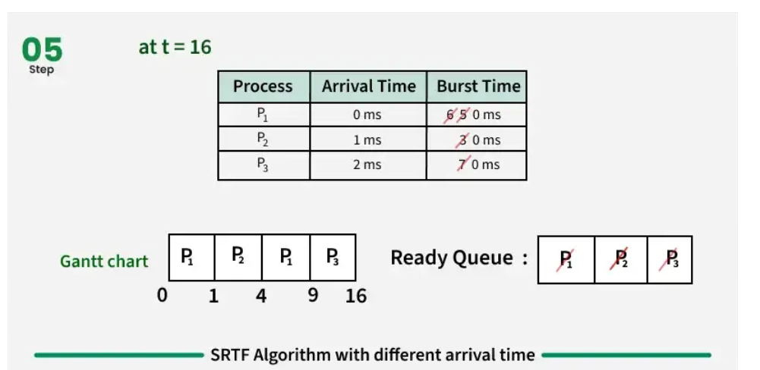

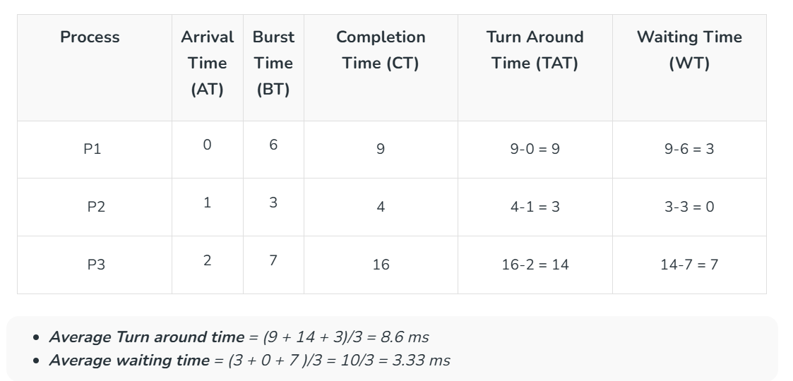

Implementation of SRTF Algorithm
Step 1: Input number of processes with arrival time and burst time.
Step 2: Initialize remaining times (burst times), current time = 0, and counters.
Step 3: At each time unit, add processes that have arrived into the ready queue.
Step 4: Select the process with the shortest remaining time (preempt if a shorter one arrives).
Step 5: Execute the selected process for 1 unit, reduce its remaining time, and increment current time.
Step 6: If a process completes:
- Turnaround Time = Completion Time − Arrival Time
- Waiting Time = Turnaround Time − Burst Time
Step 7: Repeat Steps 3–6 until all processes complete.
Step 8: Calculate average waiting time and turnaround time.
Step 9: Display completion, waiting, and turnaround times for each process, along with averages.

