**Campus Kiosk**

A

MINOR PROJECT REPORT

*Submitted for the partial fulfilment of*

BACHELOR OF TECHNOLOGY

IN

COMPUTER SCIENCE AND ENGINEERING

***Submitted by***

Vishal Sharma (9913103456)

Arnav Gupta (9913103457)

Ganesh Sawhney (9913103478)

Mukesh Kumar Mishra (9913103462)

**Under the Guidance**

**Of**

Asst. Prof. Anuradha Gupta

(Department of CSE/IT)



**Department of Computer Science and Engineering/IT**

**Jaypee Institute of Information Technology, Noida**

DECEMBER 2015

**ACKNOWLEDGEMENT:**

I would like to place on record my deep sense of gratitude to **Asst. Prof. Anuradha Gupta**, Designation, Jaypee Institute of Information Technology, India for his generous guidance, help and useful suggestions.

I also wish to extend my thanks to my classmates for their insightful comments and constructive suggestions to improve the quality of this project work.

**Signature(s) of Students:**

Vishal Sharma (9913103456)

Arnav Gupta (9913103457)

Ganesh Sawhney (9913103478)

Mukesh Kumar Mishra (9913103462)

# (i)

# Abstract:

# Our project is a web-based educational system, which delivers so much of easiness for students as well as for Faculties. In any academic institute, there is a need to maintain the records for student as well the Faculty like personal details of the employee. There is so much paper work fee details occurs in every academic institution, which is very messy for both, students and Faculties. But here comes our project, making everything simple and systematic. Our project delivers every academic requirement of an institution. Student can see their attendance, marks, and fee details and can communicate to their faculties also. Faculties can upload attendance, marks, can make an announcement, can give a notice and send messages to students. In short we are making academic work very easy.

# 

# (ii)

# List of Tables:

# Tables Title Page

# 

# (iii)

# List of Figures:

# Name Page No.

# Use Case Diagram

# Class Diagram

# (iv)

# List of Abbreviations:

# HTTP Hypertext Transfer Protocol

# HTTPS Secure Hypertext Transfer Protocol

# HTML Hypertext Mark-up Language

# CSS Cascading Style Sheet

# JS Java Script

# PHP Hypertext Pre-processor

# (v)

# Table of Contents:

# Topic Page No.

# Acknowledgement i

# Abstract ii

# List of Tables iii

# List of Figures iv

# Abbreviations v

# 

**Contents:**

**Chapter 1. Introduction**

1.1 Document Purpose

1.2 Product Scope

1.3 Intended Audience and Document overview

1.4 Definitions

**Chapter 2. Background Study**

**Chapter 3. Requirement Analysis**

3.1 Hardware Requirements

3.2 Software Requirements

3.3 Functional Requirements

3.4 Non-functional Requirements

3.5 User Requirements

3.6 UML Diagram

**Chapter 4. Detailed Design**

2.1 Product Perspective

2.2 Product Functionalities

2.3 Users and Characteristics

2.4 Operating Environment

2.5 Design and Implementation Constraints

2.6 Assumptions and Dependencies

**Chapter 5. Implementation**

**Chapter 6. Testing Reports**

**Chapter 7. Conclusion and Future Scope**

**Chapter 8. Gantt Chart**

**Chapter 9. Research Papers Related to Project**

**References**

**Chapter 1. Introduction:**

**1.1 Purpose**

The purpose of this document is to describe the Campus Kiosk product. This document contains the functional and non-functional requirements of the project. This document contains the guidelines for system engineers and designers to start working the project.

**1.2 Scope**

Campus Kiosk is basically updating the manual student related functions into internet-based application with key features like user (student) can see their updated attendance, exam marks (theory and lab both), attendance etc. and user (faculty) can add students, add marks, get notification for not-updated attendance etc.

This project is very useful for Faculties and students both.

Campus Kiosk can work as a powerful system for huge number of students and faculties and can provide an easy-to-use system for universities.

**1.3 Intended Audience and Document Overview**

The intended readers of this document are the developers of the site, testers, administrators (faculty members) super-administrators and coordinators.

Any suggested changes on the requirements listed on this document should be included in the last version of it so it can be a reference to developing and validating teams.

**1.4 Definitions**

* **HTML:** Hyper Text Markup Language is the predominant markup language for web pages. It provides a means to describe the structure of text-based information in a document and to supplement that text with interactive forms, embedded images, and other objects.
* **HTTP:** Hypertext Transfer Protocol is a transaction oriented client/server protocol between a web browser & a Web Server.
* **HTTPS:** Secure Hypertext Transfer Protocol is a HTTP over SSL (secure socket layer).
* **CSS:** Cascading Style Sheet is used for better user-interface.
* **PHP:** Hypertext Pre-processor is a server-side scripting language designed for web development but also used as a general-purpose programming language.

**Chapter 2. Background Study:**

There is a company named Campus Lynx. This company is providing the similar product as campus kiosk. As our college also using this system so we are very much aware of this type of system. Using this type of system, we came across an idea that we should develop a system with more functionality which campus lynx don’t have. We went through some research papers mentioned at the end of the document and got an inspiration and path for the same.

**Chapter 3. Requirement Analysis:**

**3.1 Software Requirement Analysis:**

* Operating System :Windows XP
* Client End Language :HTML, CSS, Java Script
* Server Side Language :PHP 5
* Database :My Sql
* Web Server :XAMPP
* Web Browser :Internet Explorer

**3.2 Hardware Requirement Analysis:**

* Disc space :40 GB
* Processor :Pentium 3
* Memory :512 MB RAM
* File System :32/64 bit

**3.3 Functional Requirements:**

**3.3.1 Admin:**

* Registration of students/Faculties.
* Add/Delete/Edit/View student/Faculty information.

**3.3.2 Super Admin:**

* Registration of students/Faculties/admins.
* Add/Delete/Edit/View student/Faculty/admins information.

**3.3.3 Student:**

* View your details
* Edit your details.
* View Attendance information.
* View exam information
* View medical information
* View fee status.
* Access the messaging functionality.

**3.3.4 Faculty:**

* View your details
* Edit your details.
* Avail the SMS features.
* View/edit Attendance information.
* Add/edit Marks information.
* Add exam information
* Tackle the request of a review for an attendance.
* Access the messaging functionality.

**3.4 Non-functional Requirements:**

**3.4.1 Performance Requirement:**

* The system shall accommodate high number of students and faculty members without any fault.
* Responses to view information shall take no longer than 10 seconds to appear on the screen.
* If the system loses the connection to the Internet the user should be informed.
* Information transmission should be securely transmitted to server without any changes in information.
* As the system provides the right tools for discussion, problem solving it must be made sure that the system is reliable in its operations and for securing the sensitive details.

**3.4.2 Safety and Security Requirements:**

* System use shall not cause any harm to human users.
* System will use secured database.
* Normal users can just read information but they cannot edit or modify anything except their personal and some other information.
* System will have different types of users and every user has access constraints.

**3.5 UML Diagrams:**

**3.5.1 Use-case Diagram:**



**3.5.2 Class Diagram:**

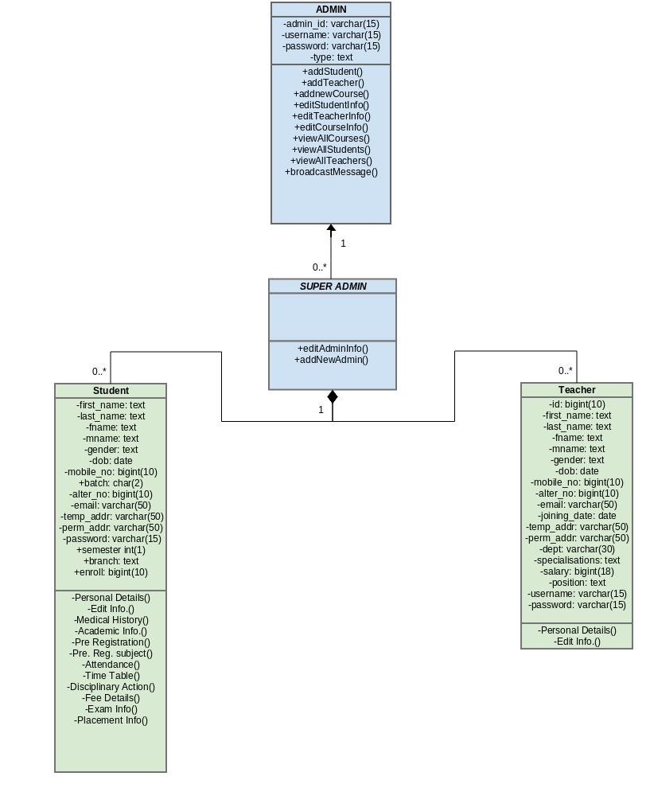

**Chapter 4. Detailed Design:**

**4.1 Product Perspective**

Campus Kiosk is a replacement for the ordinary student-Faculty related systems which depend on paper work for recording every particular student’s information.

Campus Kiosk is an advanced tool for educational system and will make it easy for the users to deal with their regular academic works.

* 1. **Product Functionalities**
     1. Messaging
     2. Marks Record
     3. TimeTable
     4. Personal Information
     5. Attendance
     6. SMS Notification
  2. **Users and Characteristics:**

Users of the website are students, faculty members and the administrators who maintain the website. Students and faculty members are assumed to have basic knowledge of computers and Internet browsing. Administrators of the system should have more knowledge of internal modules of the system and are able to rectify small problems that may arise due to disk crashes, power failures and other catastrophes. Friendly user interface, online help and user guide must be sufficient to educate the users on how to use this product without any problems or difficulties.

* 1. **Operating Environment:**

The Campus Kiosk a website and shall operate in all famous browsers, for a model we are taking Microsoft Internet Explorer versions 7.0, 8.0, 9.0, Microsoft Edge, Mozilla, Safari and Chrome.

**4.5 Design and Implementation Constraints**

* The information of all users must be stored in a database that is accessible by the website.
* My SQL Server will be used as SQL engine and database.
* The Campus Kiosk system is running 24 hours a day.
* Users may access Campus Kiosk System from any computer that has Internet browsing capabilities and an Internet connection.
* Users must have their correct usernames and passwords to enter into their online accounts and do actions.

**4.6 Assumptions and Dependencies**

* Administrator is created in the system already.
* Roles and tasks are predefined.

**Chapter 6. Testing Reports:**

Software Testing is the Process of exercising a program with the specific intent of finding errors prior to delivery to the end user.

**TESTING SCOPE:**

**IN SCOPE TESTS:**

|  |  |  |  |  |
| --- | --- | --- | --- | --- |
| **S.NO.** | **TEST NAME** | **DESCRIPTION** | **EXPECTATION** | **RESULT** |
| 1 | Admin login | With correct login info | Logged in successfully | PASS |
| 2 | Admin login | With incorrect login info | Incorrect input message displayed | PASS |
| 3 | Faculty login | With correct login info | Logged in successfully | PASS |
| 4 | Faculty login | With incorrect login info | Incorrect input message displayed | PASS |
| 5 | Student login | With correct login info | Logged in successfully | PASS |
| 6 | Student login | With incorrect login info | Incorrect input message displayed | PASS |
| 7 | Admin session destroy | Accessing logged in page after logout | Redirected to login page | PASS |
| 8 | Faculty session destroy | Accessing logged in page after logout | Redirected to login page | PASS |
| 9 | Student session destroy | Accessing logged in page after logout | Redirected to login page | PASS |
| 10 | Admin entry | Proper data | Record added | PASS |
| 11 | Admin entry | Form validation test | Error message raised for inconsistent data | PASS |
| 12 | Faculty entry | Proper data | Record added | PASS |
| 13 | Faculty entry | Form validation test | Error message raised for inconsistent data | PASS |
| 14 | Student entry | Proper data | Record added | PASS |
| 15 | Student entry | Form validation test | Error message raised for inconsistent data | PASS |
| 16 | Course entry | Proper data | Record added | PASS |
| 17 | Course entry | Form validation test | Error message raised for inconsistent data | PASS |
| 18 | View students | All | Records displayed | PASS |
| 19 | View students | Based on search parameters | Records displayed | PASS |
| 20 | View Faculties | All | Records displayed | PASS |
| 21 | View Faculties | Based on search parameters | Records displayed | PASS |
| 22 | View admins | All | Records displayed | PASS |
| 23 | View admins | Based on search parameters | Records displayed | PASS |
| 24 | View Courses | All | Records displayed | PASS |
| 25 | View Courses | Based on search parameters | Records displayed | PASS |
| 26 | Update Faculty | Proper data | Record updated | PASS |
| 27 | Update Faculty | Form validation test | Error message raised for inconsistent data | PASS |
| 28 | Update student | Proper data | Record updated | PASS |
| 29 | Update student | Form validation test | Error message raised for inconsistent data | PASS |
| 30 | Update admin | Proper data | Record updated | PASS |
| 31 | Update admin | Form validation test | Error message raised for inconsistent data | PASS |
| 32 | Update course | Proper data | Record updated | PASS |
| 33 | Update course | Form validation test | Error message raised for inconsistent data | PASS |
| 34 | Delete Faculty | Delete record | Record removed | PASS |
| 35 | Delete student | Delete record | Record removed | PASS |
| 36 | Delete admin | Delete record | Record removed | PASS |
| 37 | Delete course | Delete record | Record removed | PASS |
| 38 | Change password | New password is blank | Error message raised | PASS |
| 39 | Change password | Both passwords do not match | Error message raised | PASS |
| 40 | Change password | Previous password is wrong | Error message raised | PASS |
| 41 | Change password | Password too short | Error message raised | FAIL |
| 42 | Change password | Everything right | Password updated | PASS |
| 43 | Check messages admin | Receive messages | Messages revieved | PASS |
| 44 | Send message admin | Send messages | Message sent | PASS |
| 45 | Check messages Faculty | Receive messages | Messages revieved | PASS |
| 46 | send messages Faculty | Send messages | Message sent | PASS |
| 47 | Check messages student | Receive messages | Messages revieved | PASS |
| 48 | Send messages student | Send messages | Message sent | PASS |
| 49 | Student personal details | display personal details | Displayed | PASS |
| 50 | Student view attendance | Check student attendance | Displayed | PASS |
| 51 | Student view attendance | Under specified constraints | Displayed | PASS |
| 52 | Faculty personal details | Display personal details | Displayed | PASS |
| 53 | Admin Personal info | Display personal info of the admin | Displayed | PASS |
| 54 | Fee | Deposit Fee | Fee record added | PASS |
| 55 | Fee | Display fee records | Displayed | PASS |
| 56 | Fee | Search fee records | Displayed | PASS |
| 57 | Fee | Remove fee record | Removed | PASS |
| 58 | Classes | Add new class | Added | PASS |
| 59 | Classes | Display all classes | Displayed | PASS |
| 60 | Classes | Search specific classes | Displayed | PASS |
| 61 | Classes | Remove a class | Removed | PASS |
| 62 | Connect a student with a Faculty and course | Add a record of student with its course and Faculty | Record added | PASS |
| 63 | Display all the student with their courses and Faculties | Display all the courses opted by the student along with the Faculty | Displayed | PASS |
| 64 | Display specific student with their courses and Faculties | Based on specific search term | Displayed | PASS |
| 65 | Personal Details | Display personal info of the student | Displayed | PASS |
| 66 | Personal Details | Edit personal info of the student | Displayed | PASS |
| 67 | Medical Details | Display medical info of the student | Displayed | PASS |
| 68 | Fee Details | Display fee info of the student | Displayed | PASS |
| 69 | Marks uploaded (lab/theory) | Display Marks uploaded (lab/theory) of student | Displayed | PASS |
| 70 | Timetable | Display timetable to student | Displayed | PASS |
| 71 | Attendance | Adding new attendance by Faculty | Record Added | PASS |
| 72 | Attendance | Editing attendance by Faculty | Record Added | PASS |
| 73 | Marks | Editing marks by Faculty | Record Added | PASS |
| 74 | Marks | Adding marks by Faculty | Record Added | PASS |
| 75 | SMS | Automatic SMS on pending attendance upload. | Done | PASS |
| 76 | SQL Injection for login | Trying to login with injection query | Invalid password displayed | PASS |

**OUT OF SCOPE:**

Real life testing ie. Launching the web application for the general users was not done for this application.

**PERFORMANCE:**

NO. OF TEST CASES PERFORMED =   76

NO. OF TEST CASES PASSED=  75

NO. OF TEST CASES FAILED=  1

ACCURACY=  99%

**TEST ENVIRONMENT & TOOLS:**

Operating system - Ubuntu 14.04 LTS 64 bit

System Specification - 4 GB RAM system with Intel I5 4th generation processor 1.6 GHz

Software bundle - Lamp stack 5.5.03 consisting of mySql for database management, Apache server and PHP

Web browser - Google chrome

**Chapter 7. Conclusion and Future Scope:**

As we can see there is only one company which is providing this type of academic system, Campus Lynx. So there is a huge scope for our product. As we are providing some additional features, so we can do better in the market. There is a lot of institution wanting this system, but cost of the product is very high so every institution doesn’t have the system. But we are going to provide the better system at less cost. This will ensure our customer satisfaction and reliability.

**Chapter 8. Gantt chart:**

|  |  |  |  |  |  |  |  |  |  |
| --- | --- | --- | --- | --- | --- | --- | --- | --- | --- |
| Task | Person Responsible | Week1 | Week2 | Week3 | Week4 | Week5 | Week6 | Week7 | Week8 |
| Homepage | Mukesh,Arnav | Done |  |  |  |  |  |  |  |
| About Us | Mukesh,Arnav |  | Done |  |  |  |  |  |  |
| Login | Mukesh,Arnav |  |  | Done |  |  |  |  |  |
| Admin pages frontend | Arnav,vishal |  |  |  | Done |  |  |  |  |
| Admin pages backend | Vishal |  |  |  | Done |  |  |  |  |
| Student pages Backend | Ganesh |  |  |  |  | Done |  |  |  |
| Faculty pages Backend | Ganesh |  |  |  |  | Done |  |  |  |
| Student/Faculty  (frontend) | Arnav,Ganesh |  |  | Done |  |  |  |  |  |
| Presentation | Vishal |  |  |  |  |  |  | Done |  |
| Database | Mukesh | Done |  |  |  |  |  |  | Enhanced |
| Final Report(SRS) | Mukesh,Arnav |  |  |  |  |  |  |  | Done |

**Chapter 9. Research Papers Related to Project:**

**Paper-1:**

**Research Paper Title:** A Framework for Web Based Student Record Management System using PHP.

**Author(s): Er. Saurabh Walia**, **Er. Satinderjit Kaur Gill**

**Issue Date: 8 Aug 2014**

**Abstract—**Student Record Management System (SRMS) gives a straightforward interface to support of student data. It might be utilized by instructive universities or colleges to keep up the records of students effectively. The creation and administration of error less, exceptional data in regards to a student' scholarly profession is discriminatingly paramount in the colleges and in universities. Student information system manages all sorts of student details, academic related reports, college details, fee details, results, batch details, attendance details and other resource related details too. It tracks all the details of a student from very

first moment to the end of the course which could be utilized for all reporting purpose, tracking of attendance, progress in the study, completed semesters, years, coming semester year curriculum details, fee details, project or any other assignment details, final exam result and all these will be available through a secure, online interface embedded in the college’s Student Record Management System.

**Paper-2:**

**Research Paper Title:** A Research Paper on College Management System

**Author(s): Lalit Mohan Joshi**

**Issue Date: 11 July 2015**

**Abstract—** This paper is aimed at developing an Online Intranet College Management System (CMS) that is of importance to either an educational institution or a college. The system (CMS) is an Intranet based application that can be accessed throughout the institution or a specified department. This system may be used for monitoring attendance for the college. Students as well as staffs logging in may also access or can be search any of the information regarding college. Attendance of the staff and students as well as marks of the students will be updated by staff. This system (C.M.S ) is being developed for an engineering college to maintain and facilitate easy access to information. For this the users must be registered with the system after which they can access as well as modify data as per the permissions given to them. CMS is an intranet based application that aims at providing information to all the levels of management within an organization. This system can be used as a knowledge/information management system for the college. For a given student/staff (technical/Non-technical) can access the system to either upload or download some information from the database.

**Paper-3:**

**Research Paper Title**: Web Based Student Information ManagementSystem

**Author(s): S.R. Bharamagoudar, Geeta R.B., S.G.Totad**

**Issue Date: 6 Jun 2013**

**Abstract—** Student Information Management System (SIMS) provides a simple interface for maintenance of student information. It can be used by educational institutes or colleges to maintain the records of students easily. The creation and management of accurate, up-to-date information regarding a students’ academic career is critically important in the university as well as colleges. Student information system deals with all kind of student details, academic related reports, college details, course details, curriculum, batch details, placement details and other resource related details too. It tracks all the details of a student from the day one to the end of the course which can be used for all reporting purpose, tracking of attendance, progress in the course, completed semesters, years, coming semester year curriculum details, exam details, project or any other assignment details, final exam result and all these will be available through a secure, online interface embedded in the college’s website. It will also have faculty details, batch execution details, students’ details in all aspects, the various academic notifications to the staff and students updated by the college administration. It also facilitate us explore all the activities happening in the college, Different reports and Queries can be generated based on vast options related to students, batch, course, faculty, exams, semesters, certification and even for the entire college.

**References:**

* **Research Paper Title:** A Framework for Web Based Student Record Management System using PHP.

**Author(s):** Er. Saurabh Walia, Er. Satinderjit Kaur Gill

**Issue Date:** 8 Aug 2014

* **Research Paper Title:** A Research Paper on College Management System

**Author(s):** Lalit Mohan Joshi

**Issue Date:** 11 July 2015

* **Research Paper Title**: Web Based Student Information ManagementSystem

**Author(s):** S.R. Bharamagoudar, Geeta R.B., S.G.Totad

**Issue Date:** 6 Jun 2013