# Software Requirements Specification

**For**

**Campus Kiosk**

**Table of Contents:**

**1. Introduction**

1.1 Document Purpose

1.2 Product Scope

1.3 Intended Audience and Document overview

1.4 Definitions, acronyms and abbreviations

1.5 Document Conventions

1.6 References and Acknowledgements

**2. Overall Description**

2.1 Product Perspective

2.2 Product Functionalities

2.3 Users and Characteristics

2.4 Operating Environment

2.5 Design and Implementation Constraints

2.6 Assumptions and Dependencies

**Specific Requirements**

3.1 External Interface Requirements

3.2 Functional Requirements

3.3 Behaviour Requirements

**Non-Functional Requirements**

4.1 Performance Requirements

4.2 Safety and Security Requirements

4.2 Software Quality Attributes

**Database Requirements**

**Research Papers Related to Project**

**1. Introduction**

**1.1 Purpose**

The purpose of this document is to describe the Campus Kiosk product. This document contains the functional and non-functional requirements of the project. This document contains the guidelines for system engineers and designers to start working the project.

**1.2 Scope**

Campus Kiosk is basically updating the manual student related functions into internet-based application so that user (student) can see their updated attendance, exam marks (theory and lab both) and user (faculty) can add students, get notification for not-updated attendance.

This project is very useful for teachers and students both. Teachers can put a notice for any sudden change in schedule and students will be notified by e-mail.

Campus Kiosk can work as a powerful system for huge number of students and faculties and can provide a easy-to-use system for universities.

**1.3 Intended Audience and Document Overview**

The intended readers of this document are the developers of the site, testers, administrators (faculty members) super-administrators and coordinators.

Any suggested changes on the requirements listed on this document should be included in the last version of it so it can be a reference to developing and validating teams.

**1.4 Definitions, Acronyms and Abbreviations**

* **HTML:** Hyper Text Markup Language is the predominant markup language for web pages. It provides a means to describe the structure of text-based information in a document and to supplement that text with interactive forms, embedded images, and other objects.
* **HTTP:** Hypertext Transfer Protocol is a transaction oriented client/server protocol between a web browser & a Web Server.
* **HTTPS:** Secure Hypertext Transfer Protocol is a HTTP over SSL (secure socket layer).
* **CSS:** Cascading Style Sheet is used for better user-interface.
* **PHP:** Hypertext Pre-processor is a server-side scripting language designed for web development but also used as a general-purpose programming language.
  1. **Document Conventions**
* Normal text font : 12
* Theme Font :Times New Roman
* Heading Text font :18
* Heading Theme font and style : Times New Roman , Bold

**1.6 References and Acknowledgements**

* IEEE SRS format.

**2. Overall Description**

**2.1 Product Perspective**

Campus Kiosk is a replacement for the ordinary student-teacher related systems which depend on paper work for recording every particular student’s information.

Campus Kiosk is an advanced tool for educational system and will make it easy to update attendance, update exam marks and put notice.

* 1. **Product Functionalities**

**2.2.1 Super Administrator**

* Can add, modify and delete administrators.

**2.2.2 Administrators**

* Admin should be able to add, modify and delete student.
* Admin can update attendance.
* Can update exam marks and grades.
* Can put a notice for sudden changes.

**2.2.3 Normal Users (Students)**

* Can see their updated attendance and send their request for any error.
* Can check their marks and grades.
* Can check for urgent notices posted by particular faculty
  1. **Users and Characteristics**

Users of the website are students, faculty members and the administrators who maintain the website. Students and faculty members are assumed to have basic knowledge of computers and Internet browsing. Administrators of the system should have more knowledge of internal modules of the system and are able to rectify small problems that may arise due to disk crashes, power failures and other catastrophes. Friendly user interface, online help and user guide must be sufficient to educate the users on how to use this product without any problems or difficulties.

**2.4 Operating Environment**

The Campus Kiosk a website and shall operate in all famous browsers, for a model we are taking Microsoft Internet Explorer versions 7.0, 8.0, 9.0, Microsoft Edge, Mozilla, Safari and Chrome.

**2.5 Design and Implementation Constraints**

• The information of all users must be stored in a database that is accessible by the website.

• y SQL Server will be used as SQL engine and database.

• The Campus Kiosk system is running 24 hours a day.

• Users may access Campus Kiosk System from any computer that has Internet browsing capabilities and an Internet connection.

• Users must have their correct usernames and passwords to enter into their online accounts and do actions.

**2.6 Assumptions and Dependencies**

* Administrator is created in the system already.
* Roles and tasks are predefined.

**3. Specific Requirements.**

**3.1 External Interface Requirements**

**3.1.1 User Interface**

When the user enters on our website, this page will be seen.

Home page:



**About Us:** 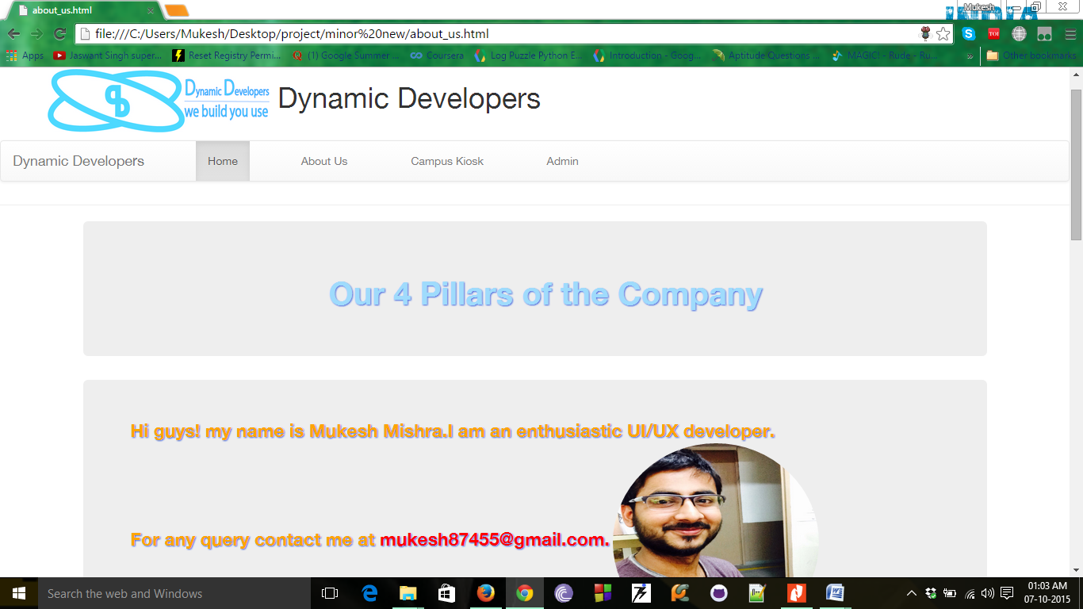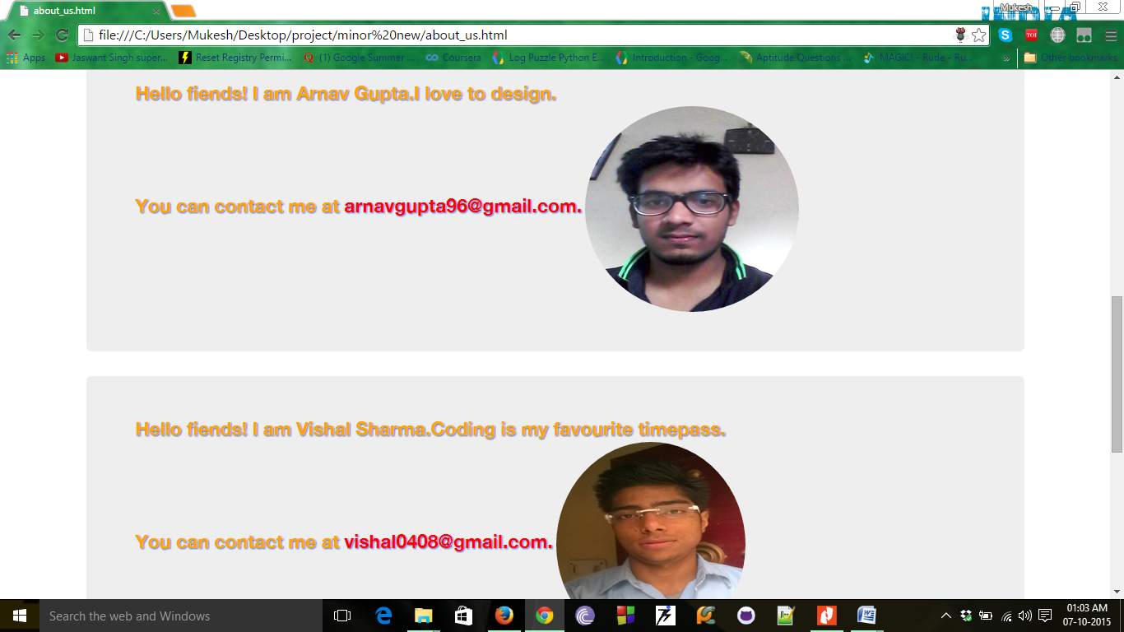

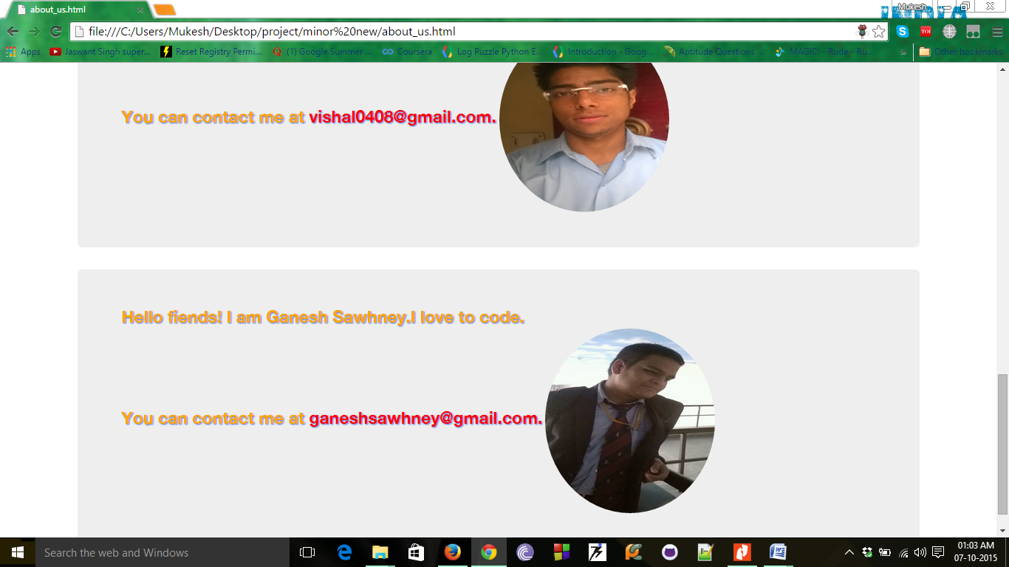

**Log in Page :**

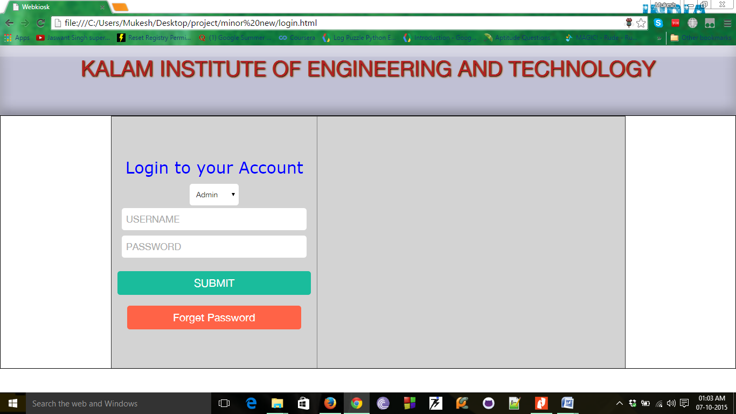

**Admin Page:**

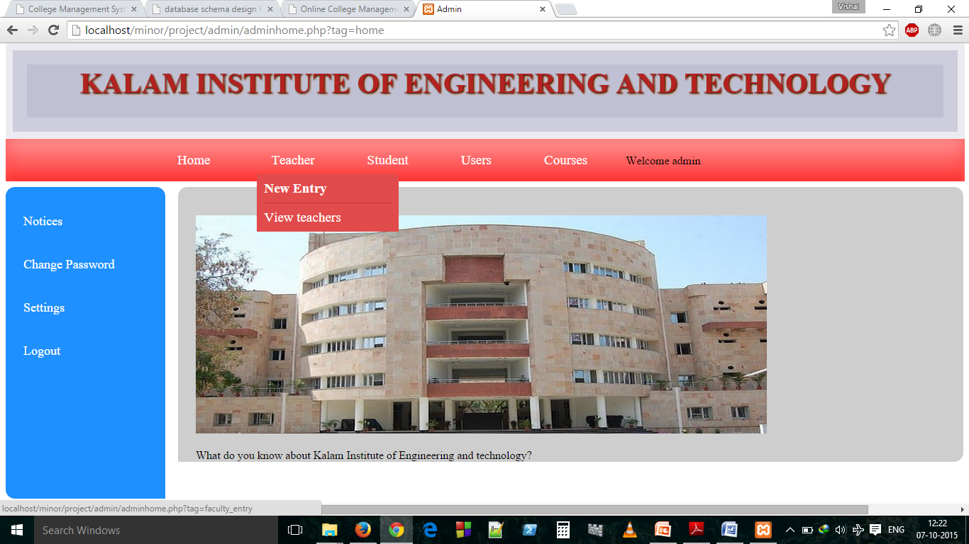

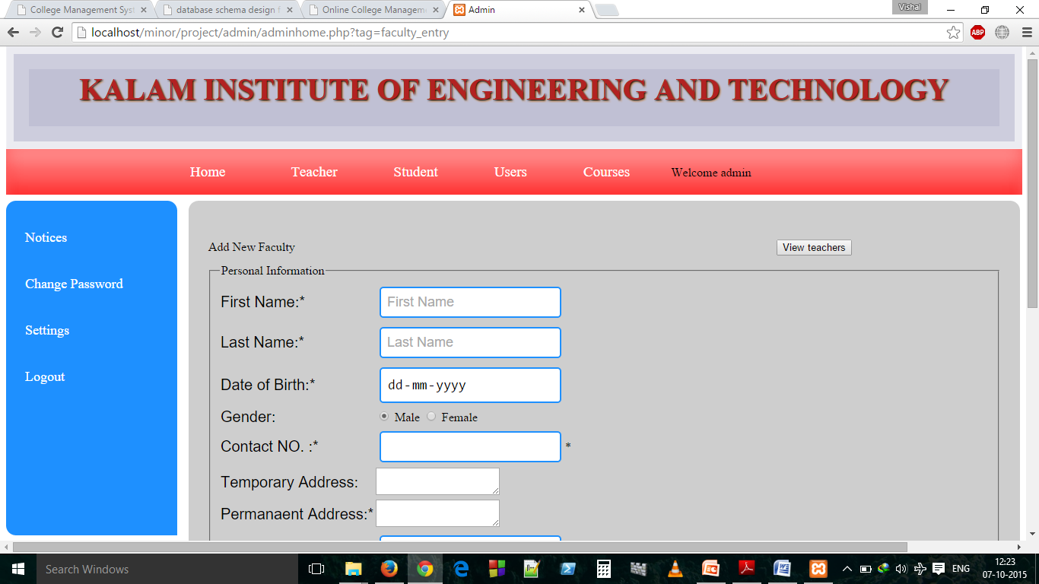

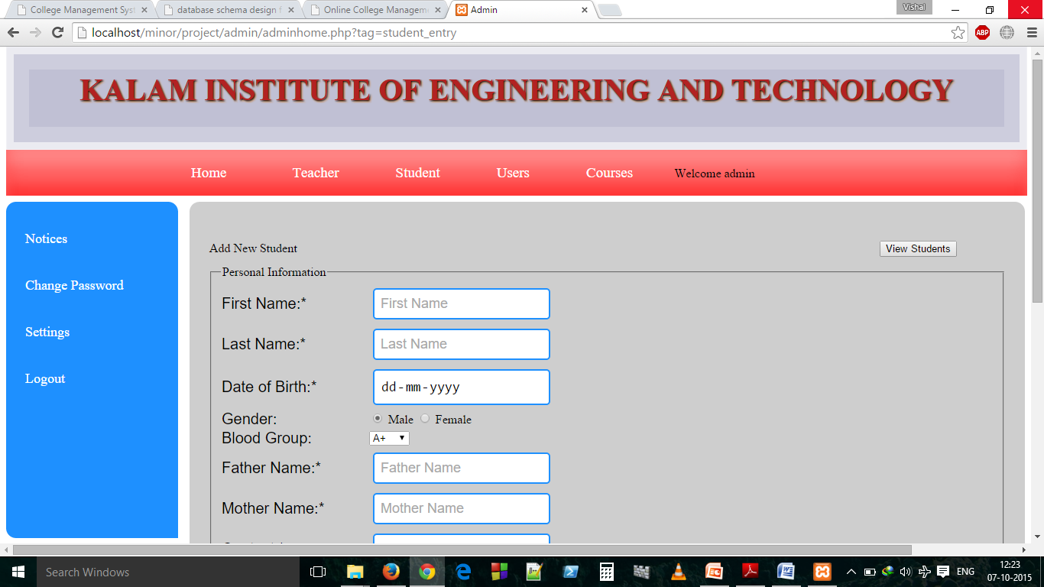

**3.1.2 Hardware Interfaces:**

* Disc space: 40 GB
* Processor: Pentium 3
* Memory: 512 MB RAM
* File System: 32/64 bit

**3.1.3 Software interfaces:**

* Operating System :Windows XP
* Client End Language :HTML, CSS, Java Script
* Server Side Language :PHP 5
* Database :My Sql
* Web Server :XAMPP
* Web Browser :Internet Explorer

**3.1.4 Communications Interfaces:**

The communication between the different parts of the system is important since they depend on each other. However, in what way the communication is achieved is not important for the system and is therefore handled by the underlying operating systems for both the mobile application and the web portal.

**3.2 Functional Requirements:**

3.2.1 Admin:

* Registration of students/teachers.
* Add/Delete/Edit/View student/teacher information.

3.2.2 Super Admin

* Registration of students/teachers/admins.
* Add/Delete/Edit/View student/teacher/admins information.

3.2.3 Student

* View your details
* Edit your details.
* View Attendance information.
* View exam information
* View fee status.
* Request a review for an attendance.

3.2.4 Teacher

* View your details
* Edit your details.
* View/edit Attendance information.
* View exam information
* Tackle the request of a review for an attendance.

**3.3 Behaviour Requirements**

**3.3.1 Use Case View:**

**3.3.2 Class Diagram:**

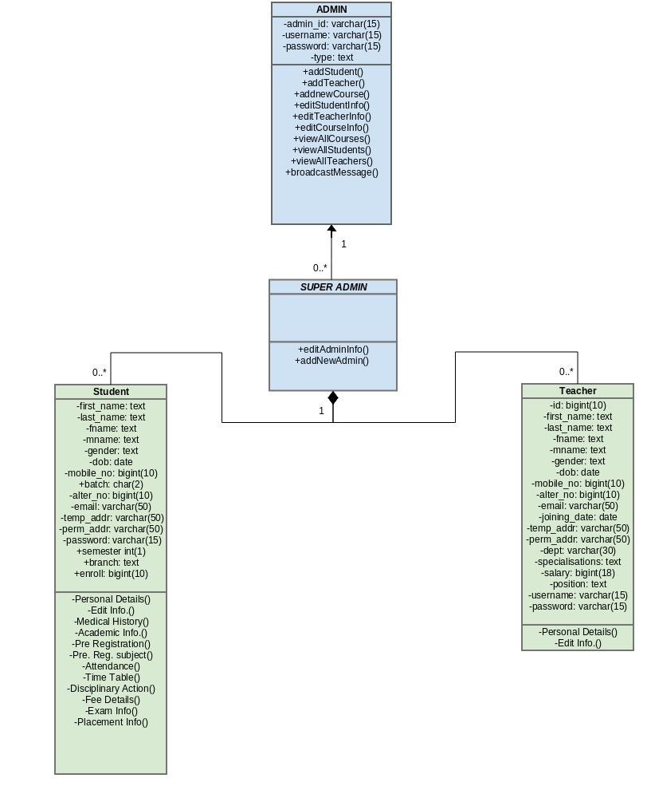

**4. Non-Functional Requirements**

**4.1 Performance Requirement**

* The system shall accommodate high number of students and faculty members without any fault.
* Responses to view information shall take no longer than 10 seconds to appear on the screen.
* If the system loses the connection to the Internet the user should be informed.
* Information transmission should be securely transmitted to server without any changes in information.
* As the system provides the right tools for discussion, problem solving it must be made sure that the system is reliable in its operations and for securing the sensitive details.

**4.2 Safety and Security Requirements**

* System use shall not cause any harm to human users.
* System will use secured database.
* Normal users can just read information but they cannot edit or modify anything except their personal and some other information.
* System will have different types of users and every user has access constraints.

**4.3 Software Quality Attributes**

**Availability:**

If the internet service gets disrupted while sending information to the server, the information can be send again for verification.

**Security:**

The main security concern is for users account hence proper login mechanism should be used to avoid hacking. The tablet id registration is way to spam check for increasing the security. Hence, security is provided from unwanted use of recognition software.

**Usability:**

As the system is easy to handle and navigates in the most expected way with no delays. In that case the system program reacts accordingly and transverses quickly between its states.

**5. Database Requirements**

**5.1 Admin Table:**

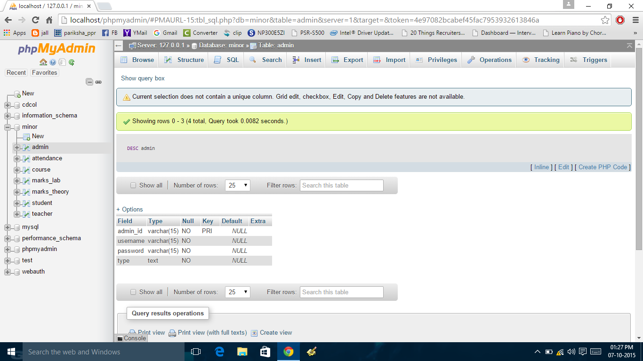

**5.2 Attendance Table:**

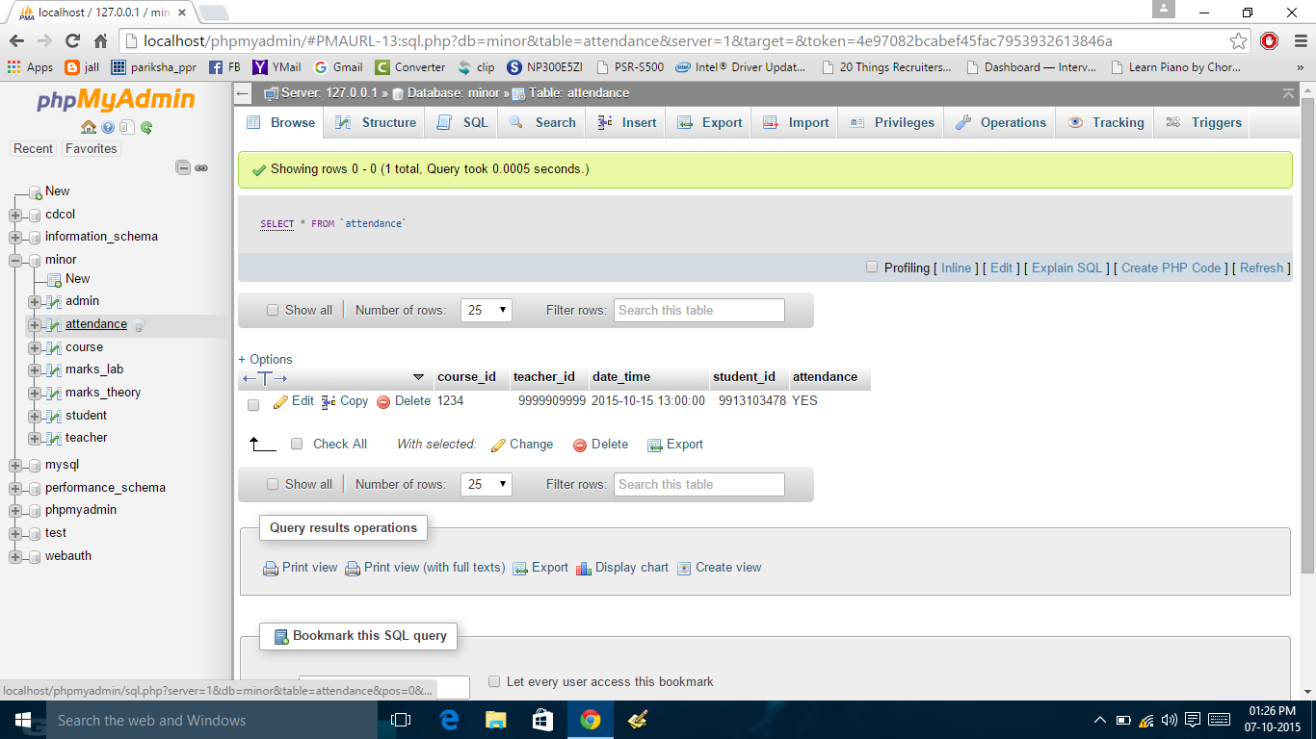

**5.3 Course table:**

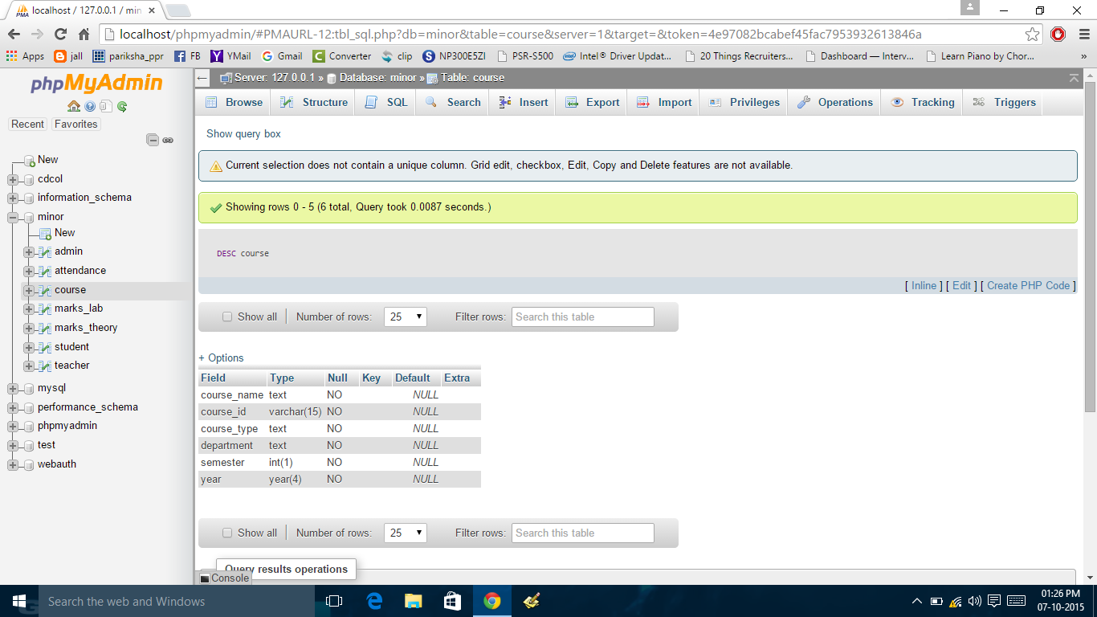

**5.4 Marks_ Lab Table:**

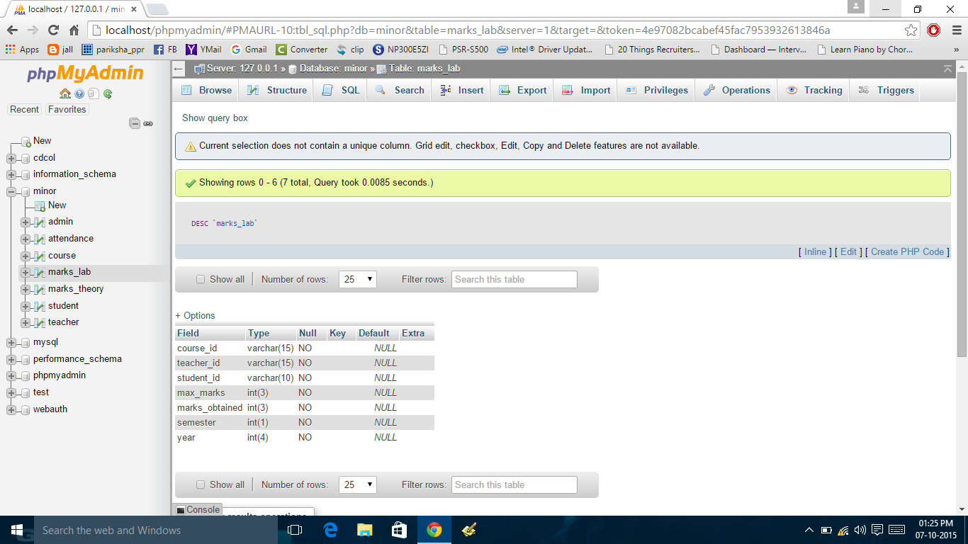

**5.5 Marks_Theory Table:**

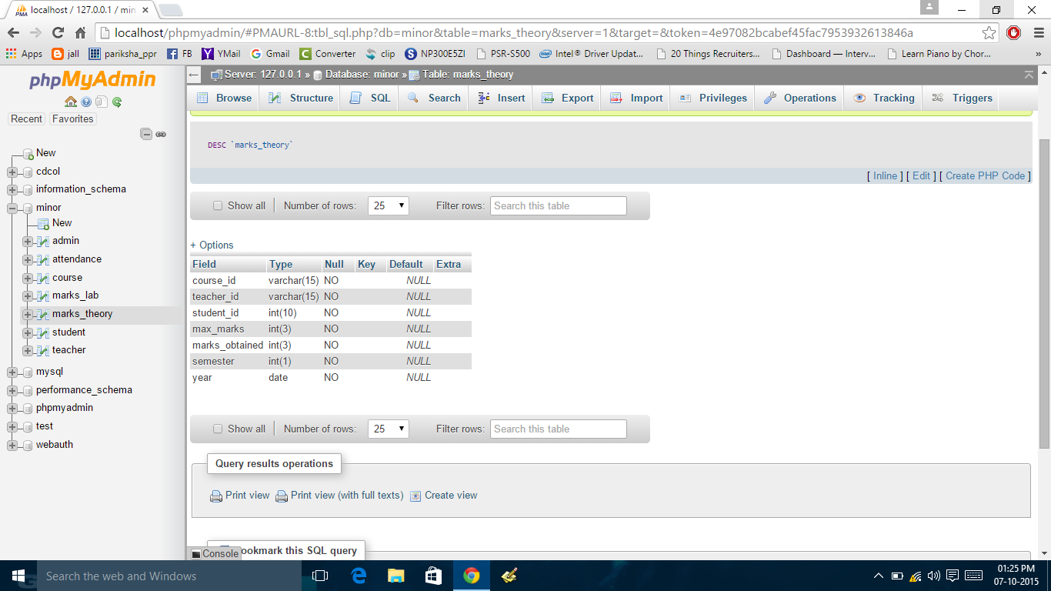

**5.6 Student Table:**

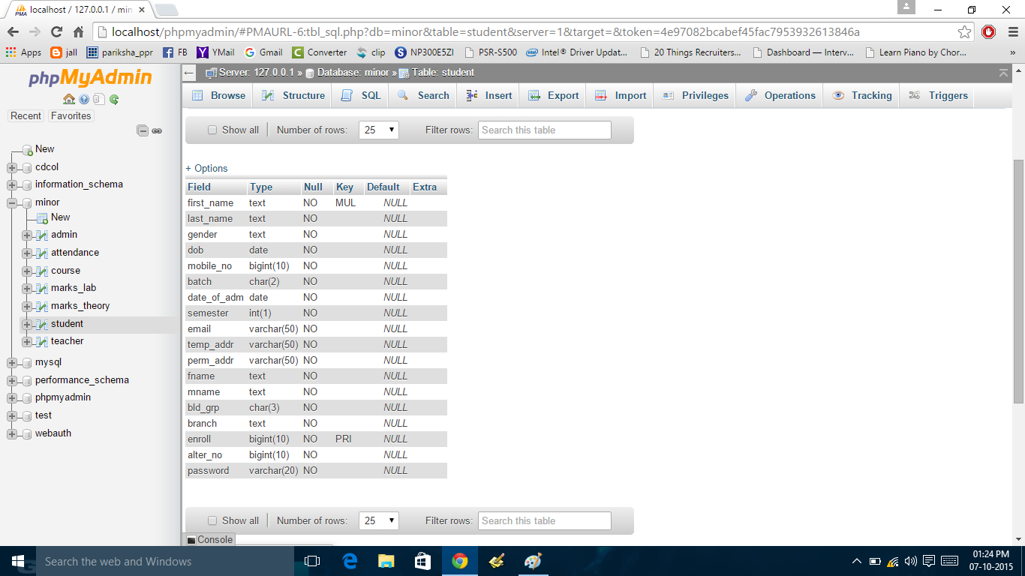

**5.7 Teacher Table:**

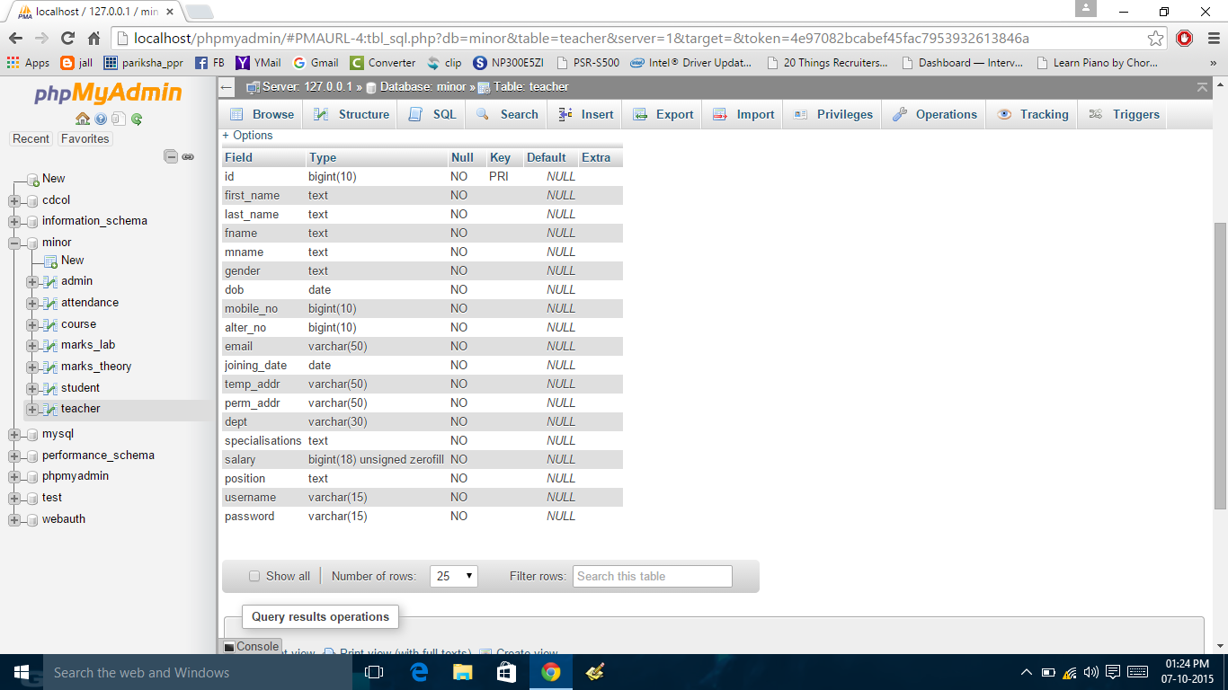

**R**

**Appendix: Reference Paper Summary & Gantt Chart**

|  |  |  |  |  |  |  |  |  |  |
| --- | --- | --- | --- | --- | --- | --- | --- | --- | --- |
| Task | Person Responsible | Week1 | Week2 | Week3 | Week4 | Week5 | Week6 | Week7 | Week8 |
| Homepage | Mukesh,Arnav | Done |  |  |  |  |  |  |  |
| About Us | Mukesh,Arnav |  | Done |  |  |  |  |  |  |
| Login | Mukesh,Arnav |  |  | Done |  |  |  |  |  |
| Admin pages frontend | Arnav,vishal |  |  |  | Done |  |  |  |  |
| Admin pages backend | Vishal |  |  |  | Done |  |  |  |  |
| Student pages Backend | Ganesh |  |  |  |  | Done |  |  |  |
| Teacher pages Backend | Ganesh |  |  |  |  | Done |  |  |  |
| Student/teacher  (frontend) | Arnav,Ganesh |  |  | Done |  |  |  |  |  |
| Presentation | Vishal |  |  |  |  |  |  | Done |  |
| Database | Mukesh | Done |  |  |  |  |  |  | Enhanced |
| Final Report(SRS) | Mukesh,Arnav |  |  |  |  |  |  |  | Done |

**Research Papers Related to Project:**

1. **Paper-1:**

**Research Paper Title:** A Framework for Web Based Student Record Management System using PHP.

**Author(s): Er. Saurabh Walia**, **Er. Satinderjit Kaur Gill**

**Issue Date: 8 Aug 2014**

**Abstract—**Student Record Management System (SRMS) gives a straightforward interface to support of student data. It might be utilized by instructive universities or colleges to keep up the records of students effectively. The creation and administration of error less, exceptional data in regards to a student' scholarly profession is discriminatingly paramount in the colleges and in universities. Student information system manages all sorts of student details, academic related reports, college details, fee details, results, batch details, attendance details and other resource related details too. It tracks all the details of a student from very

first moment to the end of the course which could be utilized for all reporting purpose, tracking of attendance, progress in the study, completed semesters, years, coming semester year curriculum details, fee details, project or any other assignment details, final exam result and all these will be available through a secure, online interface embedded in the college’s Student Record Management System.

1. **Paper-2:**

**Research Paper Title**: A Research Paper on College Management System

**Author(s): Lalit Mohan Joshi**

**Issue Date: 11 July 2015**

**Abstract—** This paper is aimed at developing an Online Intranet College Management System (CMS) that is of importance to either an educational institution or a college. The system (CMS) is an Intranet based application that can be accessed throughout the institution or a specified department. This system may be used for monitoring attendance for the college. Students as well as staffs logging in may also access or can be search any of the information regarding college. Attendance of the staff and students as well as marks of the students will be updated by staff. This system (C.M.S ) is being developed for an engineering college to maintain and facilitate easy access to information. For this the users must be registered with the system after which they can access as well as modify data as per the permissions given to them. CMS is an intranet based application that aims at providing information to all the levels of management within an organization. This system can be used as a knowledge/information management system for the college. For a given student/staff (technical/Non-technical) can access the system to either upload or download some information from the database.

1. **Paper-3:**

**Research Paper Title**: Web Based Student Information ManagementSystem

**Author(s): S.R. Bharamagoudar, Geeta R.B., S.G.Totad**

**Issue Date: 6 Jun 2013**

**Abstract—** Student Information Management System (SIMS) provides a simple interface for maintenance of student information. It can be used by educational institutes or colleges to maintain the records of students easily. The creation and management of accurate, up-to-date information regarding a students’ academic career is critically important in the university as well as colleges. Student information system deals with all kind of student details, academic related reports, college details, course details, curriculum, batch details, placement details and other resource related details too. It tracks all the details of a student from the day one to the end of the course which can be used for all reporting purpose, tracking of attendance, progress in the course, completed semesters, years, coming semester year curriculum details, exam details, project or any other assignment details, final exam result and all these will be available through a secure, online interface embedded in the college’s website. It will also have faculty details, batch execution details, students’ details in all aspects, the various academic notifications to the staff and students updated by the college administration. It also facilitate us explore all the activities happening in the college, Different reports and Queries can be generated based on vast options related to students, batch, course, faculty, exams, semesters, certification and even for the entire college.