**Cloud Application Development**

Media Streaming with IBM Cloud Video Streaming

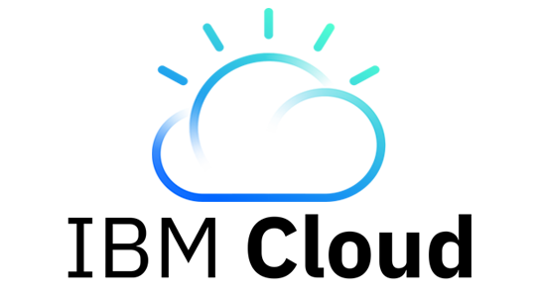

**GROUP MEMBERS:**

Ganesh S (311621104017)

Gowtham P (311621104018)

Jaganathan S (311621104021)

Thameem sayyed (311621104305)

Let us breakdown our project into following steps:

**STEP 1**: Sign in page

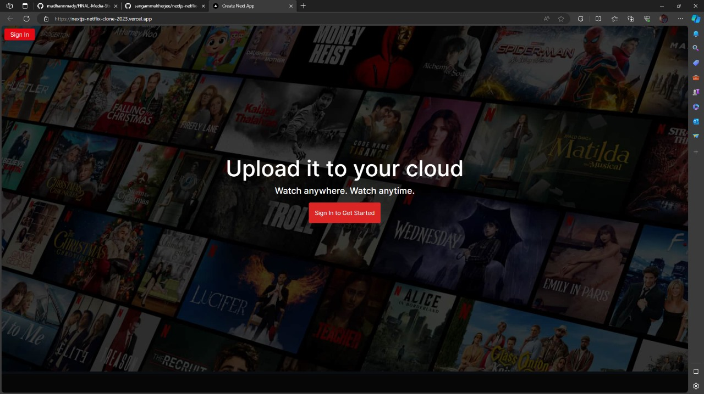

This is the Sign In page. Here the user should sign in to get started and can watch the movies and TV shows anywhere, anytime.

**STEP 2:** Profile page

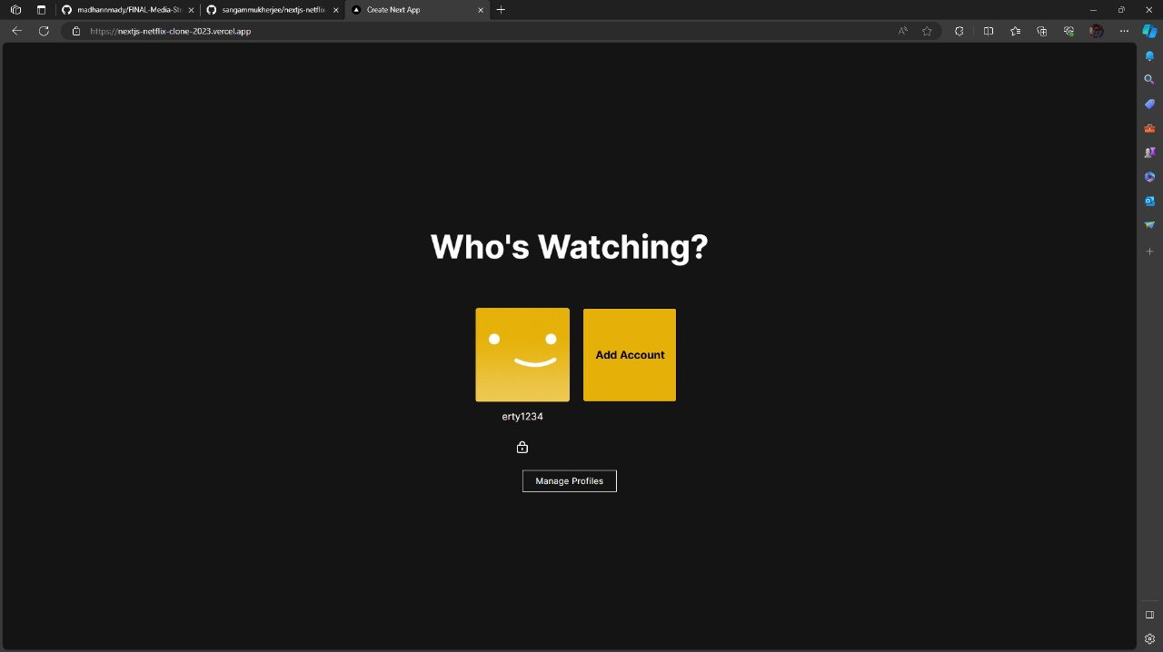

After clicking “Sign in” button, Profile page will appear.

This page is used to manage different profiles for different individuals or even the same individual. The user can select their particular profile in order to start watching the content.

**Step 3:** Authentication Page

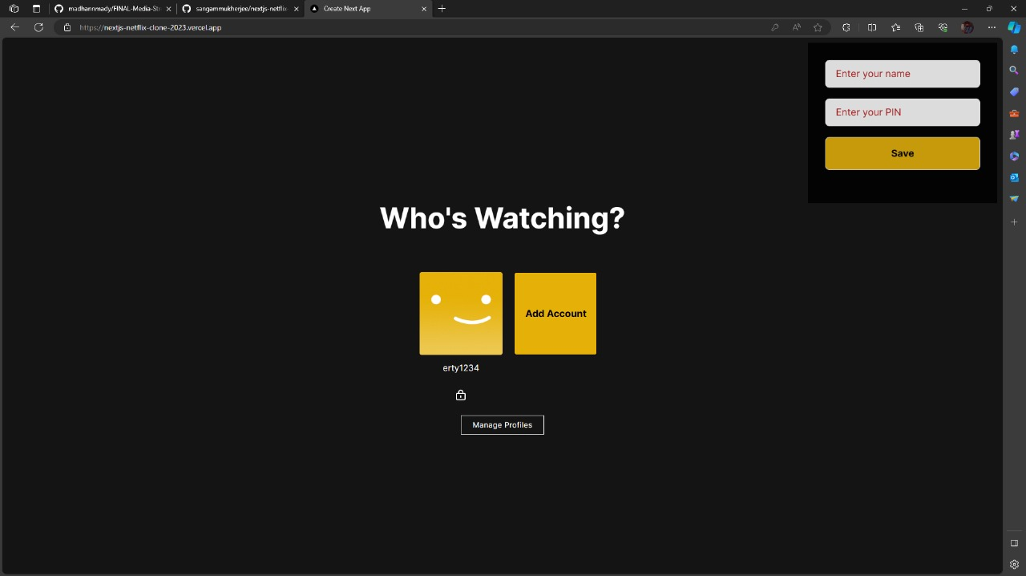

To create the authentication page, we use IBM cloud app ID service.

If the user wants to create a new account, by clicking the Add Account option, we can create a new account. Above is the space to enter our details.

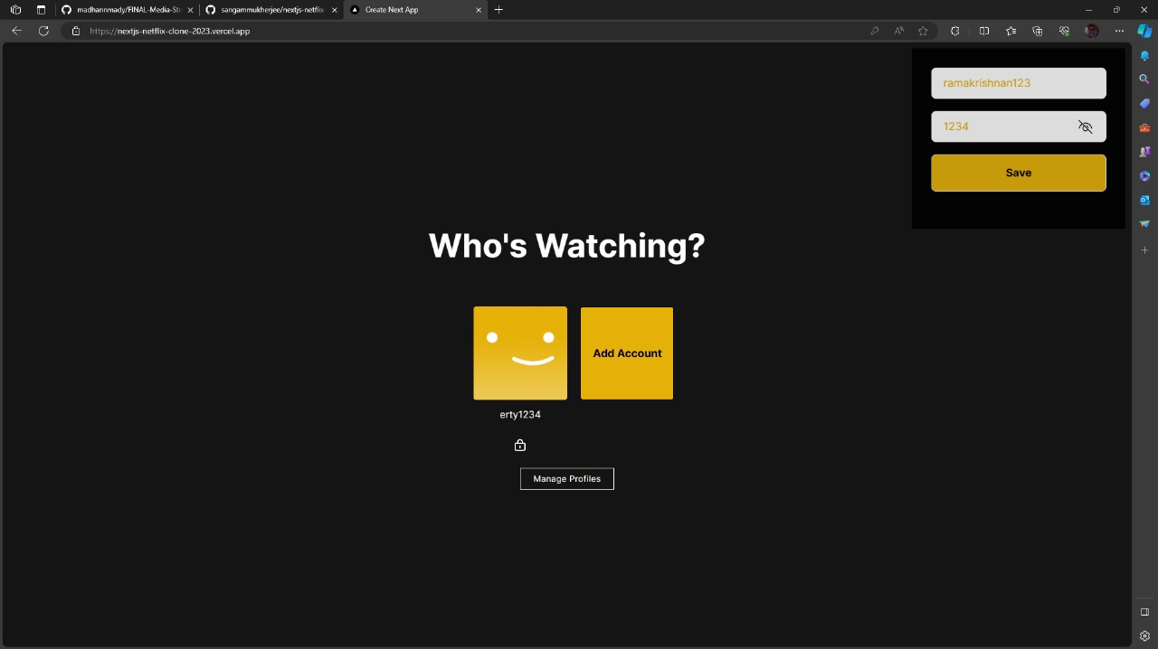

The details of the user are given to create a new account. Then by clicking the Save button, the account will get added.

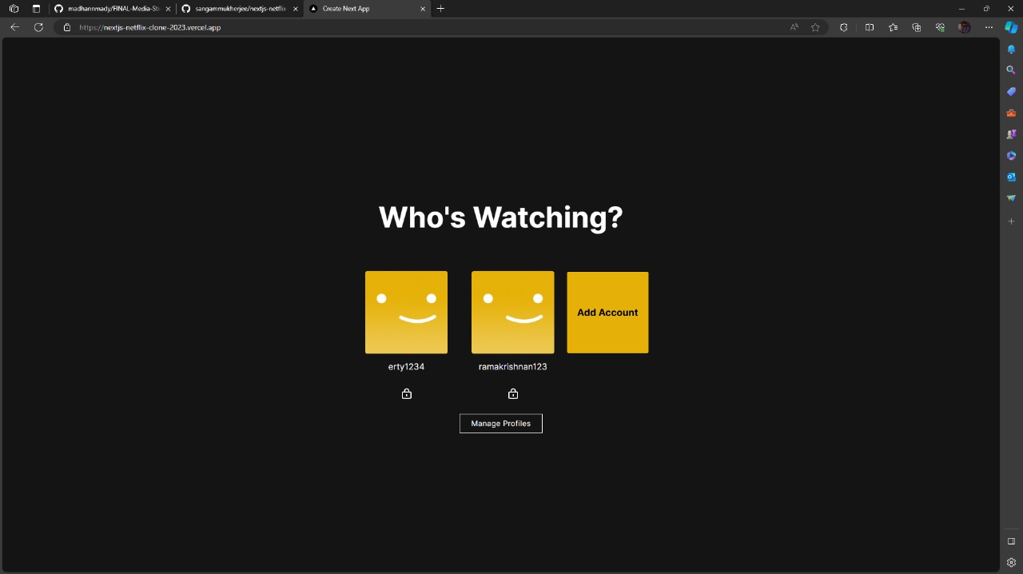

Here the user has created another profile and it has been added as a separate profile so that the user can select the profile needed of his choice.

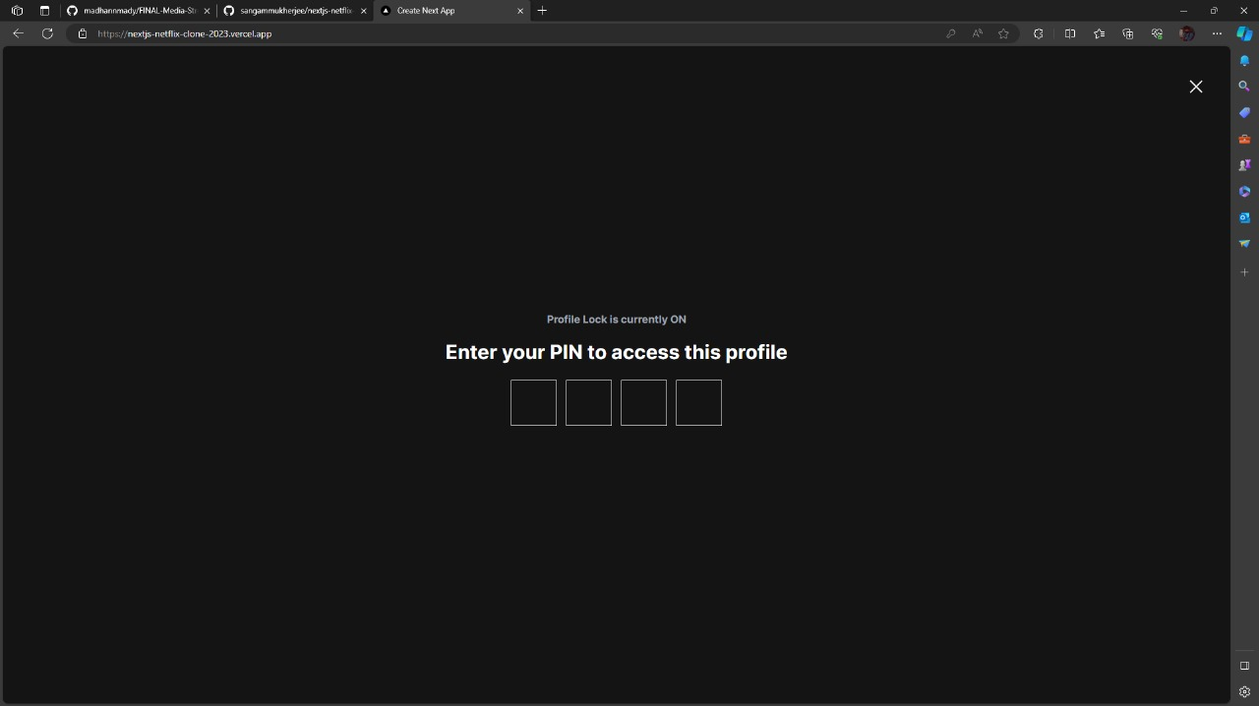

In order to confirm which user is using the account, the PIN must be entered so that the website can make sure that it is the authorized individual who created the account.

**Step 4:** Homepage

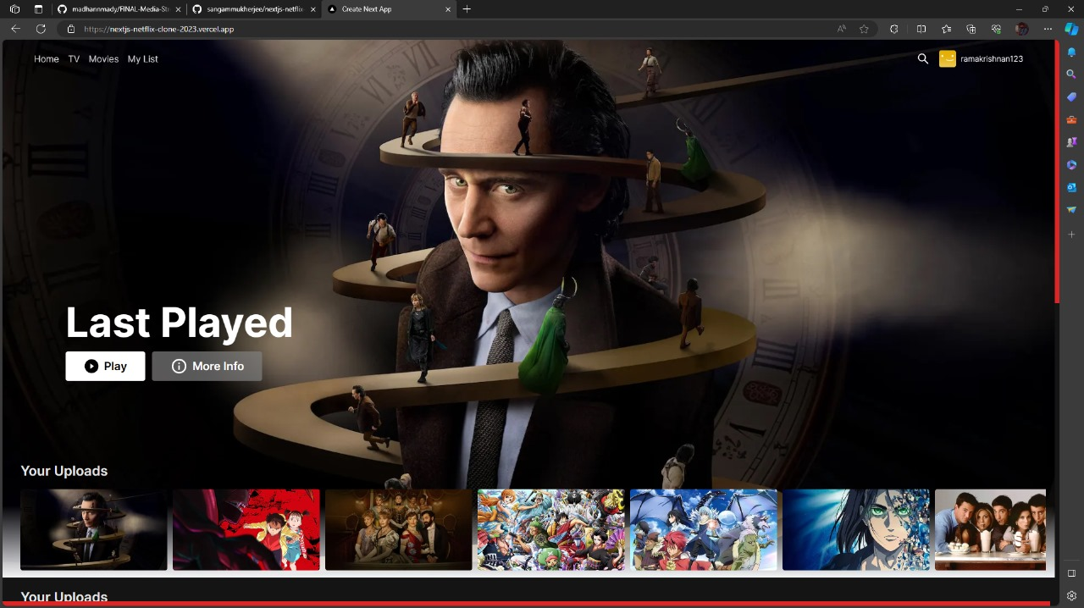

Our homepage has been displayed. We can now watch the content which has been uploaded by the user. The user can also upload any type of genre according to his wish and can stream it. The user has also given four options where each one has different purposes:

• **HOME** button can be used to go back to the Sign In page.

• **TV** button is where the user can access to all TV shows he has uploaded.

• **MOVIES** button is also same as TV, where the user can watch different types of movies he has uploaded.

• **MY LIST** button can be used to have a particular list of content where the user has saved them in order to watch them later.

**Step 5:** Streaming page

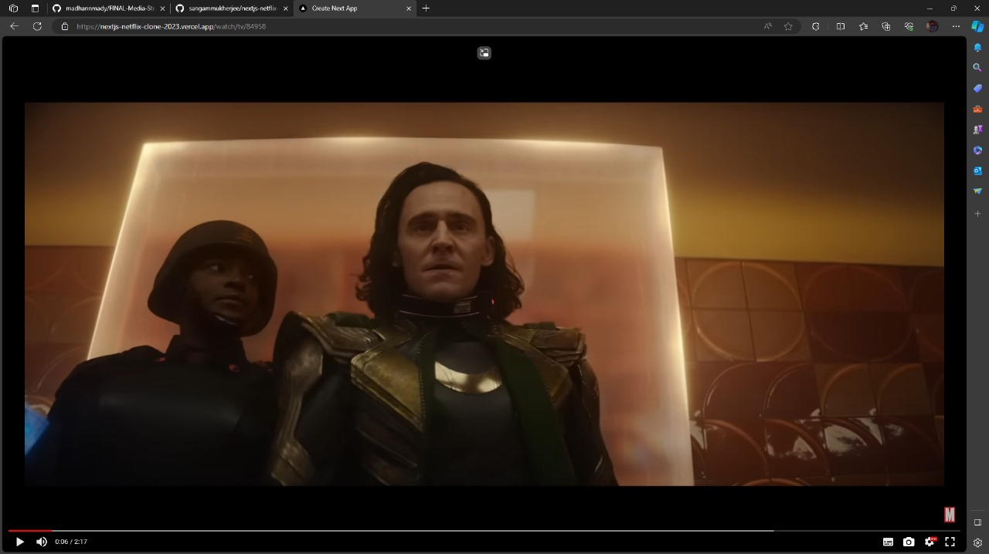

Here the user has clicked a TV show and he is being send to that particular content which has been uploaded and now can be streamed anytime, anywhere.

**Key Features:**

**1. Content Management**: The platform will offer an easy-to-use content management system for media creators and administrators. It allows the uploading, categorization, and organization of audio and video files, including metadata and cover art.

**2. User Authentication and Authorization:** Users will be able to create accounts, log in, and have personalized experiences. Different user roles (e.g., viewers, content creators, administrators) will have varying levels of access and privileges.

**3. Content Delivery:** The core functionality of the platform is efficient content delivery. It should support adaptive streaming, ensuring optimal quality based on the viewer's internet connection. Content will be delivered securely over HTTPS.

**4. Search and Recommendation:** Implement a powerful search algorithm to help users find content easily. Additionally, a recommendation engine can

suggest new content based on a user's viewing history and preferences.

**5. Streaming Analytics:** Collect data on user interactions, playback statistics, and engagement metrics. Use these analytics to make informed decisions about content creation and delivery optimization.

**6. Cross-Platform Compatibility:** Ensure the platform is accessible on a variety of devices and operating systems, including web browsers, mobile apps (iOS and Android), smart TVs, and streaming devices like Roku, Amazon Fire