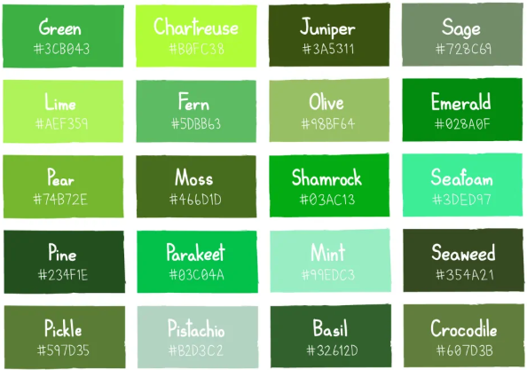

1) Hibiscus Light shade

227 63 62 - #e33f3e

2) Hibiscus dark shade

144 18 32 - #901220

3) Hibiscus very dark shade

195 52 54 - #c33436