.NET Types

# Value types and Reference types

Value types: Value types are data types that store data directly in their placeholders.

Reference types: Reference types are data types that store the address of the variable in their placeholders.

Fig.1 illustrates this in C-pointer syntax.

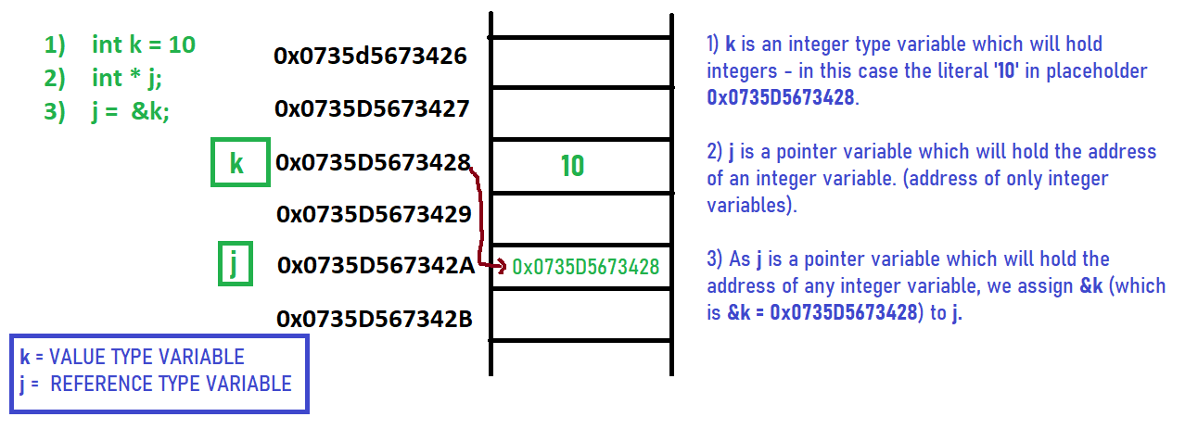

**Fig.1** Value & reference types.

In the case of .NET, value types are stored in the memory area called as the stack (the other one being heap).

# Strongly typed vs weakly typed data types

.NET Languages (and hence C#) is a strongly-typed language. It means we must declare the type of a variable which indicates the kind of values it is going to store such as integer, float, decimal, bool, etc.

**Javascript** is not strongly typed as for every variable (weather the literal is ‘ganesh’ or 108 or true) it is going to be stored in a var – not in int or string or bool.

# .NET Data types

Most of the basic data types (pre-defined) are value types. object and string which are basic data types are reference types and are created in the heap.

Instances of classes, which are user defined data types, are reference types and are created in the managed heap. Instances of structs and enums which are user defined types are value types and are created in the stack. Fig.2 shows the types versus allocation place matrix.

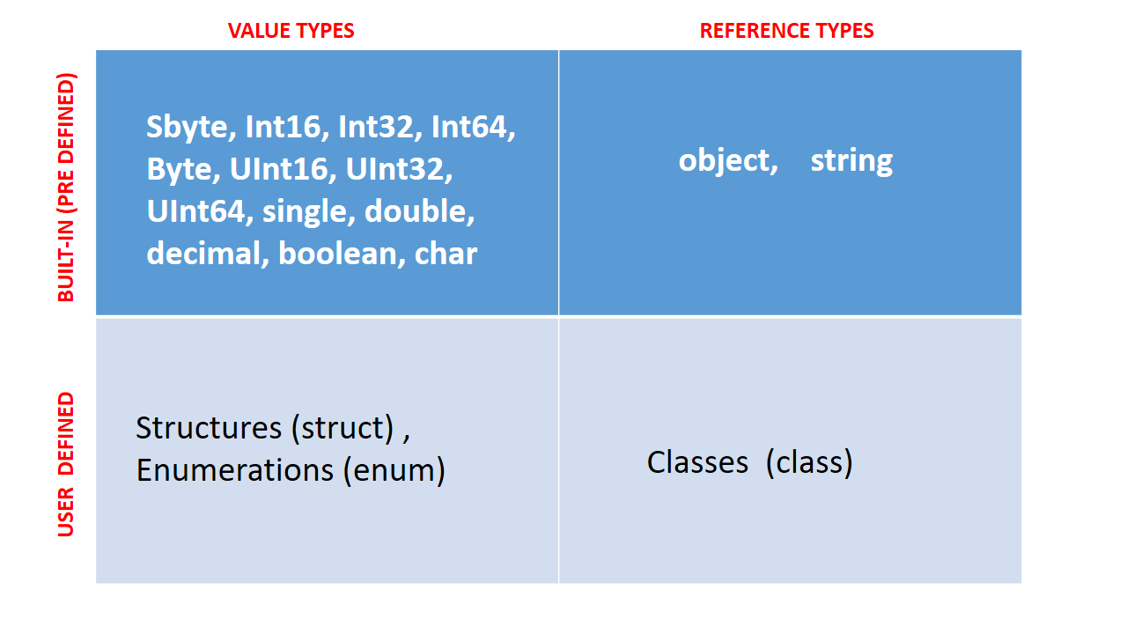

Fig.2. The Types Matrix.

Fig.3 below shows a detailed table about the predefined data types and their allocations.

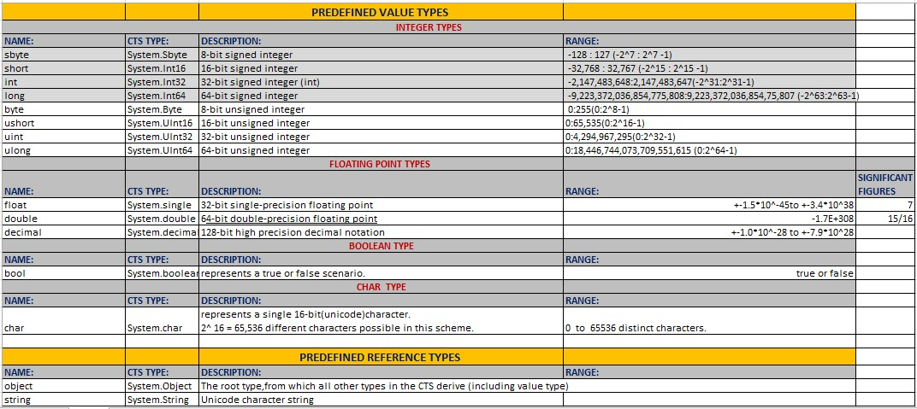

Fig.3. Pre-defined types of the .NET Framework