# Conditional Control Structures

## If statement

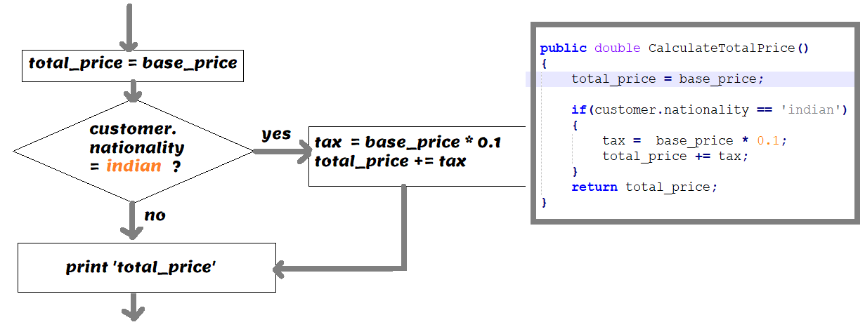

**Illustration #1**: If statement

Download If Statement codes

## If...else statement

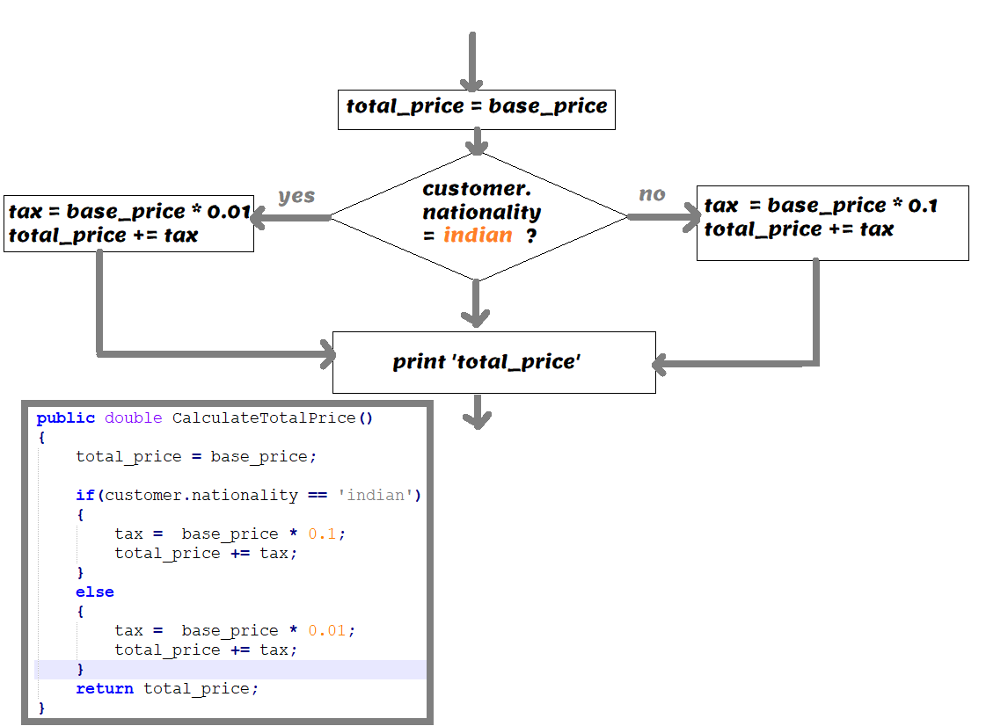

**Illustration #2**: If – else statement

Download If…else statement codes

## switch…case

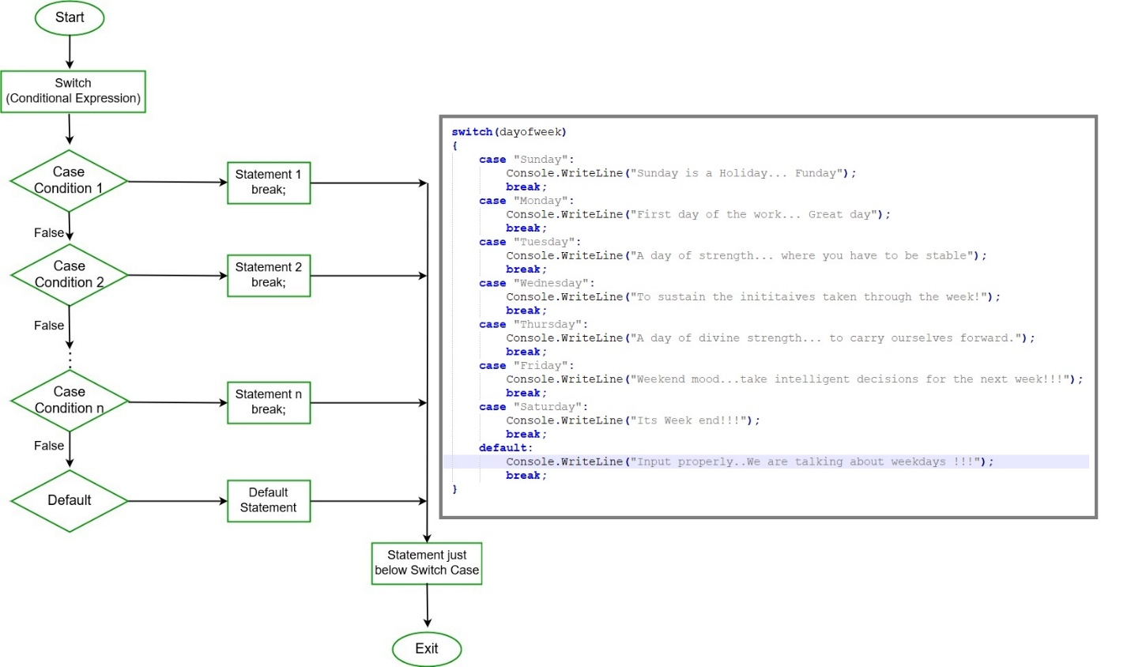

**Illustration #3**: switch…case statement

Download switch…case statement codes

# Looping Control Structures

## For

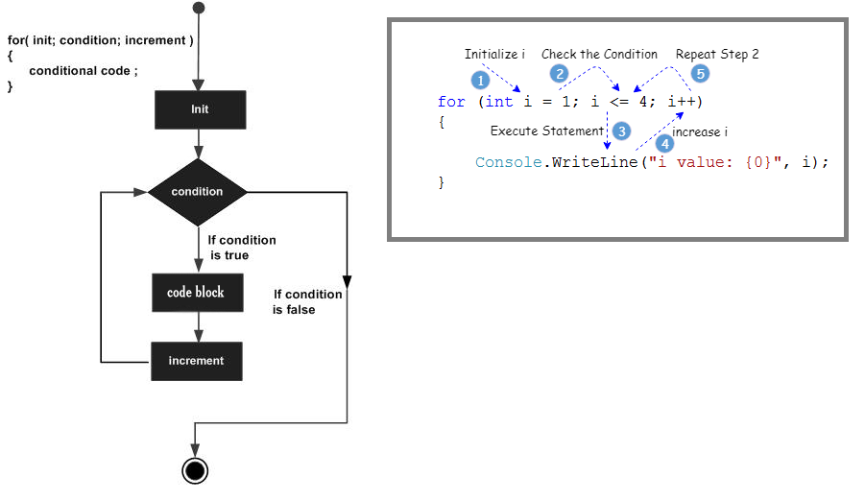

**Illustration #4**: for loop statement

Download for loop statement codes

## do…while

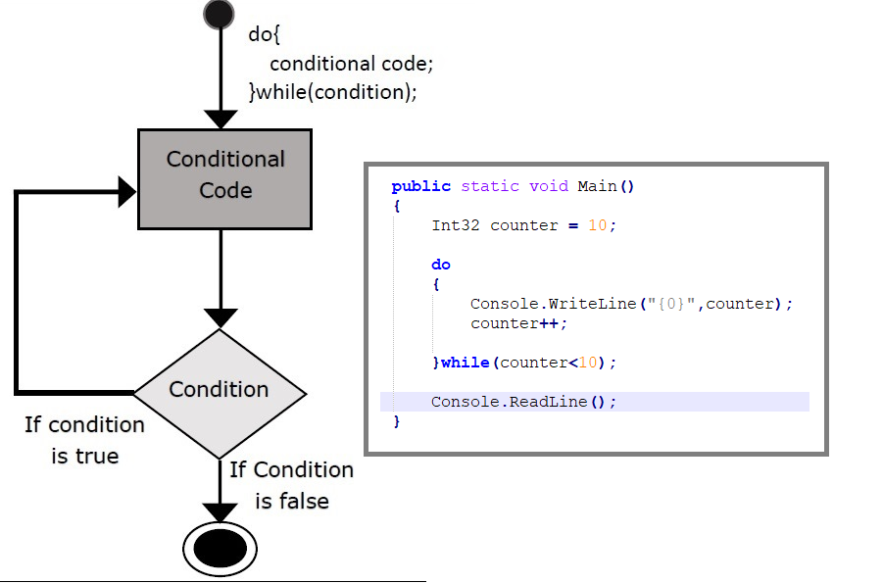

**Illustration #5**: do…while statement

Download do…while statement codes

## while

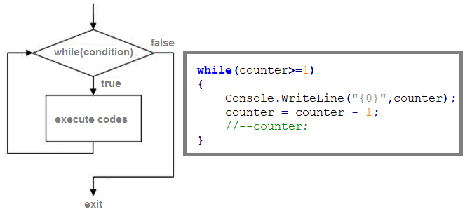

**Illustration #6**: do…while statement

Download while statement codes

## foreach

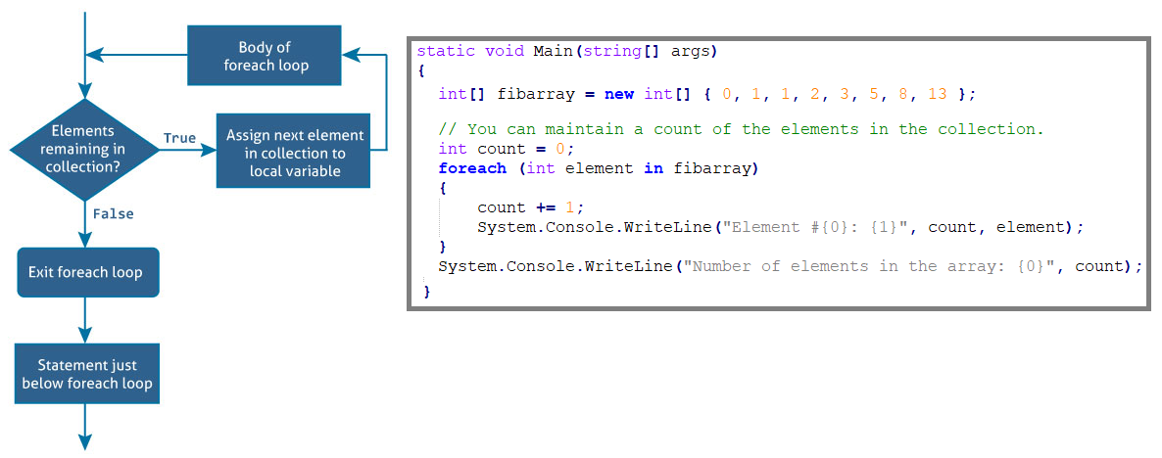

**Illustration #7**: foreach statement

Download foreach statement codes

# Unconditional control Structures

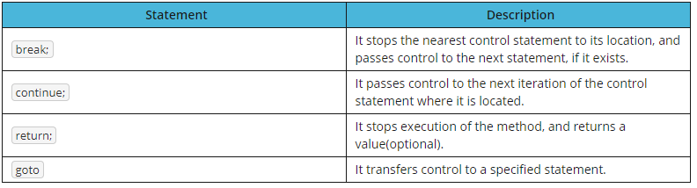

**Illustration #8**: UN-conditional statements.

Download codes illustrating unconditional statement codes