# Half Pyramid (n =5)

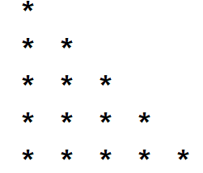

# Full Pyramid (n =5)

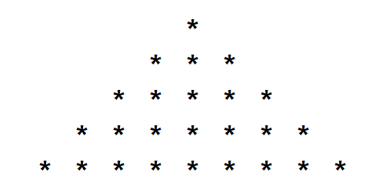

# Inverted Half Pyramid (n =5)

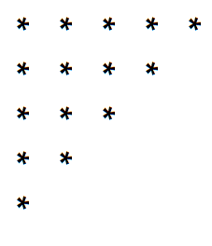

# Inverted Full Pyramid (n =5)

