# Definition

Namespaces are used to organize classes, structs, delegates, enums etc that make up a program into logical containers. They are not mandatory but highly recommended.

Class library’s supplied by 3rd party vendors (and even Microsoft) often categorizes the components into namespaces packed in one or more assembly(s).

Fig.1 shows classes categorized in namespaces.

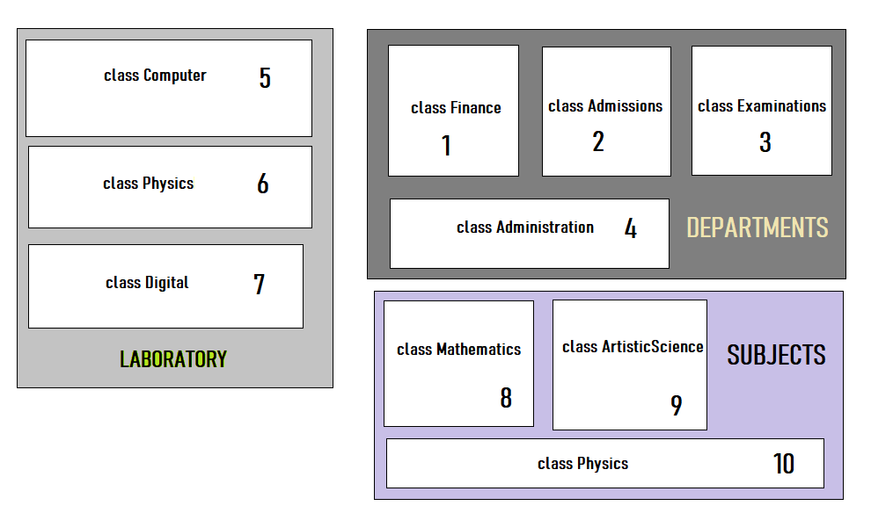

Fig.1. Classes organized in Namespaces.

Fig.2 illustrates that classes that are packed in namespaces can be distributed in multiple assembly(s).

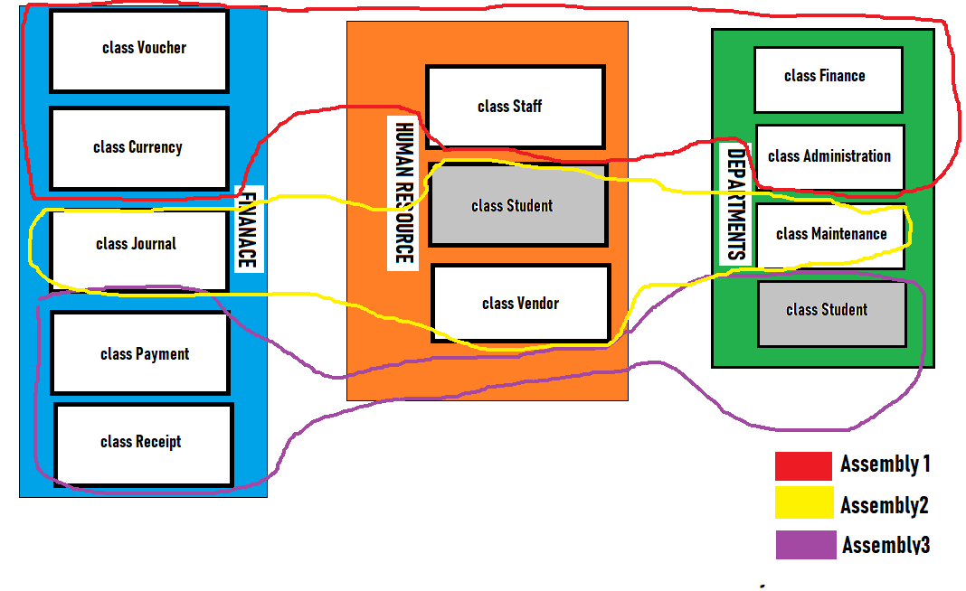

Fig.2. Classes organized in Namespaces and Assemblies.

Table.2 shows the classes that are distributed across namespaces and the assemblies.

|  |  |  |  |
| --- | --- | --- | --- |
| **Sl No.** | **Class Name** | **Namespace** | **Assembly** |
| 1 | Voucher |  |  |
| 2 | Currency |  |  |
| 3 | Finance |  |  |
| 4 | Administration |  |  |
| 5 | Staff |  |  |
| 6 | Journal |  |  |
| 7 | Student |  |  |
| 8 | Vendor |  |  |
| 9 | Maintenance |  |  |
| 10 | Payment |  |  |
| 11 | Receipt |  |  |
| 12 | Student |  |  |