Encapsulation

The bundling of variables and the methods that are going to operate on those variables, into one single unit (a class), is called as encapsulation. Fig.1 shows the accessibility pattern-

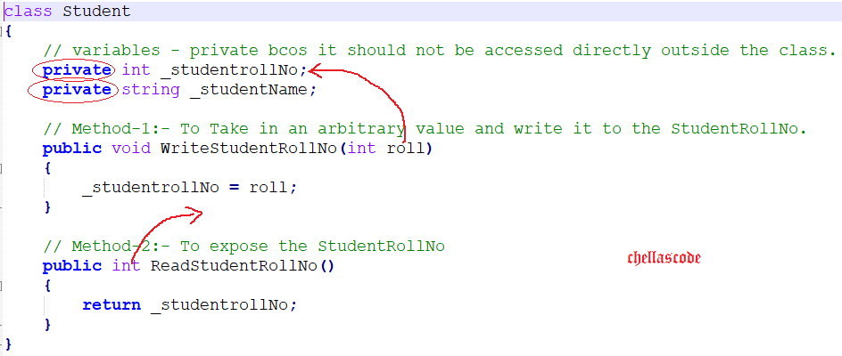

Fig.1 Accessibility Pattern

**Important Points**

1) The variables - _studentrollNo and _studentName are private and cannot be accessed outside the class. They can be accessed only by methods that are within that class – WriteStudentRollNo(int roll) and ReadStudentRollNo().

2) Methods are marked public so that they can accessed from outside. The programmer accesses the variables indirectly by calling the methods directly.