C# classes and Instantiation

Fig.1 shows a class template named Stock that gets instantiated in the heap. Each instance of Stock will occupy 44 bytes in the heap shown in Table 1.

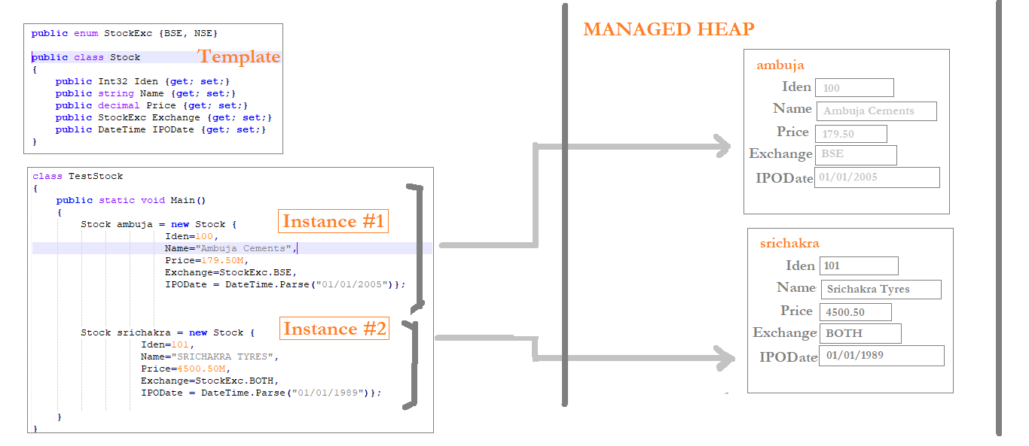

Fig.1 Allocation of memory in managed heap.

|  |  |  |  |  |
| --- | --- | --- | --- | --- |
| **Sl.** | **Field Name** | **Type** | **Allocated Memory** | **Comments** |
| 1 | Iden | Int32 | 4 bytes |  |
| 2 | Name | string | 4 bytes | String being reference type – it store the 4 byte address where the actual string literal is stored. |
| 3 | Price | decimal | 24 bytes |  |
| 4 | Exchange | Enum | 4 bytes | StockExch is an Enum which will take 4 bytes to store the index number as Int32. |
| 5 | IPODate | DateTime | 8 bytes |  |
| **TOTAL:** | | | **44 bytes** |

Table 1: Memory Allocation for a Stock Instance.