## Static Class

A static class is a class which cannot be instantiated (you cannot make instances or objects using the new keyword) – or rather which is not meant to be instantiated. Why? – Because it doesn’t store something that changes from instance to instance.

To understand this lets look into Fig.1.

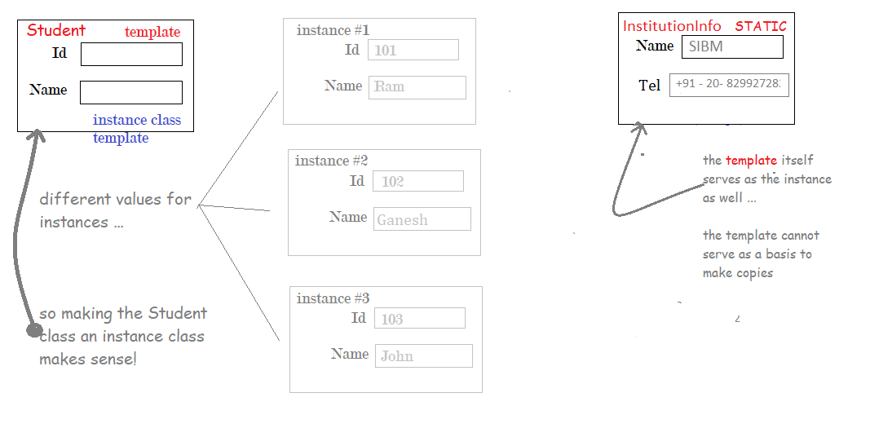

Point 1: We create the Student class as an instance class (in contrast to a static class) because the Id and Name property changes for every instance of student the programmer creates.

Point 2: We create the InstitutionInfo as a static class because the Name and Tel will be the same – it will not change from instance to instance. Name and Tel both are static properties and will not change – so when all the members of the class are static we can make the class also static.

**Important**: A static class cannot have instance members – no point in it.

Point 3: The members of a static class (which are again static variables or static properties) have to be initialized. Static constructors are used to initialize the static components.

**Important**: A static constructor is used to initialize the static members of a class and an instance constructor is used to initialize the instance members of a class.

Point 4:

## Static Variables

## Static Methods

## Static Properties

## Static Constructors