Observer Pattern

# Definition

The Observer design pattern defines a one-to-many dependency between objects so that when one object changes state, all its dependents are notified and updated automatically.

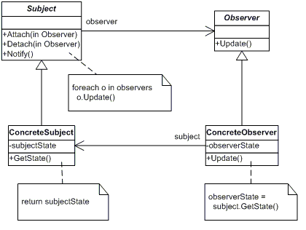

# Participants

The classes and objects participating in this pattern include:

* Subject  (Doctor)
  + knows its observers. Any number of Observer objects may observe a subject
  + provides an interface for attaching and detaching Observer objects.
* ConcreteSubject  (Ganesh)
  + stores state of interest to ConcreteObserver
  + sends a notification to its observers when its state changes
* Observer  (IDean)
  + defines an updating interface for objects that should be notified of changes in a subject.
* ConcreteObserver  (Dean)
  + maintains a reference to a ConcreteSubject object
  + stores state that should stay consistent with the subject's
  + implements the Observer updating interface to keep its state consistent with the subject's

# References

https://www.dofactory.com/net/observer-design-pattern