Files and Registry

# File and Registry

**File:** A file is the common storage unit in a computer, and all programs and data are "written" into a file and "read" from a file. A folder holds one or more files, and a folder can be empty until it is filled. A folder can also contain other folders (sub folder) , and there can be many levels of folders within folders.

**Registry**: A central hierarchical database used in Windows 98, Windows CE, Windows NT, Windows 2000 and later modern Windows Operating system used to store information that is necessary to configure the system for one or more **users**, **applications**, and **hardware devices**.

# Managing the File System

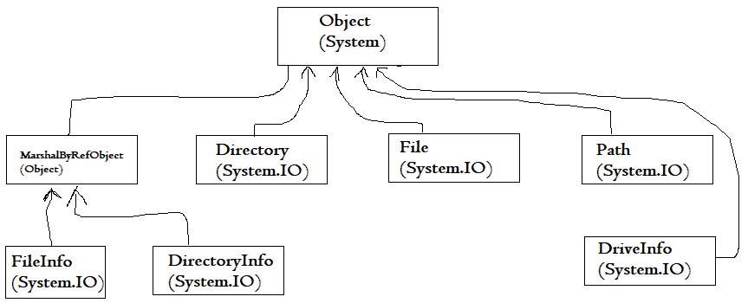

## System.MarshalByRefObject

Base object class for .NET classes that are remotable; permits marshalling of data between applications.

## FileSystemInfo

Base class that represents any File system object

## FileInfo and File

Represent a file on the File system. Class File contains only static method and are never instantiated. Use the File class by using the appropriate file system object whenever you call a member method. When you want to work only on a single method on the File, use the File class.

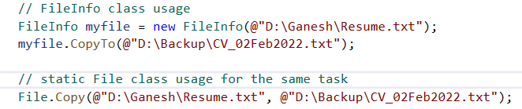

## DirectoryInfo and Directory

Represents a Directory (Folder in windows terminology) in the File system. Class Directory contains only static method and are never instantiated. Use the directory class by using the appropriate file system object whenever you call a member method. When you want to work only on a single method on the Directory, use the Directory class.

## Path

Contains static members that you can use to manipulate path names.

## DriveInfo

Provides properties and methods that provide information on a selected drive.

## Commonality - DirectoryInfo and FileInfo

They implement roughly the same methods as their static counterparts – Directory and File respectively. In addition to this, it also implements some public properties and constructors. They are stateful and the members of these classes are not static. You need to instantiate these classes before you can use them.

## Properties – FileInfo and DirectoryInfo

|  |  |  |
| --- | --- | --- |
| **Sl.No** | **Name** | **Description** |
| 1 | CreationTime | File or Folder creation time. |
| 2 | DirectoryName  (FileInfo) | Full path name of the containing folder. |
| 3 | Parent  (DirectoryInfo) | The parent directory of a specified subdirectory. |
| 4 | Exists | File or Folder Exists |
| 5 | Extension | Extension of the file. Returns blank for the folders. |
| 6 | FullName | Full pathname of the file or folder. |
| 7 | LastAccessTime | Time File or folder was last accessed. |
| 8 | LastWriteTime | Time File of folder was last modified. |
| 9 | Name | Name of the file or folder. |
| 10 | Root  (DirectoryInfo) | The root portion of the path. |
| 11 | Length  (FileInfo) | The size of the file in bytes. |

## Methods – FileInfo and DirectoryInfo

|  |  |  |
| --- | --- | --- |
| **Sl.No** | **Name** | **Description** |
| 1 | Create() | Creates a folder or file of a given name. For a FileInfo, this also returns a stream object to let you write to the file. |
| 2 | Delete() | Deletes the file or folder. For folders, there is an option to delete recursively. |
| 3 | MoveTo() | Move and / or renames the file or folder. |
| 4 | CopyTo() | FileInfo only. Not available for DirectoryInfo |
| 5 | GetDirectories() | DirectoryInfo only. Returns an array of DirectoryInfo DirectoryInfo objects representing all folders contained in this folder. |
| 6 | GetFiles() | (Only DirectoryInfo) Returns an array of FileInfo objects representing all the FileInfo objects contained in this folder. |
| 7 | GetFileSystemInfos() | (Only DirectoryInfo) Returns FileInfo and DirectoryInfo objects representing all objects contained in this folder. – As an array of **FileSystemInfo** objects. |

# Windows Registry

A central hierarchical database used in Windows 98, Windows CE, Windows NT, and Windows 2000 used to store information that is necessary to configure the system for one or more **users**, **applications**, and **hardware devices**.

The Registry contains information that Windows continually references during operation, such as **profiles for each user**, the **applications installed** on the computer and the **types of documents** that each can create, **property sheet settings** for folders and **application icons**, what **hardware** exists on the system, and the **ports** that are being used.

The Registry replaces most of the text-based **.ini** files that are used in Windows 3.x and **MS-DOS** configuration files, such as the **Autoexec.bat** and **Config.sys**. Although the Registry is common to several Windows operating systems, there are some differences among them.  A registry hive is a group of **keys**, **subkeys**, and **values** in the registry that has a set of supporting files that contain backups of its data.

## REGISTRY HIVES

A registry hive is a **group** of **keys**, **subkeys**, and **values** in the registry that has a set of supporting files that contain backups of its data.

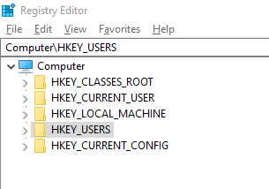

The keys are container objects very similar to folders that can contain other keys or values. The values can be a **string**, **binary**, or **DWORD** depending on the scenario.

### ****HKEY_CLASSES_ROOT****

This root element holds the information about registered (installed) applications and associated file extensions. For example, Windows is able to open the .pdf extension with Acrobat Reader because of the settings in this key. It is not advised to alter these keys manually and the Folder Options in the Windows Explorer should be used instead.

### ****HKEY_CURRENT_USER****

This root element represents the currently logged-in user and their specific settings. It is a link to a subkey of HKEY_USERS that corresponds to the current user. It cannot be edited.

### ****HKEY_LOCAL_MACHINE****

This root element contains five sub-keys (hardware, security accounts manager, security, software, system) that are used for storing many kinds of settings used by the operating system. Hardware, security and security accounts manager subkeys can't be edited. It is not advised to manually alter the rest as it might result in a system crash.

### ****HKEY_USERS****

This root element holds all the user profiles used on the machine. Even though it can be edited, you should be very cautious when doing so.

### ****HKEY_CURRENT_CONFIG****

This root element contains read-only settings about the available hardware settings. These settings are not permanently stored on disk, but generated at the boot time and updated at runtime.

## Registry - Reading and Writing Operations

# References

<https://docs.microsoft.com/en-us/troubleshoot/windows->

server/performance/windows-registry-advanced-users