LinkedIn Post: Loan Underwriting Orchestrator
Draft ready to paste. Attach the architecture diagram below as the post image.

Post text
I just built an AI-assisted Loan Underwriting Orchestrator, and the design principle behind it matters more than the model it uses: let AI read and reason, but let deterministic code decide.
Here is how it works:
📄 A RiskOps user uploads a loan PDF. A 7-step workflow runs it: ingest, extraction, compliance, scorecard, risk, decision, finalize.
🤖 LLMs handle the language-heavy parts: pulling financial metrics with per-field confidence, raising compliance flags with evidence, and drafting a risk recommendation with rationale.
⚖️ The scorecard and the approve/deny/escalate decision are plain, versioned code (policy DM-1.0.0). Same inputs, same answer, fully auditable. Low-confidence extractions escalate to a human instead of guessing.
👤 An Underwriter makes the final call. Approve, deny or override, with a reason, and never on a case they submitted themselves. Every step lands in an audit trail.
💬 A grounded Q&A (RAG) lets reviewers ask questions about a case. Guardrails block prompt injection, citations must map to retrieved excerpts, and a grounding check verifies every figure in the answer.
Stack: ASP.NET Core 8 minimal APIs, React + Vite, SQL Server with vector search, and SignalR.
The part I am happiest with: the same code runs fully on-prem with Foundry Local (Phi-4-mini on a local GPU, no data leaving the machine) or in Azure with Azure OpenAI and Entra ID. One config switch changes the mode.
Lesson learned: local models need operational care. The server must be running and the model loaded, or you get connection-refused and 'model not loaded' errors. I documented this in the architecture so the next person does not lose an afternoon to it.
Regulated decisions need explainability, human accountability and audit trails, not just a clever prompt. Curious how others are drawing the line between AI and deterministic logic in financial workflows.
#AI #GenerativeAI #FinTech #CreditRisk #LoanUnderwriting #RAG #AzureOpenAI #FoundryLocal #DotNet #React #ResponsibleAI

Image: system architecture
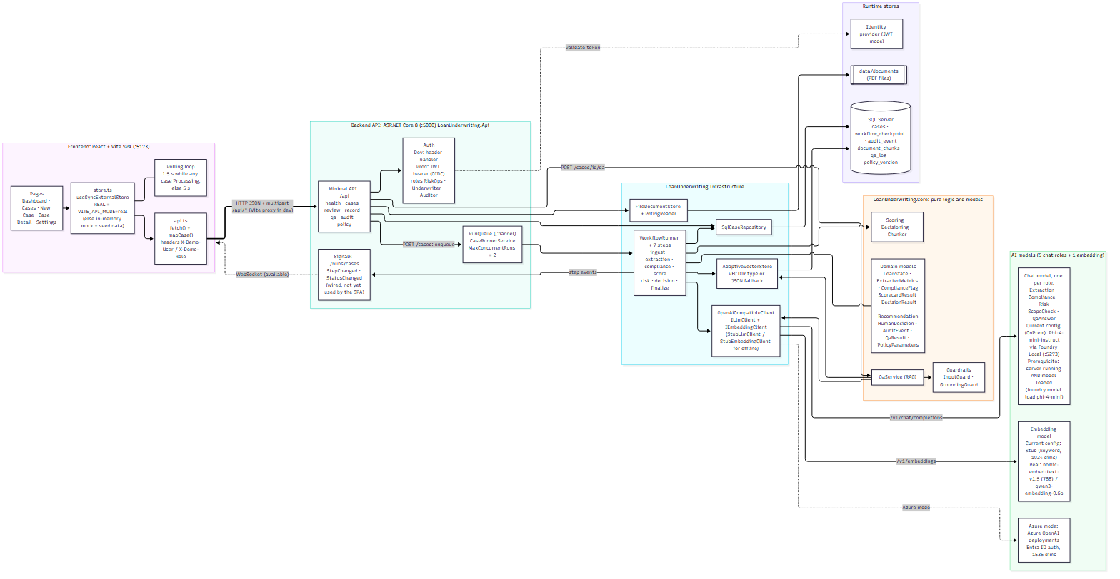

Project at a glance
- Purpose: AI-assisted loan underwriting with human-in-the-loop approval and a full audit trail.
- Frontend: React + Vite single-page app; polls for progress, SignalR hub available.
- Backend: ASP.NET Core 8 minimal API, queued workflow runner (max 2 concurrent runs).
- Data: SQL Server (cases, checkpoints, audit events, document chunks, Q&A log) with vector search; PDFs on disk.
- Models: five chat roles (Extraction, Compliance, Risk, ScopeCheck, QaAnswer) plus embeddings.
- Deployment modes: OnPrem (Foundry Local, no auth) or Azure (Azure OpenAI, Entra ID).
- Roles: RiskOps, Underwriter, Auditor.

Posting tips
- Post on a weekday morning; put the first two lines where they show before "see more".
- Add the repo link in the first comment rather than the post body, if you choose to share it.
- Do not include real applicant data or credentials in screenshots.

