**Question 1:**

**Working with RDS**

Task 1: Create an RDS Database Instance

**Screenshot 1:** Db instance page

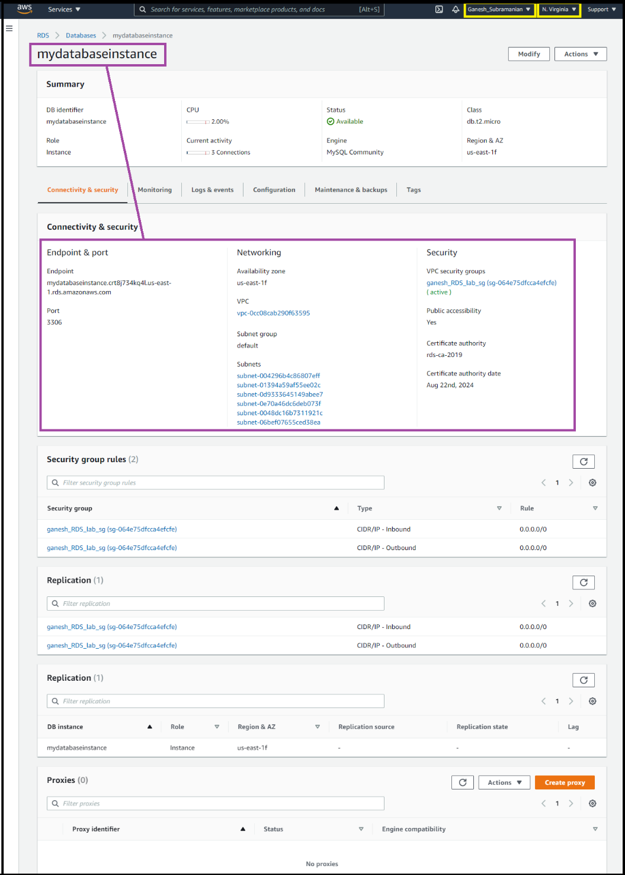

**Screenshot 2:** DB instance details

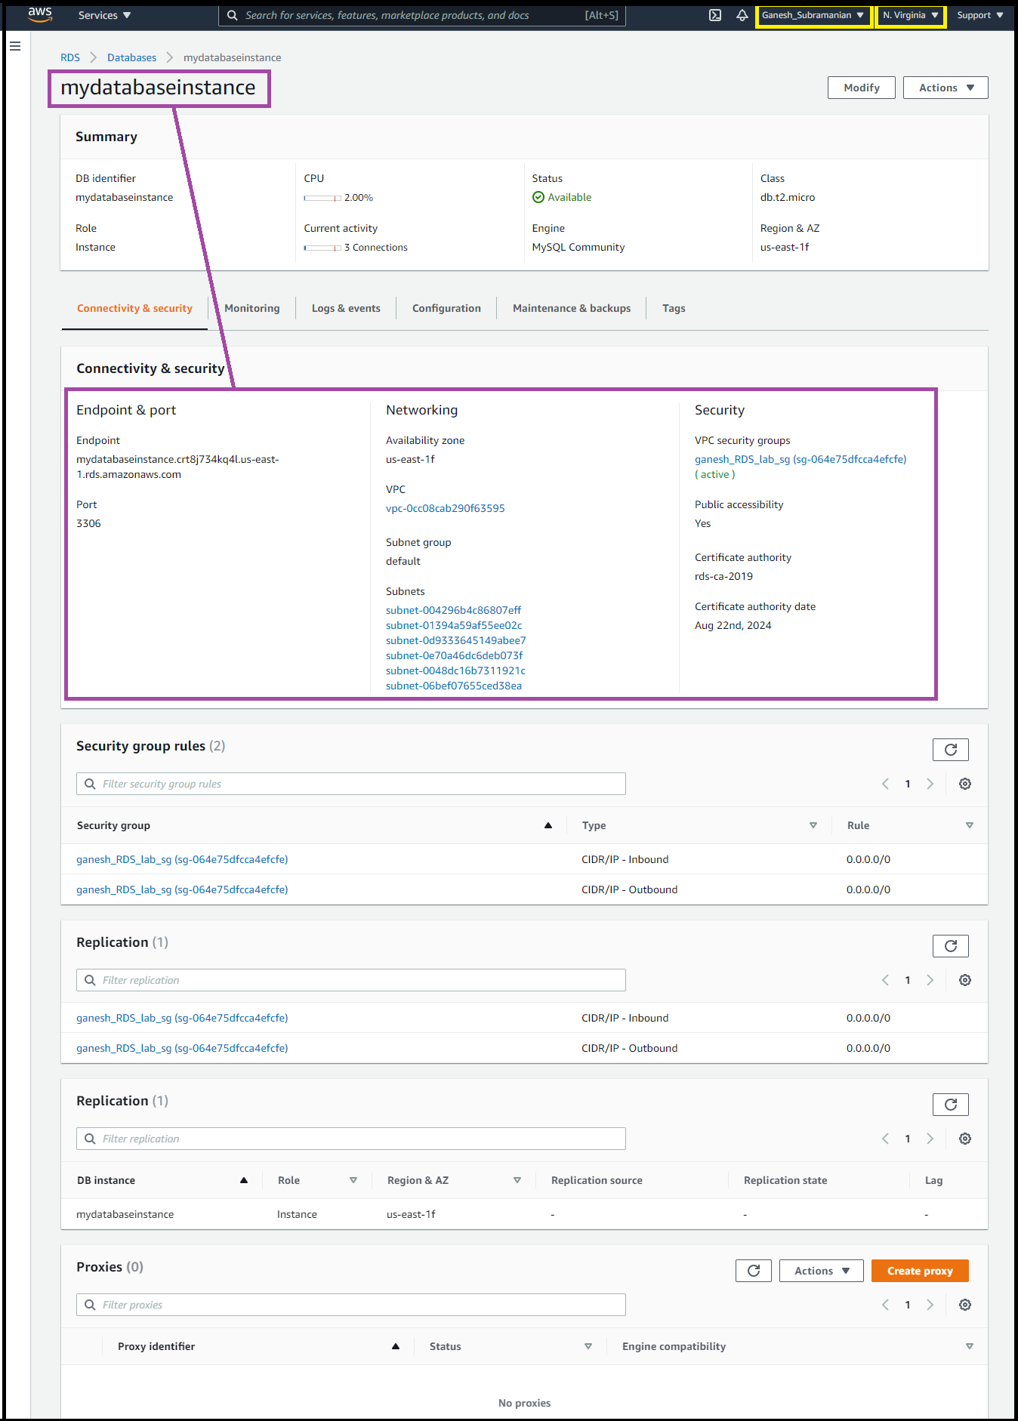

**Screenshot 3:** security group inbound rules+ multiple changes made to a security group

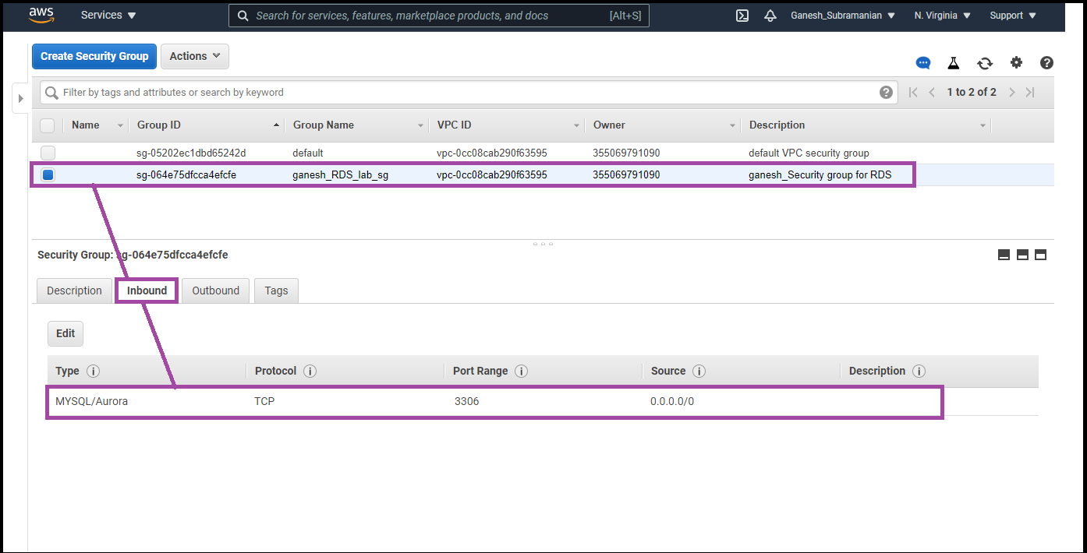

**Screenshot 4:** sql workbench endpoint added

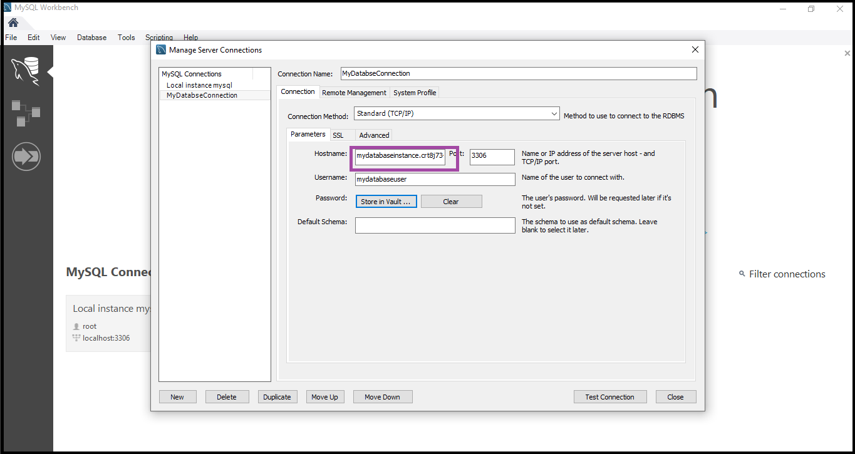

**Screenshot 5:** secret vault entry

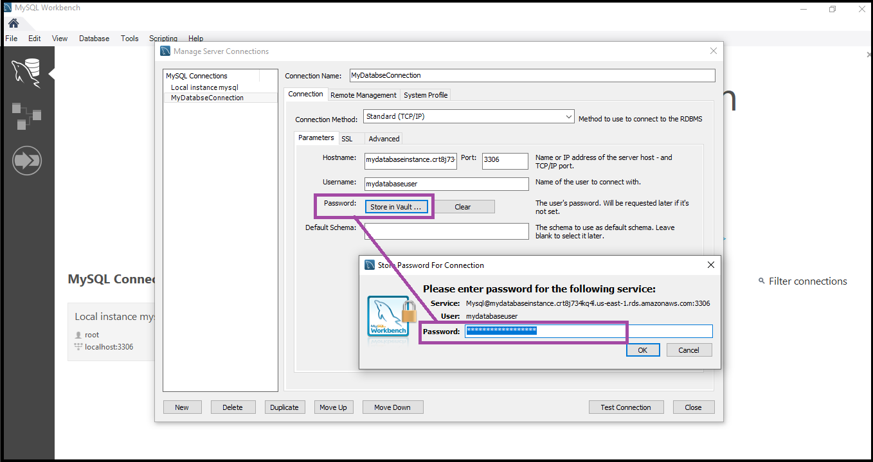

**Screenshot 6:** confirm connectivity screen

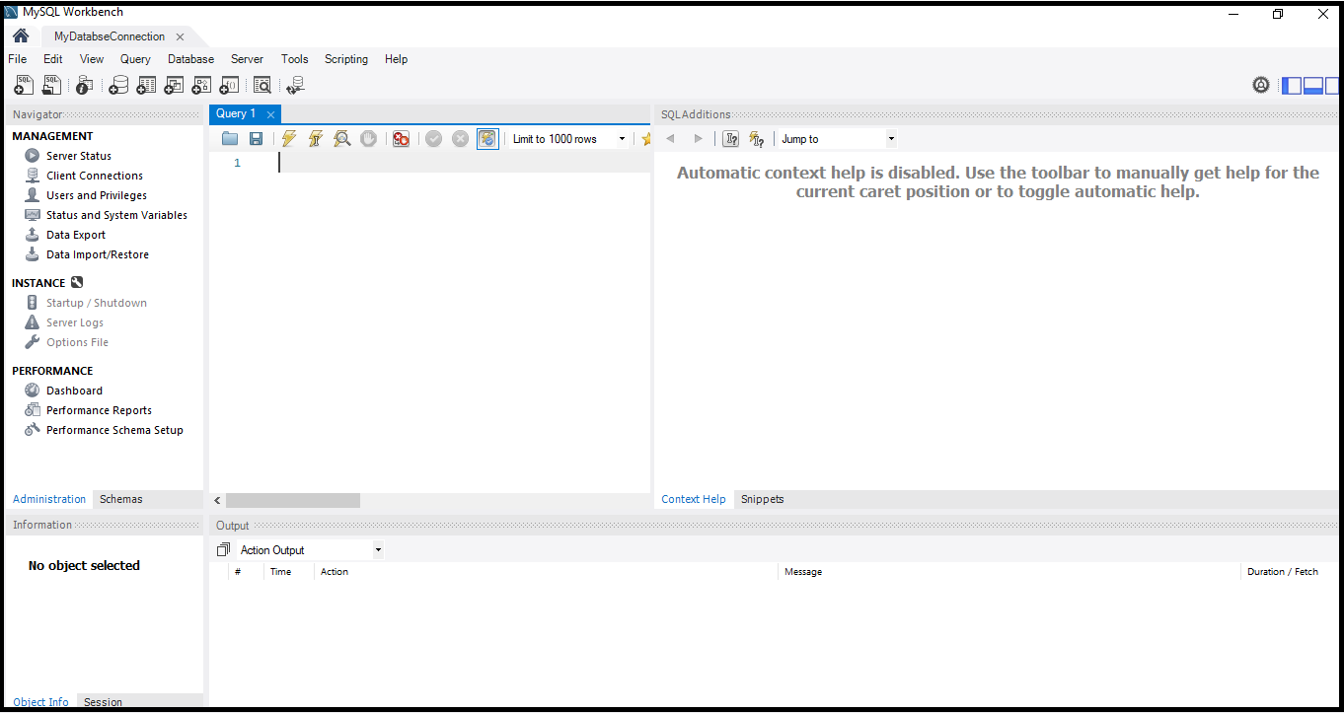

Task 2: Connecting to RDS Database on a DB Instance using the MySQL Workbench

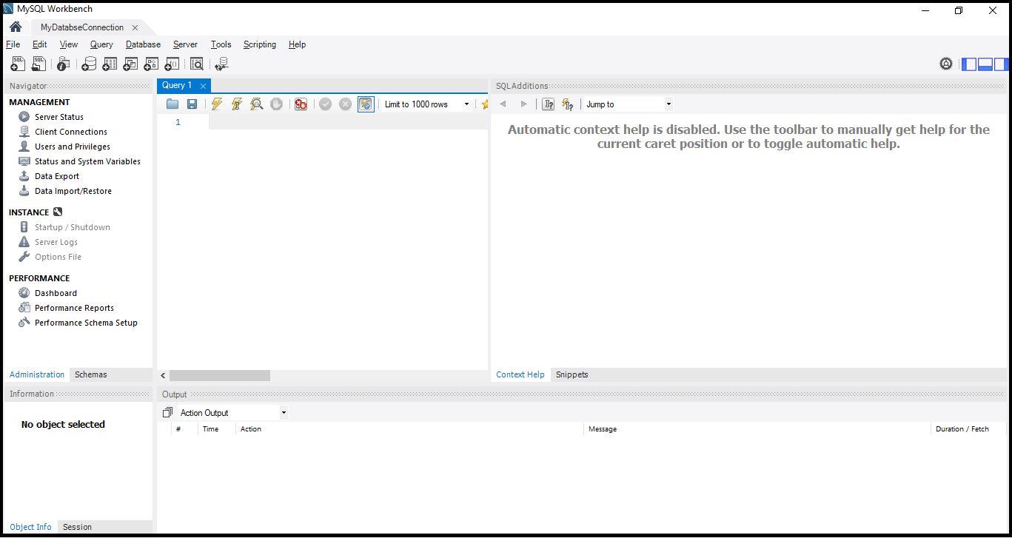

Task 3: Test Connection

