**Question 1: Working with Lambda**

**Step1:** Create two s3 buckets with the name

Sourcebucket **arn:aws:s3:::ganeshsubramaniansourcebucket**

Destinationbucket **arn:aws:s3:::ganeshsubramaniandestinationbucket**

**Screenshot 1:** S3 Console with two buckets

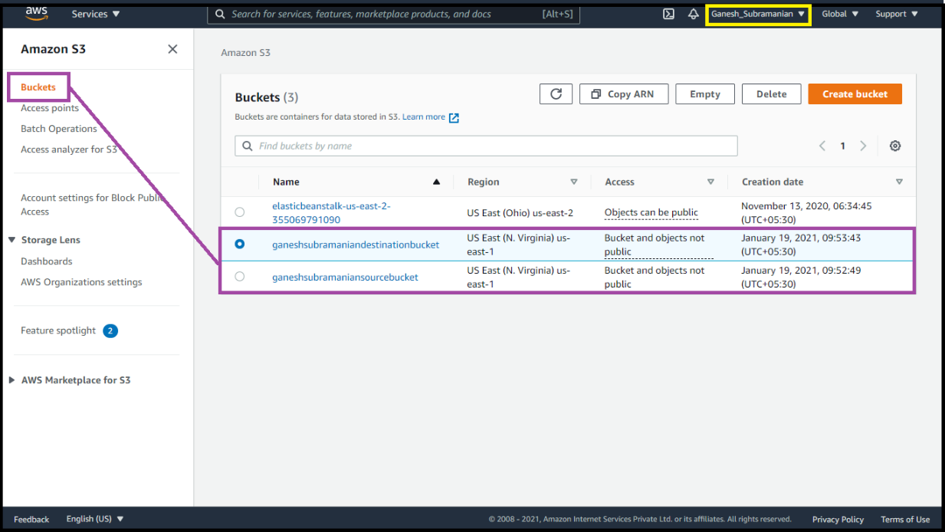

**Step2:** Create a policy with limited Read-write permissions using a JSON script

**Screenshot 2:** json script in place

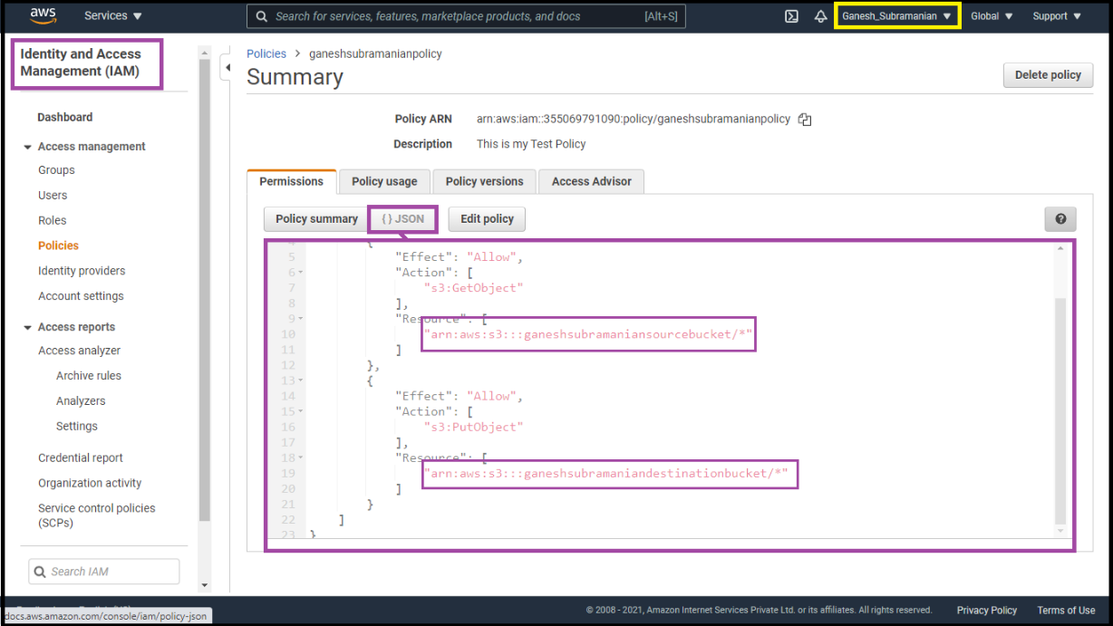

**Screenshot 3:** Policy Console with your policy filtered

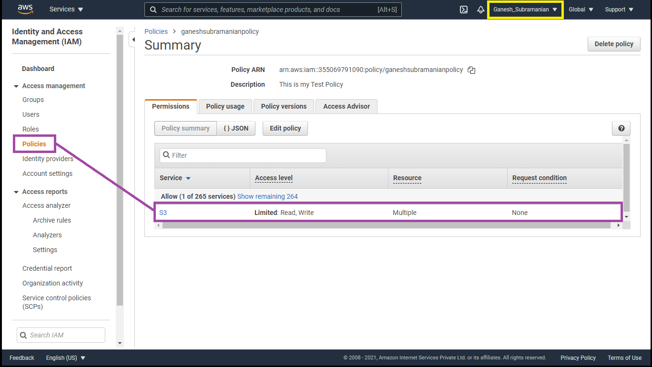

**Step3:** Create a role and attach the policy that was created in the previous step.

**Screenshot 4:** Role console showing details of the role

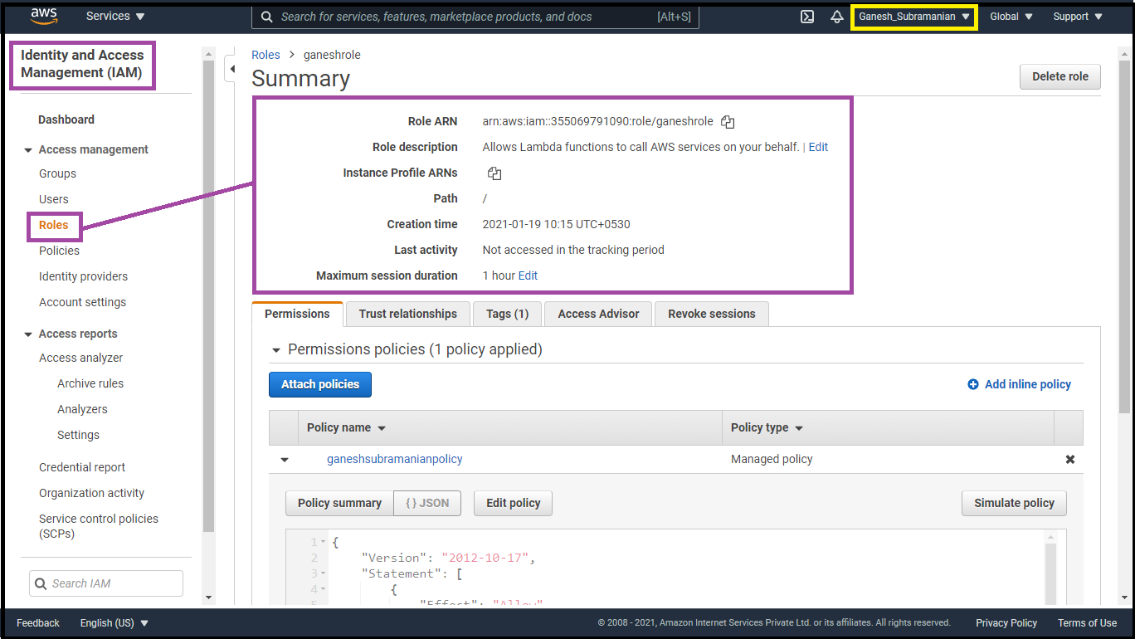

**Step4:** Create a Lambda function

**Screenshot 5:** lambda functions dashboard

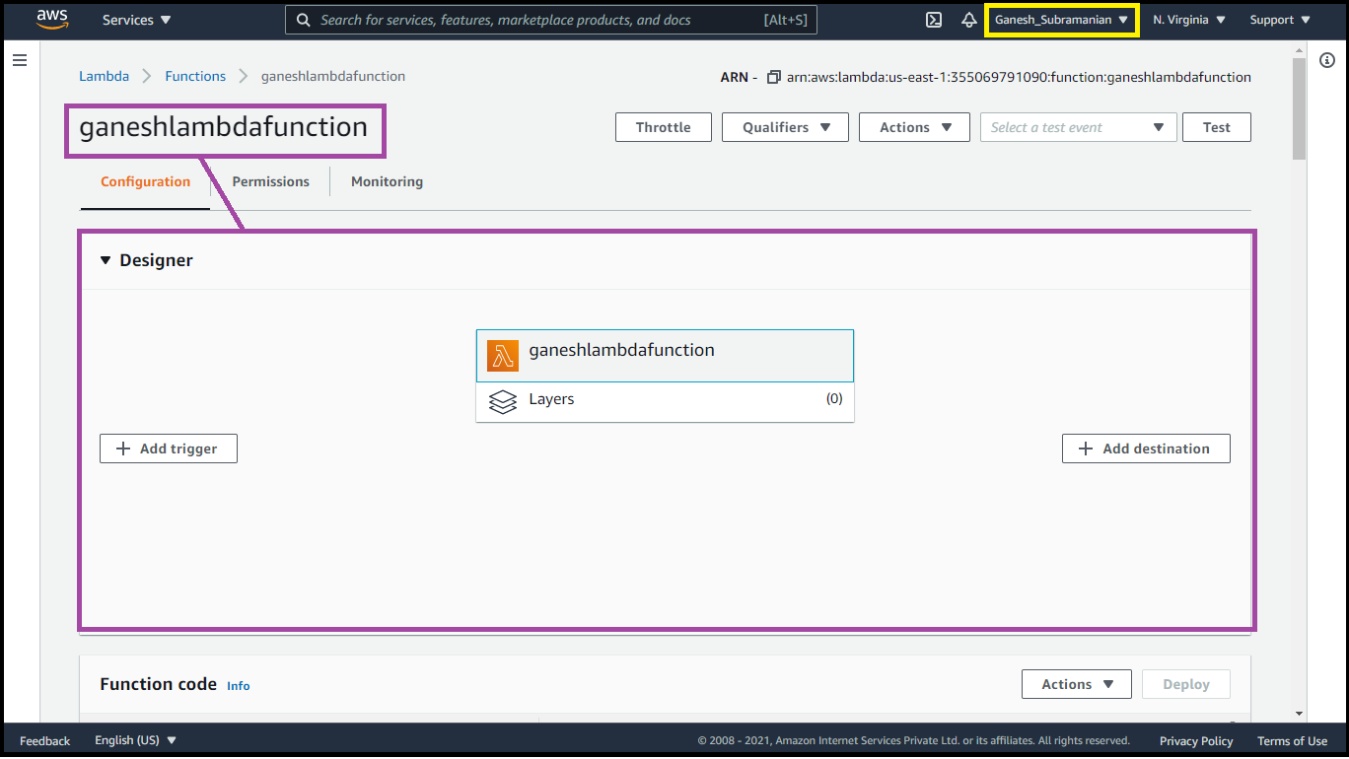

**Screenshot 6:** js file edited

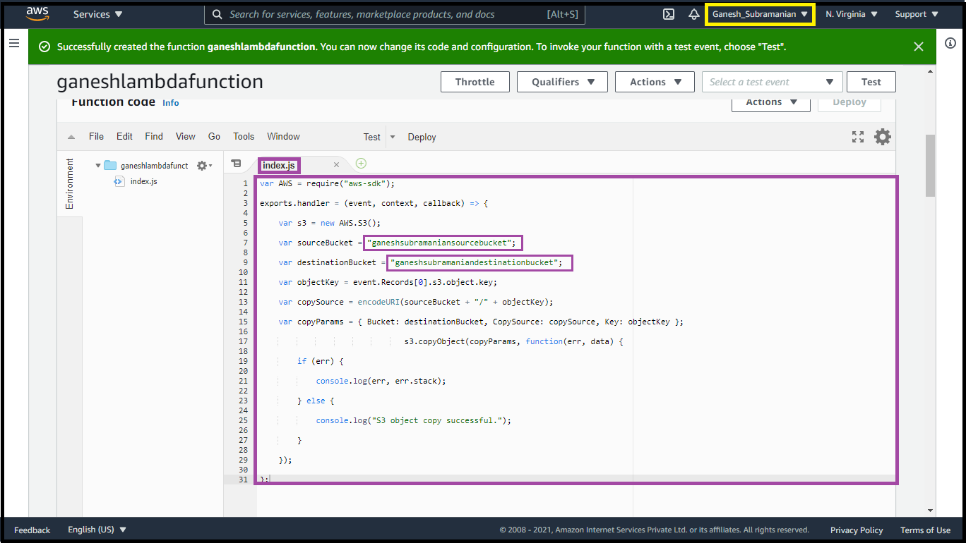

**Screenshot 7:** adding trigger-s3, bucket name, confirmation for having separate buckets

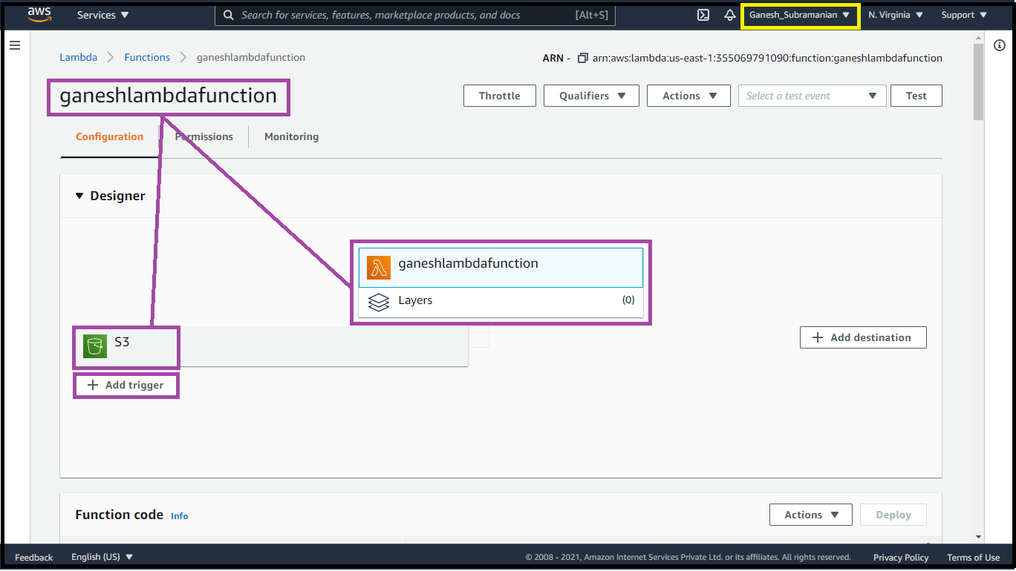

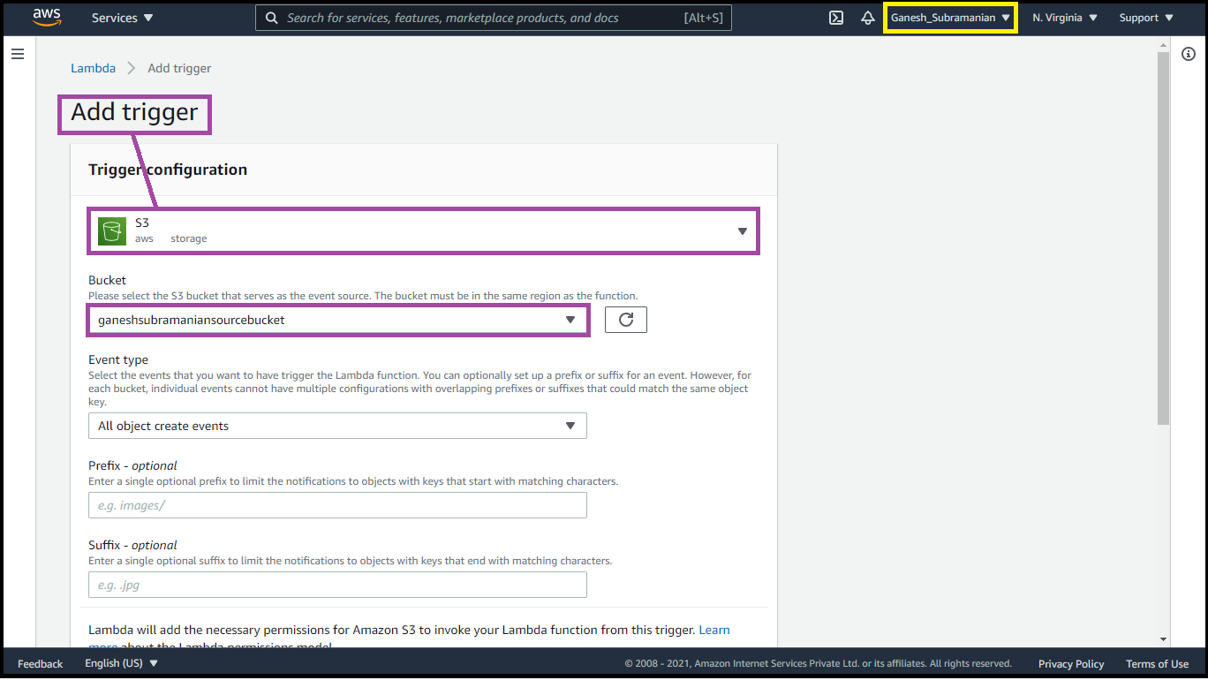

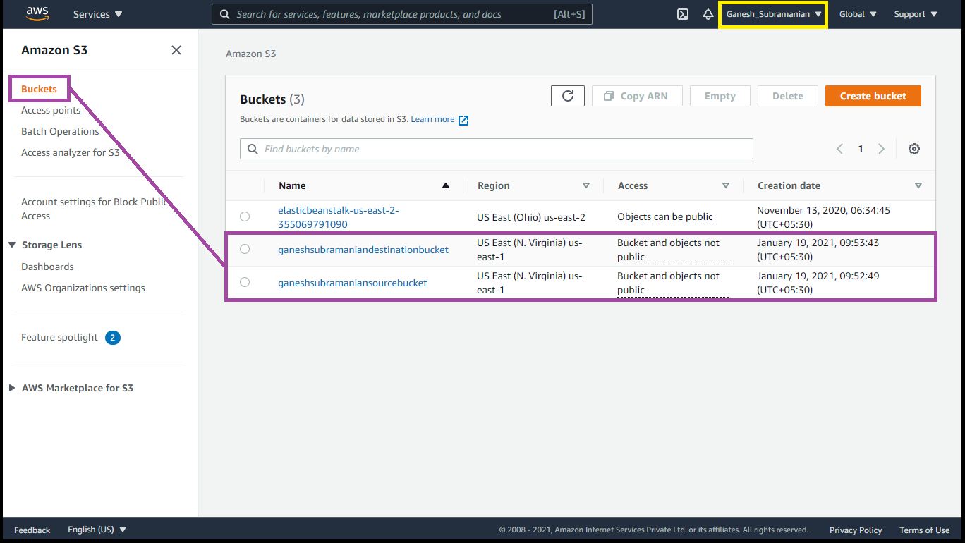

**Step5:** Adding triggers to the lambda function

**Screenshot 8:** lambda configuration page with trigger added

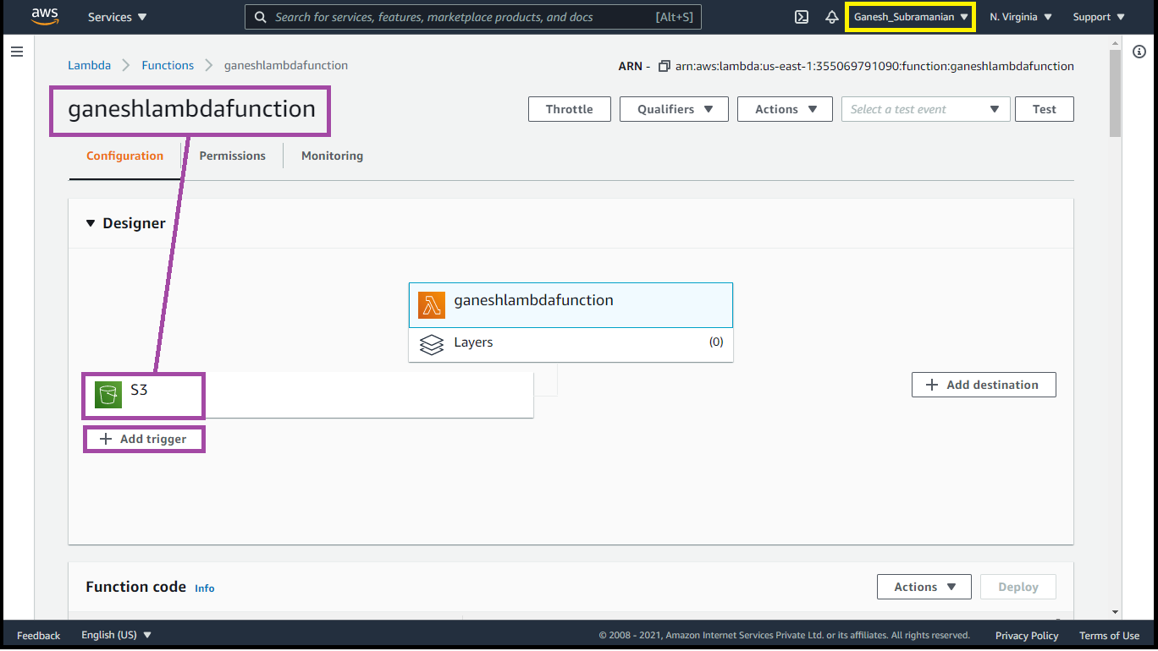

**Step6:** Test by uploading objects into the source bucket

**Screenshot 9:** object uploaded in the source bucket

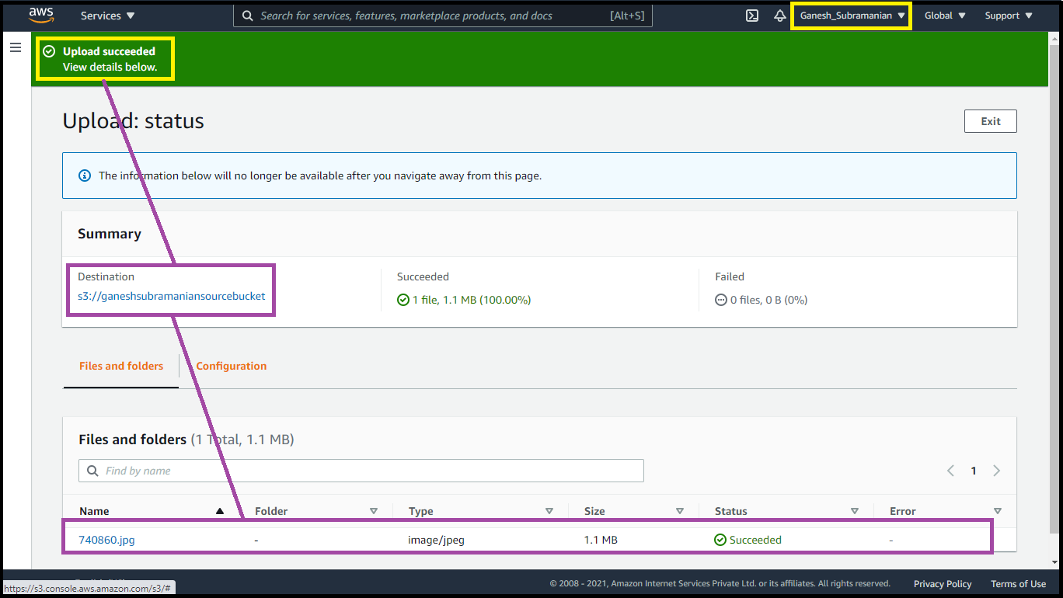

**Screenshot 10:** object replicated in the destination bucket.

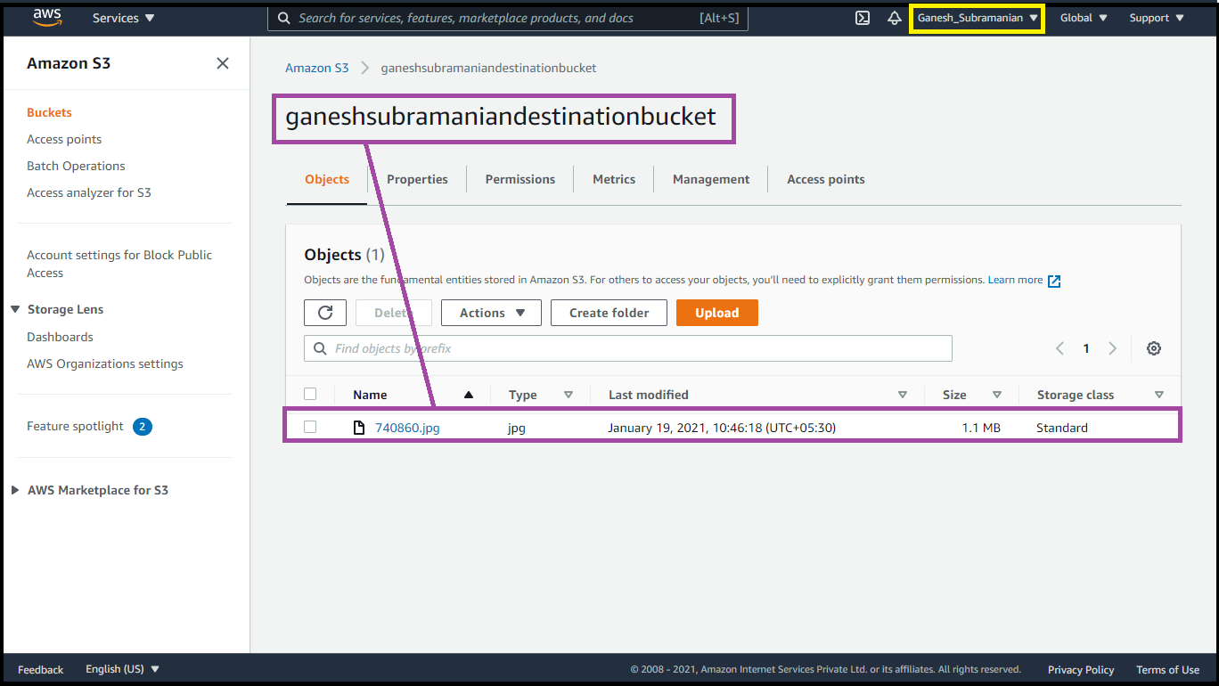

**Question 2: Working with Elastic container service using fargate**

**Step1:** Getting started with amazon ECS using fargate

**Screenshot 1:** ECS console

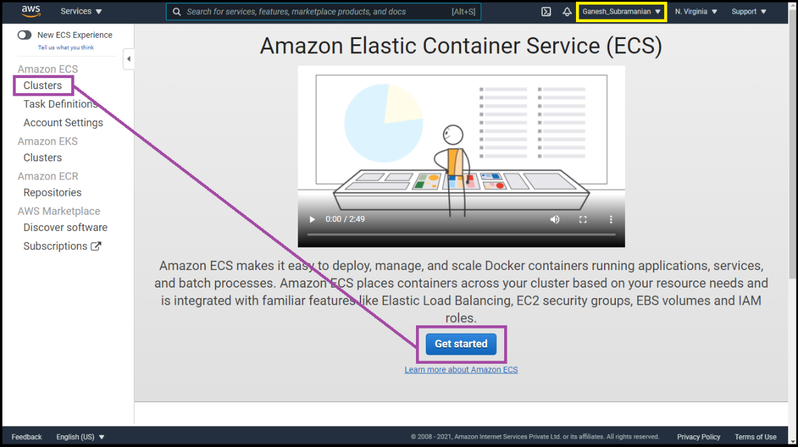

**Step2:** Creating container and task definition

**Screenshot 2:** 2nd panel with all options visible

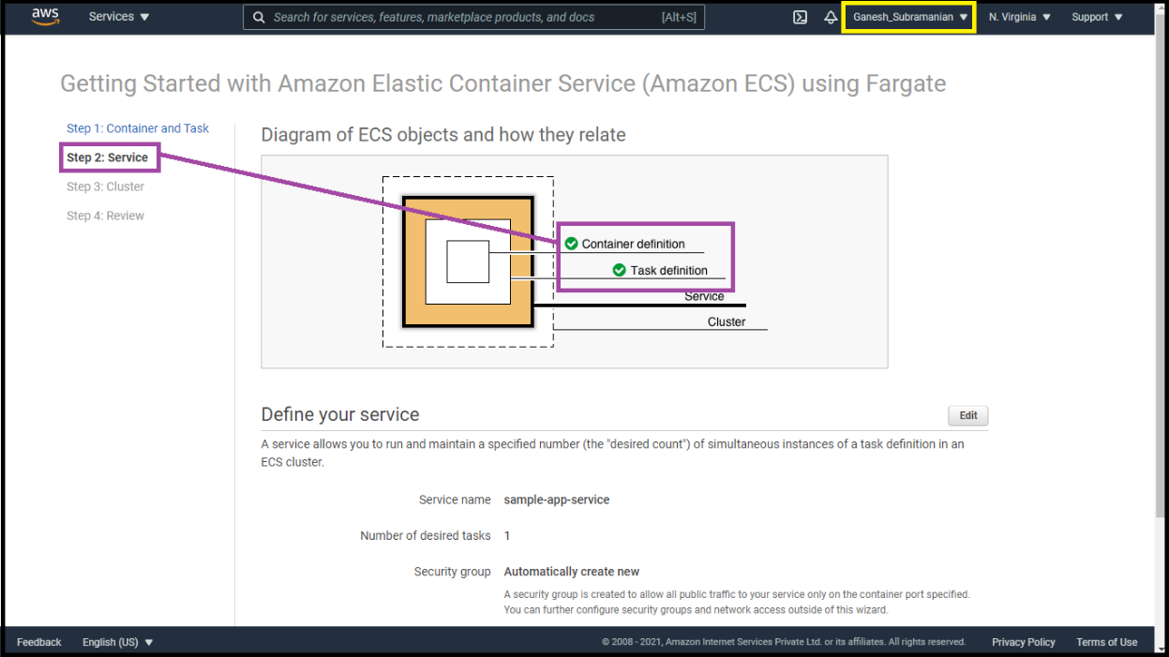

**Step3:** Configuring the service

**Screenshot 3:** Next panel

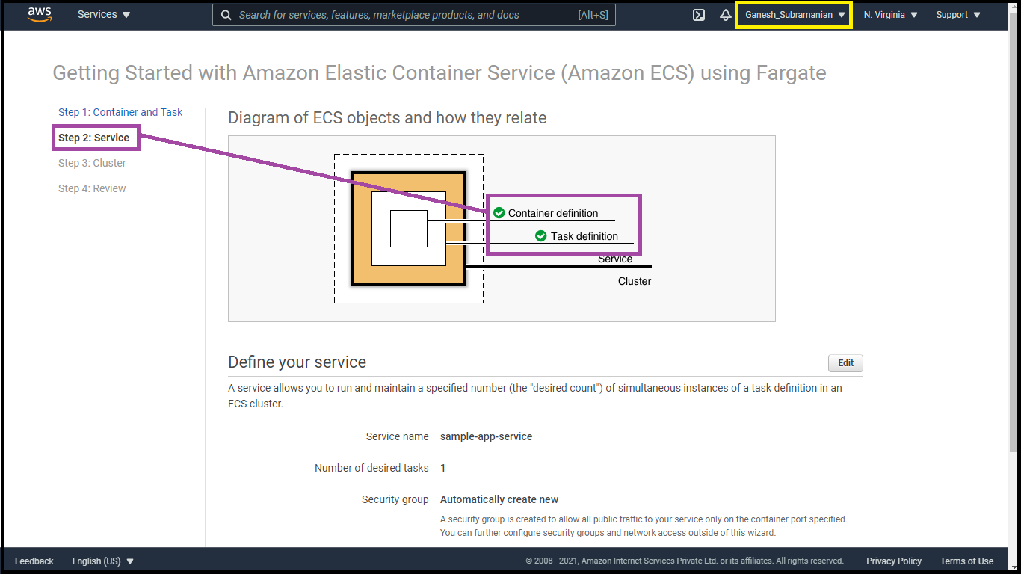

**Step4:** Configuring the cluster

**Screenshot 4:** Next panel

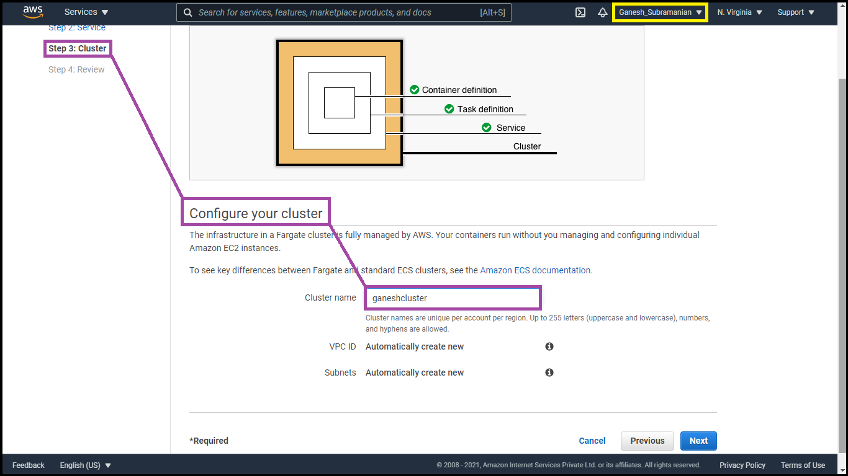

**Step5:** Viewing the service

**Screenshot 5:** Dashboard displaying the cluster created

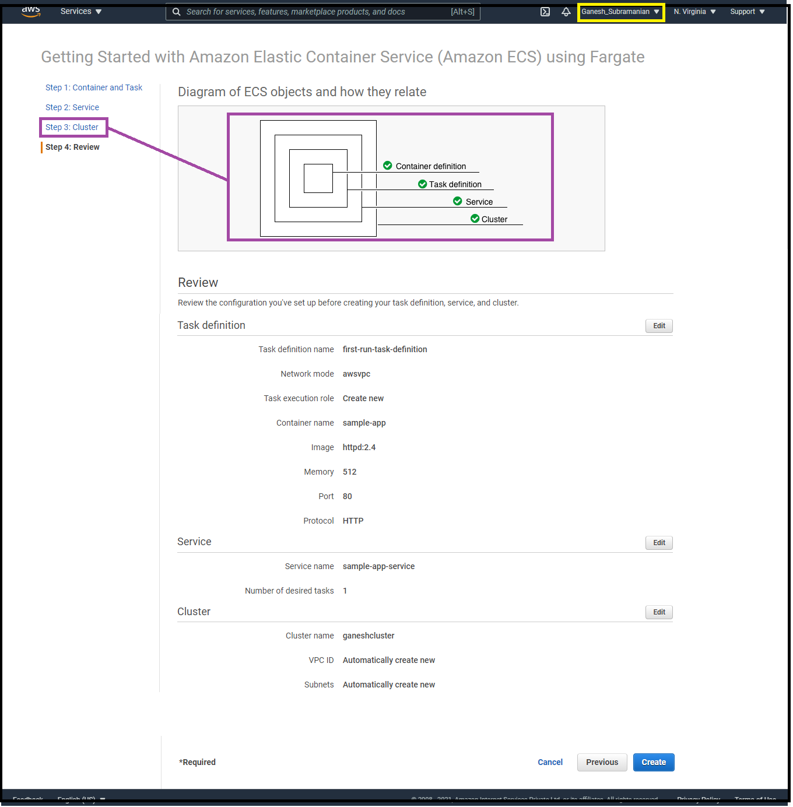

**Screenshot 6:** Cluster information

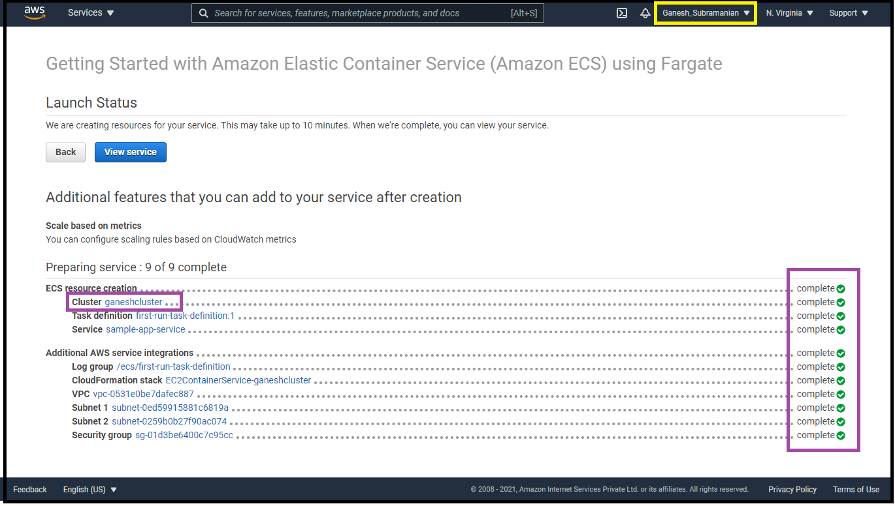

**Screenshot 7:** Panel displaying ENI ID

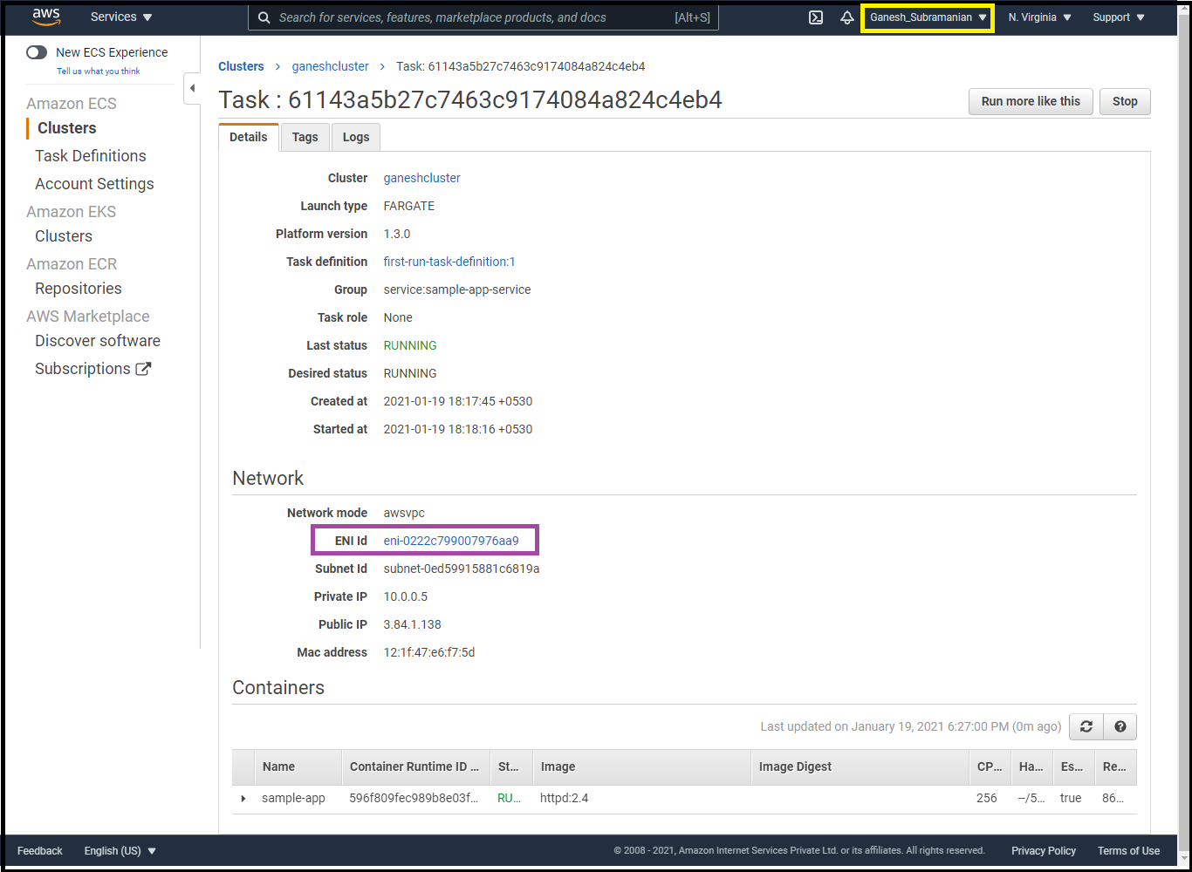

**Screenshot 8:** Panel displaying the private, public, and the mac id

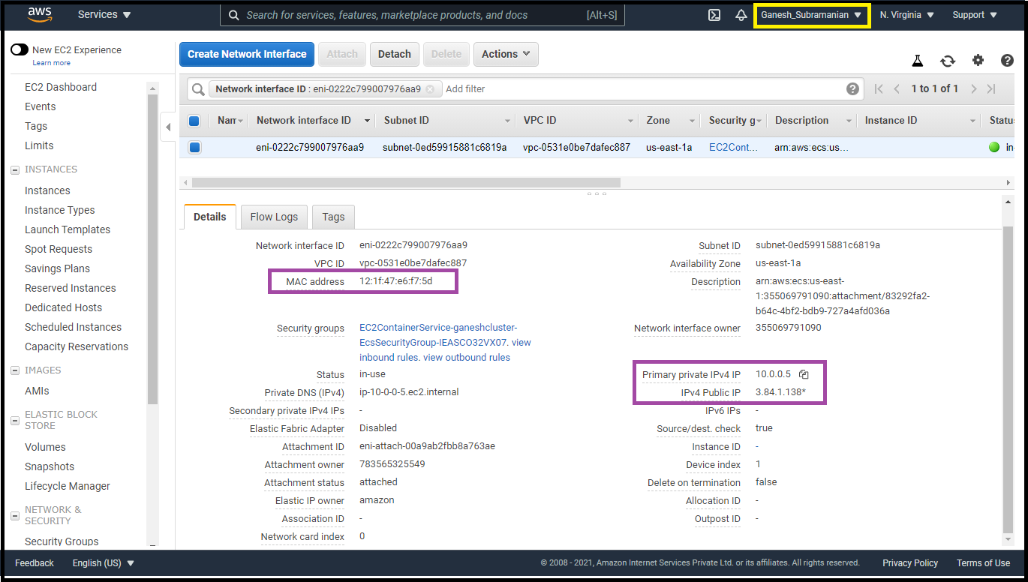

**Screenshot 9:** Display application

