**PROJECT 1:**

**Working with IAM Roles with S3 and bootstrapping with EC2**

**Task 1:** Creating a bootstrapped instance

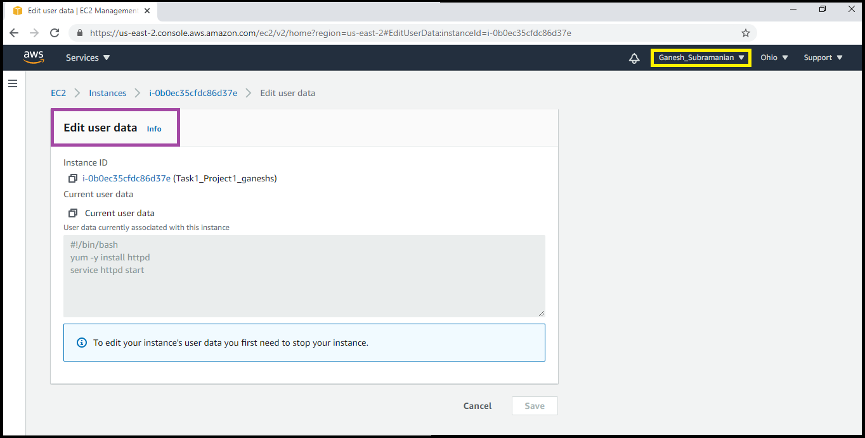Edit User Data

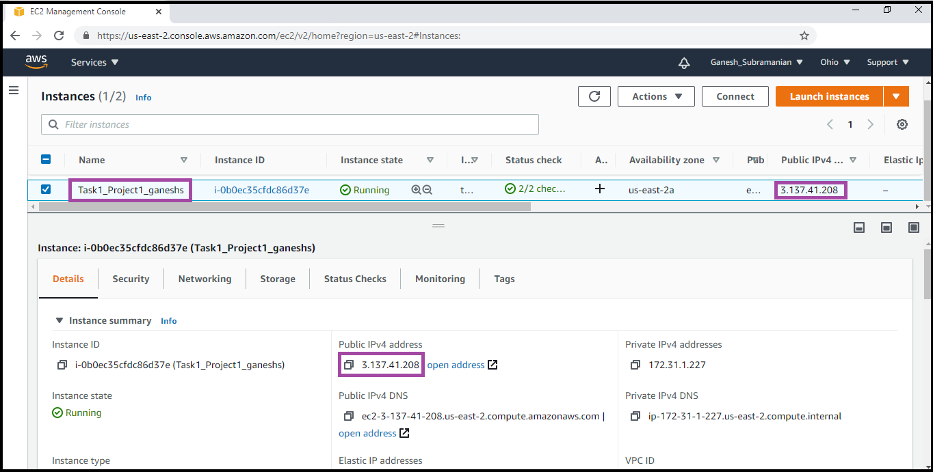List of ec2 instances with description

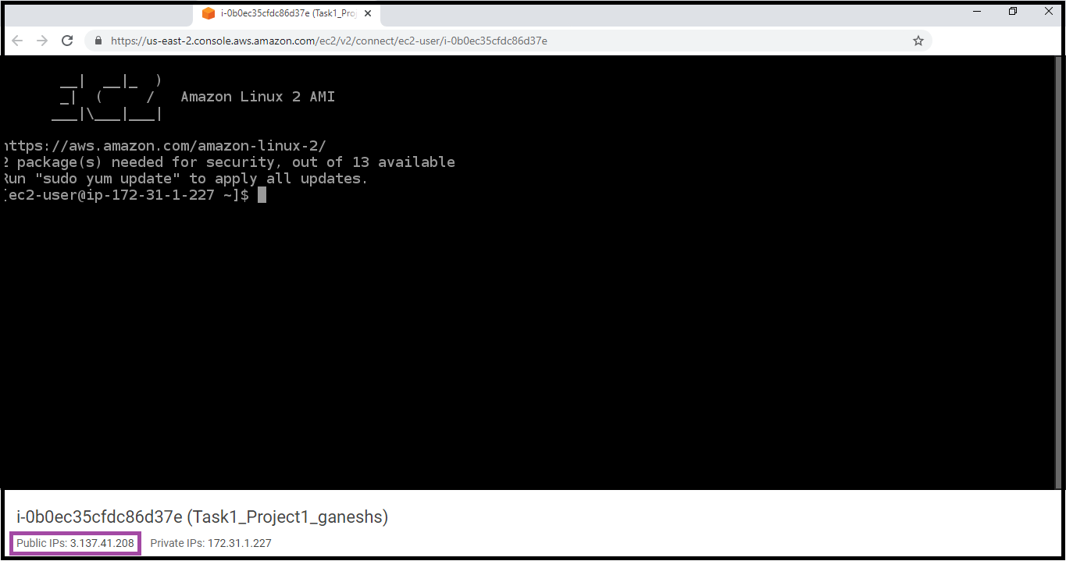

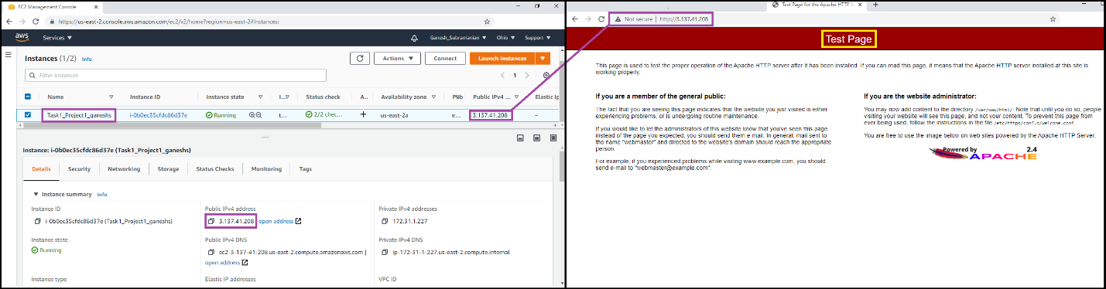Successful Display of the Test page

**Task 2:** Checking bucket list and creating a new bucket from EC2 using IAM Roles

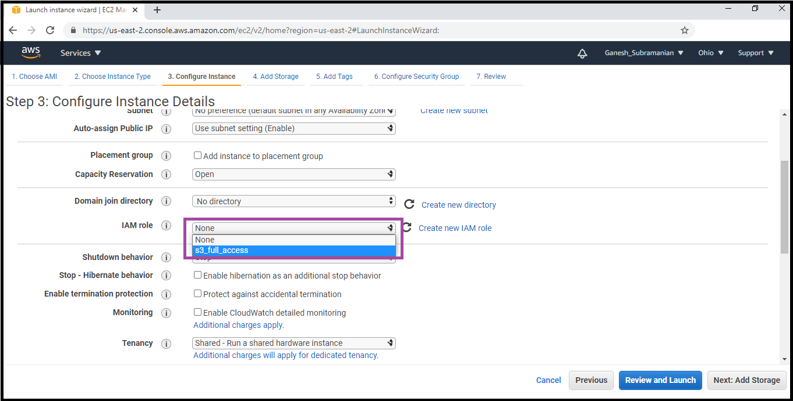EC2 instance getting attached to IAM Role

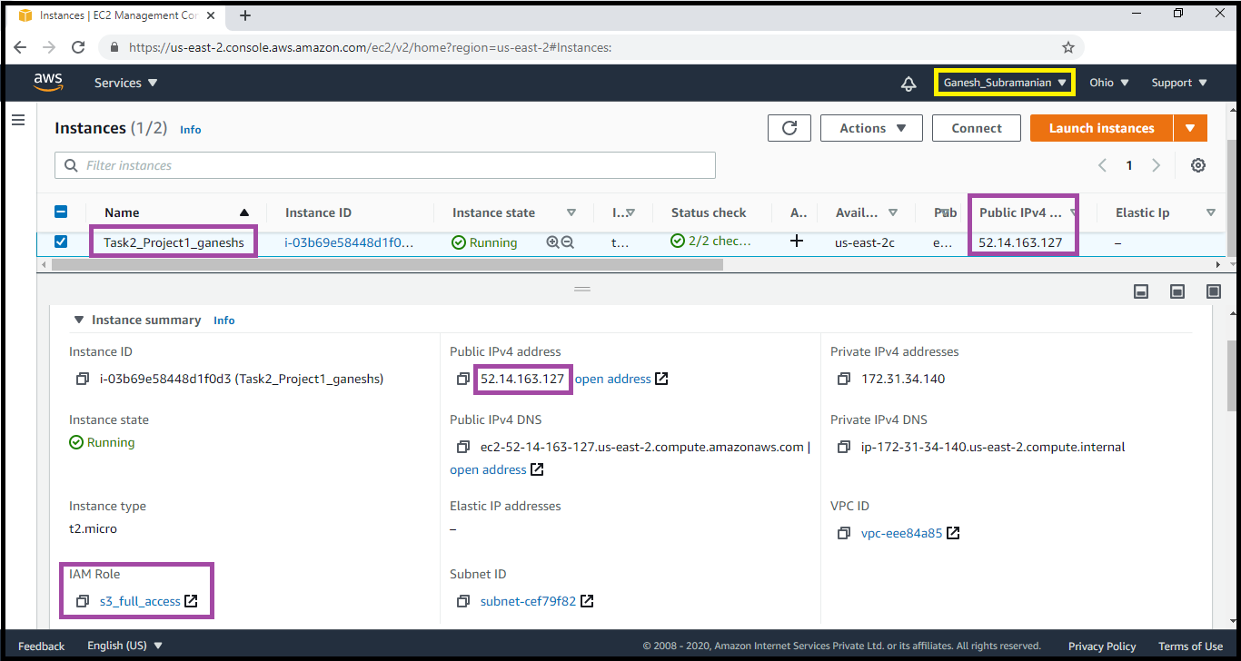EC2 instances with its relevant description

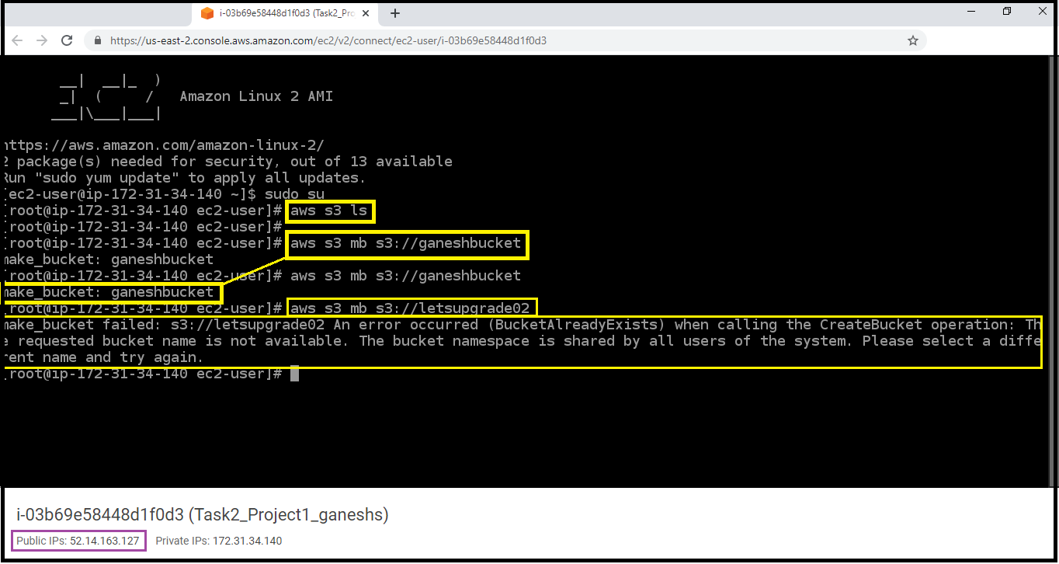Commands which were executed (Highlighted in Yellow) and their respective outputs being displayed

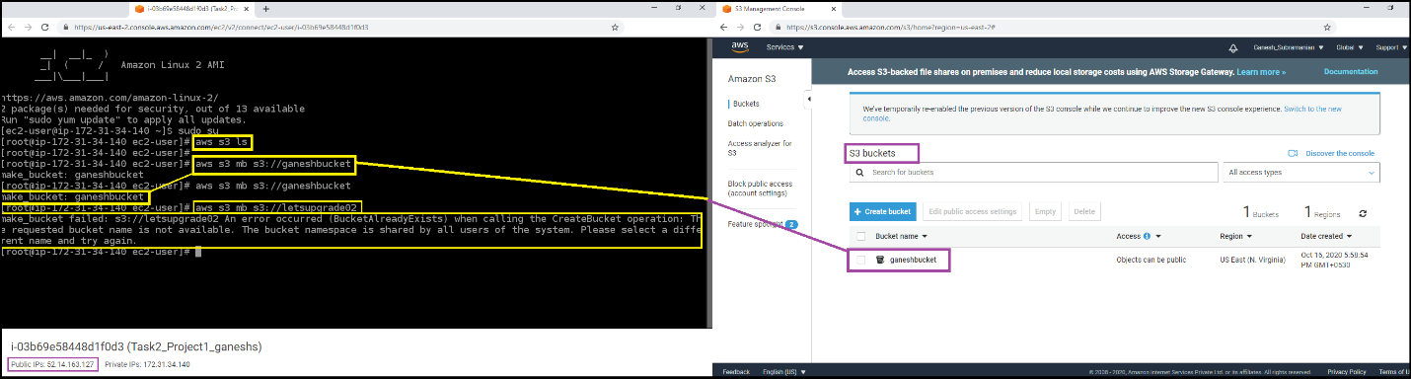Executed Commands through CLI and the same is being reflected in the GUI

(New Bucket “ganeshbucket”) created via CLI is being displayed in the GUI of S3 Bucket section

**Task 3:** Hosting a webpage using the bootstrap script on ec2.

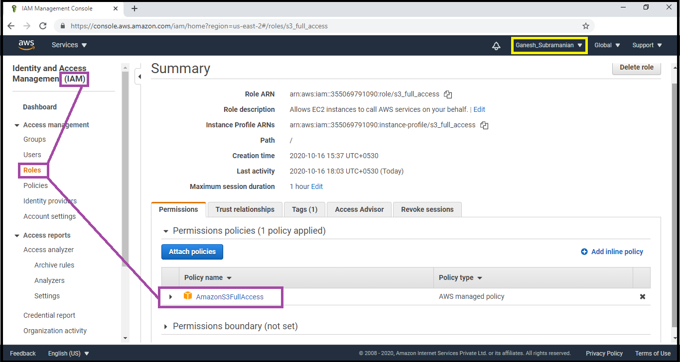

Creation of IAM Role (AmazonS3FullAccess)

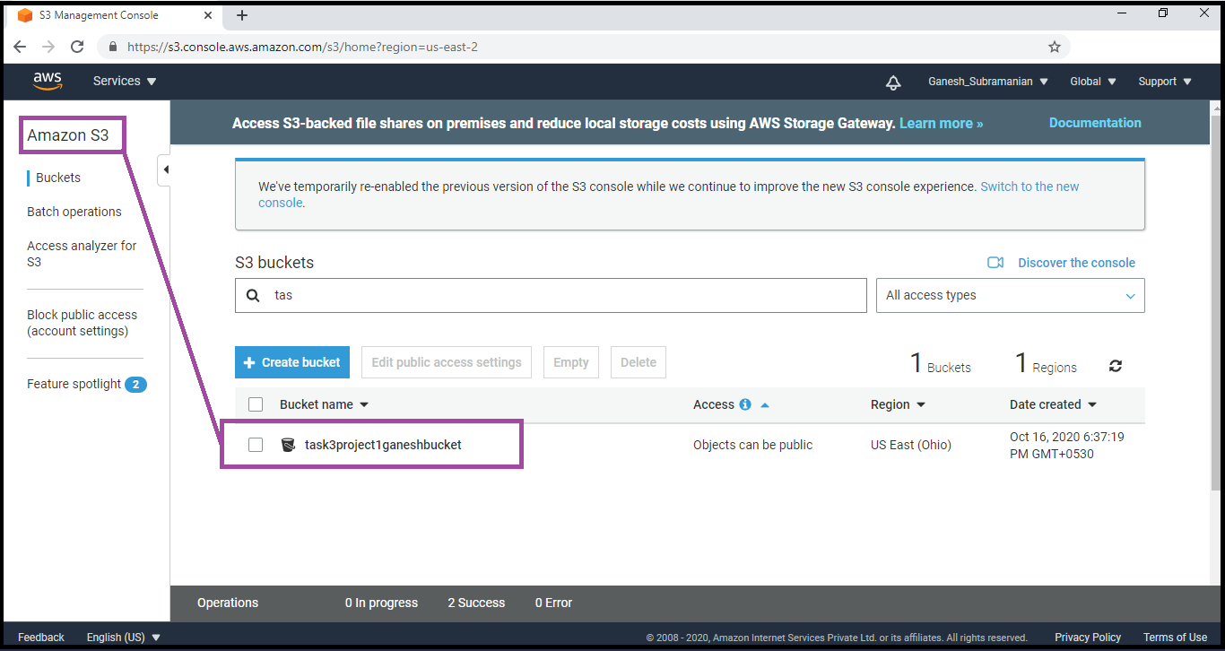Creation of a S3 Bucket

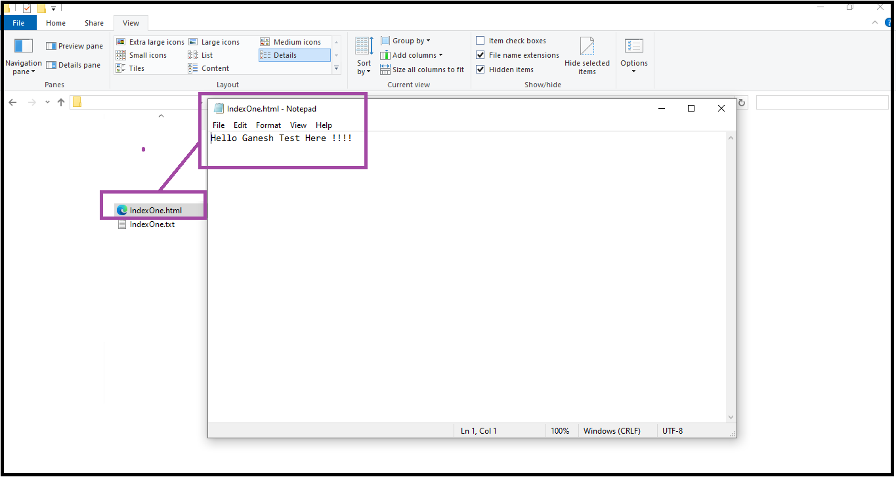Creation of IndexOne.html file

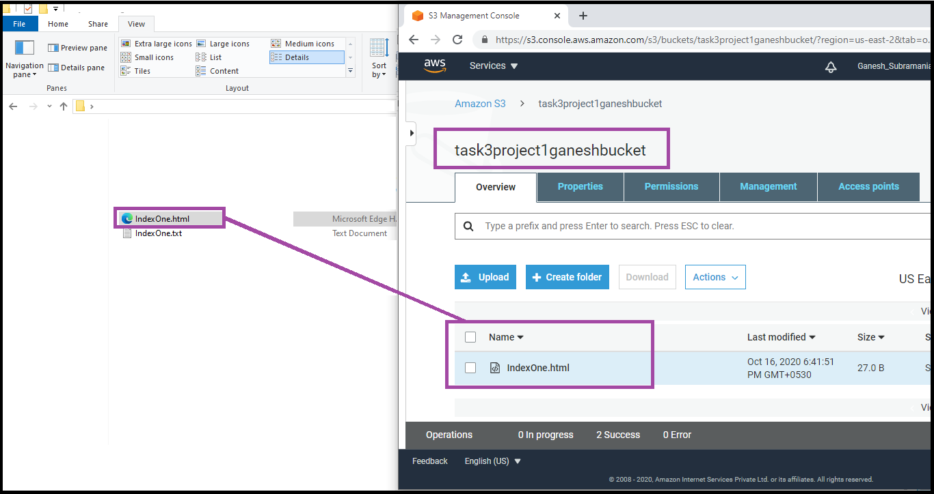Uploading the IndexOne.html to the S3 Created Bucket (task3project1ganeshbucket)

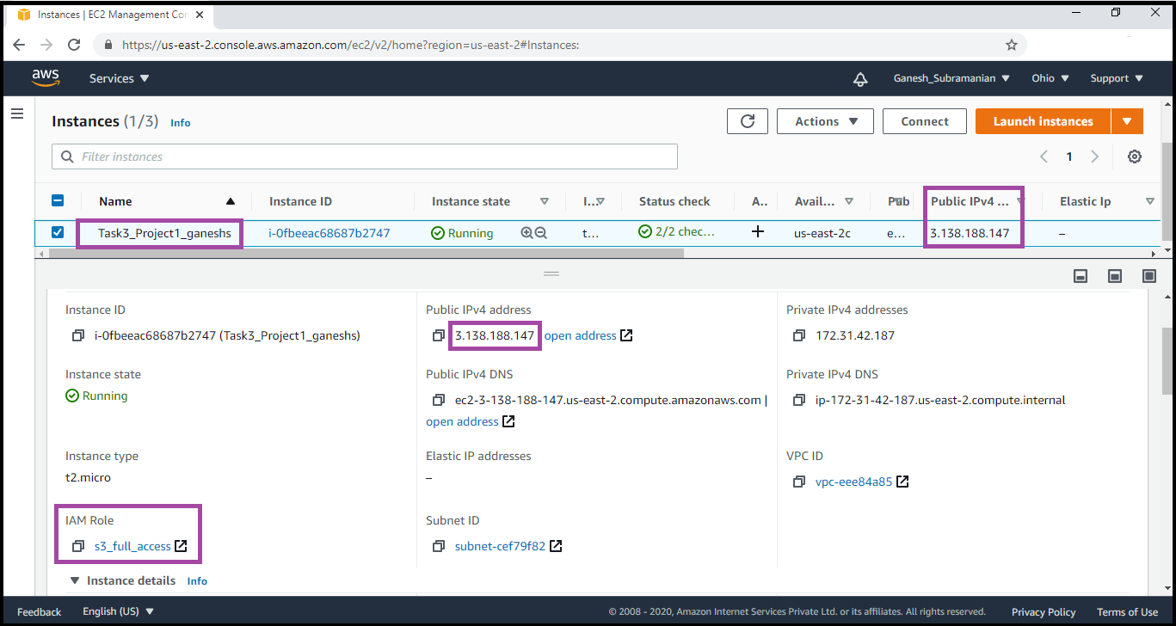Creation of EC2 Instance with IAM Roles (Highlighted in the above image)

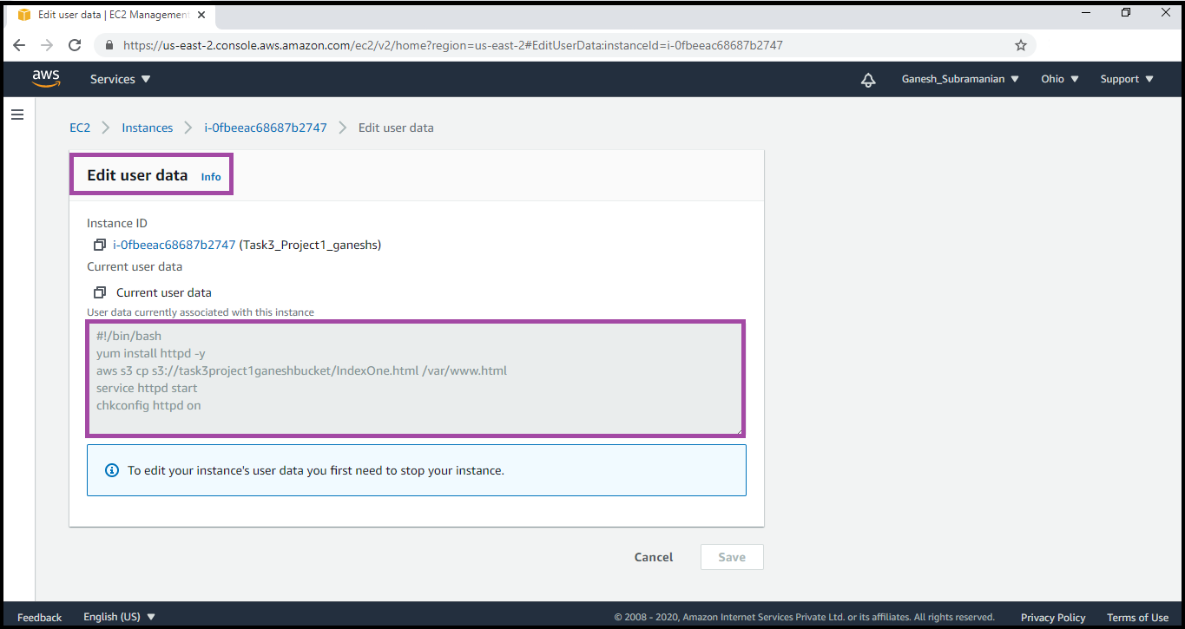Edit User Data Details

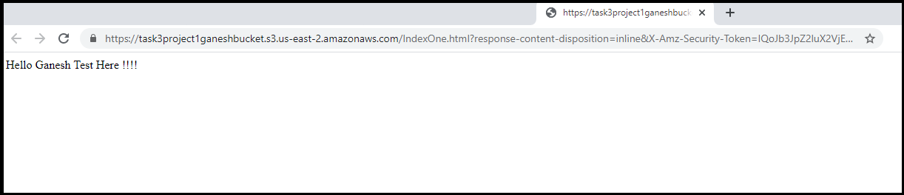The Content of the HTML File uploaded

**PROJECT 2:**

**Creating an EC2 instance in custom VPC**

**Task1:** Create a VPC

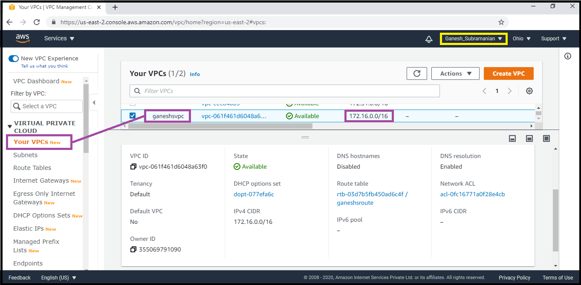

VPC (ganeshsvpc) Created

**Task 2:** Create an Internet gateway

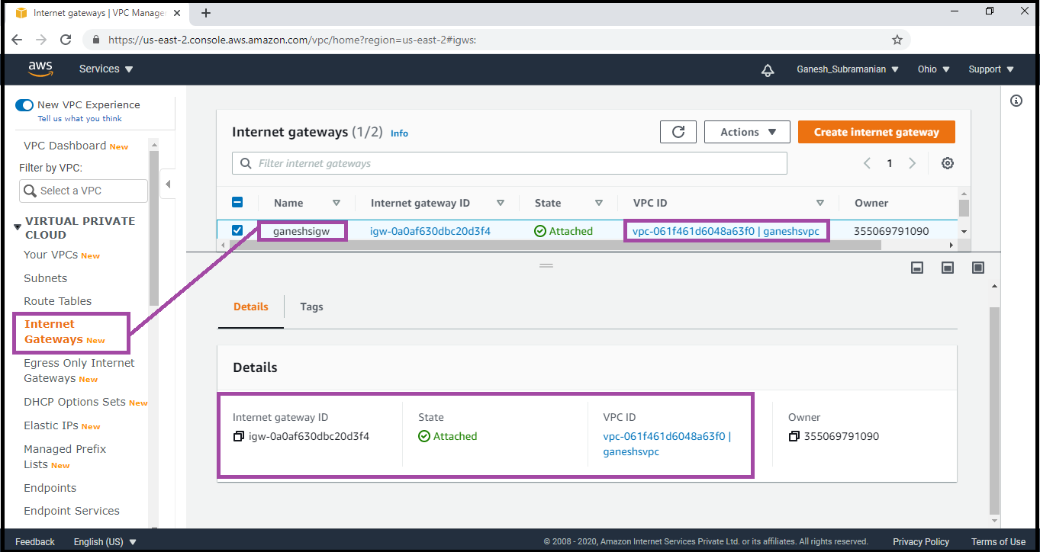

Internet Gateway (ganeshsigw) associated with vpc (ganeshsvpc)

**Task3:** Create a route table

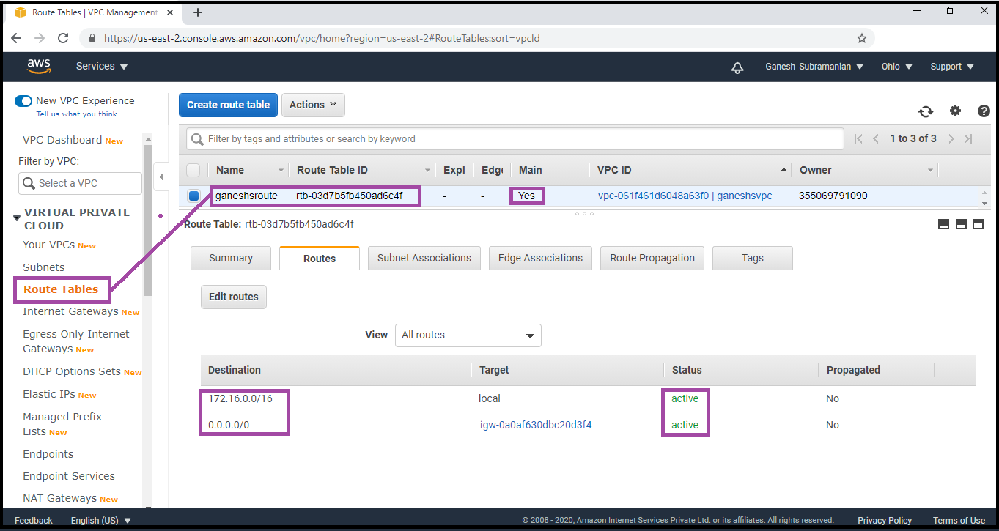

Route table with routes (ganeshsroute)

**Task4:** Create a subnet

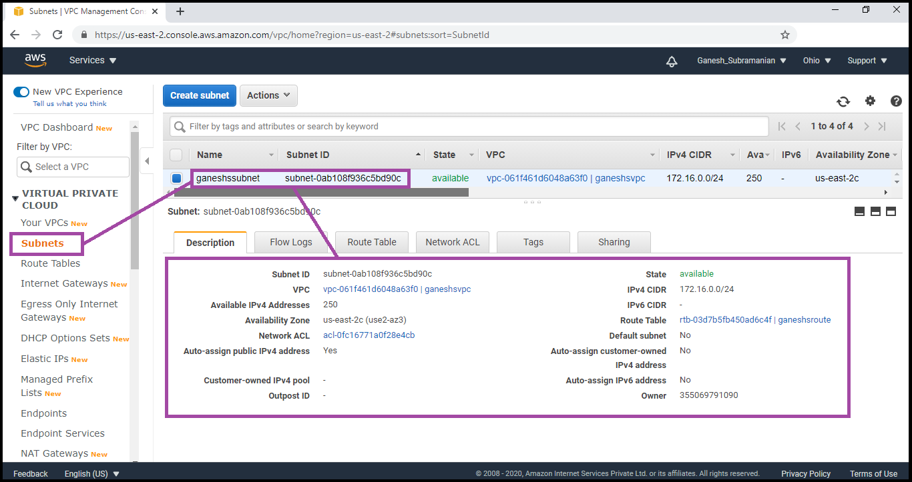

Subnet created (ganeshssubnet)

**Task5:** Create an EC2 in custom vpc

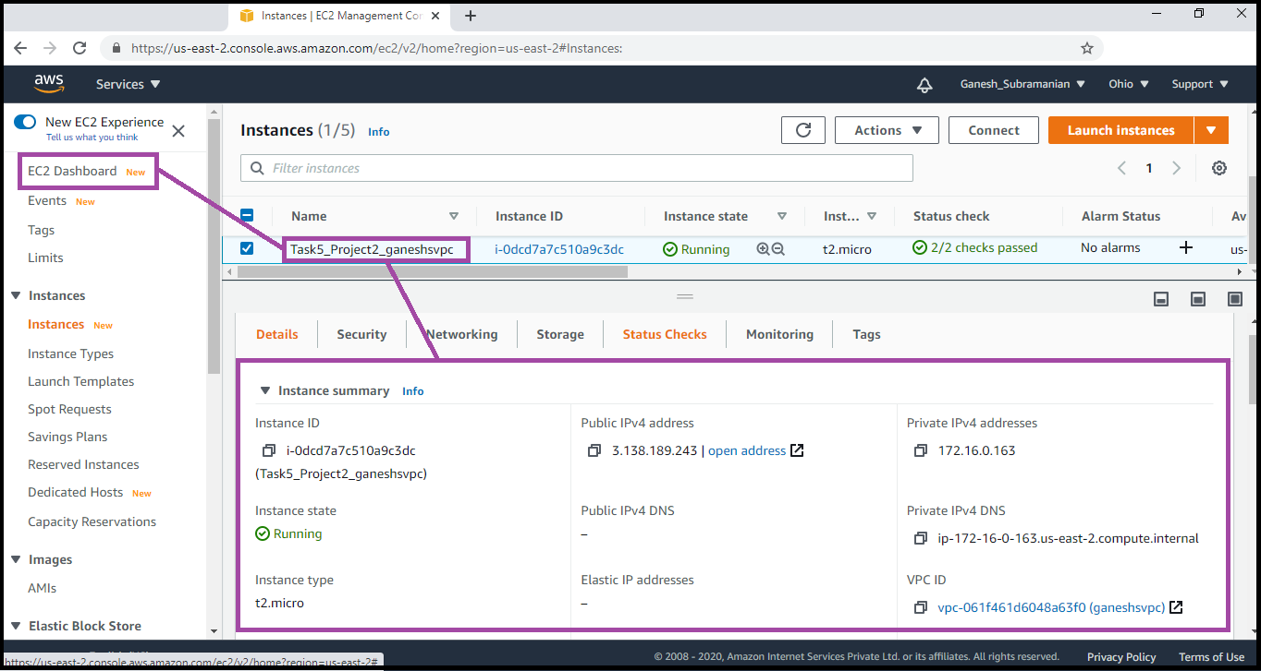

EC2 Instance dashboard details

**Task 6:** Check ipconfig in VM command prompt.

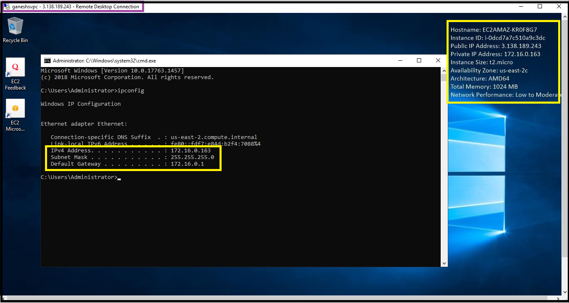

Ipconfig of the RDP displayed (Highlighted)