**Project 2**

Deploying Amazon RDS Multi-AZ and Read Replica, Simulate Failover

* **EC2 Console with instance details**

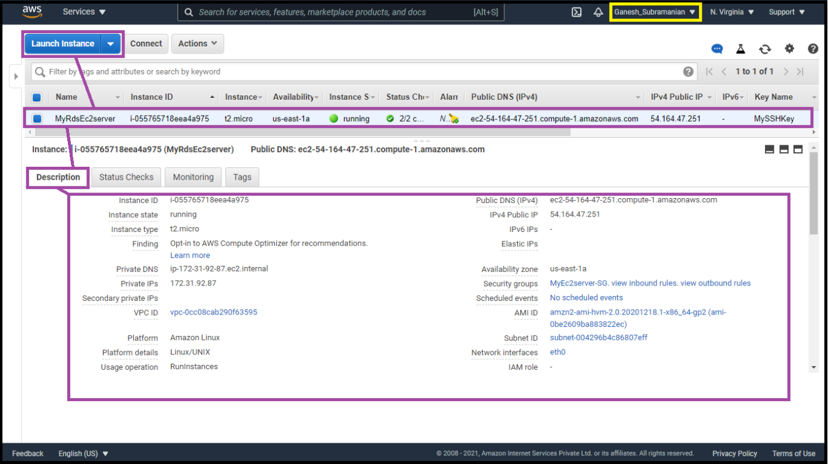

* **User Data field showing MySQL installation**

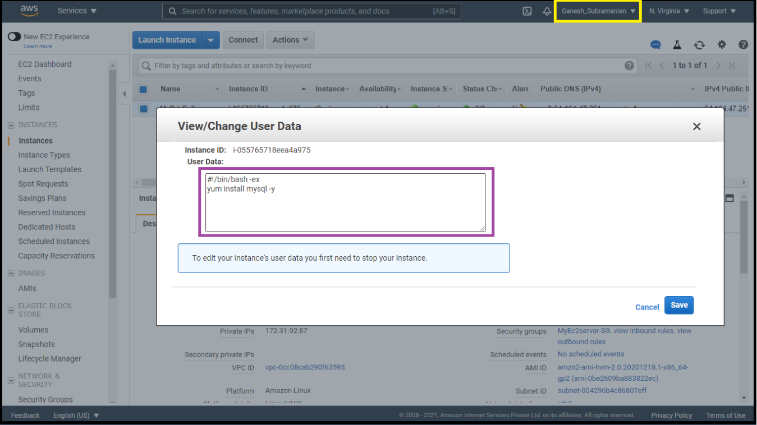

* **Create a Security group with the name MyEC2server-SG and display security group**

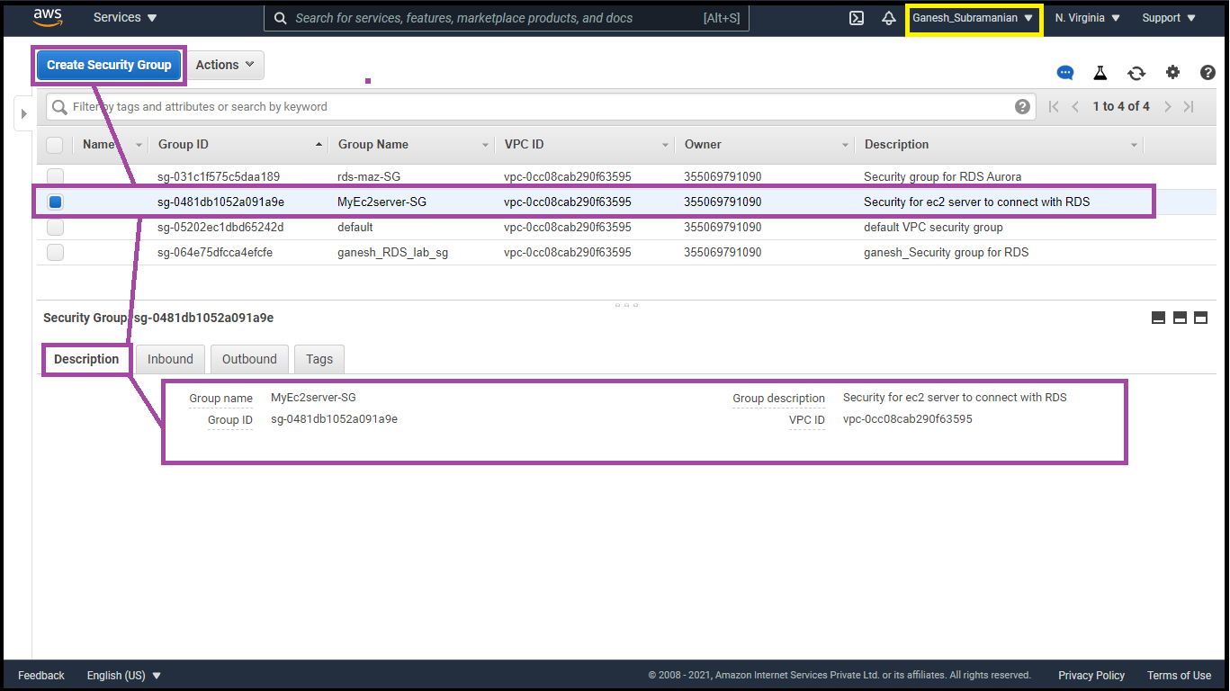

* **Display Security group information of rds-maz-SG**

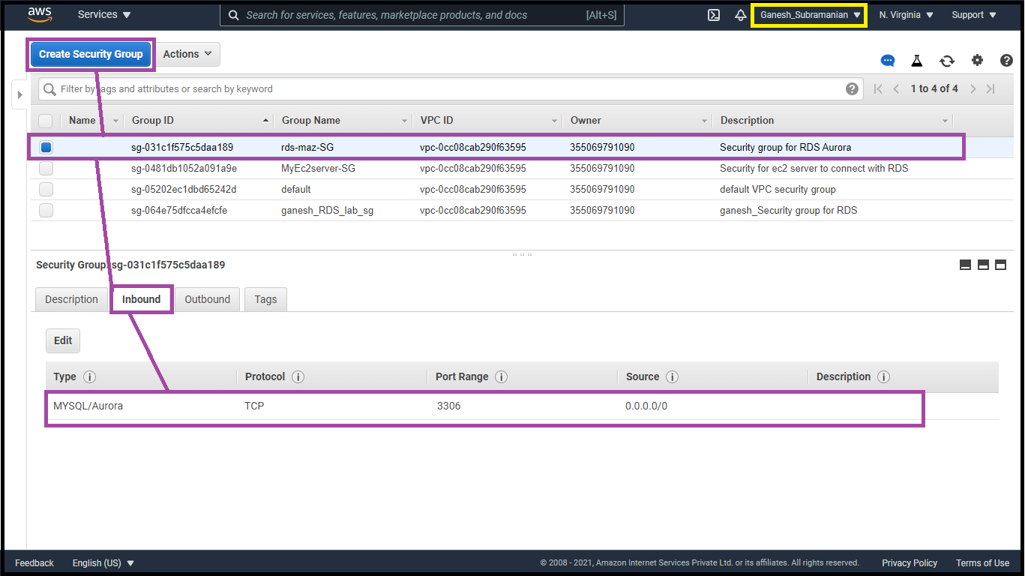

* **Display Enabling Multi AZ**

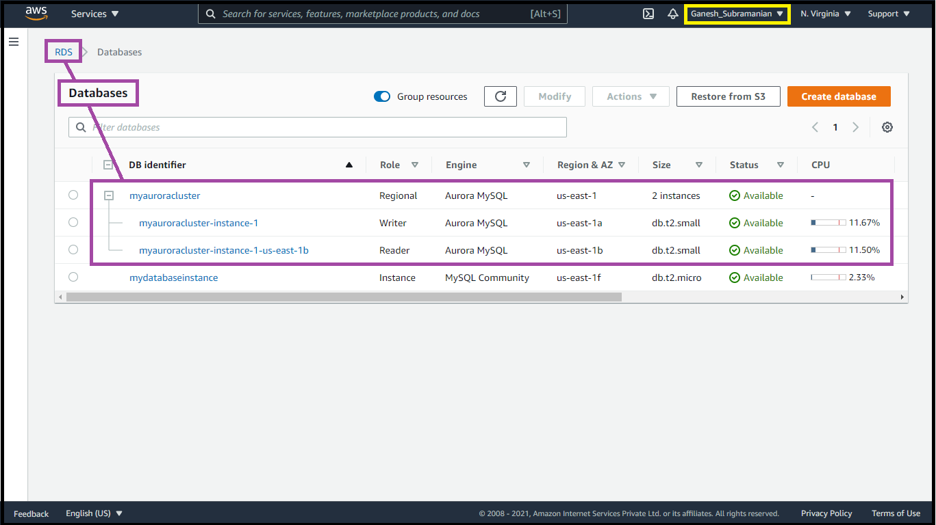

* **Execute database operation and display details**

Creating a table named students and inserting few rows of data using list of commands as shown below

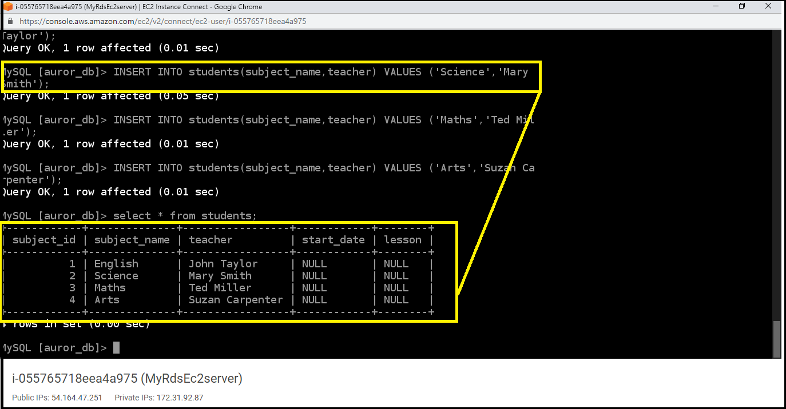

* **Show Databases console with Reader and Writer**



* **Connect to rds and show console details**

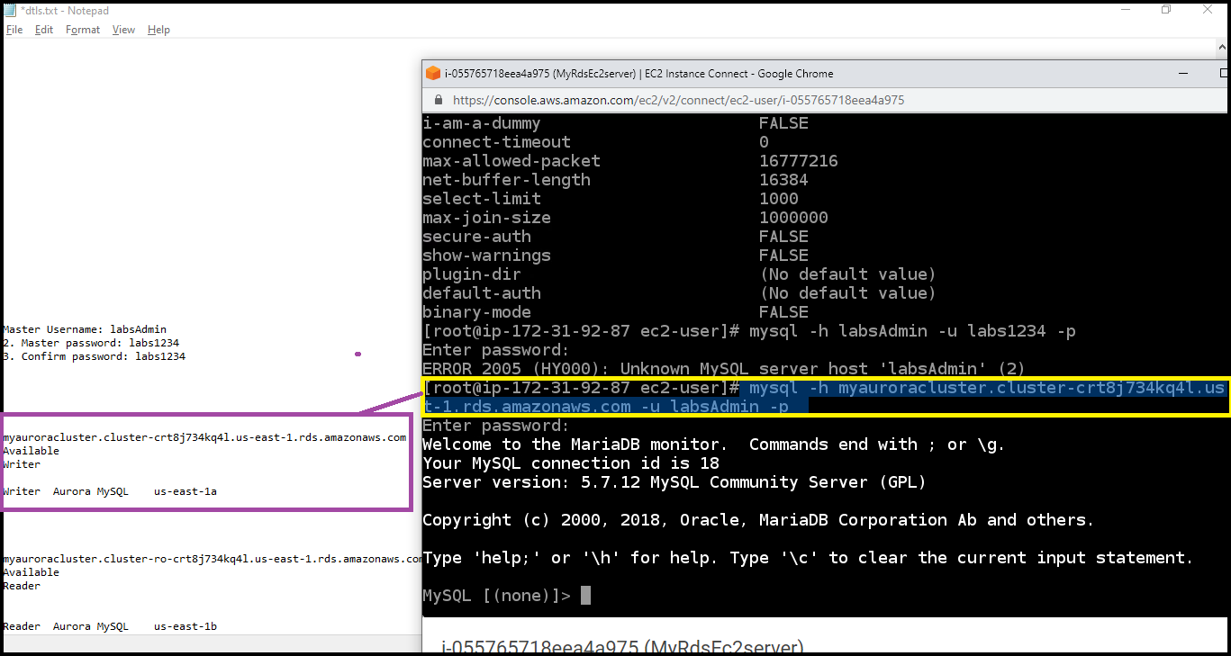

* **Show Failover in Action**

Created a situation where master fails and the read replica has to become the new Master(Writer).

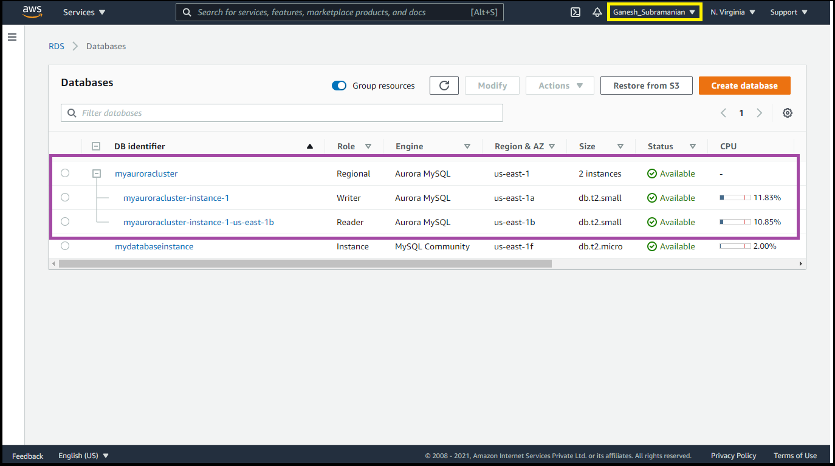

Master(Writer) becomes Reader and Reader becomes Master(Writer) as shown below

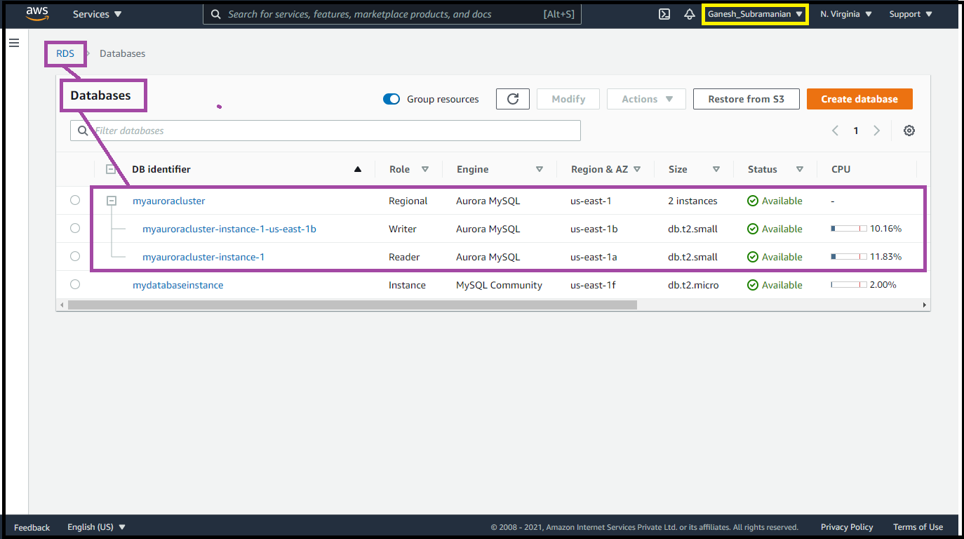

Connecting to RDS with new Master endpoint and to check if the original master db (auror_db) is still present. The original master db (auror_db) is present, implying that the Failover worked successfully.

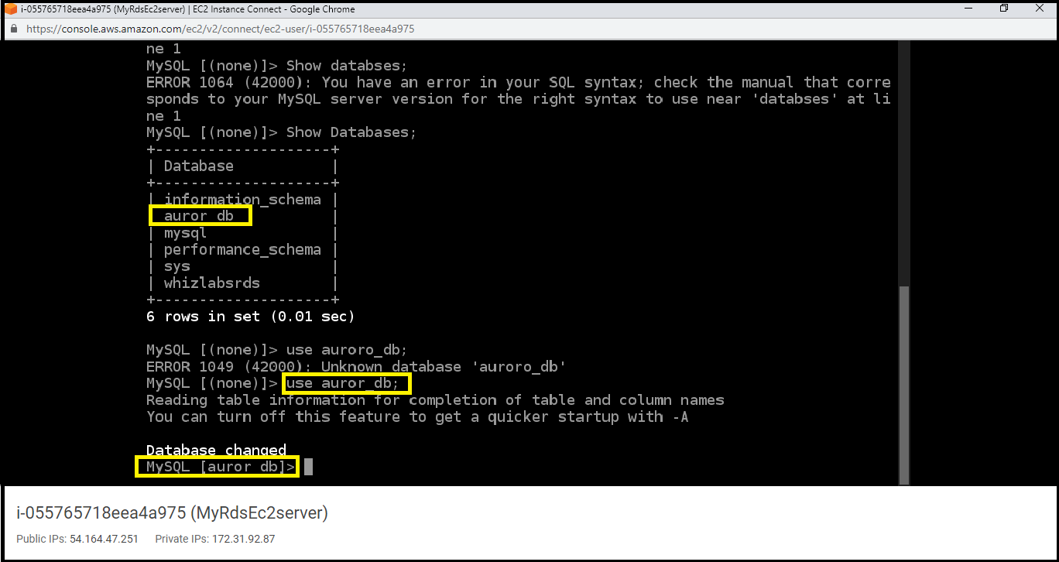

Existence of table named students and data can be seen

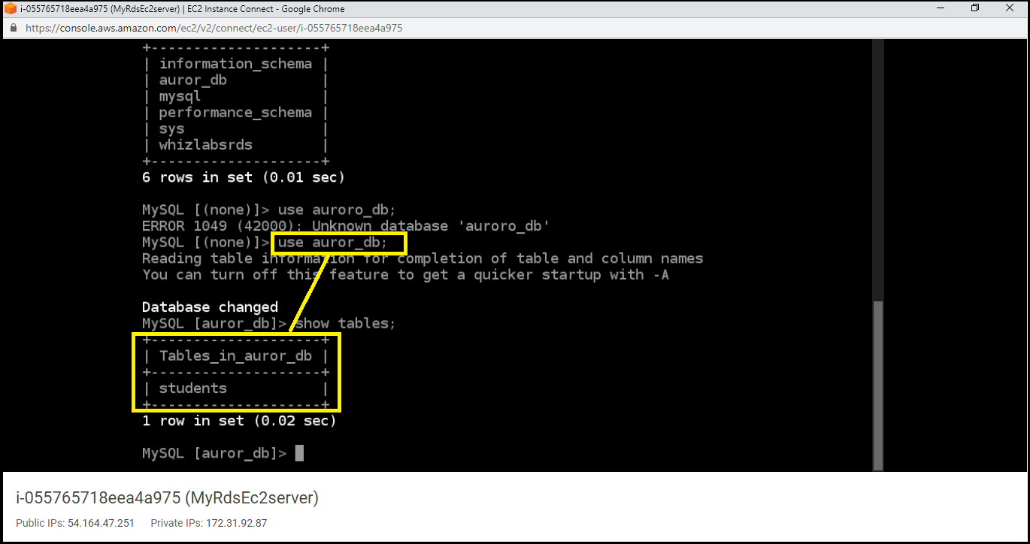

Inserting of new data into the existing students table.

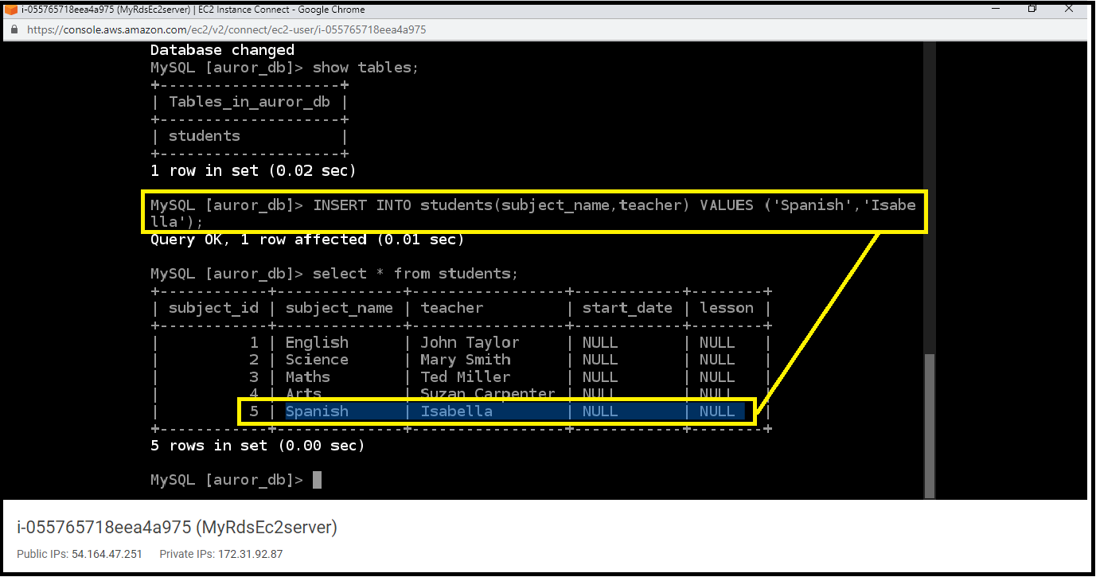

The newly created data is reflected in the Table

