**Project 3**

Provision EC2 instance with Lambda

* **Login to EC2 Console**
* **Create an IAM Policy**

**Screenshot 1:** Create IAM Policy with EC2 Configuration

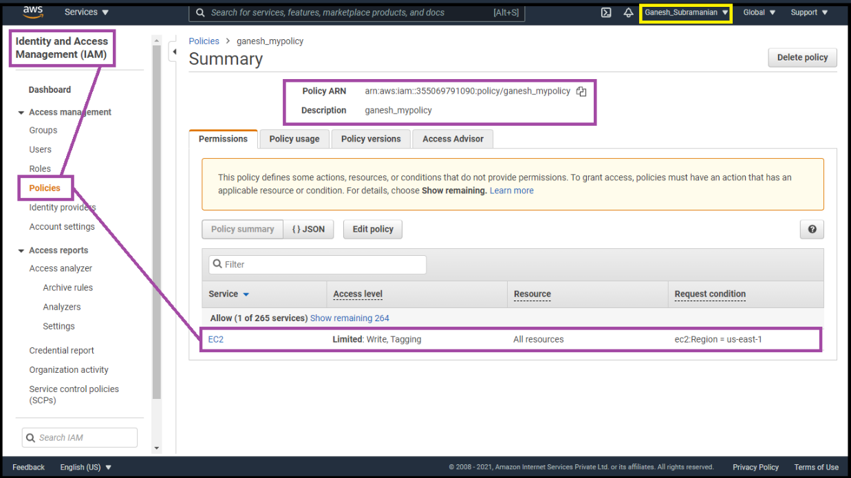

**Screenshot 2:** Create Role

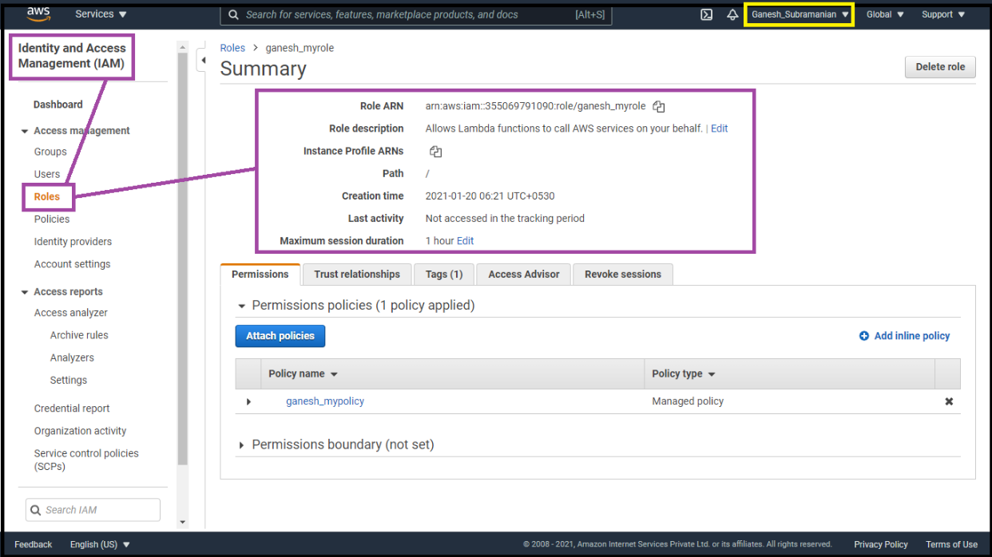

* **Create Lambda Function**

**Screenshot 3:** Lambda function – Code pasted (Configuration)

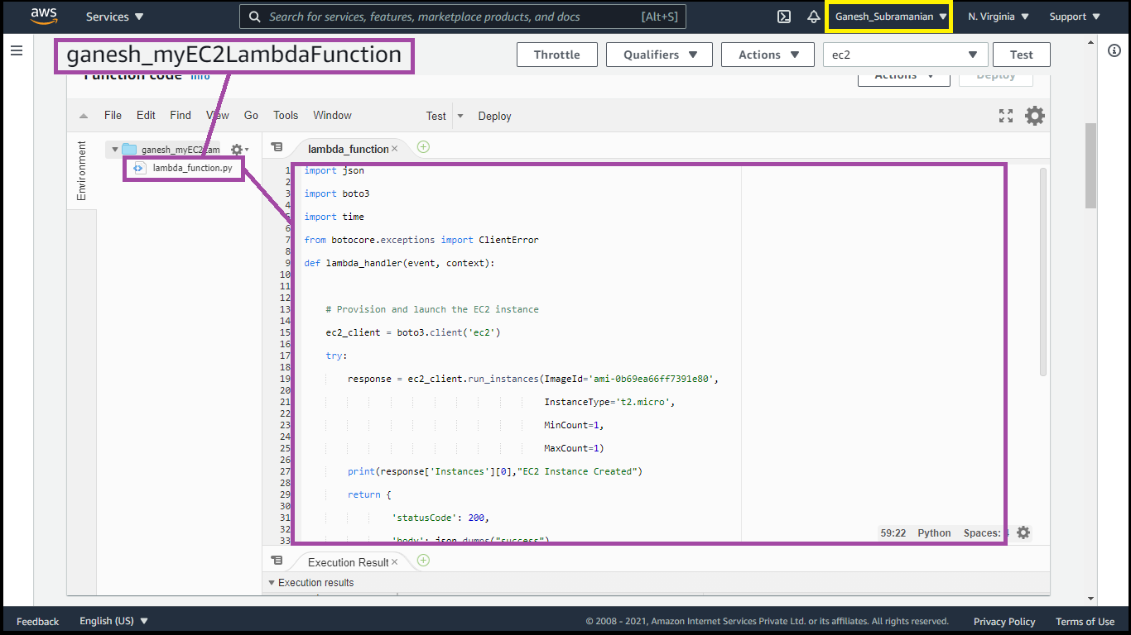

**Screenshot 4:** Timeout Settings

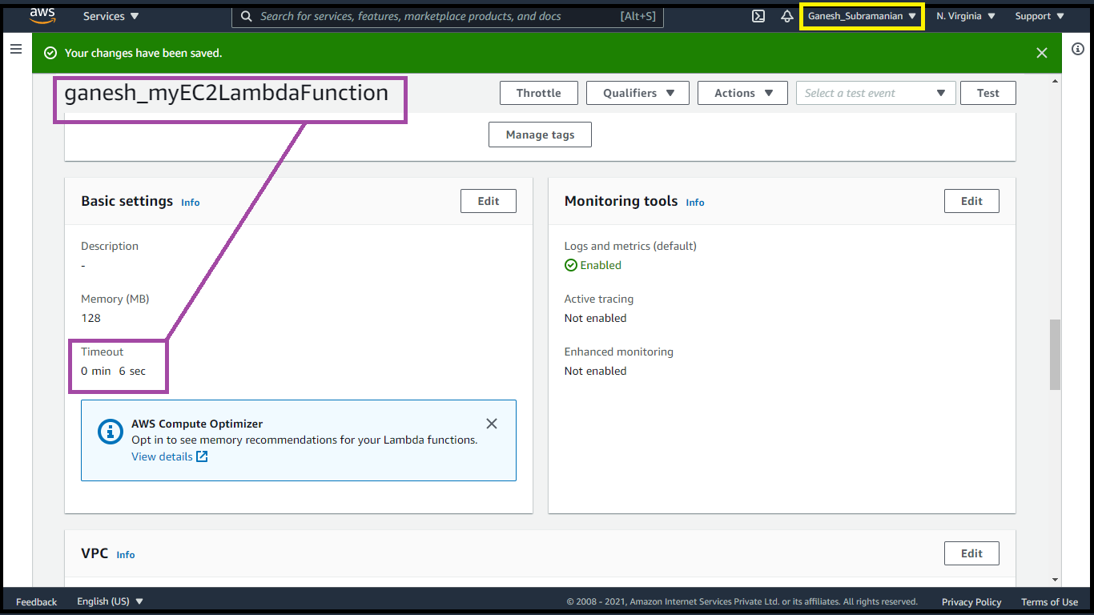

* **Configure Test Event**

**Screenshot 5:** Configuration the Test Page

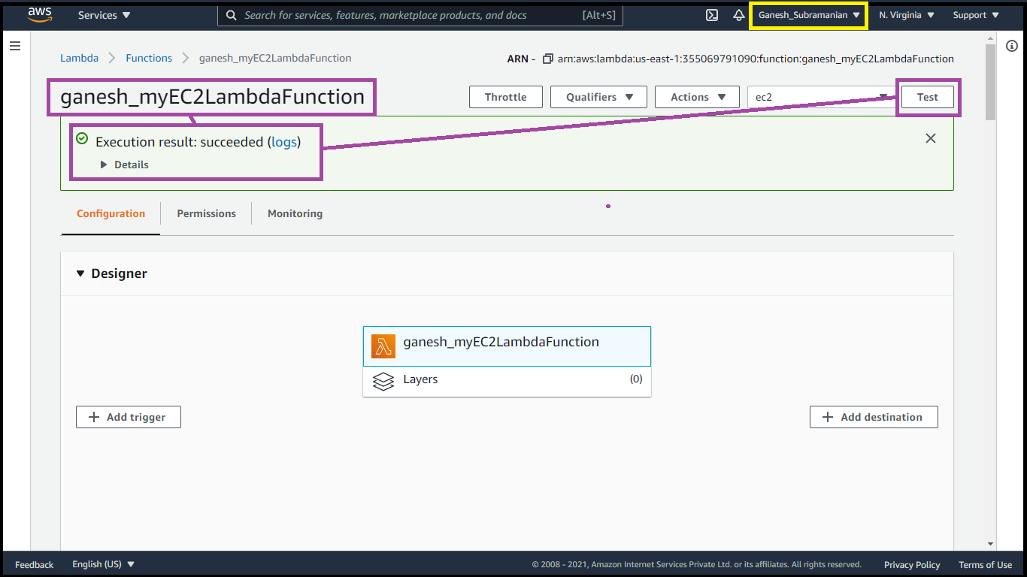

* **Trigger the Lambda functionality using the Test events**

**Screenshot 6:** Details of instance deployed from Lambda Console

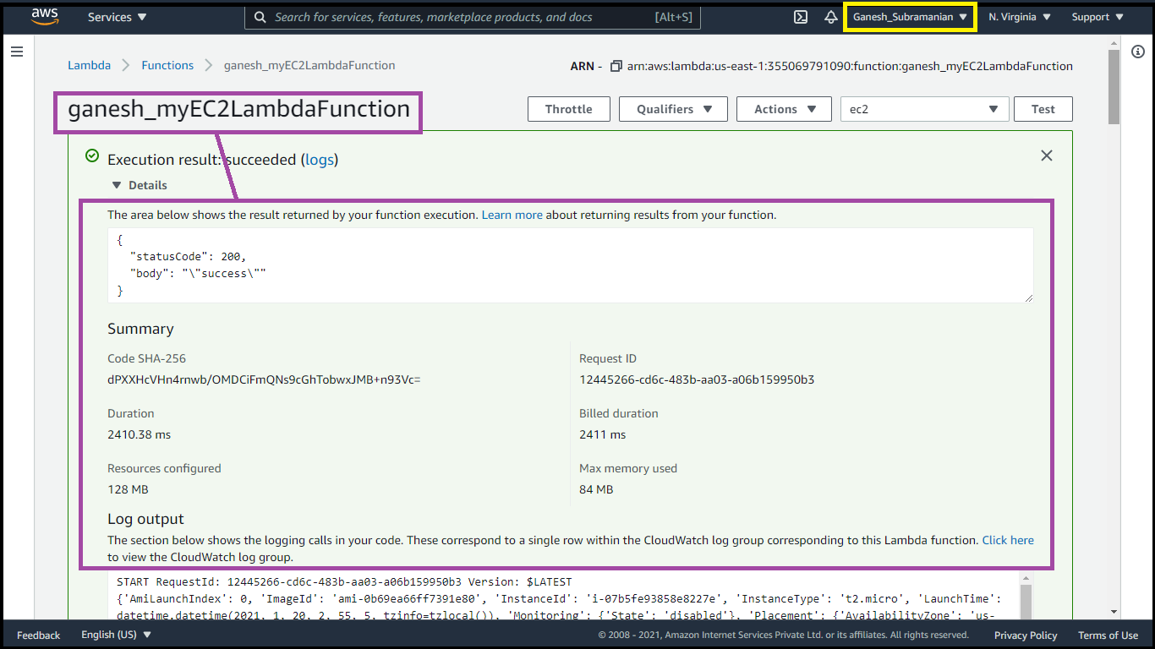

**Screenshot 7:** EC2 Dashboard & Then display instance details

