**Project 4**

Git Project

**Task1:** create a repository in github

● git init

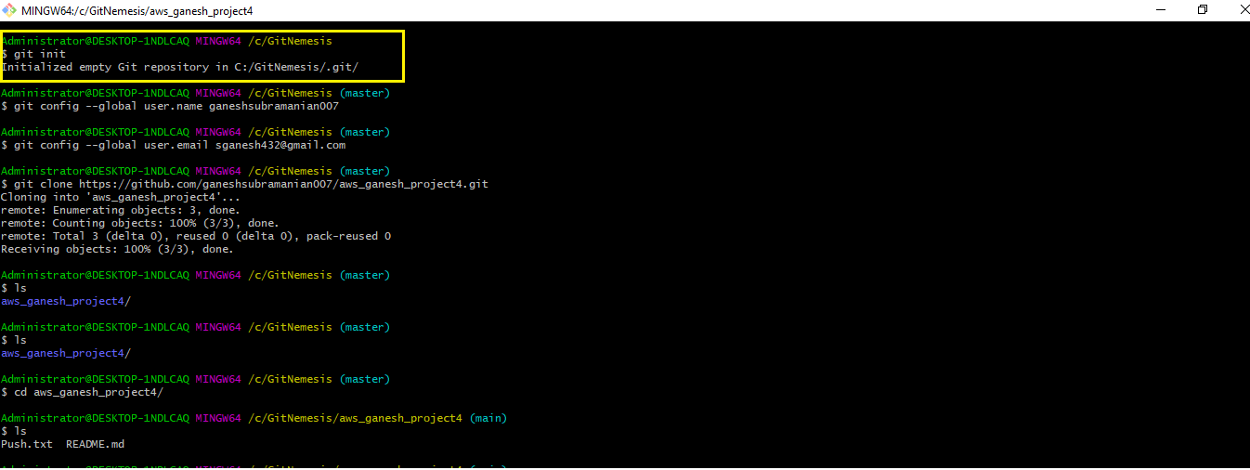

● Both config commands

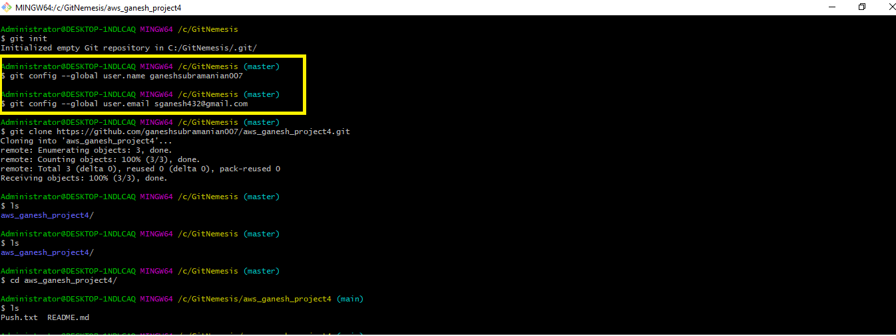

* git config --global user.name “**ganeshsubramanian007”**
* git config --global user.email “**sganesh432@gmail.com”**

**Task2:** open git bash and clone contents from remote repository

● clone

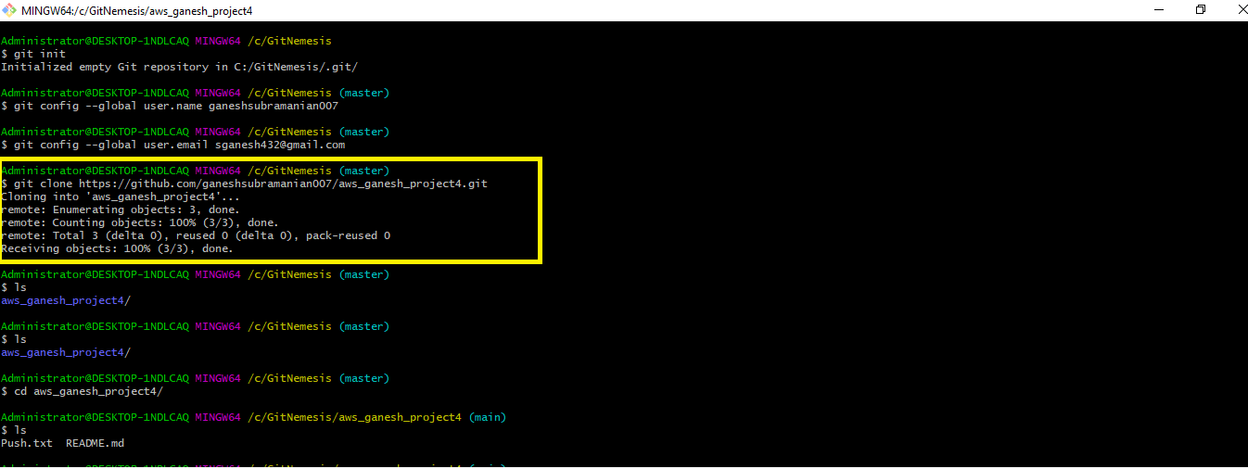

* git clone https://github.com/ganeshsubramanian007/aws_ganesh_project4.git

● show the folder in local repository

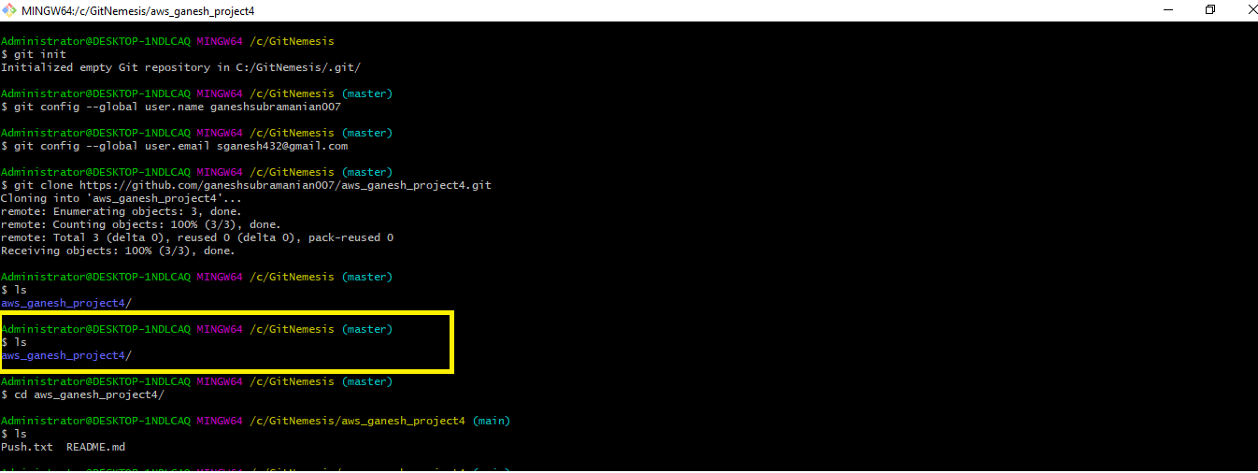

**Task3:** create a file in the local space and push it to the remote repository

● add

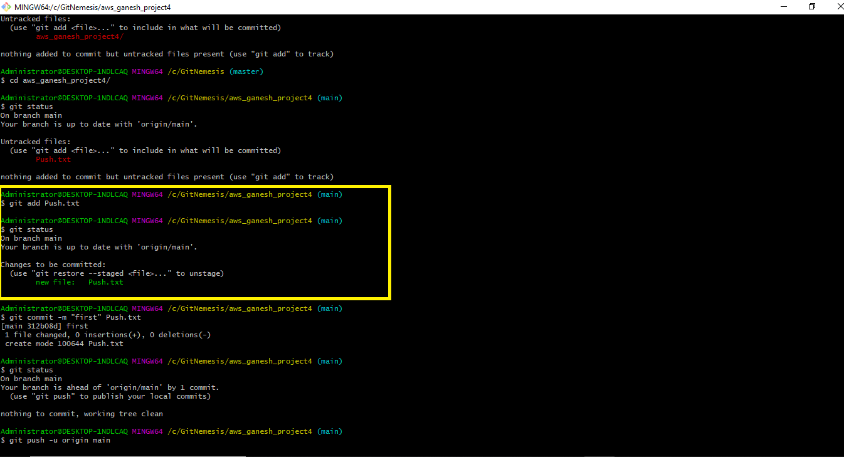

* git add **“Push.txt”**

● commit

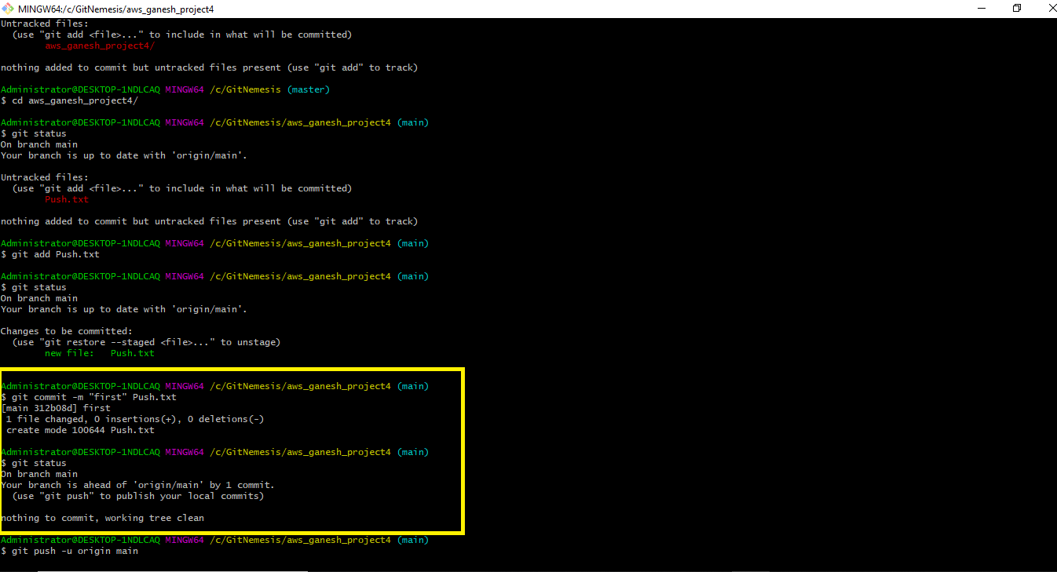

* git commit -m **"first" Push.txt**

● push successful

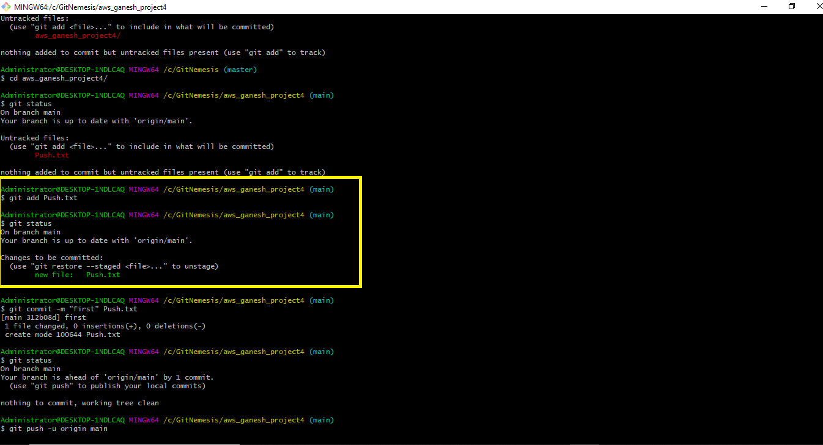

● show the file in remote repository

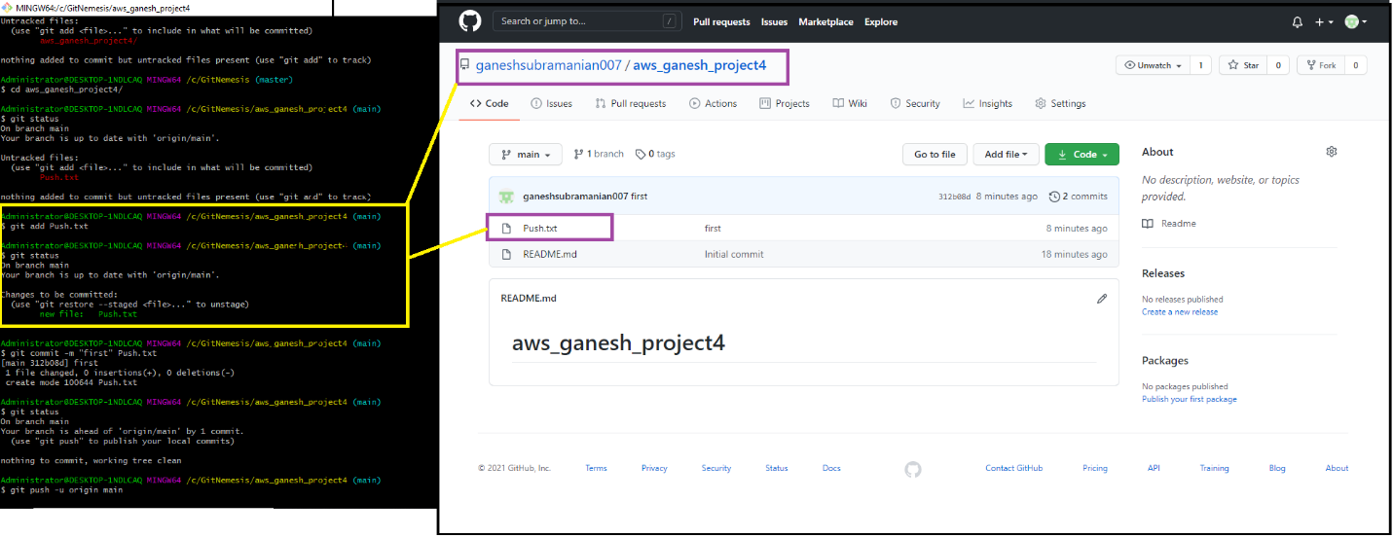

**“Push.txt”** is reflected in the **Remote Repository**

**Task4:** Branching and merging

Execute all commands and add screenshots

Git branching:

● git branch

● git branch branchname

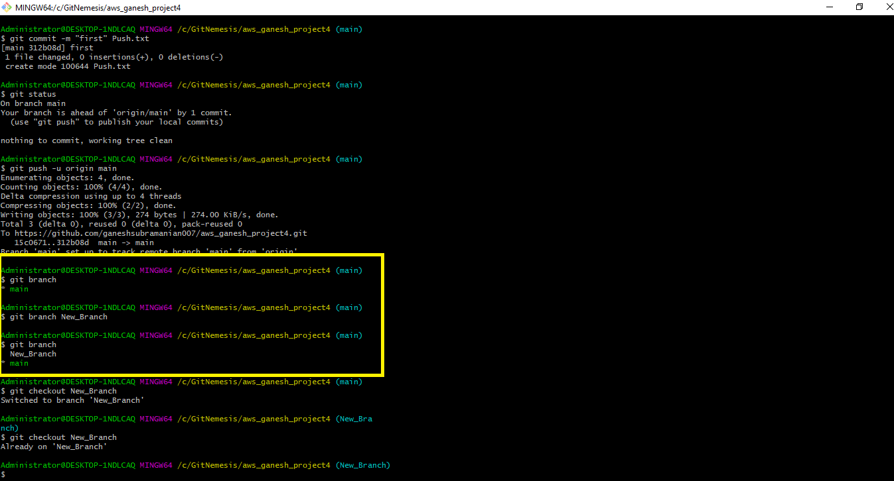

● git checkout branchname

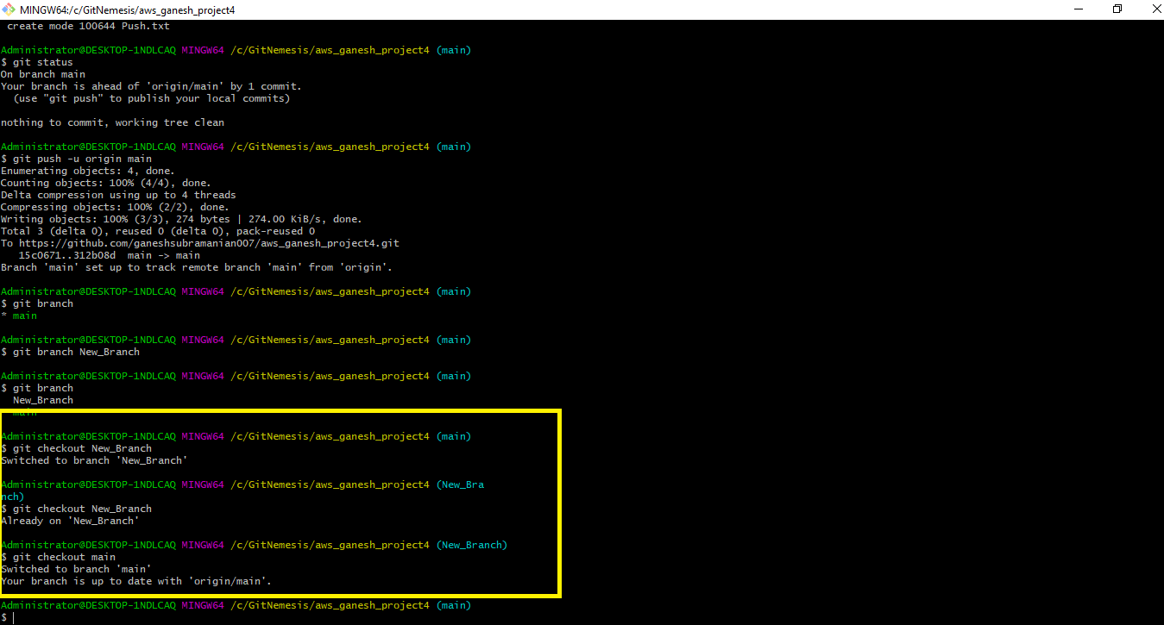

* git checkout **“New_Branch”**

● git merge branchname

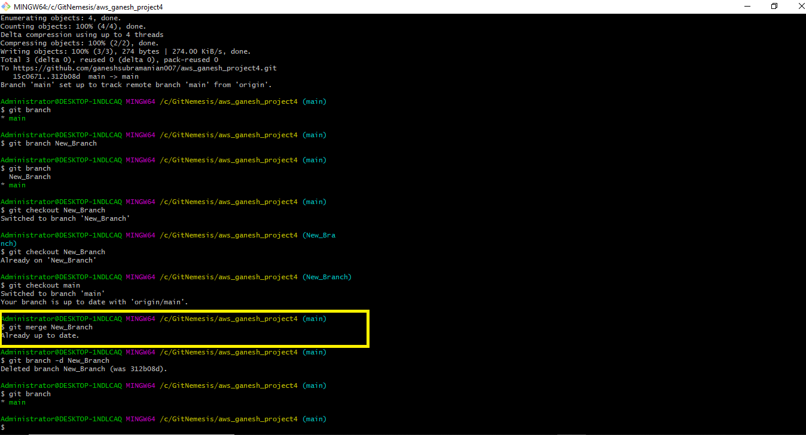

* git merge **“New_Branch”**

● git branch -d branchname

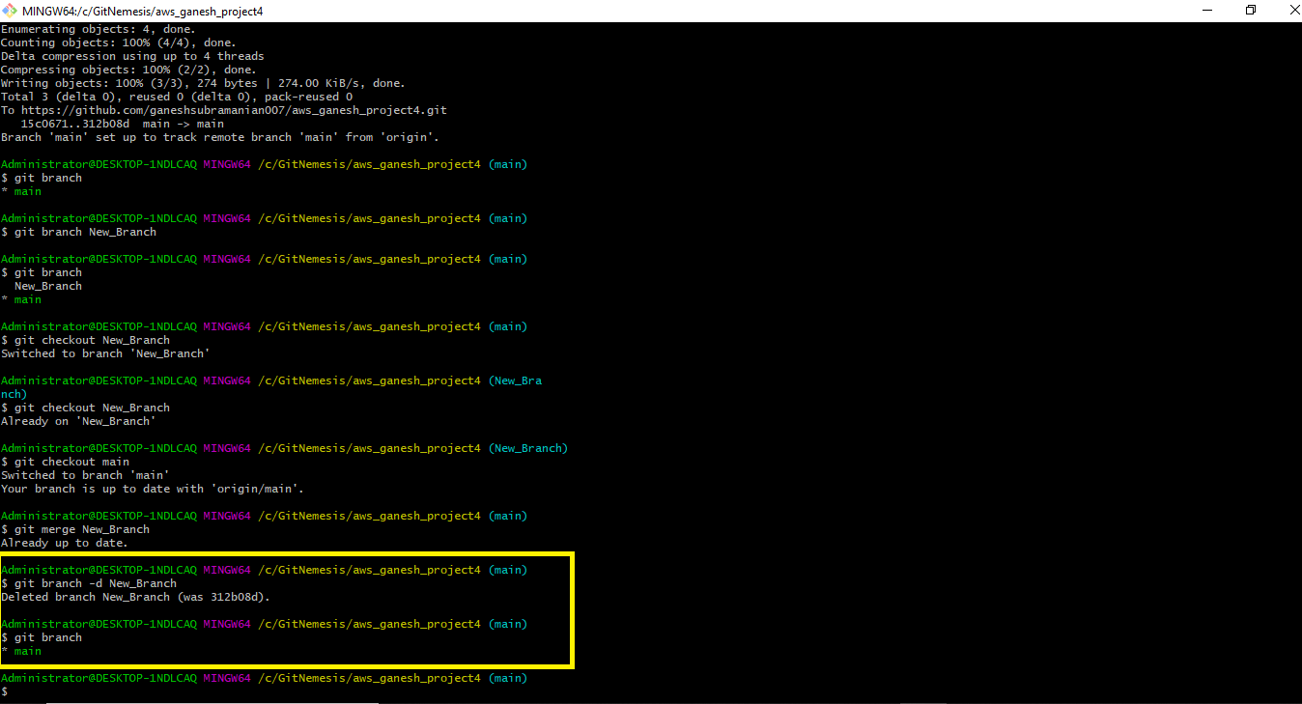

* git branch -d **“New_Branch”**

● git branch -D branchname

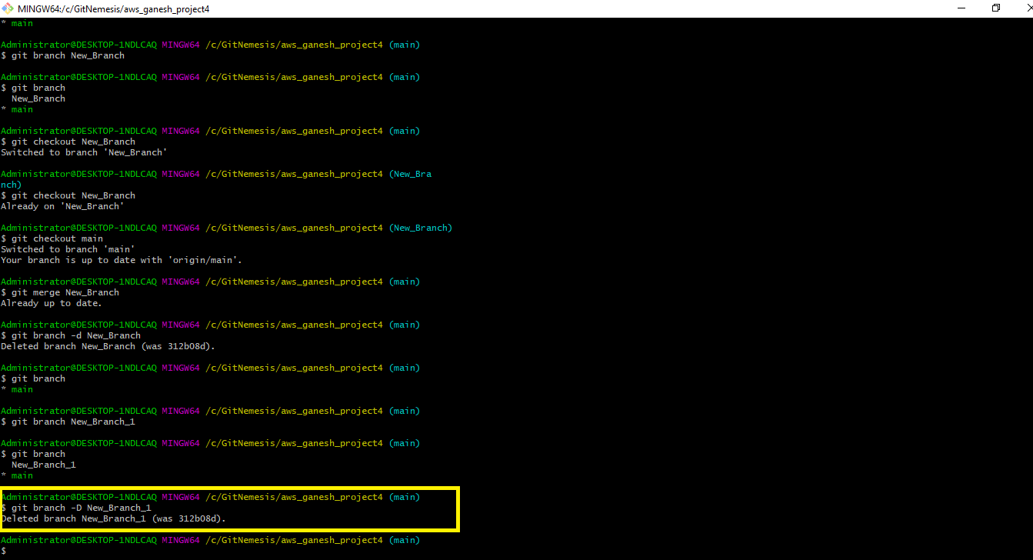

* git branch -D **“New_Branch_1”**

● git checkout -b branchname

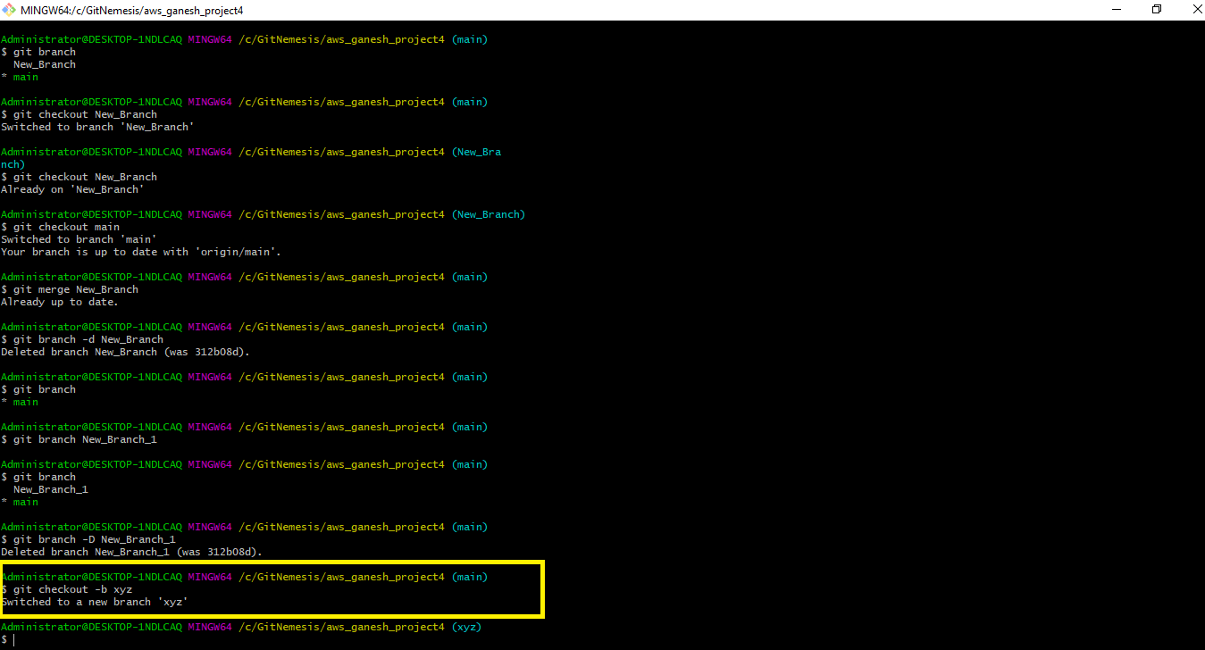

* git checkout -b **“xyz”**

● git log

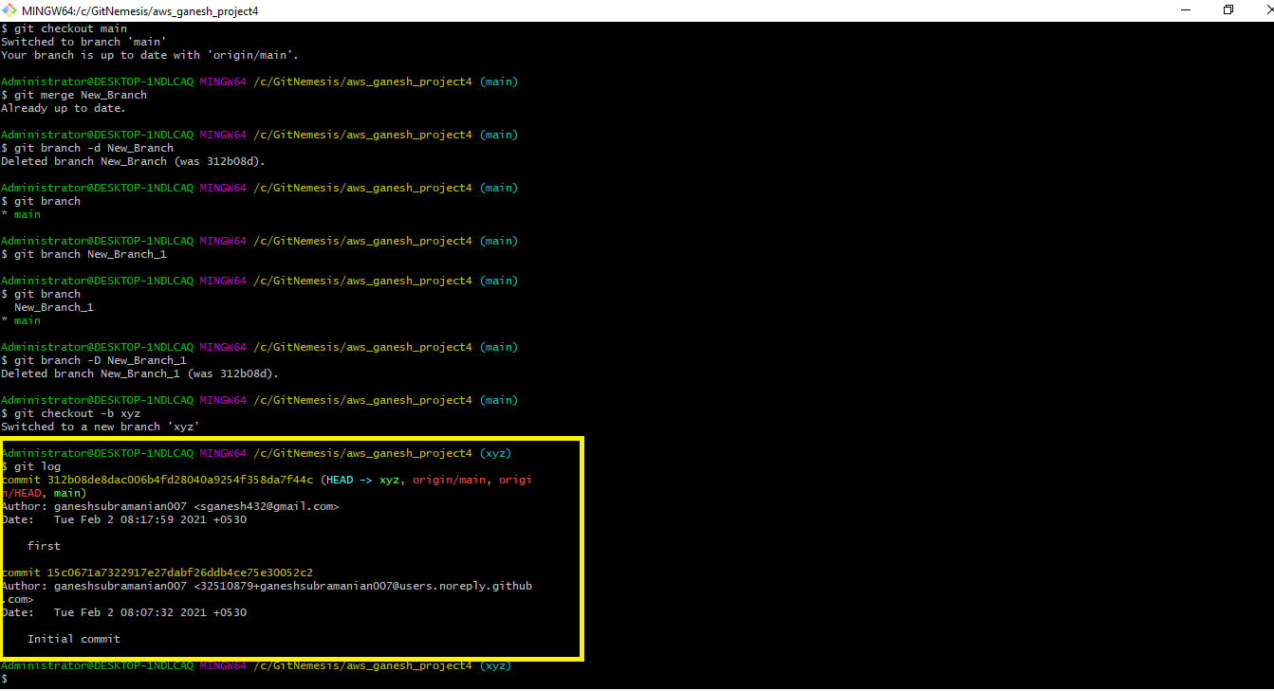

* git log