**Project 5**

Scheduling a basic job in Jenkins

* **Task 1:** Create a free style project

**Screenshot 1:** Jenkins home page with job list

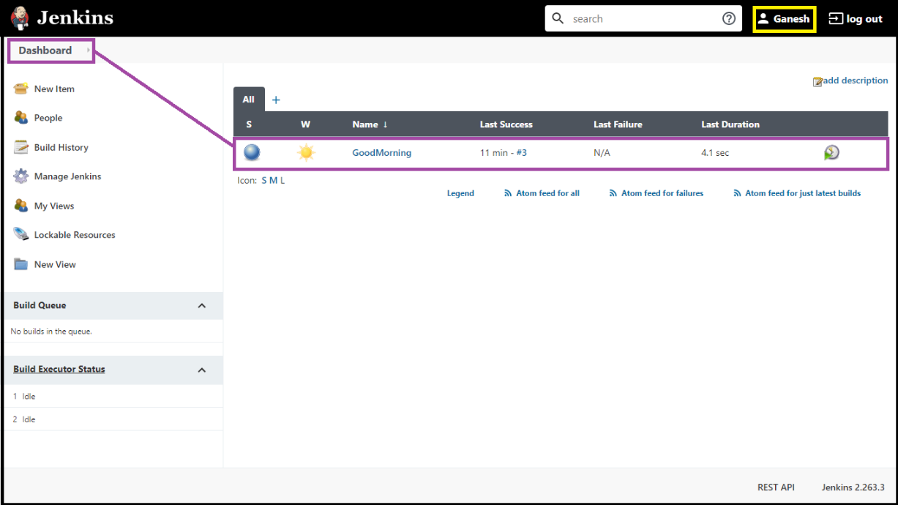

* **Task 2:** Configure Git SCM

**Screenshot 2:** Git Source Code Management config tab

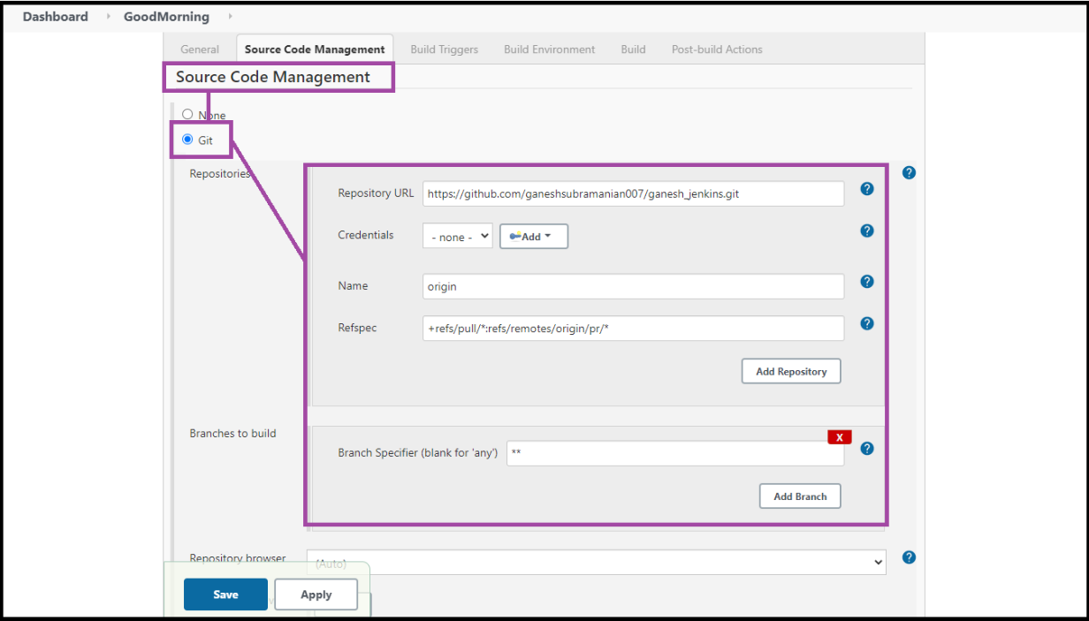

* **Task 3:** Add build step-java commands in execute windows batch commands

**Screenshot 3:** commands

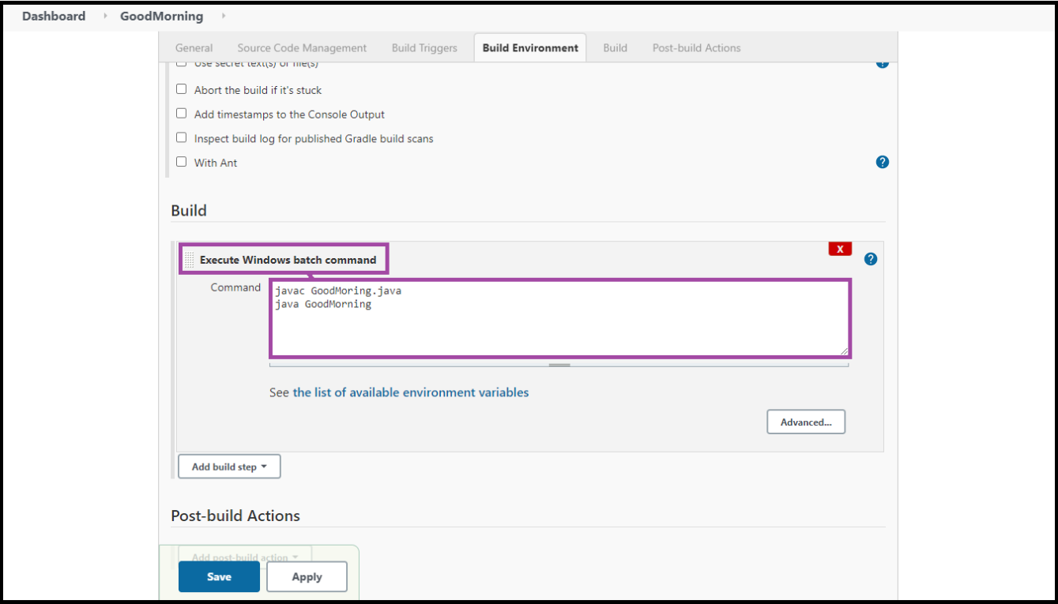

* **Task 4:** Run a build and show console output

**Screenshot 4:** Console Output-build success

