**Project 7**

Project-DevOps-Jenkins-Installation and Configuration on Linux

**Task 1:** https://pkg.jenkins.io/redhat-stable/

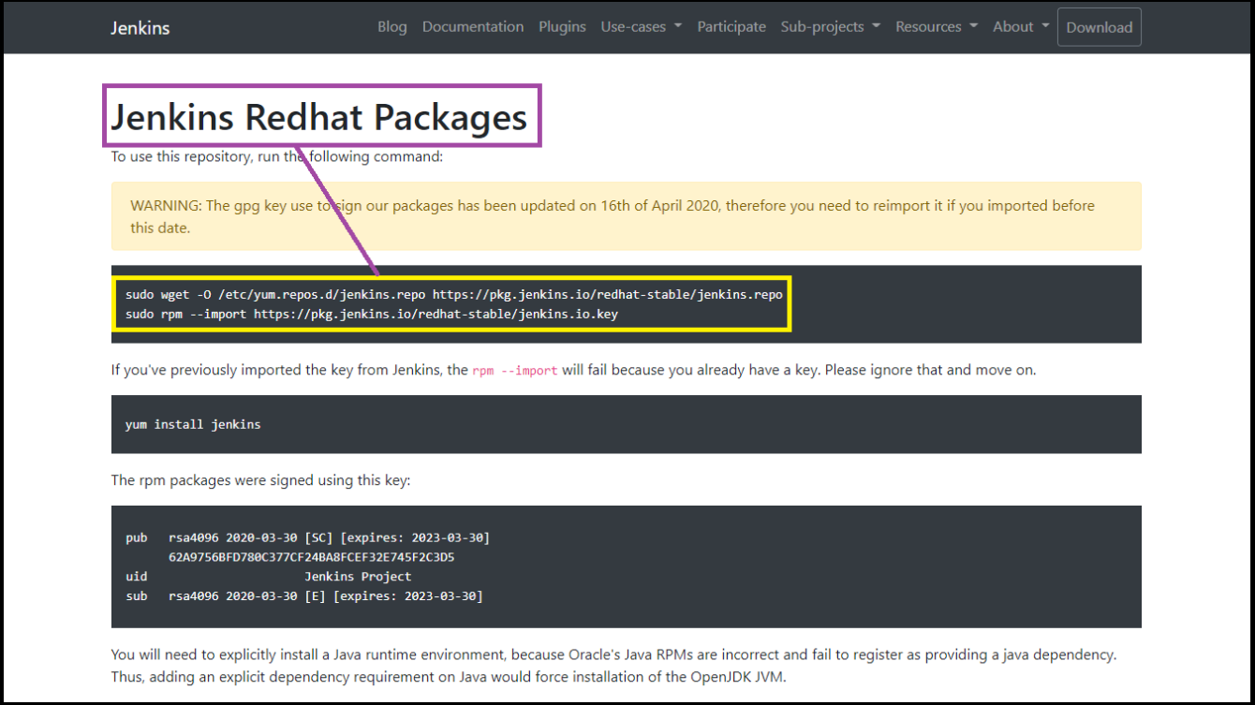

**Task 2:** Install java

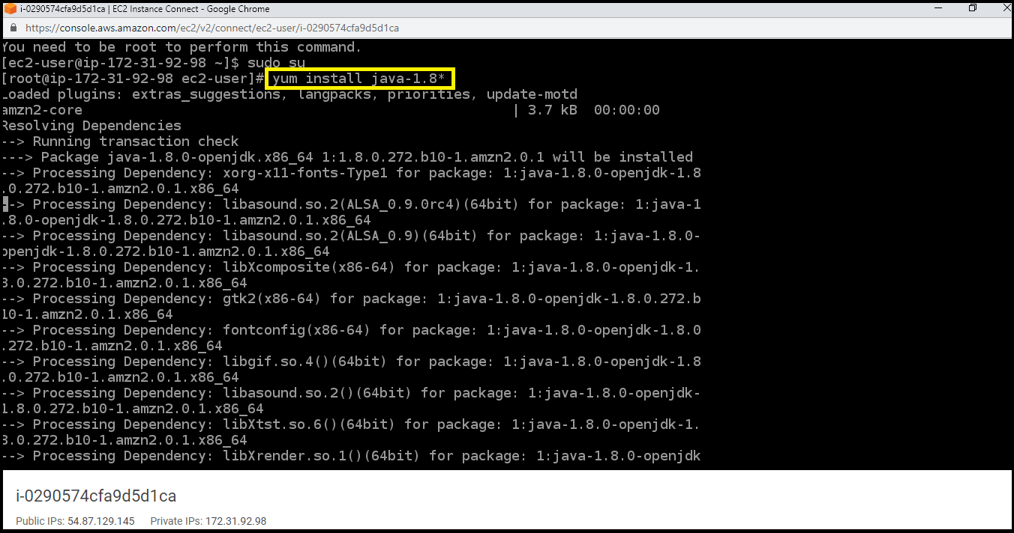

**Task 3:** sudo wget -O /etc/yum.repos.d/jenkins.repo https://pkg.jenkins.io/redhat-stable/jenkins.repo

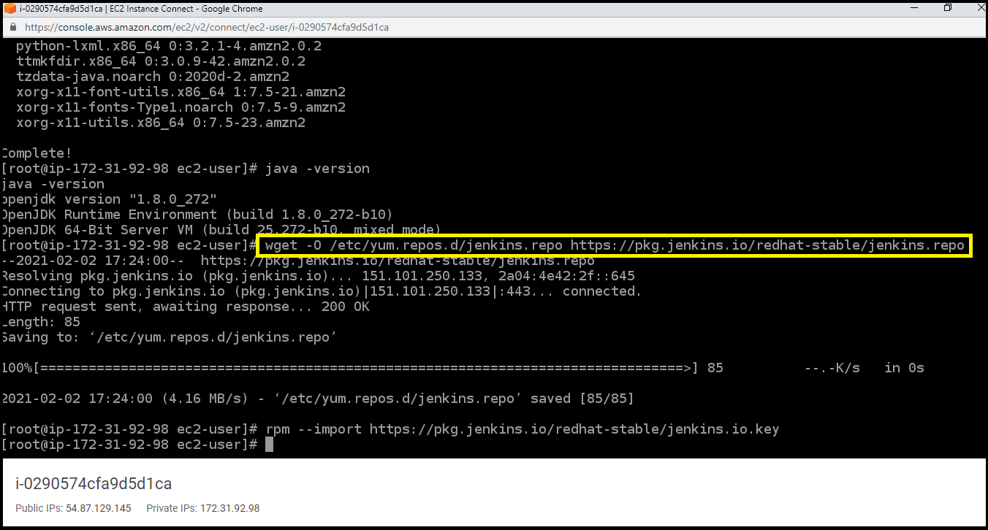

**Task 4:** sudo rpm --import https://pkg.jenkins.io/redhat-stable/jenkins.io.key

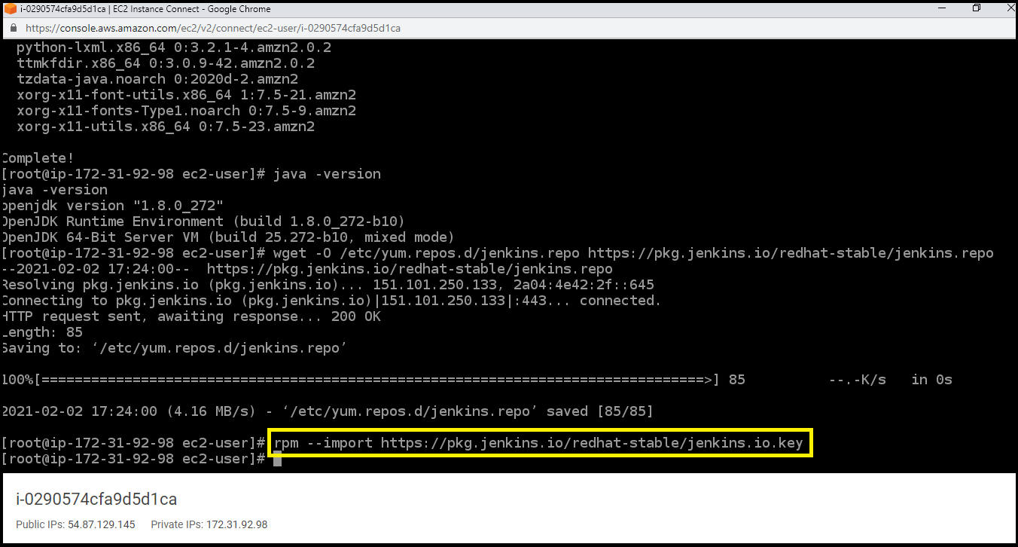

**Task 5:** yum install Jenkins

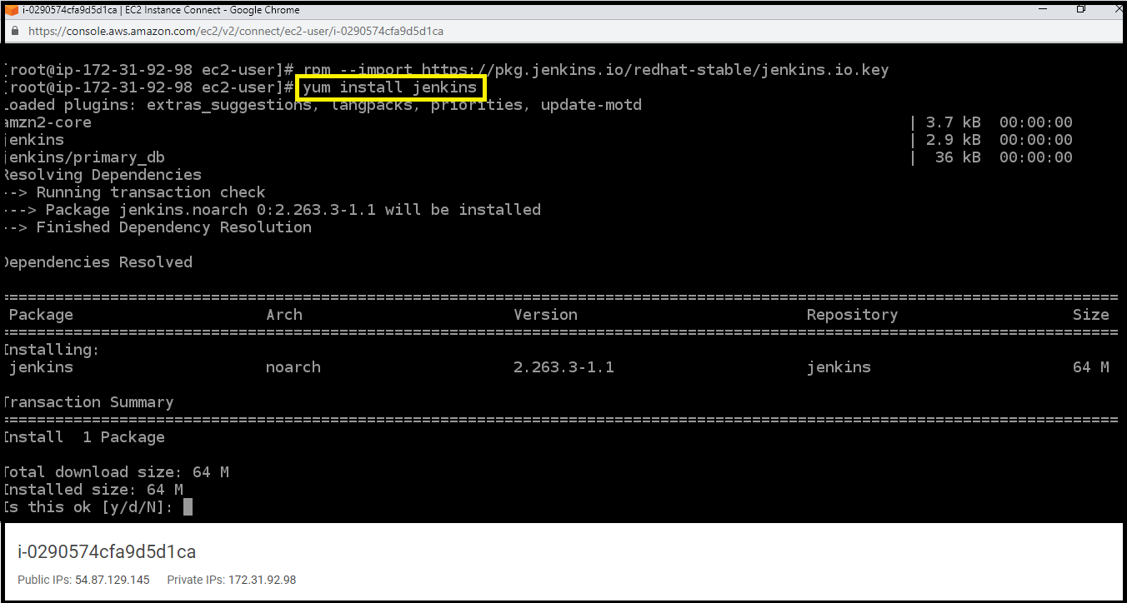

**Task 6:** Extract the password from the location

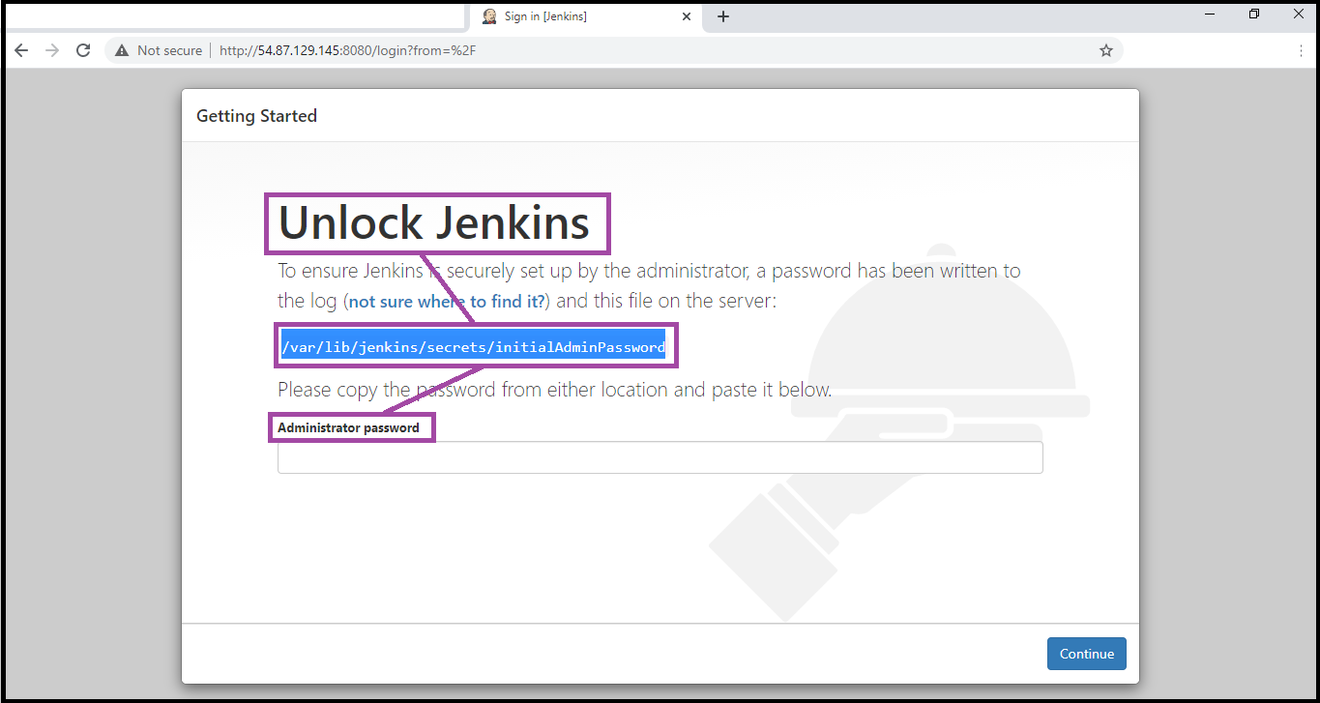

**Task 7:** Skip installing plugins

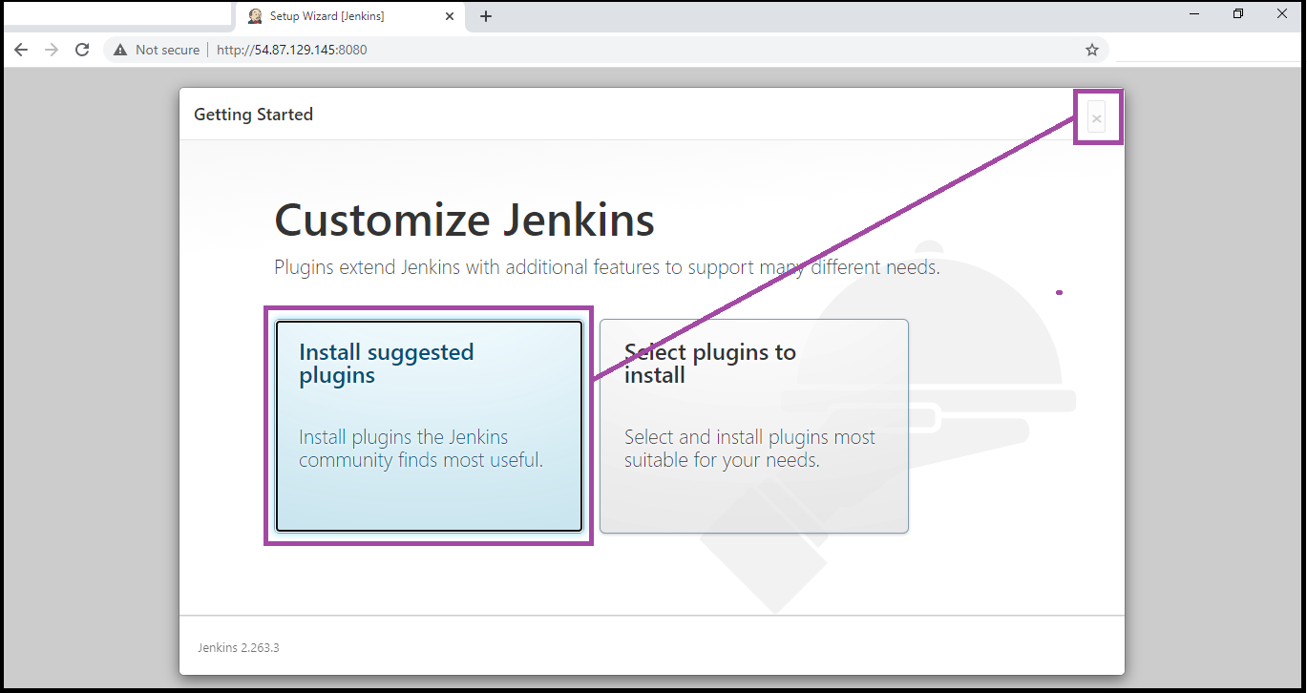

**Task 8:** Start using Jenkins

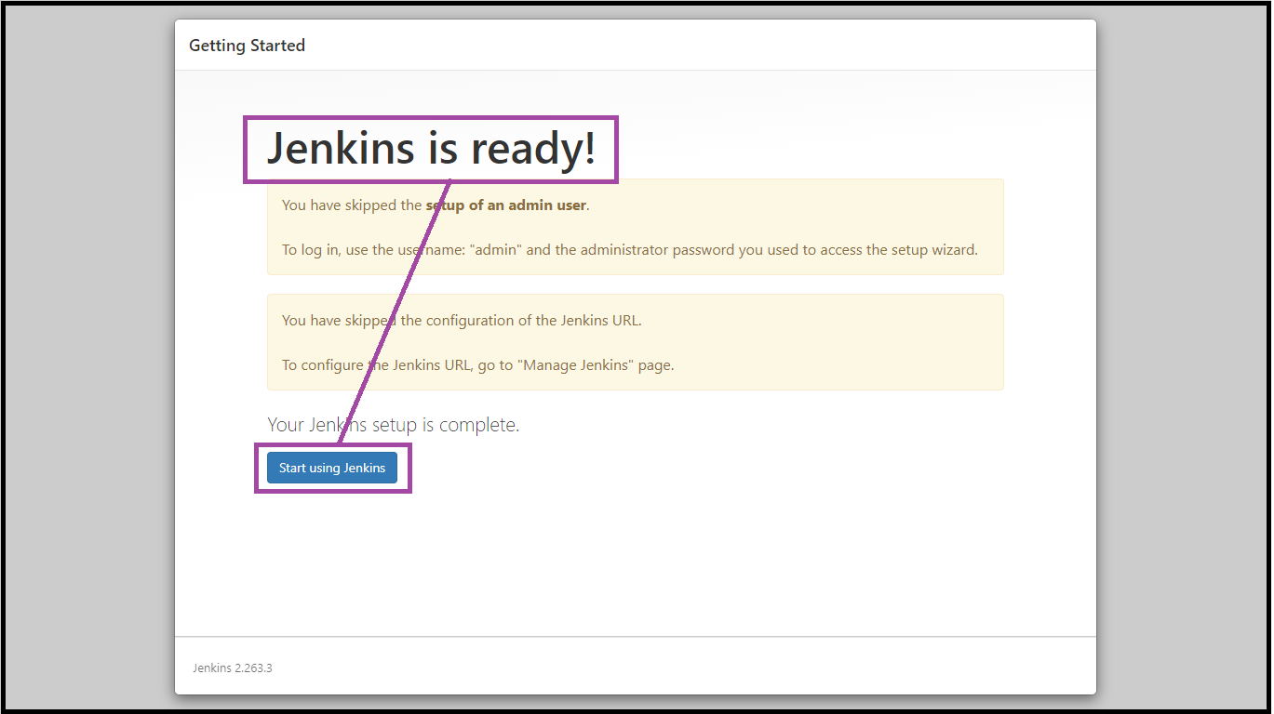

**Task 9:** Change the admin password

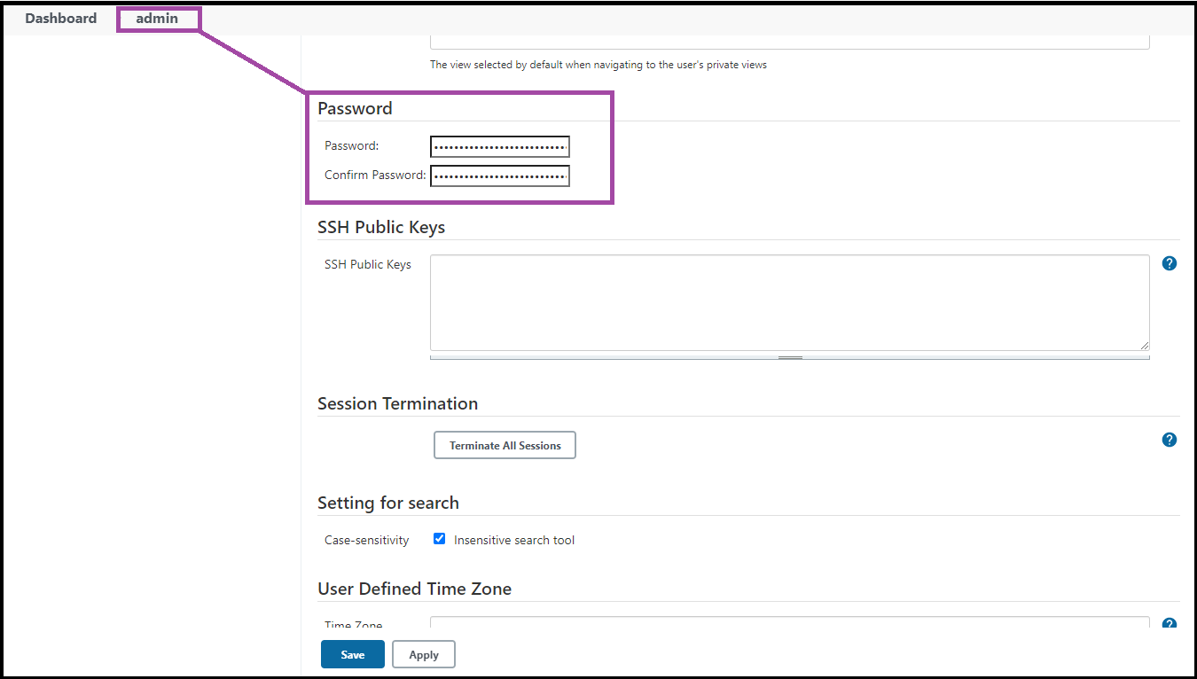

**Task 10:** Create a new job

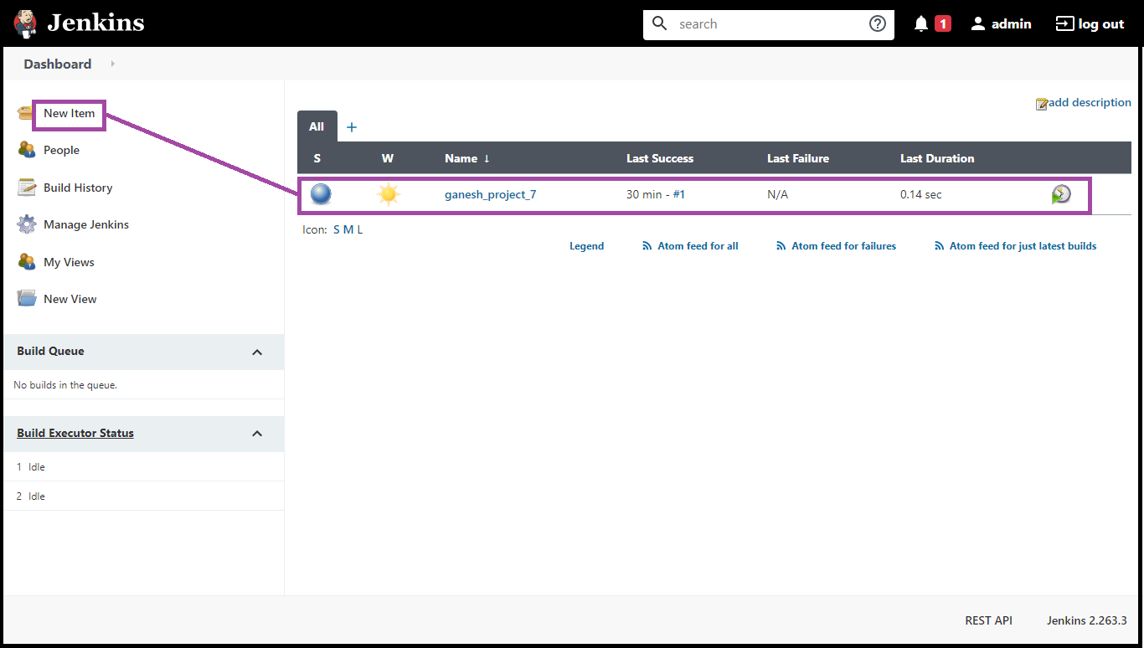

**Task 11:** Build step: execute shell

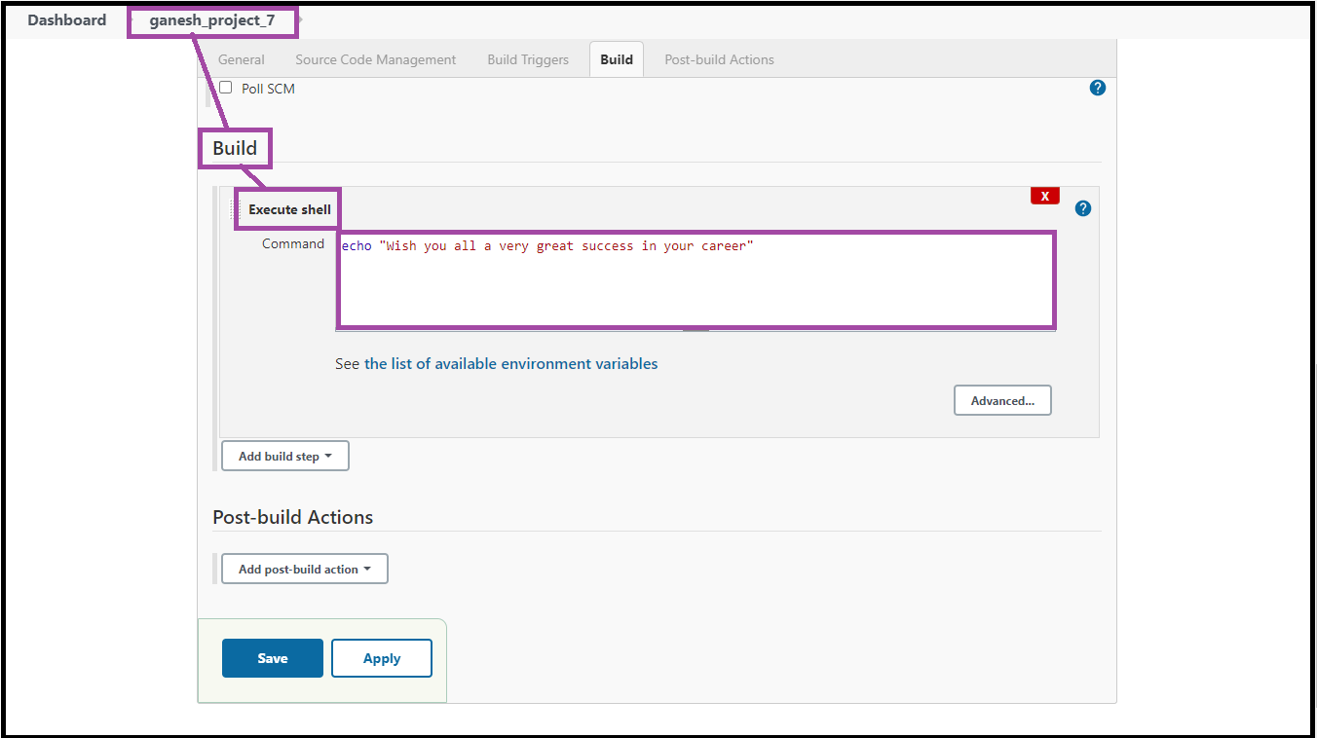

**Task 12:** echo "Wish you all a very great success in your career"

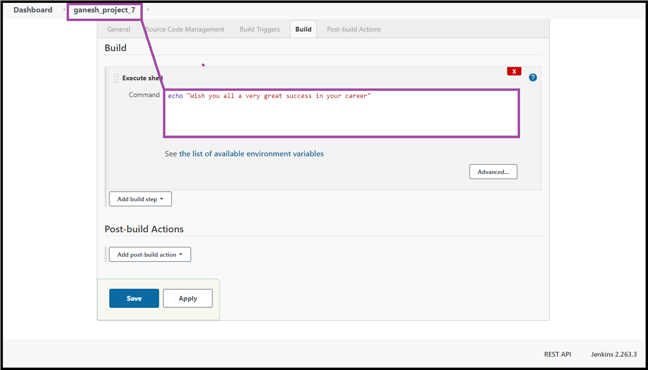

**Task 13:** Build the job

