**Question 1:**

Find out the mail servers of the following domain:

Ibm.com

Open CMD: Type the below commands one by one.

nslookup (wait for couple of seconds and then Press Enter)

www.ibm.com (wait for couple of seconds and then Press Enter)

set type=mx (wait for couple of seconds and then Press Enter)

ibm.com

mail server exchange for ibm = mx0b-001b2d01.pphosted.com

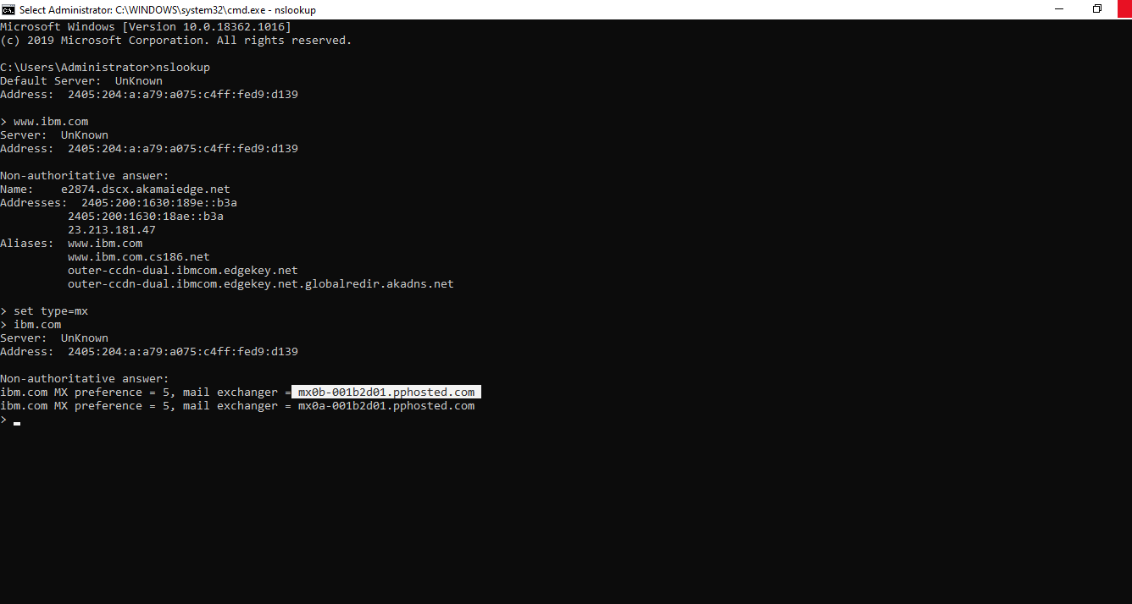

Wipro.com

nslookup (wait for couple of seconds and then Press Enter)

www.wipro.com (wait for couple of seconds and then Press Enter)

set type=mx

wipro.com

mail server exchange for wipro = wipro-com.mail.protection.outlook.com

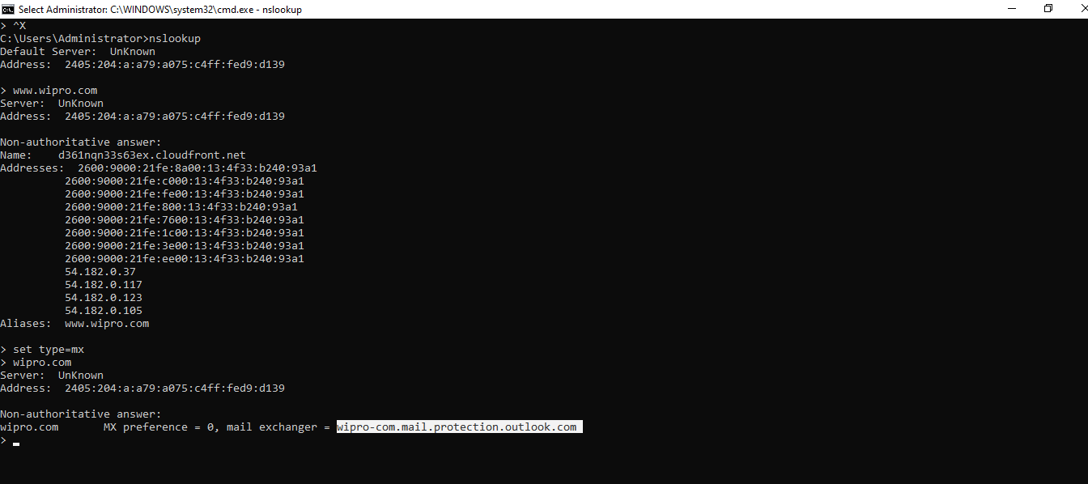

**Question 2:**

Find the locations, where these email servers are hosted.

Open google chrome

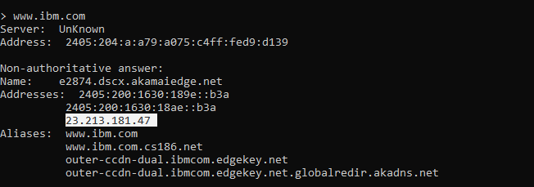

Open IP Location Finder

Type 23.213.181.47 (ibm)

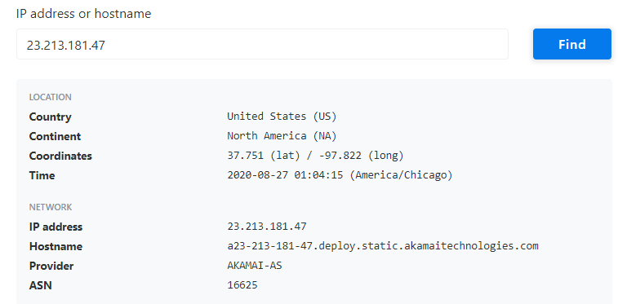

Open google chrome

Open IP Location Finder

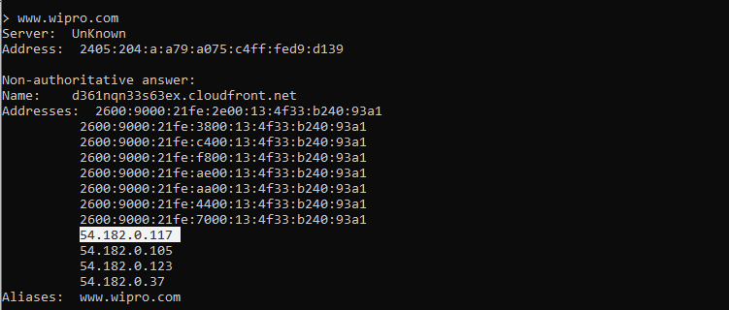

Type 54.182.0.117 (wipro)

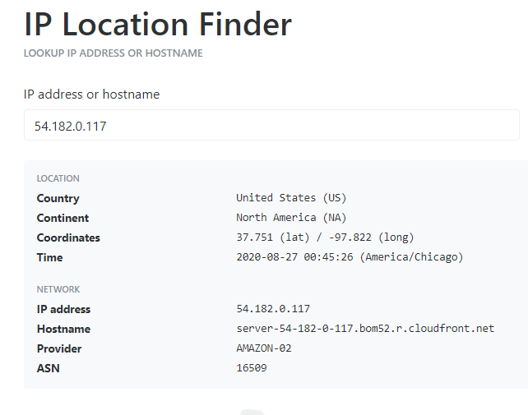

**Question 3:**

Scan and find out port numbers open 203.163.246.23

In kali with Root Access User Type the below command

root@kali:~# nmap -Pn -sS -A -v 203.163.246.23

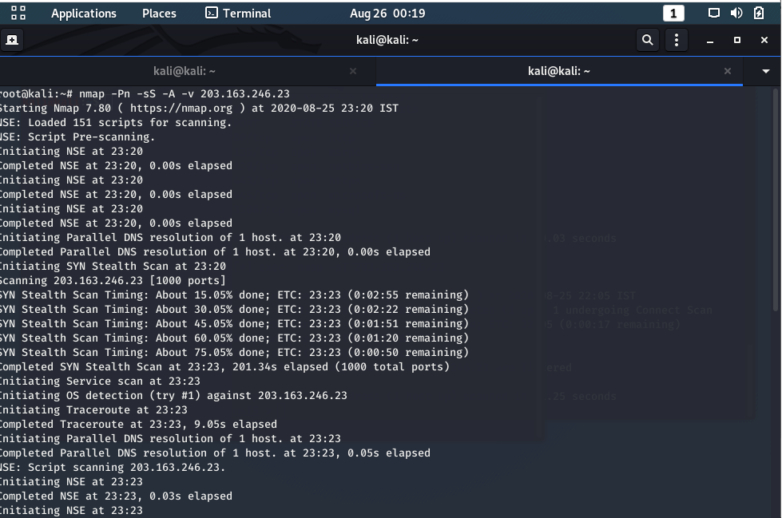

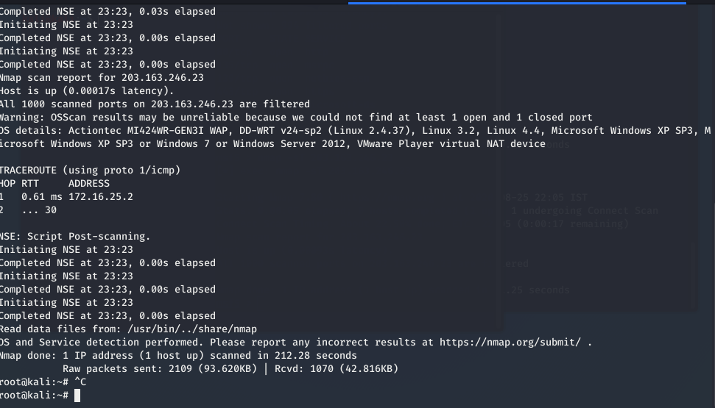

**Question 4:**

Install nessus in a VM and scan your laptop/desktop for CVE.

Installed Nessus in VM and Scanned Laptop for CVE

Please find the below details of the same

