Name : Ganesh Kumar
Reg.no.:11712737
Section: k17YP
Group: B
Roll no.: B39
Email Address: ganeshswami98@icloud.com
Github Link: https://github.com/ganeshswami98/11712737

Ques. Reena’s operating system uses an algorithm for deadlock avoidance to manage the allocation of resources say three namely A, B, and C to three processes P0, P1, and P2. Consider the following scenario as reference .user must enter the current state of system as given in this example :
Suppose P0 has 0,0,1 instances , P1 is having 3,2,0 instances and P2 occupies 2,1,1 instances of A,B,C resource respectively.
Also the maximum number of instances required for P0 is 8,4,3 and for p1 is 6,2,0 and finally for P2 there are 3,3,3 instances of resources A,B,C respectively. There are 3 instances of resource A, 2 instances of resource B and 2 instances of resource C available. Write a program to check whether Reena’s operating system is in a safe state or not in the following independent requests for additional resources in the
current state:
1. Request1: P0 requests 0 instances of A and 0 instances of B and 2 instances of C.
2. Request2: P1 requests for 2 instances of A, 0 instances of B and 0 instances of C. All the request must be given by user as input.

Code:

#include<stdio.h>
#include<stdlib.h>
#include<windows.h>

int main(){
int process = 3;
int resource = 3;
int i,j;
int allocation[3][3] = { { 0, 0, 1 }, // P0
{ 3, 2, 0 }, // P1
{ 2, 1, 1 }, // P2
};
int maximum[3][3] = { { 8, 4, 3 }, // P0
{ 6, 2, 0 }, // P1
{ 3, 3, 3 }, // P2
};
int available[3] = {3,2,2};

findSafeState(process,resource,available,allocation,maximum);

}

int findSafeState(int process,int resource,int *available,int allocation[3][3],int maximum[3][3])
{
int i=0,j=0,k=0;
int finish[process];
int need[process][resource];
int safeSequence[process];
int isFound = 0;
int work[resource];
for (i = 0; i <resource ; i++)
work[i] = available[i];
int completed=0;

printf("Need Matrix is : \n");
for(i=0;i<process;i++)
{
finish[i]=0;
for(j=0;j<resource;j++)
{
need[i][j] = maximum[i][j]-allocation[i][j];
printf("\t%d",need[i][j]);
}
printf("\n");

}
printf("Enter the requesting process : P");
int pr;
scanf("%d",&pr);
int request[resource];
for(i=0;i<resource;i++)
{
printf("R%d : ",i);scanf("%d",&request[i]);
}
int allowed = 0;
for(i=0;i<resource;i++)
{
if(request[i]<=available[i])
{allowed=1;}
else
{allowed=0;break;}
}
if(allowed==1)
{

for(i=0;i<resource;i++)
{
allocation[pr][i]+=request[i];
need[pr][i]-=request[i];
available[i]-=request[i];

}
}
else{
printf("Deadlock Is Present So Unable to Find The Safe sequence...");
exit(1);
}

/*Calculation for need completed*/
printf("\n\n\t\t\t\t\t Deadlock Is Not Present So Finding Safe Sequence ....\n\n\n\t\t");
while(completed<process)
{
for(i=0;i<process;i++)
{
if(finish[i]==0)
{
for(j=0;j<resource;j++)
{
if(need[i][j]>work[j])
{
break;
}
}
if(j==resource)
{
for(k=0;k<resource;k++)
{
work[k]+=allocation[i][k];
}
Sleep(800);
completed++;
isFound = 1;
finish[i]=1;
safeSequence[completed-1] = i;
printf("\tP%d\t",safeSequence[completed-1]);
}
}
}
if (isFound == 0)
{
printf("Deadlock is There \nCould not get safe Sequence");
return -1;
}
}
printf("\n\n\t\t ! ..... Safe Sequence found .....!");

sleep(3);
system("CLS");

printf("\n\n\t\t\tSafe Sequence is :\n\n\t\t----------------------------------------------\n\t\t");
for(i=0;i<3;i++)
{
printf(" P%d | ",safeSequence[i]);Sleep(400);
}
Sleep(500);
}

Algorithm:
Let us assume that there are n processes and m resource types. Some data structures that are used to implement the banker's algorithm are:

1. Available
It is an array of length m. It represents the number of available resources of each type. If Available[j] = k, then there are k instances available, of resource type R(j).

2. Max
It is an n x m matrix which represents the maximum number of instances of each resource that a process can request. If Max[i][j] = k, then the process P(i) can request atmost k instances of resource type R(j).

3. Allocation
It is an n x m matrix which represents the number of resources of each type currently allocated to each process. If Allocation[i][j] = k, then process P(i) is currently allocated k instances of resource type R(j).

4. Need
It is an n x m matrix which indicates the remaining resource needs of each process. If Need[i][j] = k, then process P(i) may need k more instances of resource type R(j) to complete its task.
Need[i][j] = Max[i][j] - Allocation [i][j]

Resource Request Algorithm
This describes the behavior of the system when a process makes a resource request in the form of a request matrix. The steps are:
- If number of requested instances of each resource is less than the need (which was declared previously by the process), go to step 2.
- If number of requested instances of each resource type is less than the available resources of each type, go to step 3. If not, the process has to wait because sufficient resources are not available yet.
- Now, assume that the resources have been allocated. Accordingly do,
Available = Available - Requesti
Allocation(i) = Allocation(i) + Request(i)
Need(i) = Need(i) - Request(i)

This step is done because the system needs to assume that resources have been allocated. So there will be less resources available after allocation. The number of allocated instances will increase. The need of the resources by the process will reduce. That's what is represented by the above three operations.
After completing the above three steps, check if the system is in safe state by applying the safety algorithm. If it is in safe state, proceed to allocate the requested resources. Else, the process has to wait longer.

Safety Algorithm
- Let Work and Finish be vectors of length m and n, respectively. Initially,
Work = Available
Finish[i] =false for i = 0, 1, ... , n - 1.
This means, initially, no process has finished and the number of available resources is represented by the Available array.
- Find an index i such that both
Finish[i] ==false
Needi <= Work
If there is no such i present, then proceed to step 4.
It means, we need to find an unfinished process whose need can be satisfied by the available resources. If no such process exists, just go to step 4.
- Perform the following:
Work = Work + Allocation;
Finish[i] = true;
Go to step 2.
When an unfinished process is found, then the resources are allocated and the process is marked finished. And then, the loop is repeated to check the same for all other processes.
- If Finish[i] == true for all i, then the system is in a safe state.
That means if all processes are finished, then the system is in safe state.

Constraints & Boundary conditions:-

- Each process can request any resource.
- After Completing the Process Instance of Resource is Free.
- Process which is requesting Resource will Release all the Resources After the Completion of Task.

Test Case:-

OUTPUT:
Enter The Process No. Which Is requesting The Resources : P0
Enter Instances of Resource R0 : 0
Enter Instances of Resource R1 : 0
Enter Instances of Resource R2 : 2
Safe Sequence Is P1 P2 P0

Snippets:-
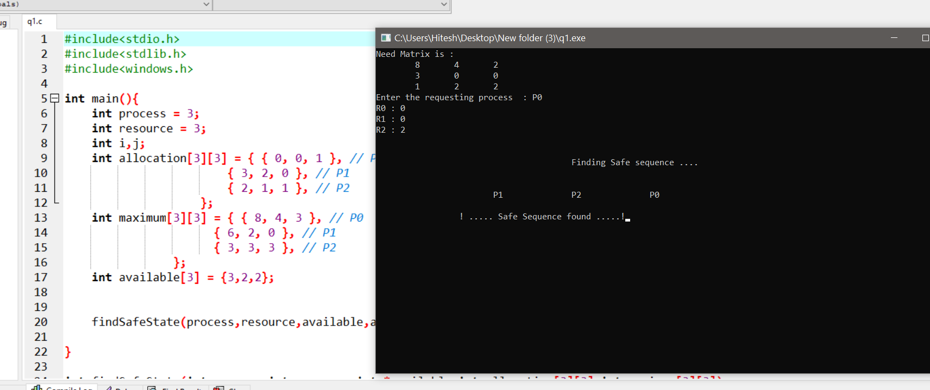
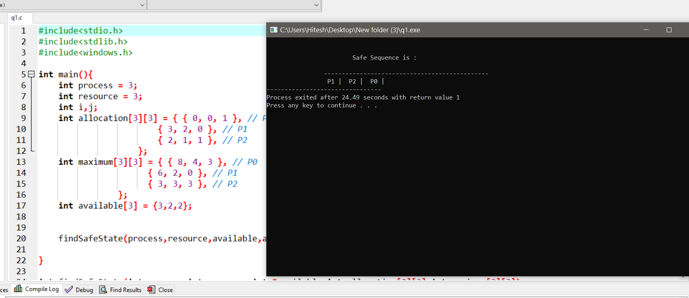

Have you made minimum 5 revisions of solution on GitHub?
-Yes
GitHub Link: https://github.com/ganeshswami98/11712737

