A REALTIME RESEARCH PROJECT
On GOOGLE GLASS
Submitted in the partial fulfilment of the requirements for the award of the degree in
BACHELOR OF TECHNOLOGY

IN

COMPUTER SCIENCE & ENGINEERING(DATA SCIENCE )
T.GANESH 23BR1A6723
U.RAVALI 23BR1A6724
B.SANDEEP 23BR1A6706
Under the Guidance of
Mrs.K.SESHA RAJA KUMARI



DEPARTMENT OF COMPUTER SCIENCE ANDENGINEERING(DATA SCIENCE)
Kavitha Memorial Educational Society's
VIJAYA ENGINEERING COLLEGE
Approved By AICTE New Delhi& Affiliated To JNTUH-Hyderabad AMMAPALEM (V), NEAR THANIKELLA, KHAMMAM-507305
2023-2027


Kavitha Memorial Educational Society’s VIJAYA ENGINEERING COLLEGE
DEPARTMENT OF COMPUTER SCIENCE AND ENGINEERING
(DATA SCIENCE)
(Approved By AICTE-New Delhi & Affililiated to JNTUH-Hyderabad) AMMAPALE(V), NEAR THANIKELLA KHAMMAM-507305
BONAFIDE CERTIFICATE

This is to certify that dissertation entitled as GOOGLE GLASS
is a Bonafide work carried out by T.GANESH,U.RAVALI,B.SANDEEP Reg.No:23BR1A6723,23BR1A6724,23BR1A6706 submitted technical seminar report and presented in manner required for its acceptance in
partial fulfilment for award of degree of Bachelor of technology in computer Science and Engineering of Jawaharlal Nehru Technologies University Hyderabad, Hyderabad during the academic year 2023-2027

Internal Guide Head of the department.
Mrs.K.SESHA RAJA KUMARI S.NARESH KUMAR

External viva voice held on External examiner


Kavitha Memorial Educational Society’s

VIJAYA ENGINEERING COLLEGE
(Approved by AICTE, New Delhi& Affiliated to JNTUH, Hyderabad)

WYRA ROAD, THANIKELLA-507305, KHAMMAM.
E-mail: vec.vijaya@gmail.com,www.vjeckmm.edu.in
DEPARTMENT OF COMPUTER SCIENCE AND ENGINEERING(DATA SCIENCE)

DECLARATION BY THE STUDENT
I, hereby declare that the Project report entitled "GOOGLE GLASS“under the guidance Mrs K.SESHA RAJA KUMARI , Assistant Professor, Department of Computer Science, Vijaya Engineering College Khammam, is submitted in partial fulfilment of the requirements for the award of the degree of Bachelor of Technology in Computer Science and Engineering.
This is a record of Bonafide work carried out by us and the results embodied in this report have not been reproduced or copied from any source. The results shown in this thesis have not been submitted to any other University or Institute for the award of any Degree or Diploma.

Name of the Student Hall Ticket No. Signature
T.GANESH 23BR1A6723
U.RAVALI 23BR1A6724
B.SANDEEP 23BR1A6706

ACKNOWLEDGEMENT

I wish to convey my sincere thanks to Mr. PARUPALLI USHAKIRAN KUMAR Garu, Secretary of Vijaya Engineering College.

I hereby that the Vice Chairperson Smt. PARUPALLI VIJAYA LAXMI Garu for providing every requirement needed for completion of this technical seminar report.

I hereby thank the Principal Dr.V.CHINNAIAH sir for providing every requirement needed for completion of this technical seminar report.

I hereby thank the Vice-Principal Smt.Dr.MD.AYESHA madam for providing every requirement needed for completion of this technical seminar report.

I offer my sincere thanks to MR S.NARESH KUMAR Head of the department Computer Science and Engineering (DATA SCIENCE ) providing every requirement needed for completion of this technical seminar report.

I heartly thank my guide Mrs. K.SESHA RAJA KUMARI for suggesting and giving the support to complete this technical seminar report.

T.GANESH 23BR1A6723
U.RAVALI 23BR1A6724
B.SANDEEP 23BR1A6706

ABSTRACT

Project Glass is a research and development program by Google to develop an augmented reality Head-Mounted Display (HMD). The intended purpose of Project Glass products would be the hands-free displaying of information currently available to most smartphone users, and allowing for interaction with the Internet via natural language voice commands. These glasses will have the combined features of virtual reality and augmented reality. Google glasses are basically wearable computers that will use the same Android software that powers Android smartphones and tablets.
Google Glass is as futuristic a gadget we’ve seen in recent times. A useful
technology for all kinds of people including handicapped/disabled
Table of Contents
ABSTRACT 1
Keywords 2
Introduction 3
about google 3
Virtual reality (VR) 3
Augmented reality (AR) 4
Project Glass 4
Android 5
Overview 6
Technologies used 8
Wearable Computing 8
Ambient Intelligence 9
Smart Clothing 10
Eye Tap Technology 10
Smart Grid Technology 11
4G Technology 11
Android Operating System 12
How it Works? 13
Design 13
Video Display: 13
Camera 13
Speaker: 13
Button 14
Microphone: 14
Working 14
Advantages and Disadvantages 22
Advantages 22
Disadvantages: 22
Future Scope 23
CONCLUSION 24
REFERENCES 25

Keywords

Virtual Reality: Term that applies to computer-simulated environments that can simulate physical presence in places in the real world, as well as in imaginary worlds
Augmented Reality(AR) : AR is a live, direct or indirect, view of a physical, real-world environment whose elements are augmented by computer-generated sensory input such as sound, video, graphics or GPS data.
Eye Tap: EyeTap is a device that is worn in front of the eye that acts as a camera to record the scene available to the eye as well as a display to superimpose a computer-generated imagery on the original scene available to the eye.
Android: An open source operation system developed for smartphones to improve the accessibility and to be user friendly.
4G: Fourth generation technology is successor of 3g and can support upto 100Mbps transfer rate
Other keywords : Smart Clothing , project glasses

Introduction

About google
Google Inc. is an American multinational corporation specializing in Internet-related services and products. These include search, cloud computing, software and online advertising technologies. Google began in January 1996 as a research project by Larry Page and Sergey Brin. It was originally a search engine who ranks the websites(PageRank) and return them as search results according to user query, with time Google grew and presently it provides many other features than only search results i.e. it now provides image search, YouTube(largest collection of online videos) and many more. It has its own R & D department know as “Google X”, where the project “Google Glass” was made. Google glass uses virtual and augmented reality to interact with user.

Virtual reality (VR):
Virtual reality is a term that applies to computer-simulated environments that can simulate physical presence in places in the real world, as well as in imaginary worlds.
It covers remote communication environments which provide virtual presence of users with the concepts of telepresence and telexistence or a virtual artifact (VA). The simulated environment can be similar to the real world in order to create a life like experience.
Virtual reality is often used to describe a wide variety of applications commonly associated with immersive, highly visual, 3D environments. The development of CAD software, graphics hardware acceleration, head mounted displays, database gloves, and miniaturization.

Augmented reality (AR):
Augmented reality is a live, direct or indirect, view of a physical, real-world environment whose elements are augmented by generated sensory input such as sound, video, graphics or GPS data. It is related to a more general concept called mediated reality, in which a view of reality is modified (possibly even diminished rather than augmented) by a computer. As a result, the technology functions by enhancing one’s current perception of reality. By contrast, virtual reality replaces the real world with a simulated one. Augmentation is conventionally in real-time and in semantic context with environmental elements.

Project Glass:
Project Glass is a research and development program by Google to develop an augmented reality head-mounted display (HMD). It is part of the Google X Lab, which works on other futuristic technologies. The intended purpose of Project Glass products would be the hands-free displaying of information currently available to
most smartphone users, and allowing for interaction with the Internet via natural language voice commands. The functionality and physical appearance (minimalist design of the aluminum strip with 2 nose pads) has been compared to Steve
Mann's EyeTap, which was also referred to as "Glass" ("EyeTap Digital Eye Glass", i.e. uses of the word "Glass" in singular rather than plural form "Glasses").
The operating system software used in the glass will be Google's Android.

Android:
Android is a Linux-based operating system designed primarily for touchscreen mobile devices such as smartphones and tablet computers. Initially developed by Android, Inc., which Google backed financially and later bought in 2005, Android was unveiled in 2007 along with the founding of the Open Handset Alliance: a consortium of hardware, software, and telecommunication companies devoted to advancing open standards for mobile devices.

Overview

As per many reports, Google is expected to start selling eyeglasses that will project information, entertainment and, this being a Google product, advertisements onto the lenses. These glasses will have the combined features of virtual reality and augmented reality.
The Google Glasses can use a 4G cell connection to pull in information from Google’s mountain of data and display info about the real world in augmented reality on the lens in front of your eye. As you turn your head you’ll get information about your surroundings and nearby objects from Google Goggles, info on buildings and establishments from Google Maps, even your friends’ nearby check-ins from Latitude. The company has no plans to sell ads into your newly augmented view of the world, but will consider it if the product really catches on.
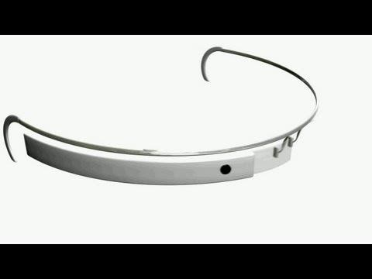
The glasses are not being designed to be worn constantly — although Google engineers expect some users will wear them a lot — but will be more like smartphones, used when needed, with the lenses serving as a kind of see-through computer monitor.
Google glasses are basically wearable computers that will use the same Android software that powers Android smartphones and tablets. Like smartphones and tablets, the glasses will be equipped with GPS and motion sensors. They will also contain a camera and audio inputs and outputs.
Several people who have seen the glasses, but who are not allowed to speak publicly about them, said that the location information was a major feature of the glasses. Through

the built-in camera on the glasses, Google will be able to stream images to its rack computers and return augmented reality information to the person wearing them. For instance, a person looking at a landmark could see detailed historical information and comments about it left by friends. If facial recognition software becomes accurate enough, the glasses could remind a wearer of when and how he met the vaguely familiar person standing in front of him at a party. They might also be used for virtual reality games that use the real world as the playground.

Technologies used:

Wearable Computing:
Wearable computers, also known as body-borne computers are miniature electronic devices that are worn by the bearer under, with or on top of clothing. This class of wearable technology has been developed for general or special purpose information technologies and media development. Wearable computers are especially useful for applications that require more complex computational support than just hardware coded logics.

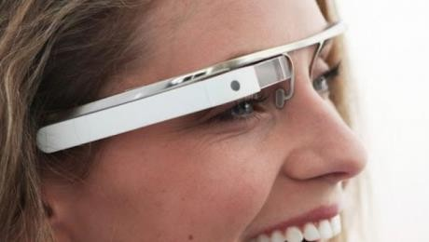
One of the main features of a wearable computer is consistency. There is a constant interaction between the computer and user, i.e. there is no need to turn the device on or off. Another feature is the ability to multi-task. It is not necessary to stop what you are doing to use the device; it is augmented into all other actions. These devices can be incorporated by the user to act like a prosthetic. It can therefore be an extension of the user’s mind and/or body.

Ambient Intelligence:
Ambient Intelligence (AmI) refers to electronic environments that are sensitive and responsive to the presence of people. Ambient intelligence is a vision on the future of consumer electronics, telecommunications and computing.

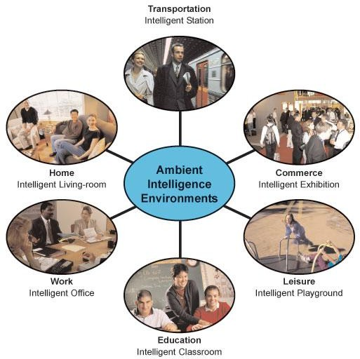

In an ambient intelligence world, devices work in concert to support people in carrying out their everyday life activities, tasks and rituals in easy, natural way using information and intelligence that is hidden in the network connecting these devices.
As these devices grow smaller, more connected and more integrated into our environment, the technology disappears into our surroundings until only the user interface remains perceivable by users.

Smart Clothing:
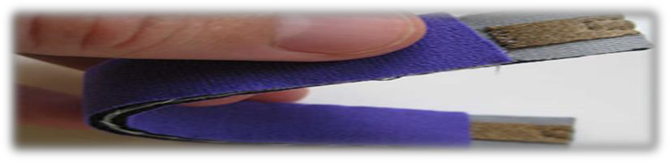

Smart clothing is the next generation of apparel. It is a combination of new fabric technology and digital technology, which means that the clothing is made with new signal-transfer fabric technology installed with digital devices. Since this smart clothing is still under development, many problems have occurred due to the absence of the standardization of technology. Therefore, the efficiency of technology development can be strengthened through industrial standardization. This study consists of three phases. The first phase is selecting standardization factors to propose a standardization road map. The second phase is to research and collect related test evaluation methods of smart clothing. For this, we selected two categories, which are clothing and electricity/electron properties.
The third phase is establishing a standardization road map for smart clothing. In this study, test evaluations have not yet been conducted and proved. However, this study shows how to approach standardization. We expect that it will be valuable for developing smart clothing technology and standardization in the future.

Eye Tap Technology:
An EyeTap is a device that is worn in front of the eye that acts as a camera to record the scene available to the eye as well as a display to superimpose a computer-generated imagery on the original scene available to the eye. This structure allows the user's eye to operate as both a monitor and a camera as the EyeTap intakes the world around it and augments the image the user sees allowing it to overlay computer-generated data over top

of the normal world the user would perceive. The EyeTap is a hard technology to categorize under the three main headers for wearable computing (Constancy, Augmentation, and Mediation) for while it is in theory a constancy technology in nature it also has the ability to augment and mediate the reality the user perceives.
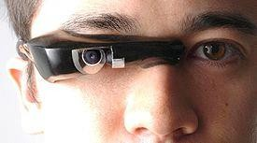

Smart Grid Technology:
A smart grid is an electrical grid that uses information and communications technology to gather and act on information, such as information about the behaviors of suppliers and consumers, in an automated fashion to improve the efficiency, reliability, economics, and sustainnability of the production and distribution of electricity.

4G Technology:
4G is the fourth generation of cell phone mobile communications standards. It is a successor of the third generation (3G) standards. A 4G system provides mobile ultra- broadband Internet access, for example to laptops with USB wireless modems, to smartphones, and to other mobile devices.

Android Operating System:
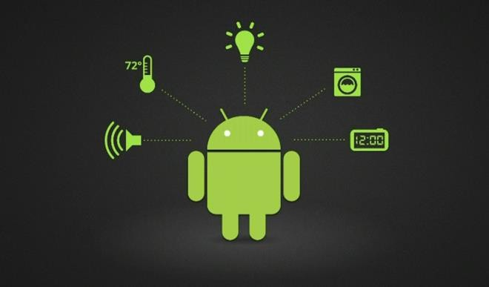
Android is a Linux-based operating system for mobile devices such as smart phones and tablet computers, developed by Google in conjunction with the Open Handset Alliance. Android is open source and Google releases the code under the Apache License. This open source code and permissive licensing allows the software to be freely modified and distributed by device manufacturers, wireless carriers and enthusiast developers. Additionally, Android has a large community of developers writing applications ("apps") that extend the functionality of devices, written primarily in a customized version of the Java programming language. In October 2012, there were approximately 700,000 apps available for Android, and the estimated number of applications downloaded from Google Play, Android's primary app store, was 25 billion.

How it Works?

Design:

Video Display:
Its features with the small video display that is used to display the pop up hands free information.
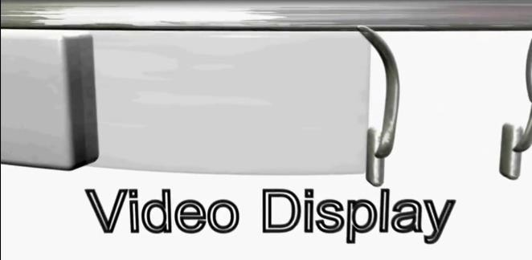

Camera:
It also has the front facing video camera with which photos and videos can be taken in a glimpse.
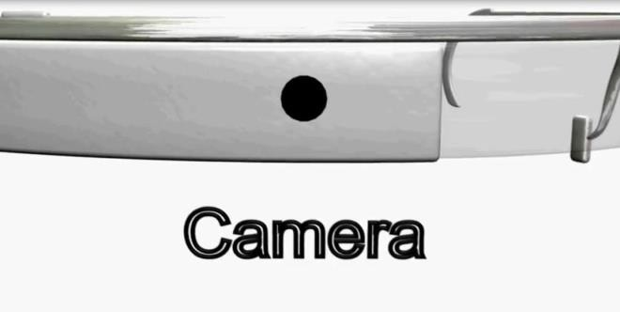

Speaker:
Google glasses are designed to be hands free wearable device that can be used to make or receive calls too. So a speaker is also designed by the ear.
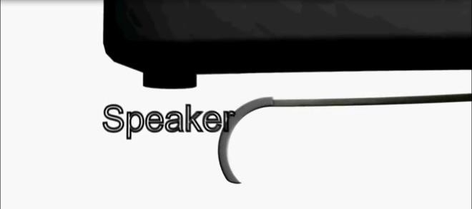

Button:
A single button on the side of the frame sophisticates the glasses to work with the physical touch input.
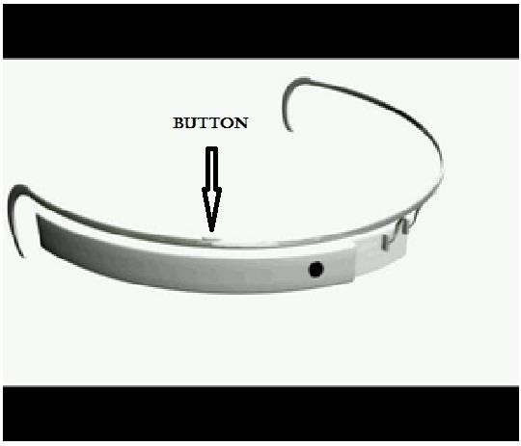

Microphone:
A microphone is also put in, that can take the voice commands of the wearer of user. This microphone is also used for having telephonic communication.

Working:


The overall design of Google glasses
The device will probably communicate with mobile phones through Wi-Fi and display contents on the video screen as well as respond to the voice commands of the user.
Google put together a short video demonstrating the features and apps of Google glasses. It mainly concentrates on the social networking, navigation and communication.

The video camera senses the environment and recognizes the objects and people around. The whole working of the Google glasses depends upon the user voice commands itself.

Overall Working

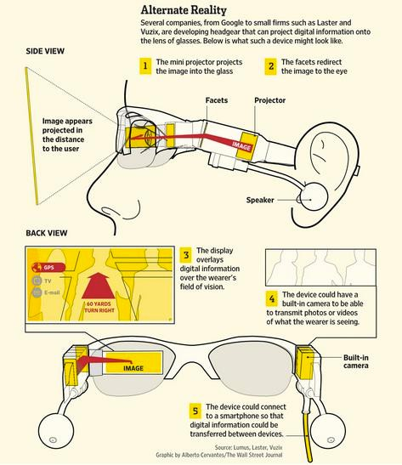
The overall working of Google glasses

Multiple features of Glass can be seen in a product video released in February 2013:

Feature | Voice activation text
1. Record video | "ok, glass, record a video."
2. Take picture | "ok, glass, take a picture."
3. Use Google Now | "ok, glass, [question]."
4. Start Google+ hangout | "ok, glass, hang out with [person/circle]."
5. Search | "ok, glass, google [search query]."
6. Search photos | "ok, glass, google photos of [search query]."
7. Translate | "ok, glass, say [text] in [language]."
8. Give directions | "ok, glass, give directions to [place]."
9. Send message | "ok, glass, send a message to [name]." "ok, glass, send [name] that [message]." "ok, glass, send [message] to [name]."
10. Display weather | none/automatically (Google Now)  "ok, glass, how is the weather in [location]?" "ok, glass, do I need an umbrella today?"
11. Give flight details | none/automatically (Google Now)  "ok, glass, when does flight [flight number] depart from  [airport]?"
Pictorial Representation of Voice Commands and how they work:

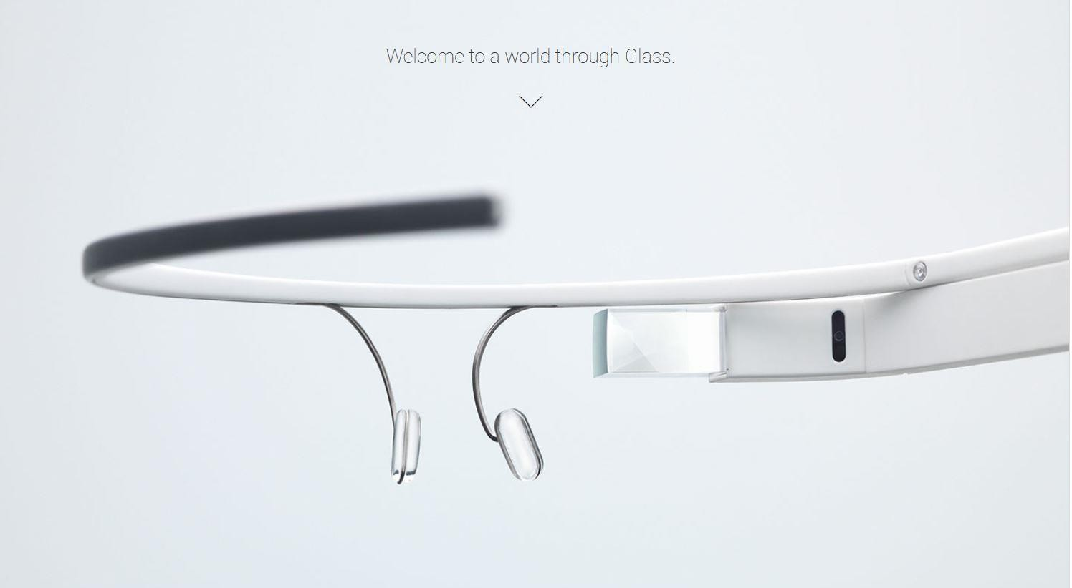
Say “ok glass” to give voice commands and to perform actions. It’s
simple.

- Say “ok glass record video” to start recording what you see, and share the video with
friends.

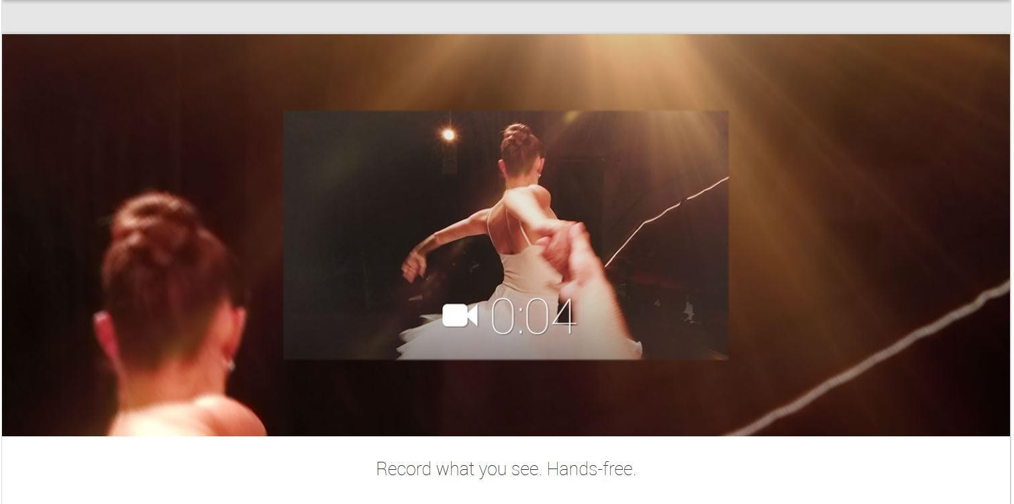
- Say “ok glass take a picture” to capture the moment and make the memories that last
forever.
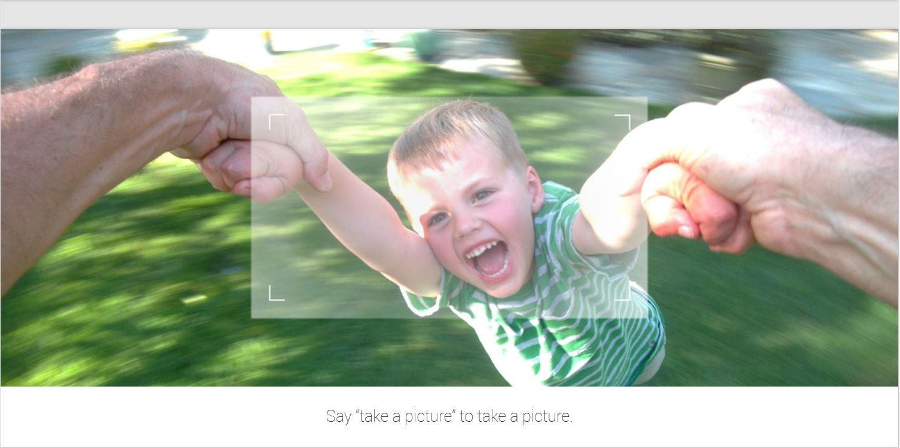

4. Start a hangout to share the view to your friends using google plus.


- Translate your language into visiting local languages or to other languages.

- “ok glass get directions to Boynton Canyon Road” to get directions to your favourite
locations.

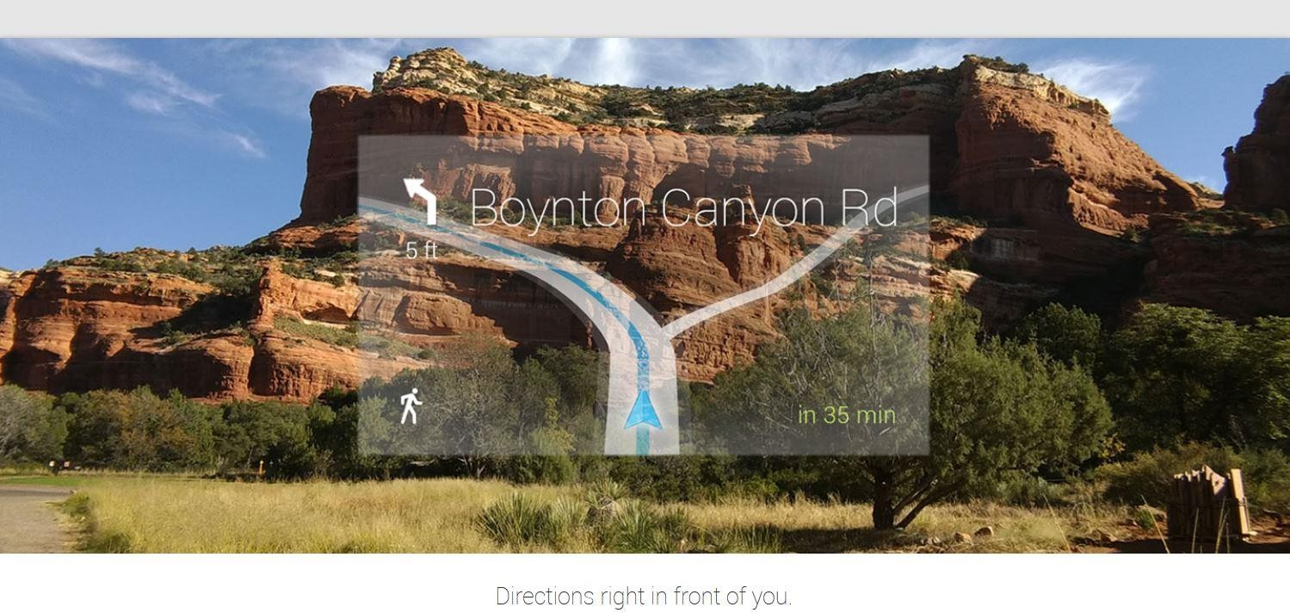
- Sends a message to your friends and family by just saying “ok glass send a message
….”
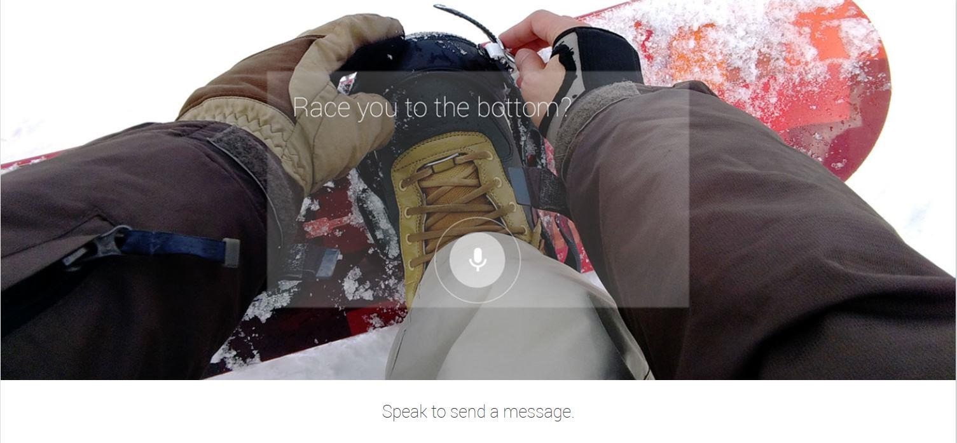
- Never miss any flight ,meetings or train by getting automatic reminders by google glass.


Never Hesistate to ask anything to glass, it will answer to almost all questions using its database.
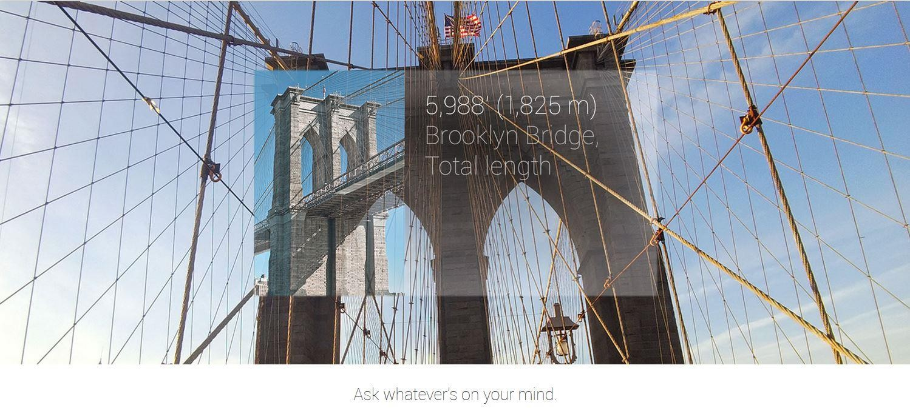

Advantages and Disadvantages

Advantages:
  - Easy to wear and use.

  - Sensitive and responsive to the presence of people.

  - Fast access of maps, documents, videos, chats and much more.

  - A new trend for fashion lovers together being an innovative technology.

  - A spectacle based computer to reside directly on your eyes rather than in your pouch or pocket.
  - A useful technology for all kinds of handicapped/disabled people.

Disadvantages:
  - Can be easily broken or damaged. Though Google wants these glasses to be as modest as achievable, they seem to be extremely breakable. Users will have a tough time taking care of it.
  - These glasses show the retrieved data in front of users eyes so it will be a tough experience for them since they will focus on that data and will eventually miss the surroundings that may lead to accidents while driving.
  - The resource for running these glasses is still unknown. Will there be a battery or it will run using solar energy?
  - Privacy of people may breach with new glasses.

Future Scope

Google Glass is as futuristic a gadget we’ve seen in recent times. It’s limited in scope right now, but the future, Google believes, is bright and the device itself is “incredibly compelling”.
Google is trying their hardest to push the Project Glass through the FCC this year. Reports show that Google is trying to get the approval by the FCC this year but there are already several hundred glasses made for testing internally.

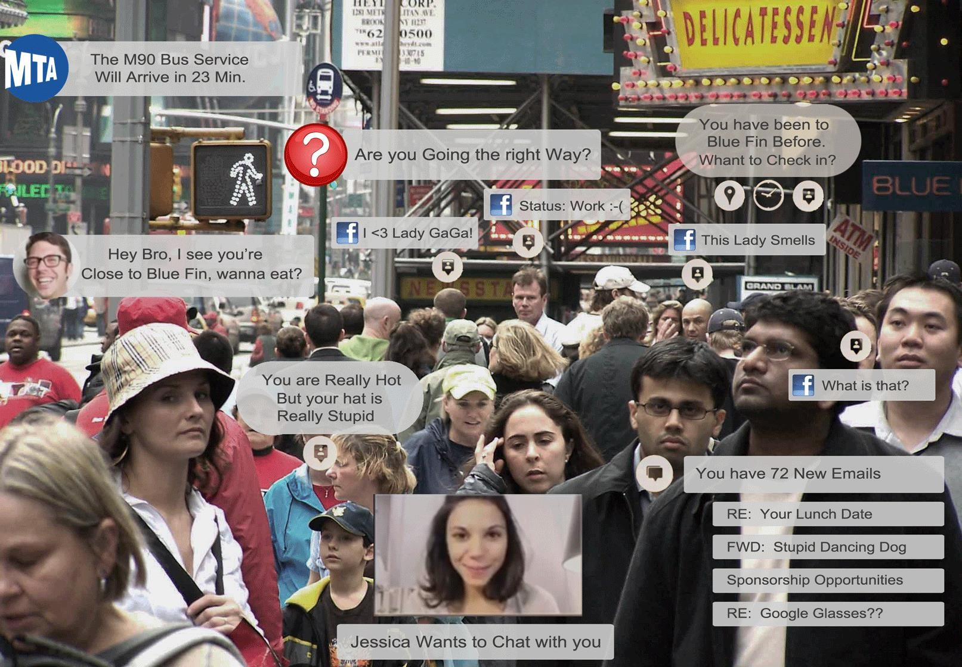

CONCLUSION

Google glasses are basically wearable computers that use the evolving familiar technologies that brings the sophistication and ease of communication and information access even for the physically challenged class of people those literally could not use general way of palmtops and mobiles.

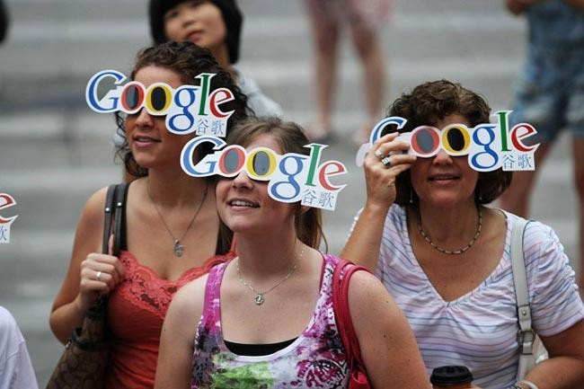

REFERENCES

http://en.wikipedia.org/wiki/Project_Glass

http://www.smart-glasses.org/benefits-smart-glasses/

http://en.wikipedia.org/wiki/EyeTap

http://www.techpark.net/2012/02/29/google-glasses-with-virtual-and-augmented- reality/
http://dl.acm.org/citation.cfm?id=1601355

http://en.wikipedia.org/wiki/Android_(operating_system)

http://www.webmd.boots.com/eye-health/news/20120411/will-google-glasses-be-safe

http://www.thenewstribe.com/2012/04/08/google-project-glasses-success-or-another- failure/#.UFMcL7LiaAA
http://www.redmondpie.com/google-project-glass-gets-an-awesome-skydiving-demo- at-io-explorer-edition-up-for-pre-order-video/

