Dr. RVR NRI Institute of Technology
Department of Computer Science and Engineering
(Artificial Intelligence and Machine Learning)
PROJECT REPORT
Python Programs using Conditionals, Loops, Lists and Strings
Ten Mini Projects on Billing, Analysis and Simulation
Submitted by | Thota Ganesh
Roll Number | 26001040
Section | CSM-3
Course | B.Tech, 1st Year
Academic Year | 2026 - 2027
Submitted to

Acknowledgement
I would like to thank my college, Dr. RVR NRI Institute of Technology, and the Department of Computer Science and Engineering (AI and ML) for giving me the chance to do these mini projects. I am thankful to my faculty for teaching us the basics of Python and for guiding us during the lab sessions.
I also thank my friends and my family for their support and for helping me test my programs with different inputs.
Thota Ganesh
Abstract
In this report I have explained ten small programs written in Python. The programs solve problems like progressive electricity billing, hospital billing, employee payroll, retail billing with discounts, manufacturing profit analysis, travel budget in different currencies, campus event planning, exam results with grace marks, attendance recovery and an ATM simulation.
All the programs are built with only four basic things: conditionals, loops, simple lists and strings. No external library is used. For each program the report gives the problem statement, objectives, assumptions, algorithm, flowchart, pseudocode, source code, test cases, output screenshots and a conclusion. All the test cases were run and the results were checked by hand calculation.
Index
Chapter | Title
1 | Introduction
2 | Project 1: Progressive Electricity Billing
3 | Project 2: Hospital Billing and Patient Classification
4 | Project 3: Employee Payroll and Deduction Analysis
5 | Project 4: Retail Billing with Multiple Discount Rules
6 | Project 5: Manufacturing Cost and Profitability Analysis
7 | Project 6: Multi-Currency Travel Budget Analysis
8 | Project 7: Campus Event Financial Planning
9 | Project 8: Examination Result and Grace-Mark Validation
10 | Project 9: Attendance Recovery Computation
11 | Project 10: ATM Transaction Sequence Simulation
12 | Overall Conclusion
 | References
Every project chapter has these parts: problem statement, objectives, assumptions, algorithm, flowchart, pseudocode, Python source code, test cases, output screenshots and conclusion.

Chapter 1: Introduction

1.1 About this Report
This report is about ten small Python programs that I made as my mini projects in the first year. Each program takes some input from the keyboard, applies some rules and prints the result on the screen. The problems are taken from daily life, for example electricity bill, hospital bill, salary, shop bill, ATM and attendance.
For every project I have written the problem statement, objectives, assumptions, algorithm, flowchart, pseudocode, the full Python source code, test cases and the output screenshots, followed by a short conclusion.

1.2 Software Used
- Python 3 (the programs use only built-in features, no extra library).
- IDLE / VS Code to write the code.
- Command prompt (terminal) to run the programs and see the output.

1.3 Programming Concepts Used
Concept | How I used it
Conditionals | if, elif and else to select slabs, discounts, grades, status and error messages.
Loops | for loops to go through lists and while loops to repeat until the user types done, n or a correct value.
Lists | To store names, rates, prices, marks and the transaction history.
Strings | strip(), title(), upper(), isdigit(), center(), join() and f-strings to clean the input and print neat tables.
Functions | Used in a few programs (electricity and hospital) to keep the logic separate.

1.4 How to Run the Programs
- Install Python 3 and keep all the .py files in one folder.
- Open the command prompt in that folder.
- Type python followed by the file name, for example: python 03_hospital_billing.py
- Type the inputs when the program asks for them. Type done, n or 5 where the program asks to stop.

1.5 List of Projects
Chapter | Project | Source file
2 | Progressive Electricity Billing | 02_progressive_electricity_billing.py
3 | Hospital Billing and Patient Classification | 03_hospital_billing.py
4 | Employee Payroll and Deduction Analysis | 04_employee_payroll.py
5 | Retail Billing with Multiple Discount Rules | 07_retail_billing.py
6 | Manufacturing Cost and Profitability Analysis | 08_manufacturing_profit.py
7 | Multi-Currency Travel Budget Analysis | 09_travel_budget.py
8 | Campus Event Financial Planning | 10_campus_event_planning.py
9 | Examination Result and Grace-Mark Validation | 11_exam_result_grace.py
10 | Attendance Recovery Computation | 12_attendance_recovery.py
11 | ATM Transaction Sequence Simulation | 13_atm_simulation.py

Chapter 2: Project 1 - Progressive Electricity Billing

2.1 Problem Statement
In our houses the electricity bill is not calculated with one fixed rate. When we use more units, the rate per unit becomes higher. This is called the slab system. I have to write a Python program that takes the customer name and the units used, and then prints the complete bill with slab-wise charges, fixed charge and duty.

2.2 Objectives
- To understand how slab (progressive) billing works.
- To use if-elif-else and loops to divide the units into slabs.
- To store the slab data in lists and use them in a loop.
- To print a neat bill using string formatting.
- To check the user input so that the program does not crash.

2.3 Assumptions
- Slab rates are: first 100 units Rs. 3.50, next 100 units Rs. 4.50, next 100 units Rs. 6.00 and above 300 units Rs. 7.50. These are sample rates, not the real tariff.
- Fixed charge is Rs. 50 and electricity duty is 5% of the energy charge.
- Units are entered as a whole number (no decimals).
- Usage is Low up to 100 units, Moderate up to 300 units and High above that.

2.4 Algorithm
- Start the program.
- Read the customer name. If it is empty, show a message and ask again.
- Read the units. If it is not a number, show a message and ask again.
- Set remaining = units.
- For each slab, take the slab size if remaining is more than the slab size, otherwise take whatever is remaining. The last slab takes all the remaining units.
- Charge of the slab = units taken x rate. Then reduce remaining by the units taken.
- Energy charge = sum of all slab charges. Duty = 5% of energy charge.
- Total = energy charge + fixed charge + duty.
- Print the bill and save the name and total in the lists.
- Ask for another bill. If the answer is y, go back to step 2.
- Print the summary of all bills and the total collection. Stop.

2.5 Flowchart
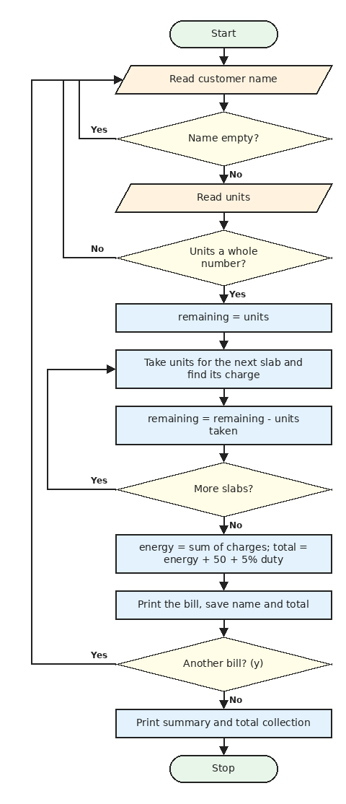
Figure 2.1: Flowchart of Project 1: Progressive Electricity Billing

2.6 Pseudocode
START
slab_sizes = [100, 100, 100]
slab_rates = [3.50, 4.50, 6.00, 7.50]
fixed = 50, duty_percent = 5
REPEAT
READ name
IF name is empty THEN PRINT error and CONTINUE
READ units_text
IF units_text is not digits THEN PRINT error and CONTINUE
units = INTEGER(units_text)
remaining = units
FOR i = 0 TO 3
IF i < 3 THEN
IF remaining > slab_sizes[i] THEN take = slab_sizes[i]
ELSE take = remaining
ELSE
take = remaining
charge[i] = take * slab_rates[i]
remaining = remaining - take
END FOR
energy = SUM(charge)
duty = energy * 5 / 100
total = energy + fixed + duty
PRINT bill, ADD name and total to lists
READ again
IF again is not y THEN BREAK
END REPEAT
PRINT summary and total collection
STOP

2.7 Python Source Code
File name: 02_progressive_electricity_billing.py
slab_labels = ["First 100", "Next 100", "Next 100", "Above 300"]
slab_sizes = [100, 100, 100]
slab_rates = [3.50, 4.50, 6.00, 7.50]

FIXED_CHARGE = 50
DUTY_PERCENT = 5

def calculate_slabs(units):
remaining = units
used = []
charges = []

for i in range(len(slab_rates)):
if i < len(slab_sizes):
if remaining > slab_sizes[i]:
take = slab_sizes[i]
else:
take = remaining
else:
take = remaining

used.append(take)
charges.append(take * slab_rates[i])
remaining = remaining - take

return used, charges

def usage_level(units):
if units <= 100:
return "Low usage"
elif units <= 300:
return "Moderate usage"
else:
return "High usage"

def print_bill(name, units):
used, charges = calculate_slabs(units)

energy_charge = sum(charges)
duty = energy_charge * DUTY_PERCENT / 100
total = energy_charge + FIXED_CHARGE + duty

line = "-" * 44
print("\n" + line)
print("ELECTRICITY BILL".center(44))
print(line)
print("Customer :", name)
print("Units :", units, "(" + usage_level(units) + ")")
print(line)
print(f"{'Slab':<12}{'Units':>6}{'Rate':>8}{'Amount':>10}")

for i in range(len(slab_labels)):
if used[i] > 0:
print(f"{slab_labels[i]:<12}{used[i]:>6}{slab_rates[i]:>8.2f}{charges[i]:>10.2f}")

print(line)
print(f"{'Energy charge':<26}{energy_charge:>18.2f}")
print(f"{'Fixed charge':<26}{FIXED_CHARGE:>18.2f}")
print(f"{'Duty (' + str(DUTY_PERCENT) + '%)':<26}{duty:>18.2f}")
print(line)
print(f"{'TOTAL (Rs.)':<26}{total:>18.2f}")
print(line)

return total

names = []
totals = []

while True:
name = input("\nEnter customer name: ").strip().title()
if name == "":
print("Name cannot be empty.")
continue

units_text = input("Enter units consumed: ").strip()
if not units_text.isdigit():
print("Please enter units as a whole number.")
continue

units = int(units_text)
total = print_bill(name, units)

names.append(name)
totals.append(total)

again = input("\nGenerate another bill? (y/n): ").strip().lower()
if again != "y":
break

print("\nSUMMARY")
for i in range(len(names)):
print(f"{i + 1}. {names[i]:<15} Rs. {totals[i]:.2f}")
print("Total collection: Rs.", round(sum(totals), 2))

2.8 Test Cases
TC | Input | Expected output | Actual output | Result
1 | Ravi, 80 units | 280.00 + 50 + 14.00 = 344.00 | TOTAL (Rs.) 344.00 | Pass
2 | Ravi, 150 units | 350 + 225 = 575, total 653.75 | TOTAL (Rs.) 653.75 | Pass
3 | Ravi, 350 units | All 4 slabs, total 1913.75 | TOTAL (Rs.) 1913.75 | Pass
4 | Units typed as abc | Error message, then total 417.50 | Please enter units as a whole number. | TOTAL (Rs.) 417.50 | Pass
5 | Empty name, then 0 units | Error message, then only fixed charge 50.00 | Name cannot be empty. | TOTAL (Rs.) 50.00 | Pass

2.9 Output Screenshots
Output 1: one customer using 350 units (all four slabs used)
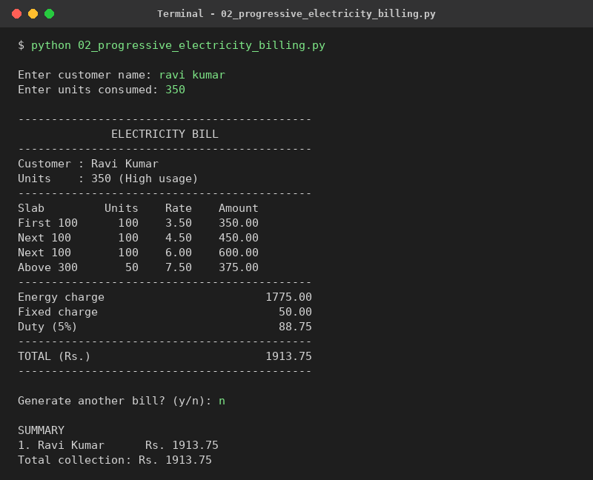
Output 2: invalid units and an empty name
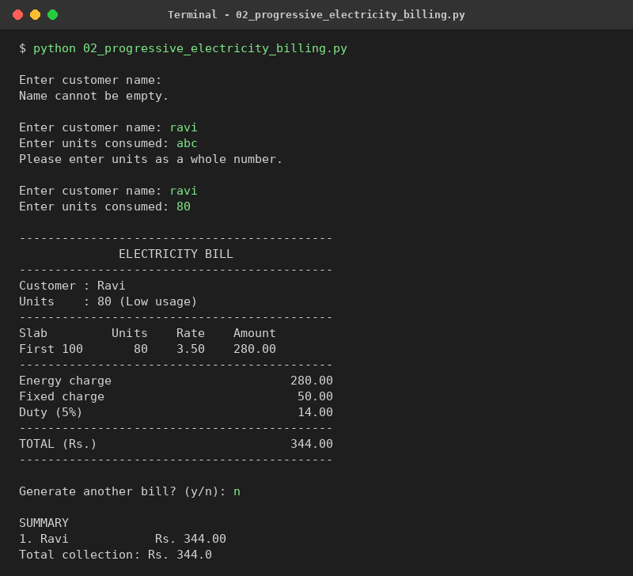

2.10 Conclusion
This project helped me understand the slab system. The tricky part for me was dividing the units into slabs, but the remaining variable and a for loop made it easy. The program gives correct bills for all my test cases. In future it can be improved by reading the tariff from a file and saving the bills.

Chapter 3: Project 2 - Hospital Billing and Patient Classification

3.1 Problem Statement
A hospital needs a program to prepare the bill of an admitted patient. The bill depends on the ward type, number of days and the extra services like tests and scans. The hospital also wants to classify the patient by age and by length of stay, and give a discount to children and senior citizens.

3.2 Objectives
- To prepare a hospital bill from ward charges and service charges.
- To classify the patient as Pediatric, Adult or Senior Citizen using the age.
- To find the stay type (Short, Regular or Long) from the number of days.
- To use lists for wards and a while loop for any number of services.
- To use functions that return more than one value.

3.3 Assumptions
- Ward charges per day are General Rs. 1000, Semi-Private Rs. 2000, Private Rs. 3500 and ICU Rs. 7000 (sample values).
- Discount is 5% for age below 18, 0% for 18 to 59 and 10% for 60 and above.
- The discount is given on the full bill (room charges + services).
- Stay type: up to 2 days is Short, up to 7 days is Regular, above 7 days is Long.
- No tax or insurance is considered.

3.4 Algorithm
- Start the program.
- Read the patient name, age and number of days admitted.
- Show the ward list using a for loop and read the ward number. If it is not between 1 and 4, ask again.
- Read the services one by one (name and charge) until the user types done. Store them in two lists.
- Room charge = days x rate of the chosen ward.
- Subtotal = room charge + total of all services.
- Find the category and discount percent from the age, and the stay type from the days.
- Discount = subtotal x percent / 100. Total = subtotal - discount.
- Print the bill. If the ward is ICU, print the critical care note.
- Stop.

3.5 Flowchart
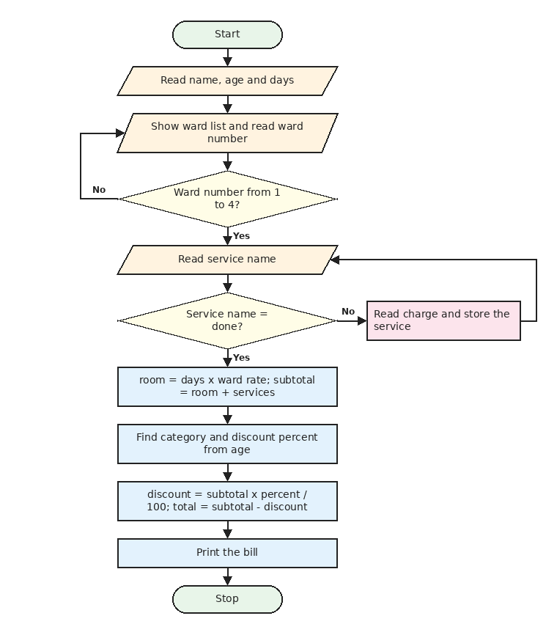
Figure 3.1: Flowchart of Project 2: Hospital Billing

3.6 Pseudocode
START
ward_names = [General, Semi-Private, Private, ICU]
ward_rates = [1000, 2000, 3500, 7000]
READ name, age, days
FOR i = 0 TO 3: PRINT ward number, name and rate
READ choice
WHILE choice < 1 OR choice > 4
READ choice again
END WHILE
WHILE TRUE
READ service
IF service is done THEN BREAK
READ charge, ADD service and charge to lists
END WHILE
room = days * ward_rates[choice - 1]
subtotal = room + SUM(service_costs)
IF age < 18 THEN category = Pediatric, percent = 5
ELSE IF age < 60 THEN category = Adult, percent = 0
ELSE category = Senior Citizen, percent = 10
discount = subtotal * percent / 100
total = subtotal - discount
PRINT the bill
STOP

3.7 Python Source Code
File name: 03_hospital_billing.py
ward_names = ["General", "Semi-Private", "Private", "ICU"]
ward_rates = [1000, 2000, 3500, 7000]

def classify_patient(age):
if age < 18:
return "Pediatric", 5
elif age < 60:
return "Adult", 0
else:
return "Senior Citizen", 10

def stay_type(days):
if days <= 2:
return "Short stay"
elif days <= 7:
return "Regular stay"
else:
return "Long stay"

name = input("Patient name: ").strip().title()
age = int(input("Age: "))
days = int(input("Days admitted: "))

print("\nWard types")
for i in range(len(ward_names)):
print(f"{i + 1}. {ward_names[i]:<14} Rs. {ward_rates[i]} per day")
choice = int(input("Choose ward number: "))
while choice < 1 or choice > len(ward_names):
choice = int(input("Invalid choice. Choose ward number: "))

service_names = []
service_costs = []
print("\nEnter services (type done to finish)")
while True:
service = input("Service name: ").strip().title()
if service == "Done":
break
service_names.append(service)
service_costs.append(float(input("Charge: ")))

ward = ward_names[choice - 1]
room_charge = days * ward_rates[choice - 1]
subtotal = room_charge + sum(service_costs)

category, discount_percent = classify_patient(age)
discount = subtotal * discount_percent / 100
total = subtotal - discount

line = "-" * 44
print("\n" + line)
print("HOSPITAL BILL".center(44))
print(line)
print("Patient :", name)
print("Category :", category, "| Age", age)
print("Stay :", stay_type(days), f"({days} days)")
print("Ward :", ward)
if ward == "ICU":
print("Note : Critical care patient")
print(line)
print(f"{'Room charges':<30}{room_charge:>14.2f}")
for i in range(len(service_names)):
print(f"{service_names[i]:<30}{service_costs[i]:>14.2f}")
print(line)
print(f"{'Subtotal':<30}{subtotal:>14.2f}")
print(f"{'Discount (' + str(discount_percent) + '%)':<30}{-discount:>14.2f}")
print(f"{'TOTAL (Rs.)':<30}{total:>14.2f}")
print(line)

3.8 Test Cases
TC | Input | Expected output | Actual output | Result
1 | Meena, 10 years, General, 3 days | Pediatric, 5% off, total 2850.00 | Category : Pediatric | Age 10 | TOTAL (Rs.) 2850.00 | Pass
2 | Kiran, 30 years, Private, 2 days, ECG 500 | Adult, no discount, total 7500.00 | Category : Adult | Age 30 | TOTAL (Rs.) 7500.00 | Pass
3 | Lakshmi, 65 years, ICU, 5 days, 1200 + 800 | Senior, 10% off, total 33300.00 | Category : Senior Citizen | Age 65 | Note : Critical care patient | TOTAL (Rs.) 33300.00 | Pass
4 | Wrong ward number 9, then 2 | Invalid choice message, total 2000.00 | Invalid choice. Choose ward number: 2 | TOTAL (Rs.) 2000.00 | Pass
5 | Sita, 20 years, General, 8 days | Long stay, total 8000.00 | Stay : Long stay (8 days) | TOTAL (Rs.) 8000.00 | Pass

3.9 Output Screenshots
Output 1: senior citizen in ICU for 5 days with two services
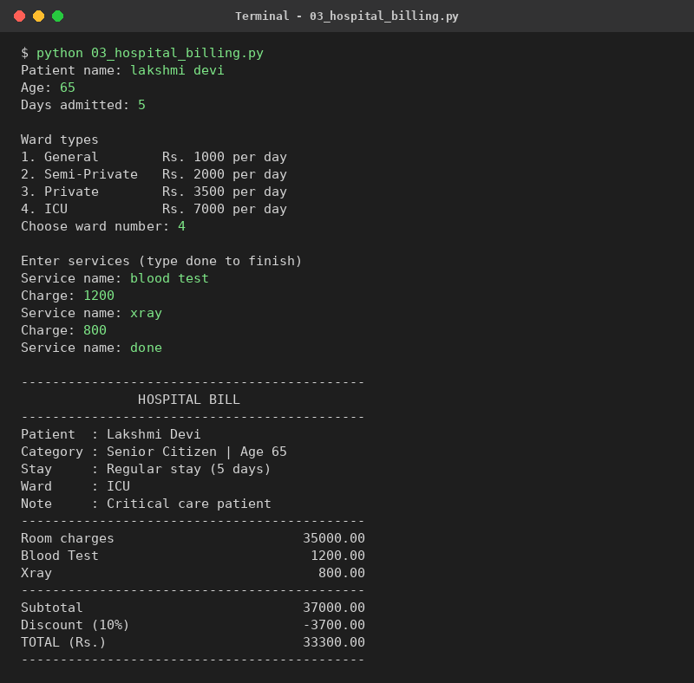
Output 2: child in a general ward, wrong ward number entered first
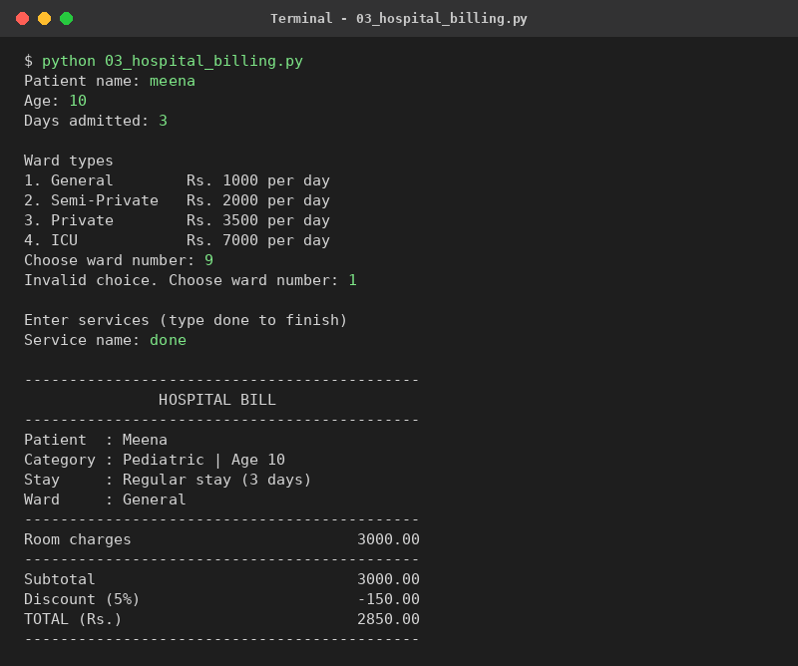

3.10 Conclusion
In this project I learnt how to return two values from a function and how to use a while loop with the word done to stop. The bill matches my hand calculation in every test case. The program can be extended later by adding medicine charges, insurance and saving patient records.

Chapter 4: Project 3 - Employee Payroll and Deduction Analysis

4.1 Problem Statement
A company wants to calculate the monthly salary of its employees. From the basic salary we have to find allowances, deductions like PF and taxes, and the net salary. After that the company wants a small analysis to see how much of each salary is deducted and who gets the highest net salary.

4.2 Objectives
- To calculate gross salary and net salary from the basic salary.
- To use if-elif-else for professional tax and income tax slabs.
- To store results of all employees in lists.
- To analyse the data using a second loop (deduction percent, level, highest, average).

4.3 Assumptions
- HRA is 20% of basic salary and DA is 10% of basic salary.
- PF is 12% of basic salary.
- Professional tax is Rs. 200 if gross is above 20000, Rs. 150 if above 15000, otherwise 0.
- Income tax is 0% if gross is up to 25000, 5% if up to 50000 and 10% above that. These rules are simplified.
- Deduction level: above 20% is High, above 10% is Medium, otherwise Low.

4.4 Algorithm
- Start the program and read the number of employees.
- Repeat for every employee: read the name and the basic salary.
- Calculate HRA, DA and gross salary = basic + HRA + DA.
- Calculate PF = 12% of basic.
- Find the professional tax and the income tax using if-elif-else.
- Deductions = PF + professional tax + income tax. Net salary = gross - deductions.
- Print the payslip and add the values to the four lists.
- After all employees, loop through the lists and find the deduction percent and level of each employee, and the employee with the highest net salary.
- Print the total gross pay, total deductions, average net salary and the highest net salary.
- Stop.

4.5 Flowchart
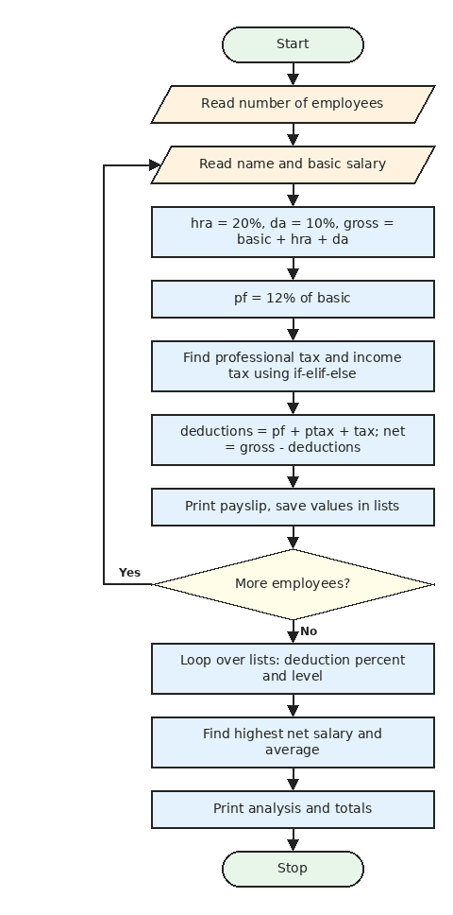
Figure 4.1: Flowchart of Project 3: Employee Payroll

4.6 Pseudocode
START
READ count
FOR i = 1 TO count
READ name, basic
hra = basic * 0.20, da = basic * 0.10
gross = basic + hra + da
pf = basic * 0.12
IF gross > 20000 THEN ptax = 200
ELSE IF gross > 15000 THEN ptax = 150
ELSE ptax = 0
IF gross <= 25000 THEN rate = 0
ELSE IF gross <= 50000 THEN rate = 5
ELSE rate = 10
tax = gross * rate / 100
deductions = pf + ptax + tax
net = gross - deductions
PRINT payslip, ADD values to lists
END FOR
best = 0
FOR each employee i
percent = deductions[i] / gross[i] * 100
IF percent > 20 THEN level = High
ELSE IF percent > 10 THEN level = Medium
ELSE level = Low
IF net[i] > net[best] THEN best = i
END FOR
PRINT totals, average net salary, highest net salary
STOP

4.7 Python Source Code
File name: 04_employee_payroll.py
names = []
gross_list = []
deduction_list = []
net_list = []

count = int(input("Number of employees: "))

for i in range(count):
name = input(f"\nEmployee {i + 1} name: ").strip().title()
basic = float(input("Basic salary: "))

hra = basic * 0.20
da = basic * 0.10
gross = basic + hra + da

pf = basic * 0.12

if gross > 20000:
prof_tax = 200
elif gross > 15000:
prof_tax = 150
else:
prof_tax = 0

if gross <= 25000:
tax_rate = 0
elif gross <= 50000:
tax_rate = 5
else:
tax_rate = 10
income_tax = gross * tax_rate / 100

deductions = pf + prof_tax + income_tax
net = gross - deductions

print(f"--- Payslip: {name} ---")
print(f"Basic {basic:.2f} + HRA {hra:.2f} + DA {da:.2f} = Gross {gross:.2f}")
print(f"PF {pf:.2f} | Prof. tax {prof_tax:.2f} | Income tax {income_tax:.2f}")
print(f"Total deductions {deductions:.2f} | Net salary {net:.2f}")

names.append(name)
gross_list.append(gross)
deduction_list.append(deductions)
net_list.append(net)

print("\nDEDUCTION ANALYSIS")
print(f"{'Name':<14}{'Gross':>10}{'Deduct':>10}{'Net':>10}{'Ded %':>8} Level")
best = 0
for i in range(len(names)):
percent = deduction_list[i] / gross_list[i] * 100
if percent > 20:
level = "High"
elif percent > 10:
level = "Medium"
else:
level = "Low"
print(f"{names[i]:<14}{gross_list[i]:>10.2f}{deduction_list[i]:>10.2f}{net_list[i]:>10.2f}{percent:>8.1f} {level}")
if net_list[i] > net_list[best]:
best = i

print("\nTotal gross pay :", round(sum(gross_list), 2))
print("Total deductions :", round(sum(deduction_list), 2))
print("Average net salary :", round(sum(net_list) / len(net_list), 2))
print("Highest net salary :", names[best], "-", round(net_list[best], 2))

4.8 Test Cases
TC | Input | Expected output | Actual output | Result
1 | Basic 10000 | Gross 13000, net 11800.00 | Total deductions 1200.00 | Net salary 11800.00 | Pass
2 | Basic 20000 | Gross 26000, net 22100.00 | Total deductions 3900.00 | Net salary 22100.00 | Pass
3 | Basic 60000 | Gross 78000, net 62800.00 | Total deductions 15200.00 | Net salary 62800.00 | Pass
4 | Basic 15000 | Professional tax 150, net 17550.00 | PF 1800.00 | Prof. tax 150.00 | Income tax 0.00 | Total deductions 1950.00 | Net salary 17550.00 | Pass
5 | Two employees | Highest net is Vikram, average 42450.0 | Highest net salary : Vikram - 62800.0 | Average net salary : 42450.0 | Pass

4.9 Output Screenshots
Output 1: payroll of two employees
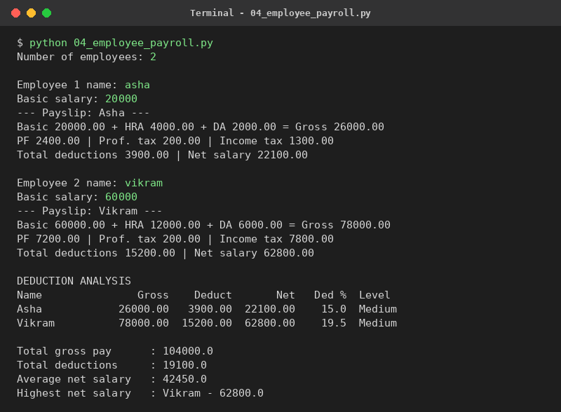

4.10 Conclusion
From this project I understood how many small rules can be combined to get one final answer. Using parallel lists made the analysis part very easy. All the net salaries were checked by hand. A real payroll system would need real tax rules and a database, which can be a future improvement.

Chapter 5: Project 4 - Retail Billing with Multiple Discount Rules

5.1 Problem Statement
A shop gives different discounts at the same time: a discount for buying many pieces of one item, a discount for a big bill, a discount for loyalty members and a festival coupon. After the discounts, GST has to be added. I have to write a program that prepares the bill by applying all these rules one after another.

5.2 Objectives
- To read any number of items using a loop.
- To apply several discount rules in the correct order.
- To keep the discount rules that apply in lists and use them in a loop.
- To use string methods (strip, title, upper) on the input.
- To print a clear bill with GST.

5.3 Assumptions
- Item discount: 10% if quantity is 10 or more, 5% if quantity is 5 to 9.
- Bill discount on the subtotal: 10% if above Rs. 5000, 5% if above Rs. 2000.
- Loyalty members get 3% extra and the coupon code FEST5 gives 5% extra.
- Each discount is applied on the amount left after the previous discount.
- GST is 18% and it is added at the end.

5.4 Algorithm
- Start the program.
- Read the item name. If it is done, stop reading items.
- Read the price and quantity. Find the item discount from the quantity and reduce the line amount.
- Store the item details in lists and go back to step 2.
- If no item was entered, print a message and stop.
- Subtotal = sum of all line totals.
- Decide the bill value discount from the subtotal and add it to the rule lists.
- Ask if the customer is a member and read the coupon. Add the member discount and the FEST5 discount to the lists if they are valid.
- Loop through the rule lists: reduce the current amount by each discount and print it.
- GST = 18% of the final amount. Total = amount + GST. Print the bill. Stop.

5.5 Flowchart
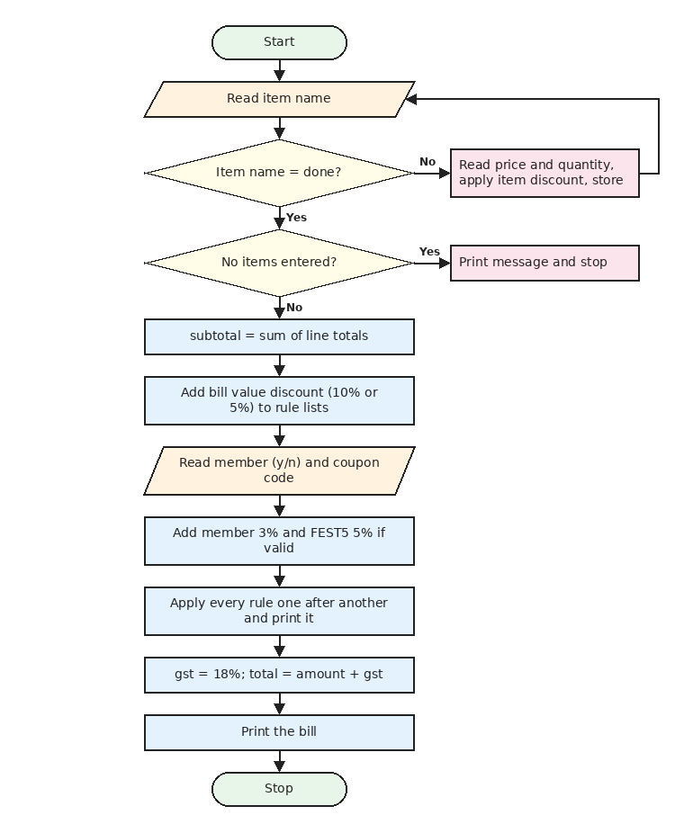
Figure 5.1: Flowchart of Project 4: Retail Billing

5.6 Pseudocode
START
GST = 18
WHILE TRUE
READ item
IF item is done THEN BREAK
READ price, qty
amount = price * qty
IF qty >= 10 THEN rate = 10
ELSE IF qty >= 5 THEN rate = 5
ELSE rate = 0
amount = amount - amount * rate / 100
ADD item, price, qty, amount to lists
END WHILE
IF no items THEN PRINT message and STOP
subtotal = SUM(line_totals)
IF subtotal > 5000 THEN ADD bill discount 10
ELSE IF subtotal > 2000 THEN ADD bill discount 5
READ member; IF member is y THEN ADD member discount 3
READ coupon (make it upper case)
IF coupon is FEST5 THEN ADD coupon discount 5
ELSE IF coupon is not empty THEN PRINT invalid coupon
current = subtotal
FOR each rule in the lists
cut = current * rate / 100
current = current - cut
PRINT the discount
END FOR
gst = current * 18 / 100
PRINT current + gst as TOTAL
STOP

5.7 Python Source Code
File name: 07_retail_billing.py
GST_PERCENT = 18

names = []
prices = []
quantities = []
line_totals = []

print("Enter items (type done as the item name to finish)")
while True:
item = input("Item name: ").strip().title()
if item == "Done":
break
price = float(input("Price per unit: "))
qty = int(input("Quantity: "))

amount = price * qty
if qty >= 10:
item_rate = 10
elif qty >= 5:
item_rate = 5
else:
item_rate = 0
amount = amount - amount * item_rate / 100

names.append(item)
prices.append(price)
quantities.append(qty)
line_totals.append(amount)

if len(names) == 0:
print("No items entered.")
raise SystemExit

subtotal = sum(line_totals)

rule_names = []
rule_rates = []

if subtotal > 5000:
rule_names.append("Bill value discount")
rule_rates.append(10)
elif subtotal > 2000:
rule_names.append("Bill value discount")
rule_rates.append(5)

member = input("Loyalty member? (y/n): ").strip().lower()
if member == "y":
rule_names.append("Member discount")
rule_rates.append(3)

coupon = input("Coupon code (press Enter to skip): ").strip().upper()
if coupon == "FEST5":
rule_names.append("Coupon FEST5")
rule_rates.append(5)
elif coupon != "":
print("Invalid coupon code.")

line = "-" * 46
print("\n" + line)
print("RETAIL BILL".center(46))
print(line)
print(f"{'Item':<16}{'Qty':>5}{'Price':>10}{'Amount':>12}")
for i in range(len(names)):
print(f"{names[i]:<16}{quantities[i]:>5}{prices[i]:>10.2f}{line_totals[i]:>12.2f}")
print(line)
print(f"{'Subtotal (after item discounts)':<34}{subtotal:>12.2f}")

current = subtotal
for i in range(len(rule_names)):
cut = current * rule_rates[i] / 100
current = current - cut
label = f"{rule_names[i]} ({rule_rates[i]}%)"
print(f"{label:<34}{-cut:>12.2f}")

gst = current * GST_PERCENT / 100
print(f"{'GST (' + str(GST_PERCENT) + '%)':<34}{gst:>12.2f}")
print(f"{'TOTAL (Rs.)':<34}{current + gst:>12.2f}")
print(line)

5.8 Test Cases
TC | Input | Expected output | Actual output | Result
1 | Soap, price 100, qty 3 | No discount, 300 + 54 GST = 354.00 | TOTAL (Rs.) 354.00 | Pass
2 | Rice, price 100, qty 10 | 10% item discount, total 1062.00 | TOTAL (Rs.) 1062.00 | Pass
3 | Fan, price 2500, qty 1 | 5% bill discount, total 2802.50 | TOTAL (Rs.) 2802.50 | Pass
4 | Three items, member, coupon fest5 | All rules, total 5277.77 | TOTAL (Rs.) 5277.77 | Pass
5 | Pen price 10, qty 1, coupon abc | Invalid coupon message, total 11.80 | Invalid coupon code. | TOTAL (Rs.) 11.80 | Pass
6 | No items (type done first) | Message No items entered. | No items entered. | Pass

5.9 Output Screenshots
Output 1: all discount rules applied on one bill
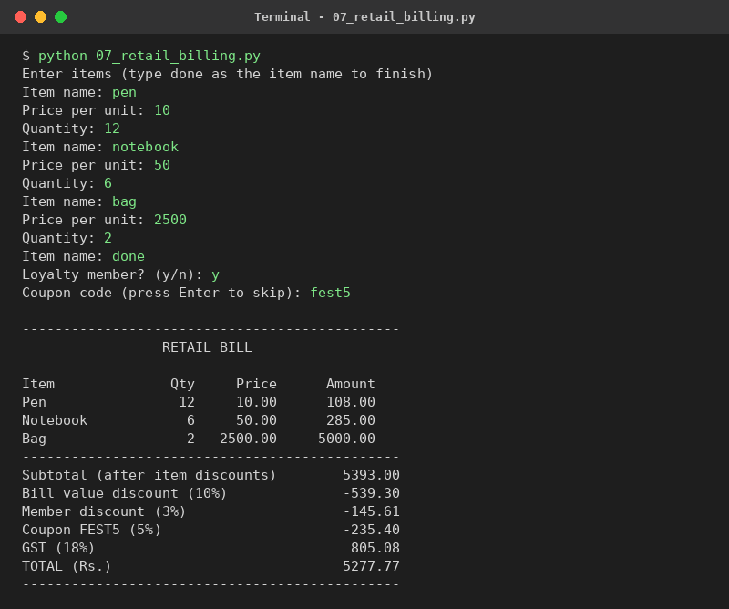
Output 2: small bill with an invalid coupon
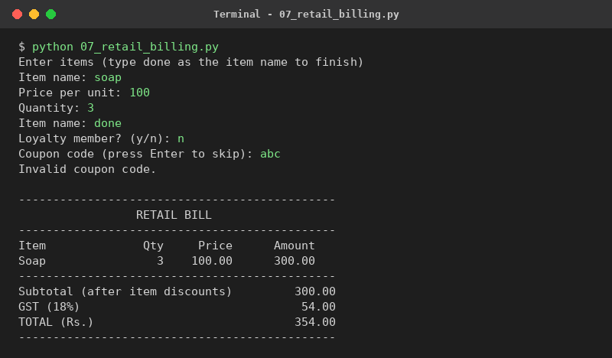

5.10 Conclusion
This was the project where I understood why the order of discounts matters, because every discount is calculated on the amount left by the previous one. Keeping the rules in two lists made the final loop short and easy to explain. All six test cases passed. In future more coupon codes can be added using a list of codes.

Chapter 6: Project 5 - Manufacturing Cost and Profitability Analysis

6.1 Problem Statement
A small factory makes more than one product. The owner wants to know the cost of one unit of each product (material, labour and a share of the fixed overhead), the profit and margin on each product, the number of units to sell to cover the overhead (break-even) and which product is the most profitable.

6.2 Objectives
- To calculate the cost per unit, revenue, profit and profit margin.
- To classify each product as Loss, Low profit, Good or Excellent.
- To find the break-even units of every product.
- To find the highest profit using a loop over a list.

6.3 Assumptions
- All units produced are sold.
- The total fixed overhead is shared equally per unit among all products.
- Margin less than 10% is Low profit, less than 25% is Good and 25% or more is Excellent.
- Break-even units = overhead share of the product / (price - material - labour). If this value is zero or negative, N/A is printed.

6.4 Algorithm
- Start the program and read the number of products and the total overhead.
- For each product read the name, units, material cost, labour cost and selling price, and store them in lists.
- Overhead per unit = total overhead / total units of all products.
- For each product: cost per unit = material + labour + overhead per unit.
- Revenue = price x units. Profit = revenue - cost per unit x units. Margin % = profit / revenue x 100.
- Break-even units = overhead share / (price - material - labour), or N/A if the contribution is not positive.
- Decide the status using if-elif-else on the profit and margin.
- Print the row of the table and save the profit in a list.
- Find the product with the highest profit, print the totals and stop.

6.5 Flowchart
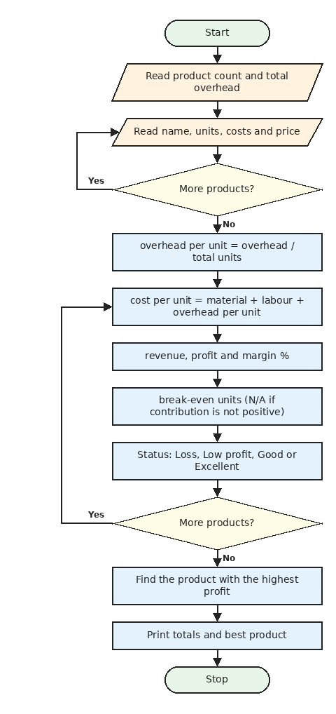
Figure 6.1: Flowchart of Project 5: Manufacturing Profitability

6.6 Pseudocode
START
READ count, overhead
FOR i = 0 TO count - 1
READ name, units, material, labour, price
ADD each value to its list
END FOR
overhead_per_unit = overhead / SUM(units)
FOR i = 0 TO count - 1
cost = material[i] + labour[i] + overhead_per_unit
revenue = price[i] * units[i]
profit = revenue - cost * units[i]
margin = profit / revenue * 100
contribution = price[i] - material[i] - labour[i]
IF contribution > 0 THEN bep = overhead_per_unit * units[i] / contribution
ELSE bep = N/A
IF profit < 0 THEN status = Loss
ELSE IF margin < 10 THEN status = Low profit
ELSE IF margin < 25 THEN status = Good
ELSE status = Excellent
PRINT row, ADD profit to profits
END FOR
best = index of the highest profit
PRINT overhead per unit, total profit, best product
STOP

6.7 Python Source Code
File name: 08_manufacturing_profit.py
names = []
units = []
materials = []
labours = []
prices = []

count = int(input("Number of products: "))
overhead = float(input("Total fixed overhead for the month: "))

for i in range(count):
names.append(input(f"\nProduct {i + 1} name: ").strip().title())
units.append(int(input("Units produced and sold: ")))
materials.append(float(input("Material cost per unit: ")))
labours.append(float(input("Labour cost per unit: ")))
prices.append(float(input("Selling price per unit: ")))

overhead_per_unit = overhead / sum(units)

print(f"\n{'Product':<12}{'Cost/unit':>10}{'Revenue':>11}{'Profit':>11}{'Margin%':>9}{'BEP units':>11} Status")
profits = []
for i in range(count):
cost_per_unit = materials[i] + labours[i] + overhead_per_unit
revenue = prices[i] * units[i]
profit = revenue - cost_per_unit * units[i]
margin = profit / revenue * 100

contribution = prices[i] - materials[i] - labours[i]
if contribution > 0:
bep = overhead_per_unit * units[i] / contribution
bep_text = str(round(bep))
else:
bep_text = "N/A"

if profit < 0:
status = "Loss"
elif margin < 10:
status = "Low profit"
elif margin < 25:
status = "Good"
else:
status = "Excellent"

profits.append(profit)
print(f"{names[i]:<12}{cost_per_unit:>10.2f}{revenue:>11.2f}{profit:>11.2f}{margin:>9.1f}{bep_text:>11} {status}")

best = 0
for i in range(count):
if profits[i] > profits[best]:
best = i

print("\nOverhead per unit :", round(overhead_per_unit, 2))
print("Total profit :", round(sum(profits), 2))
print("Most profitable item :", names[best])

6.8 Test Cases
TC | Input | Expected output | Actual output | Result
1 | Chair: 100 units, 50 + 30 cost, price 200, overhead 1000 | Margin 55%, Excellent | Chair 90.00 20000.00 11000.00 55.0 8 Excellent | Pass
2 | Same, price 110 | Margin 18.2%, Good | Chair 90.00 11000.00 2000.00 18.2 33 Good | Pass
3 | Same, price 95 | Margin 5.3%, Low profit | Chair 90.00 9500.00 500.00 5.3 67 Low profit | Pass
4 | Same, price 80 | Loss, break-even N/A | Chair 90.00 8000.00 -1000.00 -12.5 N/A Loss | Pass
5 | Three products (chair, table, stool) | Most profitable item is Chair | Most profitable item : Chair | Pass

6.9 Output Screenshots
Output 1: three products with different statuses
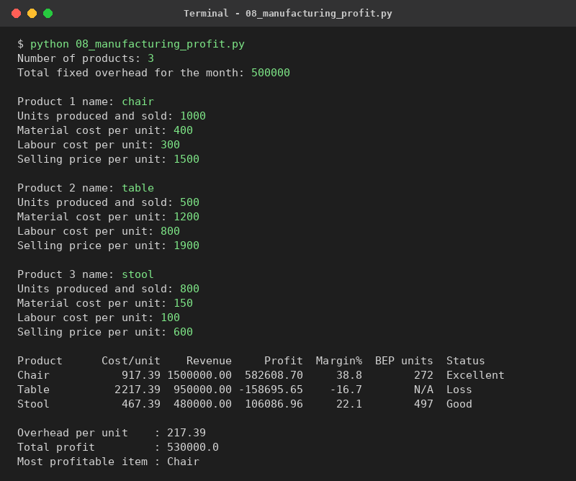

6.10 Conclusion
I learnt how to share a common cost among products and how to find the maximum value from a list with a loop. The table clearly shows which product gives profit and which gives loss. One limitation is that the overhead is shared equally per unit, which real factories may not do.

Chapter 7: Project 6 - Multi-Currency Travel Budget Analysis

7.1 Problem Statement
A student is planning a trip abroad. The costs are in a foreign currency like dollars or pounds, but the budget is in rupees. I have to write a program that converts all the expenses to rupees, shows how much is spent on each category, and tells whether the trip is inside the budget or not.

7.2 Objectives
- To convert foreign currency amounts to rupees using lists of rates.
- To use a list of True/False flags to decide which costs are per day.
- To compare the total expense with the budget using if-else.
- To find the category with the highest spending.

7.3 Assumptions
- Sample rates are: 1 USD = Rs. 83, 1 EUR = Rs. 90, 1 GBP = Rs. 105, 1 AED = Rs. 22.6 and 1 SGD = Rs. 61. Real rates change every day.
- Flights and shopping are entered as a total for the trip. Hotel, food and local transport are entered per day.
- Only the five listed currencies are supported.
- The budget is entered in rupees.

7.4 Algorithm
- Start the program and print the supported currencies.
- Read the currency code and convert it to upper case. If it is not in the list, ask again.
- Find the rate using the position (index) of the code in the list.
- Read the number of days and the budget in rupees.
- For each of the five categories read the cost. If the category is per day, multiply by the days.
- Convert the cost to rupees (cost x rate) and store it in a list.
- Total = sum of the list.
- Print each category with its share percent and find the highest category.
- If total is less than or equal to the budget, print the money left. Otherwise print the amount over the budget.
- Print the cost per day and the highest spending category. Stop.

7.5 Flowchart
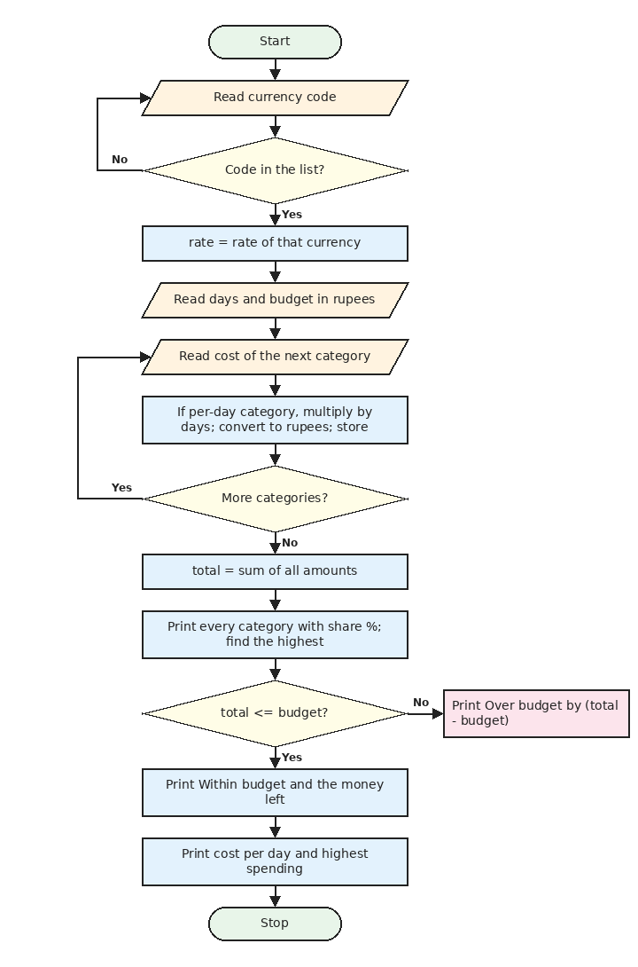
Figure 7.1: Flowchart of Project 6: Travel Budget

7.6 Pseudocode
START
currency_codes = [USD, EUR, GBP, AED, SGD]
rates = [83.0, 90.0, 105.0, 22.6, 61.0]
categories = [Flights, Hotel, Food, Local transport, Shopping]
per_day = [False, True, True, True, False]
READ code, convert to upper case
WHILE code is not in currency_codes
READ code again
END WHILE
rate = rates[index of code]
READ days, budget
FOR i = 0 TO 4
READ value
IF per_day[i] THEN value = value * days
ADD value * rate to amounts_inr
END FOR
total = SUM(amounts_inr)
top = 0
FOR i = 0 TO 4
share = amounts_inr[i] / total * 100
PRINT category, amount, share
IF amounts_inr[i] > amounts_inr[top] THEN top = i
END FOR
IF total <= budget THEN PRINT within budget, money left
ELSE PRINT over budget by total - budget
PRINT total / days, categories[top]
STOP

7.7 Python Source Code
File name: 09_travel_budget.py
currency_codes = ["USD", "EUR", "GBP", "AED", "SGD"]
rates_to_inr = [83.0, 90.0, 105.0, 22.6, 61.0]
categories = ["Flights", "Hotel", "Food", "Local transport", "Shopping"]
per_day = [False, True, True, True, False]

print("Supported currencies:", ", ".join(currency_codes), "(sample rates)")
code = input("Destination currency: ").strip().upper()
while code not in currency_codes:
code = input("Not supported. Enter again: ").strip().upper()
rate = rates_to_inr[currency_codes.index(code)]

days = int(input("Number of days: "))
budget = float(input("Total budget in INR: "))

amounts_inr = []
print(f"\nEnter costs in {code} (hotel, food and transport are per day)")
for i in range(len(categories)):
value = float(input(f"{categories[i]}: "))
if per_day[i]:
value = value * days
amounts_inr.append(value * rate)

total = sum(amounts_inr)

line = "-" * 44
print("\n" + line)
print(f"TRAVEL BUDGET: {days} days, 1 {code} = Rs. {rate}")
print(line)
print(f"{'Category':<18}{'Amount (Rs.)':>14}{'Share':>10}")
top = 0
for i in range(len(categories)):
share = amounts_inr[i] / total * 100
print(f"{categories[i]:<18}{amounts_inr[i]:>14.2f}{share:>9.1f}%")
if amounts_inr[i] > amounts_inr[top]:
top = i
print(line)
print(f"{'Total':<18}{total:>14.2f}")
print(f"{'Budget':<18}{budget:>14.2f}")

if total <= budget:
print(f"Status: Within budget, Rs. {budget - total:.2f} left")
else:
print(f"Status: Over budget by Rs. {total - budget:.2f}")
print(f"Cost per day: Rs. {total / days:.2f}")
print("Highest spending on:", categories[top])

7.8 Test Cases
TC | Input | Expected output | Actual output | Result
1 | USD, 5 days, budget 150000 | Total 130725, Rs. 19275.00 left | Status: Within budget, Rs. 19275.00 left | Pass
2 | GBP, 4 days, budget 60000 | Over budget by Rs. 88050.00 | Status: Over budget by Rs. 88050.00 | Pass
3 | Wrong code xyz, then eur | Asks again, then uses 1 EUR = 90.0 | Not supported. Enter again: eur | TRAVEL BUDGET: 2 days, 1 EUR = Rs. 90.0 | Pass
4 | Lower case code aed | Accepted, rate 22.6 | TRAVEL BUDGET: 1 days, 1 AED = Rs. 22.6 | Pass
5 | Highest spending check (USD) | Flights is the highest | Highest spending on: Flights | Pass

7.9 Output Screenshots
Output 1: 5-day trip in USD, within budget
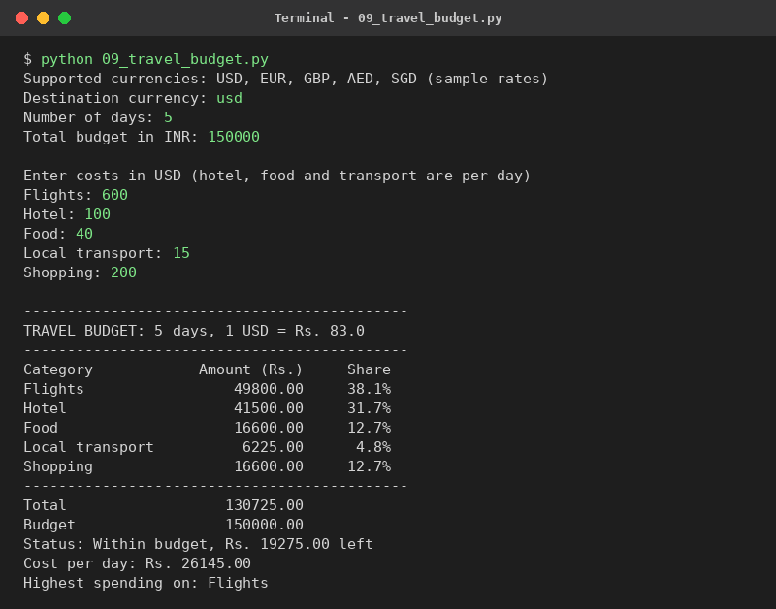
Output 2: 4-day trip in GBP, over budget
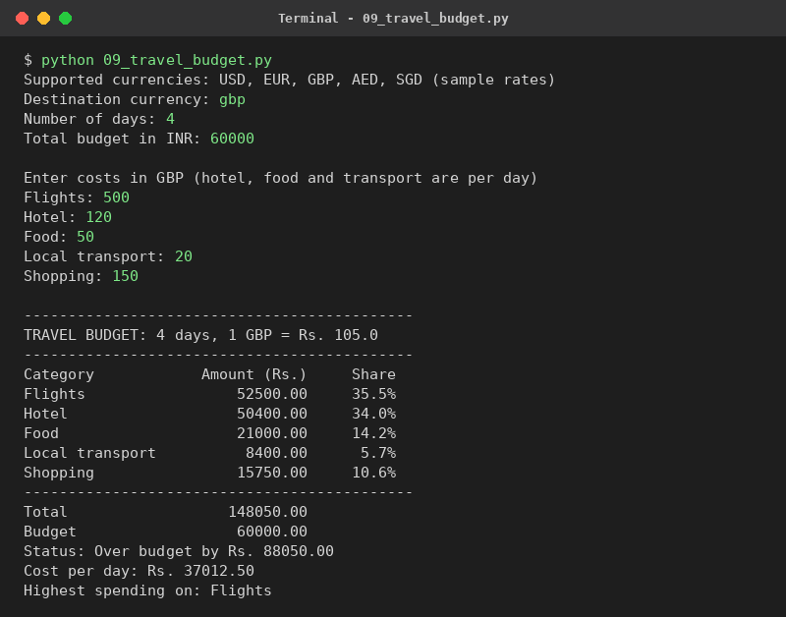

7.10 Conclusion
In this project I used one list for currency codes and another list for the rates, and the index() function connects them. The boolean list per_day was a nice idea to avoid writing many if statements. The totals matched my calculator. The rates must be updated manually, so using live exchange rates would be a good improvement.

Chapter 8: Project 7 - Campus Event Financial Planning

8.1 Problem Statement
Our college clubs organise events like a technical fest. Before the event, the club has to check whether the money coming in (registration fees and sponsors) is enough to pay all the expenses. I have to write a program that finds the surplus or deficit, shows the risk level and finds how many participants are needed to break even.

8.2 Objectives
- To read sponsors and expenses using loops that stop at the word done.
- To calculate total income, total expenses and surplus or deficit.
- To mark major expenses (more than 20% of the total).
- To decide the status as Deficit, Risky or Healthy.
- To find the break-even number of participants.

8.3 Assumptions
- Income comes only from registration fees and sponsors.
- Sponsor money is fixed and does not depend on the number of participants.
- An expense above 20% of the total expenses is Major.
- Surplus below 10% of the expenses is Risky.
- Break-even participants = (expenses - sponsors) / fee, rounded up. It is 0 if sponsors already cover all expenses.

8.4 Algorithm
- Start the program. Read the registration fee and the expected participants.
- Registration income = fee x participants.
- Read the sponsors (name and amount) until the user types done.
- Read the expenses (name and amount) until the user types done.
- Total income = registration income + sponsor total. Surplus = total income - total expenses.
- Print the income. For each expense print the amount, its share percent and the Major tag if the share is above 20%.
- If surplus is 0 or more, print Surplus. Otherwise print Deficit.
- Find the margin = surplus / expenses x 100 and print the status.
- Find the break-even participants and round the value up. Print it. Stop.

8.5 Flowchart
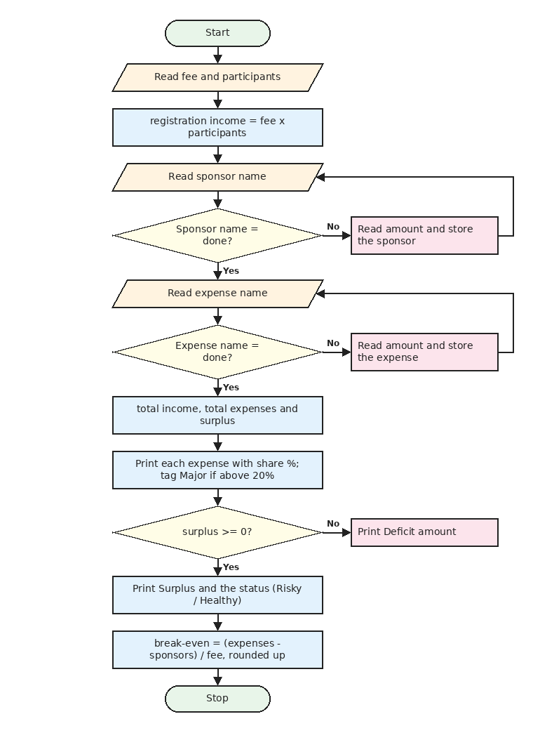
Figure 8.1: Flowchart of Project 7: Campus Event Planning

8.6 Pseudocode
START
READ fee, participants
registration = fee * participants
WHILE TRUE
READ sponsor
IF sponsor is done THEN BREAK
READ amount, ADD to sponsor lists
END WHILE
WHILE TRUE
READ expense
IF expense is done THEN BREAK
READ amount, ADD to expense lists
END WHILE
income = registration + SUM(sponsors)
total_expense = SUM(expenses)
surplus = income - total_expense
FOR each expense
share = amount / total_expense * 100
IF share > 20 THEN tag = Major
PRINT expense, amount, share, tag
END FOR
IF surplus >= 0 THEN PRINT Surplus ELSE PRINT Deficit
margin = surplus / total_expense * 100
IF surplus < 0 THEN status = Deficit
ELSE IF margin < 10 THEN status = Risky
ELSE status = Healthy
needed = (total_expense - SUM(sponsors)) / fee
break_even = needed rounded up (0 if needed <= 0)
PRINT status, break_even
STOP

8.7 Python Source Code
File name: 10_campus_event_planning.py
fee = float(input("Registration fee per participant: "))
participants = int(input("Expected participants: "))
registration_income = fee * participants

sponsor_names = []
sponsor_amounts = []
print("\nEnter sponsors (type done to finish)")
while True:
sponsor = input("Sponsor name: ").strip().title()
if sponsor == "Done":
break
sponsor_names.append(sponsor)
sponsor_amounts.append(float(input("Amount: ")))

expense_names = []
expense_amounts = []
print("\nEnter expenses (type done to finish)")
while True:
expense = input("Expense name: ").strip().title()
if expense == "Done":
break
expense_names.append(expense)
expense_amounts.append(float(input("Amount: ")))

sponsor_total = sum(sponsor_amounts)
total_income = registration_income + sponsor_total
total_expense = sum(expense_amounts)
surplus = total_income - total_expense

line = "-" * 44
print("\n" + line)
print("EVENT FINANCIAL PLAN".center(44))
print(line)
print(f"{'Registration fees':<30}{registration_income:>14.2f}")
for i in range(len(sponsor_names)):
print(f"{'Sponsor: ' + sponsor_names[i]:<30}{sponsor_amounts[i]:>14.2f}")
print(f"{'Total income':<30}{total_income:>14.2f}")
print(line)
for i in range(len(expense_names)):
share = expense_amounts[i] / total_expense * 100
if share > 20:
tag = "Major"
else:
tag = ""
print(f"{expense_names[i]:<20}{expense_amounts[i]:>12.2f}{share:>8.1f}% {tag}")
print(f"{'Total expenses':<30}{total_expense:>14.2f}")
print(line)

if surplus >= 0:
print(f"Surplus : Rs. {surplus:.2f}")
else:
print(f"Deficit : Rs. {-surplus:.2f}")

margin = surplus / total_expense * 100
if surplus < 0:
status = "Deficit - reduce expenses or raise the fee"
elif margin < 10:
status = "Risky - safety margin below 10%"
else:
status = "Healthy"
print("Status :", status)

needed = (total_expense - sponsor_total) / fee
break_even = int(needed)
if break_even < needed:
break_even = break_even + 1
if needed <= 0:
break_even = 0
print("Break-even participants:", break_even)

8.8 Test Cases
TC | Input | Expected output | Actual output | Result
1 | Fee 200, 300 participants, sponsor 20000, expenses 65000 | Surplus 15000, Healthy, break-even 225 | Surplus : Rs. 15000.00 | Status : Healthy | Break-even participants: 225 | Pass
2 | Fee 100, 50 participants, expense 8000 | Deficit 3000.00 | Deficit : Rs. 3000.00 | Pass
3 | Fee 100, 100 participants, expense 9500 | Surplus 500, margin 5.3%, Risky | Status : Risky - safety margin below 10% | Pass
4 | Sponsor 20000 covers expense 5000 | Break-even participants 0 | Break-even participants: 0 | Pass

8.9 Output Screenshots
Output 1: event with 300 participants, one sponsor and three expenses
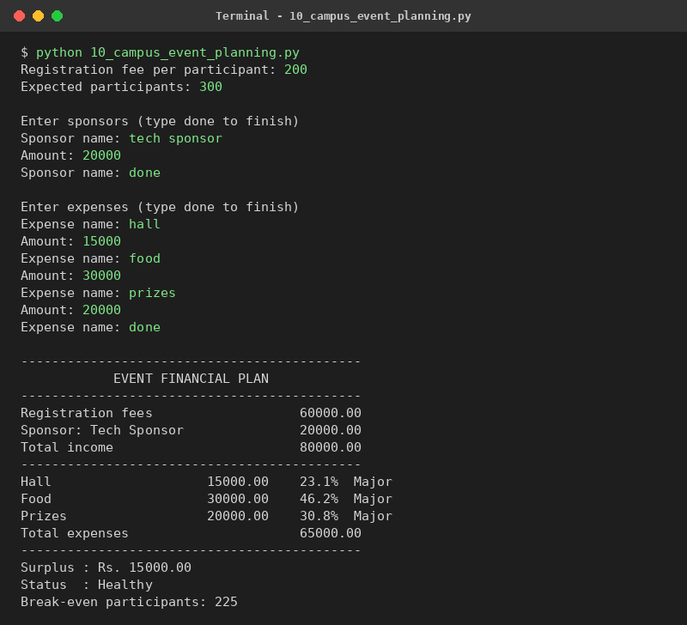
Output 2: an event that ends in a deficit
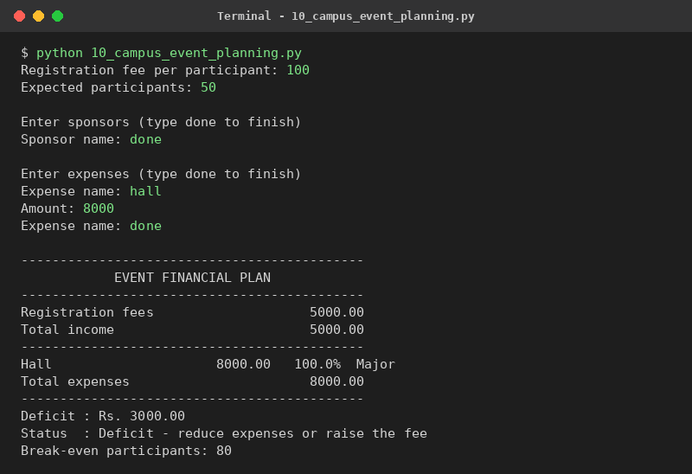

8.10 Conclusion
This project showed me how a loop that stops at the word done can read any number of values. The break-even part needed rounding up without importing anything, so I used int() and an if statement. The results match my manual calculation. A future improvement could be to save the plan in a file so that the club can open it later.

Chapter 9: Project 8 - Examination Result and Grace-Mark Validation

9.1 Problem Statement
After the exam, the marks of the students must be checked. A student passes if he gets at least 35 marks in every subject. If a student fails in only one subject by a small margin, grace marks can be given. I have to write a program that validates the marks, applies the grace-mark rule and prints the result and class of every student.

9.2 Objectives
- To validate marks so that only numbers from 0 to 100 are accepted.
- To find the failed subjects and store their positions in a list.
- To apply the grace-mark rule using if-elif-else.
- To find the total, percentage and class of each student.
- To count the passed and failed students and find the pass percentage.

9.3 Assumptions
- There are five subjects: Maths, Physics, Chemistry, English and Programming, each for 100 marks.
- The pass mark is 35 in each subject.
- Grace marks are given only when exactly one subject is failed and the shortage is 5 marks or less. The mark is then raised to 35.
- Class: 75% and above is Distinction, 60% and above is First Class, 50% and above is Second Class, otherwise Pass Class.
- A failed student does not get a class.

9.4 Algorithm
- Start the program and read the number of students.
- For each student read the name.
- Read the marks of the five subjects. A mark is valid only if it is a number from 0 to 100, otherwise ask again.
- Make a list failed with the positions of subjects where marks are below 35.
- If the list is empty the result is PASS.
- If exactly one subject is failed and the shortage is 5 or less, give the grace marks and the result is PASS (with grace). Otherwise the result is FAIL.
- Total = sum of marks. Percentage = total / 5.
- Find the class from the percentage if the student has passed.
- Print the marks with notes and the result. Increase the pass or fail count.
- After all students print the pass count, fail count and pass percentage. Stop.

9.5 Flowchart
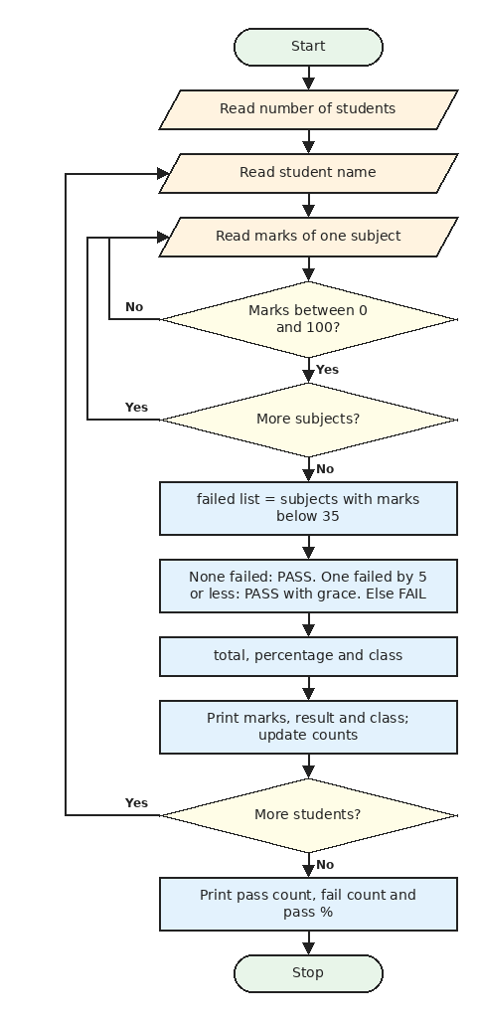
Figure 9.1: Flowchart of Project 8: Exam Result and Grace Marks

9.6 Pseudocode
START
subjects = [Maths, Physics, Chemistry, English, Programming]
PASS_MARK = 35, MAX_GRACE = 5
READ count
FOR each student
READ name
marks = empty list
FOR each subject
READ text
WHILE text is not digits OR text > 100
READ text again
END WHILE
ADD INTEGER(text) to marks
END FOR
failed = positions of marks below 35
IF length of failed = 0 THEN result = PASS
ELSE IF length of failed = 1 AND shortage <= 5 THEN
raise that mark to 35, result = PASS (with grace)
ELSE result = FAIL
total = SUM(marks), percent = total / 5
IF result is FAIL THEN grade = -
ELSE IF percent >= 75 THEN grade = Distinction
ELSE IF percent >= 60 THEN grade = First Class
ELSE IF percent >= 50 THEN grade = Second Class
ELSE grade = Pass Class
PRINT marks, total, percent, result, grade
END FOR
PRINT pass count, fail count, pass percentage
STOP

9.7 Python Source Code
File name: 11_exam_result_grace.py
subjects = ["Maths", "Physics", "Chemistry", "English", "Programming"]
PASS_MARK = 35
MAX_GRACE = 5

count = int(input("Number of students: "))
pass_count = 0
fail_count = 0

for s in range(count):
name = input(f"\nStudent {s + 1} name: ").strip().title()
marks = []
for subject in subjects:
text = input(f"{subject} marks (0-100): ").strip()
while not text.isdigit() or int(text) > 100:
text = input("Invalid. Enter marks between 0 and 100: ").strip()
marks.append(int(text))

failed = []
for i in range(len(marks)):
if marks[i] < PASS_MARK:
failed.append(i)

grace_used = 0
if len(failed) == 0:
result = "PASS"
elif len(failed) == 1 and PASS_MARK - marks[failed[0]] <= MAX_GRACE:
grace_used = PASS_MARK - marks[failed[0]]
marks[failed[0]] = PASS_MARK
result = "PASS (with grace)"
else:
result = "FAIL"

total = sum(marks)
percent = total / len(marks)

if result == "FAIL":
grade = "-"
elif percent >= 75:
grade = "Distinction"
elif percent >= 60:
grade = "First Class"
elif percent >= 50:
grade = "Second Class"
else:
grade = "Pass Class"

print(f"--- {name} ---")
for i in range(len(subjects)):
note = ""
if i in failed and result == "FAIL":
note = " (failed)"
elif i in failed:
note = f" (+{grace_used} grace)"
print(f"{subjects[i]:<14}{marks[i]:>4}{note}")
print(f"Total {total}/500 | Percentage {percent:.1f}% | Result: {result} | Grade: {grade}")

if result == "FAIL":
fail_count += 1
else:
pass_count += 1

print("\nPassed:", pass_count, "| Failed:", fail_count)
print(f"Pass percentage: {pass_count / count * 100:.1f}%")

9.8 Test Cases
TC | Input | Expected output | Actual output | Result
1 | 80, 70, 60, 90, 75 | 375/500, 75.0%, Distinction | Total 375/500 | Percentage 75.0% | Result: PASS | Grade: Distinction | Total 375/500 | Percentage 75.0% | Result: PASS | Grade: Distinction | Pass
2 | 32, 40, 50, 60, 70 | 3 grace marks, PASS (with grace) | Maths 35 (+3 grace) | Total 255/500 | Percentage 51.0% | Result: PASS (with grace) | Grade: Second Class | Pass
3 | 29, 60, 60, 60, 60 | Shortage is 6, so FAIL | Total 269/500 | Percentage 53.8% | Result: FAIL | Grade: - | Pass
4 | 30, 30, 60, 60, 60 | Two failed subjects, FAIL | Total 240/500 | Percentage 48.0% | Result: FAIL | Grade: - | Pass
5 | 105 (invalid) then 90, 60, 60, 60, 60 | Asks again, then 66.0%, PASS | Invalid. Enter marks between 0 and 100: 90 | Total 330/500 | Percentage 66.0% | Result: PASS | Grade: First Class | Pass

9.9 Output Screenshots
Output 1: a pass, a pass with grace marks and a fail
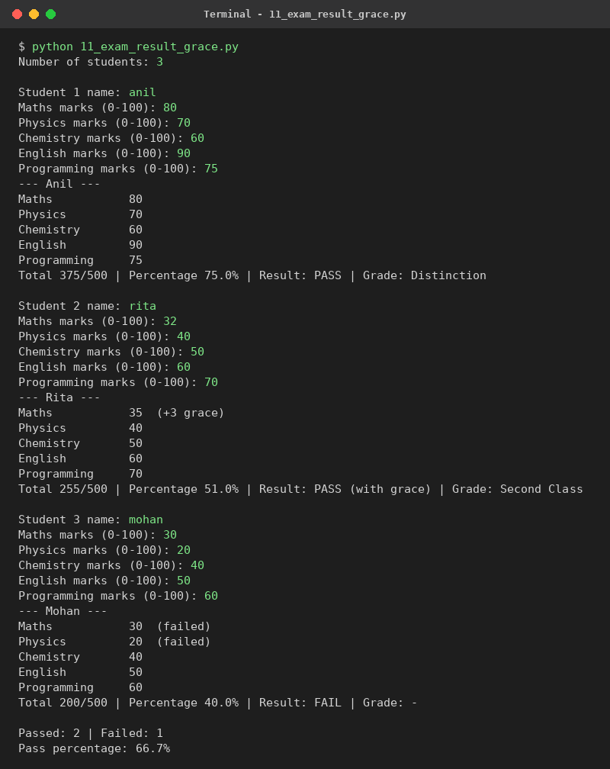

9.10 Conclusion
In this project the validation loop was new for me because the while loop asks again until the input is correct. Storing the positions of failed subjects in a list made the grace rule simple. All the test cases gave the expected result. The grace rule I used is my assumption, so it should be changed according to the college rules.

Chapter 10: Project 9 - Attendance Recovery Computation

10.1 Problem Statement
In our college we need at least 75% attendance in every subject. Many students do not know how many classes they must attend to recover a shortage, or how many classes they can still miss. I have to write a program that takes the held and attended classes of each subject and gives this advice.

10.2 Objectives
- To calculate the attendance percentage of every subject.
- To find how many classes can be missed when attendance is safe.
- To find how many classes must be attended continuously when there is a shortage.
- To check whether the recovery is possible in the remaining classes.
- To use while loops with a counter.

10.3 Assumptions
- The required attendance is 75%.
- The same number of classes is remaining for every subject.
- A student who attends a class increases both attended and held by 1. A missed class increases only held.
- Classes held must be more than 0 and attended cannot be more than held.

10.4 Algorithm
- Start the program. Read the number of subjects and the remaining classes.
- For each subject read the name, classes held and classes attended. If attended is more than held or held is 0, ask again.
- Percentage = attended x 100 / held. Print it.
- If the percentage is 75 or more, set can_skip = 0 and keep increasing it while the final attendance after missing one more class is still 75% or more (and can_skip is less than the remaining classes).
- Print Safe and the number of classes that can be missed.
- If the percentage is below 75, set need = 0 and keep adding one attended class (attended + 1, held + 1, need + 1) until the percentage is 75.
- If need is less than or equal to the remaining classes, print how many classes must be attended continuously.
- Otherwise print the maximum possible percentage and advise condonation. Stop.

10.5 Flowchart
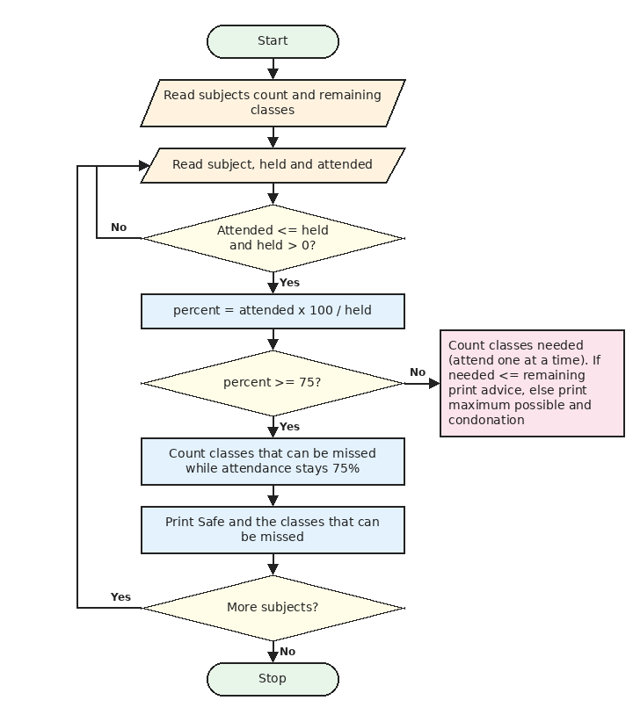
Figure 10.1: Flowchart of Project 9: Attendance Recovery

10.6 Pseudocode
START
REQUIRED = 75
READ count, remaining
FOR each subject
READ subject, held, attended
WHILE attended > held OR held = 0
PRINT error, READ held, attended again
END WHILE
percent = attended * 100 / held
IF percent >= REQUIRED THEN
can_skip = 0
WHILE can_skip < remaining AND
(attended + remaining - can_skip - 1) * 100 / (held + remaining) >= REQUIRED
can_skip = can_skip + 1
END WHILE
PRINT Safe, can_skip
ELSE
need = 0, a = attended, h = held
WHILE a * 100 / h < REQUIRED
a = a + 1, h = h + 1, need = need + 1
END WHILE
IF need <= remaining THEN PRINT attend next need classes
ELSE
best = (attended + remaining) * 100 / (held + remaining)
PRINT cannot reach 75, best, condonation
END FOR
STOP

10.7 Python Source Code
File name: 12_attendance_recovery.py
REQUIRED = 75

count = int(input("Number of subjects: "))
remaining = int(input("Classes remaining in the semester (per subject): "))

for i in range(count):
subject = input(f"\nSubject {i + 1} name: ").strip().title()
held = int(input("Classes held so far: "))
attended = int(input("Classes attended: "))
while attended > held or held == 0:
print("Attended cannot be more than held, and held must be above 0.")
held = int(input("Classes held so far: "))
attended = int(input("Classes attended: "))

percent = attended * 100 / held
print(f"{subject}: {attended}/{held} = {percent:.1f}%")

if percent >= REQUIRED:
can_skip = 0
while can_skip < remaining and (attended + remaining - can_skip - 1) * 100 / (held + remaining) >= REQUIRED:
can_skip += 1
print("Status: Safe")
print(f"You can miss up to {can_skip} of the remaining {remaining} classes.")
else:
need = 0
a = attended
h = held
while a * 100 / h < REQUIRED:
a += 1
h += 1
need += 1
print("Status: Shortage")
if need <= remaining:
print(f"Attend the next {need} classes continuously to reach {REQUIRED}%.")
else:
best = (attended + remaining) * 100 / (held + remaining)
print(f"Cannot reach {REQUIRED}% even with full attendance. Maximum possible: {best:.1f}%")
print("Apply for condonation or medical leave.")

10.8 Test Cases
TC | Input | Expected output | Actual output | Result
1 | 34 attended out of 40, 20 remaining | Safe, can miss 9 classes | Status: Safe | You can miss up to 9 of the remaining 20 classes. | Pass
2 | 25 attended out of 40, 20 remaining | Attend the next 20 classes | Attend the next 20 classes continuously to reach 75%. | Pass
3 | 10 attended out of 40, 20 remaining | Maximum possible 50.0% | Cannot reach 75% even with full attendance. Maximum possible: 50.0% | Pass
4 | 30 attended out of 40 (exactly 75%) | Safe, can miss 5 classes | Status: Safe | You can miss up to 5 of the remaining 20 classes. | Pass
5 | Attended 45 out of 40 (wrong), then 30 | Error message, then Safe | Attended cannot be more than held, and held must be above 0. | Status: Safe | Pass

10.9 Output Screenshots
Output 1: one safe subject, one recoverable shortage and one that cannot be recovered
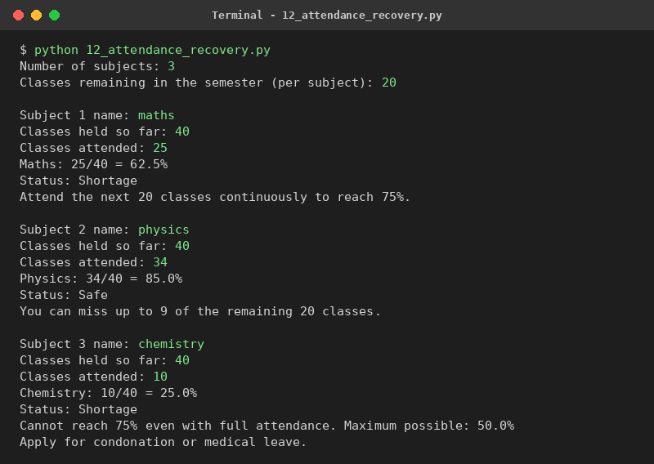

10.10 Conclusion
This project gave me practice with while loops that count. At first I thought a formula was needed, but a loop that adds one class at a time was easier for me to understand and explain. The program works for safe, shortage and impossible cases. A future improvement is to accept different remaining classes for each subject.

Chapter 11: Project 10 - ATM Transaction Sequence Simulation

11.1 Problem Statement
An ATM allows a customer to check balance, deposit money, withdraw money and see a mini statement, but only after the correct PIN is entered, and only if the rules of the bank are followed. I have to write a program that simulates an ATM session and applies all these rules.

11.2 Objectives
- To allow only 3 PIN attempts and then block the card.
- To create a menu-driven program using a while loop.
- To check the withdrawal rules using if-elif-else.
- To keep a list of the transactions and show the last five.
- To validate the amounts entered by the user.

11.3 Assumptions
- The correct PIN is 1234 and the opening balance is Rs. 15000 (sample values).
- The minimum balance to be kept in the account is Rs. 500.
- The daily withdrawal limit is Rs. 20000.
- Withdrawal amount must be a multiple of 100.
- Data is not saved, so the balance starts again from 15000 every time the program runs.

11.4 Algorithm
- Start the program. Set the balance, daily limit, minimum balance and an empty statement list.
- Ask for the PIN. For a wrong PIN increase the attempts and show how many are left.
- If three wrong PINs are entered, print Card blocked and stop.
- After the correct PIN, show the menu and read the choice.
- Choice 1: print the balance.
- Choice 2: read the amount. If it is a positive number, add it to the balance and save a line in the statement list.
- Choice 3: read the amount and check in order: valid number, multiple of 100, not more than balance minus 500, and not above the daily limit. If all are fine, reduce the balance and save a line in the statement.
- Choice 4: print the last five lines of the statement list.
- Choice 5: print a thank you message and stop. Any other choice prints Invalid option.
- Repeat from step 4 until the choice is 5.

11.5 Flowchart
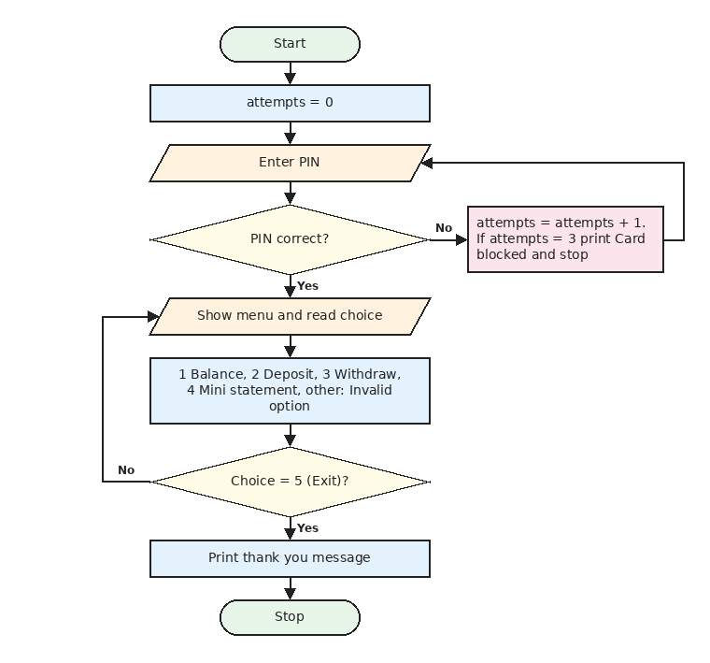
Figure 11.1: Flowchart 1 of Project 10: PIN check and menu
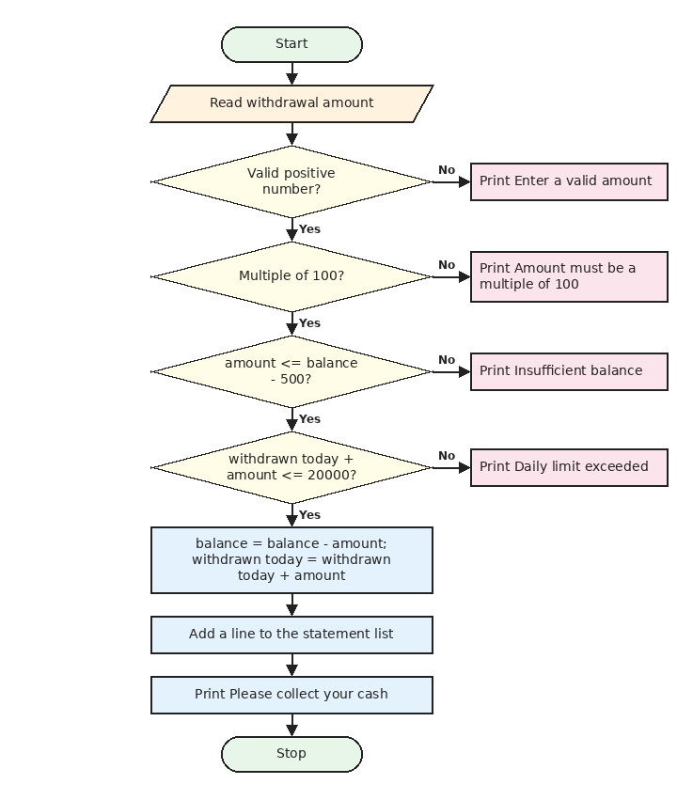
Figure 11.2: Flowchart 2 of Project 10: checks for a withdrawal

11.6 Pseudocode
START
CORRECT_PIN = 1234, DAILY_LIMIT = 20000, MIN_BALANCE = 500
balance = 15000, withdrawn_today = 0, statement = empty list
attempts = 0, logged_in = False
WHILE attempts < 3
READ pin
IF pin = CORRECT_PIN THEN logged_in = True, BREAK
attempts = attempts + 1
PRINT attempts left
END WHILE
IF NOT logged_in THEN PRINT Card blocked and STOP
WHILE TRUE
PRINT menu, READ choice
IF choice = 1 THEN PRINT balance
ELSE IF choice = 2 THEN
READ amount
IF amount is a positive number THEN balance = balance + amount, save in statement
ELSE PRINT error
ELSE IF choice = 3 THEN
READ amount
IF amount is not a positive number THEN PRINT error
ELSE IF amount MOD 100 is not 0 THEN PRINT multiple of 100
ELSE IF amount > balance - MIN_BALANCE THEN PRINT insufficient balance
ELSE IF withdrawn_today + amount > DAILY_LIMIT THEN PRINT limit exceeded
ELSE balance = balance - amount, withdrawn_today = withdrawn_today + amount, save in statement
ELSE IF choice = 4 THEN PRINT last 5 entries of statement
ELSE IF choice = 5 THEN PRINT thank you, BREAK
ELSE PRINT invalid option
END WHILE
STOP

11.7 Python Source Code
File name: 13_atm_simulation.py
CORRECT_PIN = "1234"
DAILY_LIMIT = 20000
MIN_BALANCE = 500

balance = 15000
withdrawn_today = 0
statement = []

attempts = 0
logged_in = False
while attempts < 3:
pin = input("Enter 4-digit PIN: ").strip()
if pin == CORRECT_PIN:
logged_in = True
break
attempts += 1
print(f"Wrong PIN. {3 - attempts} attempt(s) left.")

if not logged_in:
print("Card blocked. Please contact your bank.")
raise SystemExit

print("\nWelcome to the ATM")
while True:
print("\n1. Balance 2. Deposit 3. Withdraw 4. Mini statement 5. Exit")
choice = input("Choose option: ").strip()

if choice == "1":
print(f"Available balance: Rs. {balance}")

elif choice == "2":
text = input("Deposit amount: ").strip()
if text.isdigit() and int(text) > 0:
amount = int(text)
balance += amount
statement.append(f"Deposit +{amount:<7} Balance {balance}")
print("Deposit successful.")
else:
print("Enter a valid amount.")

elif choice == "3":
text = input("Withdrawal amount: ").strip()
if not text.isdigit() or int(text) <= 0:
print("Enter a valid amount.")
else:
amount = int(text)
if amount % 100 != 0:
print("Amount must be a multiple of 100.")
elif amount > balance - MIN_BALANCE:
print(f"Insufficient balance. Rs. {MIN_BALANCE} must remain in the account.")
elif withdrawn_today + amount > DAILY_LIMIT:
print(f"Daily limit exceeded. You can still withdraw Rs. {DAILY_LIMIT - withdrawn_today} today.")
else:
balance -= amount
withdrawn_today += amount
statement.append(f"Withdraw -{amount:<7} Balance {balance}")
print("Please collect your cash.")

elif choice == "4":
if len(statement) == 0:
print("No transactions yet.")
else:
print("Last transactions:")
for entry in statement[-5:]:
print(" ", entry)

elif choice == "5":
print("Thank you for banking with us.")
break

else:
print("Invalid option.")

11.8 Test Cases
TC | Input | Expected output | Actual output | Result
1 | Correct PIN, check balance | Balance Rs. 15000 | Available balance: Rs. 15000 | Pass
2 | Three wrong PINs | Card blocked message | Card blocked. Please contact your bank. | Pass
3 | Deposit 500, then balance | Balance Rs. 15500 | Available balance: Rs. 15500 | Pass
4 | Withdraw 250 | Must be a multiple of 100 | Amount must be a multiple of 100. | Pass
5 | Withdraw 14600 from 15000 | Insufficient balance (500 must remain) | Insufficient balance. Rs. 500 must remain in the account. | Pass
6 | Deposit 20000, withdraw 15000 and then 6000 | Daily limit exceeded, 5000 left | Daily limit exceeded. You can still withdraw Rs. 5000 today. | Daily limit exceeded. You can still withdraw Rs. 5000 today. | Pass

11.9 Output Screenshots
Output 1: wrong PIN once, deposit, invalid and valid withdrawals, statement
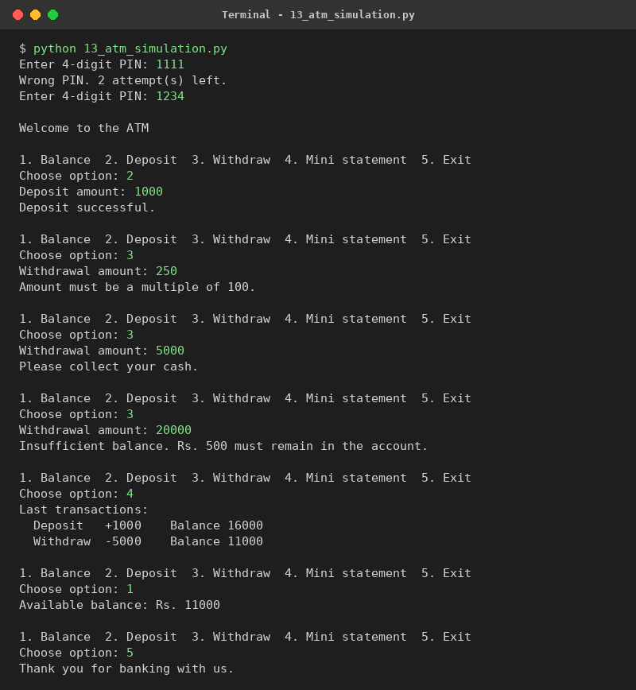
Output 2: card blocked after three wrong PINs
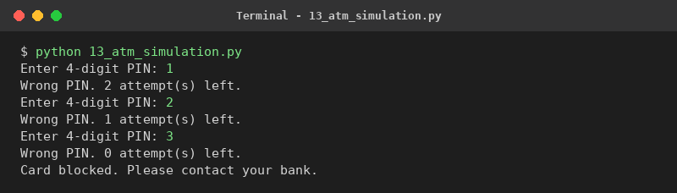

11.10 Conclusion
The ATM project was the most interesting for me because it uses almost everything I learnt: while loops, if-elif chains, lists and strings together. The order of the withdrawal checks is important, and I tested it with six cases. The main limitation is that nothing is saved to a file. In future a file or database can store the balance.

Chapter 12: Overall Conclusion
Through these ten projects I learnt how to turn a real-life problem into a Python program. First I understand the rules, then I write the algorithm and the flowchart, then I write the code and finally I test it with different inputs. This order helped me to find my mistakes early.

12.1 What I Learnt
- Using if, elif and else to apply rules like slabs, discounts and eligibility.
- Using for and while loops to repeat work and to read any number of inputs.
- Storing related data in lists and using the same index for the same item.
- Cleaning and checking user input with string methods like strip(), title(), upper() and isdigit().
- Printing neat bills and tables with f-string formatting.
- Writing test cases and checking the answers by hand.

12.2 Difficulties I Faced
At the beginning I made small mistakes with indentation and with data types, because input() always gives a string and it has to be changed to int or float. Dividing the units into slabs and finding the order of the discounts were also difficult for me, but drawing the flowchart first made them easy.

12.3 Limitations and Future Scope
- The programs do not save any data. In future the data can be stored in files or a database.
- The rates, tax slabs and exchange rates are sample values. They can be read from a file or taken from the internet.
- A graphical interface (for example with Tkinter) can be added so that the programs are easy for everyone to use.
- Repeated parts of the code can be moved into functions to make the programs shorter.

References
- Python 3 documentation, https://docs.python.org/3/
- Class notes and lab manual of Python programming.

